Supplementary Table 1. Association between timing of antibiotic initiation and 28-day mortality
Variable | Model 1 HR (95% CI) | P value | Model 2 HR (95% CI) | P value | Model 3 HR (95% CI) | P value
Antibiotics >1 h | Reference | — | Reference | — | Reference | —
Antibiotics ≤1 h | 1.39 (0.16–11.92) | 0.763 | 1.24 (0.14–10.98) | 0.847 | 1.32 (0.12–15.14) | 0.822

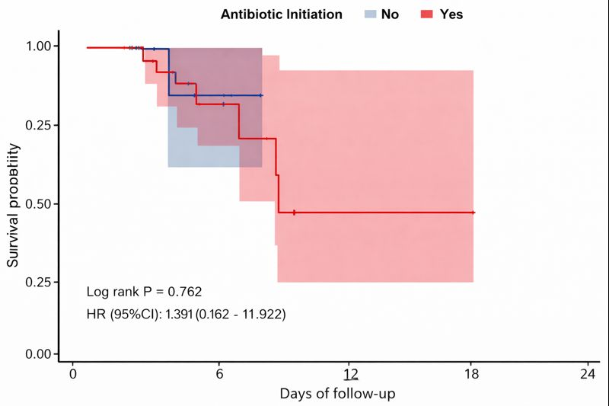Supplementary Figure 1. Survival stratified by timing of antibiotic initiation
Kaplan–Meier survival curves comparing patients who received antibiotic therapy within 1 hour of disease onset and those who received antibiotics later. Survival trajectories largely overlapped throughout the observation period, with no significant difference between groups by log-rank test (P = 0.762).

