Appendix

Table of Contents | Page
Figure A1. Scatterplot of calculated LogMAR UCVA versus days postoperation overlaid with regression line from mixed-effects linear regression, after accounting for patient age and sex. | 2
Figure A2. Scatterplot of calculated LogMAR UCVA versus days postoperation by country, overlaid with regression lines from mixed-effects linear regression, after accounting for patient age and sex, with density of ophthalmologists performing cataract surgery. | 3
Table A1. Country socioeconomic information by year | 4
Table A2. Summary of mixed-effects models for changes in LogMAR UCVA per day for the first four days after cataract surgery, accounting for age and sex, overall as well as within each country. | 5

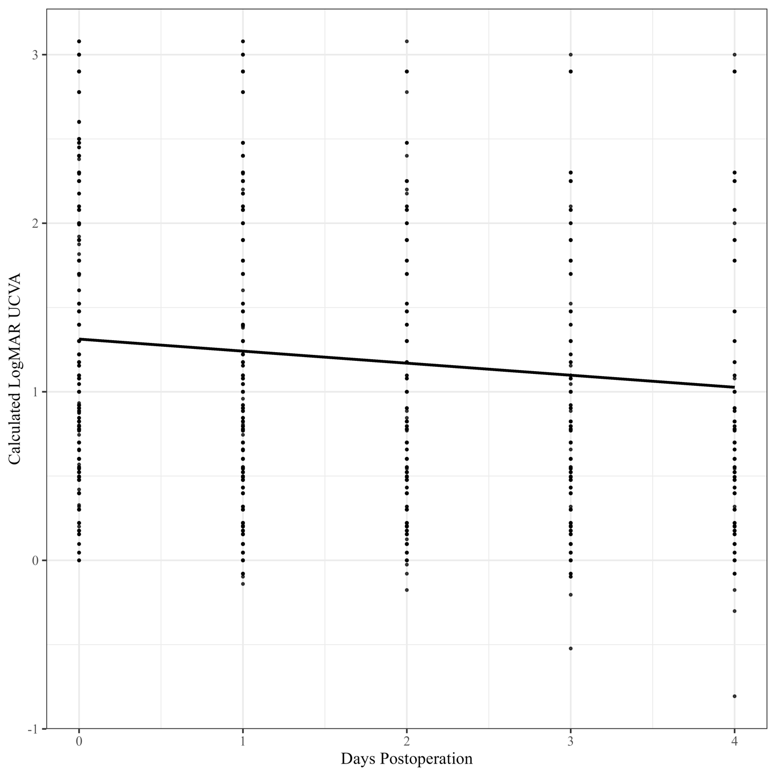
Figure A1. Scatterplot of calculated LogMAR UCVA versus days postoperation overlaid with regression line from mixed-effects linear regression, after accounting for patient age and sex.

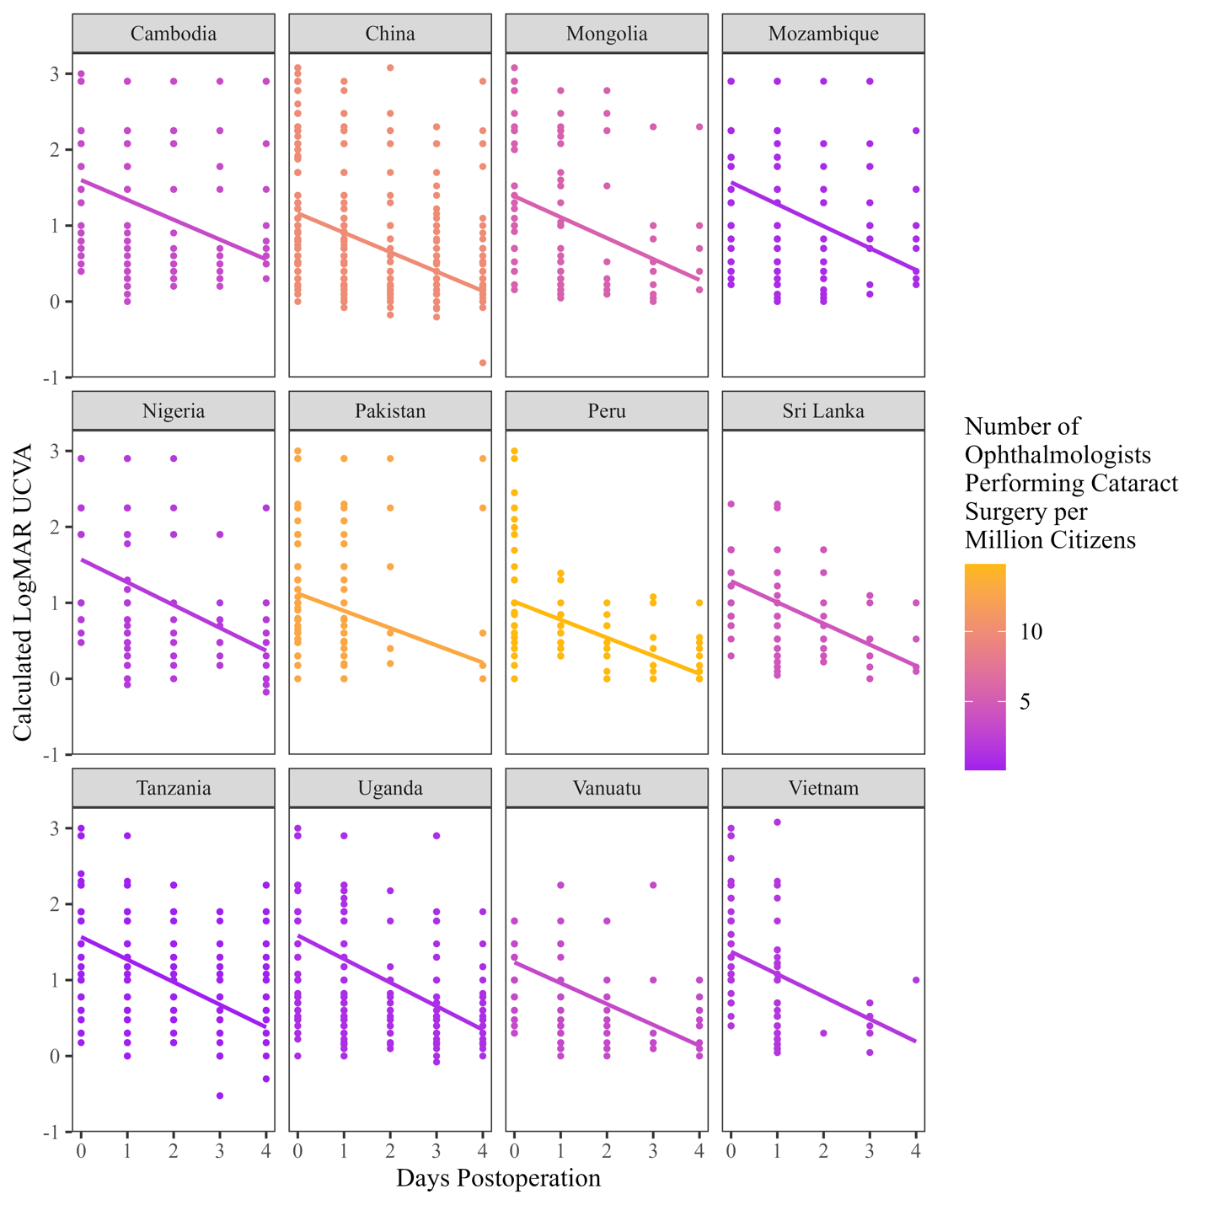
Figure A2. Scatterplot of calculated LogMAR UCVA versus days postoperation by country, overlaid with regression lines from mixed-effects linear regression, after accounting for patient age and sex, with density of ophthalmologists performing cataract surgery.

Table A1. Country socioeconomic information by year.

Country | Year | Human Development Index (HDI) | GDP per Capita, PPP (2021 international $) | Cataract Surgical Rate (CSR) per Million | Number of Ophthalmologists per Million | Number of Ophthalmologists per Million Performing Cataract Surgery
Bangladesh | 2019 | 0·646 | 6838·326 | 2600 | 6·2 | ··
Bangladesh | 2020 | 0·657 | 7015·198 | 2600 | 6·2 | ··
Cambodia | 2023 | ·· | ·· | ·· | ·· | ··
China | 2014 | 0·732 | 13696·517 | 1067 | 26·4 | 9·9
China | 2018 | 0·766 | 17490·167 | 2070 | 26·4 | 9·9
China | 2019 | 0·775 | 18465·299 | 2070 | ·· | ··
Kyrgyzstan | 2016 | 0·692 | 5715·011 | ·· | 43·8 | ··
Kyrgyzstan | 2018 | 0·698 | 5951·829 | ·· | 43·8 | ··
Kyrgyzstan | 2019 | 0·699 | 6087·602 | ·· | ·· | ··
Kyrgyzstan | 2023 | ·· | 6403·143 | ·· | ·· | ··
Mauritania | 2018 | 0·546 | 6153·638 | ·· | 1·5 | ··
Mauritania | 2022 | 0·540 | 6053·262 | ·· | ·· | ··
Mongolia | 2014 | 0·735 | 13943·428 | 1068 | 43·9 | 5·5
Mongolia | 2022 | 0·741 | 15310·435 | ·· | ·· | ··
Morocco | 2017 | 0·671 | 8450·009 | 2924 | 34·3 | ··
Morocco | 2018 | 0·677 | 8611·750 | ·· | 34·3 | ··
Morocco | 2023 | 0·698 | 8868·712 | ·· | ·· | ··
Mozambique | 2018 | 0·458 | 1538·835 | 357 | 1·0 | 0·9
Mozambique | 2023 | 0·461 | 1511·637 | ·· | ·· | ··
Nigeria | 2018 | 0·530 | 5628·741 | 317 | 3·0 | 1·9
Nigeria | 2022 | 0·548 | 5552·838 | ·· | ·· | ··
Pakistan | 2014 | 0·519 | 4520·235 | 2819 | 14·8 | 13·0
Pakistan | 2018 | 0·535 | 5255·064 | ·· | 14·8 | 13·0
Pakistan | 2023 | 0·540 | 5439·188 | ·· | ·· | ··
Peru | 2018 | 0·770 | 15388·998 | 2119 | 39·6 | 14·8
Sri Lanka | 2018 | 0·774 | 14759·825 | 4000 | 5·0 | 4·4
Tanzania | 2018 | 0·525 | 3392·689 | 407 | 0·8 | 0·1
Tanzania | 2019 | 0·533 | 3484·633 | 407 | 0·8 | ··
Tanzania | 2023 | 0·532 | 3620·793 | ·· | ·· | ··
Uganda | 2019 | 0·544 | 2689·410 | ·· | ·· | ··
Uganda | 2020 | 0·545 | 2678·009 | ·· | ·· | ··
Uganda | 2023 | 0·550 | 2791·056 | ·· | ·· | ··
Uzbekistan | 2014 | 0·698 | 7145·110 | ·· | 68·7 | ··
Uzbekistan | 2017 | 0·714 | 8047·054 | ·· | 68·7 | ··
Uzbekistan | 2018 | 0·719 | 8348·961 | ·· | 68·7 | ··
Vanuatu | 2023 | ·· | 3118·396 | ·· | ·· | ··
Vietnam | 2014 | ·· | 8751·883 | 2435 | 13·9 | 1·7
Vietnam | 2018 | ·· | 10936·894 | ·· | 13·9 | 1·7
Vietnam | 2022 | ·· | 12930·256 | ·· | ·· | ··

 |  |  | Mixed-Effects Model
Country | Median Age (Years) | Percent Female | Average Decrease in LogMAR UCVA per Day (95% CI) | P-Value
All | 69 | 55·2% | 0·286 (0·274 to 0·298) | < 0·0001
Bangladesh | 60 | 48·9% | 0·176 (0·109 to 0·242) | < 0·0001
Cambodia | 63 | 67% | 0·131 (0·064 to 0·198) | 0·0002
China | 73 | 61·9% | 0·256 (0·23 to 0·283) | < 0·0001
Kyrgyzstan | 69 | 59·7% | 0·331 (0·292 to 0·37) | < 0·0001
Mauritania | 67 | 48·9% | 0·305 (0·248 to 0·362) | < 0·0001
Mongolia | 70 | 69·1% | 0·325 (0·219 to 0·43) | < 0·0001
Morocco | 70 | 52·4% | 0·329 (0·298 to 0·36) | < 0·0001
Mozambique | 69 | 46·6% | 0·281 (0·208 to 0·354) | < 0·0001
Nigeria | 63 | 43·6% | 0·357 (0·29 to 0·424) | < 0·0001
Pakistan | 60 | 48·7% | 0·209 (0·131 to 0·287) | < 0·0001
Peru | 67 | 53·6% | 0·258 (0·203 to 0·313) | < 0·0001
Sri Lanka | 68 | 57·1% | 0·302 (0·226 to 0·378) | < 0·0001
Tanzania | 69 | 52·1% | 0·227 (0·193 to 0·261) | < 0·0001
Uganda | 65 | 55·6% | 0·374 (0·33 to 0·418) | < 0·0001
Uzbekistan | 68 | 55·2% | 0·27 (0·232 to 0·307) | < 0·0001
Vanuatu | 67 | 41·5% | 0·144 (0·083 to 0·205) | < 0·0001
Vietnam | 71 | 64·8% | 0·854 (0·781 to 0·926) | < 0·0001
Table A2. Summary of mixed-effects models for changes in LogMAR UCVA per day for the first four days after cataract surgery, accounting for age and sex, overall as well as within each country.

