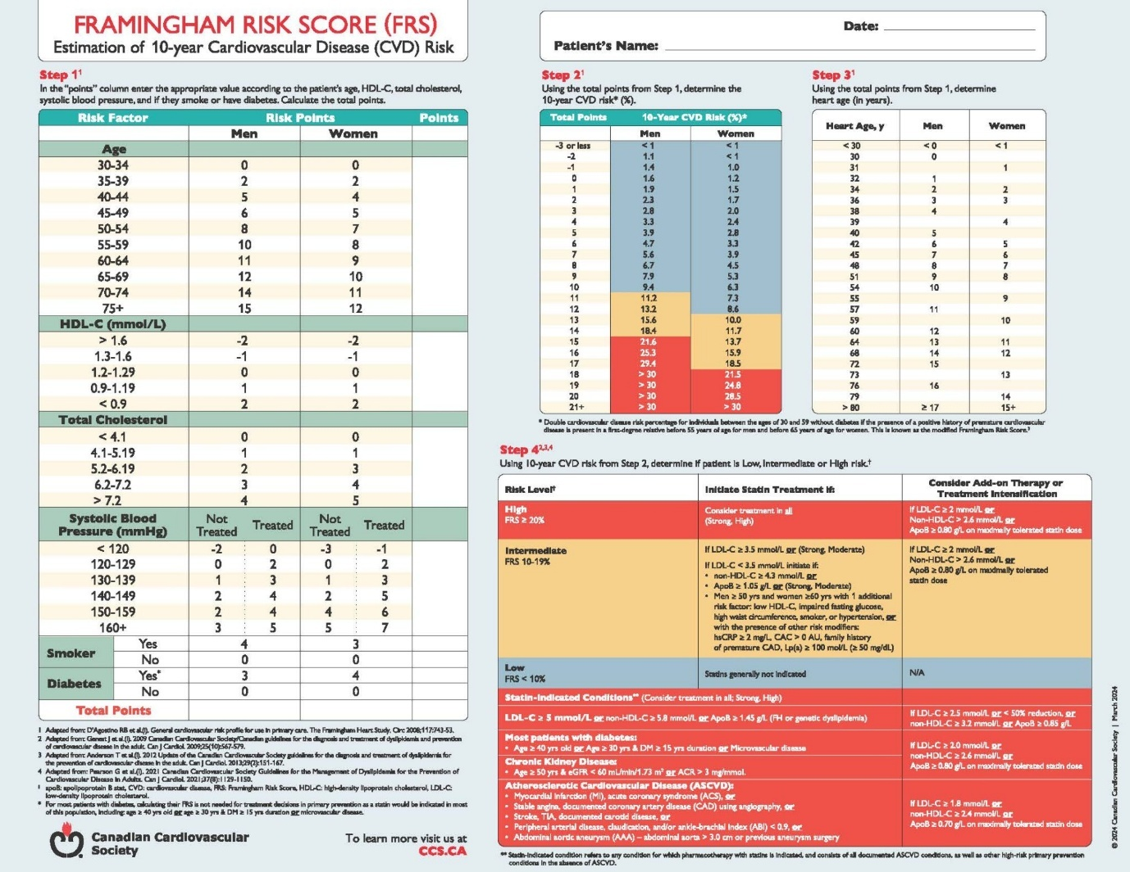
Figure 2: Framingham risk score

