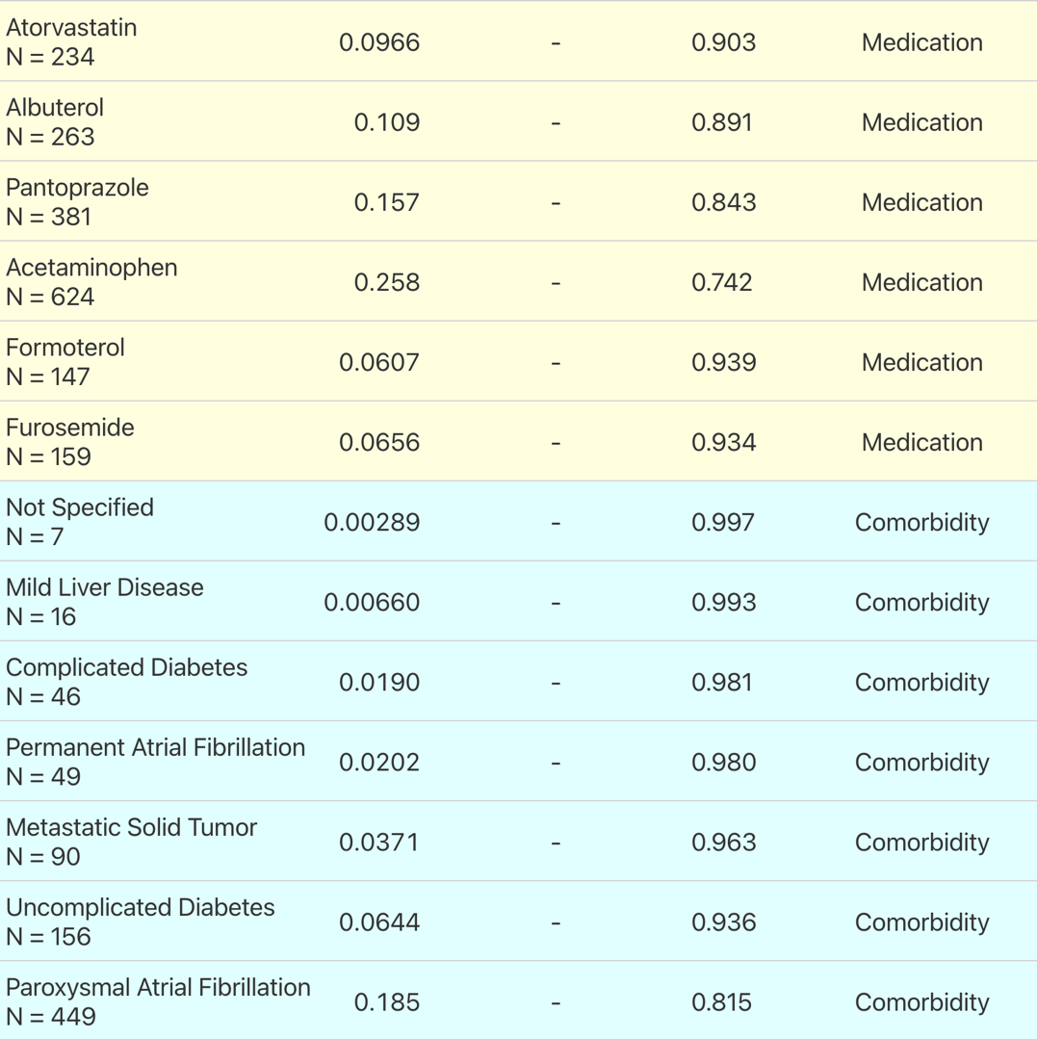
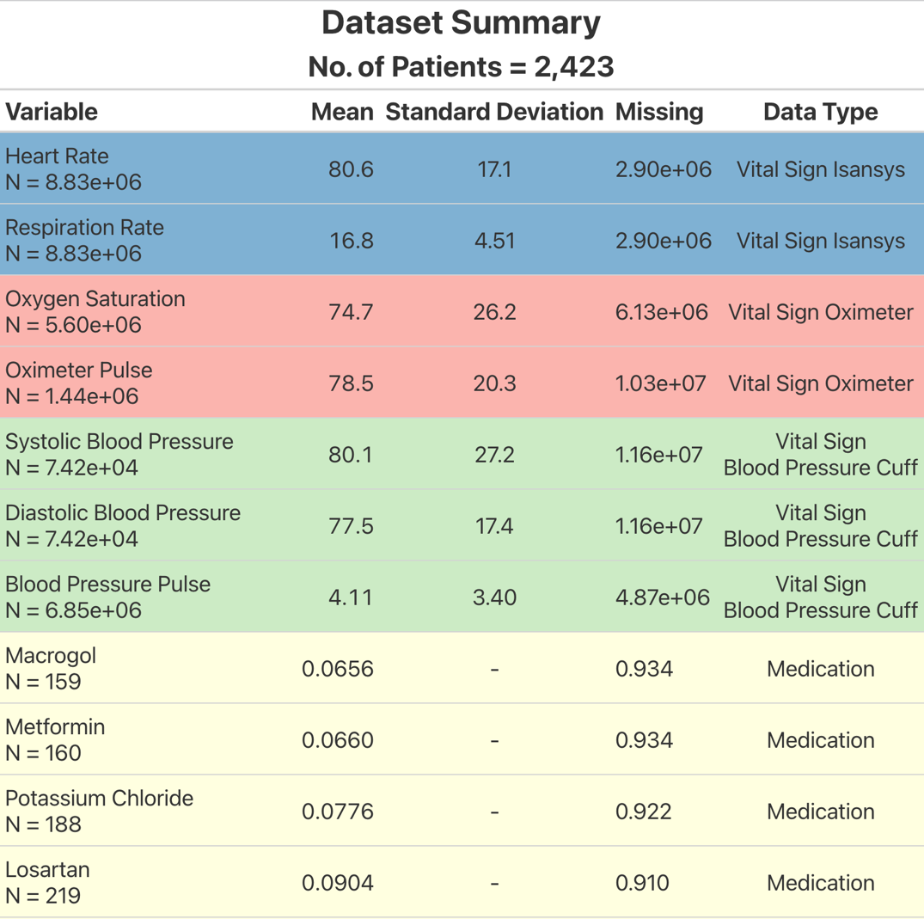
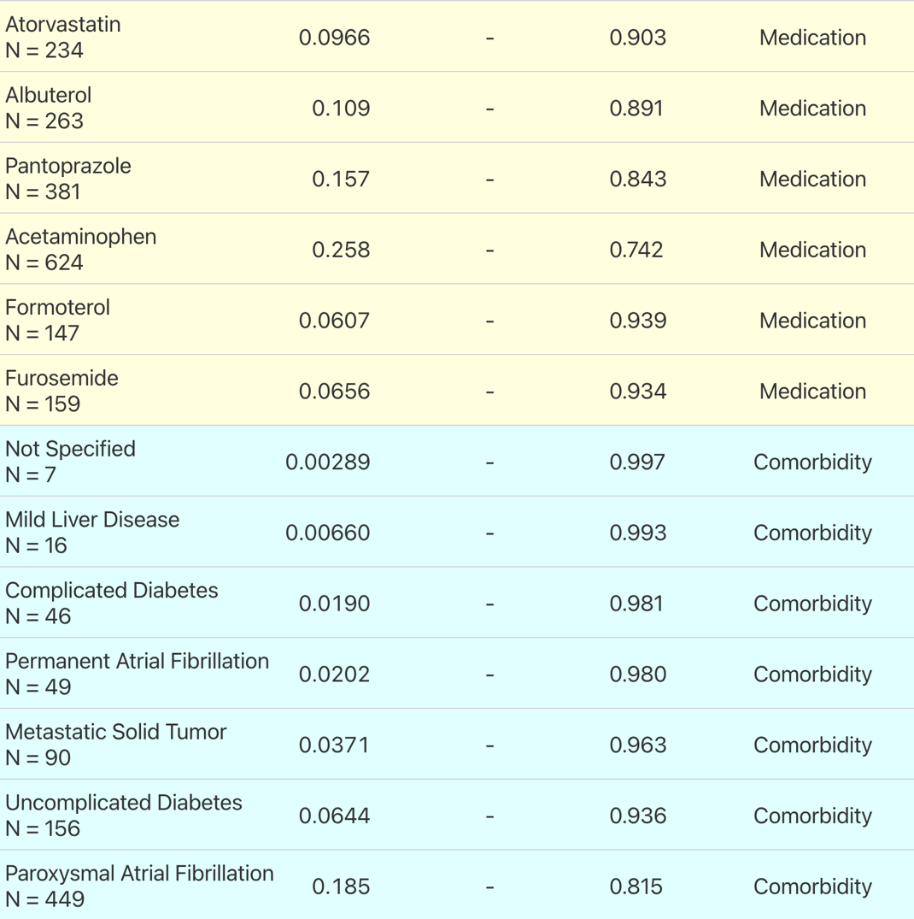
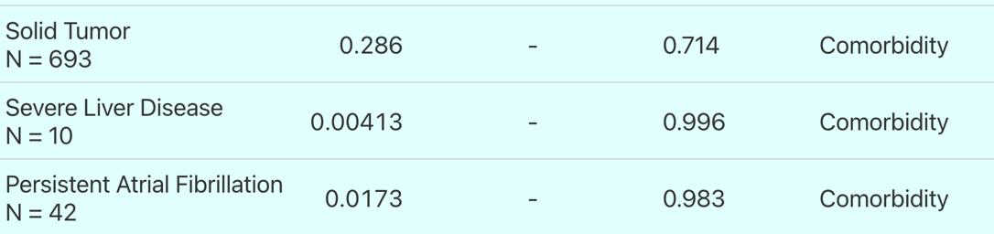
Supplementary Information: SI Table 1:
Supplementary Table 1:
In depth description of dataset used for this paper with 1393 patients. Blue, red and green rows indicate data recorded by three separate devices- yellow and light blue indicate information about patient medication and comorbidities respectively.

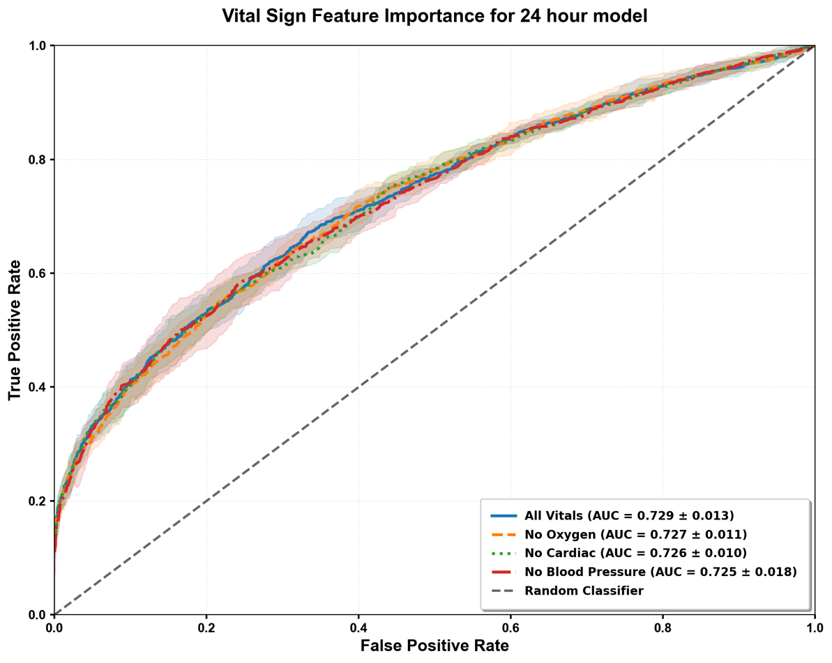
SI Figure 1: This figure shows the predictive performance of the machine learning model without each of the three differnet recording devices for the vital signs, demonstrating that the model is capbable of predicting well in the absence of any one of the devices, wihout significantly losing performance.

Vital Sign | Rate | Device
Heart Rate, Respiration Rate | pr minute | Single-lead ECG patch. Lifetouch, Isansys Lifecare, Oxfordshire, UK
Blood Oxygen Saturatio, Pulse Rate | pr minute | Oximeter, Wristox 3150, Nonin Medical Inc, Plymouth, MN, US
Systolic Blood Pressure, Diastolic Blood Pressure and Blood Pressure Derived Pulse | Every 30 minutes during the day and eveyr hour at night | Blood pressure cuff. TM-2440, A&D, Tokyo, Japan or BlueBP-05, Medictech Ltd,, Hungary
Supplementary Table 2: The vital signs and corresponding sampling rate along with the devices used to record the vital signs.

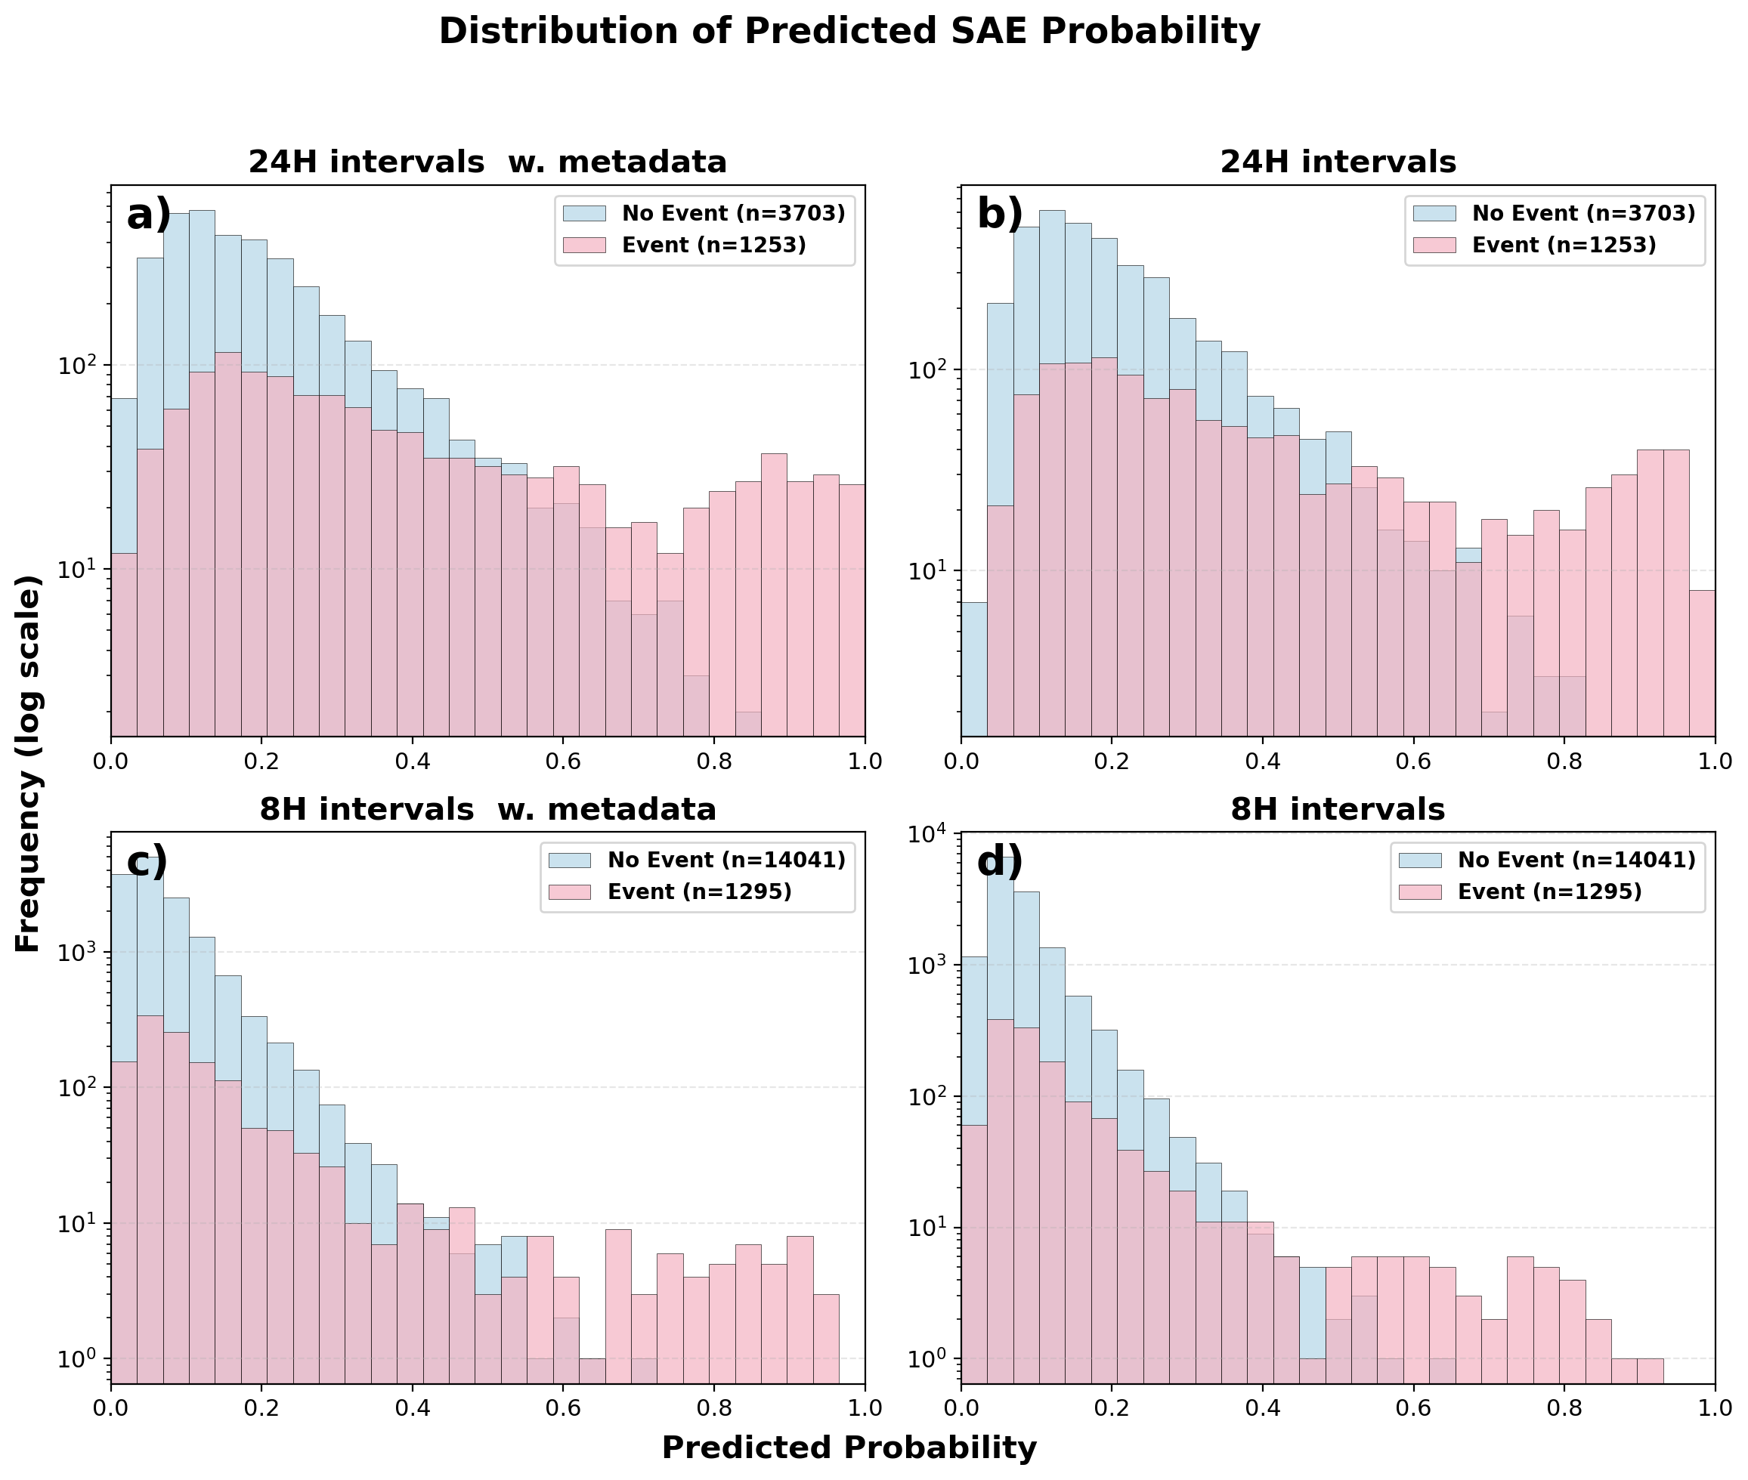
SI Figure 2: The distributions of calculcated probabilities where 1 is a interval containing an SAE. a) Shows probabilities for 24 hour intervals with patient metadata, b) shows probabilites for 24 hour intervals with vvital signs alone, c) shows probabilities for 8 hour intervals with metadata and d) shows probabilities for 8 hour intervals with vital signs alone.

