Supplementary Information 1

Methods

Statistical analyses
We evaluated linear model (LM) assumptions with residual-vs-fitted and normal Q–Q plots, Shapiro–Wilk tests of studentized residuals (normality), and Breusch–Pagan tests (homoscedasticity). We screened influential observations using Cook’s distance (flag > 4/n), and we ran sensitivity analyses excluding flagged points and using HC3 robust standard errors when diagnostics warranted. For right-skewed positive responses, we confirmed inferences with Gamma GLMs (log link). For Poisson GLMs, we assessed overdispersion using the Pearson χ²/df statistic (expected ≈1 under a correctly specified Poisson model^{1,2}. When dispersion materially exceeded 1 (≈1.3 - 1.5), we refitted quasi-Poisson and negative-binomial models as sensitivity checks.
We assessed binomial GLMM model adequacy for egg-sac viability with the DHARMa simulation-based residual diagnostic method³, using 2,000 simulated scaled residuals. We tested residual uniformity (Kolmogorov–Smirnov test), dispersion, zero inflation, and within-female temporal autocorrelation (DHARMa’s testTemporalAutocorrelation, or per-female Ljung–Box tests when necessary). We also inspected standard DHARMa diagnostic plots. The model showed no evidence of misspecification: residual uniformity p = 0.634; dispersion p = 0.587; zero-inflation p = 0.882. Lag-1 temporal autocorrelation was flagged for ~6% of females, consistent with weak/occasional within-female dependence and not suggestive of a systematic violation. All conclusions reported below were robust to these diagnostics.
Model checks for inter-egg-sac interval and egg-sac mass across egg-sac order included residual–fitted and Q–Q plots, tests of normality and homoscedasticity from the performance package⁴, simulation-based residual diagnostics with DHARMa³, and assessment of within-female lag-1 temporal autocorrelation on simulated scaled residuals (Ljung–Box tests). Because diagnostics indicated deviations from normality, we confirmed inference using cluster-robust CR2 standard errors (R package clubSandwich⁵; and by fitting a Gamma GLMM with log link in glmmTMB⁶. Both robustness checks yielded qualitatively identical conclusions to the original LMM.

Supplementary Information 2

Results
Table S1. Per–egg-sac order counts of oviposited egg-sacs, viable egg-sac, percentage of viable egg-sacs, inter-egg-sac interval (egg-sac 1: days from mating to first oviposition; eggs 2+: days between consecutive ovipositions), and egg-sac mass. N = 101 females.
Egg-sac order | N oviposited egg-sacs | N  viable | % viable | Inter-egg-sac interval  (days) |  | Egg-sac mass  (g)
 |  |  |  | mean | SD | mean | SD
1 | 101 | 101 | 100.00 | 38.7 | 22.1 | 0.310 | 0.107
2 | 101 | 98 | 97.03 | 34.6 | 14.0 | 0.311 | 0.117
3 | 92 | 87 | 94.57 | 35.8 | 25.3 | 0.324 | 0.126
4 | 89 | 79 | 88.76 | 31.1 | 16.1 | 0.313 | 0.108
5 | 80 | 73 | 91.25 | 27.6 | 9.7 | 0.318 | 0.102
6 | 69 | 56 | 81.16 | 27.2 | 8.3 | 0.320 | 0.109
7 | 60 | 43 | 71.67 | 27.0 | 9.9 | 0.305 | 0.113
8 | 47 | 29 | 61.70 | 28.4 | 13.1 | 0.284 | 0.133
9 | 41 | 18 | 43.90 | 25.6 | 8.0 | 0.291 | 0.105
10 | 28 | 5 | 17.86 | 22.9 | 6.5 | 0.263 | 0.094
11 | 17 | 3 | 17.65 | 26.8 | 7.8 | 0.291 | 0.098
12 | 10 | 0 | 0 | 22.0 | 5.6 | 0.295 | 0.084
13 | 6 | 0 | 0 | 26.2 | 20.8 | 0.245 | 0.110
14 | 4 | 0 | 0 | 17.5 | 5.5 | 0.168 | 0.087
15 | 3 | 0 | 0 | 26.3 | 12.1 | 0.163 | 0.100
16 | 2 | 0 | 0 | 17.5 | 0.7 | 0.117 | 0.024
17 | 2 | 0 | 0 | 30.0 | 7.1 | 0.125 | 0.036

Oviposition span, viable oviposition span, and post-reproductive periods
Standardised ln body mass negatively predicted the duration of oviposition, i.e., oviposition period (β = −18.67 ± 7.48 days, t = −2.50, p = 0.014), whereas copulation number had no detectable effect (β = −15.53 ± 22.23 days, t = −0.70, p = 0.486). By contrast, for the viable oviposition period, neither female mass (β = −10.09 ± 6.38 days, t = −1.58, p = 0.117) nor copulation number (β = −8.48 ± 18.95 days, t = −0.45, p = 0.656) explained significant variation. For the difference between total and viable oviposition spans, the intercept indicated an average excess of 42.8 ± 5.6 days (t = 7.71, p < 0.001), but neither mass (β = −8.58 ± 5.21 days, t = −1.65, p = 0.102) nor copulation number (β = −7.06 ± 15.47 days, t = −0.46, p = 0.649) had significant effects.
Female mass did not predict post-oviposition period (β = 9.94 ± 7.20 days, t = 1.38, p = 0.170), but copulation number had a significant negative effect: twice-mated females had a shorter post-oviposition period than once-mated females (β = −48.90 ± 21.38 days, t = −2.29, p = 0.024). A similar pattern emerged for the post-viable oviposition period, which averaged 123.1 ± 9.7 days. Again, female mass was unrelated to the latter (β = 1.36 ± 9.12 days, t = 0.15, p = 0.882), whereas twice-mated females survived less time after their last viable egg-sac than once-mated females (β = −55.95 ± 27.10 days, t = −2.07, p = 0.042).
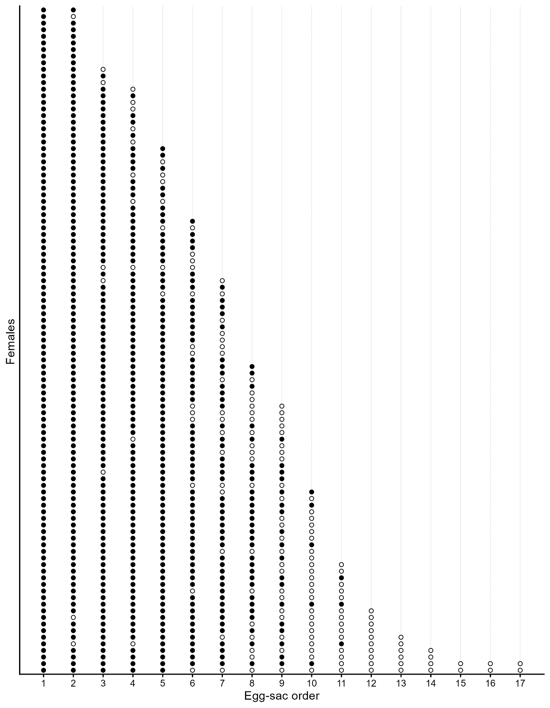
Figure S1. Per-female oviposition sequences. Each row is one female. Columns show egg-sac order. Filled circles = viable egg-sacs; open circles = non-viable egg-sacs.

Supplementary Information 3
Discussion
Table S2. Candidate mechanisms underlying age-dependent fecundity and their expected signatures. For each mechanism, we summarise key predictions, evaluate support from our data, and provide an overall verdict for Nephilingis cruentata.
mechanism | key predictions | evidence in this study | verdict
sperm depletion | viability declines with time since mating; terminal non-viable phase; egg-sac mass ~ stable | viability declines with time since mating, terminal non-viable phases present; egg-sac mass ~ stable | supported
reproductive senescence | egg-sac mass and viability decline with time; inter-egg-sac intervals increase with order | egg-sac mass and viability decline with time / order, but order signal disappears when restricted to viable sacs; no inter-egg-sac intervals increase with order | little supported
terminal investment | late-life increase in egg-sac mass and inter-egg-sac interval decrease just before death | no late increase in egg-sac mass; moderate decrease of inter-egg-sac interval before death (but the eggs are non-viable) | not supported
adaptive restraint | modest early investment with prolonged viable oviposition period | not required given observed time-since-mating viability schedule | no evidence required

Limitation and ecological context
As a potential study limitation (in the context of fecundity), all females were maintained under identical feeding conditions irrespective of their body size. Because larger females have higher baseline metabolic costs, they could require proportionally more food for strict comparability. We aimed to feed females ad libitum; this was supported by routinely observing uneaten prey, suggesting food was generally non-limiting, although some residual limitation cannot be ruled out. Any departure from true ad libitum feeding could disproportionately constrain larger females by reducing food per unit body mass, potentially reducing body or egg-sac mass over time and lengthening latency to first oviposition. In contrast, smaller females—with lower maintenance costs—may have received higher effective food portions and thus may have shown more consistent increases in body and egg-sac mass and oviposited earlier than larger females. Indeed, smaller females showed shorter inter-egg-sac intervals; however, a non-exclusive explanation is that smaller egg-sacs take less time and energy to produce, which would also shorten intervals for smaller relative to larger females.
To further assess feeding adequacy, we analysed longitudinal changes in body mass across egg-sac order. Female mass increased with egg-sac order, and among-individual rank differences persisted, i.e., females that were initially of low or high size rank remained so across egg-sac orders (Figure S2). This pattern is consistent with sufficient food availability rather than pervasive food limitation. Accordingly, it is unlikely that food availability constrained lifetime reproductive output disproportionately in larger females. Under our standardised feeding regime, size-dependent allocation could nevertheless generate subtle trade-offs in provisioning that affect progeny survival. As a cautious note, any residual deviation from true ad libitum could have acted indirectly via egg nutrition, though body and egg-sac mass trajectories argue against pervasive food limitation (Figure S2).
Our study was conducted under standardised laboratory conditions, which likely differ from environmental conditions experienced in the field. In nature, females may live shorter than under benign laboratory conditions, and variation in food availability, mate encounters, and predation could alter both fecundity schedules and offspring survival. N. cruentata are so-called “income breeders”—organisms that maintain little or no stored energy reserves and whose reproductive output depends largely on current food intake, such that reproduction entails direct energetic costs^{7,8}. Under natural conditions, larger females may forage more efficiently and secure greater energy intake, thereby increasing fecundity and sustaining investment across more egg-sacs. In the standardised laboratory regime, however, feeding likely reduced variation in energetic conditions across body sizes, limiting the scope for body size to influence reproductive rate and potentially masking ecological advantages of large size. Beyond, verifying truly ad libitum intake, ultimately field studies are needed to test whether the patterns observed here persist under natural constraints. Nevertheless, our results implicate sperm limitation—which should also operate in the field—rather than inadequate food availability as the primary constraint on fecundity.
Additional statistical analyses and results
We examined whether female body mass at reaching sexual maturity (baseline body mass) predicts how female body mass changes across egg-sac order. Repeated body mass measurements from orders 1…N were modelled with a linear mixed model (LMM, random effects in parentheses):
body_massat_order ∼ 1 + egg-sac_order_c × baseline_body_mass_c +(1+order_c∣animal),
where egg-sac_order_c and baseline_body_mass_c are mean-centred egg-sac order and each female’s baseline body mass (order 0), respectively. Random intercepts and random slopes for order were included for each female. Models were fitted by maximum likelihood with lme4; 95% CIs are Wald intervals. We also fitted a change-from-baseline model with outcome: Δbody_mass _{at_order} = body_mass _{at_order} − baseline_body_mass.
Female body mass increased with egg-sac order (β_{order} = 0.010 g per order; 95% CI = 0.007–0.014; t=6.16). Baseline body mass (female body mass at reaching sexual maturity) strongly predicted overall body mass across orders (β_{baseline body mass} = 0.960; 95% CI = 0.849–1.071; t=16.98). Critically, the interaction was negligible and imprecise (β_{order x baseline body mass} = 0.002; 95% = CI −0.021–0.025; t=0.19), indicating parallel trajectories: heavier females at baseline remained heavier but did not change faster or slower over time. Random-effects variance was modest (female slope SD ≈ 0.010), with a high intercept–slope correlation (~0.87). Model fit was good (marginal/conditional R2 = 0.598/0.816). The change-from-baseline model led to the same conclusion (interaction ≈ 0, 95% CI (−0.021–0.025); = $R_{m}^{2}R_{mc}^{2}=$0.082/0.580).
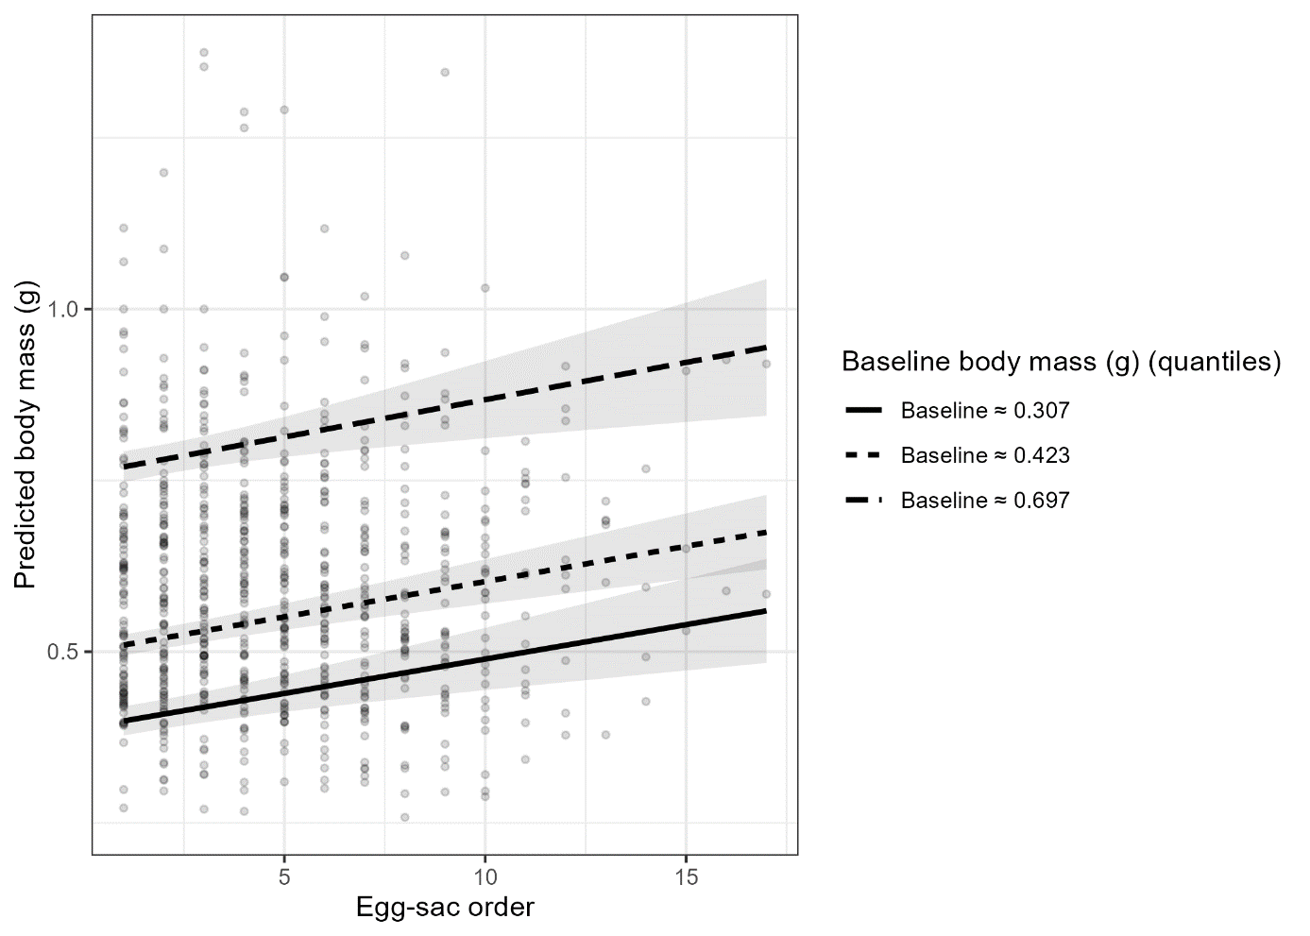
Figure S2. Predicted female body mass (g) across egg-sac order from a mixed model. Lines with 95% CIs show fixed-effect trajectories at the 10th (solid), 50th (dashed), and 90th (dot-dashed) baseline body mass (female body mass at reaching sexual maturity) quantiles; points are observed body masses. The order × baseline body mass interaction was not significant (parallel slopes).

References
1. Zuur, A. F., Ieno, E. N., Walker, N. J., Saveliev, A. A. & Smith, G. M. Mixed effects models and extensions in ecology with R. (New York: Springer., 2009).
2. Cameron, A. C. & Trivedi, P. K. Regression analysis of count data. (Cambridge university press., 2013).
3. Hartig, F. DHARMa: residual diagnostics for hierarchical regression models. Compr. R Arch. Netw. (2020).
4. Lüdecke, D., Ben-shachar, M. S., Patil, I. & Makowski, D. performance : An R Package for Assessment , Comparison and Testing of Statistical Models Statement of Need. 6, 1–8 (2021).
5. Pustejovsky, J. E., Pekofsky, S. & Zhang, J. clubSandwich [R package]. (2023).
6. Brooks, M. et al. glmmTMB: Generalized linear mixed models using template model builder.
7. Sibly, R. & Calow, P. Why breeding earlier is always worthwhile. J. Theor. Biol. 123, 311–319 (1986).
8. Jonsson, K. I. Capital and Income Breeding as Alternative Tactics of Resource Use in Reproduction. Oikos 78, 57–66 (1997).

