supplementary material

Supplementary List 1 : Removed probes unrelated to BBB endothelial biology: AR, Aurora.B, B7.H4, CD134, CD20, CD4, CD45, Claudin.7, c.Kit, E.Cadherin, EMA, ER, ER.a_pS118, GATA3, Granzyme.B, HER2, HER2_pY1248, HER3, HER3_pY1289, Heregulin, Lck, MS12, NAPSIN.A, Oct.4, P.Cadherin, PD.1, PR, Rab25, Syk, Tau, TTF1, UGT1A, UBAC1, ZAP.70, PLC.gamma2_pY759, MYH11, PDGFR.b, Notch3. Pericyte-related probes included in pericyte/astrocyte analysis: MYH11, PDGFR.b, Notch3.

Supplementary Table 1: Sample-level quality control metrics and the resulting Limma weights for the hCMEC/D3 contrasts identified as having reduced group coherence and increased within-group variability based on having Mahalanobis distances greater than 2.5 or negative Silhouette widths. The Limma weight applied to each sample is listed in the final column.
Dataset | Contrast | Sample | Group | Mahalanobis dist. | Silhouette width | Weight
HD3 | ab40ins_vs_ab40 | x7_3a_abeta_40_1hr | ab40 | 0.04695 | 0.19761 | 1.20
HD3 | ab40ins_vs_ab40 | x8_3b_abeta_40_1hr | ab40 | 2.12002 | 0.28934 | 1.05
HD3 | ab40ins_vs_ab40 | x9_3c_abeta_40_1hr | ab40 | 1.73742 | 0.14479 | 1.09
HD3 | ab40ins_vs_ab40 | x10_4a_abeta_40_insulin | ab40_insulin | 2.63089 | -0.07614 | 0.33
HD3 | ab40ins_vs_ab40 | x11_4b_abeta_40_insulin | ab40_insulin | 0.60798 | 0.16011 | 1.68
HD3 | ab40ins_vs_ab40 | x12_4c_abeta_40_insulin | ab40_insulin | 0.85674 | 0.13219 | 1.31
HD3 | ab42ins_vs_ab42 | x13_5a_abeta_42_1hr | ab42 | 0.46365 | 0.16072 | 1.02
HD3 | ab42ins_vs_ab42 | x14_5b_abeta_42_1hr | ab42 | 0.00866 | 0.21246 | 2.09
HD3 | ab42ins_vs_ab42 | x15_5c_abeta_42_1hr | ab42 | 0.36650 | 0.17958 | 1.11
HD3 | ab42ins_vs_ab42 | x16_6a_abeta_42_insulin | ab42_insulin | 2.22765 | -0.06779 | 0.43
HD3 | ab42ins_vs_ab42 | x17_6b_abeta_42_insulin | ab42_insulin | 2.66262 | 0.04448 | 1.15
HD3 | ab42ins_vs_ab42 | x18_6c_abeta_42_insulin | ab42_insulin | 2.27092 | -0.00558 | 0.84

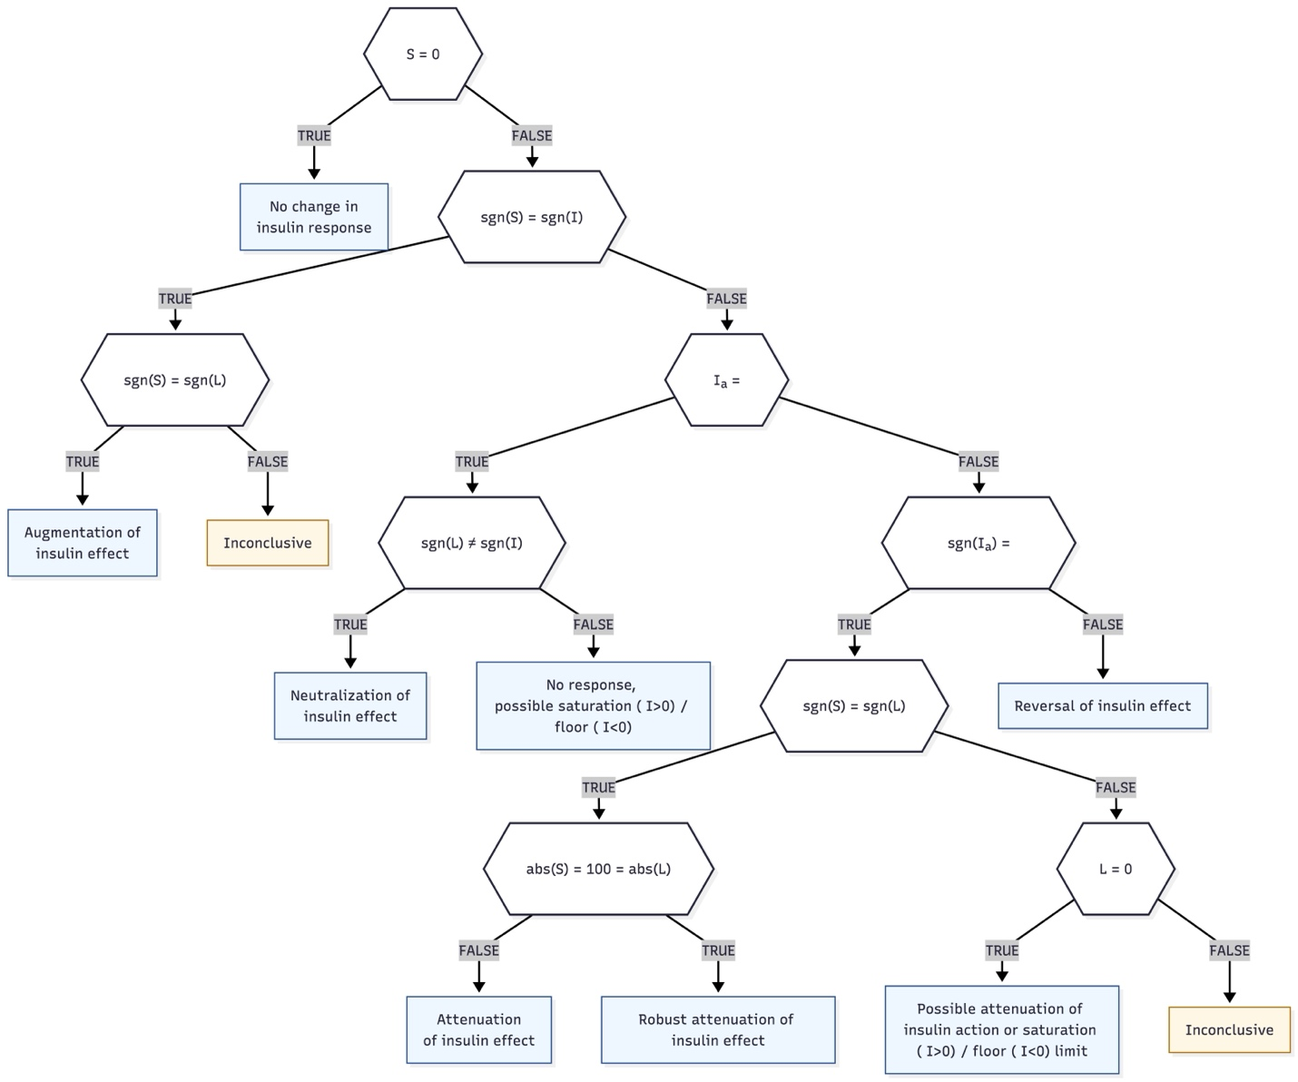
Supplementary Figure 1: Decision tree for interpreting modulation of insulin response by Aβ using second-order and level contrasts. Contrasts are I = (insulin − untreated), Iₐ = (insulin with Aβ - Aβ), L = (Aβ+insulin - insulin), and S = Iₐ − I. Each contrast is discretized with the same scoring thresholds used in Table 2. Nonzero values require |log₂ fold-change| > 0.138 and FDR < 0.1 (sign from LFC). The tree assigns: no change (S = 0); augmentation (sgn(S) = sgn(L)); reversal (sgn(Iₐ) ≠ sgn(I)); or attenuation when sgn(S) = sgn(I) = sgn(L). Attenuation strength is qualified as robust if |S| = |L| = 100 Cases with L = 0 under the attenuation branch are labeled “possible attenuation or saturation/floor.”

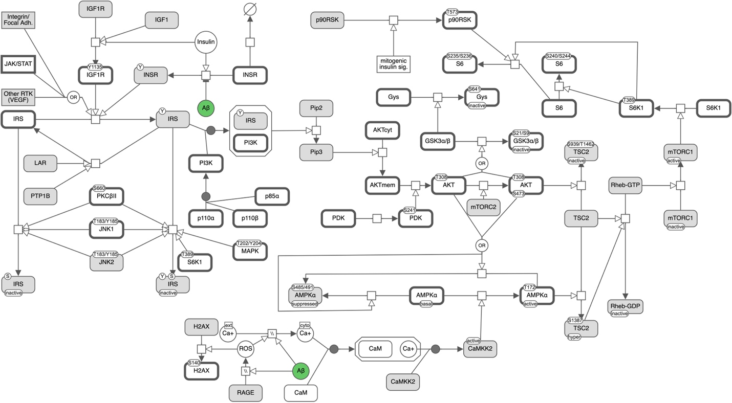
Supplementary Figure 2: Systems Biology Graphical Notation (SBGN) Process Description graph of metabolic insulin signaling and related processes that includes measured RPPA probes in white and nodes without corresponding probes in grey.

