SUPPORTING INFORMATION: The energy, material and carbon handprint of lithium-ion batteries in electric vehicles
Busch P., Yunzhu C., Kendall, A. (2026). The energy, material and carbon handprint of lithium-ion batteries in electric vehicles. Journal of Industrial Ecology.
This supporting information provides additional information on the data sources used on the life cycle assessment model, including their temporal and spatial resolution. This supporting information also includes descriptive figures of the main inputs of the model and additional results to support the analysis on the main text.
Supplementary tables: Table S1 to Table S2
Supplementary figures: Figure S1 to Figure S12

Supporting Information S1: Characteristics and details of the main data sources used in the life cycle assessment model.
Table S1. Model data sources detail, with temporal and spatial resolution.
Module | Data | Source | Time | Spatial | Details
Fleet Stock | Vehicle sales forecast | ICCT Roadmap v2.6 (ICCT, 2024) | 2025-2050 | US | "Ambitious" Scenario. 100% ZEV sales by 2040.
Fleet Stock | Historical EV sales | AFDC & EVVolumes (DOE, 2024; J.D. Power, 2025) | 2016-2024 | State | EVVolumes has data on total US sales, AFDC provides EV registrations by state.
Fleet Stock | Vehicle sales shares by type | EIA Annual Energy Outlook 2025. Table 38 (EIA, 2025b) | 2025-2050 | EIA Transport Region | Light-duty vehicle types: cars and light trucks.
Manufac-turing | Vehicle manufacturing LCI | ecoinvent 3.11 (Ecoinvent Association, 2022) | 2000-2024 | Global | passenger car production, petrol/natural gas; passenger car production, electric, without battery.
Manufac-turing | Vehicle curb weight | GREET (Argonne National Laboratory, 2024) | 2024 | US | Not including battery.
Manufac-turing | Battery manufacturing LCI | ecoinvent 3.11 (Ecoinvent Association, 2022) | 2017-2025 | China | battery production, Li-ion, rechargeable for LFP, NCA, NMC111, NMC532, NMC622, NMC811.
Manufac-turing | Battery capacity | EV Volumes (J.D. Power, 2025) | 2024 | US | By vehicle type.
Vehicle Driving | Vehicle energy consumption | EIA Annual Energy Outlook 2025. Table 40. (EIA, 2025b) | 2025-2050 | US | Reference case.
Vehicle Driving | Temperature adjustment factors | Woody et al, 2022 (10.1088/1748-9326/ac5142) (SI Figure S3) (Woody et al., 2022) | 2016-2020 | County | Changes in vehicle energy consumption due to monthly temperature variation.
Vehicle Driving | Annual vehicle miles traveled | Transportation Energy Data Book (Davis & Boundy, 2022) | 2022 | US | By vehicle age and vehicle type.
Vehicle Driving | Electricity upstream LCI | ecoinvent 3.11 (Ecoinvent Association, 2022) | 1980-2024 | Electricity Market Module regions | By energy source type (see Table S2 for further detail).
Vehicle Driving | Electricity grid generation share | EIA Annual Energy Outlook 2025. Table 54 and Table 56. eGrid 2025 (Alaska and Hawaii) (EIA, 2025b, 2025c, 2025a) | 2025-2050 | Electricity Market Module regions | By energy source type (see Table S2 for further detail).
Vehicle Driving | Gasoline upstream LCI | ecoinvent 3.11 (Ecoinvent Association, 2022) | 2005-2024 | Europe (without Switzerland) | petrol production, low-sulfur.
Vehicle Driving | Gasoline combustion emissions | ecoinvent 3.11 (Ecoinvent Association, 2022) | 2012-2024 | Europe | Unitary process for combustion emissions: transport, passenger, car, petrol, large size, EURO 5 (u-so).
Vehicle Driving | Vehicle maintenance LCI | ecoinvent 3.11(Ecoinvent Association, 2022) | 2000-2024 | Global | maintenance, passenger car and electric (without battery).
Recycling | Battery recycling LCI | ecoinvent 3.11 (Ecoinvent Association, 2022) | 2005-2024 | Global | treatment of used Li-ion battery, hydrometallurgical treatment.
Recycling | Vehicle recycling LCI | ecoinvent 3.11 (Ecoinvent Association, 2022) | 1990-2024 | Global | treatment of used light commercial vehicle.
Recycling | Lithium production LCI | ecoinvent 3.11 (Ecoinvent Association, 2022) | 2009-2024 | Global | lithium carbonate production, from spodumene (50%) and concentrated brine (50%).
Table S2. Primary energy source EIA match with LCI ecoinvent 3.11 process, along with electricity balancing regions.
EIA Energy Source | ecoinvent 3.11 process | Region available
Distributed Generation | electricity production, photovoltaic, 3kWp slanted-roof installation, multi-Si, panel, mounted | US-HICC, US-NPCC, US-RFC, US-SERC, US-TRE, US-WECC
Nuclear | electricity production, nuclear, pressure water reactor | US-MRO, US-NPCC, US-RFC, US-SERC, US-TRE, US-WECC
Pumped Storage/Other | electricity production, hydro, pumped storage | US-ASCC, US-HICC, US-MRO, US-NPCC, US-RFC, US-SERC, US-TRE, US-WECC
Petroleum | electricity production, oil | US-ASCC, US-HICC, US-MRO, US-NPCC, US-RFC, US-SERC, US-TRE, US-WECC
Coal | electricity production, lignite | US-ASCC, US-HICC, US-MRO, US-NPCC, US-RFC, US-SERC, US-TRE, US-WECC
Natural Gas Combined Cycle | electricity production, natural gas, combined cycle power plant | US-ASCC, US-MRO, US-NPCC, US-RFC, US-SERC, US-TRE, US-WECC
Natural Gas Conventional | electricity production, natural gas, conventional power plant | US-ASCC, US-MRO, US-NPCC, US-RFC, US-SERC, US-TRE, US-WECC
Wind | electricity production, wind, >3MW turbine, onshore | US-ASCC, US-HICC, US-MRO, US-NPCC, US-RFC, US-SERC, US-TRE, US-WECC
Offshore Wind | electricity production, wind, 1-3MW turbine, offshore | GB
Solar Photovoltaic | electricity production, photovoltaic, 570kWp open ground installation, multi-Si | US-HICC, US-NPCC, US-RFC, US-SERC, US-WECC
Hydropower | electricity production, hydro, reservoir, non-alpine region | US-HICC, US-SERC, US-TRE
Solar Thermal | electricity production, solar thermal parabolic trough, 50 MW | US-SERC, US-WECC
Geothermal | electricity production, deep geothermal | US-HICC, US-SERC, US-WECC
Wood and Other Biomass | electricity production, natural gas, conventional power plant | US-ASCC, US-MRO, US-NPCC, US-RFC, US-SERC, US-TRE, US-WECC
Biogenic Municipal Waste | electricity, from municipal waste incineration to generic market for electricity, medium voltage | CA-ON

Supporting Information S2: Descriptive figures of data inputs.
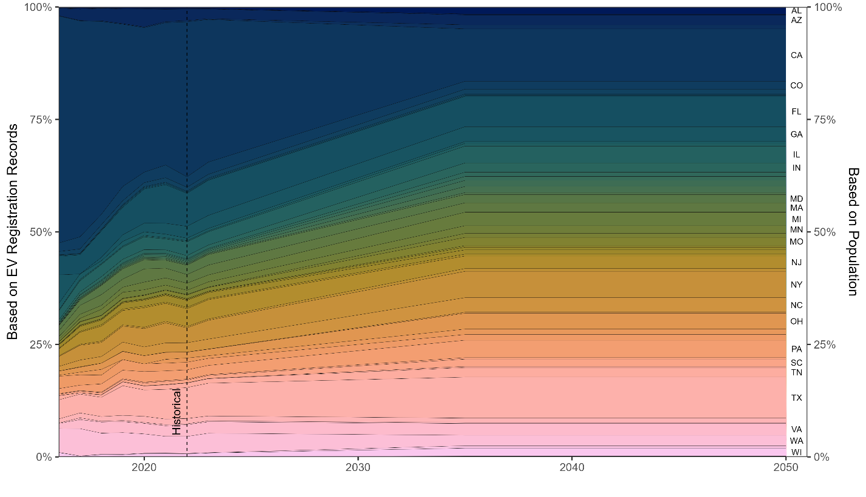
Figure S1. Vehicle sales disaggregation by state based on historical data of EV registrations (difference year-to-year) (DOE, 2024) and based on population shares by state (U.S. Census Bureau, 2025). From 2022 to 2035 a linear interpolation between 2022 EV registration shares and population shares was assumed.

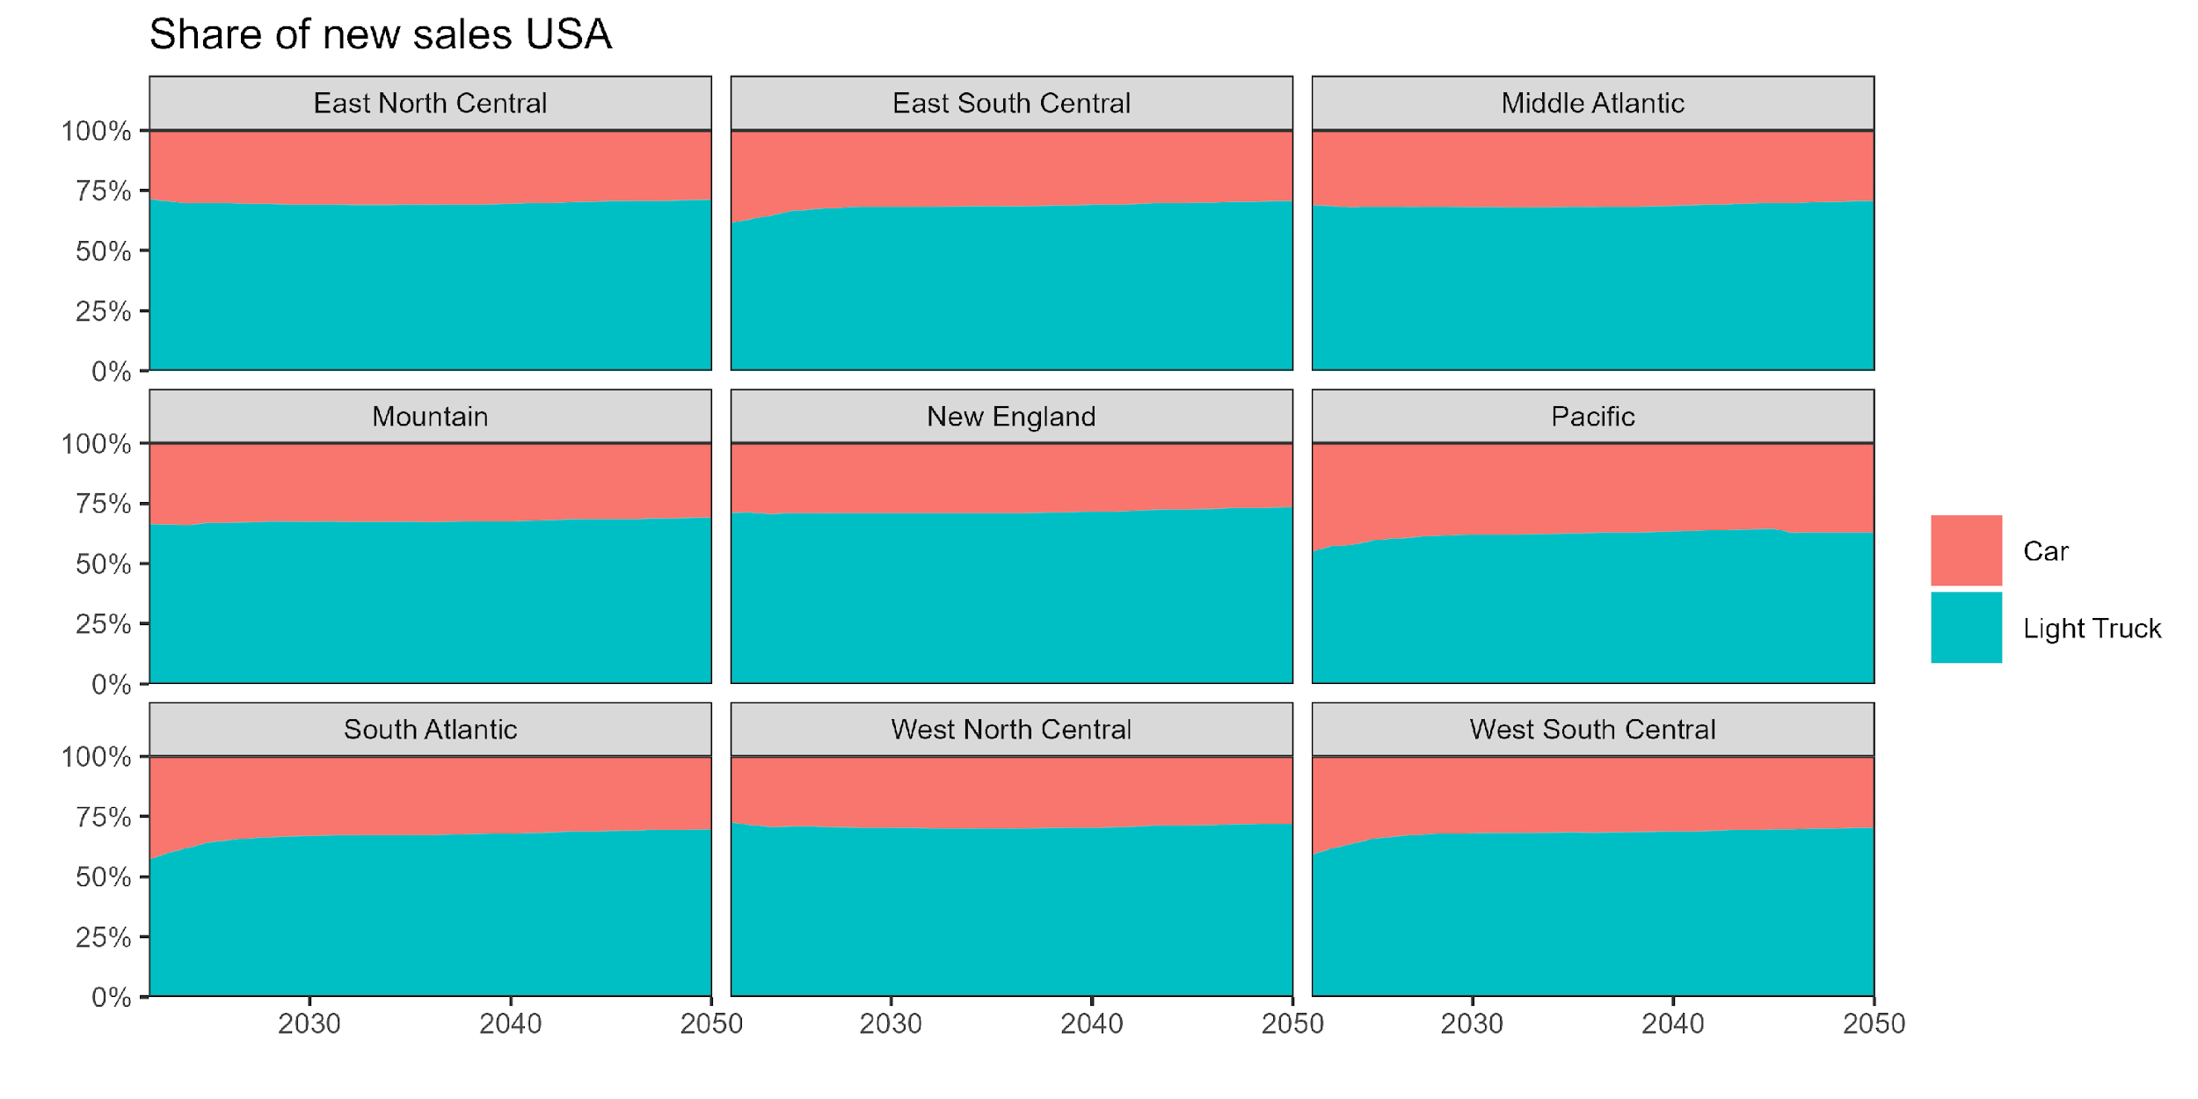
Figure S2. Share of new vehicle sales by vehicle type (car or light truck) and transport region. Source: (EIA, 2025b) Table 38. Light-Duty Vehicle Sales by Technology Type.

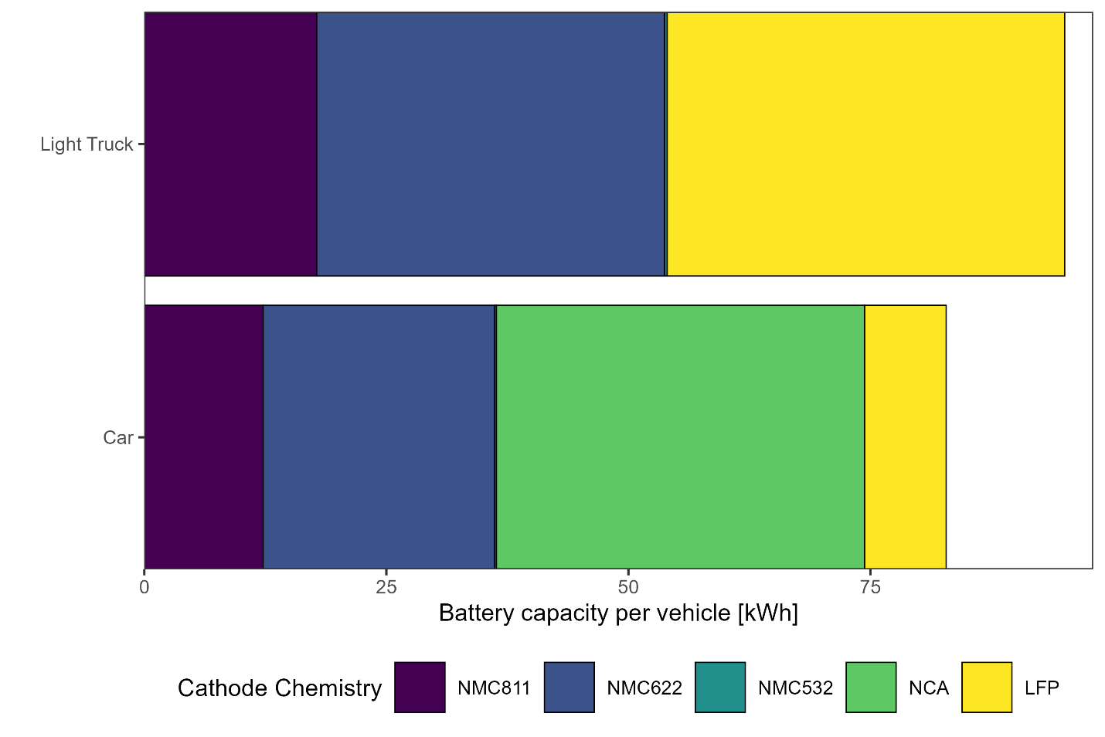
Figure S3. Average battery capacity by cathode chemistry and vehicle type. Source: EV Volumes(J.D. Power, 2025).
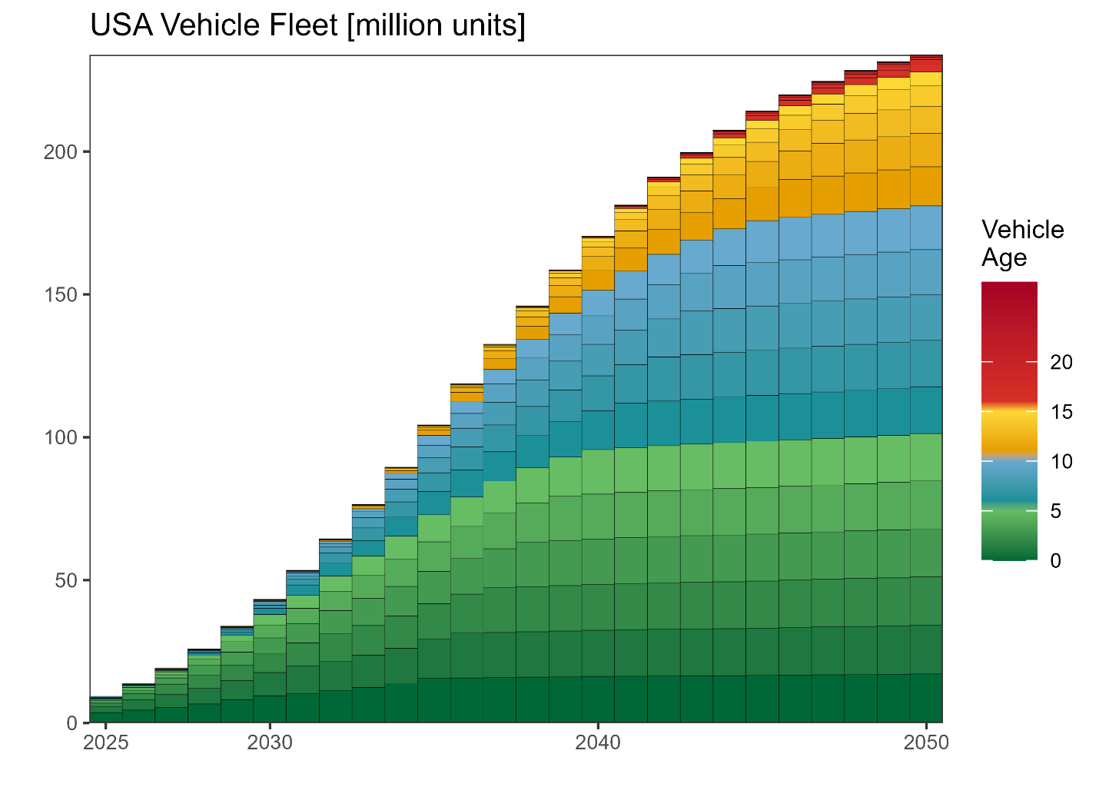
Figure S4. Vehicle fleet for EV in the US, or ICEV counterfactual. The model scope ignores current ICEV fleet or projected ICEV sales, it only considers a counterfactual scenario where each future EV sold becomes an ICEV.
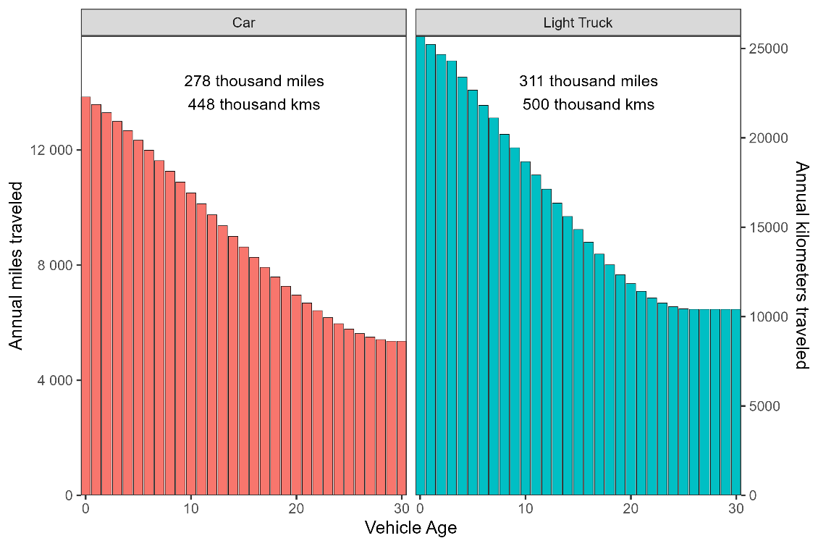
Figure S5. Annual miles traveled by vehicle age and type. Source: (Davis & Boundy, 2022).
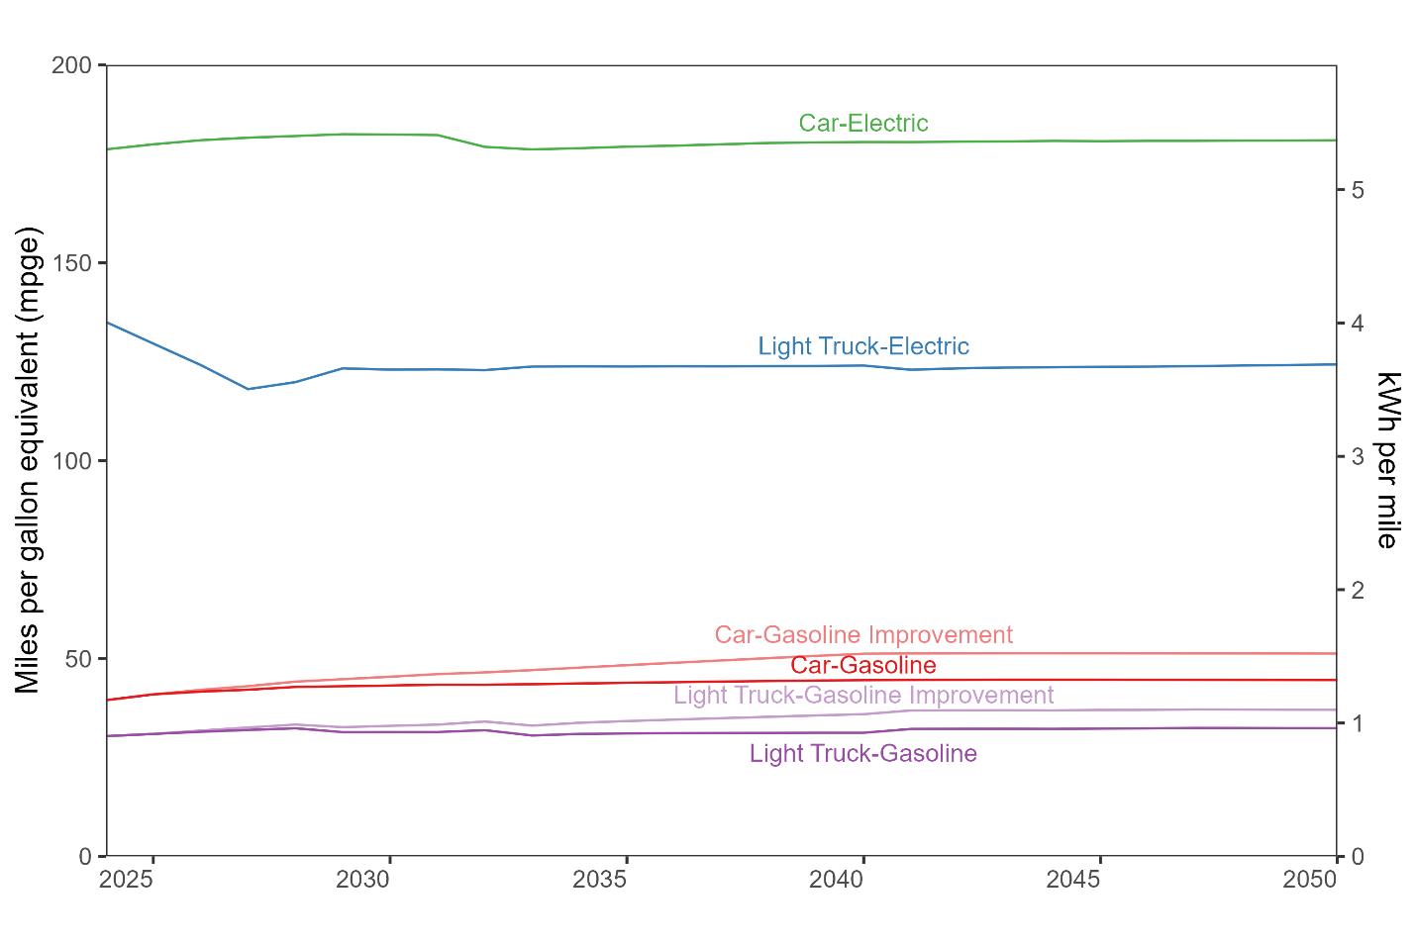
Figure S6. Energy consumption in miles per gallon equivalent (using EPA conversion factor of 33.7 kWh per gallon of gasoline). ICEV vehicles have a scenario with a further 15% improvement in their efficiency. Source: EIA Annual Energy Outlook 2025. Table 40(EIA, 2025b).

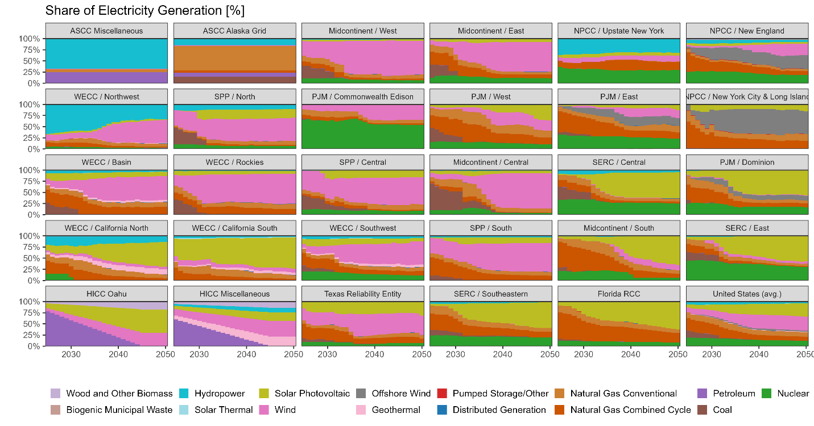
Figure S7. Electricity generation forecast by EIA electricity market module region. Natural gas was disaggregated into conventional and combined cycle based on installed capacity. Source: EIA Annual Energy Outlook 2025 Electricity and renewable fuel tables (tables 54–56) (EIA, 2025b). mix forecast for Alaska and Hawaii systems, based on 2023 mix provided by EPA eGRID. For Alaska a constant value from 2023 was assumed, and for Hawaii the 2045 policy mandate of 100% renewable energy was assumed, with a linear interpolation (EIA, 2025c, 2025a). Source: EPA eGRID (EIA, 2025b).

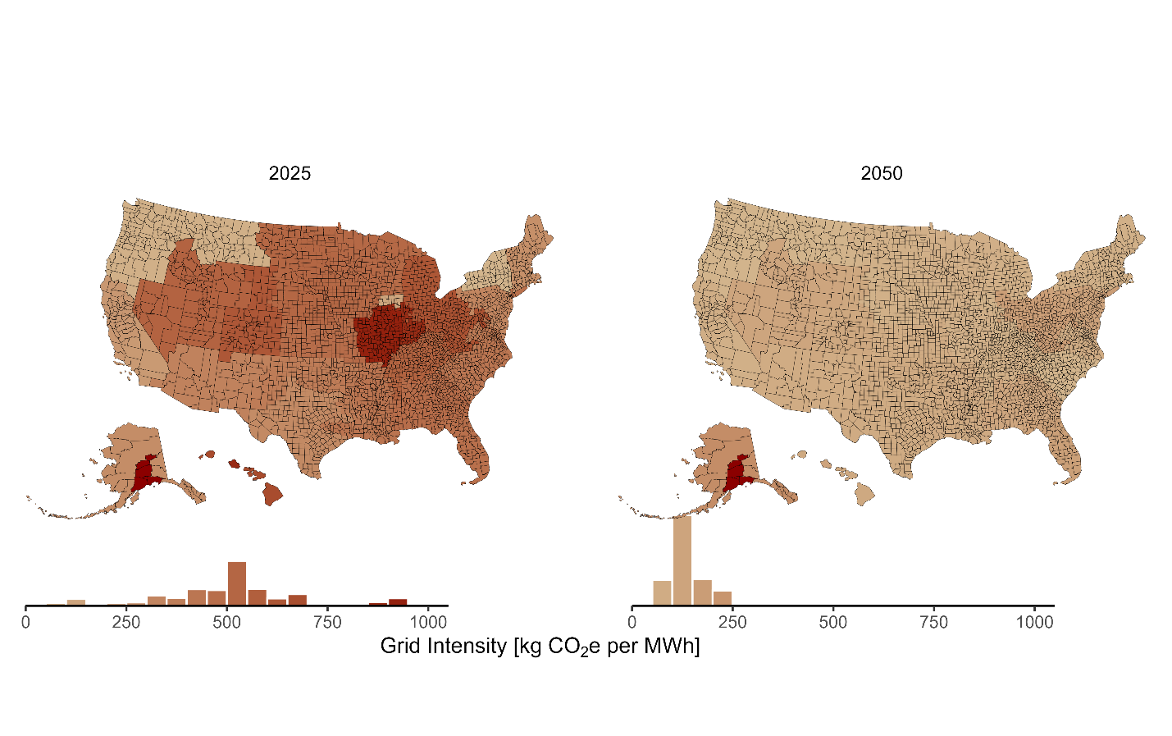
Figure S8. Carbon intensity of electricity by county, in kg CO₂e per MWh of electricity generated. Transmission and distribution losses are assumed to be 5%. Electricity emissions are estimated based on the forecast of electricity generation (EIA, 2025b; EPA, 2025), ecoinvent 3.9 life cycle inventory emissions (Ecoinvent Association, 2022) using AR6 impact factors excluding biogenic.
Supporting Information S3: Additional results and scenarios.
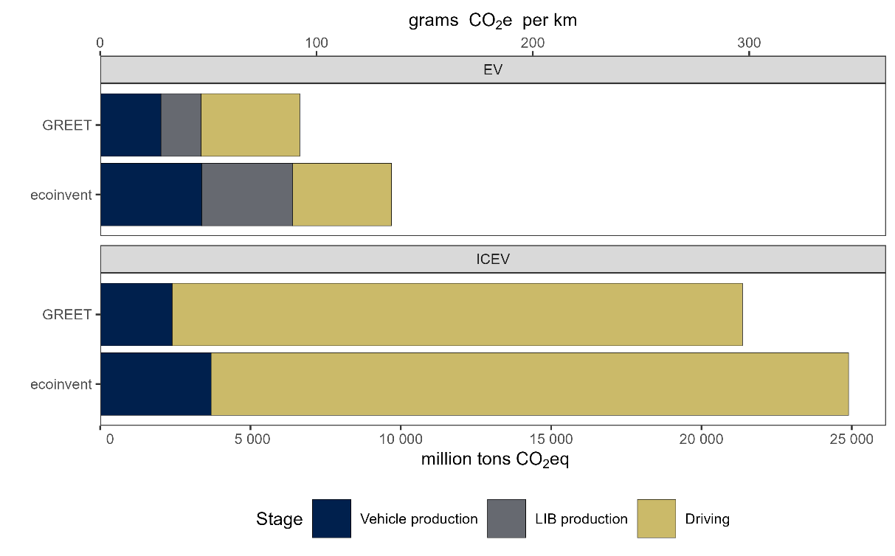
Figure S9. Cumulated GHG emissions (2025-2050) comparison between an EV fleet versus a counterfactual ICEV fleet using either ecoinvent 3.11 or GREET 2024 for upstream emissions associated with vehicle manufacturing and LIB production (Argonne National Laboratory, 2024; Ecoinvent Association, 2022). GREET has lower unitary GHG emissions for vehicle and LIB manufacturing, increasing the difference between EVs and ICEVs.

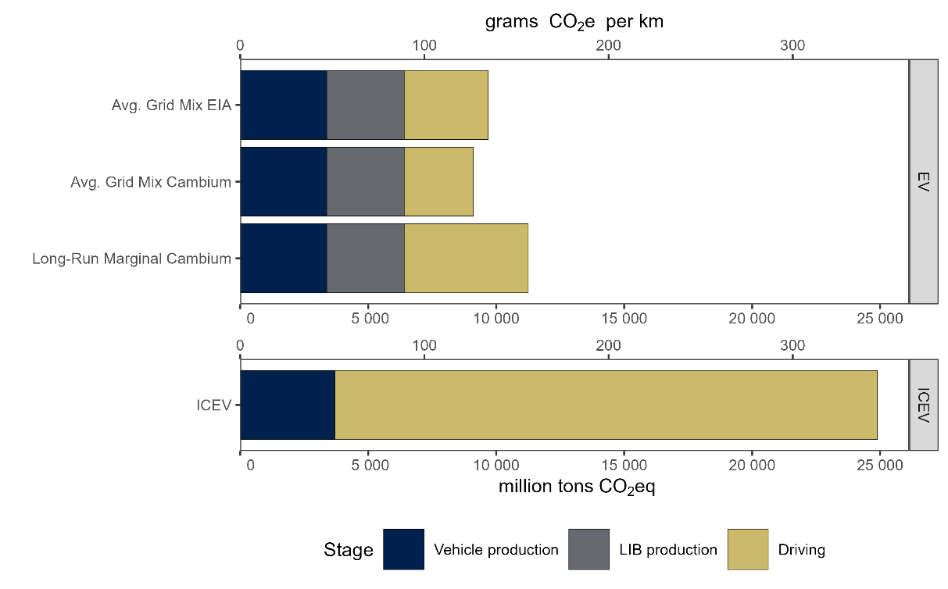
Figure S10. Cumulated GHG emissions (2025-2050) comparison between an EV fleet versus a counterfactual ICEV fleet using different electricity grid GHG emission factors. Both average grid mix EIA and Cambium uses average share of primary energy used for electricity generation combined with ecoinvent upstream impacts. Long-run marginal refers to estimated emissions factors by NREL Cambium model that take into account induces changes in the electricity grid (NREL, 2025).

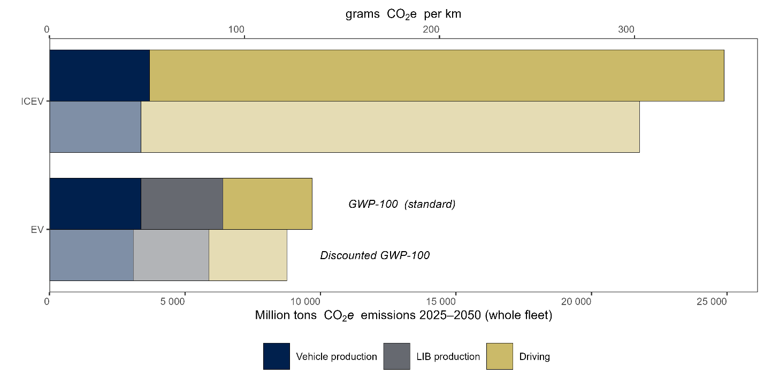
Figure S11. Cumulated GHG emissions (2025-2050) comparison between an EV fleet versus a counterfactual ICEV using standard GWP-100 factors or using time-adjusted global warming potentials(Kendall, 2012). The discounted represents emissions of CO₂ equivalent to present (2025) emissions, taking into account the radiate forcing profile of each climate pollutant and warming horizon of 100 years (2025 to 2125).

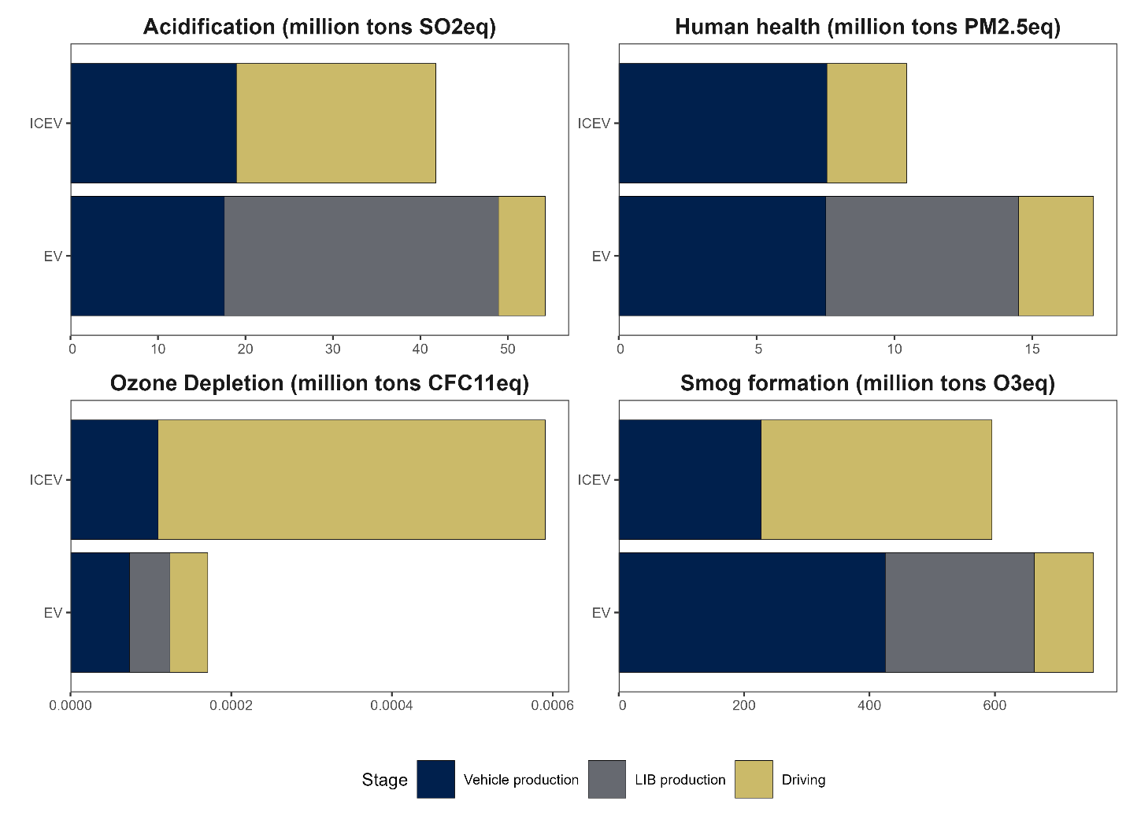
Figure S12. Fleet level impact for an EV fleet and a counterfactual ICEV fleet (2025-2050). All impacts equivalencies were calculated using TRACI 2.2 methodology (EPA, 2021).

