Supporting Information

Table S1
Location of samples from urban recreational waters in Changchun City
site | sample | latitude (N) | longitude (E)
Beihu Lake (BH) | BH1 | 43.9811 | 125.3570
 | BH2 | 43.9810 | 125.3575
 | BH3 | 43.9823 | 125.3580
 | BH4 | 43.9827 | 125.3586
 | BH5 | 43.9836 | 125.3604
 | BH6 | 43.9847 | 125.3608
 | BH7 | 43.9801 | 125.3565
 | BH8 | 43.9796 | 125.3564
Nanhu Lake (NH) | NH1 | 43.8499 | 125.3005
 | NH2 | 43.8500 | 125.2983
 | NH3 | 43.8532 | 125.3119
 | NH4 | 43.8548 | 125.3055
 | NH5 | 43.8568 | 125.3020
 | NH6 | 43.8529 | 125.3010
 | NH7 | 43.8504 | 125.3037
 | NH8 | 43.8508 | 125.3109
Jingyue Lake (JY) | JY1 | 43.7902 | 125.4462
 | JY2 | 43.7738 | 125.4578
 | JY3 | 43.7859 | 125.4375
 | JY4 | 43.7807 | 125.4440
 | JY5 | 43.7753 | 125.4489
 | JY6 | 43.7890 | 125.4549
 | JY7 | 43.7897 | 125.4532
 | JY8 | 43.7884 | 125.4415

Table S2
Physicochemical properties of water samples from Nanhu Lake (NH), Jingyue Lake (JY), Beihu Lake (BH) in Changchun City
ID | NH₄⁺-H | pH | EC | TOC | TN | TP
ID | (mg/L) |  | (μS/cm) | (mg/L) | (mg/L) | (mg/L)
sNH1 | 0.58 | 8.40 | 0.438 | 49.21 | 0.459 | 0.028
sNH2 | 0.16 | 8.52 | 0.440 | 46.52 | 0.742 | 0.024
sNH3 | 0.68 | 8.33 | 0.443 | 44.94 | 0.74 | 0.023
sNH4 | 0.51 | 8.60 | 0.422 | 42.86 | 0.816 | 0.012
sNH5 | 0.87 | 8.01 | 0.355 | 30.94 | 0.551 | 0.013
sNH6 | 0.59 | 7.91 | 0.401 | 40.20 | 1.107 | 0.012
sNH7 | 0.27 | 8.08 | 0.445 | 46.86 | 0.851 | 0.014
sNH8 | 0.38 | 8.58 | 0.418 | 41.64 | 0.926 | 0.041
sJY1 | 0.04 | 7.95 | 0.547 | 47.57 | 0.98 | 0.011
sJY2 | 0.11 | 8.07 | 0.425 | 43.59 | 0.715 | 0.002
sJY3 | 0.07 | 8.15 | 0.398 | 43.67 | 0.702 | 0.007
sJY4 | 0.15 | 8.03 | 0.311 | 47.44 | 0.82 | 0.006
sJY5 | 0.07 | 7.98 | 0.310 | 42.81 | 0.495 | 0.002
sJY6 | 0.03 | 8.25 | 0.308 | 43.60 | 0.796 | 0.012
sJY7 | 0.11 | 8.12 | 0.311 | 45.12 | 0.842 | 0.007
sJY8 | 0.07 | 8.08 | 0.309 | 44.77 | 0.662 | 0.008
sBH1 | 0.09 | 8.24 | 0.498 | 48.12 | 0.879 | 0.009
sBH2 | 0.08 | 8.23 | 0.493 | 47.85 | 0.855 | 0.011
sBH3 | 0.06 | 8.28 | 0.497 | 48.14 | 0.883 | 0.009
sBH4 | 0.07 | 8.31 | 0.500 | 47.61 | 0.855 | 0.016
sBH5 | 0.06 | 8.20 | 0.495 | 47.19 | 0.752 | 0.008
sBH6 | 0.08 | 8.19 | 0.489 | 48.59 | 0.908 | 0.011
sBH7 | 0.07 | 8.08 | 0.493 | 48.05 | 0.883 | 0.019
sBH8 | 0.07 | 8.30 | 0.520 | 50.04 | 1.108 | 0.004
aNH1 | 0.79 | 8.02 | 0.382 | 36.83 | 0.805 | 0.038
aNH2 | 0.67 | 7.86 | 0.377 | 37.66 | 1.202 | 0.012
aNH3 | 0.67 | 7.94 | 0.357 | 34.71 | 1.001 | 0.014
aNH4 | 0.61 | 7.92 | 0.396 | 35.83 | 0.984 | 0.014
aNH5 | 0.75 | 7.98 | 0.375 | 37.57 | 0.913 | 0.009
aNH6 | 0.51 | 8.09 | 0.370 | 36.45 | 1.059 | 0.016
aNH7 | 0.45 | 8.02 | 0.374 | 37.16 | 1.119 | 0.032
aNH8 | 0.23 | 7.96 | 0.372 | 36.37 | 1.059 | 0.023
aJY1 | 0.09 | 7.87 | 0.299 | 38.88 | 1.061 | 0.011
aJY2 | 0.38 | 8.09 | 0.299 | 37.89 | 0.954 | 0.012
aJY3 | 0.02 | 8.13 | 0.298 | 35.64 | 1.14 | 0.009
aJY4 | 0.04 | 8.27 | 0.297 | 35.40 | 1.029 | 0.014
aJY5 | 0.02 | 8.12 | 0.296 | 36.24 | 0.969 | 0.012
aJY6 | 0.33 | 8.15 | 0.299 | 36.59 | 0.799 | 0.012
aJY7 | 0.20 | 8.13 | 0.298 | 36.02 | 1.122 | 0.008
aJY8 | 0.36 | 8.21 | 0.294 | 37.57 | 0.938 | 0.008
aBH1 | 0.22 | 7.82 | 0.398 | 39.27 | 1.212 | 0.012
aBH2 | 0.47 | 7.92 | 0.438 | 39.77 | 1.056 | 0.002
aBH3 | 0.32 | 7.99 | 0.374 | 36.89 | 1.101 | 0.007
aBH4 | 0.60 | 7.87 | 0.357 | 33.90 | 1.133 | 0.012
aBH5 | 0.23 | 8.02 | 0.365 | 37.17 | 0.976 | 0.011
aBH6 | 0.51 | 7.91 | 0.380 | 36.24 | 1.082 | 0.006
aBH7 | 0.49 | 8.01 | 0.452 | 39.40 | 1.104 | 0.011
aBH8 | 0.52 | 7.90 | 0.450 | 37.45 | 1.013 | 0.007
sNH, sJY and sBH represented Spring water samples from Nanhu Lake (NH), Jingyue Lake (JY), Beihu Lake, respectively. aNH, aJY and aBH represented Autumn water samples from Nanhu Lake (NH), Jingyue Lake (JY), Beihu Lake, respectively. NH₄⁺-N, ammonium nitrogen; EC, electrical conductivity; TOC, total organic carbon; TN, total nitrogen; TP, total phosphorus.

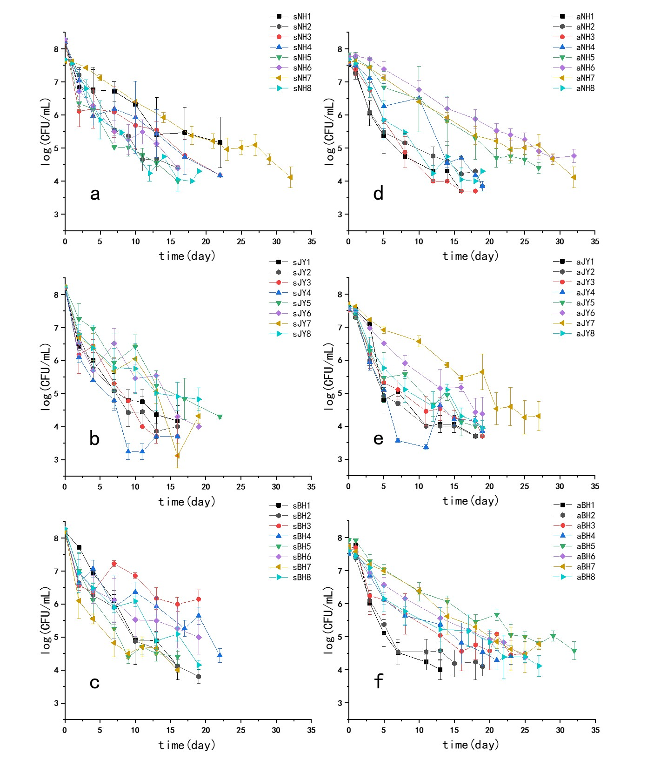

Fig. S1. Survival profiles of E. coli O157:H7 from total 48 water samples. sNH (a), sJY (b) and sBH (c) represented Spring water samples from Nanhu Lake (NH), Jingyue Lake (JY), Beihu Lake, respectively. aNH (d), aJY (e) and aBH (f) represented Autumn water samples from Nanhu Lake (NH), Jingyue Lake (JY), Beihu Lake, respectively.

