Supplementary Material

Table A.1. Sociodemographic characteristics of survey participants, including missing data.
Characteristic | Tested for Sexually Transmitted and Bloodborne Infections
 | In the last 12 months, n (%#) | More than 12 months ago or had never been tested, n (%#) | Missing, n (%#) | Total, n (%#)
Total | 207 (47.8^) | 109 (25.2^) | 117 (27.0^) | 433 (100.0^)
Age  19 to 39  40 or older  Missing | 76 (36.7)  126 (60.9)  <20& | 41 (37.6)  67 (61.5)  <20& | 46 (39.3)  63 (53.8)  <20& | 163 (37.6)  256 (59.1)  <20&
Gender identity  Male/man  Female/woman  Trans/gender expansive  Missing | 122 (58.9)  71 (34.0)  <20&  <20& | 71 (65.1)  30 (27.6)  <20&  <20& | 74 (63.2)  41 (35.0)  <20&  <20& | 267 (61.7)  142 (32.8)  <20&  <20&
Sexual orientation  Heterosexual/straight  LGBQA+  Missing | 159 (76.8)  38 (18.4)  10 | 84 (77.1)  18 (16.5)  7 | 94 (80.3)  13 (11.1)  10 | 337 (77.8)  69 (15.9)  27
Health authority  Vancouver Coastal  Fraser  Interior  Northern  Island | 48 (23.2)  35 (16.9)  31 (15.0)  41 (19.8)  52 (25.1) | 16 (14.7)  26 (23.9)  20 (18.3)  29 (26.6)  18 (16.5) | 13 (11.1)  28 (23.9)  18 (15.4)  39 (33.3)  19 (16.2) | 77 (17.8)  89 (20.6)  69 (15.9)  109 (25.2)  89
Housing%  Has regular housing  No regular housing  Missing | 97 (46.9)  100 (48.3)  10 | 53 (48.6)  50 (45.9)  6 | 42 (35.9)  56 (47.9)  19 | 192 (44.3)  206 (47.6)  35
Employment  Work part-time or full-time  Not employed  Missing | 47 (22.7)  153 (73.9)  7 | 22 (20.2)  82 (75.2)  5 | 15 (12.8)  90 (76.9)  12 | 84 (19.4)  325 (75.1)  24
Community size  Small (<30,000 people)  Large (≥30,000 people) | 77 (37.2)  130 (62.8) | 56 (51.4)  53 (48.6) | 53 (45.3)  64 (54.7) | 186 (43.0)  247 (57.0)
Abbreviations: Lesbian, gay, bisexual/pansexual, queer/questioning, or asexual plus (LGBQA+)
#Column percentages
^Row percentages
&Cross-tabulations that resulted in categories with <20 participants were suppressed to align with the survey privacy protection protocol.
%Regular housing includes private residences, band-owned homes, or other residences (e.g., hotel/motel, single room occupancy, supportive housing). Those without regular housing reported no fixed place to stay (homeless, tent, couch-surfing) or living in a shelter.

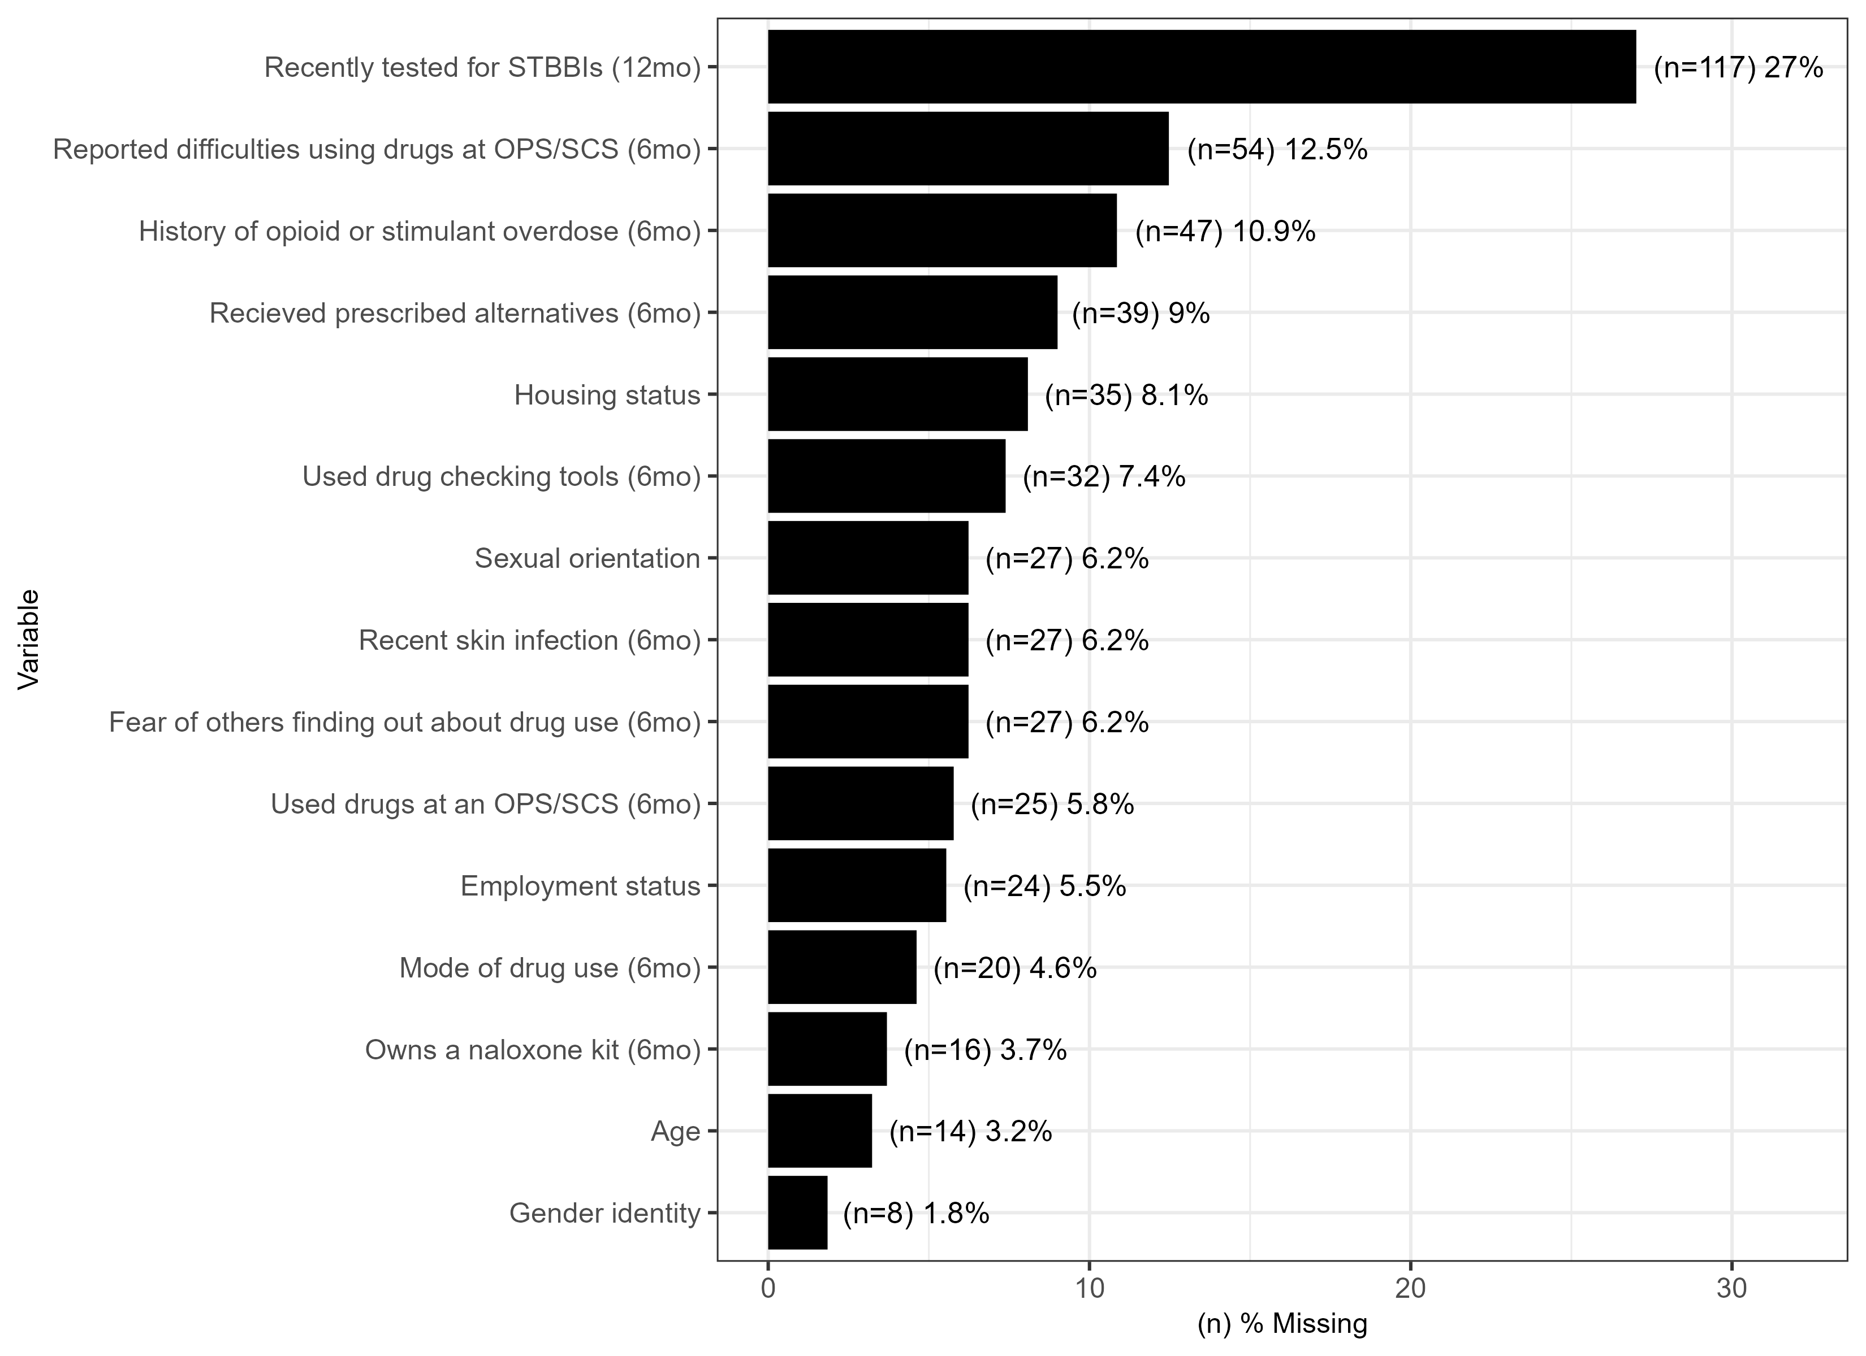Figure A.2. Percentage of missingness across variables used in this analysis from the 2023 British Columbia Harm Reduction Client Survey (N=433). Abbreviations: Sexually transmitted and bloodborne infections (STBBI); 12 months (12mo); Overdose prevention or supervised consumption site (OPS/SCS); 6 months (6mo).
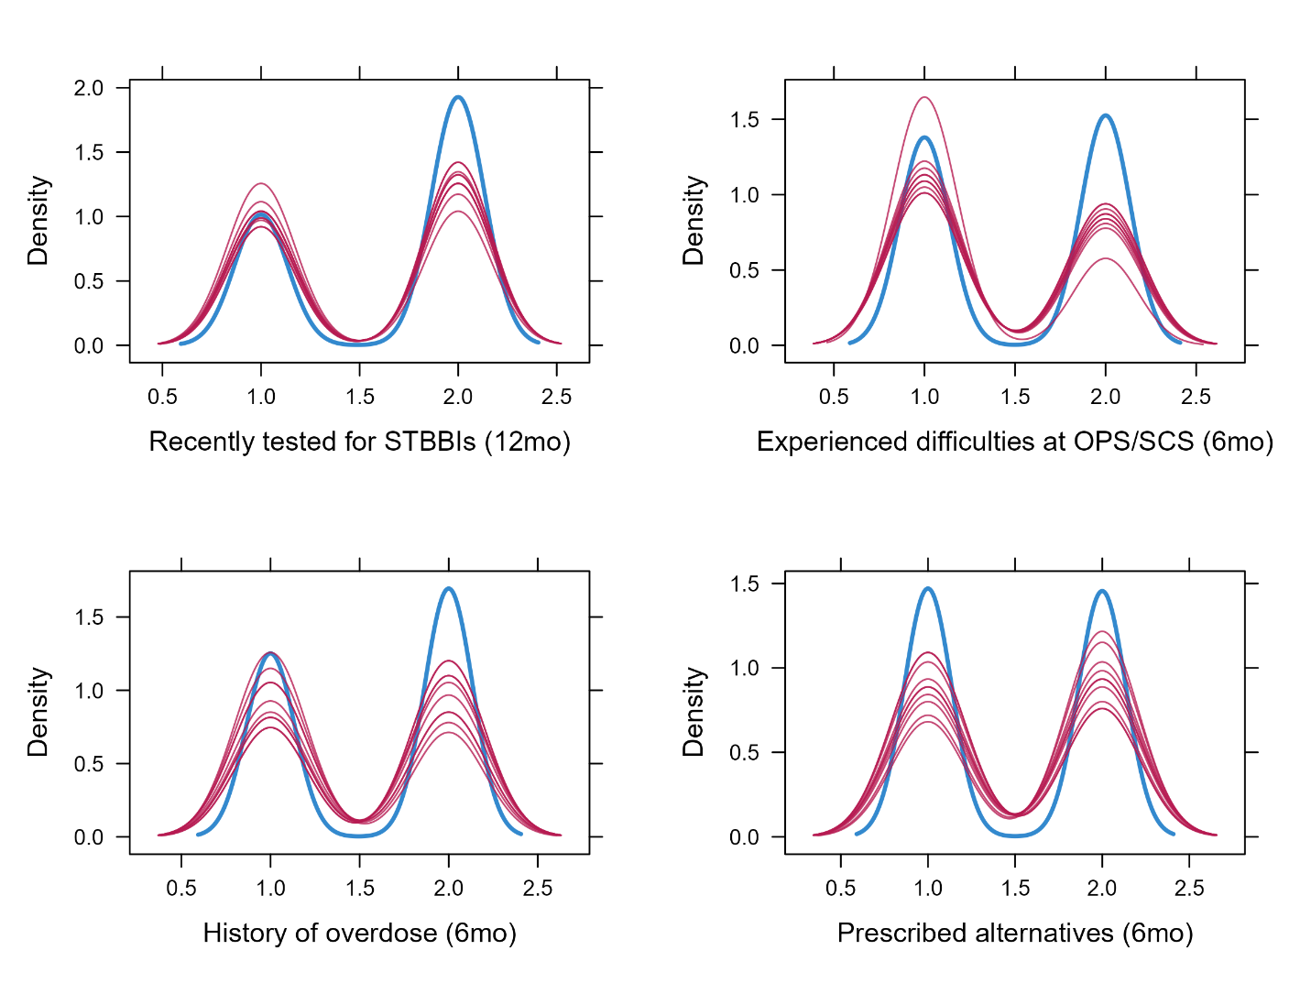Figure A.3. Density plots of variables with high percentage of missingness (>10%). The blue line represents the observed values (non-missing data) while the red lines represent the imputed values. Abbreviations: Sexually transmitted and bloodborne infections (STBBI); Overdose prevention or supervised consumption site (OPS/SCS).

