Supplementary Information for
Dominant climate drivers of wintertime severe particulate pollution in North China

Jiandong Li¹, Xin Hao^{2, 3}, Hong Liao^{1,*}, Yuhang Wang⁴, Wenju Cai^{5,6}, Ke Li⁷, Xu Yue¹, Yang Yang¹, Haishan Chen⁸, Yuhao Mao¹, Yu Fu⁹, Lei Chen¹ and Jia Zhu¹

¹ Jiangsu Key Laboratory of Atmospheric Environment Monitoring and Pollution Control, Jiangsu Collaborative Innovation Center of Atmospheric Environment and Equipment Technology, School of Environmental Science and Engineering, Nanjing University of Information Science & Technology, Nanjing 210044, China
² Collaborative Innovation Center on Forecast and Evaluation of Meteorological Disasters/Key Laboratory of Meteorological Disaster, Ministry of Education, Nanjing University for Information Science & Technology, Nanjing 210044, China
³ Nansen-Zhu International Research Centre, Institute of Atmospheric Physics, Chinese Academy of Sciences, Beijing 100029, China
⁴School of Earth and Atmospheric Sciences, Georgia Institute of Technology, Atlanta, GA 30332, USA
⁵Key Laboratory of Physical Oceanography–Institute for Advanced Ocean Studies, Ocean University of China and Qingdao National Laboratory for Marine Science and Technology, Qingdao, China.
⁶Centre for Southern Hemisphere Oceans Research (CSHOR), CSIRO Oceans and Atmosphere, Hobart, Tasmania, Australia.
⁷John A. Paulson School of Engineering and Applied Sciences, Harvard University, Cambridge, MA, USA
⁸Key Laboratory of Meteorological Disaster, Ministry of Education (KLME)/Joint International Research Laboratory of Climate and Environment Change (ILCEC)/ Collaborative Innovation Center on Forecast and Evaluation of Meteorological Disasters (CIC–FEMD), Nanjing University of Information Science and Technology (NUIST), Nanjing, China
⁹Climate Change Research Center, Chinese Academy of Sciences, Beijing, 100029, China

*Corresponding author: Hong Liao (hongliao@nuist.edu.cn)

Supplementary Text.
Supplementary Text1. Excluding other climate factors
In our work, we identified EA/WR teleconnection and VM of SSTAs as the first and second dominant climate drivers of SPPDs by both correlation analyses and dynamical diagnosis. EA/WR teleconnection and VM of SSTAs are climate drivers for T5 and T7 (the two conducive weather patterns that were responsible for the most occurrence of SPPDs), respectively. We excluded other climate factors for the reasons described below.
- Considering climate drivers for T5, EA/WR teleconnection is more important than climate factors reported in previous studies because:
- Arctic sea ice
The correlation of T5 CWP with the preceding total autumn Arctic sea ice cover is statistically insignificant (R = 0.28);
Several studies reported that the preceding autumn Arctic sea ice cover in the regions of Barents-Kara Seas and Beaufort-Chukchi Seas can impact the winter circulations in East Asia because of their large variabilities ^{1, 2, 3}. In Supplementary Fig. 10, using autumn Arctic sea ice regressed on T5 to quantify changes in sea ice cover, we observed no significant variations in sea ice over these two key regions;
In addition, we found that the moderately polluted weather pattern T2 exhibited negative correlations with preceding autumn arctic sea ice over the Barents Sea, the Laptev Sea and the Chukchi Sea, which resembles previous findings of a negative relationship between Arctic sea ice area and haze pollution in North China ^{4, 5, 6}. We speculate that the declined preceding autumn arctic sea ice may have a potential influence on the moderately polluted pattern of T2, instead of the severely polluted weather patterns of T5 and T7.
- SST
Correlation between T5 and 26 SST indices are lower than 0.5 (Supplementary Fig. 9). We selected indices with high correlations, i.e., SST-index-1 (0.47) and SST-index-15 (-0.50), and then used them to regress on winter mean fields of U200, Z500 and V850 for a direct comparison with T5 weather pattern. Both could not reproduce the characteristics of T5 weather pattern (Supplementary Fig. 11). For example, we observed none significant positive anomalies on V850 field over BTH region, indicating these indices were insufficient to explain T5.
- Atmospheric teleconnections
High correlations (0.5~0.8) were found between T5 and indices describing Eurasian continent circulations, in which EA/WR teleconnection had the highest correlation of 0.76. The EA/WR pattern starts from the mid-latitude Atlantic at approximately 40°N, then propagates to East Asia via western Europe and western Russia. High correlation of 59-Eurasian Zonal Circulation Index (0.62) and 61-Asian Zonal Circulation Index (0.74) are calculated basing on subregions which influenced by EA/WR (Supplementary Fig. 12a). The 72-East Atlantic pattern (0.58) is also a leading mode by EOF decomposition of winter mean Z500 field, but mainly influenced the winter circulation around Japan, instead of North China (Supplementary Fig. 12b). Therefore, the EA/WR is more important for T5 due to higher correlation and a better dynamic meaning.
- Considering climate drivers for T7, VM SSTA is more important than climate factors reported in previous studies because:
- Arctic sea ice
We find T7 CWP have no correlation with total preceding autumn Arctic sea ice (R = 0.00)
- SST
As shown by Supplementary Fig. 9, T7 is highly correlated with the SST indices of the Pacific Ocean (0.45 to 0.58), but poorly correlated with those of the Atlantic Ocean (0.0 to 0.22) and Indian Ocean (-0.2 to 0.18). Highly correlated indices depicted SST variabilities in the Pacific Ocean are defined over subregions affected by VM SSTA. As seen in Supplementary Fig. 13, indices cover the areas with high variabilities of VM have higher correlations with T7. VM index ranks the highest correlation of 0.65, indicating these subregion indices are insufficient to explain T7.
- Atmospheric indices
Atmospheric indices with high correlations (ranging from -0.52 to 0.66) are also tied to the Pacific Ocean. Three of them (27, 28, and 33) represent variations in the Pacific Subtropical High and the remain one indicates the intensity of East Asian Trough (64). In Supplementary Fig. 14, we use VM index to regress on the winter mean Z500 fields over 1979-2019. The positive anomalies weaken the East Asian Trough, while the ‘+-’ pattern over the North Pacific are responsible for the shift of subtropical high. Also, numerical experiments show a similar atmospheric response to the VM SST anomalies ^{7, 8}. Therefore, these high correlated atmospheric indices are also tied to VM SSTA.

Supplementary Text 2. Establish prediction model with EA/WR and VM
Commonly used approaches for seasonal to interannual predictions can be classified as three types: 1) empirical approach trained using observational data, 2) dynamical approach using the general circulation models (GCMs), and 3) the combined empirical-dynamical approach. The prediction of CWPs (SPPDs) in the manuscript employs the third approach, with the following detailed procedure:
- The EA/WR and VM indices are used as predictors. These factors with understanding of physical mechanisms on how predictors impact targets are expected to provide skillful seasonal forecasts.
- An empirical prediction model is established. We employ MLR (Multiple Linear Regression) method to obtain the empirical equation of y=a₁x₁+a₂x₂+b, in which y denotes number of CWPs in a winter in BTH, x₁ and x₂ are EA/WR and VM indices (seasonal means), respectively. The MLR covers 41 winters of 1979-2019.
- The regression equation from (2) is evaluated by cross-validation and independent hindcast. For cross-validation, a one-year-out-cross-validation approach is used, with any individual year out of 1979–2019 being the target year and the regression model established for the remaining 40 years. As for independent hindcasts, period of 1979–2012 was used for training empirical forecast model in step (2). CWPs in each year of 2013–2019 was predicted and compared with the observed CWPS of 2013-2019. For cross-validation, the correlation coefficient, root mean square error and percentage of the same mathematical sign in Fig. 5a is 0.68, 7.68 days, and 80.5% (33/41), respectively. The predicted CWPs by independent hindcast can well reproduce the interannual variability of observed CWPs in 2013–2019 with correlation coefficient and root mean square error being 0.89 and 6.3 day (Fig. 5b). These evaluations indicate that the empirical model from step (2) can be applied to forecast frequency of CWPs.
- Prediction of future wintertime frequency of CWPs combines empirical relationship (as a function of EA/WR and VM indices) with seasonal forecast of climate models. For example, if one wants to predict frequency of CWPs in winter of 2020, an empirical model can be trained spanning historical period of 1979-2019. Using preceding forecasts of Z500 and SST from a climate model, the EA/WR and VM indices and hence the frequency of CWPs for winter of 2020 can be predicted.
Seasonal climate forecast of Z500 and SST from climate models are available from:
- NCEP coupled forecast system model (9 months ahead are available):
https://www.cpc.ncep.noaa.gov/products/people/wwang/cfsv2fcst/
- ECMWF multi-system seasonal forecast service (6 months ahead are available):
https://cds.climate.copernicus.eu/cdsapp#!/dataset/seasonal-postprocessed-pressure-levels?tab=form
- BCC seasonal forecast system (12 months ahead, data requests are unpublic for now):
http://cmdp.ncc-cma.net/pred/cs2gen.php

References：
1. Shi X, Gu Y, Sun J, Dong J, Geng M. Impact of the Barents Sea SST in Autumn on the Winter Climate in Northeast China. Journal of Geoscience and Environment Protection 2017, 05: 89-95.
2. Chen Z, Wu R, Chen W. Impacts of Autumn Arctic Sea Ice Concentration Changes on the East Asian Winter Monsoon Variability. J Clim 2014, 27(14): 5433-5450.
3. Wu B, Su J, D’Arrigo R. Patterns of Asian Winter Climate Variability and Links to Arctic Sea Ice. J Clim 2015, 28(17): 6841-6858.
4. Shen L, Jacob DJ, Mickley LJ, Wang Y, Zhang Q. Insignificant effect of climate change on winter haze pollution in Beijing. Atmos Chem Phys 2018, 18(23): 17489-17496.
5. Zou Y, Wang Y, Zhang Y, Koo JH. Arctic sea ice, Eurasia snow, and extreme winter haze in China. Sci Adv 2017, 3(3): e1602751.
6. Wang H, Chen H, Liu J. Arctic Sea Ice Decline Intensified Haze Pollution in Eastern China. Atmos Ocean Sci Lett 2015, 8(1): 1-9.
7. Ding R, Li J, Tseng Y-h, Sun C, Guo Y. The Victoria mode in the North Pacific linking extratropical sea level pressure variations to ENSO. J Geophys Res Atmos 2015, 120(1): 27-45.
8. Ding R, Li J, Tseng Y-h, Sun C, Zheng F. Linking a sea level pressure anomaly dipole over North America to the central Pacific El Niño. Clim Dyn 2017, 49(4): 1321-1339.

Supplementary Tables.
Supplementary Table 1 | Atmospheric Indices used in Supplementary Figs. 7-8. The monthly indices are downloaded from the National Climate Centre of the Chinese Meteorology Administration. A more detailed definition of each index can be found at https://cmdp.ncc-cma.net/Monitoring/cn_index_130.php.
 | Atmospheric Indices
1 | Northern Hemisphere Subtropical High Area Index
2 | North African Subtropical High Area Index
3 | North African-North Atlantic-North American Subtropical High Area Index
4 | Indian Subtropical High Area Index
5 | Western Pacific Subtropical High Area Index
6 | Eastern Pacific Subtropical High Area Index
7 | North American Subtropical High Area Index
8 | Atlantic Subtropical High Area Index
9 | South China Sea Subtropical High Area Index
10 | North American-Atlantic Subtropical High Area Index
11 | Pacific Subtropical High Area Index
12 | Northern Hemisphere Subtropical High Intensity Index
13 | North African Subtropical High Intensity Index
14 | North African-North Atlantic-North American Subtropical High Intensity Index
15 | Indian Subtropical High Intensity Index
16 | Western Pacific Subtropical High Intensity Index
17 | Eastern Pacific Subtropical High Intensity Index
18 | North American Subtropical High Intensity Index
19 | North Atlantic Subtropical High Intensity Index
20 | South China Sea Subtropical High Intensity Index
21 | North American-North Atlantic Subtropical High Intensity Index
22 | Pacific Subtropical High Intensity Index
23 | Northern Hemisphere Subtropical High Ridge Position Index
24 | North African Subtropical High Ridge Position Index
25 | North African-North Atlantic-North American Subtropical High Ridge Position Index
26 | Indian Subtropical High Ridge Position Index
27 | Western Pacific Subtropical High Ridge Position Index
28 | Eastern Pacific Subtropical High Ridge Position Index
29 | North American Subtropical High Ridge Position Index
30 | Atlantic Sub Tropical High Ridge Position Index
31 | South China Sea Subtropical High Ridge Position Index
32 | North American-North Atlantic Subtropical High Ridge Position Index
33 | Pacific Subtropical High Ridge Position Index
34 | Northern Hemisphere Subtropical High Northern Boundary Position Index
35 | North African Subtropical High Northern Boundary Position Index
36 | North African-North Atlantic-North American Subtropical High Northern Boundary Position Index
37 | Indian Subtropical High Northern Boundary Position Index
38 | Western Pacific Subtropical High Northern Boundary Position Index
39 | Eastern Pacific Subtropical High Northern Boundary Position Index
40 | North American Subtropical High Northern Boundary Position Index
41 | Atlantic Subtropical High Northern Boundary Position Index
42 | South China Sea Subtropical High Northern Boundary Position Index
43 | North American-Atlantic Subtropical High Northern Boundary Position Index
44 | Pacific Subtropical High Northern Boundary Position Index
45 | Western Pacific Sub Tropical High Western Ridge Point Index
46 | Asia Polar Vortex Area Index
47 | Pacific Polar Vortex Area Index
48 | North American Polar Vortex Area Index
49 | Atlantic-European Polar Vortex Area Index
50 | Northern Hemisphere Polar Vortex Area Index
51 | Asia Polar Vortex Intensity Index
52 | Pacific Polar Vortex Intensity Index
53 | North American Polar Vortex Intensity Index
54 | Atlantic-European Polar Vortex Intensity Index
55 | Northern Hemisphere Polar Vortex Intensity Index
56 | Northern Hemisphere Polar Vortex Central Longitude Index
57 | Northern Hemisphere Polar Vortex Central Latitude Index
58 | Northern Hemisphere Polar Vortex Central Intensity Index
59 | Eurasian Zonal Circulation Index
60 | Eurasian Meridional Circulation Index
61 | Asian Zonal Circulation Index
62 | Asian Meridional Circulation Index
63 | East Asian Trough Position Index
64 | East Asian Trough Intensity Index
65 | Tibet Plateau Region 1 Index
66 | Tibet Plateau Region-2 Index
67 | India-Burma Trough Intensity Index
68 | Arctic Oscillation, AO
69 | Antarctic Oscillation, AAO
70 | North Atlantic Oscillation, NAO
71 | Pacific/ North American Pattern, PNA
72 | East Atlantic Pattern, EA
73 | West Pacific Pattern, WP
74 | North Pacific Pattern, NP
75 | East Atlantic-West Russia Pattern, EA/WR
76 | Tropical-Northern Hemisphere Pattern, TNH
77 | Polar-Eurasia Pattern, POL
78 | Scandinavia Pattern, SCA
79 | Pacific Transition Pattern, PT
80 | 30hPa zonal wind Index
81 | 50 hPa zonal wind Index
82 | Mid-Eastern Pacific 200mb Zonal Wind Index
83 | West Pacific 850mb Trade Wind Index
84 | Central Pacific 850mb Trade Wind Index
85 | East Pacific 850mb Trade Wind Index
86 | Atlantic-European Circulation W Pattern Index
87 | Atlantic-European Circulation C Pattern Index
88 | Atlantic-European Circulation E Pattern Index

Supplementary Table 2 | SST indices used in Supplementary Fig. 9.
 | SST Indices
1 | NINO 1+2 SSTA Index
2 | NINO 3 SSTA Index
3 | NINO 4 SSTA Index
4 | NINO 3.4 SSTA Index
5 | NINO W SSTA Index
6 | NINO C SSTA Index
7 | NINO A SSTA Index
8 | NINO B SSTA Index
9 | NINO Z SSTA Index
10 | Tropical Northern Atlantic SST Index
11 | Tropical Southern Atlantic SST Index
12 | Western Hemisphere Warm Pool Index
13 | Indian Ocean Warm Pool Area Index
14 | Indian Ocean Warm Pool Strength Index
15 | Western Pacific Warm Pool Area Index
16 | Western Pacific Warm Pool Strength Index
17 | Atlantic Multi-decadal Oscillation Index
18 | Oyashio Current SST Index
19 | West Wind Drift Current SST Index
20 | Kuroshio Current SST Index
21 | ENSO Modoki Index
22 | Nino Eastern Pacific Index
23 | Nino Central Pacific Index
24 | Indian Ocean Basin-Wide Index
25 | Tropic Indian Ocean Dipole Index
26 | South Indian Ocean Dipole Index

Supplementary Figures:

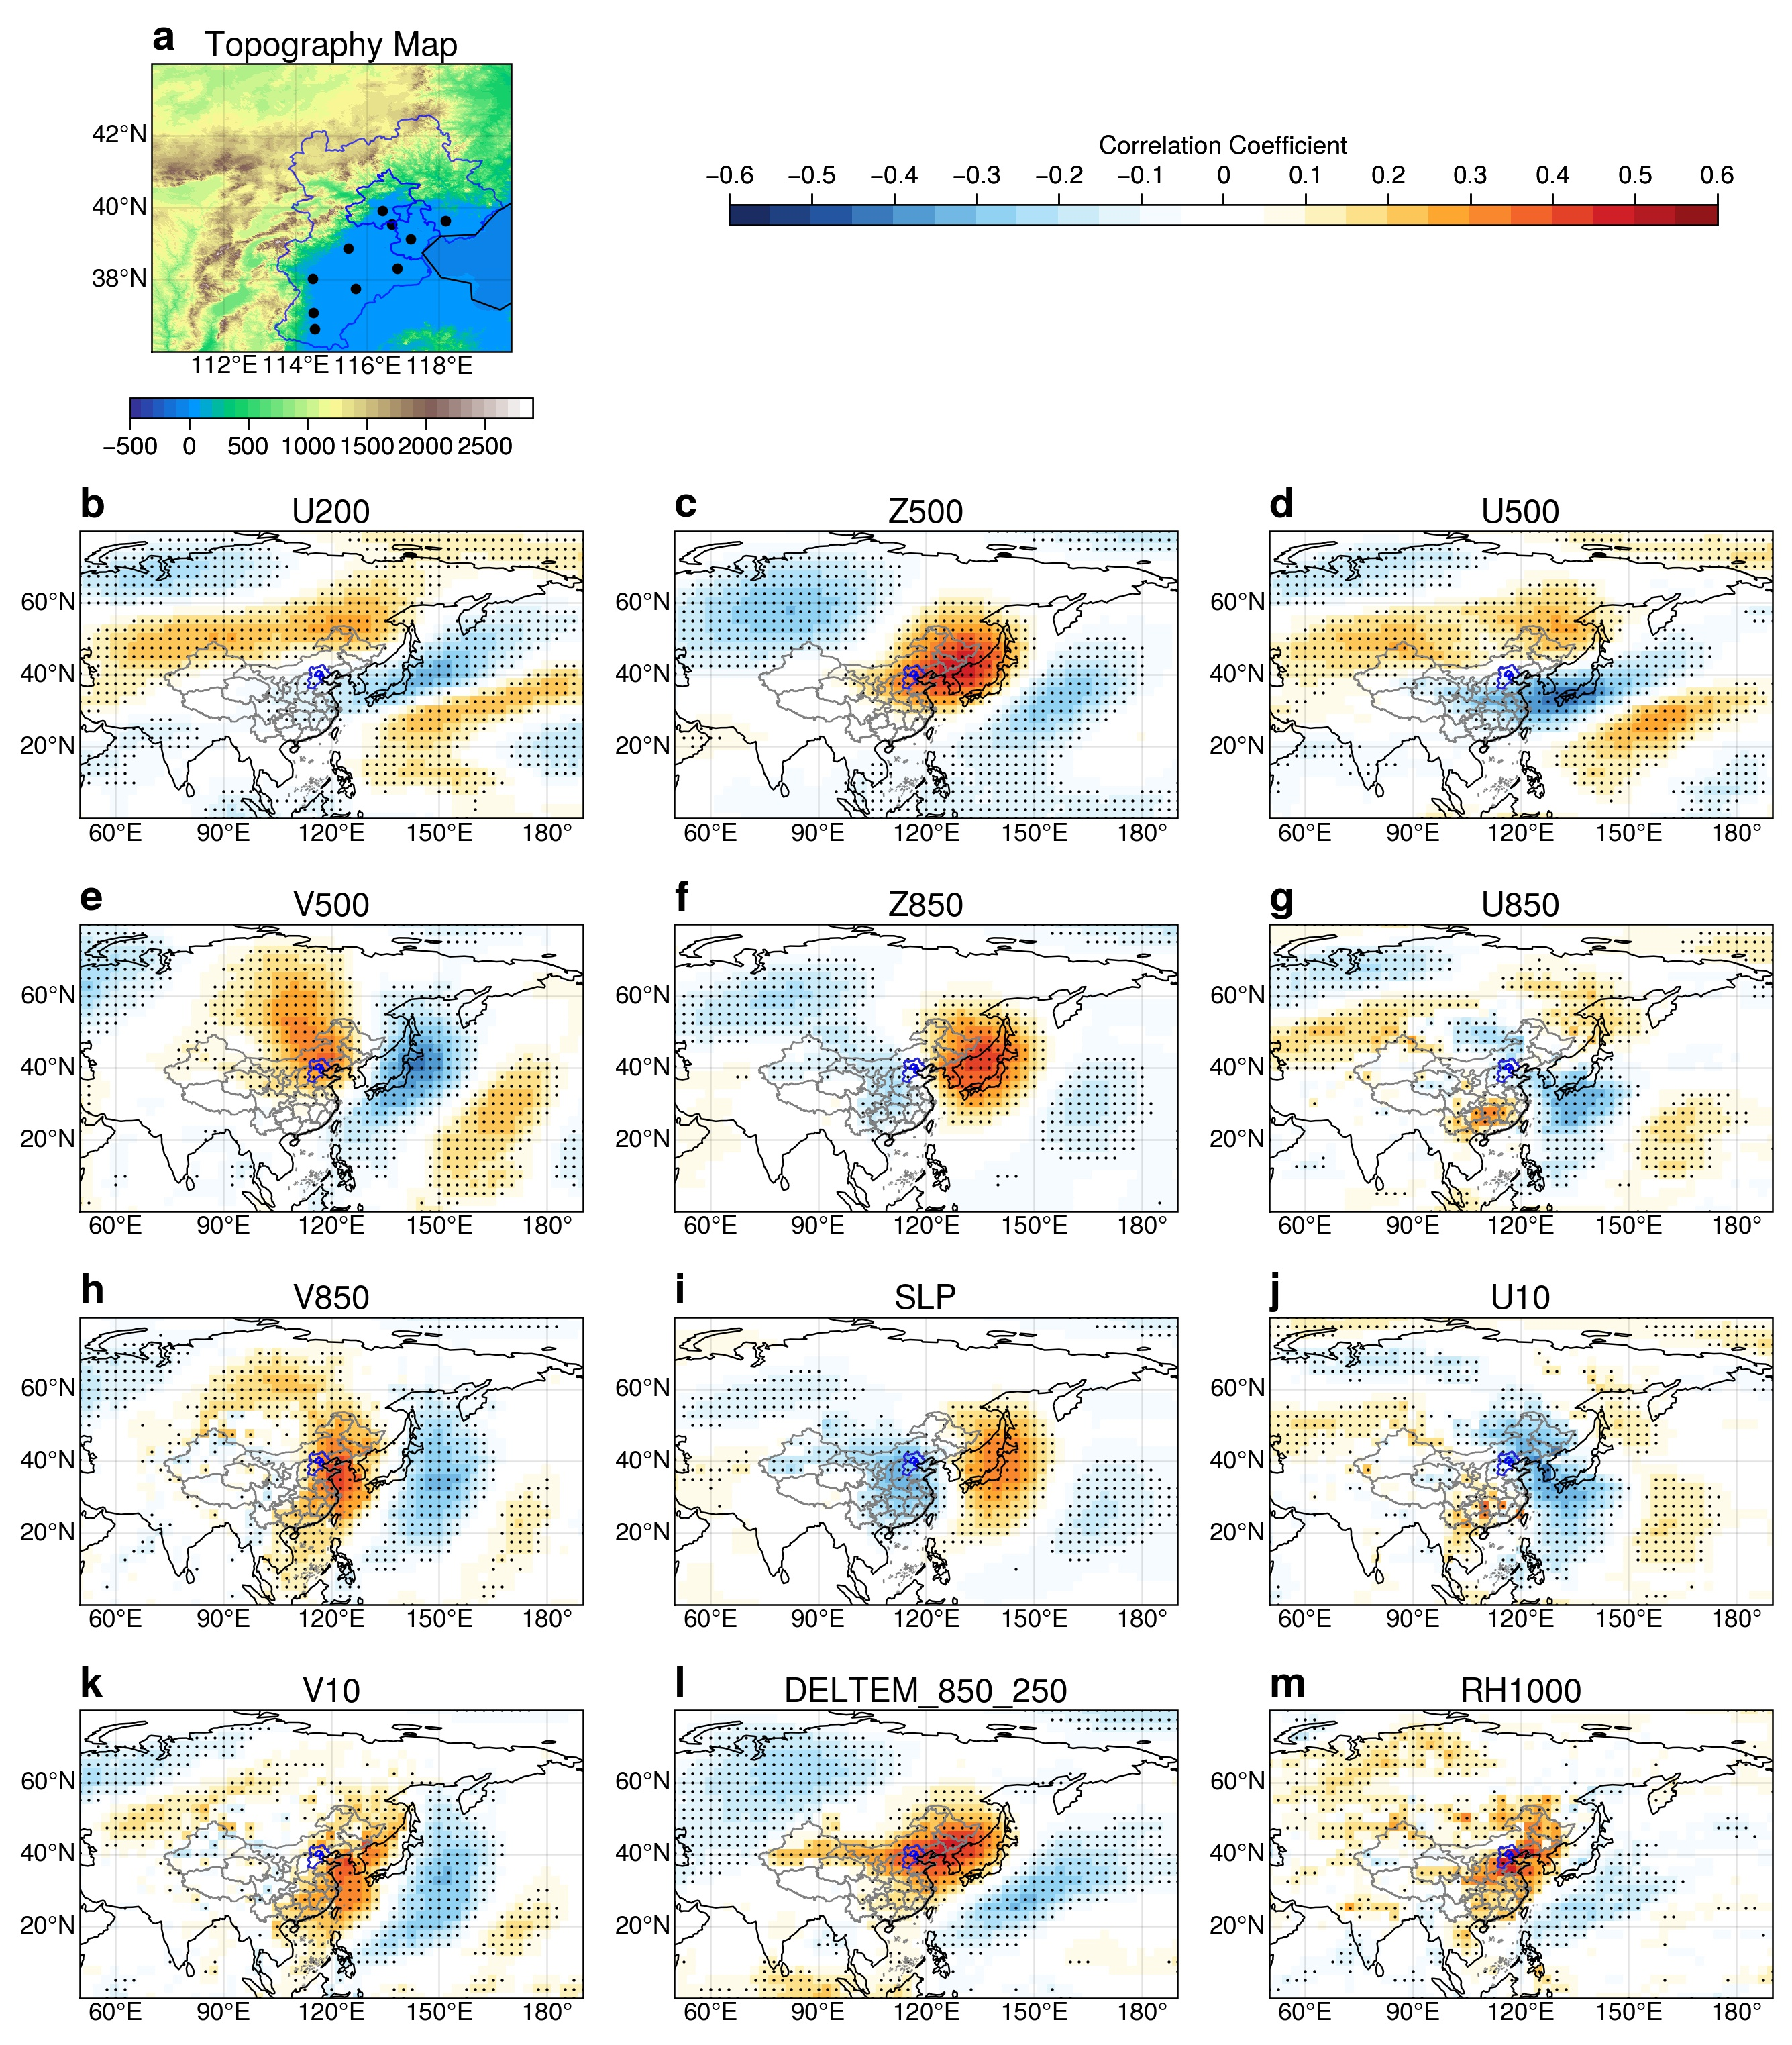
Supplementary Fig. 1 | Correlation between daily meteorology anomalies and winter PM_{2.5}. a, Topographic map of the North China Plain (shading, unit: m) and locations of cities (black dots) with observed PM_{2.5} concentrations used in this study. b-m, Distribution of correlation coefficients between daily mean PM_{2.5} concentrations and daily meteorological fields during DJFs from 2013 to 2019. Stippled regions in b-m denote those areas exceeding the 95% significance level based on the t-test. The blue line is the boundary of the BTH region.
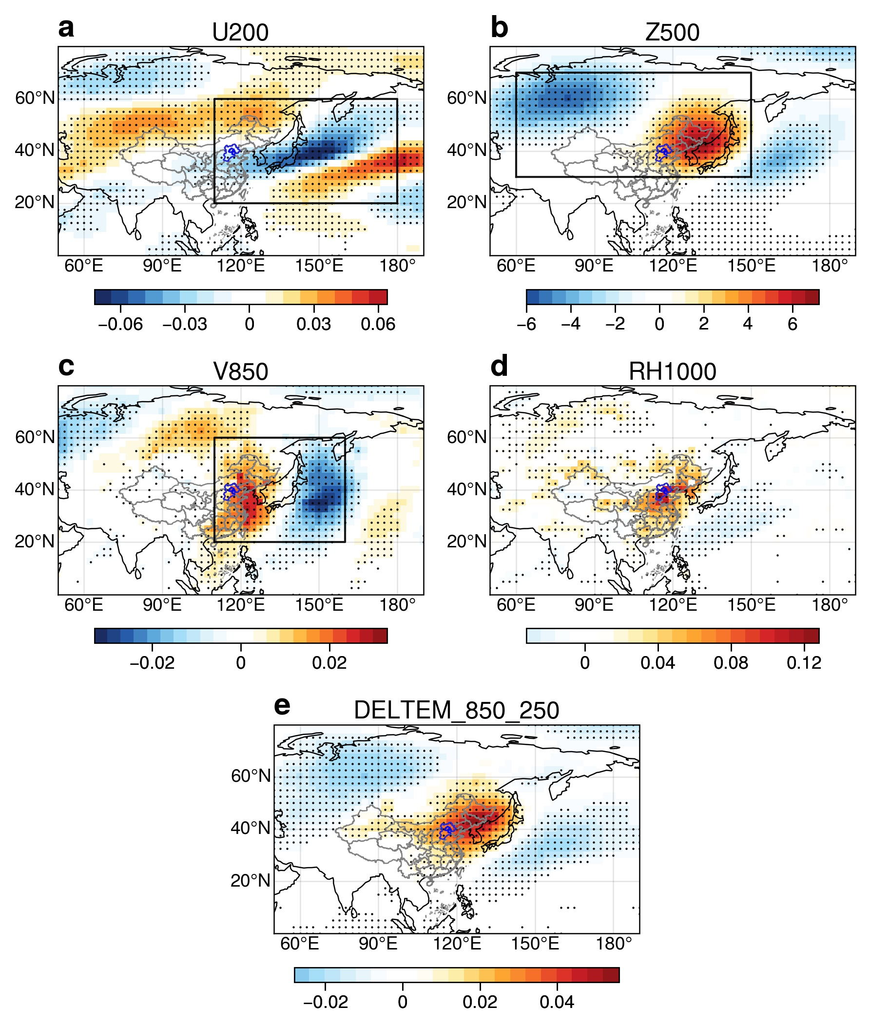
Supplementary Fig. 2 | Regression between daily meteorological anomalies and winter PM_{2.5}. Distribution of regression coefficients between daily mean PM_{2.5} concentrations with daily (a) U200, (b) Z500, (c) V850, (d) RH1000 (relative humidity at 1000 hPa) and (e) Deltem_850_250 (vertical difference in the temperature anomalies between 850 hPa and 250 hPa) during DJFs from 2013 to 2019. Stippled regions denote those areas exceeding the 95% significance level based on the t-test. The blue line is the boundary of the BTH region. The black rectangles in a-c are selected regions for each variable.
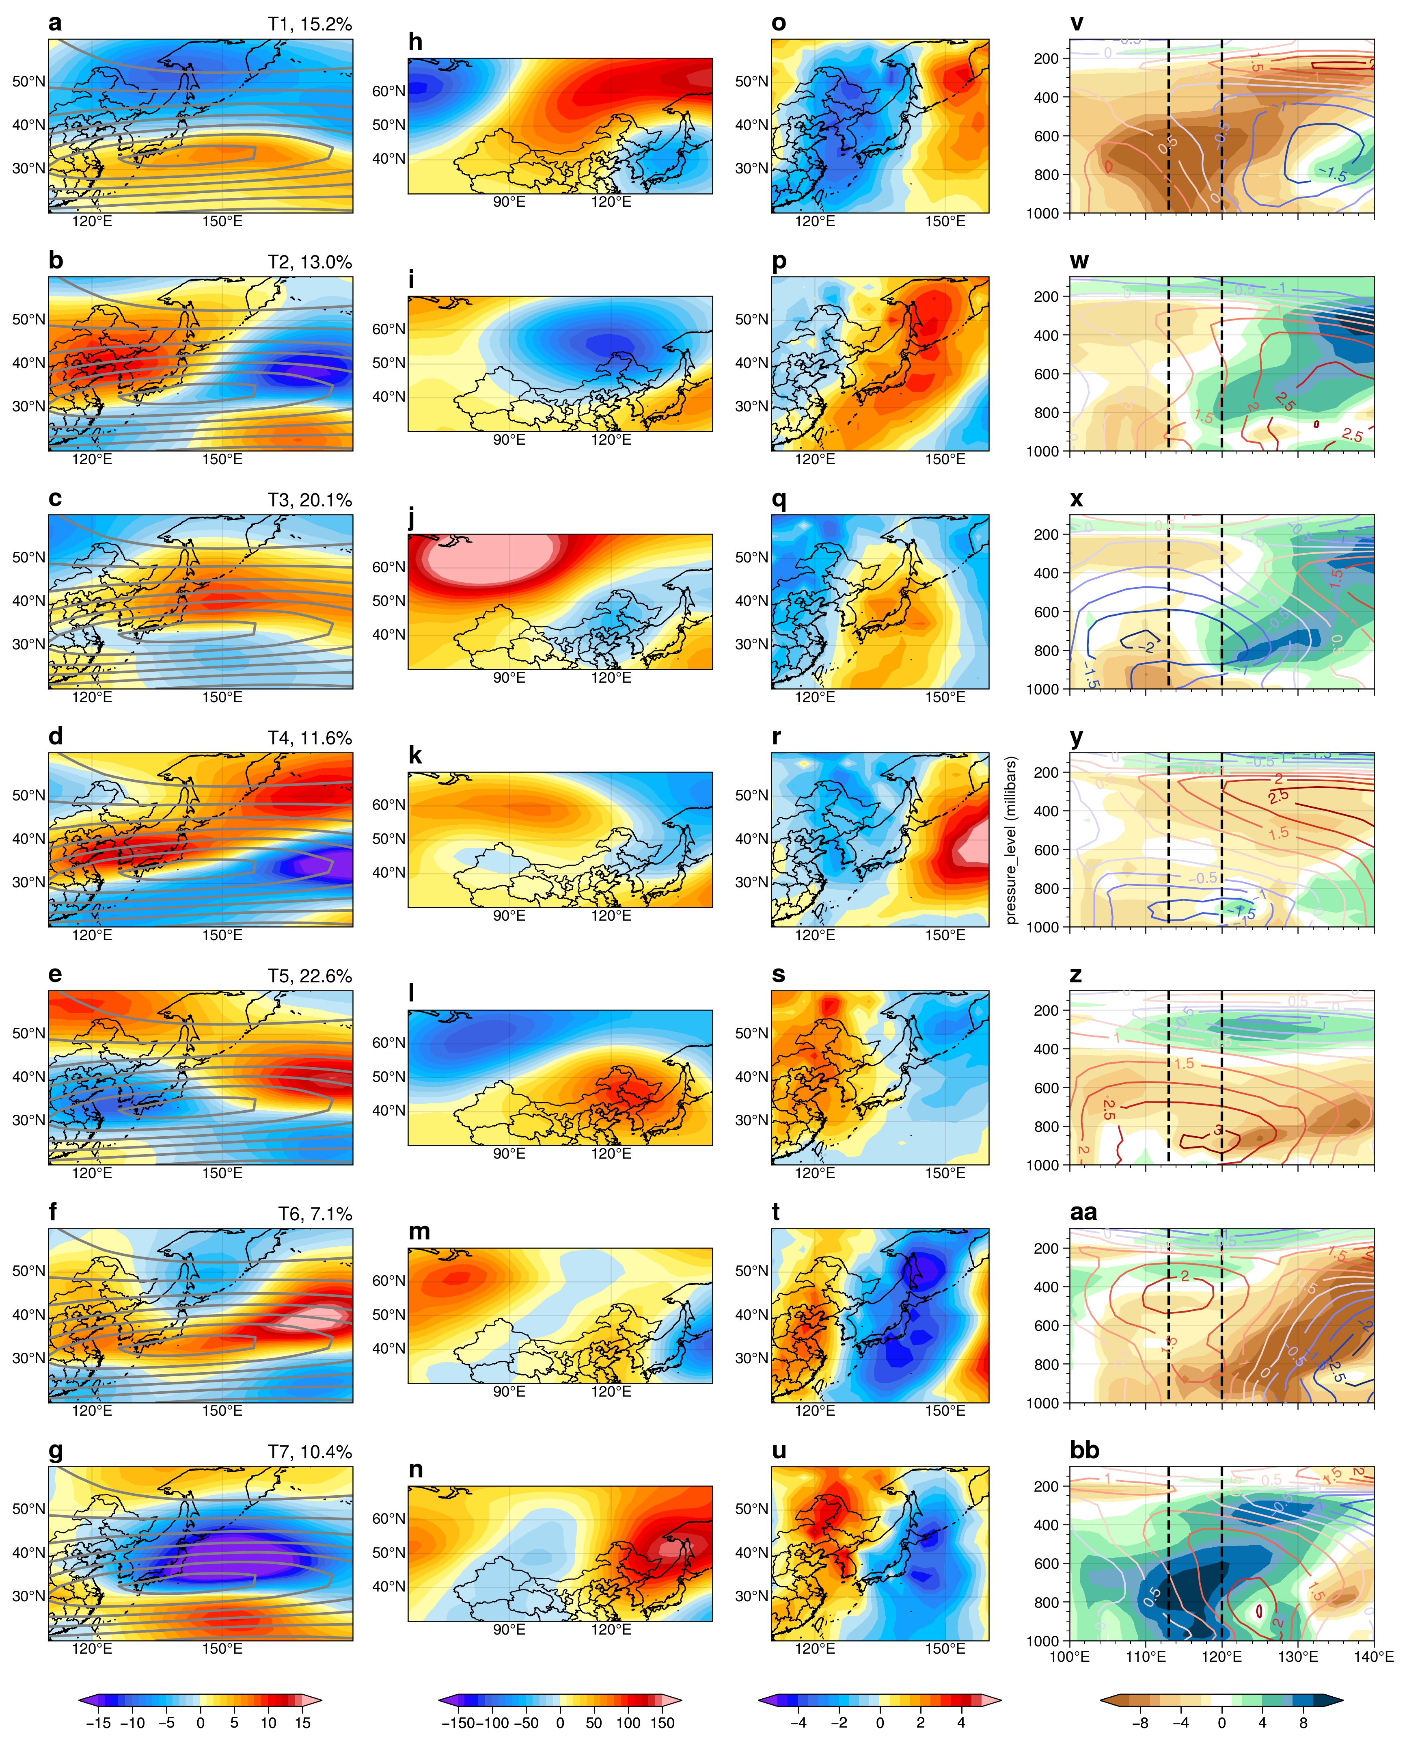
Supplementary Fig. 3 | Composited weather patterns for T1–T7 during the DJFs of 2013–2019. a-bb, Composite anomalies of (a-g) U200 (units: m s⁻¹), (h-n) Z500 (units: m² s⁻²), (o-u) V850 (units: m s⁻¹), and (v-bb) pressure-longitude cross sections of the relative humidity (shadings, units: %) and temperature (contour, unit: ℃) for each weather type. The gray contours in a-g are the western jet streams calculated by the DJF means of U200 from 1979 to 2018. The cross sections in v-bb are averaged over 30–40°N, and areas between the two black dashed lines denote the BTH region.
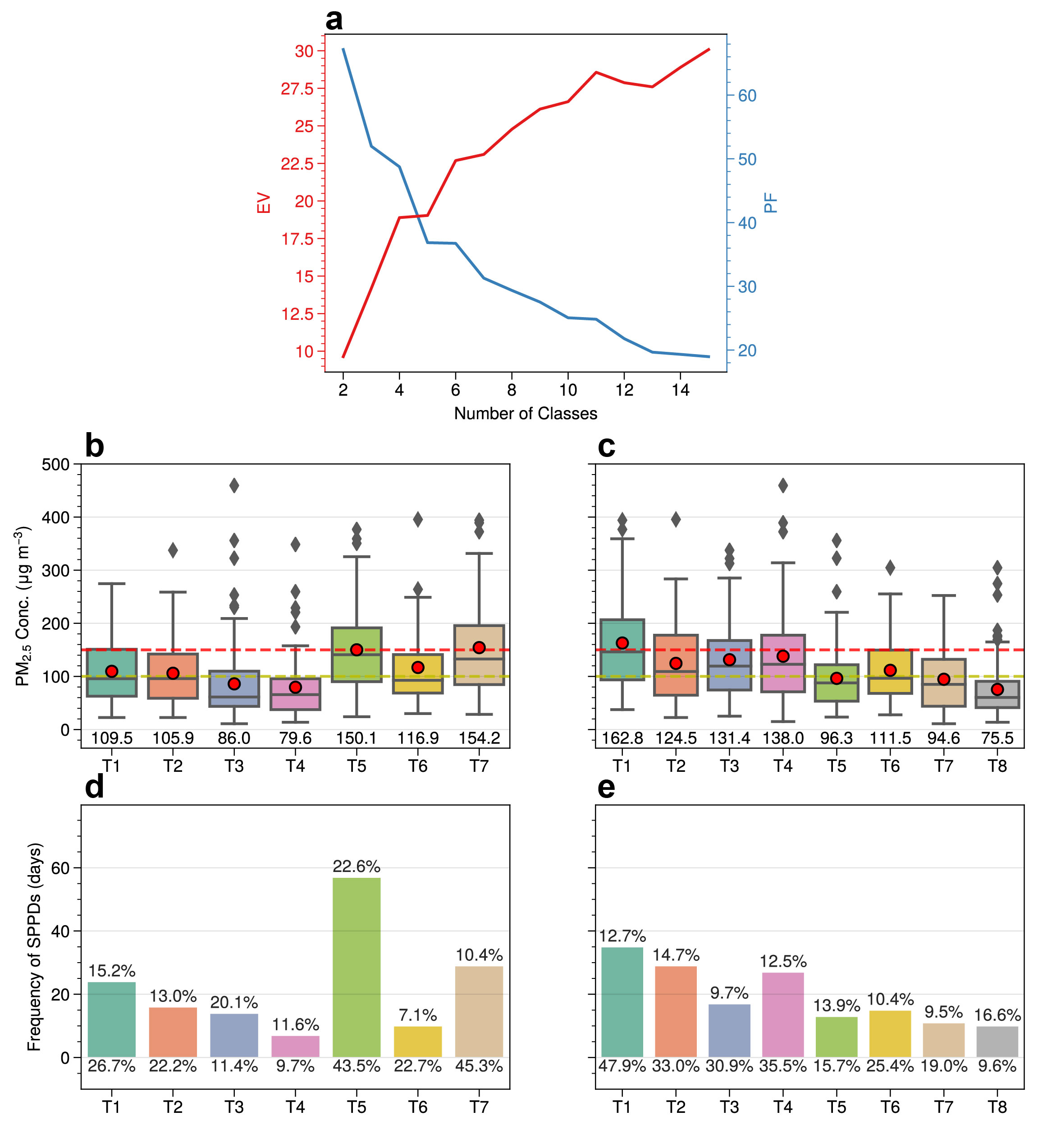
Supplementary Fig. 4 | Evaluation for different classifications. a, The explained variation (EV) and pseudo-F (PF) values corresponding to different classifications. b-e, Box and whisker plots of the average PM_{2.5} concentrations (b, c) and frequencies of SPPDs (d, e) under each Type for 6 (b, d) and 7 (c, e) classes in a. The red dots in boxes (b, c) denote mean PM_{2.5} concentrations and their values are listed below boxes. The numbers above the histograms are the frequencies of each type in DJFs during 2013–2019, and those below the histograms are the SPPDs frequencies within each type.

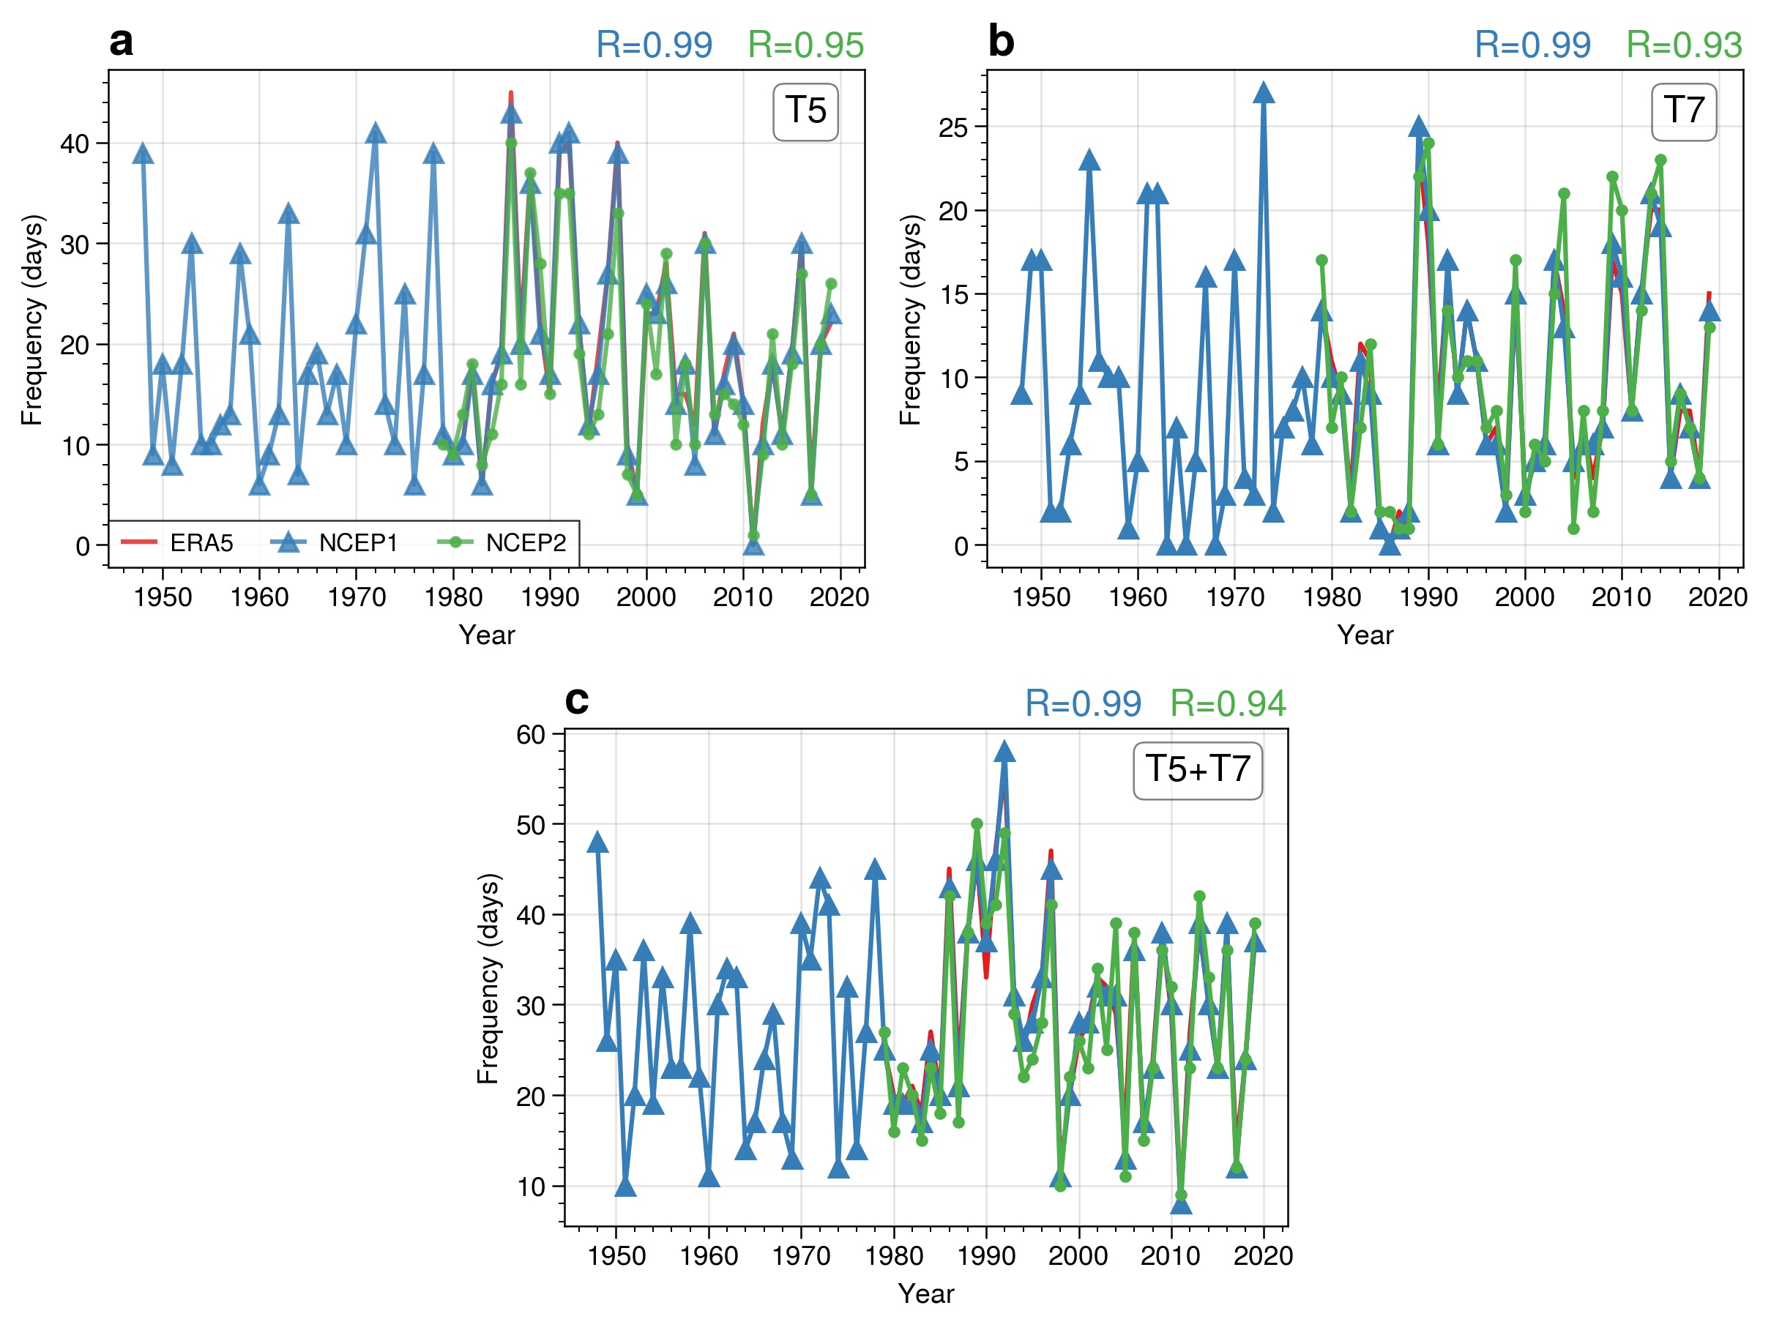
Supplementary Fig. 5 | Long-term variations of R-CWPs using different reanalysis data. a-c, Time series of occurrence frequencies for the R-CWPs in winters of 1979–2019 by using the ERA5 (red), NCEP1(blue) and NCEP2 (green) reanalysis datasets, respectively. The inset texts in the top right corner of each panel denote correlation coefficients between R-CWPs with ERA5 reanalysis and R-CWPs using NCEP1 and NCEP2 reanalysis in 1979-2019, respectively.

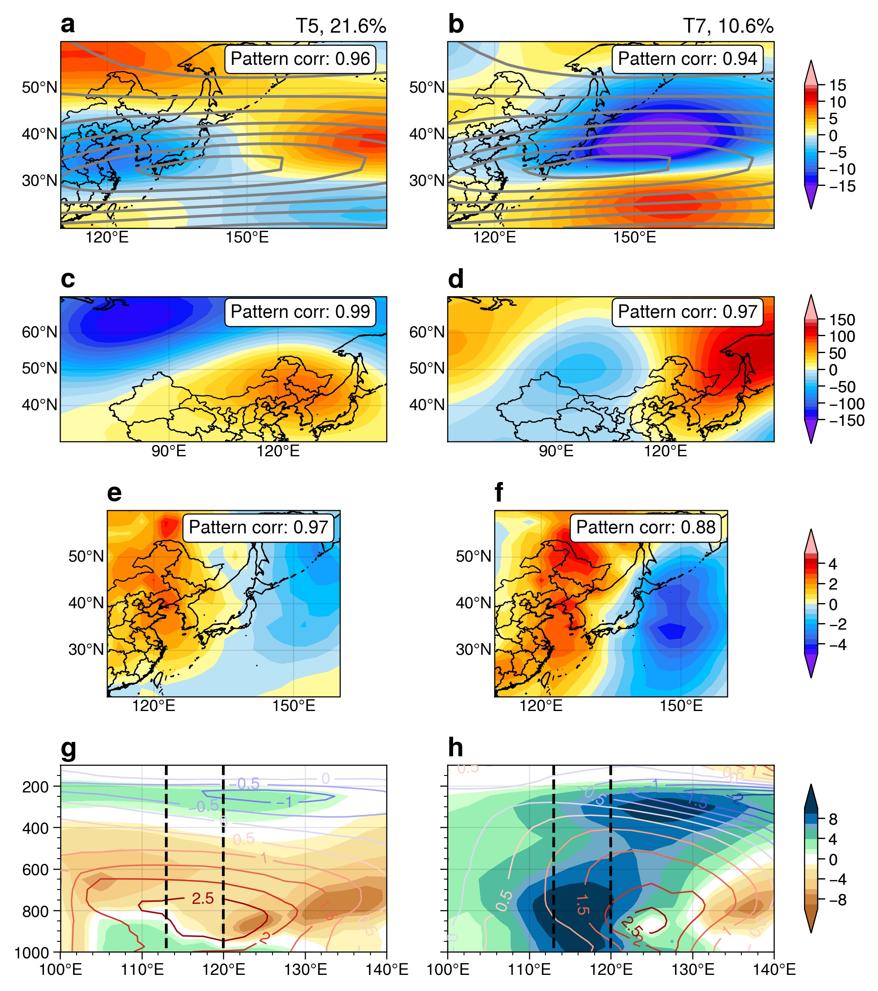
Supplementary Fig. 6 | Composited weather patterns of R-CWPs for T5 and T7 over the years of 1979–2019. a-h, Composite anomaly distributions of (a, b) U200 (units: m s⁻¹), (c, d) Z500 (units: m² s⁻²), (e, f) V850 (units: m s⁻¹) and (g, h) pressure-longitude cross sections of the relative humidity (shadings, units: %) and temperature (contour, unit: ℃) for the reconstructed T5 and T7 weather types. The gray contours in a and b are the western jet streams calculated by the DJF means of U200 from 1979 to 2018. The cross sections are averaged over 30–40°N, and areas between the two black dashed lines denote the BTH region. The “Pattern corr” in a-f denote the pattern correlation between the composites in Fig. 1c-h and a-f.

Supplementary Fig. 7 | Heatmap of correlation coefficients between various atmospheric indices and frequency of T5 R-CWPs. Correlation coefficients between the time series of T5/T7 and climate indices in Supplementary Fig. 7-9 are all detrended to remove linear trends.
Supplementary Fig. 8 | Heatmap of correlation coefficients between various atmospheric indices and frequency of T7 R-CWPs.

Supplementary Fig. 9 | Heatmap of correlation coefficients between SST indices and T5/T7.
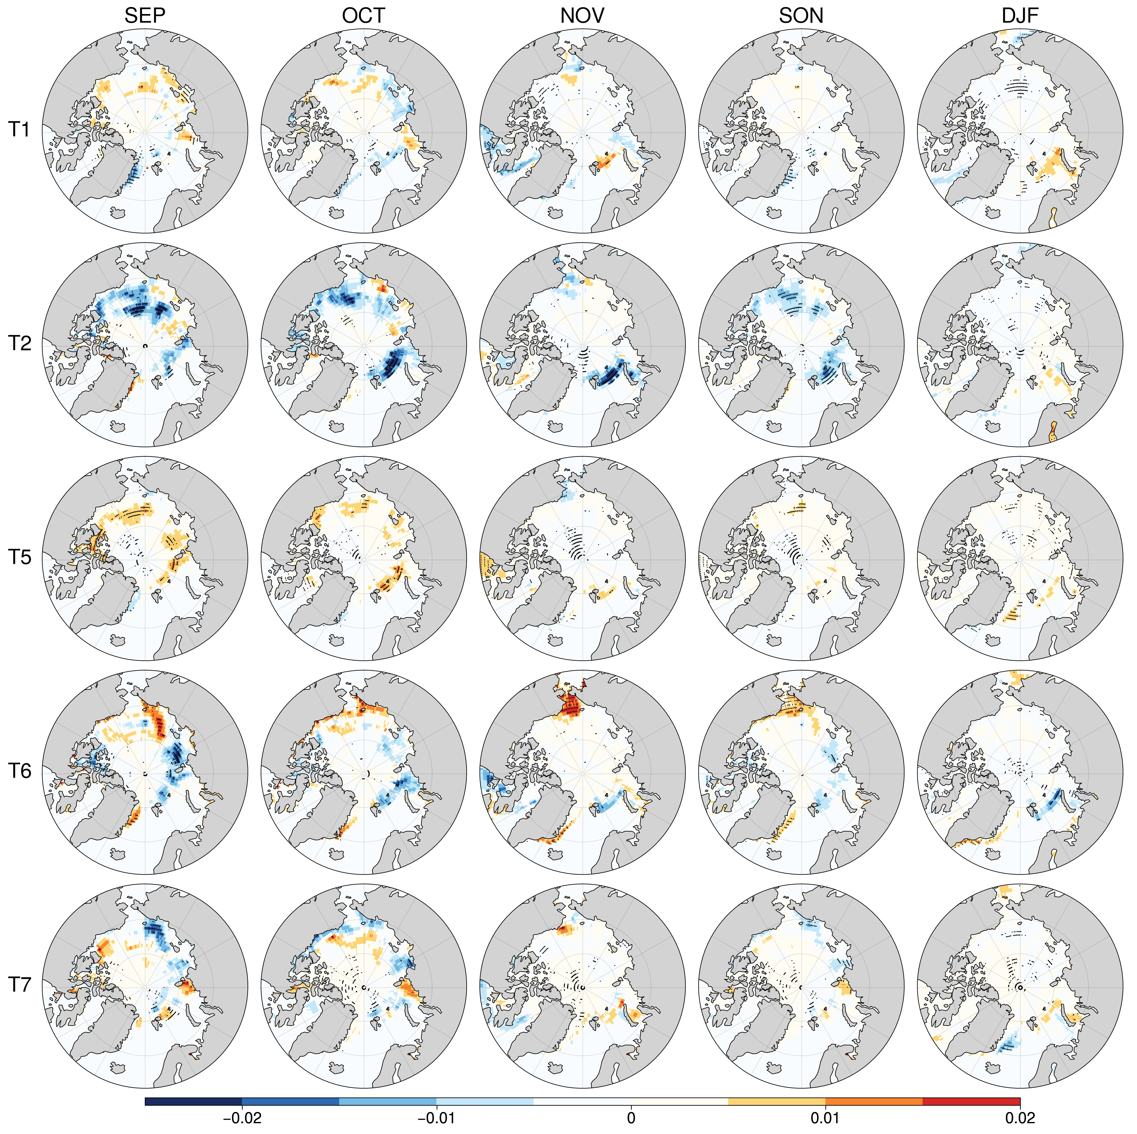
Supplementary Fig. 10 | Distribution of regression coefficients between the arctic sea ice and different weather patterns. The observed sea ice concentrations from the Hadley Centre are downloaded from https://www.metoffice.gov.uk/hadobs/hadisst/. The arctic sea ice cover generally reached its annual minimum in September. The regression analyses are conducted for both autumn and winter. Stippled regions denote those areas exceeding the 95% significance level based on the t-test.
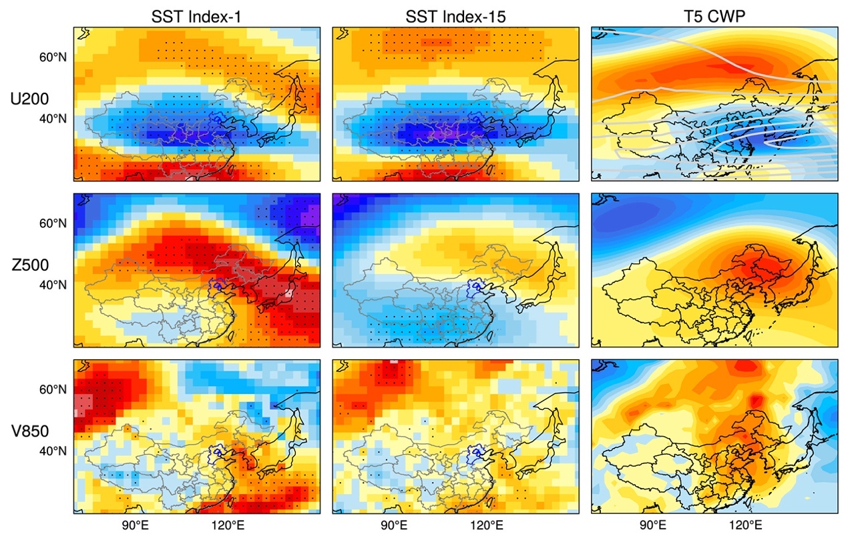
Supplementary Fig. 11 | Comparison between SST shaped circulations and composite anomalies of T5 CWP. The left two columns display regression slopes using simple linear regression (y=ax+b) with different SST indices being x and wintertime mean fields of U200, Z500 and V850 being y. Stippled regions denote those areas exceeding the 95% significance level based on the t-test. The right most column are composite anomalies of T5 CWP.

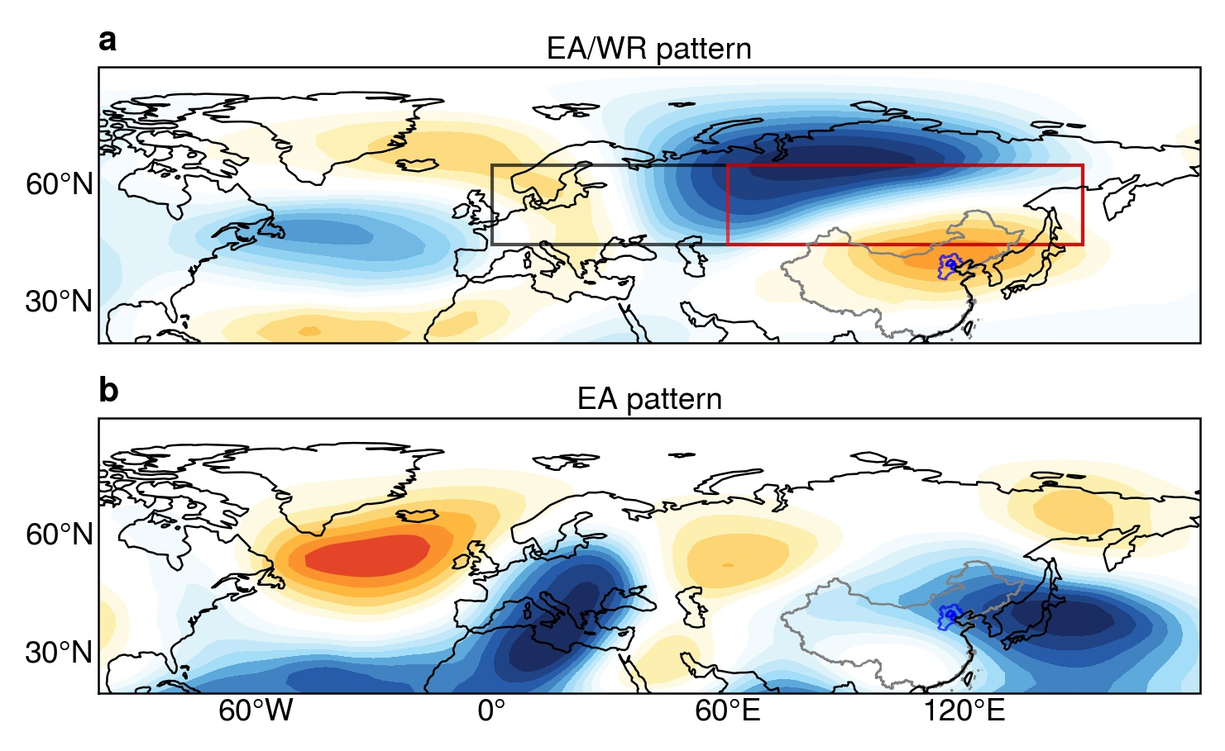
Supplementary Fig. 12 | Typical teleconnection pattern for EA/WR and EA. a, The EA/WR teleconnection pattern (shadings) and regions used for calculation of 59-Eurasian Zonal Circulation Index (black rectangle, 0°-150°E, 45°-65°N) and 61-Asian Zonal Circulation Index (red rectangle, 60°-90°E, 45°-65°N). b, The EA teleconnection pattern (shadings).

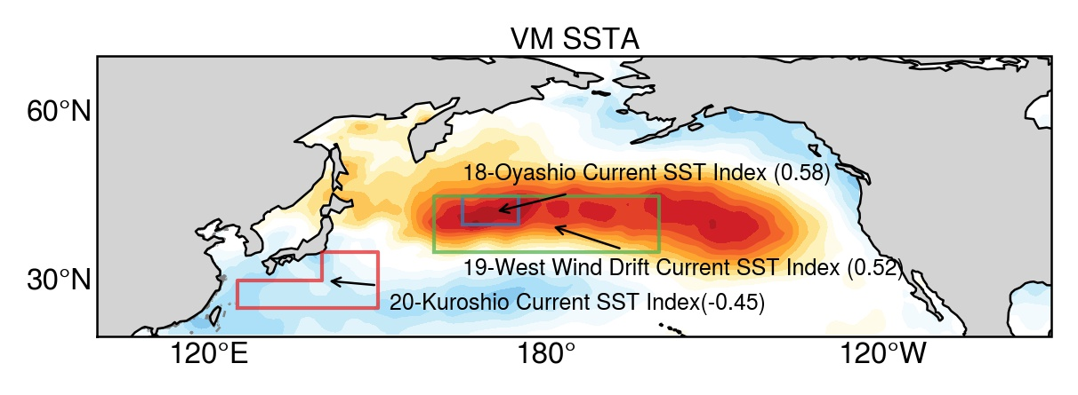
Supplementary Fig. 13 | Typical Victoria Mode of SSTA. The red polygon, green and blue rectangles are regions used for definitions of 20-Kuroshio Current SST index, 19-West Wind Drift SST index and 18-Oyashio Current SST index, respectively.

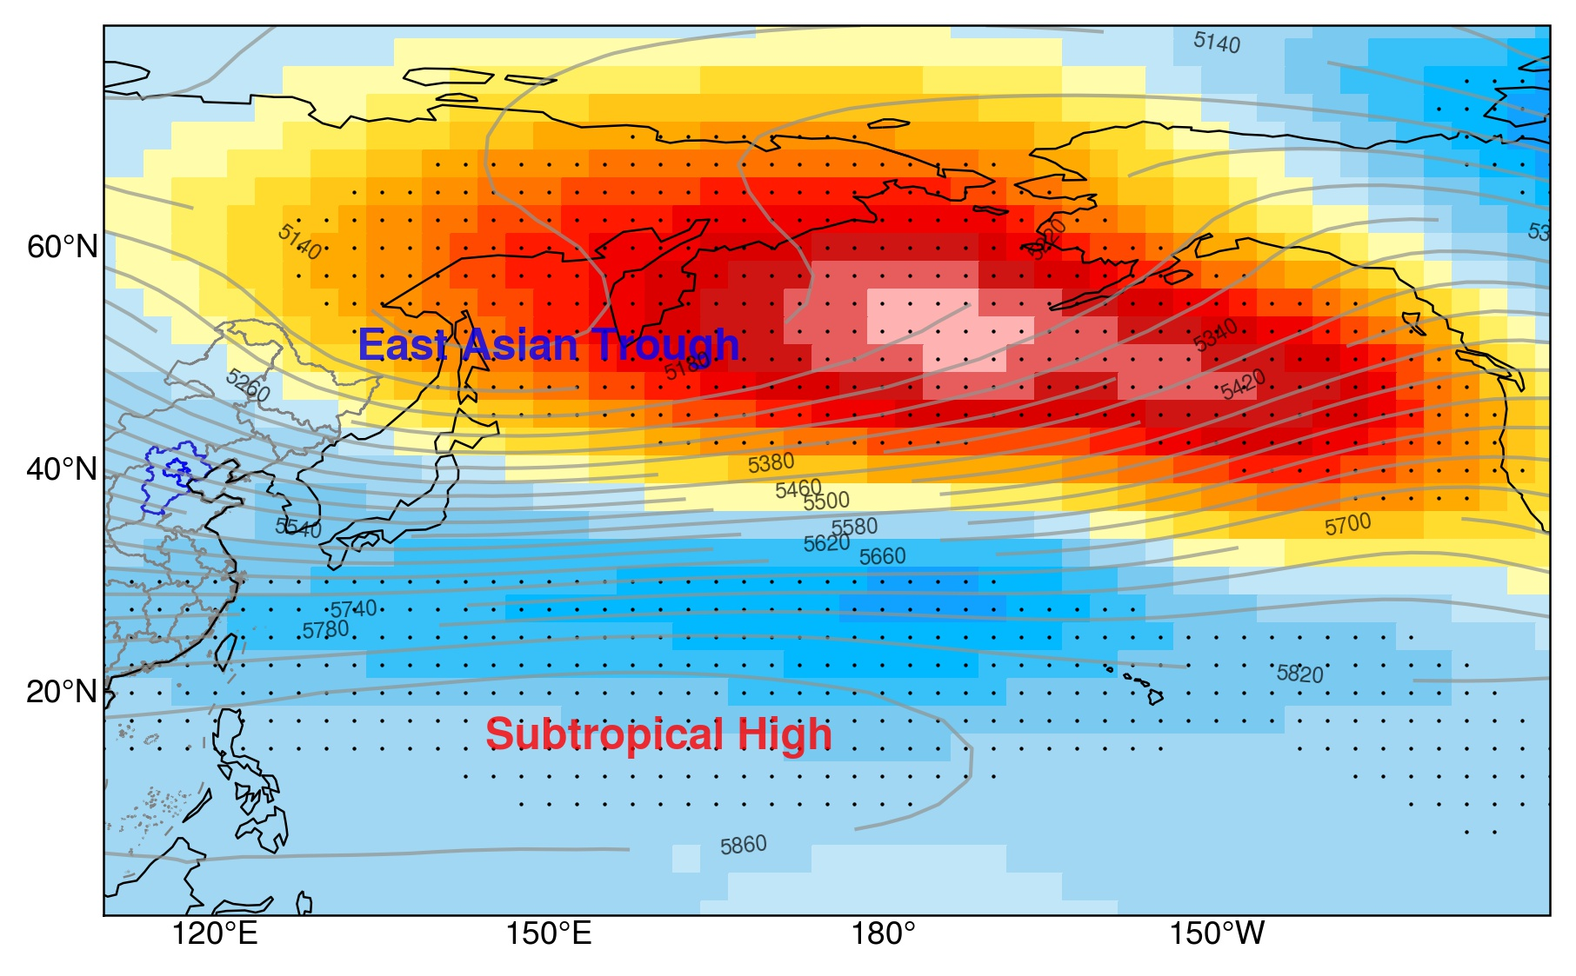
Supplementary Fig. 14 | Relationship between VM and Z500. The regression is the same as Supplementary Fig. 11. The gray contours are Z500 climatology of DJF means from 1979 to 2018. Stippled regions denote those areas exceeding the 95% significance level based on the t-test.

