Supplementary tables

Table S1 Implied carbon coefficient of recyclable waste
Category | (t CO₂/t waste) | (t CO₂/t waste)
Paper | 2.035 | 1.576
Plastic | 1.363 | 0.339
Metal | 9.265 | 1.113
Glass | 0.709 | 0.395
Textile | 3.777 | 0.401

Table S2 Data source information
Indicator | Period | Data source
Population | 1949-2024 | National Bureau of  Statistics of China
GDP | 1952-2024 | National Bureau of  Statistics of China
Labor force | 1978-2024 | National Bureau of  Statistics of China
Capital | 1981-2024 | National Bureau of  Statistics of China
Waste disposal volume | 2008-2024 | National Bureau of  Statistics of China
Waste landfill volume | 2008-2024 | National Bureau of  Statistics of China
Waste incineration volume | 2008-2024 | National Bureau of  Statistics of China
Waste composting volume | 2013-2022 | National Bureau of  Statistics of China

Table S3 Parameter settings for 5 DETs
Parameter | DET1 | DET2 | DET3 | DET4 | DET5
Capital adjustment parameter | 0.866 | 1.037 | 0.900 | 0.983 | 1.061
Population adjustment parameter | -0.008 | -0.006 | -0.004 | -0.011 | -0.008
Basic total factor productivity adjustment parameter | 6.595 | 4.192 | 6.506 | 5.323 | 3.701
Ratio of capital adjustment parameter | 0.711 | 0.850 | 0.584 | 0.707 | 0.952

Supplementary figures
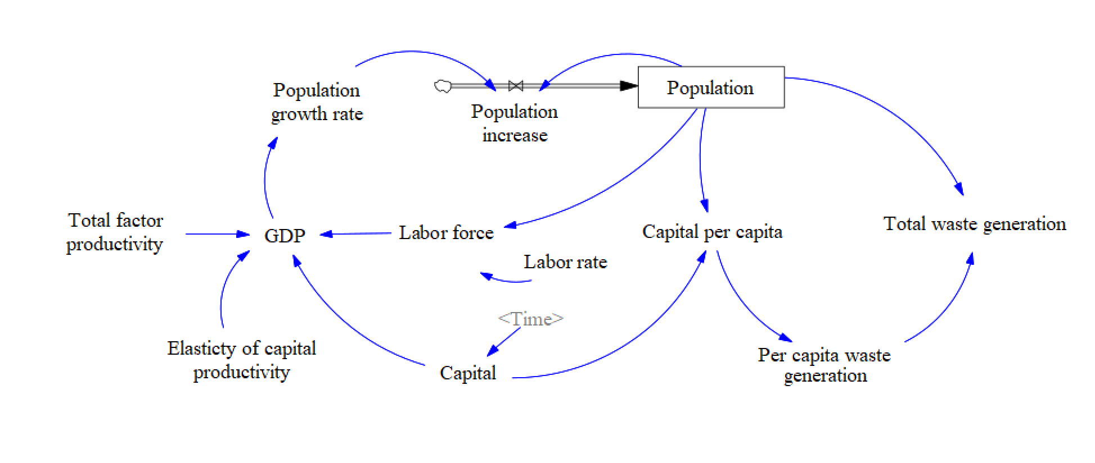

Fig. S1 Overview of the domestic waste generation subsystem. Arrows indicate a causal relationship between two variables or parameters. The rectangular box represents a stock variable, which is a cumulative quantity, and the black arrow pointing to the stock indicates the change rate.

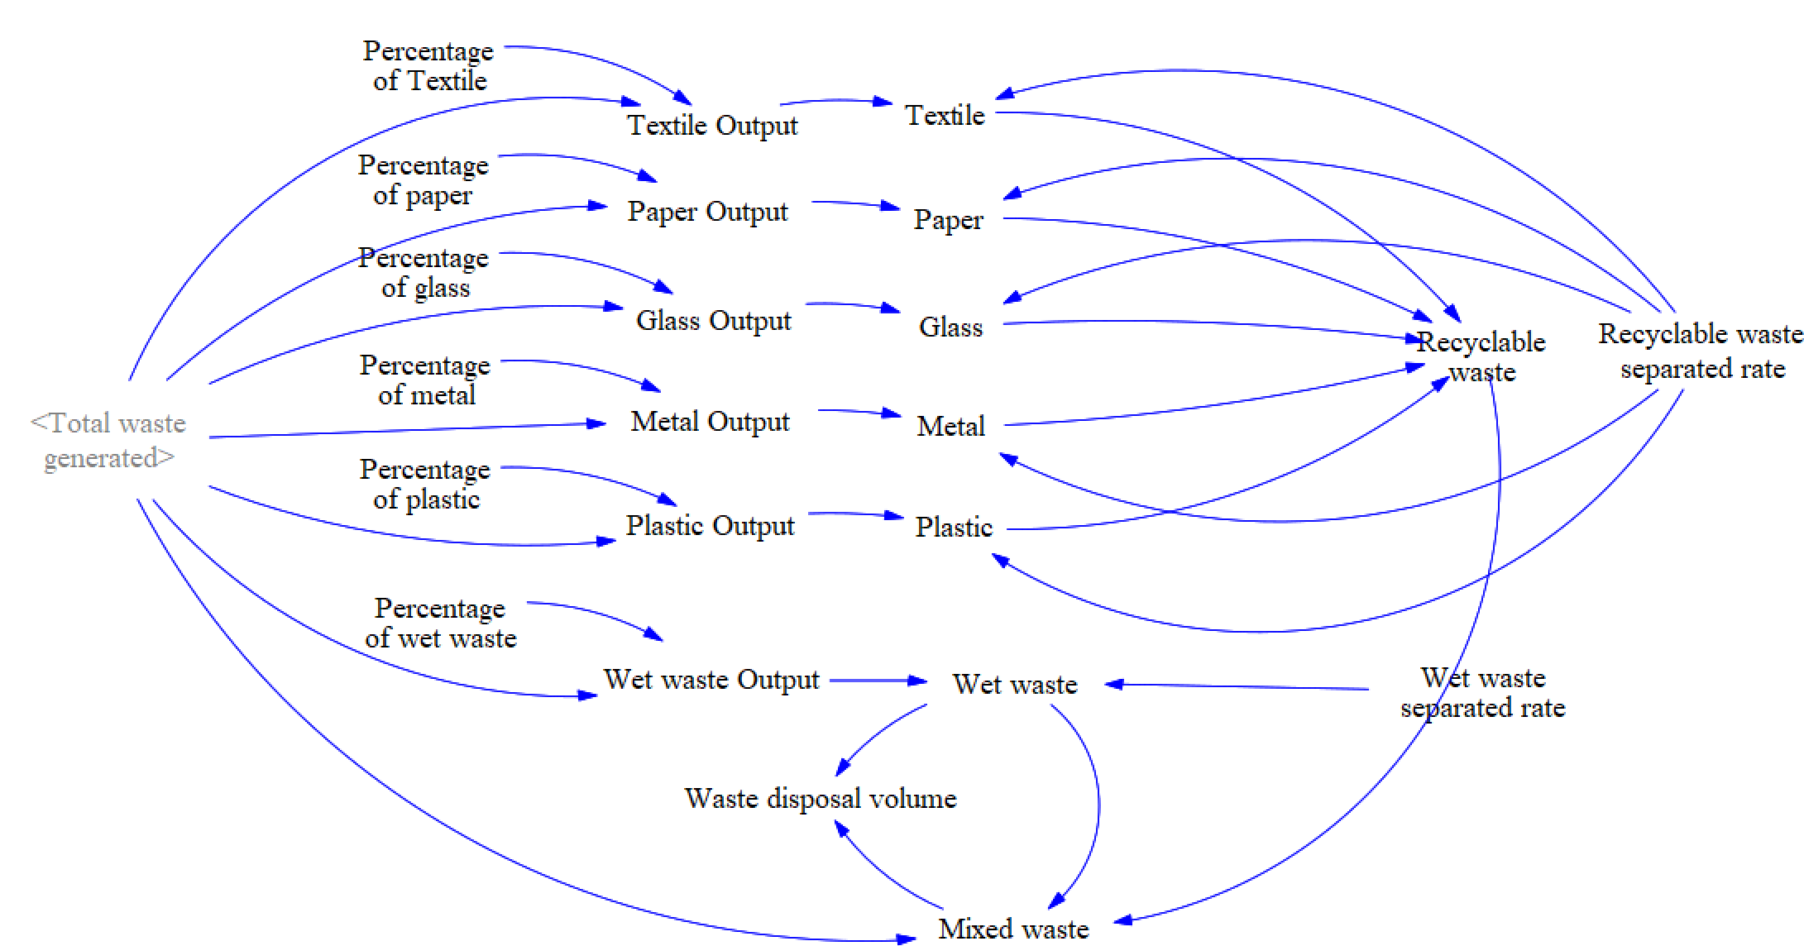

Fig. S2 Overview of the domestic waste classification subsystem.
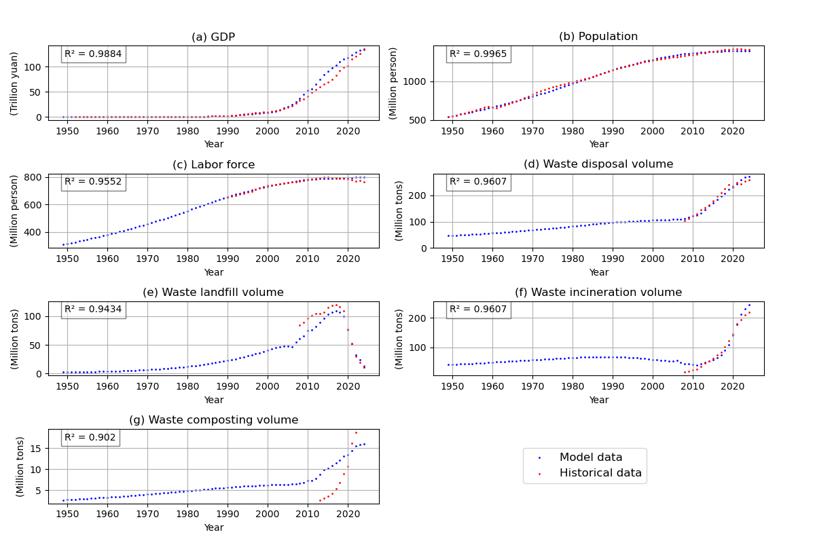

Fig. S3 Comparison between the model’s outputs and historical data. R² is the coefficient of determination, representing the fitting effect between the model’s outputs and historical data. The larger the R² value, the better the fitting effect.

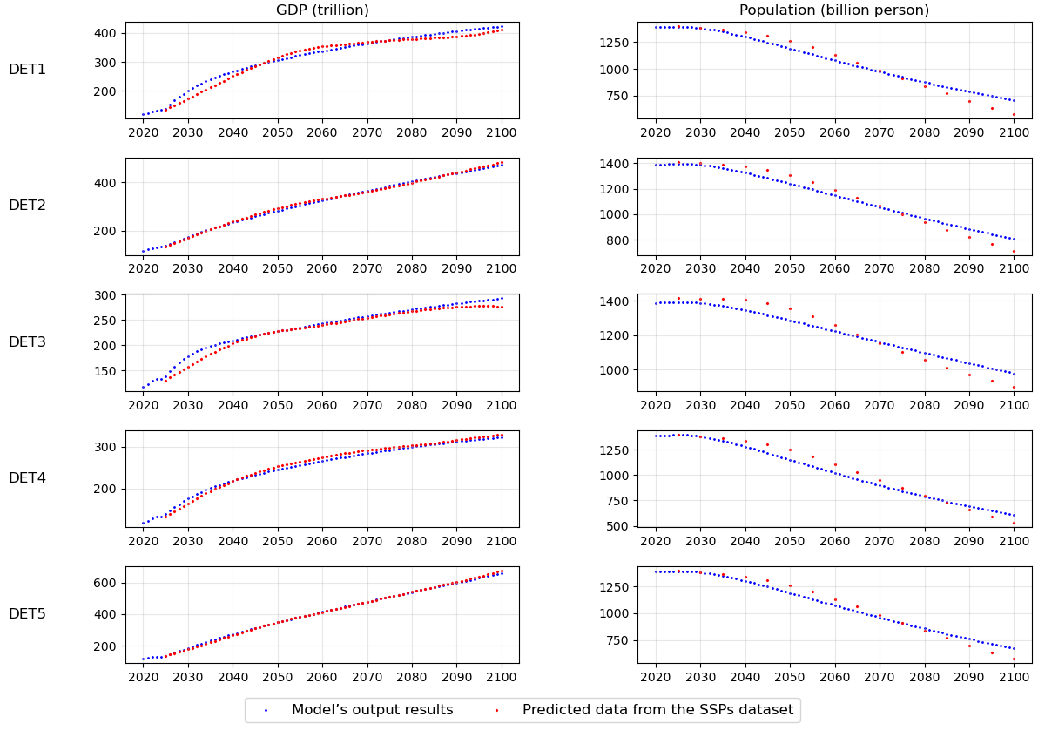

Fig. S4 Comparison of 5 DETs simulated by our model and predicted trajectories from the China’s SSPs dataset.

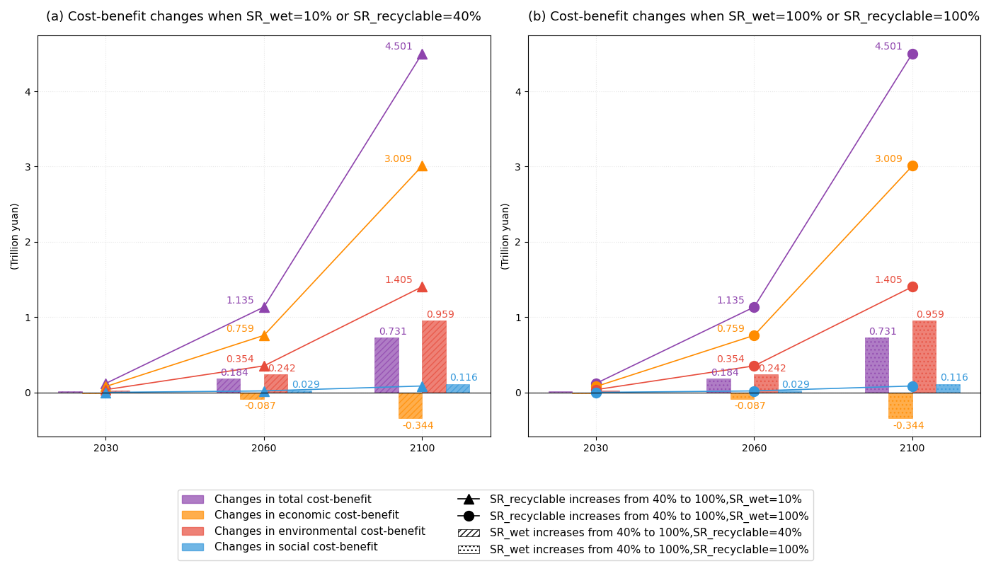

Fig. S5 Cost-benefit changes influenced by changes of recyclable and wet waste separation rates. SR_recyclable and SR_wet denote the sepatarion rate of recyclable and wet waste, respectively. Four colors represent cost-benefit changes in total, economic, social and environmental dimensions. Different line or frame styles represent changes of waste separation rate.

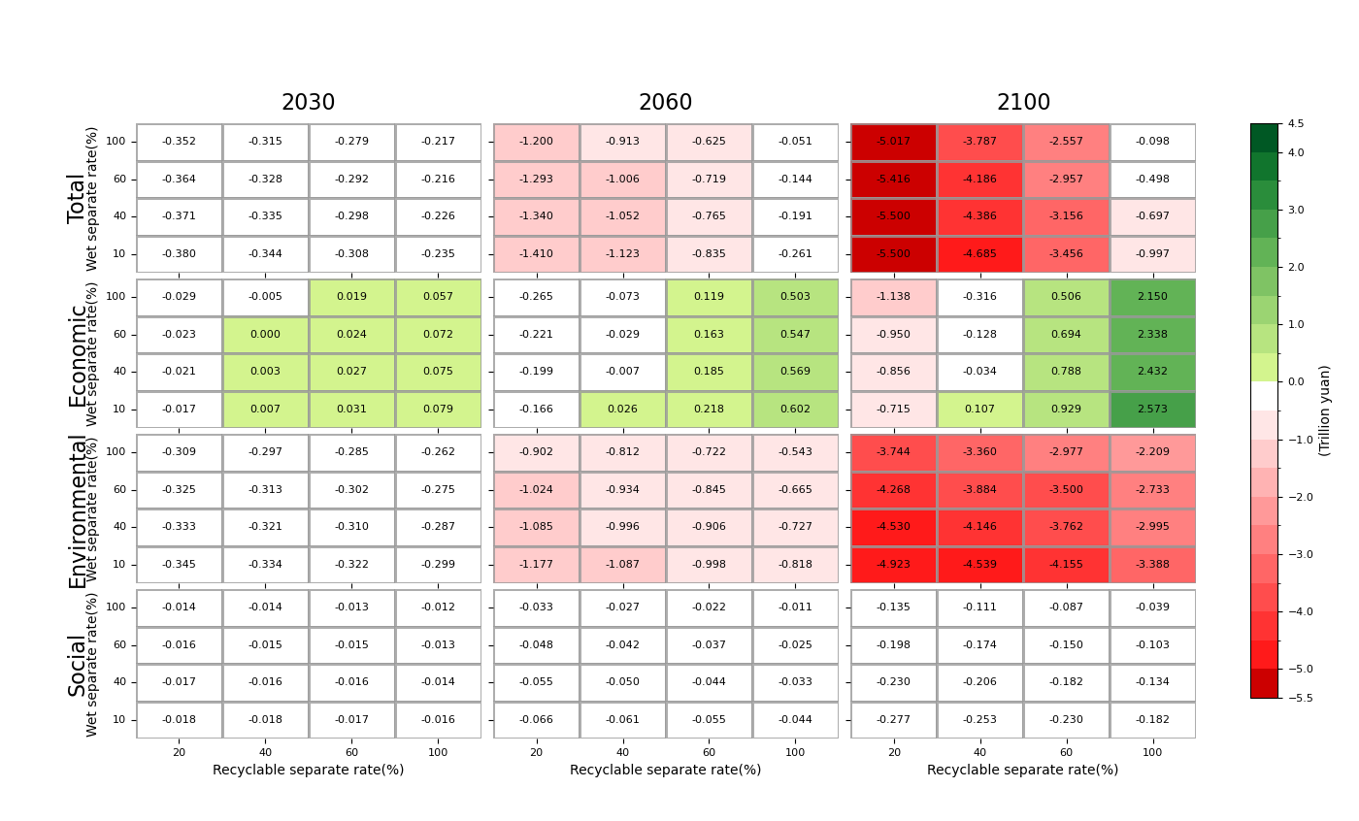Fig. S6 Multidimensional cost-benefit results under different waste separation rate levels and DET1 in 2030, 2060 and 2100.

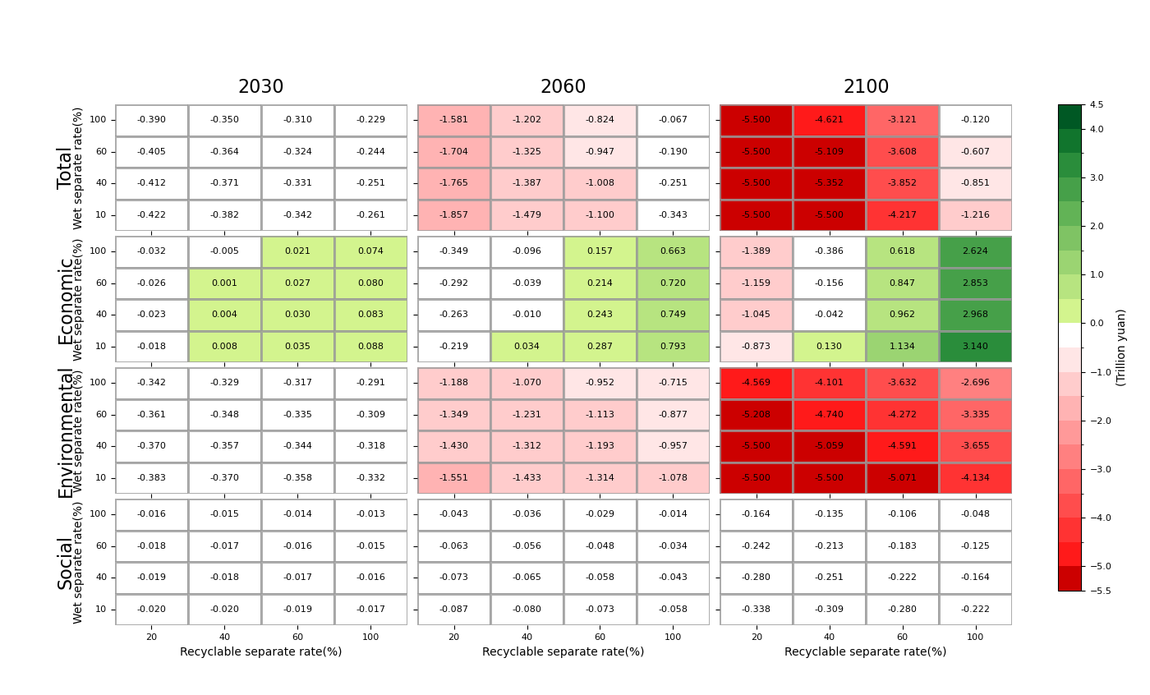

Fig. S7 Multidimensional cost-benefit results under different waste separation rate levels and DET2 in 2030, 2060 and 2100.

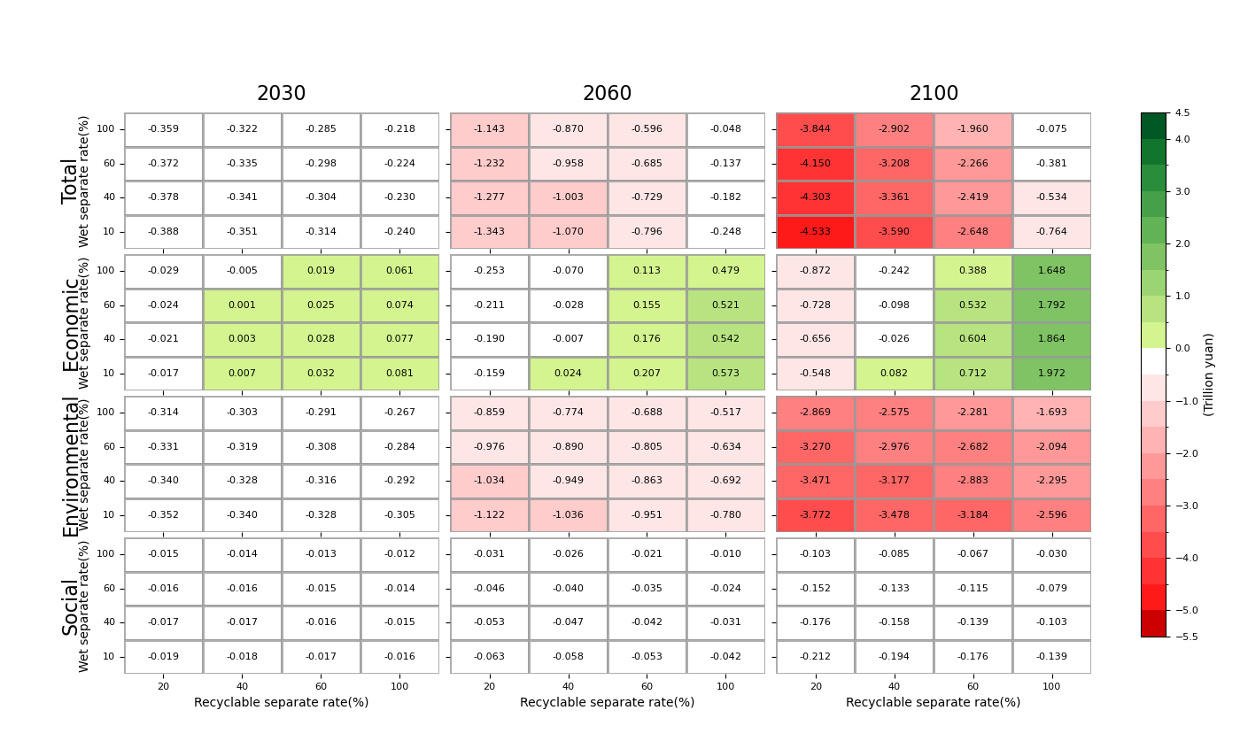

Fig. S8 Multidimensional cost-benefit results under different waste separation rate levels and DET3 in 2030, 2060 and 2100.

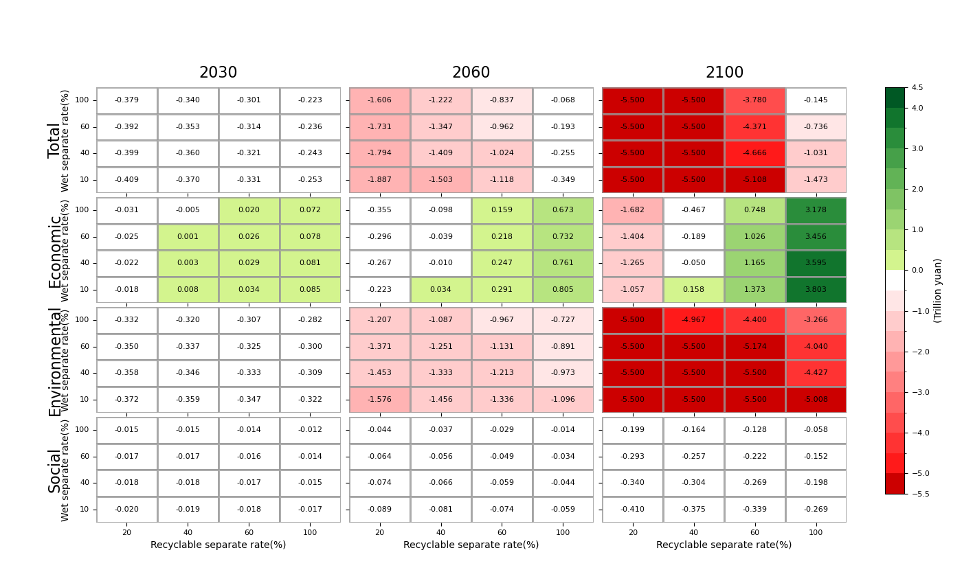

Fig. S9 Multidimensional cost-benefit results under different waste separation rate levels and DET4 in 2030, 2060 and 2100.

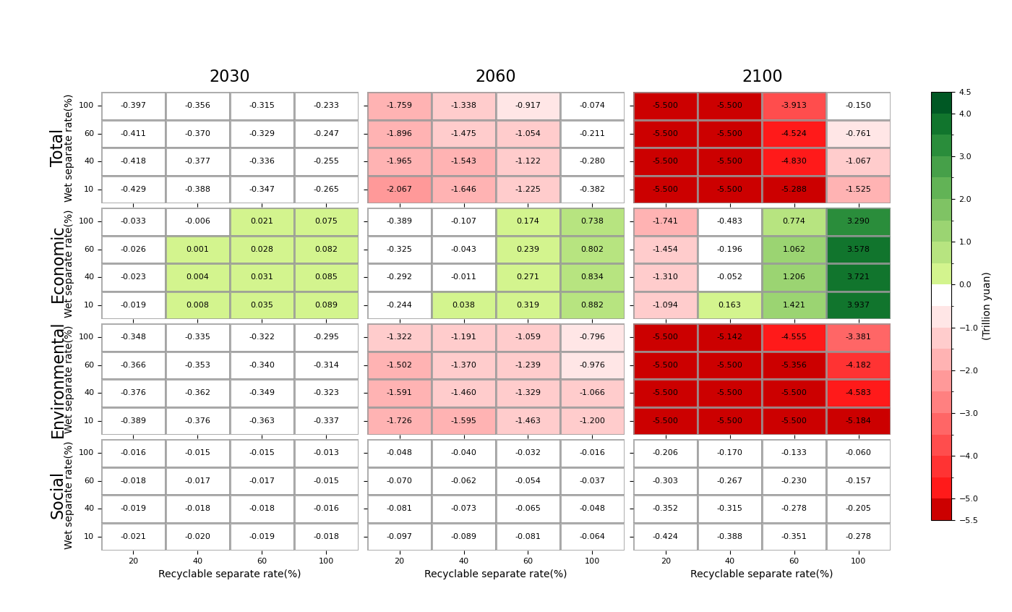

Fig. S10 Multidimensional cost-benefit results under different waste separation rate levels and DET5 in 2030, 2060 and 2100.

