Supplement 3
Figure S1. Estimated AUC/ Actual AUC ratio plot for prospective prediction of the limited sampling strategy in 13 patients. 2
Figure S2. Goodness-of-fit plots for the final model. 3
Figure S3. Prediction-corrected visual predictive check obtained from 500 simulations. 4

Figure S1. Estimated AUC/ Actual AUC ratio plot for prospective prediction of the limited sampling strategy in 13 patients.
The estimation of AUC was based on concentrations at 0.5 h and 8 h after the end of infusion.

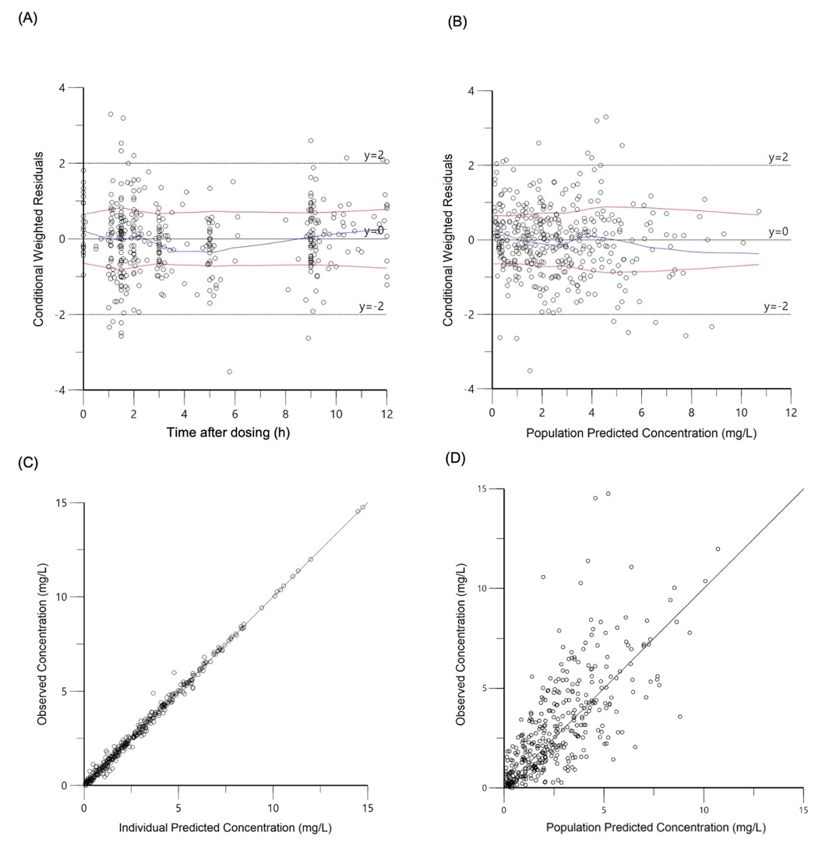

Figure S2. Goodness-of-fit plots for the final model.
(A) Conditional weighted residuals versus time after dose; (B) conditional weighted residuals versus population predicted concentrations (CWRES versus PRED); (C) Observed concentration versus individual predicted concentrations (DV versus IPRED); (d) Observed concentration (DV) versus population predicted concentrations (DV versus PRED).
The blue lines represent smoothed regression lines; the red lines represent computed absolute regression lines (with their negative reflection).

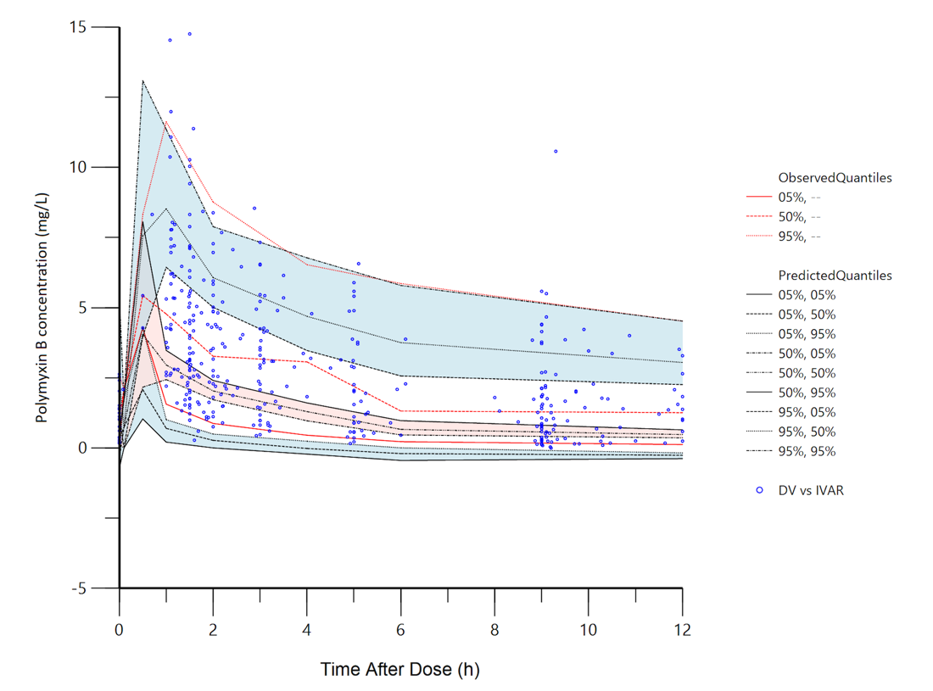
Figure S3. Prediction-corrected visual predictive check obtained from 500 simulations.
The dots are the observed drug concentrations. Red lines represent the 5th, 50th and 95th percentiles of the observed concentrations; black lines represent the 5th, 50th and 95th percentiles of the predicted concentrations. Shaded areas represent the 95% CIs of the 5th, 50th and 95th percentiles of the simulated concentrations, respectively.

