SUPPLEMENTAL FIGURES
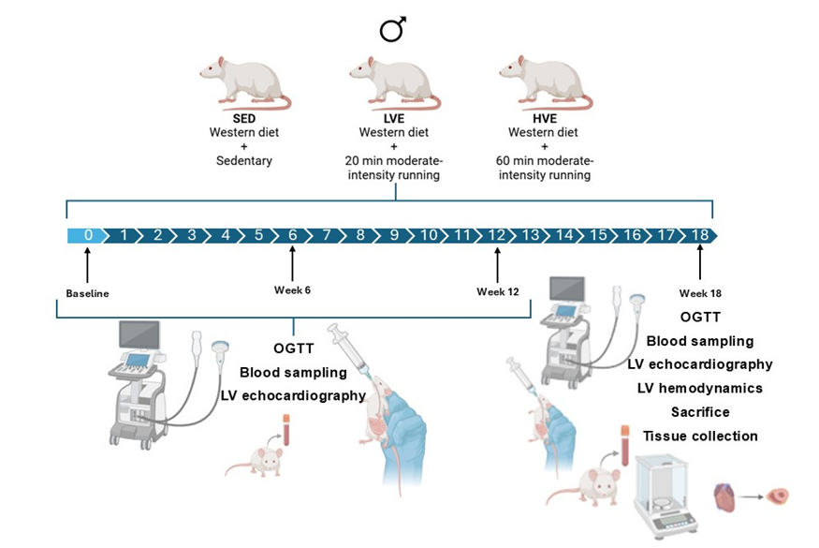
Figure S1: Representation of the study design. Male Sprague Dawley rats were fed a daily in-house high-glucose (western) diet to induce T2DM and randomly assigned to an experimental group. Rats performed five days per week LVE or HVE training, and results were compared with SED control rats to evaluate the preventive mechanisms of exercise volume training in DCM progression. T2DM, type 2 diabetes; SED, sedentary; LVE, low-volume exercise; HVE, high-volume exercise; DCM, cardiomyopathy; OGTT, oral glucose tolerance test; LV, left ventricle.
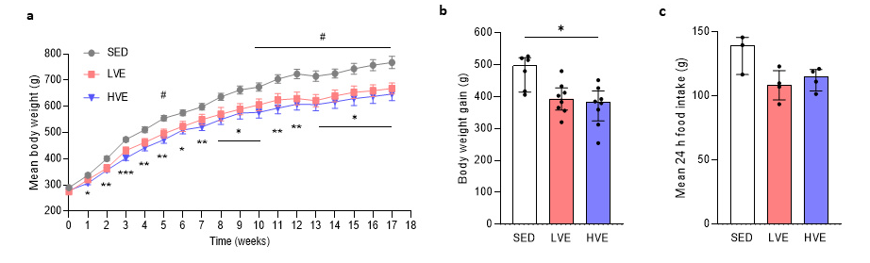
Figure S2: Body weight gain in T2DM rats is independent from training volume. (a) Mean body weight of rats at different time points over 18 weeks. (b) Mean body weight gain per group. (n = 6-8 per group). (c) Mean 24-hour food intake per cage. Each cage represents the housing of two rats from the same group. (n = 3-4 per group). Data are presented as median [Q1, Q3]. (a) * denotes p < 0.05; ** denotes p < 0.01; *** denotes p < 0.001 SED vs HVE; # denotes p < 0.05 SED vs LVE. (b) * denotes p < 0.05 vs SED.
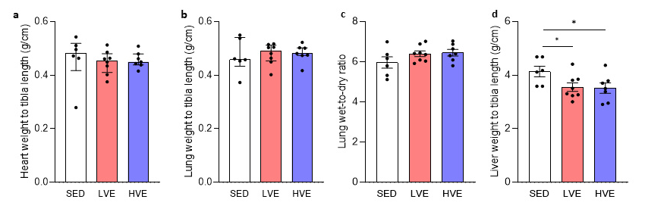
Figure S3: Organ weights after 18 weeks. (a) Heart weight corrected by tibia length. (b) Lung weight corrected by tibia length. (c) Lung weight wet to dry ratio as an indicator for pulmonary oedema. (d) Liver weight corrected by tibia length. (n = 6-8 per group). Data are presented as median [Q1, Q3]. * denotes p < 0.05 vs SED.
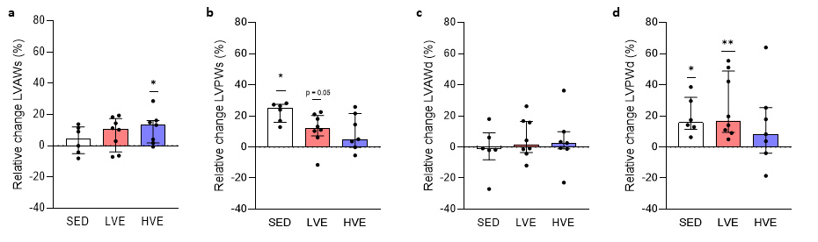
Figure S4: HVE training prevents diastolic LV hypertrophy. Conventional echocardiography in M-mode was performed to evaluate anterior and posterior wall thickness. Data represents percentage change in (a, b) systolic and (c, d) diastolic LV anterior and posterior wall thickness after 18 weeks. Data are presented as median [Q1, Q3]. # denotes p < 0.05; # # denotes p < 0.01 vs baseline (value = 0). LV, left ventricular; LVAW, left ventricular anterior wall thickness; LVPWs, left ventricular posterior wall thickness.

