Table S1: Examples of lahars that have been documented to reach the coastline and/or enter the ocean. While these are all cases where lahars have likely transferred sediment to the ocean, none of these studies have provided observations offshore from the coastline.

Site and reference | Sediment fluxes and extent of flow
1) Glacier melt-triggered lahars following eruption of Redoubt volcano in 2009, Cook Inlet, Alaska¹¹ | Caused extensive inundation oil storage and transfer station Peak discharge of 100,000 m³/s.  Lahar volumes up to 10⁷–10⁸ m³.  Travelled >35 km.
2) Soufrière Hills Volcano, Montserrat following eruptions from 1995 – 2010²⁸ | Major sediment discharge along the Belham River that created new coastal delta which grew 265 m seaward. Houses buried, with infill of some rivers by more of 20 m.
3) Primary and secondary lahars in 1902, 1929, 1970, 1980 and 2010 along valleys that radiate from Mount Pelée, Martinique^{38,49} | In 1902, 35 m-high lahar entered the sea at a speed of 100 km/hour, triggering a 4-5 m-high tsunami that took no lives, but caused material damage.  Lahars damaged the coastal road network, with a total of 56 recorded lahars between 1902 and 2010.
4) Secondary lahars sourced from La Soufrière volcano, Guadeloupe⁴⁹ | At least 39 lahars documented between 1539-2009, which submerged critical roads.
5) Primary and secondary lahars that continued until at least 1908 following 1902 and 2020/21 eruption of La Soufrière, St Vincent²³ | In 1908, multiple lahars reached the sea along multiple catchments to the north, east and west, with substantive modification to the shoreline, and progressive coastal erosion.  In 2021, volumes of at least 1 x 10⁵ m³ for individual lahars that travelled down multiple catchments. Lahars led to total losses estimated at US$12M to land-based infrastructure.
6) Following 2008/9 eruption of Chaiten volcano, Chile³⁹ | Rapid accumulation of new deltaic deposit 13.5 km downstream and accumulation of sediment in the the lower 3.5 km of the river that triggered an avulsion, and formed a new delta to the north (new land area of 0.1-0.15 km²).  Estimated sediment volume of 1-5 x 10⁶ m³ in individual event.  Two years after the eruption, Chaiten River had discharged 25–70 × 10⁶ m³.
7) Secondary lahars triggered by heavy rainfall after 2010 eruption of Eyjafjallajökull, Iceland⁴⁰ | Hyperconcentrated flows reached the ocean  Damaged main coastal road.
8) Rainfall-triggered secondary lahars in 2012, following 2005 eruption of Karthala Volcano, Grande Comore Island⁴¹ | Lahars reached west and east coasts of the island, travelling up to 14 km with average individual flow volumes of around 0.5 x 10⁶ m³.
9) Secondary lahars triggered by rainfall after 1963/4 eruption of Agung volcano, Bali, Indonesia⁴⁵ | Much of the original volume was remobilised after rainy seasons (40% after the first), which transported material into the sea off the north and south coasts travelling >20 km from the volcano.
10) Secondary lahars during monsoon seasons in 1991 and 1992 following 1991 eruption of Mount Pinatubo, Philippines⁴³ | Excluding sediment that entered the ocean (unknown), 8.8 x 10⁸ m³ sediment transported of which 2.5 x 10⁷ m³ was eroded (mostly tephra fall deposits)
11) Primary lahars in 1984 following the eruption of Mayon Volcano, Philippines; typhoon-triggered secondary lahar in 1985⁴⁴ | Eroded 5 km long, 15-70 m wide and 2-22 m deep channel  Up to 40 x 10⁶ m³ sediment transported.  Travelled up to 12 km to reach the coast.
12) Secondary lahars triggered by heavy rainfall at Marapi volcano, Indonesia, in 2024⁴² | More than 40 people died in flooding and villages destroyed. Lahars reached the coastline along multiple catchments.
13) Lahars that reached the coast following the multiple small eruptions of Semeru volcano between 1981 and 2008⁵⁰ | Repeated lahars occurring between 1981 and 2008, some of which reach a coastal delta 35 km from source, following small explosivity eruptions. Effects on sediment transport felt over at least 2-5 years.
14) Primary lahars triggered during 2022 eruption of Alaid Volcano, Northern Kuril Islands46 | Travelled 3.3-4.6 km. Where they reached the coast, lahars built out a new beach, forming a delta/fan at the coastline, creating new land area of 129,000 m² in October 2022, which decreased up to March 2023 due to reworking.
15) Primary and secondary lahars resulting from the 2017-18 eruption of Mount Ambae, Vanuatu26 | Lahars destroyed villages and built out beaches on all sides of the island, with progradation of up to tens of meters.
16) Mt. Ruapehu 1861, 1953, 1975, 1995, 2007 lahars, Aotearoa New Zealand^{47,48} | Ice-barrier crater lake breakouts (1861 and 1953) and a short lived eruption (1975) generated major lahars that reached the coast at 195 km from the volcano.  Of >35 documented lahars occurring by crater-lake eruptions during the 1995 eruption or subsequent rain-triggering, at least ten reached the coast at 195 km from the source.  2007 lahar reached the coast, triggering landslide that contributed additional 1 x 10⁶ m³ material, travelling over 215 km in 17 hours (average speed of 13 km /hour).

Table S2. Statistics for turbidity values for sea surface plumes offshore from the Wallibou River comparing pre-eruption and post eruption values
Turbidity of sea surface plume [FNU] and
Difference from pre-eruption values [%]
Time Period | 2016 to 2021 eruption  (N=196; equivalent to N=39 per year) | 2021 - post-eruption (N=82 in 8 months; equivalent to N=123 per year) | 2022  (N=68 per year) | 2023  (N=81 per year) | 2024  (N=79 per year)
Std Dev | 10.1 | 38.4 | 55.4 | 44.0 | 39.5
Mean | 8.1 | 43.5 | 36.8 | 32.0 | 29.3
Difference in Mean |  | 534.4% | 452.5% | 393.6% | 359.6%
Min | 1.8 | 3.3 | 2.4 | 2.3 | 2.6
Difference in Min |  | 183.2% | 131.3% | 126.3% | 142.5%
25th percentile | 3.9 | 18.0 | 7.0 | 7.0 | 7.6
Increase in 25th percentile |  | 464.2% | 179.9% | 179.1% | 195.1%
Median | 5.6 | 30.9 | 11.4 | 15.3 | 13.0
Difference in Median |  | 554.6% | 204.5% | 274.3% | 233.2%
75th percentile | 8.2 | 57.5 | 33.0 | 41.9 | 34.6
Difference in 75th percentile |  | 698.4% | 401.5% | 509.5% | 420.7%
Max | 90.5 | 227.8 | 292.5 | 298.4 | 227.2
Difference in Max |  | 251.7% | 323.3% | 329.8% | 251.1%

Table S3. Statistical tests reveal a significant difference between pre-eruption sea surface turbidity compared to years following the 2021 eruption at the Wallibou River outflow
Comparison | T-test p-value | Mann-Whitney p-value
2016–eruption vs 2021 (post-eruption) | 1.93 × 10⁻¹² | 4.72 × 10⁻²⁸
2016–eruption vs 2022 | 6.73 × 10⁻⁵ | 3.25 × 10⁻¹²
2016–eruption vs 2023 | 5.88 × 10⁻⁶ | 3.40 × 10⁻¹²
2016–eruption vs 2024 | 1.06 × 10⁻⁵ | 1.42 × 10⁻¹⁵

Table S4. Documented lahar events on St Vincent that reached the coastline in 2021 (modified from Phillips et al., 2024²³)
Date | Lahar location | No. rivers with lahars | Max rainfall on any rain gauge (mm)
11 April 2021 | Wallibou and Rabacca rivers | 2 | 9.4
20 April 2021 | Rabacca and other east coast rivers | 9 | 20.8
22 April 2021 | Undetermined | ? | 5.8
27 April 2021 | All valleys around Soufrière | 8 | 57.8
28 April 2021 | All valleys around Soufrière | 25 | 115.5
29 April 2021 | All valleys around Soufrière | 25 | 82.2
3 May 2021 | All valleys around Soufrière | 25 | 84.6
4 May 2021 | All valleys around Soufrière | 25 | 5.8
5 May 2021 | Small lahars | 3 | 11.3
5 June 2021 | Sandy Bay, Rabacca, Wallibou | 3 | 43.4
2 July 2021 | Richmond | 1 | 119.6
7 July 2021 | Richmond | 1 | 25.6
16 August 2021 | Lahars in most valleys around Soufrière | 20 | 110.6
20 August 2021 | Heavy rainfall – lahar signals | At least 1 | 144.2
21 August 2021 | Heavy rainfall – lahar signals | At least 1 | 23.1
22 August 2021 | Heavy rainfall – lahar signals | At least 1 | 83.1
23 August 2021 | Heavy rainfall – lahar signals | At least 1 | 151.2
24 August 2021 | Lahar signals | At least 1 | 63.6
25 August 2021 | Lahar signals | At least 1 | ?
26 September 2021 | Lahar signals | At least 1 | 53.9
11 October 2021 | Lahar signals | At least 1 | 45.7
18 October 2021 | Lahar signals | At least 1 | 32.2
31 October 2021 | Lahar signals | At least 1 | 22.3
28 November 2021 | Lahar signals | At least 1 | 44.9
Total in 8 months = At least 158;
Equivalent to at least 237 over a year

Table S5. Comparison of previously published global budget for ocean sediment fluxes from ocean islands with inferred fluxes delivered from lahars at St Vincent in 2021.
Annual ocean sediment budget delivered from ocean islands globally [Mt]⁽³²⁾ | Ocean sediment delivery at St Vincent in 2021based on N=158 lahars as observed over 8 months [Mt] |  | Ocean sediment delivery at St Vincent in 2021 based on N=237 lahars over 12 months (scaled up from 8 months observations) [Mt] |  | Ocean sediment delivery at St Vincent assuming post-eruption reduced lahar frequency of 55% [Mt]
 | Sediment mass [Mt] | % of global budget | Sediment mass [Mt] | % of global budget | Sediment mass [Mt] | % of global budget
5 (low estimate) | 0.24 | 5% | 0.36 | 7% | 0.20 | 4%
8 (median estimate) | 0.24 | 3% | 0.36 | 5% | 0.20 | 3%
11 (high estimate) | 0.24 | 2% | 0.36 | 3% | 0.20 | 2%

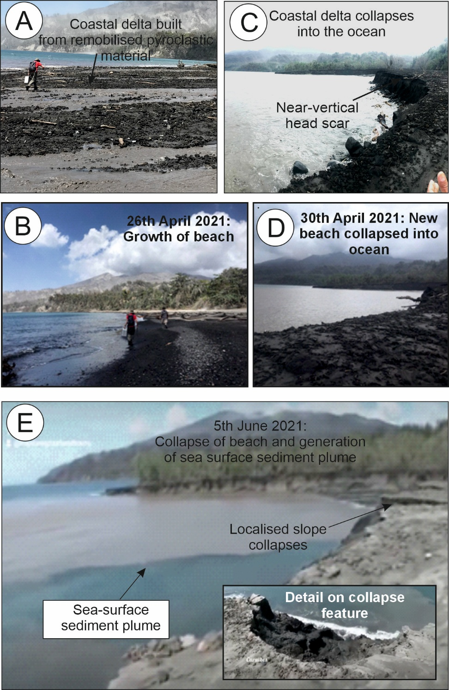

Fig. S1. Examples of coastal delta that grew out towards the sea following lahars at the Wallibou River outflow on the west coast of St Vincent, and subsequent collapses. A and B) New beach formed by accumulation of sediment delivered by lahar. C and D) Subsequent partial collapse of subaerial delta into the ocean. These collapses lead to the generation of sea surface sediment plumes (E), which occur as retrogressive and piecemeal failures (from 5 June 2021).

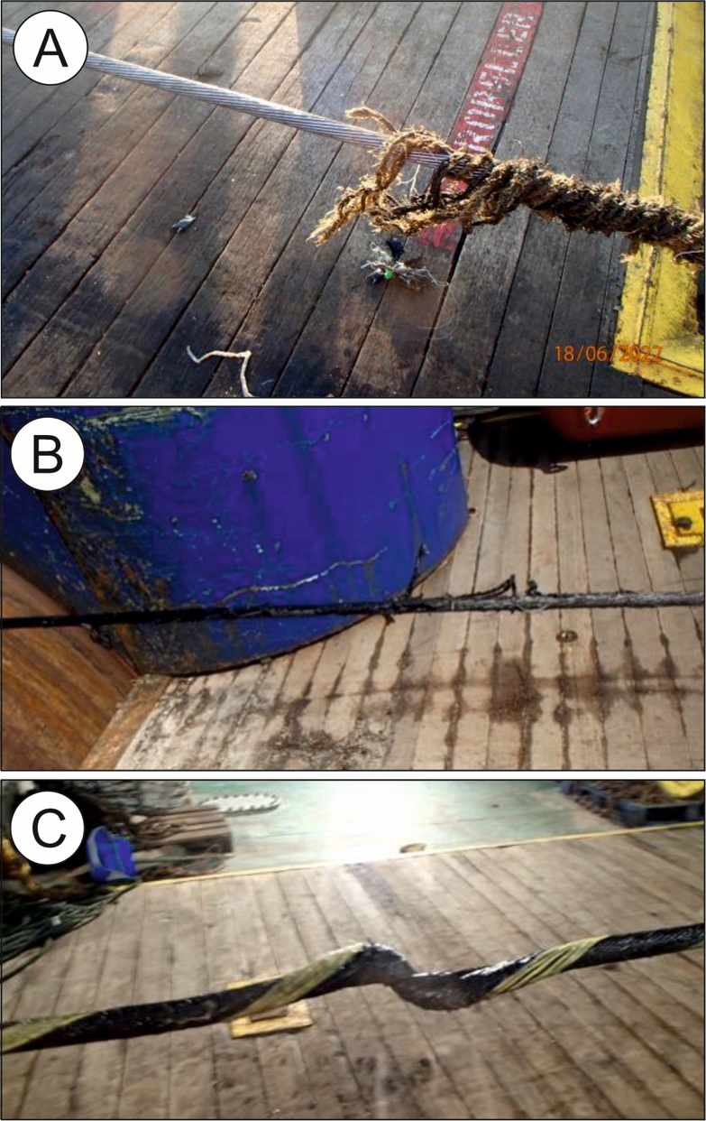
Fig. S2. Evidence of damage from recovered lengths of subsea cable. A) Plastic outer sheath has been stripped from the cable – presumably by abrasive effects of a sediment density current; B) abrasion of cables outer sheath and damage to inner protective armour wires; C) contorted and twisted section of cable.

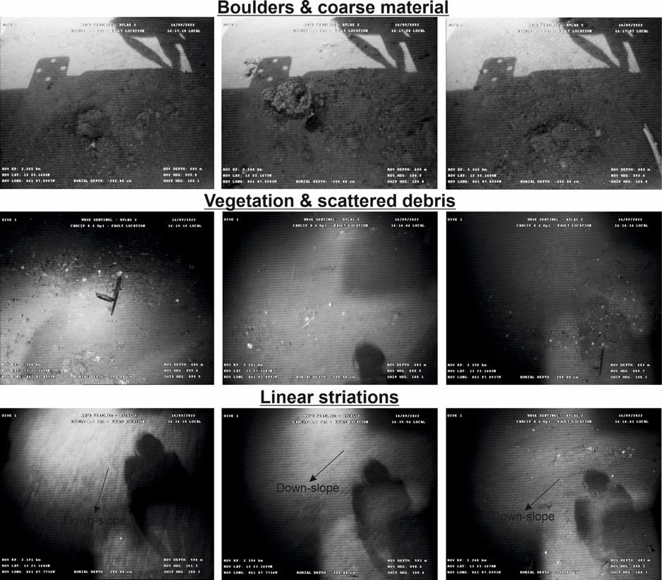
Fig. S3. Images from video acquired by Remotely Operated Vehicle survey during cable repair detailing evidence of sediment transport events. These include transport of coarse material and boulders (upper panels), scattered vegetation debris carried from on land (middle panels), and linear striations caused by erosion that are aligned downslope (lower panels).

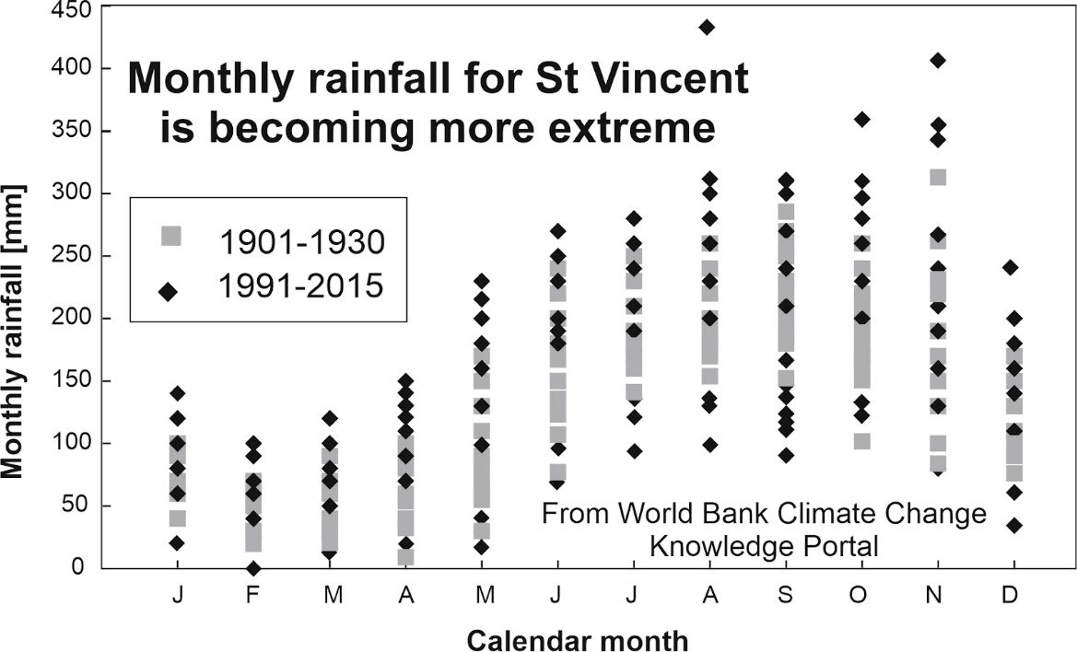
Fig. S4: Monthly rainfall for St Vincent is becoming more extreme. Monthly data for time periods of 1901-1930 and 1991-2015 based on World Bank data⁶⁴.

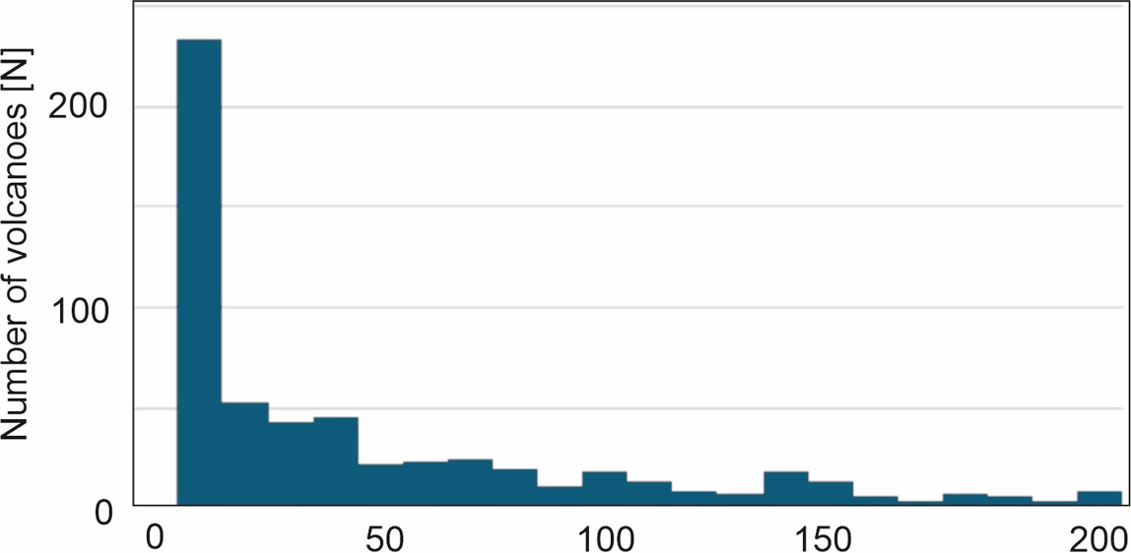

Fig. S5: Frequency distribution of volcanoes from the GVP database⁸ in relation to the distance of their vent to the shoreline. Data shown are the N=589 subaerial arc volcanoes that have dated Holocene eruptions.

References for Supplementary Materials
- Woodhouse, M.J., Johnson, C.G., Hogg, A.J., Phillips, J.C., Espín Bedón, P.A., Almeida, S. and Andrade, D., 2016. LaharFlow: a web-based lahar hazard model. Cities on Volcanoes, 9.
- Diefenbach, A.K., Airborne lidar survey of St Vincent, Eastern Caribbean, following the 2020-21 eruption of La Soufriere Volcano. U.S. Geological Survey data release, https://doi.org/10.5066/P13ZHRG3
- CHARIM, 2014. Caribbean Handbook on Risk Management, http://www.charim.net, last accessed 23 June 2025.
- Bailey, L.P., Shugar, D.H., Tilston, M., Hubbard, S.M., Giesbrecht, I., Del Bel Belluz, J., Jackson, J.M., Clare, M.A., Cartigny, M.J., Açıkalın, S. and Hage, S., 2025. Land‐to‐sea sediment fluxes from a major glacial lake outburst flood were stepped rather than instantaneous. Journal of Geophysical Research: Earth Surface, 130(4), p.e2024JF008126.
- Vanhellemont, Q. and Ruddick, K., 2014. Turbid wakes associated with offshore wind turbines observed with Landsat 8. Remote Sensing of Environment, 145, pp.105-115.
- Vanhellemont, Q., & Ruddick, K. (2018). Atmospheric correction of metre-scale optical satellite data for inland and coastal water applications. Remote Sensing of Environment, 216, 586–597. https://doi.org/10.1016/j.rse.2018.07.015
- Vanhellemont, Q., 2019a. Adaptation of the dark spectrum fitting atmospheric correction for aquatic applications of the Landsat and Sentinel-2 archives. Remote Sensing of Environment, 225, pp.175-192.
- Vanhellemont, Q., 2019b. Daily metre-scale mapping of water turbidity using CubeSat imagery. Optics express, 27(20), pp.A1372-A1399.
- Vanhellemont, Q., 2020. Sensitivity analysis of the dark spectrum fitting atmospheric correction for metre-and decametre-scale satellite imagery using autonomous hyperspectral radiometry. Optics Express, 28(20), pp.29948-29965.
- Nechad, B., Ruddick, K. G., & Neukermans, G. (2009). Calibration and validation of a generic multisensor algorithm for mapping of turbidity in coastal waters. In Remote Sensing of the Ocean, Sea Ice, and Large Water Regions 2009 (Vol. 7473, pp. 161–171). SPIE. https://doi.org/10.1117/12.830700
- Field, A. (2013). Discovering Statistics Using IBM SPSS Statistics (4th ed.). SAGE Publications.
- Moore, D. S., McCabe, G. P., & Craig, B. A. (2017). Introduction to the Practice of Statistics (9th ed.). W.H. Freeman
- Ali, T.A. and Ameen, J.J.H., 2019. Study of fault detection techniques for optical fibers. Journal of Pure Applied Science, 31(s3), pp.143-149.
- World Bank, 2024. https://climateknowledgeportal.worldbank.org/country/st-vincent-and-grenadines/climate-data-historical , Accessed 27th June 2024.
- Cronin, S.J., Lecointre, J.A., Palmer, A.S. and Neall, V.E., 2000. Transformation, internal stratification, and depositional processes within a channelised, multi‐peaked lahar flow. New Zealand Journal of Geology and Geophysics, 43(1), pp.117-128.
- Scott, K.M., Vallance, J.W., Kerle, N., Luis Macías, J., Strauch, W. and Devoli, G., 2005. Catastrophic precipitation‐triggered lahar at Casita volcano, Nicaragua: Occurrence, bulking and transformation. Earth Surface Processes and Landforms: The Journal of the British Geomorphological Research Group, 30(1), pp.59-79

Data S1. (separate file)
Turbidity along transect. Turbidity data extracted from satellite data analysis along each of the transects along observed sea surface plumes offshore from the Wallibou River on the west coast of St Vincent.

Data S2. (separate file)
Maximum turbidity. Maximum sea surface turbidity value along transects (in Data S1), which was used as the basis of the plots in Figure 4.

Video S1. (separate file)
Modelling of Overland River illustrating elevation change during passage of a single lahar event.

Video S2. (separate file)
Modelling of Overland River illustrating changes in solids flux during passage of a single lahar event.

Video S3. (separate file)
Modelling of Overland River illustrating changes in flow speed during passage of a single lahar event.

Video S4. (separate file)
Modelling of Overland River illustrating changes in flow depth during passage of a single lahar event.

