Journal of Neural Transmission
High social jetlag in healthy youth: Differences in tryptophan levels, temporal pole-centered gray matter volume, and functional connectivity
Masatoshi Yamashita^{1,2,}*; Qiulu Shou^{1,2}; Masanori Fujieda^{1,2,3}; Hidehiko Okazawa^{2,4}; Yoshiyuki Hirano^{2,5}; Kuriko Kagitani-Shimono²; and Yoshifumi Mizuno^{1,2,3,#}
*Corresponding author
Masatoshi Yamashita, Research Center for Child Mental Development, University of Fukui, Fukui, Japan, email: myamashita.fatiguepsychology@gmail.com
#Co-corresponding author
Yoshifumi Mizuno, Research Center for Child Mental Development, University of Fukui, Fukui, Japan, email: mizunoy@u-fukui.ac.jp

Online Resource 4: Mediating effect
For temporal pole gray matter volume (GMV) (Online Resource 4 Figure), the direct effect of social jetlag (SJL) group status was marginally significant (β = -0.52, 95% CI [-1.05, 0.01], p = 0.053). The association between SJL group status and tryptophan was marginally significant (β = 0.57, 95% CI [0.05, 1.21], p = 0.054), whereas the association between tryptophan and GMV was not significant (β = -0.13, 95% CI [-0.34, 0.13], p = 0.267). The total effect was statistically significant (β = -0.59, 95% CI [-1.10, -0.10], p = 0.019), but the indirect effect was not (β = -0.07, 95% CI [-0.27, 0.04], p = 0.368).
For temporal pole-pars triangularis functional connectivity (FC; Online Resource 4 Figure), the direct effect of SJL group status was significant (β = -0.96, 95% CI [-1.39, -0.53], p < 0.001). The association between SJL group status and tryptophan was marginally significant (β = 0.57, 95% CI [0.06, 1.19], p = 0.048), whereas the association between tryptophan and FC was not statistically significant (β = -0.02, 95% CI [-0.20, 0.16], p = 0.788). Consistent with these estimates, the tryptophan-mediated effect was not statistically significant (β = -0.01, 95% CI [-0.12, 0.09], p = 0.784), while the total effect remained significant (β = -0.97, 95% CI [-1.38, -0.57], p < 0.001).
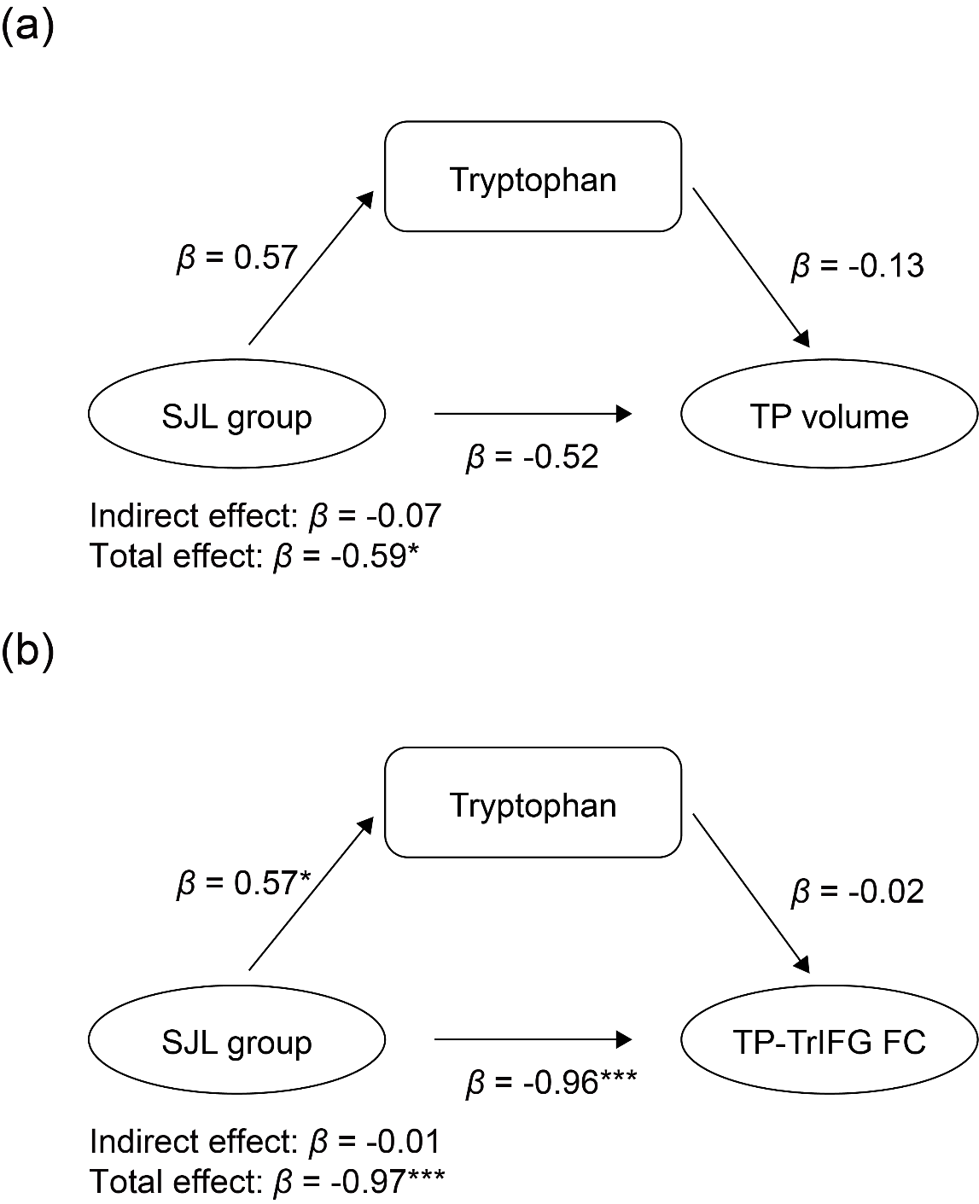
Online Resource 4 Figure. Mediation analysis results. * p < 0.05, *** p < 0.001. SJL, social jetlag; TP, temporal pole; TrIFG, triangular part of the inferior frontal gyrus (i.e., the pars triangularis).
Online Resource 4: Supplementary Discussion
In the exploratory models, urinary tryptophan did not mediate the associations between SJL group status and either temporal pole GMV or temporal pole–pars triangularis FC. Considering that urinary 5-HIAA levels did not differ between the groups (Figure 4b in the main text), this pattern suggests that, under higher SJL, increased tryptophan levels may be preferentially metabolized to the kynurenine pathway (i.e., kynurenic acid) rather than to the serotonin pathway. If so, metabolites such as kynurenic acid may be more proximal candidates for mediating the relationship between SJL and these brain measures than tryptophan as such. Future research should examine multi-mediation frameworks that incorporate the kynurenine pathway along with the serotonin pathway.

