Chemical pressure engineering of perovskite oxide nanoparticles for oxygen evolution
Sandeep Kumar¹, Sesh Mani Yadav¹, Prashant shahi¹, Shubhankar Majumdar², Prabir Kumar Saha², Sk Abdul Moyez^{3*}, Ankur Soam^{4*}, Manindra Kumar^{1*}, Deepash Shekhar Saini^{1*}
¹Department of Physics, Deen Dayal Upadhyaya Gorakhpur University, Gorakhpur, India-273009
²Department of Electronics and Communication Engineering, NIT Meghalaya, Meghalaya, India-793108
³Department of Chemical Engineering, University of Calcutta, 92 A. P. C. Road, Kolkata, India - 700009
⁴Department of Physics, School of Physical and Biological Sciences, Faculty of Science, Technology and Architecture, Manipal University Jaipur, Jaipur, India-303007
*Corresponding Author:
Deepash Shekhar Saini: deepash.phy@ddugu.ac.in, dssainiddugu@gmail.com
Manindra Kumar: manindra.phy@ddugu.ac.in
Ankur Soam: ankur.soam@jaipur.manipal.edu, ankursoam007@gmail.com
Sk Abdul Moyez: ab.moyez@gmail.com

Supporting Information
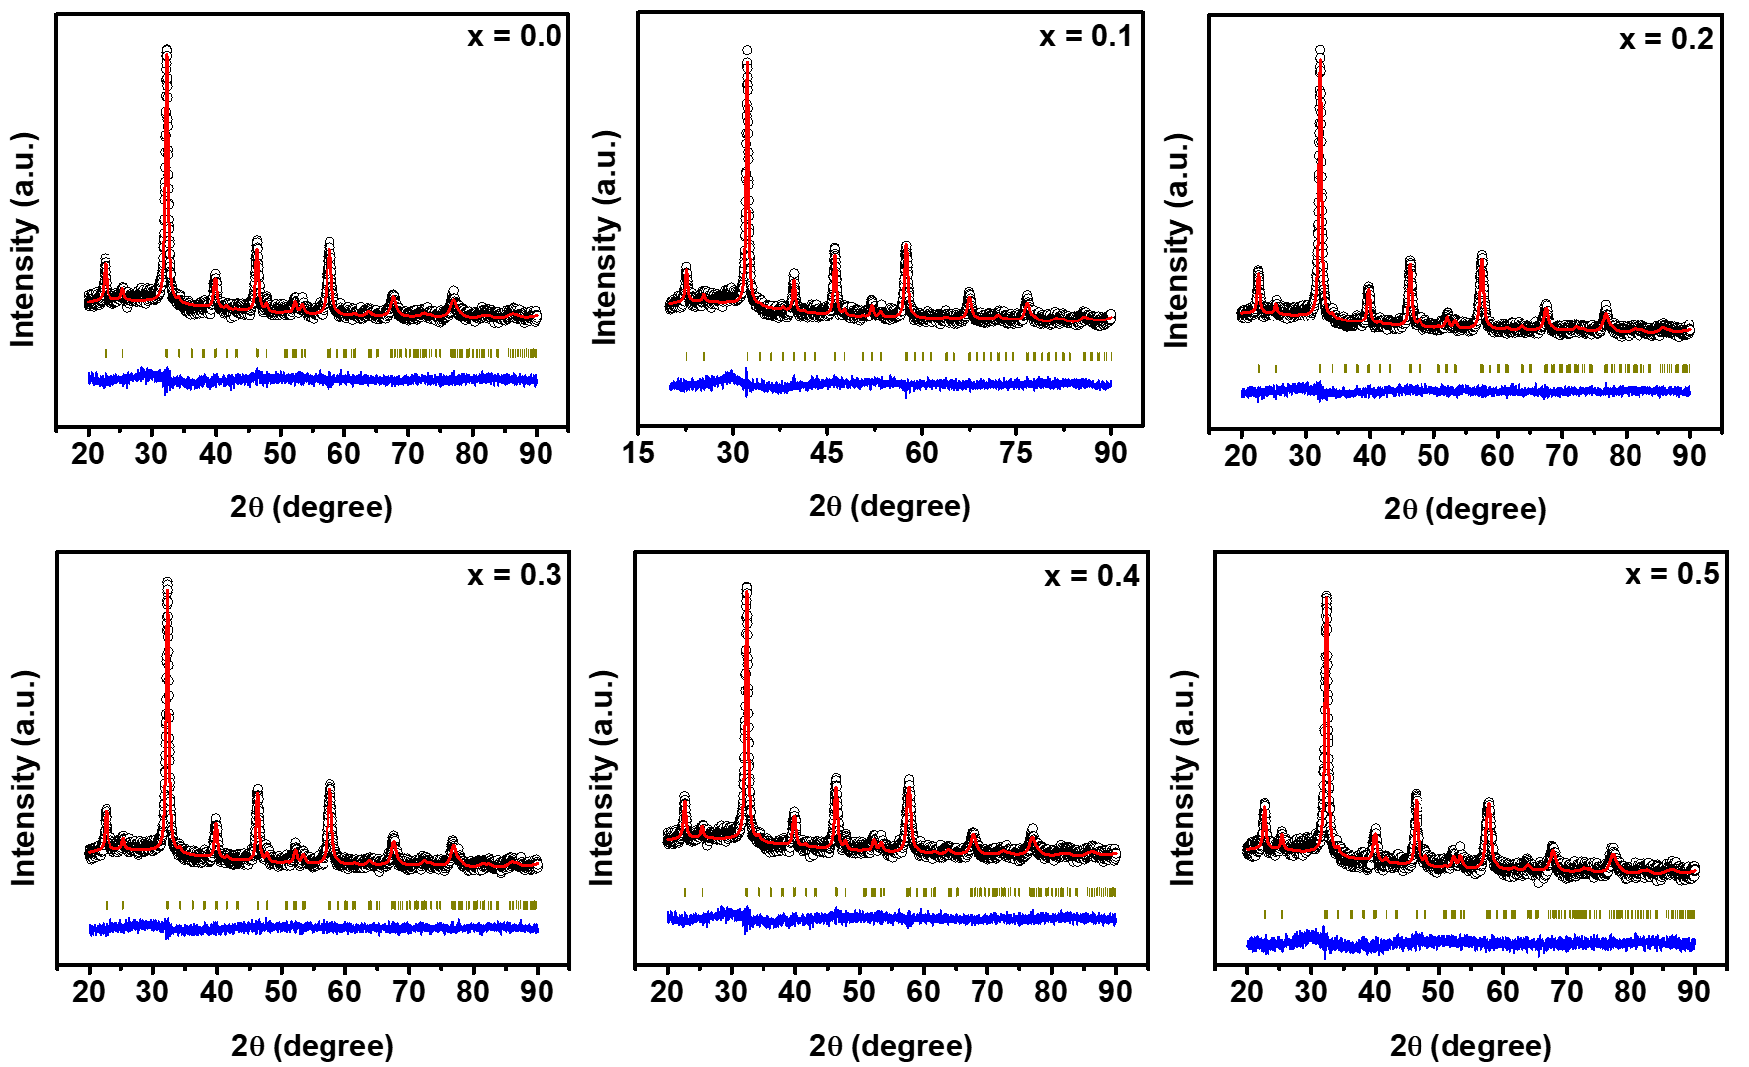

Fig. S1 The Rietveld refinement of the XRD patterns of the La_{1-x}Nd_{x}FeO₃ (0 ≤ x ≤ 0.5, Δ = 0.1) nanoparticles.

Table S1. Structural and refinement parameters of orthorhombic La_{1-x}Nd_{x}FeO₃ (x = 0.0, 0.1, 0.2, 0.3, 0.4, and 0.5) nanoparticles.
La_{1-x}Nd_{x}FeO₃ | Lattice parameter (Å) | Unit cell volume (Å³) | Density (g/cm³) | Crystallite size (nm) | Micro strain | Refinement parameter
x = 0.0 | a = 5.5635,  b = 7.8614,  c = 5.5608 | 243.2097 | 6.6296 | 54.8547 | 21.59 | R_{wp} = 5.291, R_{p} = 4.151, R_{e} = 5.049, GofF = 1.0979
x = 0.1 | a = 5.5625,  b = 7.8503,  c = 5.5500 | 242.3528 | 6.6676 | 46.11987 | 24.4 | R_{wp} = 5.571, R_{p} = 4.382, R_{e} = 5.316, GofF = 1.0979
x = 0.2 | a = 5.5606,  b = 7.8522,  c = 5.5522 | 242.4246 | 6.6803 | 216.5317 | 15.68 | R_{wp} = 5.391, R_{p} = 4.251, R_{e} = 5.276, GofF = 1.0442
x = 0.3 | a = 5.5630,  b = 7.8436,  c = 5.5387 | 241.6786 | 6.7156 | 38.61771 | 25.45 | R_{wp} = 5.289, R_{p} = 4.187, R_{e} = 5.123, GofF = 1.0658
x = 0.4 | a = 5.5659,  b = 7.8320,  c = 5.5288 | 241.0113 | 6.7489 | 26.14014 | 28.24 | R_{wp} = 5.205, R_{p} = 4.152, R_{e} = 5.036, GofF = 1.0682
x = 0.5 | a = 5.5650,  b = 7.8281,  c = 5.5204 | 240.4850 | 6.7784 | 32.98779 | 26.93 | R_{wp} = 5.032, R_{p} = 4.009, R_{e} = 4.967, GofF = 1.0263

Table S2. Bond lengths and bond angles of orthorhombic La_{1-x}Nd_{x}FeO₃ (x = 0.0, 0.1, 0.2, 0.3, 0.4, and 0.5) nanoparticles.
x | Bond length (Å) |  |  |  | Bond angle (°)
x | Fe-O1 | Fe-O2 | La/Nd-O1 | La/Nd-O2 | Fe-O1-Fe | Fe-O2-Fe | Fe-O1-La/Nd | Fe-O2-La/Nd | La/Nd-O2-La/Nd
0.0 | 2.0067(8) | 2.0057(8) | 2.4251(13) | 2.6526(8) | 155.964(16) | 156.479(8) | 101.455(8) | 87.87(4) | 98.96(4)
0.1 | 1.984(3) | 2.0882(13) | 2.512(3) | 2.5050(14) | 163.78(3) | 148.81(4) | 97.639(12) | 90.04(6) | 106.72(7)
0.2 | 1.9806(8) | 1.9494(5) | 3.0551(10) | 2.5488(6) | 163.376(8) | 154.541(9) | 83.351(4) | 92.15(3) | 101.68(3)
0.3 | 2.0117(8) | 1.9287(5) | 3.2069(10) | 2.5163(6) | 153.647(12) | 155.446(10) | 77.985(6) | 93.32(3) | 102.52(3)
0.4 | 2.0146(5) | 1.8367(4) | 3.2493(9) | 2.5152(4) | 152.002(9) | 156.111(7) | 77.329(5) | 95.519(18) | 101.479(19)
0.5 | 2.0145(5) | 1.8848(4) | 3.2588(9) | 2.5437(4) | 151.736(10) | 155.332(6) | 76.919(5) | 92.770(18) | 101.253(19)
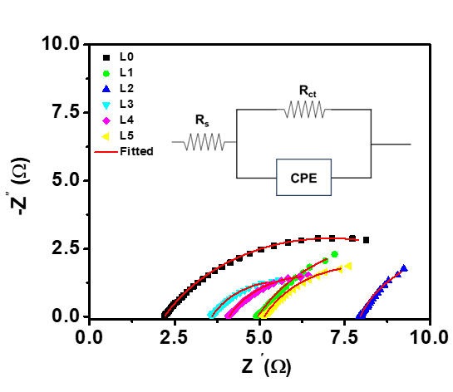

Fig. S2. Nyquist plot derived from electrochemical impedance spectra for Sample L0, L1, L2, L3, L4, and L5.
Table S3. The electrical equivalent circuit fitting parameters from the Nyquist plot.
Sample | R_{s} (Ω) | Q | n | R_{ct} (Ω)
L0 | 2.201 | 0.02003 | 0.681 | 9.754
L1 | 4.945 | 0.06581 | 0.7044 | 8.919
L2 | 7.953 | 0.08723 | 0.7757 | 6.894
L3 | 3.595 | 0.0696 | 0.7075 | 4.227
L4 | 4.096 | 0.05882 | 0.7036 | 4.815
L5 | 5.133 | 0.05704 | 0.7094 | 5.917

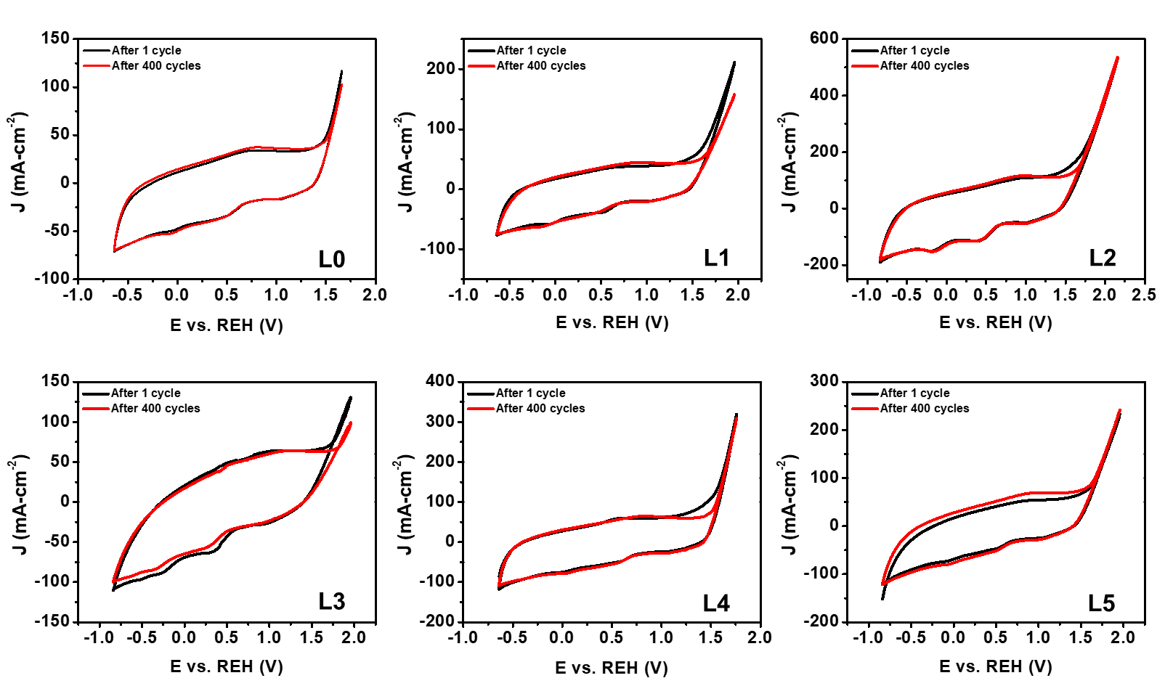

Fig. S3. Selected CV curves of the L0, L1, L2, L3, L4, and L5 samples over 400 cycles in 2M KOH electrolyte at a 1 mV s⁻¹ scan rate.

Fig. S4. The pH-dependent OER kinetic currents in 2M KOH electrolyte at a 1mV s⁻¹ scan rate.

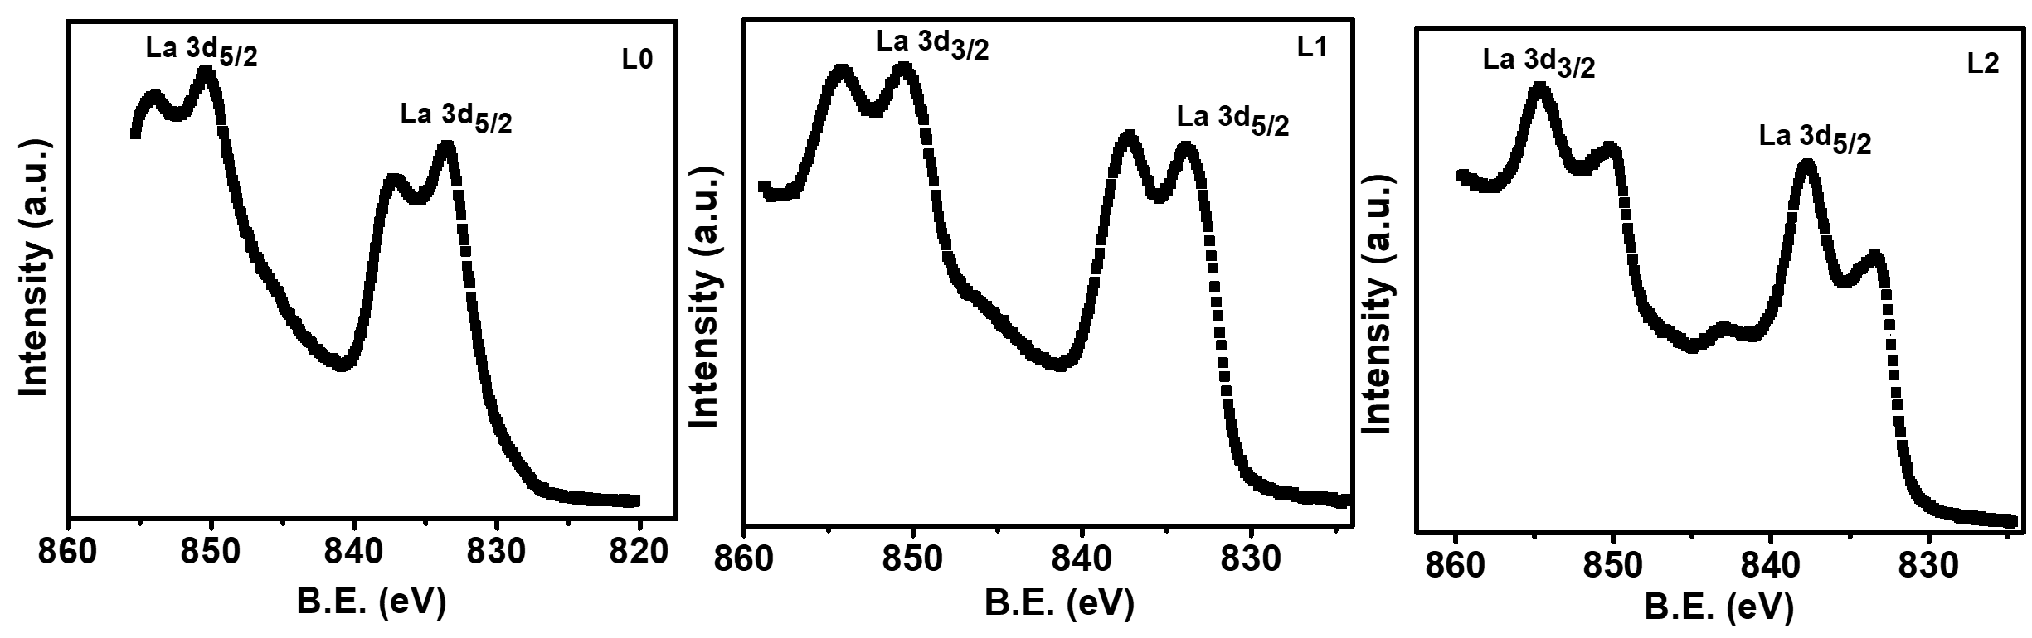
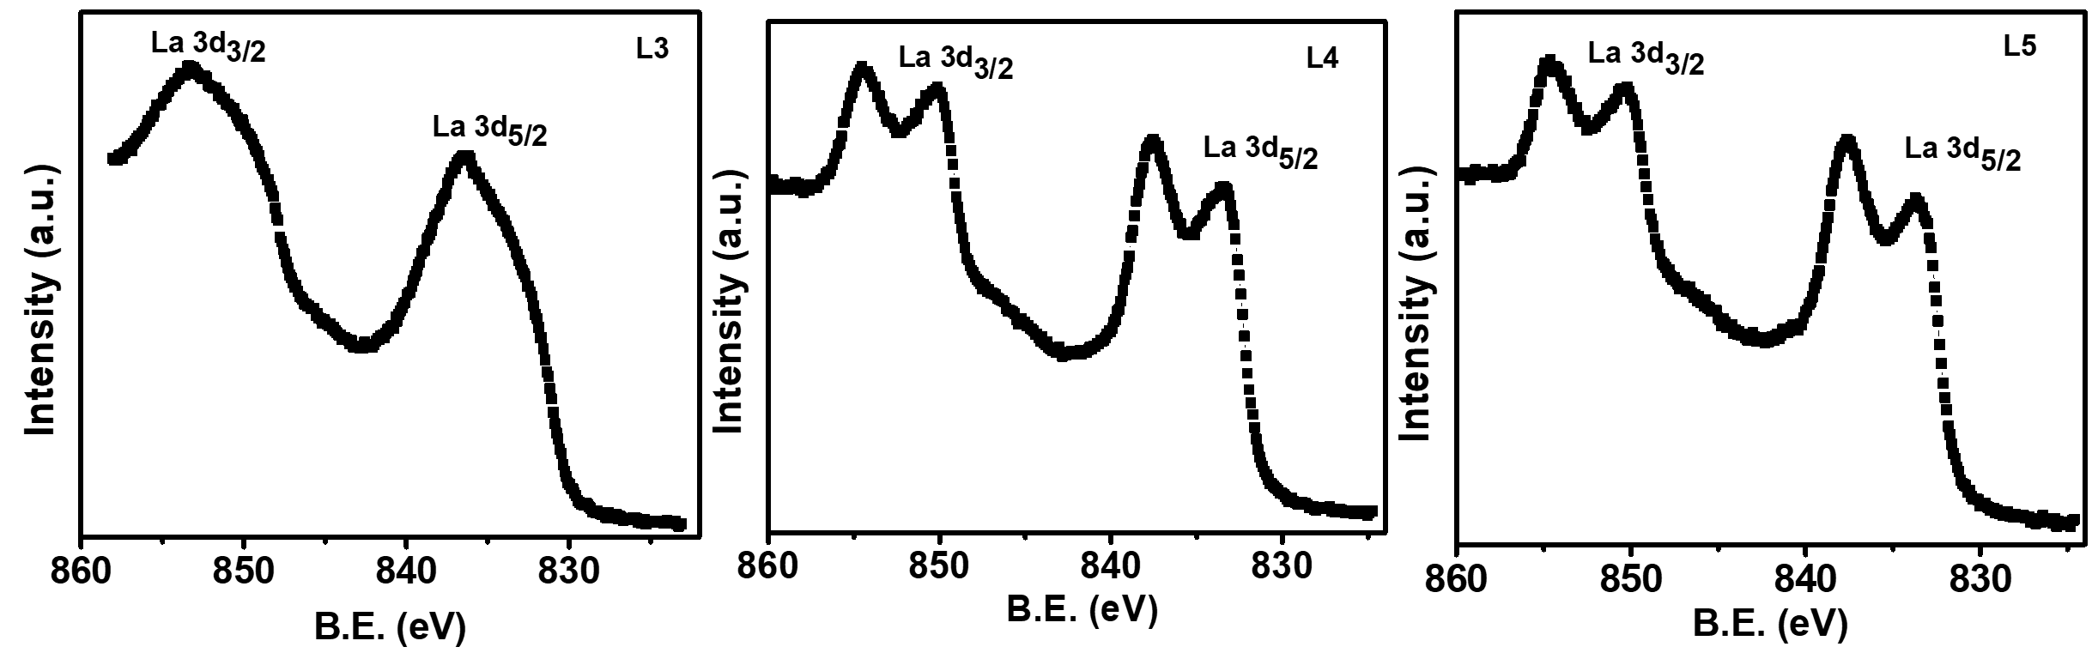

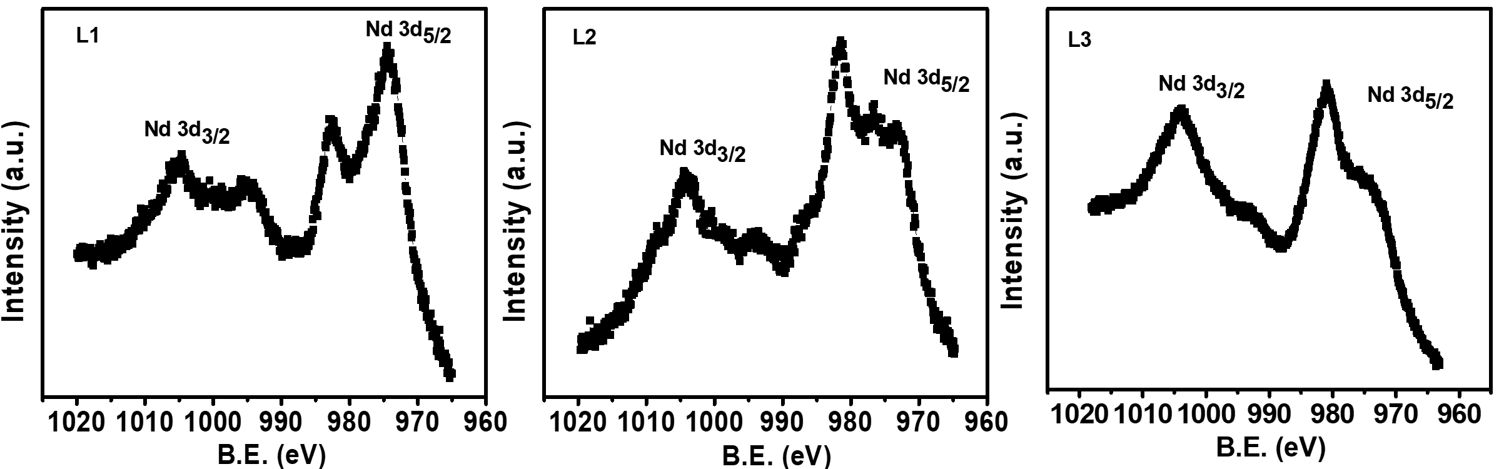
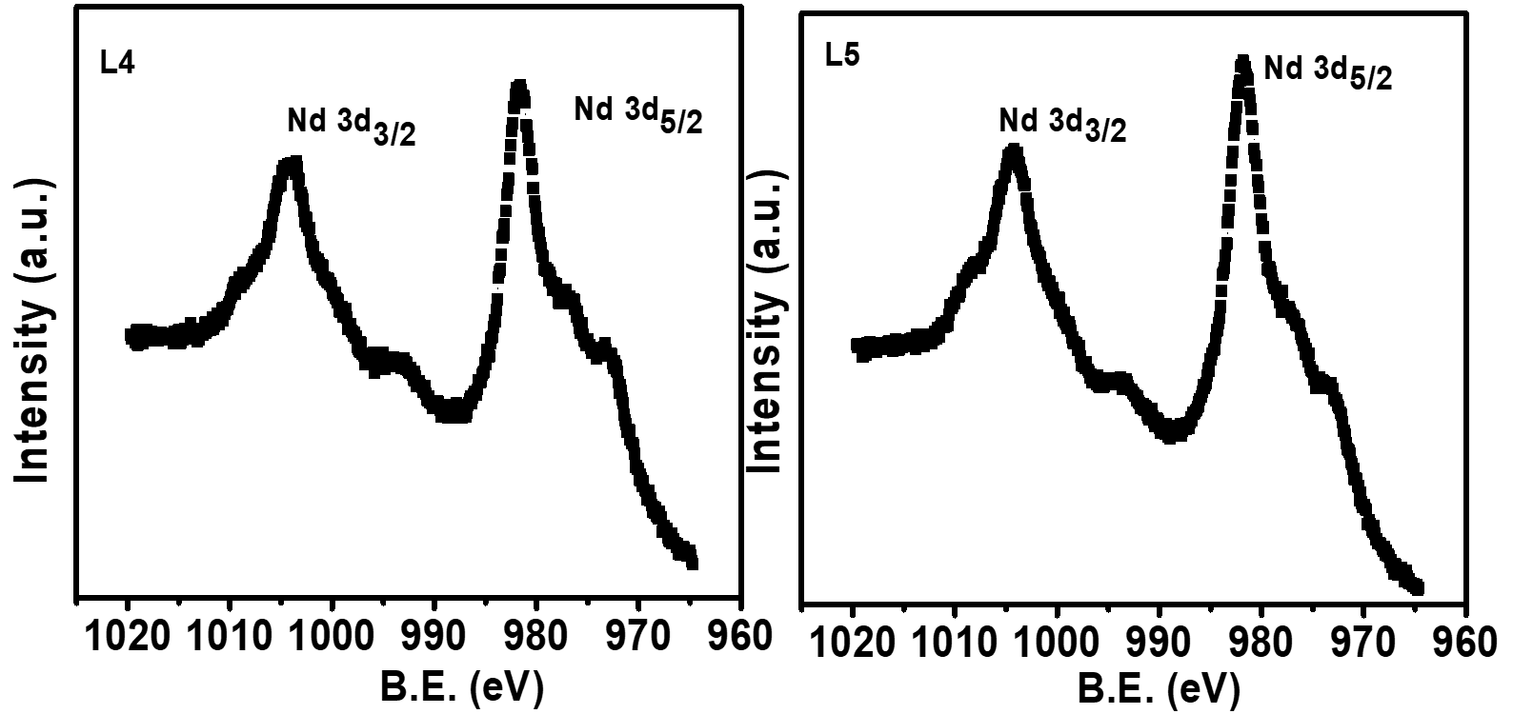
Fig. S5. XPS spectra of La 3d for (a) L0 (b) L1 (c) L2 (d) L3 (e) L4 and (f) L5 catalysts

Fig. S6. XPS spectra of Nd 3d for (a) L0 (b) L1 (c) L2 (d) L3 (e) L4 and (f) L5 catalysts

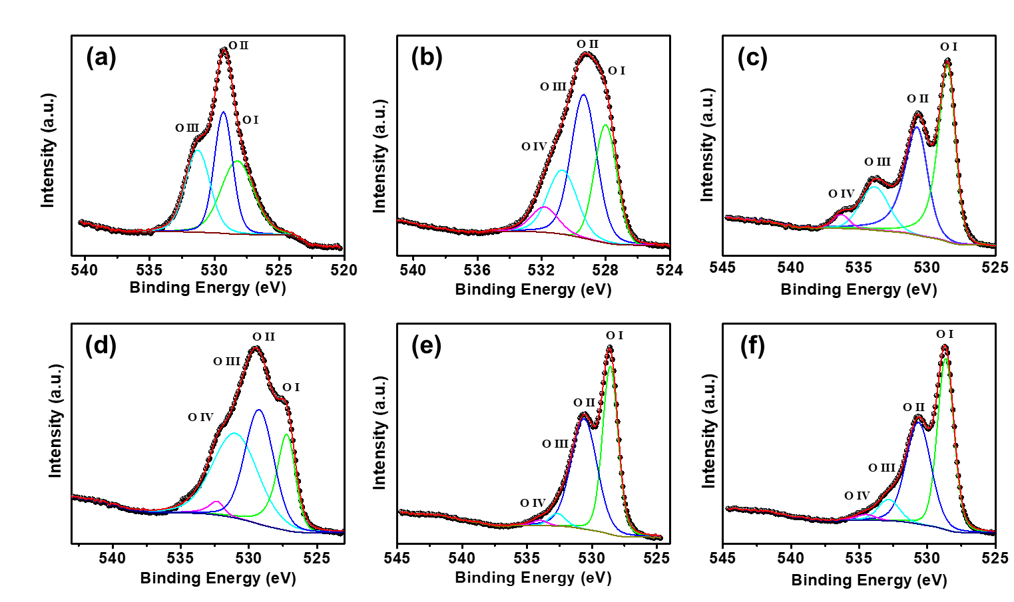

Fig.S7. XPS spectra of O1 s for (a) L0 (b) L1 (c) L2 (d) L3 (e) L4 and (f) L5 catalysts with peak fitting results based on multiple oxygen species.

Table S4. Deconvoluted value of O1s of L0, L1, L2, L3, L4 and L5 catalyst
Sample | Position (eV) |  |  |  | Area |  |  |  | Area (%)
Sample | OI (O²⁻) | OII  (O⁻,O₂²⁻) | OIII  (OH⁻, CO₃²⁻) | OIV  (H₂O) | OI | OII | OIII | OIV | OI | OII | OIII | OIV
L0 | 528.24 | 529.31 | 531.29 |  | 113470.68 | 105540.30 | 96707.26 |  | 35.95 | 33.43 | 30.63
L1 | 528 | 529.37 | 530.70 | 531.82 | 118025.55 | 179256.69 | 91073.49 | 33152.68 | 28 | 42.53 | 21.63 | 7.8
L2 | 528.42 | 530.63 | 533.84 | 536.29 | 204216.49 | 165597.62 | 71788.65 | 12333.96 | 44.99 | 36.48 | 5.8 | 2.72
L3 | 527.14 | 529.23 | 530.99 | 532.16 | 72867.15 | 63674.04 | 166462.66 | 1600515.81 | 20.54 | 34.98 | 41.64 | 2.83
L4 | 528.57 | 530.50 | 532.65 | 534.02 | 199905.02 | 219809.69 | 15514.29 | 6072.09 | 45.30 | 49.81 | 3.52 | 1.38
L5 | 528.64 | 530.64 | 532.83 | 534.50 | 232837.99 | 209337.04 | 36666.79 | 8523.73 | 47.77 | 42.45 | 7.52 | 1.75

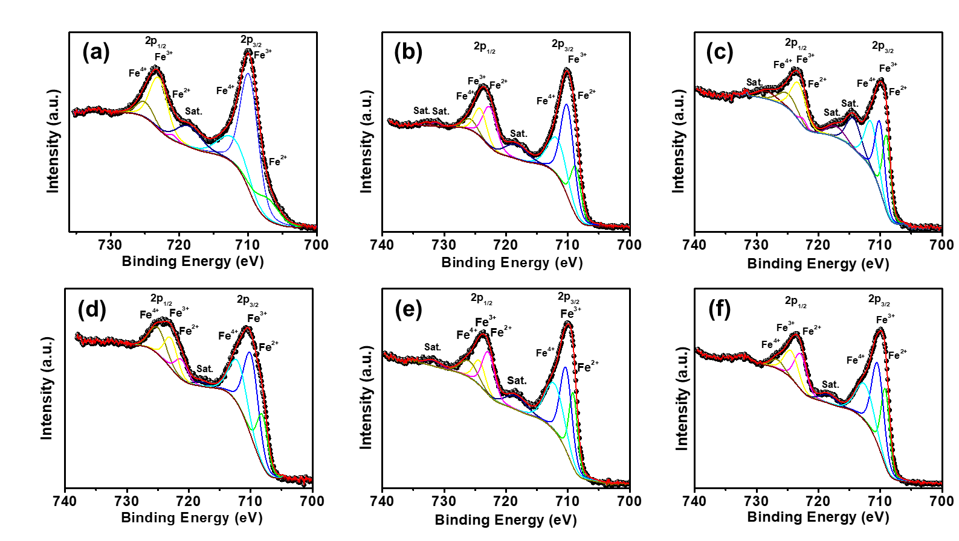

Fig. S8. Fe 2p core level XPS spectra of La_{1-x}Nd_{x}FeO₃ nanoparticles for (a) L0 (b) L1 (c) L2 (d) L3 (e) L4 and (f) L5 catalysts with peak fitting results based on multiple iron species. Here, Sat. represents satellite peaks.

Table S5. Deconvoluted value of Fe 2p spectra of L0, L1, L2, L3, L4, and L5 catalysts
Sample | 2p_{3/2} |  |  | 2p_{1/2}
Sample | Fe²⁺ % | Fe³⁺ % | Fe⁴⁺ % | Fe²⁺ % | Fe³⁺ % | Fe⁴⁺ %
L0 | 9.80 | 41.29 | 14.38 | 0.88 | 18.06 | 5.20
L1 | 13.04 | 31.49 | 18.20 | 14.58 | 9.05 | 3.80
L2 | 17.31 | 18.55 | 17.44 | 1.44 | 15.68 | 7.78
L3 | 15.08 | 32.71 | 20.82 | 6.86 | 10.77 | 12.09
L4 | 15.70 | 24.19 | 22.48 | 5.42 | 10.66 | 9.66
L5 | 19.63 | 28.87 | 19.25 | 13.18 | 11.59 | 3.39

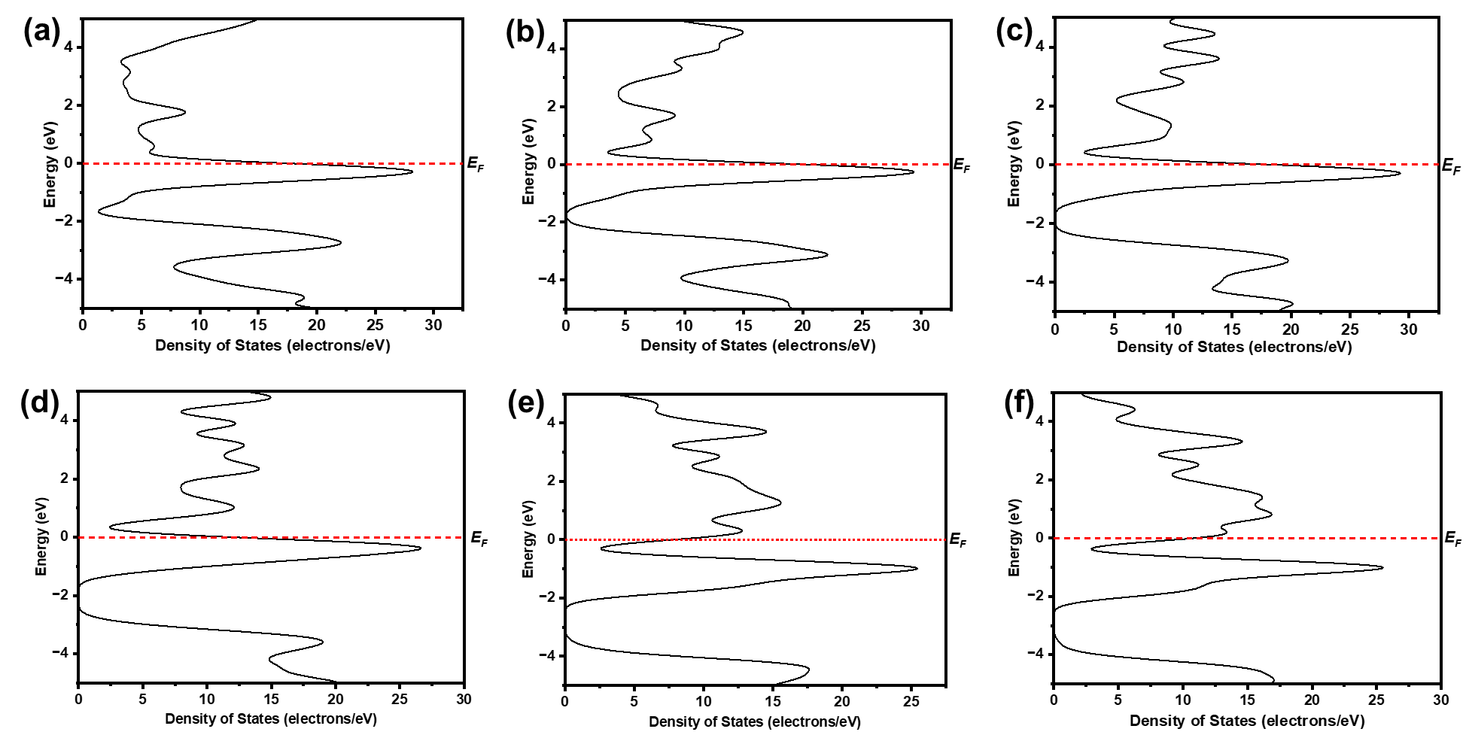
Fig. S9. The total density of states (TDOS) of orthorhombic La_{1-x}Nd_{x}FeO₃ (a) L0, (b) L1, (c) L2, (d) L3, (e) L4, and (f) L5 nanoparticles.
Table S6. Comparison of the catalytic performance of perovskite-based nanoparticles. Here, $η_{10}$ stands for overpotential at a current density of 10 mA cm⁻².
S.No. | Catalyst | electrolyte | $$η_{10}$$ | References
1. | La_{0.25}Sr_{0.75}Co_{0.5}Fe_{0.5}O_{3-δ} | 0.1M KOH | 324 mV | ¹
2. | La_{0.5}Sr_{1.5}Ni_{0.7}Fe_{0.4}O_{4±δ} | 0.1 M KOH | 360 mV | ²
3. | La_{0.9}Ce_{0.1}NiO₃ | 1 M KOH | 270 mV | ³
4. | LaNi_{1-x}Fe_{x}O₃ | 1 M KOH | 350 mV | ⁴
5. | La_{1−x}Sr_{x}FeO_{3−δ} | 0.1 M KOH | 370 mV | ⁵
6. | La_{0.2}Sr_{0.8}FeO₃ | 1 M KOH | 339.2 mV | ⁶
7. | SrCo_{1–y}Si_{y}O_{3–δ} | 0.1 M KOH | 417 mV | ⁷
8. | LaNiO₃ | 0.1 M KOH | 400 mV | ⁸
9. | La_{1-x}Sr_{x}CoO_{3-δ} | 0.1 M KOH | 220 mV | ⁹
10 | LaFeO₃ | 2 M KOH | 226 mV | Present work
11. | La_{0.90}Nd_{0.10}FeO₃ | 2 M KOH | 222 mV | Present work
12. | La_{0.80}Nd_{0.20}FeO₃ | 2 M KOH | 202 mV | Present work
13. | La_{0.70}Nd_{0.30}FeO₃ | 2 M KOH | 196 mV | Present work
14. | La_{0.60}Nd_{0.40}FeO₃ | 2 M KOH | 179 mV | Present work
15. | La_{0.50}Nd_{0.50}FeO₃ | 2 M KOH | 190 mV | Present work

References

1. Zhu, Y. et al. Self-Assembled Ruddlesden–Popper/Perovskite Hybrid with Lattice-Oxygen Activation as a Superior Oxygen Evolution Electrocatalyst. Small 16, (2020).
2. Forslund, R. P. et al. Exceptional electrocatalytic oxygen evolution via tunable charge transfer interactions in La_{0.5}Sr_{1.5}Ni_{1−x}Fe_{x}O_{4±δ} Ruddlesden-Popper oxides. Nat Commun 9, (2018).
3. Sun, Y. et al. A-Site Management Prompts the Dynamic Reconstructed Active Phase of Perovskite Oxide OER Catalysts. Adv Energy Mater 11, (2021).
4. Cheraparambil, H., Vega-Paredes, M., Scheu, C. & Weidenthaler, C. Unraveling the Evolution of Dynamic Active Sites of LaNixFe1-xO3 Catalysts During OER. ACS Appl Mater Interfaces 16, 21997–22006 (2024).
5. She, S. et al. Systematic Study of Oxygen Evolution Activity and Stability on La1- xSrxFeO3-δ Perovskite Electrocatalysts in Alkaline Media. ACS Appl Mater Interfaces 10, 11715–11721 (2018).
6. Fang, G. et al. Unveiling the electron configuration‐dependent oxygen evolution activity of 2D porous Sr‐substituted LaFeO 3 perovskite through microwave shock. Carbon Neutralization 2, 709–720 (2023).
7. Pan, Y. et al. Direct evidence of boosted oxygen evolution over perovskite by enhanced lattice oxygen participation. Nat Commun 11, (2020).
8. Petrie, J. R. et al. Enhanced Bifunctional Oxygen Catalysis in Strained LaNiO3 Perovskites. J Am Chem Soc 138, 2488–2491 (2016).
9. Mefford, J. T. et al. Water electrolysis on La1-xSrxCoO3-δ perovskite electrocatalysts. Nat Commun 7, (2016).

