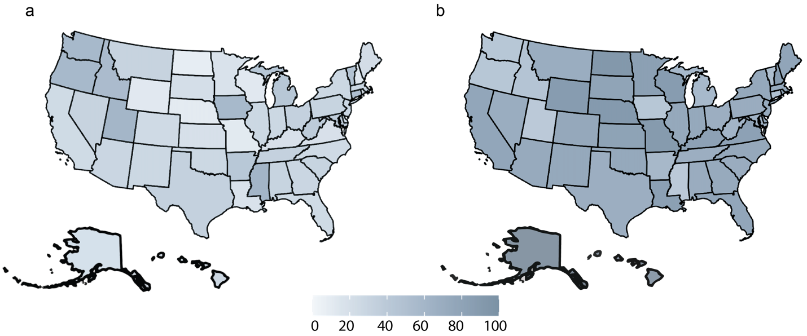

FIGURE S1 The U.S. maps show (a) the demographics of individuals with peanut allergy and (b) cases of peanut-induced anaphylaxis. The maps are recreated using the data reported by Food Allergy Research and Education (FARE).
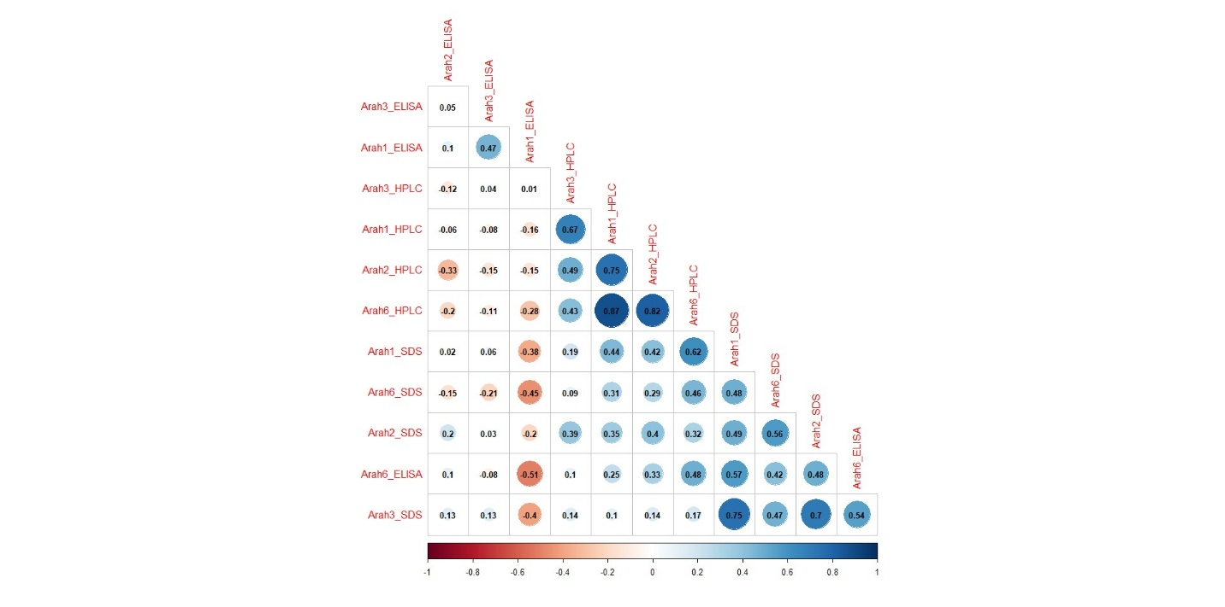
FIGURE S2 Correlation plot for selected 23 US peanut mini core accessions

