fMRI preprocessing

Structural and functional MRI data were preprocessed using fMRIPrep 20.2.7 ¹ in a Brain Imaging Data Structure (BIDS)-compliant workflow. T1-weighted structural images were corrected for intensity non-uniformity with N4BiasFieldCorrection (ANTs 2.3.3), skull-stripped using antsBrainExtraction.sh (OASIS30ANTs template), and segmented into gray matter (GM), white matter (WM), and cerebrospinal fluid (CSF) with FSL’s FAST. Cortical surface reconstruction utilized FreeSurfer 6.0.1, and nonlinear spatial normalization to MNI152NLin2009cAsym and MNI152NLin6Asym templates was achieved with ANTs.
Functional BOLD images were motion-corrected using MCFLIRT, co-registered to the T1-weighted image via boundary-based registration with FreeSurfer’s bbregister, and slice-timing corrected when applicable. Functional data were resampled to both native and standard space in a single interpolation step using antsApplyTransforms with Lanczos interpolation.
Confounding time series were estimated for each subject, including framewise displacement, DVARS, global signal (CSF, WM, and whole-brain), and physiological noise components derived via anatomical and temporal CompCor (aCompCor, tCompCor), retaining sufficient components to explain 50% of the variance within each mask ². All output data were subsequently imported into the CONN toolbox for further processing.
Functional data were spatially smoothed with a 6 mm FWHM Gaussian kernel and denoised using CONN’s standard pipeline. Denoising included regression of five principal components each from WM and CSF (aCompCor), 12 motion-related regressors (six parameters plus their derivatives), outlier scans (up to 57 regressors), session and task effects with their derivatives (eight regressors), and two linear trends ^{2–4}. High-pass filtering was then applied at 0.008 Hz. The effective degrees of freedom after denoising ranged from 116.2 to 129.7 across subjects (mean = 123.9) ⁵.

Subjective Ratings of the Visual Task
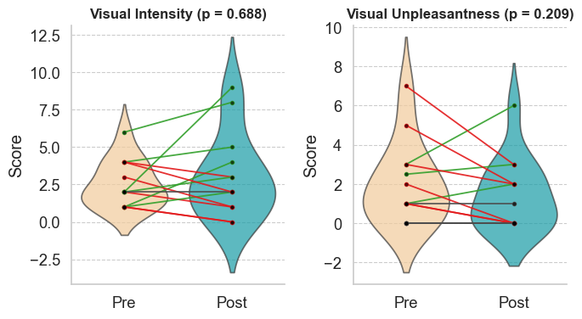
Figure S1. Subjective intensity and unpleasantness ratings of the visual task before and after nitrous oxide. Lines connect individual scores, indicating decreases (green), increases (red), or no change (dark gray).
Table S1. Changes of Subjective intensity and unpleasantness ratings of M-VAST
Subject | ∆Intensity | ∆Unpleasantness
N03 | 1 | -0.5
N05 | -1 | -1
N08 | 1 | 1
N09 | -1 | -3
N10 | -3 | 0
N11 | 1 | 2
N12 | 2 | 1
N13 | 1 | 4
N14 | -1 | 0
N15 | 0 | 0
N17 | -2 | 1
N18 | 2 | 3
N20 | -7 | 0

Table S2. ROI-Level Functional Network Connectivity of the Left Lateral Sensorimotor Region (FWE p < 0.05)
Analysis Unit (Simplified) | Statistic | p-unc | p-FDR | p-FWE
SensoriMotor.Lateral (ROI 3/32) | Size = 7 | 0.000563 | 0.008800 | 0.015
SensoriMotor.Lateral (ROI 3/32) | Mass = 95.43 | 0.000906 | 0.008267 | 0.024
SensoriMotor.Lateral (L) – IFG (LN, L) | T(12) = 4.30 | 0.001025 |  | 0.086
SensoriMotor.Lateral (L) – LPFC (FPN, L) | T(12) = 4.00 | 0.001746 |  | 0.086
SensoriMotor.Lateral (L) – PPC (FPN, L) | T(12) = 3.96 | 0.001878 |  | 0.086
SensoriMotor.Lateral (L) – RPFC (SN, L) | T(12) = 3.60 | 0.003677 |  | 0.104
SensoriMotor.Lateral (L) – IFG (LN, R) | T(12) = 3.57 | 0.003877 |  | 0.106
SensoriMotor.Lateral (L) – LPFC (FPN, R) | T(12) = 3.16 | 0.008175 |  | 0.153
SensoriMotor.Lateral (L) – pSTG (LN, L) | T(12) = 3.08 | 0.009503 |  | 0.165

PPC: Posterior Parietal Cortex
LPFC: Lateral Prefrontal Cortex
RPFC: Rostral Prefrontal Cortex
IFG: Inferior Frontal Gyrus
pSTG: Posterior Superior Temporal Gyrus
FPN: FrontoParietal Network
LN: Language Network
SN: Salience Network
L/R: Left/Right Hemisphere

Group Differences in rAI Connectivity Based on Changes in Unpleasantness and Intensity
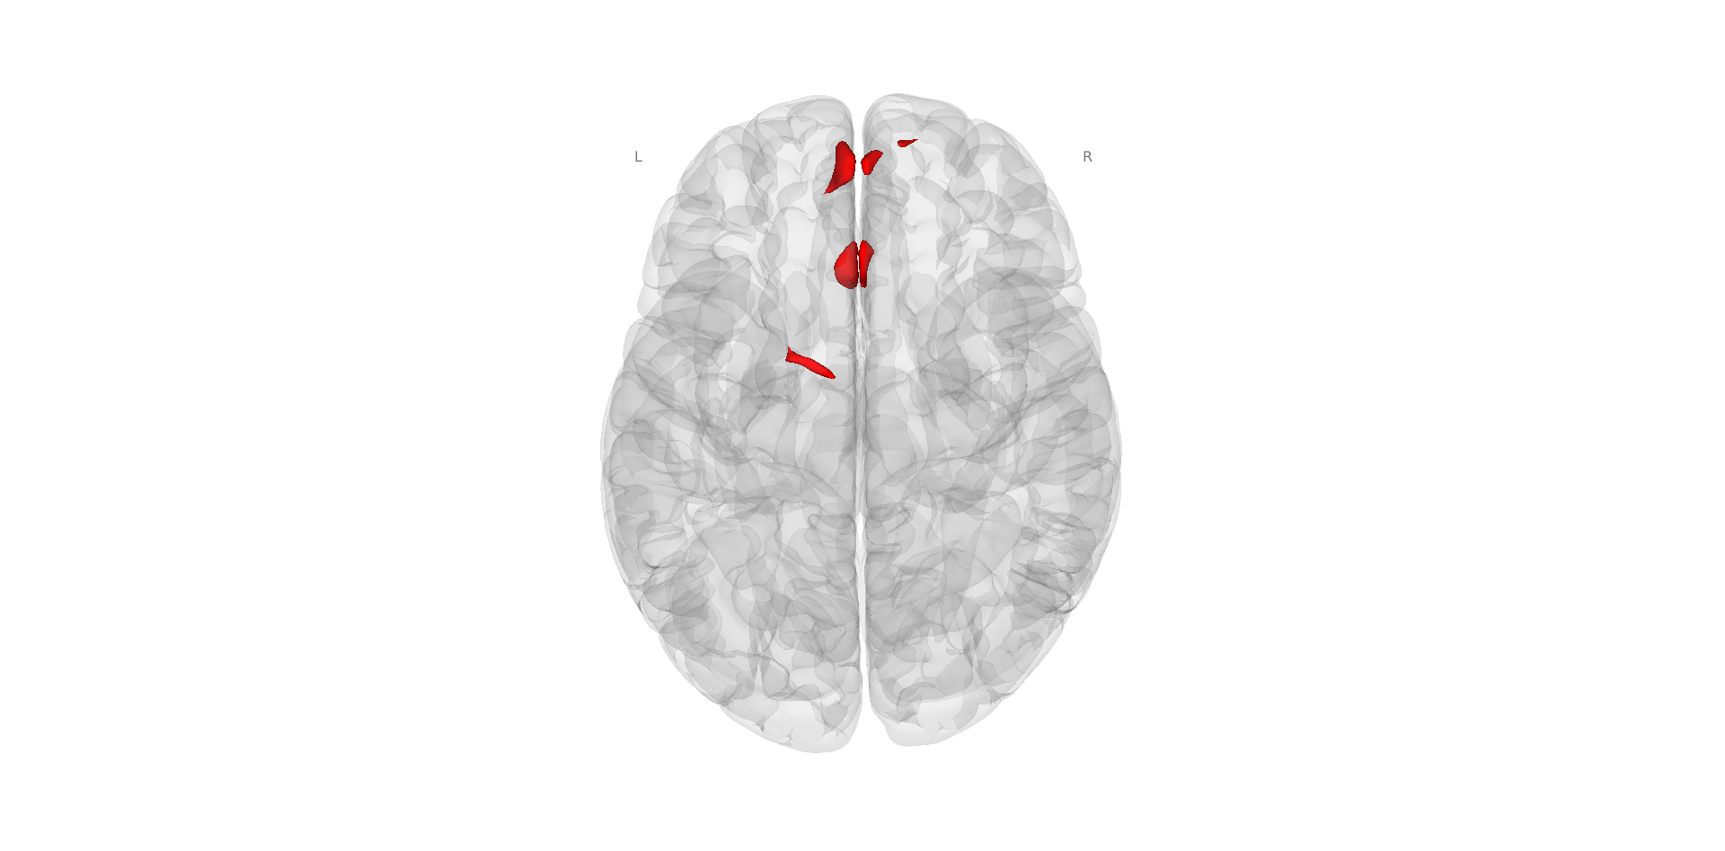
Figure S2. Regions showing greater rAI connectivity in participants reporting increased unpleasantness ratings (N=6) compared with those without increases. Three significant clusters were detected. The largest cluster, located at MNI coordinates (–4, 58, 24; 220 voxels; p_FWE = 0.000007), encompassed the left superior frontal gyrus (33%), right frontal pole (19%), right superior frontal gyrus (19%), left paracingulate gyrus (11%), left frontal pole (10%), and midline medial frontal cortex. The second cluster (–2, 22, 32; 185 voxels; p_FWE = 0.000040) involved the anterior cingulate cortex (42%), left paracingulate gyrus (28%), right paracingulate gyrus (16%), and surrounding medial frontal regions. The third cluster (–10, –2, 72; 72 voxels; p_FWE = 0.029158) was located primarily in the left superior frontal gyrus (96%). Statistical maps are thresholded at p<0.05, FWE-corrected at the cluster level.

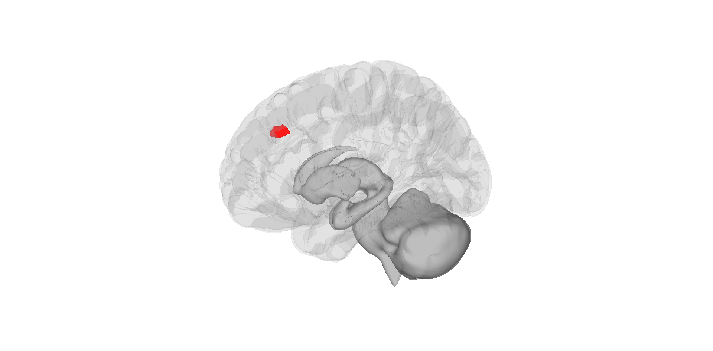
Figure S 3. Regions showing greater rAI connectivity in participants reporting increased intensity ratings ( N=6) compared with those without increases. Significant clusters were observed in the paracingulate gyrus bilaterally (48 voxels left, 27 voxels right) and a small cluster in the anterior cingulate cortex (6 voxels). The largest cluster was located at MNI coordinates (–2, 30, 34), 123 voxels in size (p_FWE = 0.00126). Statistical maps are thresholded at p<0.05, FWE-corrected at the cluster level.

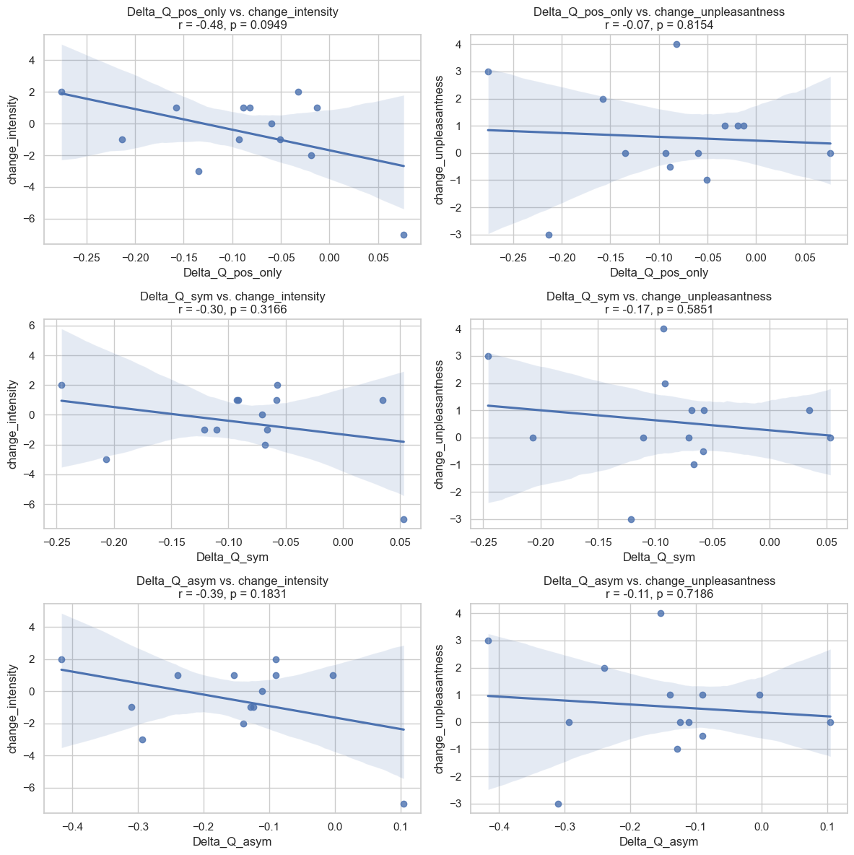
Correlations Between Modularity Changes and Visual Task’s Subjective Ratings
Figure S4. Pearson correlations between changes in modularity (ΔQ_asym) and changes in intensity (left panel) and unpleasantness (right panel) ratings showed no significant associations
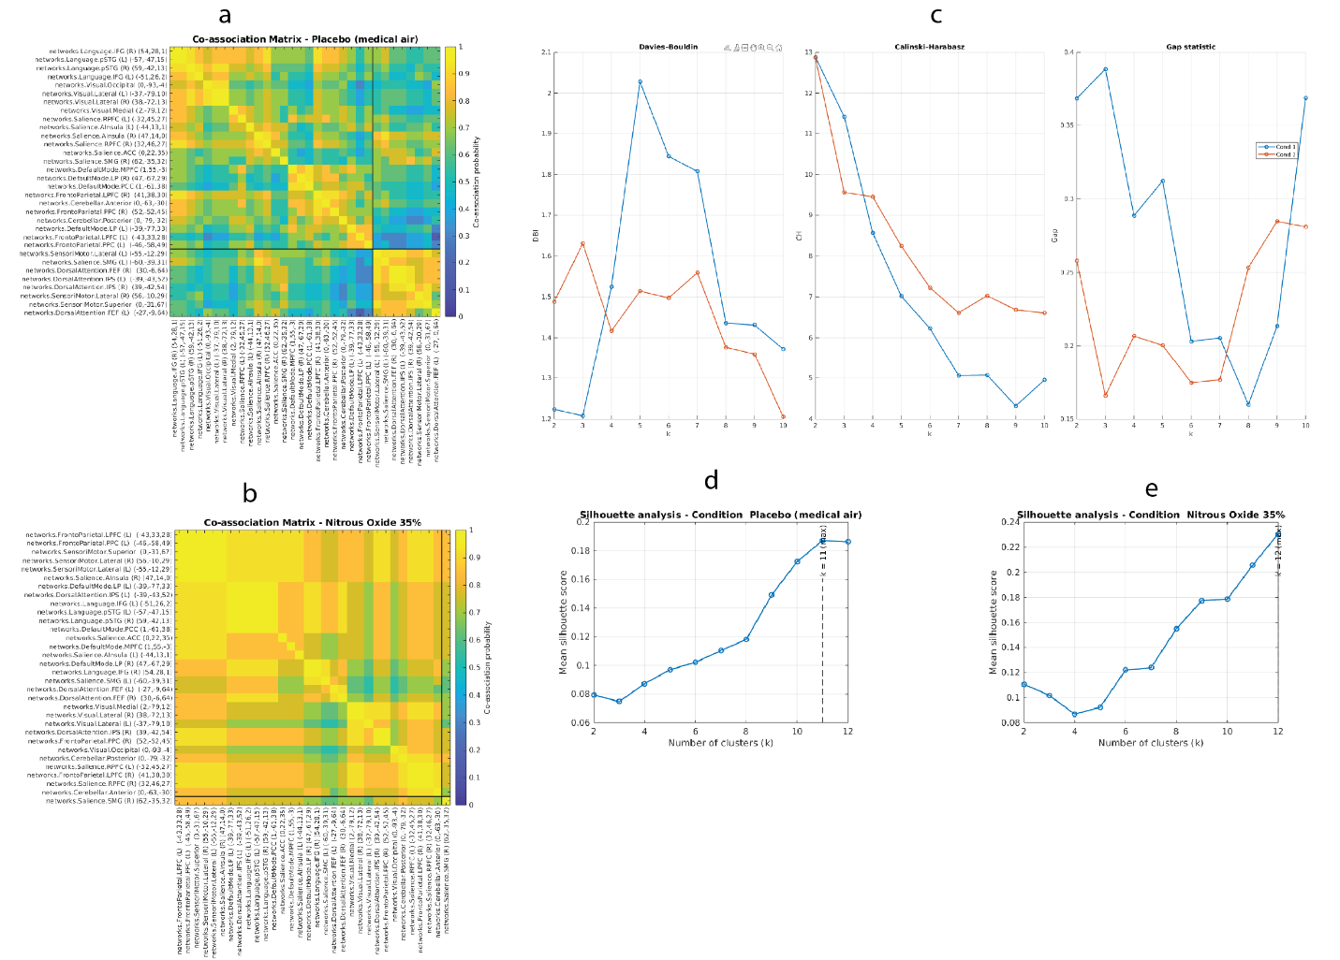
Figure s5. Coarse-resolution (k = 2) consensus clustering and cluster validity analyses. (a,b) ROI-level co-association matrices summarizing the proportion of subjects in whom each pair of regions was assigned to the same cluster, shown for the placebo (a) and nitrous oxide (b) conditions at a coarse mesoscale resolution (k = 2). (c) Internal cluster validity metrics evaluated across candidate resolutions, including the Davies–Bouldin index (left), Calinski–Harabasz criterion (middle), and gap statistic (right). (d,e) Silhouette analysis as a function of cluster number for the placebo (d) and nitrous oxide (e) conditions. These analyses reveal local optima at both coarse (k = 2) and finer (k ≥ 8) scales. At k = 2, the placebo and nitrous oxide co-association matrices exhibit marked qualitative differences, with nitrous oxide showing increased global co-assignment of regions into a common cluster relative to placebo. Direct comparison confirmed that these matrices differed significantly (p < 0.05), recapitulating the pattern observed at the biologically plausible k = 8 resolution and demonstrating robustness across clustering scales.

References
1. Esteban, O. et al. fMRIPrep: a robust preprocessing pipeline for functional MRI. Nat. Methods 16, 111–116 (2019).
2. Behzadi, Y., Restom, K., Liau, J. & Liu, T. T. A component based noise correction method (CompCor) for BOLD and perfusion based fMRI. NeuroImage 37, 90–101 (2007).
3. Chai, X. J., Castañón, A. N., Ongür, D. & Whitfield-Gabrieli, S. Anticorrelations in resting state networks without global signal regression. NeuroImage 59, 1420–1428 (2012).
4. Nieto-Castanon, A. Handbook of Functional Connectivity Magnetic Resonance Imaging Methods in CONN. (Hilbert Press, 2020).
5. Ashburner, J. Preparing fMRI Data for Statistical Analysis. in fMRI Techniques and Protocols (ed. Filippi, M.) 155–181 (Springer, New York, NY, 2016). doi:10.1007/978-1-4939-5611-1_6.

