Supplementary Information

Table of contents
Methods 3
Lentiviral knockdown of SLC16A2 and thyroid hormone (TH) analog / peptide treatments in human oligodendrocyte (OL) lineage cells 3
Co–culture and myelination assays with rat retinal ganglion cells and hESC–derived OPCs 4
Cell viability assessment of OLs following kinase inhibitor treatment 5
In vitro evaluation of TH–mimetics on OL differentiation 5
ELISA binding assay 6
Animal breeding 7
EAE Induction 7
DigiGaitTM mouse locomotor performance analysis 7
Stool grading assessment 8
Mouse periphery blood and serum collection 8
Metabolomics: 10
Proteomics 11
Ex vivo MRI acquisition and diffusion tensor imaging analysis 13
Image acquisition and analysis for OL fate mapping 14
Single molecule array (SIMOA) and detection of NfL 15
Transmission electron microscopy (TEM) for Optic nerve 15
Results 16
Recovery of dysfunctional TH signaling in hESC–derived oligodendroglial lineage cells following DITPA administration and demonstration of integrin αVβ3 receptor activation 16
Metabolomic profiling reveals distinct modulation of spinal cord metabolism in corn oil–treated EAE–induced mice compared with naïve controls 20
Metabolomic profiling reveals distinct modulation of spinal cord metabolism in LT3, or TRIAC treated EAE–induced mice compared with corn oil, or DITPA treated EAE–induced mice 22
Supplementary Figures 26
Supplementary Figure Legends 42
Supplementary Tables. 48
References 65

Methods

Lentiviral knockdown of SLC16A2 and thyroid hormone (TH) analog / peptide treatments in human oligodendrocyte (OL) lineage cells
The SLC16A2–knockdown of oligodendroglial lineage cells were generated through lentiviral transduction of the HES3 human embryonic stem cell (hESC, female) line. Lentiviruses expressing either a scrambled shRNA or a specific shRNA targeting SLC16A2 were generated using the psi–LVRU6MP vector system (Genecopoeia, USA), following previously described protocol.^{1,2} Oligodendroglial precursor cells (OPCs) were generated from the HES3–hESC cell line^{1,3,4} using a modified differentiation protocol based on International Patent Publication No. WO2016/101017A1.⁵ At the NG2⁺ stage of OPC differentiation derived from the HES3 cell line, NG2⁺ cells were isolated by flow cytometry using an NG2–APC–conjugated antibody (R&D Systems; 1:00) and sorted on a BD Influx sorter (BD Biosciences).¹ The purified NG2⁺ cells were then transduced with the respective lentiviral vectors. For transduction efficiency and drug treatment refer to previous report.¹
To evaluate the functional effects of TH analogous, OPC cultures were treated 72 hours (h) post–lentiviral transduction with either 10 nM of L–triiodothyronine (L–T3; Sigma, T2877), 3,5-diiodothyropropionic acid (DITPA; Cayman chemical, 23299), or 3,5,3'–triiodothyroacetic acid (TRIAC; Sigma, T7650) for 3 days. In some conditions, cells were co–treated with 100 nM cilengitide, a cyclized RGD (Arg–Gly–Asp motif)–containing pentapeptide as integrin αVβ3 antagonist (Sigma–Aldrich, SML1594), in the culture medium. At the end of the treatment period, cells were harvested for protein analysis and apoptosis assays. Note that protein lysates were used for standard 10% input western blotting (10 µg) and immunoprecipitation (IP;100 µg) assays described in the Proteomics section below.
For the apoptosis assay, human oligodendroglial precursor cells (hOPCs) were detached with Accutase (Gibco, A11105), centrifuged (300 × g, 5 min), resuspended in media, and filtered through a 20 µm mesh as previously reported.¹ After washing with FACS buffer (1% BSA, 0·01% sodium azide in PBS), cells were incubated with antibodies for 30 min at 4 °C to label surface (Annexin–V–APC; BD Biosciences, 1:1000) and intracellular (Caspase–3–V450; BD Biosciences, 1:1000) markers.¹ Flow cytometry was performed using a FACS Canto II (BD Biosciences), with data acquired via FACS Diva software and analysed using FlowJo v8·7·3. For each sample, at least 10,000 live cells were collected and live cells were identified using appropriate viability marker (DAPI; Thermo Fisher Scientific,1:1000).

Co–culture and myelination assays with rat retinal ganglion cells and hESC–derived OPCs
Retina were isolated from postnatal day 6 (P6) Sprague–Dawley rat pups (AMPREP Animal Ethics Committee #E–1602/2015/M) and retinal ganglion cells (RGCs) purified as previously described.¹ Pre–OLs (derived from NG2⁺ lentivirally–transduced MCT8–deficient cells) were FACS–sorted using a BD Influx sorter (BD Biosciences) following O4 antibody (O4–PE; R&D Systems) labeling as previously described.¹ Sorted O4⁺ cells were co–cultured with RGCs for 7 days in the presence of LT3, DITPA, or both (each at 10 nM).¹ All co–cultures were fixed with 2% PFA for 10 min at room temperature (RT; ~24) and used for immunocytochemistry staining using primary and secondary antibodies including: mouse anti–NF200 (Sigma–Aldrich, 1:400)/ goat anti–mouse Alexa Fluor 488 (Invitrogen; 1:200), rabbit anti–MBP (Invitrogen, 1:200)/ goat anti–rabbit Alexa Flour 555 (Invitrogen;1:200), and DAPI (Thermo Fisher Scientific,1:1000).
To minimize sampling bias, fields were selected in a systematic raster pattern across each coverslip, independent of NF200 or MBP staining, using DAPI to identify regions containing cells. Ten non–overlapping fields per coverslip (20× objective) were imaged with a Nikon A1 confocal microscope, each acquired as a single–plane scan. Myelination was quantified as the percentage of NF200⁺ axons in each field that were ensheathed by MBP⁺ myelin internodes. For axons with multiple internodes, each axon was scored as myelinated if at least one MBP⁺ segment was aligned with and wrapped around NF200⁺ axons; axons without any such segments were considered unmyelinated. The myelination index was calculated as: number of NF200⁺ axons with at least one ensheathing MBP⁺ segment / total NF200⁺ axons × 100¹.

Cell viability assessment of OLs following kinase inhibitor treatment
Human embryonic stem cell–derived OPCs (hESC–OPCs) were cultured and differentiated to the NG2⁺ stage in 96–well plates, as previously described.¹ Cells were treated with serially diluted kinase inhibitors PI–103 (Selleckchem, S1038), a phosphatidylinositol 3 phosphate kinase (PI3K)/mTOR inhibitor, and RDEA119 (Selleckchem, S1089), a mitogen–activated protein kinase 1,2 (MAPK1,2) inhibitor at concentration range of 0–320 nM ± 10 nM DITPA, compared to dimethyl sulfoxide (DMSO; Sigma–Aldrich, 472301) only. Plates were incubated for 48 h, after which cell viability was assessed using the MTT (Methylthiazolyldiphenyl–tetrazolium bromide) assay (Sigma–Aldrich, M2128) assay.

In vitro evaluation of TH–mimetics on OL differentiation
Mouse Oli–neu cells (Sigma–Aldrich, SCC261; female) were cultured according to the manufacturer’s instructions. Drugs were dissolved in DMSO (Sigma–Aldrich, 472301) then diluted in 10% ethanol in PBS (Sigma, 51976). Cells were treated for 72 h with LKE (lanthionine ketimine ester), DITPA (Cayman Chemical, 23299), L–T3 (Sigma, T2877), or TRIAC (Sigma, T7650) at concentrations ranging from 0 to 1000 nM. Cells were cultured in DMEM high–glucose medium (D5796; Sigma–Aldrich) supplemented with insulin (10 µg/mL, I9278–5ML; Sigma), apo–transferrin (10 µg/mL, T4382; Sigma), B27 Supplement (1X, 17504044; ThermoFisher), putrescine dihydrochloride (100 µM, P5780; Sigma), progesterone (200 nM, P0130; Sigma), sodium selenite (220 nM, S5261; Sigma), and penicillin–streptomycin (1% final concentration; Sigma). For treatment experiments, cells were maintained in the same base medium lacking tri-iodothyronine (T3), thyroxine (T4), and dibutyryl cAMP, unless otherwise specified. Following treatment, Oli–neu cells were detached and stained for flow cytometry. Live/dead discrimination was performed using Zombie Yellow viability dye (BioLegend, 423103). Cells were then incubated with directly conjugated primary antibodies including BCAS1/NABCA–1–Alexa Fluor 790 (Santa Cruz;1/1000), PDGFRα/CD140a–BV711 (BD Biosciences; 1:1000), MBP–APC–CY7 (Novus; 1:1000). For αVβ3 integrin detection, cells were stained with rabbit anti–αVβ3 integrin (Thermo Fisher Scientific, 1:1000) followed by goat anti–rabbit Alexa Fluor 647 (Thermo Fisher Scientific, 1:1000). Data was acquired using a Cytek Aurora cytometer with SpectroFlo software and analyzed in FlowJo (v10·8).

ELISA binding assay
A plate–based ELISA binding assay kit (ACRO Biosystems, IT3–R52E2) was employed to assess the binding affinity of DITPA (Cayman Chemical, 23299) and Cilengitide (Sigma, SML1594) to integrin αVβ3 following the manufacture’s protocol. Briefly, test compounds were serially diluted (100–1600 nM) and pre–incubated with recombinant rat integrin αVβ3 (0·5–16 µg/mL) at 37°C for 40 min. Following centrifugation (20,000 × g, 10 min), 100 µL of the supernatant was transferred to 96–well plates pre–coated with human vitronectin and incubated for 1 h at 37°C. Plates were subsequently washed and blocked, then processed for detection using a His–tag HRP–conjugated antibody and TMB substrate. The reaction was stopped with 1 M H₂SO₄, and absorbance was measured at 450 nm using a FlexA–200 microplate reader.

Animal breeding
Animal research studies were approved by the Monash University AMREP (E/1532/2015/M; E/1602/2015/M; E/8296/2022/M), and the UTAS (A0016151; A0016152; 28221) animal ethics committees. All experiments were conducted according to National Health and Medical Research Committee (NHMRC) code for the care and use of animals for scientific purposes 2013. Our research was compliant with the Victorian Cruelty to Animals Act 1986 and is reported in accordance with the ARRIVE (Animal Research Reporting of In Vivo Experiments) 2.0 updated guidelines ⁶. All mice were maintained on a 12–hour light–dark cycle at a controlled temperature (21ºC), provided ad libitum access to food and water, and acclimated to the research facility for a minimum of 7 days prior to experimentation.

EAE Induction
Experimental autoimmune encephalomyelitis (EAE) was induced in 8–12–week–old female mice by subcutaneous (s·c·) immunization with 200 µg myelin oligodendrocyte glycoprotein peptide (MOG₃₅–₅₅; GL Biochem, 51716) emulsified in complete Freund’s adjuvant (Sigma–Aldrich, F5881) containing 4 mg/mL heat–inactivated Mycobacterium tuberculosis (BD Biosciences, 231141). Mice received intraperitoneal (i·p·) injections of 350 ng pertussis toxin (List Biological Laboratories, 181) immediately after immunization and again 48 h later. Animals were weighed and examined daily, and disease severity was scored using a standard EAE clinical scale (0–3), as previously described.²

DigiGaitTM mouse locomotor performance analysis
Mice were evaluated using the DigiGaitTM imaging system and DigiGaitTM 15·0 analysis software (Mouse Specifics).⁷ Mice were acclimated to the behaviour room for 30 min before each training or trial session, and to the Digigait chamber for 5 min before the treadmill was activated. Mice were trained on the DigiGait for seven consecutive days, and the treadmill speed was incrementally increased, so that mice ran for 10 s at 5cm/s, 10cm/s or 15cm/s with 5 s intervals between speeds. Locomotor performance was assessed at day–1, 7, 10, 14, 18, 21, 24 and 30 of the 30–day EAE disease course. On the day of testing, mice that maintain speed for ≥ 5 s were considered to pass. Videos obtained from the trials were scored by a blinded investigator not conducting the trials.

Stool grading assessment
One hour following drug treatment, mice were placed in a metabolic cage with a wire base over a paper towel for 1h stool assessment.⁸ Stool number was recorded and graded [1– normal; 2– wet, and 3– watery diarrhea]. Mice with a stool grade >2 were supplemented with subcutaneous (s·c·) saline.

Mouse periphery blood and serum collection
Approximately 100 µL of blood was collected by submandibular bleed (SMB) 4 days prior to EAE induction (baseline), at day 7 (pre–onset), and peak disease (EAE clinical score 2–3), or by cardiac puncture at the experimental end point (EAE day 30). Whole blood was transferred to a K2–EDTA collection tube, lysed in ACK lysis buffer (Gibco, A1049201) for 10 min at RT, centrifuged (300 ×g, 5 min, 4ºC), the cell pellet washed in FACS buffer (2 mM EDTA / 2% FBS in 0.1M PBS), centrifugation, and the cells resuspended in FACS buffer with 5 µg/mL Fc receptor blocker (eBiosciences, 14916173) for 10 min at RT. Cells were stained with antibody cocktails containing Zombie Yellow dye (BioLegend, 423103; 1:2000), CD19–PE Cyanine 5 (Cytek; 1:1000), CD11b–FITC (eBioscience; 1:1000), CD11c–PE Cyanine7 (eBioscience:1:1000), CD3e–PE (eBioscience; 1:1000), and Ly-6G/Ly-6C–APC eFluor 780 (eBioscience; 1:1000) for 30 min at RT in the dark. Data was acquired using a Cytek Aurora cytometer with SpectroFlo software (gates excluded cellular debris and doublets; ≥ 10,000 events per sample) and analysed in FlowJo (v10·8).
At experimental endpoint of mice (EAE day 30 or at EAE clinical score 3), an additional 600–700 µL of cardiac blood was transferred to a gel serum separating tube and centrifuged at 1000 × g for 10 min. Serum (50–90 µL) was stored at –20°C for NfL analysis and the remainder was immediately transported at 4°C to Gribbles Veterinary Pathology (Clayton, Victoria) to measure T4, TSH, lipid profile (total cholesterol, triglycerides, HDL, and LDL cholesterol), liver enzymes (ALT, AST, ALP, and GGT), albumin and glucose.
Ex-vivo mouse spinal cord, optic nerve and brain tissue processing
All mice were humanely euthanized via CO2 inhalation. For proteomic, metabolomic, and ultrastructural analyses, transcardial perfusion was performed with PBS alone. Spinal cords were immediately dissected, snap–frozen in liquid nitrogen, and stored at -80°C for downstream proteomics and metabolomic profiling. For transmission electron microscopy (TEM), optic nerves were dissected and immersion–fixed in a 2·5% glutaraldehyde/4% paraformaldehyde (GTA/PFA) mixture for 24 h at 4°C. The tissues were then washed in 0·1M sodium cacodylate buffer; optic nerves were sent to the Monash Ramaciotti Centre for Cryo-Electron Microscopy.
For immunostaining and magnetic resonance imaging (MRI), mice were perfused with PBS followed by 10 mL of ice–cold 4% PFA (Sigma–Aldrich, 441244). Spinal cords were post–fixed in 4% PFA overnight and for MRI, fixed tissues were shipped in 4% PFA to the Alfred Centre, where lumbosacral spinal cords were washed twice overnight in PBS to remove fixative and incubated in Fomblin overnight for imaging. Post–MRI, samples were washed in PBS (2× overnight at 4 °C), cryoprotected in 30% sucrose, embedded in OCT, and stored at −80 °C. All OCT–embedded tissues were sectioned longitudinally at 10 µm thickness using a Leica cryostat (−20 °C) and mounted on Superfrost Plus slides (Thermo Scientific, J1800AMNZ) for downstream fate map analysis.

Metabolomics:
Sample Preparation
Metabolomic profiling of murine spinal cords was performed as has been described previously with minor modifications^{9,10} Frozen tissue samples from mouse spinal cords (lumbosacral (LSSC) and thoracis (TSC) regions; treated with TH analogous, corn oil as vehicle control, or Naive) were cryo–pulverized (30mg powder) using a 12–well biopulverizer (BioSpec Products, OK USA Part number 59012MS) according to the manufacturer’s instructions as has been described previously.⁹ Extraction was performed using a 1:3:0·5 chloroform/methanol/water solvent system with 2 µM CCPT. Cryo–pulverized tissue was weighed, and 400 µL of ice–cold extraction solvent was added on ice. After processing, additional solvent was added to reach 20 µL/mg tissue. Samples were vortexed (3 × 10 sec), sonicated (10 min, ice–water bath), and centrifuged (10 min, 4°C) to remove debris. Supernatants were stored at –80°C and used for subsequent liquid chromatography coupled to high–resolution mass spectrometry (LC−MS) analysis. For pooled biological QC (pbQC), 10 µL of reconstituted lysates from each sample were combined.
Mass Spectrometry acquisition
LC-MS analysis was performed using Vanquish Horizon coupled to a Q−Exactive Plus Orbitrap MS (Thermo Scientific, Australia). Samples were analysed by hydrophilic interaction liquid chromatography (HILIC) following a previously published method.¹¹ The chromatography utilized a HILIC Column 5µm 150 x 4·6 mm (25 °C) a iHILIC®-(P) Classic (Hilicon, Sweeden). All LC–MS procedures were performed as previously described (Emamnejad et al., 2025a; submitted). Acquired LC–MS data was processed in an untargeted fashion using open source software IDEOM, which initially used msConvert (ProteoWizard)¹² to convert raw LC–MS files to mzXML format and XCMS to pick peaks to convert to .peakML files¹³. Mzmatch was subsequently used for sample alignment and filtering.¹⁴ IDEOM was utilised for further data pre–processing, organisation and quality evaluation.¹³
Data analysis was conducted in R (v4·2·1), with intensity peaks of metabolites serving as the basis for evaluation. Missing values were imputed using the k–nearest neighbors (kNN) algorithm (parameters: neighbors = 5, sample_max = 50, feature_max = 50, by = "features"). Subsequently, we normalized the data across three categories: Probabilistic Quotient Normalization (PQN), Log10 transformation for data transformation, and Pareto Scaling using the structToolbox package. For comparative analysis between groups, multivariate statistical technique, principal component analysis (PCA) was utilized to visualize variance among samples. For univariate statistical analyses, Student’s t-tests with a significance threshold of p< 0·05 were performed. Significant changes in mean expression levels between disease and control groups were further illustrated using Volcano plots, based on –log10(p–values) and log2(fold change), with a fold change threshold of 1·5. These visualizations were created in R (v4·2·1) using the struct, structToolbox, and ggplot2 packages. Finally, heatmap and violin plots were generated using the heatmap and ggplot2 packages, respectively, to depict the expression patterns of dysregulated metabolites.
Pathway analysis:
MetaboAnalyst 6·0^{15,16} was utilized to perform enrichment pathway analysis using KEGG IDs, and Mus musculus (KEGG) pathway library. For pathway enrichment analysis, the Global Test algorithm was employed, while pathway topology analysis was conducted using relative betweenness centrality.

Proteomics
For in vitro studies, cells were harvested, centrifuged at 300 × g for 5 min at 4 °C, and the supernatant discarded. Pellets were resuspended in 400 µl ice–cold RIPA buffer (Thermo Scientific, 89901) supplemented with protease (Roche, 04693124001) and phosphatase (Roche, 04906837001) inhibitor tablets, then homogenized using a 26G needle.
Frozen mouse spinal cords were homogenized in 1 ml of the same supplemented RIPA buffer using an electric homogenizer. All homogenates were incubated on ice for 20 min and centrifuged at 13,000 rpm for 20 min at 4 °C. Supernatants were collected, and protein concentrations were determined using the bicinchoninic acid (BCA) assay (Thermo Fisher, 23227), with absorbance measured at 562 nm. Lysates were stored at −80 °C.
Sodium dodecyl sulphate–polyacrylamide gel electrophoresis (SDS–PAGE) and western blotting, IP and co– immunoprecipitation (co–IP) were performed as previously described (Emamnejad et al., 2025a; submitted).
For western blotting and immunoprecipitation, the following primary antibodies were used: AKT (Cell Signaling Technology, #9272; 1:1000), phospho–AKT (S473) (Cell Signaling Technology, #9271; 1:1000), mTOR (Cell Signaling Technology, #2972; 1:1000), phospho–mTOR (Ser2448) (Sigma-Aldrich, #SAB4504476; 1:1000), ERK1/2 (Cell Signaling Technology, #4695; 1:2000), phospho–ERK1/2 (Cell Signaling Technology, #4370; 1:2000), PANK2 (Bioss, #bs-8338R; 1:1000), MCT8 (LifeSpan BioSciences, #LS-B10928; 1:1000), MCT8 (MBL International, #BM0031; 1:1000), MCT10 (US Biological Life Sciences, #041801; 1:1000), OATP1C1 (Merck, #SAB2108225; 1:1000), DIO2 (Novus Biologicals, #NBP1-00178; 1:1500), DIO3 (Novus Biologicals, #NBP1-05767; 1:1000), MYRF (Bioss, #C11orf9; 1:1000), β–actin (Novus Biologicals, #NB600-532; 1:10 000), and β–actin (Sigma-Aldrich, #A6441; 1:5000).
The following secondary antibodies were used: goat anti–rabbit IgG (H&L), HRP conjugate (Thermo Fisher Scientific, #A16096; 1:5000); donkey anti–goat IgG (H&L), HRP conjugate (Invitrogen, #PA1-28664; 1:5000); goat anti–mouse IgG (H&L), HRP conjugate (Thermo Fisher Scientific, #31430; 1:5000); and VeriBlot for IP and co–IP detection (Abcam, #AB131366; 1:200).

Ex vivo MRI acquisition and diffusion tensor imaging analysis
At the experimental endpoint (day 30, or upon reaching a clinical score of 3), the L1 to L5 spinal cord segments were harvested from all treated mice receiving TH analogues or corn oil (vehicle control). Ex vivo tissue preparation for MRI imaging followed the procedures detailed above. Spinal cords were imaged using a 9·4 Tesla Bruker MRI scanner at the Monash Biomedical Imaging facility, located within the Alfred Research Alliance precinct. Diffusion tensor imaging (DTI) was conducted with the following acquisition parameters: repetition time/echo time, 1000/28 ms; matrix, 144 × 48 × 48; field of view, 14·40 × 4·80 × 4·80 mm³, δ = 4 ms, Δ = 13 ms, and b–value of 4000 s/mm². Structural and microstructural analyses were conducted on DTI data, focusing on three anatomically defined regions of interest (ROIs) along the lumbosacral spinal cord: rostral, mid–lumbar, and caudal segments. Within each segment, white matter (WM) and gray matter (GM) were manually segmented using ITK–SNAP (version 4·2·0), allowing for the calculation of the GM/WM volume ratio ¹⁷. Microstructural parameters, including axial diffusivity (AD), fractional anisotropy (FA), apparent diffusion coefficient (ADC), and radial diffusivity (RD), were quantified across these ROIs. Additionally, each ROI was further subdivided into dorsal, lateral, and ventral compartments to enable detailed regional analysis of AD, FA, ADC, and RD. DTI images were processed using MRtrix3 software to generate FA maps, which were used for structural visualization across all treatment and control groups. All MRI acquisition and post–processing analyses were performed in a blinded manner, with sample identities masked until completion of the data analysis.

Image acquisition and analysis for OL fate mapping
Lumbosacral spinal cords were collected from PLP-Cre transgenic mice treated with TH analogous, or corn oil (vehicle) as described in the section Ex vivo mouse spinal cord, optic nerve, and brain tissue processing. Tissues were used for immunofluorescence staining and OL fate mapping. For each experimental condition, three OCT-embedded cryosections (10 µm thick) were collected at 70 µm intervals. Sections were stained with Hoechst (Life Technologies, #V35118; 1:500) and incubated with primary antibodies including anti-GFP biotin goat polyclonal antibody (Abcam, #AB6658; 1:100), MYRF rabbit polyclonal antibody ( Bioss, #C11orf9; 1:100), and B-CAS1 (NaBC1, clone F-4) mouse monoclonal antibody (Santa Cruz Biotechnology, #sc-3937430; 1:100), followed by appropriate secondary antibodies: streptavidin–Alexa Fluor™ 488 (Invitrogen, #S32354; 1:200), donkey anti-rabbit IgG (L+H) Alexa Fluor™ 555 (Invitrogen, #A32794; 1:200), and donkey anti-mouse IgG (L+H) Alexa Fluor™ 647 (Invitrogen, #A31571; 1:200).
All images were captured using a Leica Thunder Imager equipped with a Plan Apo 20x/0·75 IMM Corr objective on the Glyc setting, and a K5s CMOS camera. Image acquisition and initial processing were performed using Leica software, while quantitative image processing and analysis were conducted using Nikon NIS Elements Analysis software (version 5·5). A ROI was manually drawn to encompass the white matter in the lumbosacral region of the spinal cord from all treated groups in PLP–YFP transgenic mice. We quantified three cell populations: GFP⁺ (488 nm) MYRF⁺ (555nm) OLs; GFP⁺ (488 nm) OLs, or MYRF⁺ (555nm) BCAS1⁺ (647 nm) OLs. The fluorescent channels (including DAPI (405 nm)) were segmented by thresholding to generate binary images for cell counting. Please refer to supplementary figure 11 for a visual outline of the image analysis pipeline.

Single molecule array (SIMOA) and detection of NfL
Neurofilament light chain (NfL) levels in the serum of mice were assessed using SIMOA HD–X AnalyzerTM (Quanterix, Billerica, MA, USA). The blood samples were collected by transcardial collection from all experimental mouse groups at the experimental endpoint (day 30 and when mice reached score 3), and whole blood transferred to a gel serum separator tube. Samples were centrifuged at 1000 x g for 10 min and the resulting serum was collected and stored at –20°C for the analysis of NfL level. 42 μL of serum from each sample was used to perform immunoassays in duplicate using the Simoa® NF–lightTM Advantage Kits (Quanterix–104073) as per the manufacturer’s instructions, with the exception that samples were run using an eight–times benchtop dilution rather than a four–times machine dilution. Experimenters conducted the immunoassays under a blinded condition. All measured NfL concentrations exceeded the analytical lower limit of quantification (LLOQ) of 0·64 pg/mL in the diluted samples. The assay’s limit of detection (LOD) was 0·141 pg/mL.

Transmission electron microscopy (TEM) for Optic nerve
The prepared optic nerves as described above were sent to the Monash University Ramaciotti Centre for Cryo–Electron Microscopy. Samples were contrasted using 1% osmium tetroxide/0·2 M sodium cacodylate buffer for 2 h at RT, washed in 0·1 M sodium cacodylate Buffer, dehydrated in a sequential ethanol gradient from 70–100% and transversely mounted in Epon. Semi–thin cross sections (0·9 µm) were prepared and stained with toluidine–blue for qualitative analysis using an Olympus BX51 microscope attached to a 100x oil immersion objective. Ultra–thin sections (80 nm) were cut and stained with 1% aqueous uranyl acetate for analysis using a JEOL 1400 Plus 120 keV transmission electron microscope for optic nerve ultrastructure visualization and quantification. AxonDeepSeg deep learning segmentation software was used to quantify axon and myelin measurements for use in statistical analyses. A minimum of six TEM images from six different mice were quantified using AxonDeepSeg, whereby 1·3 x 10⁴ – 5·3 x 10⁴ axons were counted and presented as G–ratio vs. Axon diameter, G–ratio, myelin thickness, myelin axon diameter distribution frequency. Re–myelination, demyelination and percentage myelination were qualified using TEM images.

Results

Recovery of dysfunctional TH signaling in hESC–derived oligodendroglial lineage cells following DITPA administration and demonstration of integrin αVβ3 receptor activation
Following the demonstration of the neuroinflammatory–mediated dysregulation of the non–genomic signalling pathway in an EAE murine model and in archival MS tissue, our group investigated the recovery of this TH–dependent, signalling cascade in SLC16A2–knockdown hESC–derived oligodendroglial lineage cells upon DITPA administration (an MCT8–dependent TH–analogue). HES3–hESC derived OPCs were utilized,¹ due to compensatory TH mechanisms present in murine slc16a2 mutant mice–namely due to the compensatory effects exerted by the TH transporter OATP1C1, responsible for the governance of TH–dependent cellular metabolism.¹⁸ We firstly demonstrated the principal outcome of restoration in TH–dependent signalling cell survival, through performance of an apoptosis assay by annexin V and caspase–3 staining of pharmacologically and genetically MCT8 knockdown OPCs, analysed by flow cytometry.¹ It was found that MCT8 dysregulation, upon SLC16A2 knockdown, enhanced the apoptosis of OPCs demonstrated by Annexin V⁺ flow cytometric analysis that identified the potentiation of cell death at ~ 34.3%, when compared to transduced OPCs with non–targeted shRNA (9·8%) (supplementary figure 1A). Amelioration of SLC16A2–knockdown induced apoptosis was affected following administration of T3, DITPA or TRIAC (10 nM) following 72–hours post–SLC16A2 knockdown in OPCs, where a reduced annexin V⁺ profile by 24·1%, 20·6% and 16·8% respectively was demonstrated (supplementary figure 1A). Quantitation of Annexin V⁺ cells supported these findings, with a significant increase in the percentage of apoptotic cells following SLC16A2 knockdown (32·95%) relative to non–targeting–shRNA control (9·42%) (p ≤ 0·0001).
Furthermore, a significant reduction in apoptosis of DITPA–treated cells (21·67%) compared to SLC16A2–shRNA (32·95%) (p ≤ 0·01). Similar reductions were seen following T3 administration (22·87%) (p≤ 0·001), with significant reductions in the cellular apoptotic population relative to SLC16A2–shRNA targeted cells (32·95%) (p≤ 0·01). Disparate reduction of apoptotic cells was seen following TRIAC administration (16·57%) when compared to SLC16A2–shRNA knockdown cells (32·95 %) (p≤ 0·0001). However, despite the most significant reduction under MCT8 deficiency, in the context of MCT8 functionality (control) (9·42%), TRIAC administration induced the least significant reduction (16·57%) (p≤ 0·05) (supplementary figure 1B). Assessment of caspase–3 activity outlined the elevated ability of DITPA to ameliorate caspase 3–dependent apoptosis (46·55%), relative to SLC16A2 knockdown cells (61·87 %) (p≤ 0·01), and outcompeted both T3 (67·64%) (p≤ 0·001) and TRIAC (59%) (p≤ 0·05). Integrin αVβ3 potentiation was trialed as a possible avenue through which DITPA may induce anti-caspase–3 activity, as demonstrated in the presence of cilengitide, a cyclized RGD (Arg–Gly–Asp motif)–containing pentapeptide (Integrin αVβ3 antagonist), resulting in a greater amelioration of caspase–3 levels (69·58%), relative to T3 (83·84%) (p≤ 0·01) and TRIAC (88·71%) (p≤ 0·001) (supplementary figure 1B). These data suggest that DITPA may be superior at inhibiting the intrinsic pathway of apoptosis in human OPCs, whereas TRIAC may work more effectively in limiting the intrinsic pathway of cell death, but further investigations are required to establish this.
It is well established that OL differentiation and maturation is dependent on a homeostatic relationship between AKT and ERK1/2 signaling.¹⁹ To demonstrate the possibility of differentiation and maturation events in OLs potentiated by DITPA through AKT and ERK1/2 signalling, western blotting was performed through 10% input of HES3 cell lysate. We observed a highly significant increase in p–AKT activity following DITPA administration (0·125 AU) relative to non–targeting–shRNA control with a 2·5–fold change (p≤ 0·001). This elevation in p–AKT activity was emulated by DITPA compared to T3 (p≤ 0·001) and TRIAC (2·5–fold change) (p≤ 0·01) (supplementary figure 1C). To assess the possibility of integrin αVβ3 activation leading to increased p–AKT, further western blotting was conducted utilizing OPCs treated with the αVβ3 receptor antagonist, cilengitide. We observed a significant reduction in p–AKT according to DITPA treatment relative to that level of p–AKT following treatment with TRIAC through a 2·5–fold change (p≤ 0·05) (supplementary figure 1D). As part of the current study, western blotting utilizing 10% input of HES3 cell lysates under identical culture conditions was performed, to assess mTOR as a downstream effector of the AKT signalling pathway, in consideration of integrin αVβ3 inhibitor (cilengitide). mTOR activity seen in SLC16A2–shRNA + DITPA treated cells was prominently downregulated in the presence of the RGD peptide (SLC16A2–shRNA + DITPA + RGD) (supplementary figure 1D), suggesting that potentiation of the AKT–mTOR signalling pathway in human OPCs, was specifically compromised when we antagonized αVβ3 activation to exert its neurobiological effects of cell survival, proliferation, and differentiation. In consideration of mTOR as the primary effector mechanism of AKT–induced myelination,²⁰ the current study proposed to demonstrate the inhibition of p–mTOR activity through antagonizing the integrin αVβ3. Immunoprecipitation of total–mTOR utilizing HES3 cell lysate was performed, allowing for the detection of p–mTOR through use of an anti–p–mTOR antibody. We observed a decrease in p–mTOR activity in SLC16A2–shRNA + DITPA + RGD treated cells relative to (TRIAC + RGD) treated cells (supplementary figure 1E), suggesting that p–mTOR may be potentiated by DITPA through the integrin αVβ3.
Since DITPA treated OPCs demonstrated enhanced myelination in co–culture experiments that included HES3 OPCs and rat ganglion cells (RGCs) with T3 or DITPA at 10 nM over a span of 72 h, these co–cultures were subsequently stained for MBP, neurofilament protein 200 (NF200) and counterstained with DAPI,¹ with these labelled cells rendered in 3–D imaging to clearly assess the level of myelin coverage (MBP⁺) over extended NF200⁺ extended axon segments. The elevated co–culture levels of MBP⁺ expression corresponding to enhanced MBP ensheathment of RGC axons was seen following DITPA treatment when compared to T3 (supplementary figure 1F–H), indicative of an ability of DITPA to induce TH–dependent expression of MBP in the context of MCT8 knockdown.
Further elucidation of the non–genomic signalling was performed by conducting OL cell culturing using human OPCs under maturation conditions, over 48–hour time interval. This was to assess what intracellular inhibition of PI3K–AKT and MAPK pathways would achieve and the impact of DITPA on these cultures. When inhibiting the PI3K–AKT pathway, cell viability was not inhibited until a concentration reached 80 nM of inhibitor in the culture medium. Increasing the concentration of PI–103 to 320 nM resulted in an ~ 50% reduction in cell viability (supplementary figure 1J). It was interesting to see that the culture treated with DITPA was able to resist inhibition till 160 nM of inhibitor was supplied. Moreover, at a concentration of 320 nM inhibition, DITPA was able to significantly rescue OPCs by approximately 30% in comparison to no DITPA administration (supplementary figure 1J).
Whereas, when inhibiting the MAPK pathway, there was an insignificant difference between treatment with and without DITPA. Cultures provided with 40 nM of RDEA119 began to exhibit reduced growth in comparison to 20 nM inhibition. However, these levels did exceed basal levels, suggesting potential cell proliferation when inhibiting MAPK pathways. This trend was similar with the DITPA treatment leading to the understanding that the mechanism of DITPA is predominantly through the PI3K–AKT pathway.
To further validate the mechanism by which DITPA can activate the αVβ3 integrin–dependent signalling complex to non–genomically signal in oligodendroglial lineage cells, we next performed a series of in silico benchmarked assays to demonstrate the binding affinity of DITPA for the αVβ3 integrin receptor. We demonstrated that DITPA can enhance the number of PDGFRα⁺, BCAS1⁺, and MBP⁺ cells when added at lower concentrations [1 nM] to mouse OPC–line cultures when benchmarked against TRIAC and LT3, along with a well–established pro–myelinating small molecule lanthionine ketamine ester²¹ (LKE ; supplementary figure 1K). Here we also show that DITPA was bound to the αVβ3 integrin vitronectin–binding domain with high affinity at all concentrations when administered in silico and assessed via ELISA (supplementary figure 1L). This binding was greater than what we were able to demonstrate with the known αVβ3 integrin antagonist cilengitide, that has been demonstrated to reduce AKT phosphorylation.²² We showed greatest binding affinity at [1600 nM] when incubated at the highest concentration of vitronectin substrate (supplementary figure 1L). These data demonstrate that DITPA shows preferential binding to αVβ3 integrin binding sites commonly used by OPCs for substratum differentiation [for review see²³].

Metabolomic profiling reveals distinct modulation of spinal cord metabolism in corn oil–treated EAE–induced mice compared with naïve controls
Compared with naïve controls, corn oil–treated EAE–induced mice displayed extensive metabolic dysregulation in the LSSC. Across multiple metabolite databases, 156 metabolites were significantly altered. Volcano plot analysis (fold change>1·5, p<0·05) identified 33 increased and 22 decreased metabolites (supplementary figure 6A and E, supplementary table 5). Pathway enrichment analysis of dysregulated metabolites revealed five significantly perturbed pathways (supplementary figure 6E, supplementary table 6). Pyrimidine metabolism was most strongly enriched (p=0·003), driven by increased thymine, deoxyuridine, and ureidopropionic acid, consistent with enhanced nucleotide turnover and DNA/RNA catabolism. Pantothenate and CoA biosynthesis (elevated dephospho–CoA and ureidopropionic acid) and β–alanine metabolism (increased ureidopropionic acid and β–alanyl–L–arginine, decreased anserine) were also significantly enriched (both p=0·01), indicating reprogramming of energy and cofactor metabolism with implications for mitochondrial function and biosynthetic demand (supplementary figure 7A). Glycerophospholipid metabolism was perturbed, as indicated by reductions in glycerophosphocholine and phosphatidylcholine [PC (18:0/24:1)] (p=0·03; supplementary figure 7C), suggesting altered membrane composition, remodelling, and lipid–derived signalling. Linoleic acid metabolism was also enriched (p=0·04; supplementary figure 7C), implicating dysregulated polyunsaturated fatty acid processing with potential effects on inflammatory signalling and oxidative stress. Collectively, these findings indicate profound remodelling of nucleotide, energy, and lipid pathways that may contribute to axomyelin pathology.
Although pathway enrichment was strongest for pyrimidine metabolism, alterations in purine intermediates, elevated xanthine and 5′–phosphoribosyl–N–formylglycinamide (supplementary figure 7B), point to broader nucleotide disruption. Such changes may exacerbate oxidative stress via uric acid generation and compromise nucleic acid stability, consistent with prior reports linking purine–pyrimidine dysregulation to neuroinflammation and myelin degeneration in EAE and other neurodegenerative outcomes and maybe key drivers of metabolic signalling deficits during the pathogenesis of axomyelin degeneration [for review see ^{24,25}].
Additional metabolite alterations, although their collective changes did not reach the threshold for pathway–level enrichment, included upregulation of gluconolactone, downregulation of anserine, and reduced triacylglycerol [TG (12:0/20:3/22:0) iso6], corresponding to perturbations in the pentose phosphate pathway, histidine metabolism, and glycerolipid metabolism, respectively. Notably, CDP–ribitol, a modulator of mannose–type O–glycan biosynthesis and pentose/glucuronate interconversions, was altered, consistent with oxidative stress–driven lipid peroxidation, OL dystrophy, and progressive myelin degeneration (supplementary tables 5,6).

Metabolomic profiling reveals distinct modulation of spinal cord metabolism in LT3, or TRIAC treated EAE–induced mice compared with corn oil, or DITPA treated EAE–induced mice
LT3 versus corn oil treatment of EAE–induced mice yielded 40 dysregulated metabolites (7 downregulated and 33 upregulated; supplementary figures 6B and F, supplementary table 7) affecting five pathways (supplementary figure 6F, supplementary table 8), including fructose and mannose metabolism, pentose phosphate pathway, glycolysis or gluconeogenesis, inositol phosphate metabolism, and glycerophospholipid metabolism (p= 0·003, 0·006, 0·007, 0·01, and 0·01, respectively). These pathways mapped with downregulation of glyceraldehyde 3–phosphate, dihydroxyacetone phosphate, and sedoheptulose 7–phosphate, and phosphorylcholine (supplementary figure 8A).
TRIAC treatment compared to corn oil revealed 27 dysregulated metabolites (p< 0·05, FC > 1·5), including 12 upregulated and 15 downregulated metabolites (supplementary figures 6 C and G, supplementary table 9). These changes indicate significant alterations in phospholipid biosynthesis (p=0·002) and phosphatidylcholine biosynthesis (p=0·05) [supplementary figure 6 G, supplementary table 10]. characterized by the upregulation of PIP (16:0/22:4) and the downregulation of phosphorylcholine (supplementary figure 8B).
We further compared DITPA and TRIAC treatments in EAE induced mice. Among 33 significantly dysregulated metabolites (p<0·05, FC >1·5; supplementary figures 6D and K, supplementary table 11), 12 were upregulated and 21 were downregulated. These changes indicated a marked dysregulation in pyrimidine metabolism (p= 0·002; supplementary figure 6K, supplementary table 12) in the DITPA–treated group, evidenced by the downregulation of thymine and ureidopropionic acid both catabolic intermediates of pyrimidine degradation, alongside the upregulation of cytidine (supplementary figure 9A), a salvageable nucleoside. This pattern suggests a shift away from pyrimidine catabolism toward enhanced salvage or preservation of nucleosides. Functionally, this may reflect reduced pyrimidine breakdown and an increased pool of cytidine available for RNA synthesis or nucleotide recycling, potentially supporting altered nucleotide homeostasis during treatment with DITPA.
Untargeted metabolomics of TSC from DITPA–treated EAE mice, compared to LT3 treatment, revealed 23 upregulated and 32 downregulated metabolites (supplementary figures 6D and J, supplementary table 13). Pathway analysis identified a significant disruption of pyrimidine (p=0·002) and glycerolipid (p=0·007) metabolism (supplementary figure 6J, supplementary table 14), indicating coordinated alterations in nucleotide and lipid homeostasis.
DITPA treatment showed marked disruptions in pyrimidine metabolism, characterized by elevations in cytidine and deoxycytidine and concomitant reductions in deoxyuridine and thymine (supplementary figure 9B). These shifts suggest altered nucleotide turnover and salvage pathway activity. Elevated cytidine pools may support membrane phospholipid synthesis and repair of damaged myelin, while reduced thymine and deoxyuridine imply decreased DNA catabolism (refer to review²⁶), collectively reflecting an adaptive metabolic state favouring neuronal and glial preservation.
Increased glycerol–3–phosphate and accumulation of a triacylglycerol species enriched in medium–chain, polyunsaturated, and very long chain fatty acids (TG 12:0/20:3/22:0[iso6]) point to active glycerolipid remodelling (supplementary figure 9B). This likely reflects enhanced availability of glycerol backbones for membrane lipid synthesis and sequestration of polyunsaturated fatty acids into neutral lipids (triacylglycerols), which can protect membranes from peroxidation and dampen lipid–driven inflammatory signalling.
Further investigation related to neuroprotection and mitochondrial preservation following DITPA treatment (vs LT3) was assessed from the dysregulated metabolites identified in the volcano plot. However, these did not meet the threshold for pathway–level enrichment using KEGG IDs. Notably, reductions in kynurenine and methylimidazoleacetic acid imply downregulation of neurotoxic tryptophan/kynurenine catabolites and histamine turnover, respectively, both of which are implicated during neuroinflammation. Decreased 2–hydroxybutyric acid may reflect improved redox homeostasis through reduced glutathione utilization (supplementary figure 9C). Activation of the kynurenine pathway and its divergence toward neurotoxic metabolites have been implicated in the progression of EAE.^{27,28} Consistent with this, the enhanced levels of 2–hydroxyisobutyrate was reported in patients with active plaques.²⁹ In addition, previous study reported that galactosemia is associated with neurological deficits, highlighting the vulnerability of the CNS to galactose dysregulation. In our study, however, galactose levels were increased in DITPA–treated EAE–induced mice compared with LT3 (supplementary figure 9C), which may reflect a distinct mobilization of galactose toward protective metabolic pathways rather than pathological accumulation. However, the observed decrease in betaine indicates altered one–carbon/methylation status that may reflect increased methylation demand or a depletion of methyl donors, a finding that warrants further investigation given its implications for remyelination and epigenetic regulation (supplementary figure 9C). Indeed, betaine restored motor function, by reducing neurotoxicity and inflammation in a rat demyelination model,³⁰ and preserves neuronal mitochondria in cuprizone–induced mouse model of demyelination.³¹
In addition, we observed that DITPA treatment in EAE–induced mice were associated with a decrease in several long chain and unsaturated acylcarnitines identified from the volcano plot results (linoelaidyl carnitine, 3–hydroxy–9–hexadecenoylcarnitine, stearoylcarnitine, 9,12–hexadecadienoylcarnitine) [supplementary figure 6D, supplementary table 13]. Since acylcarnitines accumulate under conditions of incomplete β–oxidation, mitochondrial dysfunction, and lipid peroxidation, was observed to be reduced, such results suggest restoration of mitochondrial efficiency and attenuation of lipid–derived oxidative stress.³² This metabolic normalization may be consistent with improved neuronal energetics and reduced pro–inflammatory signalling, supporting a neuroprotective mechanism in EAE.

Supplementary Figures
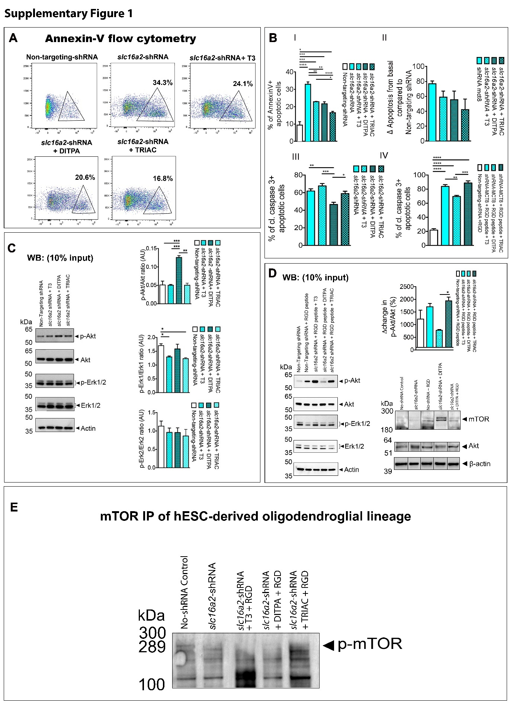

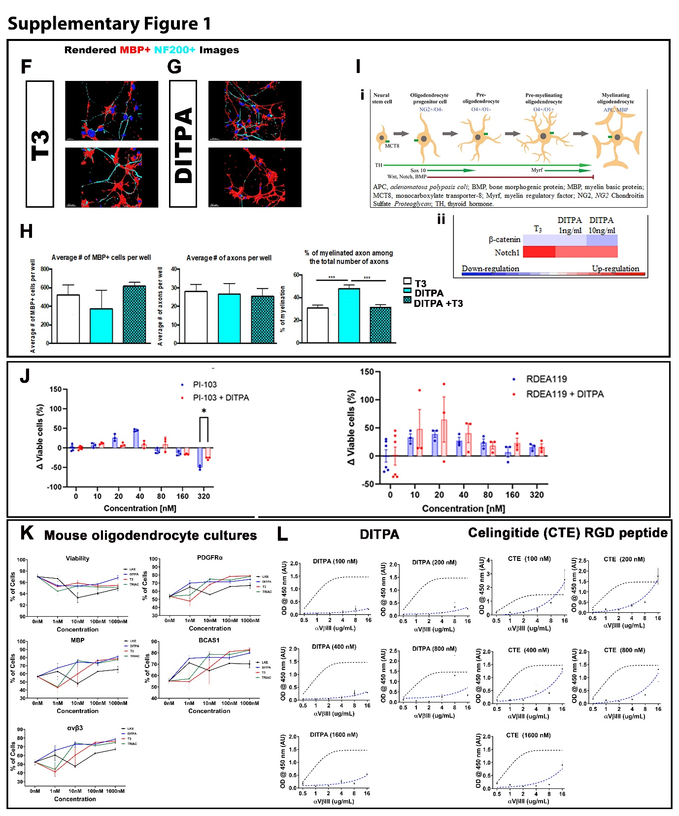

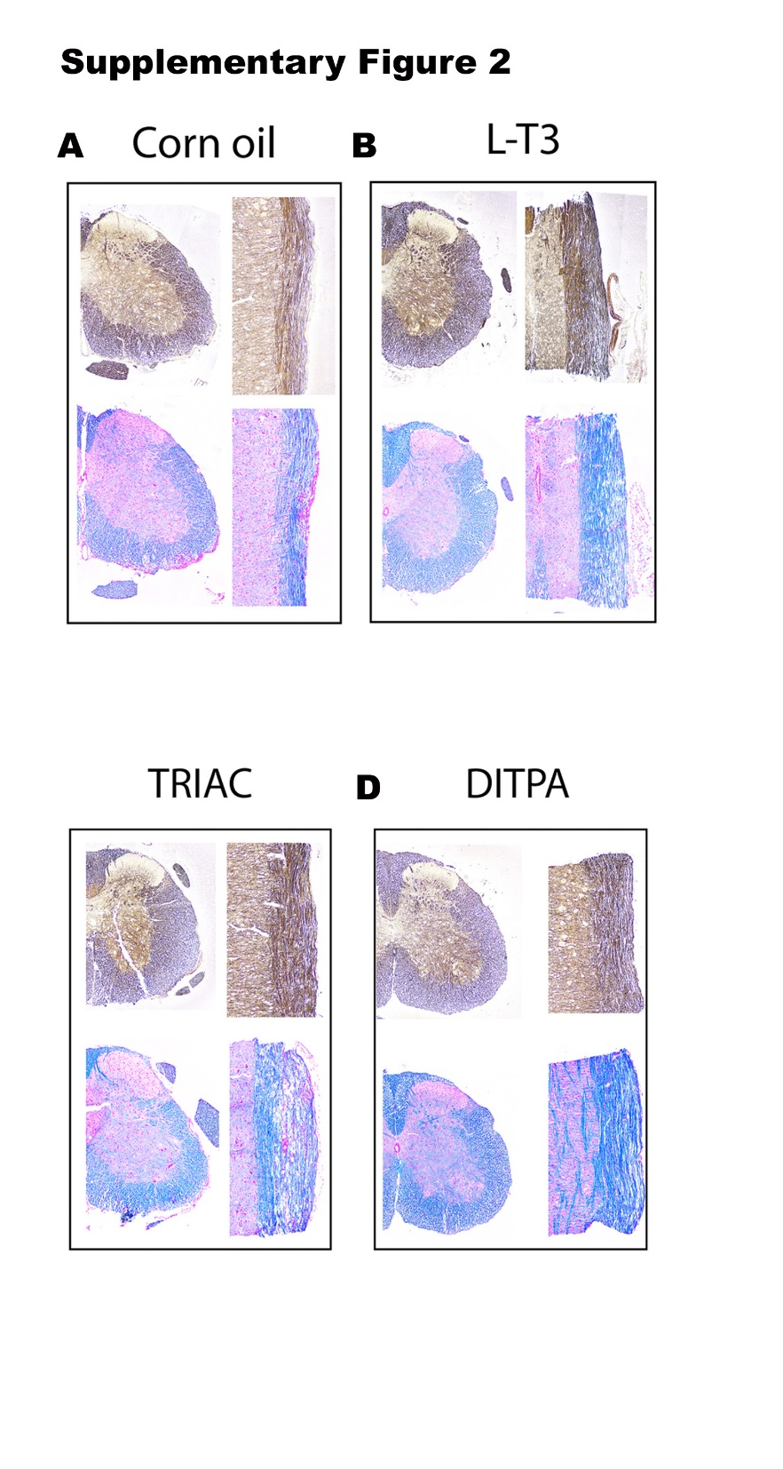

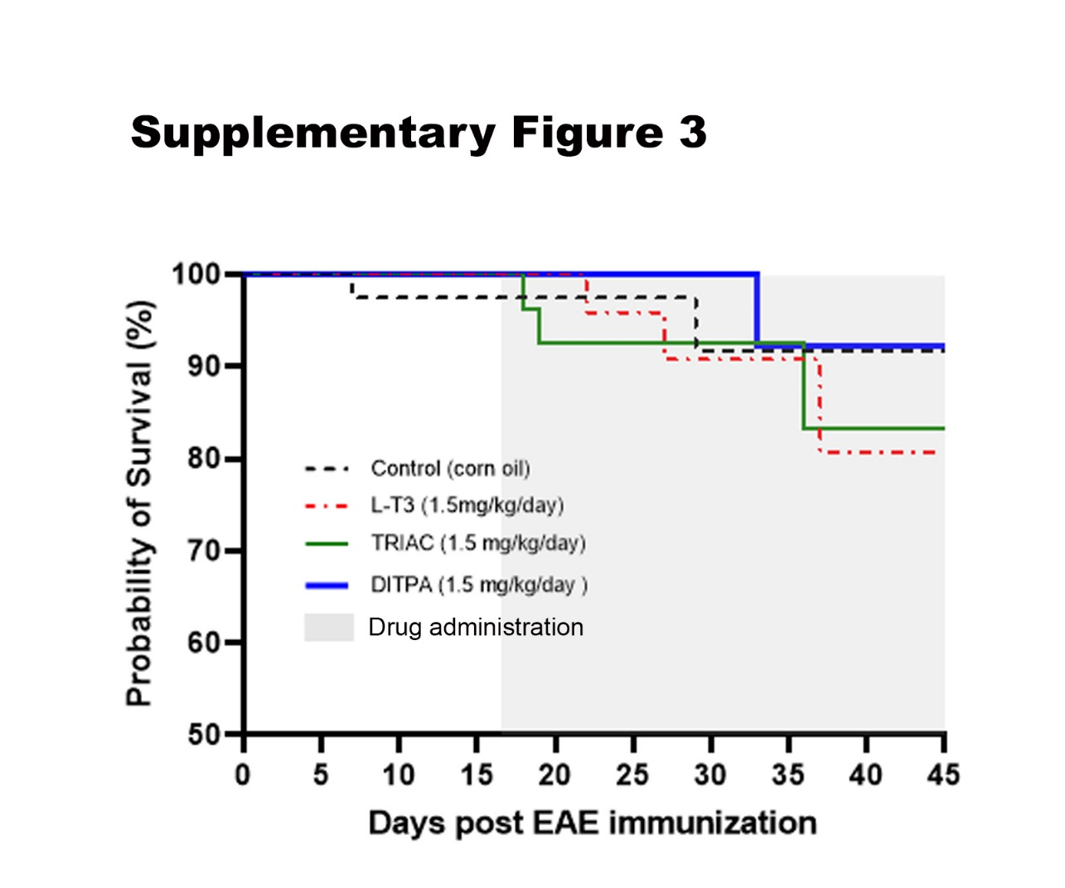

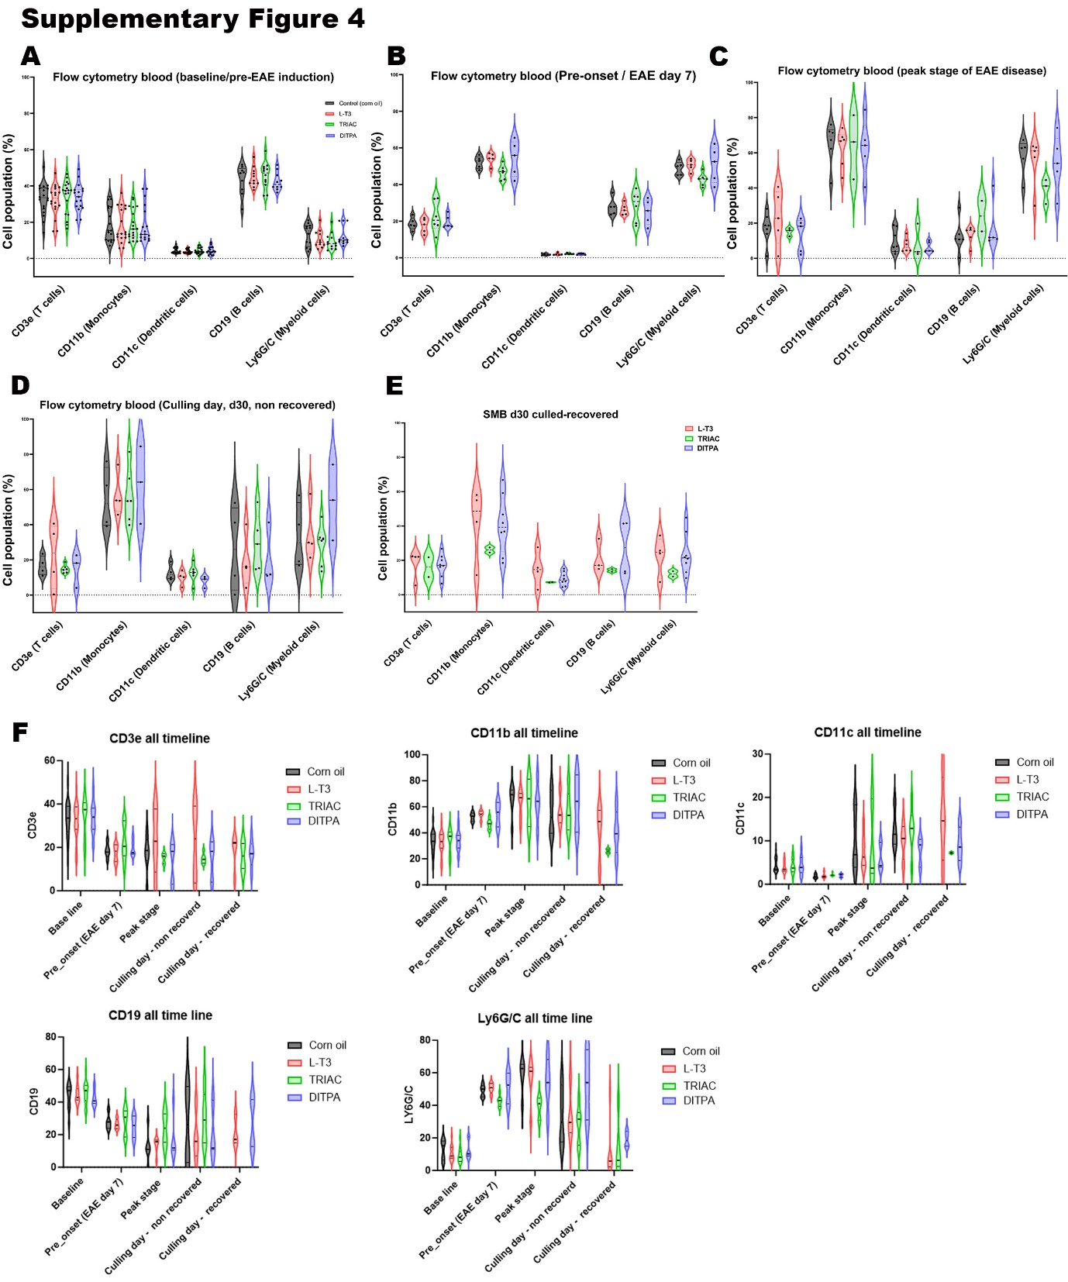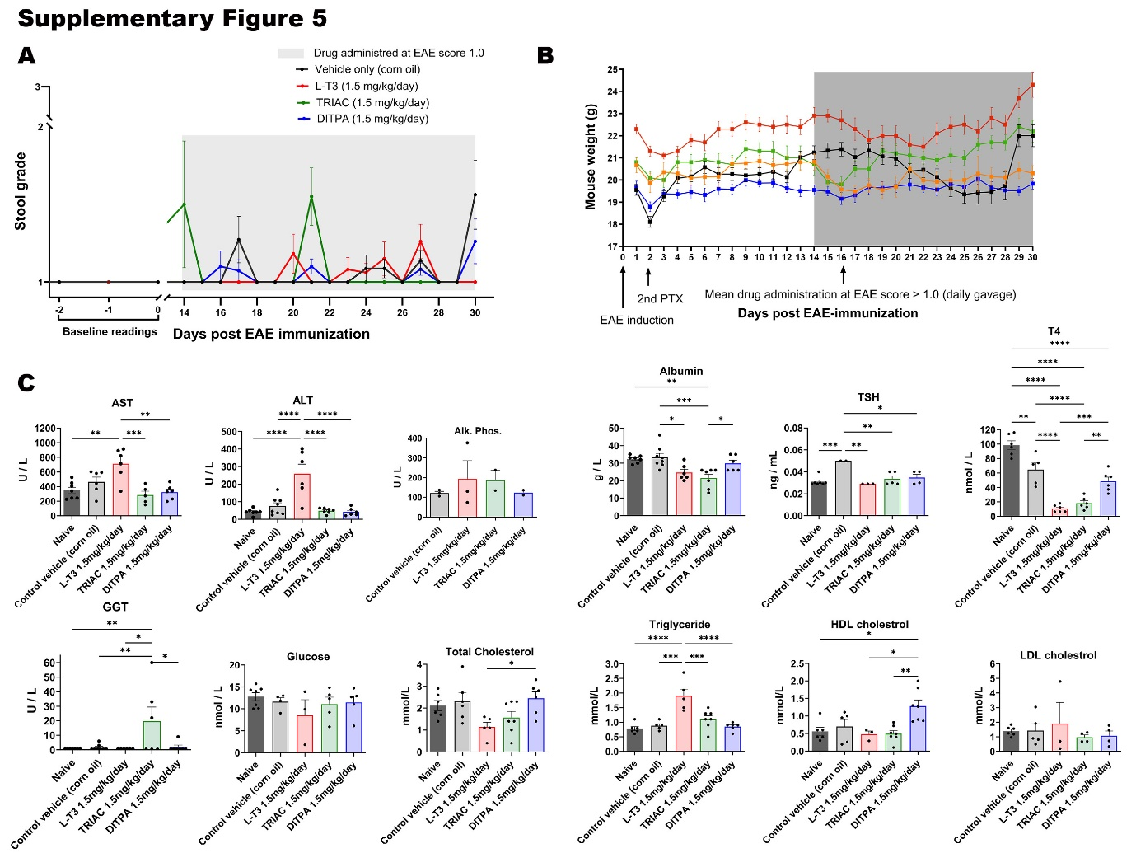
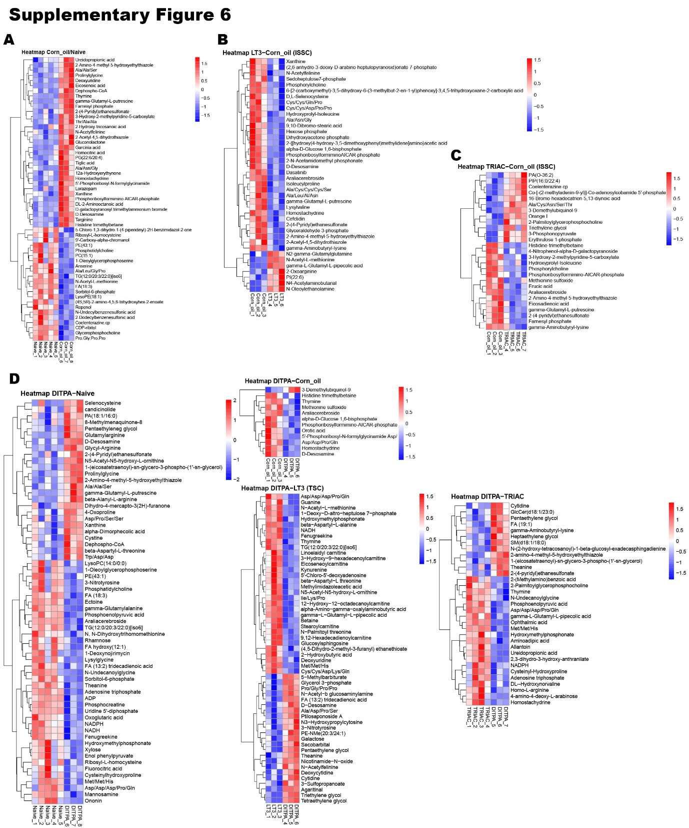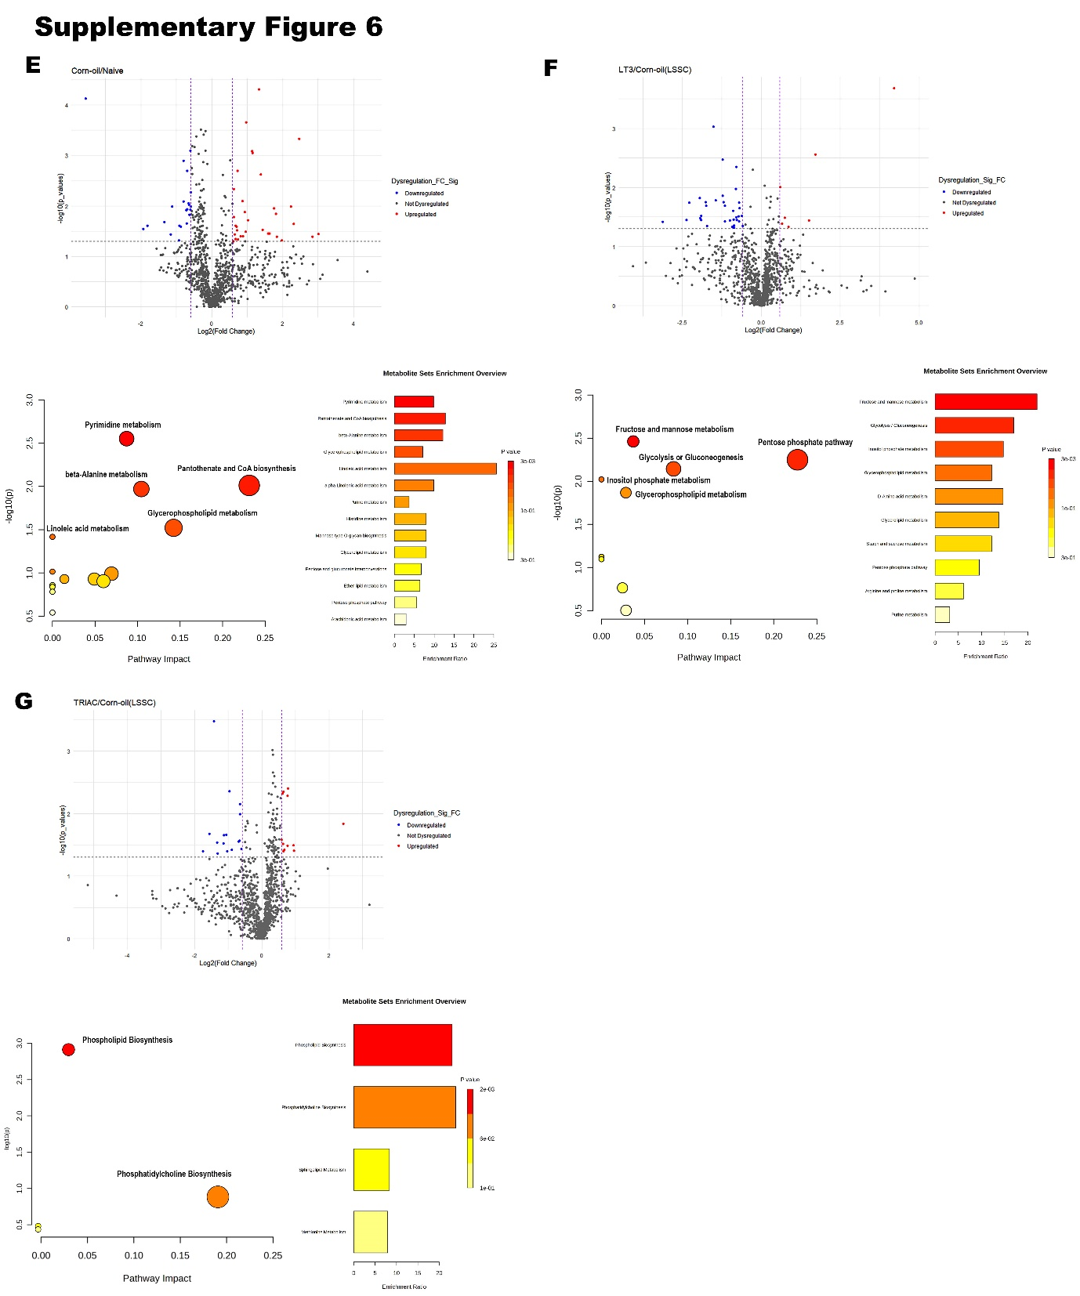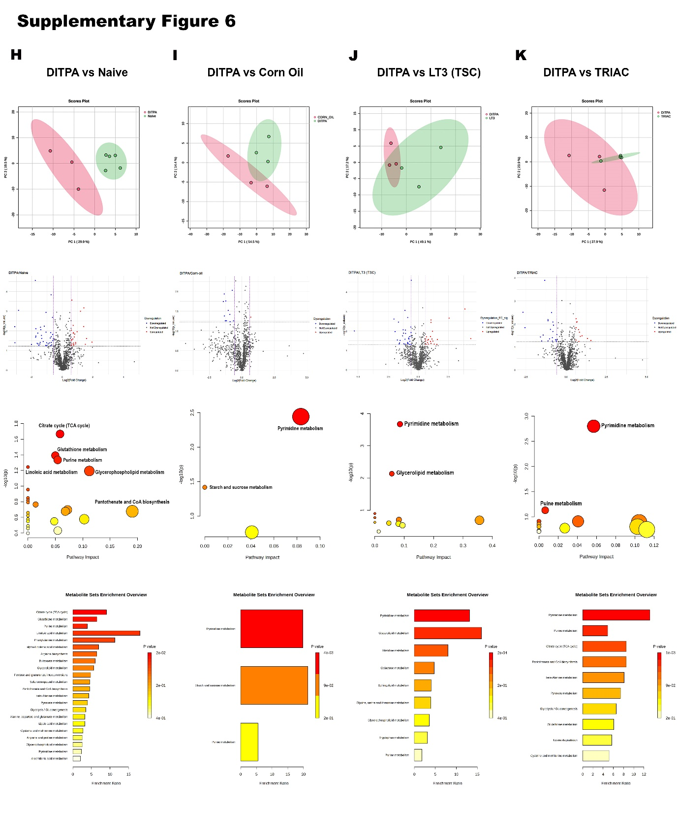

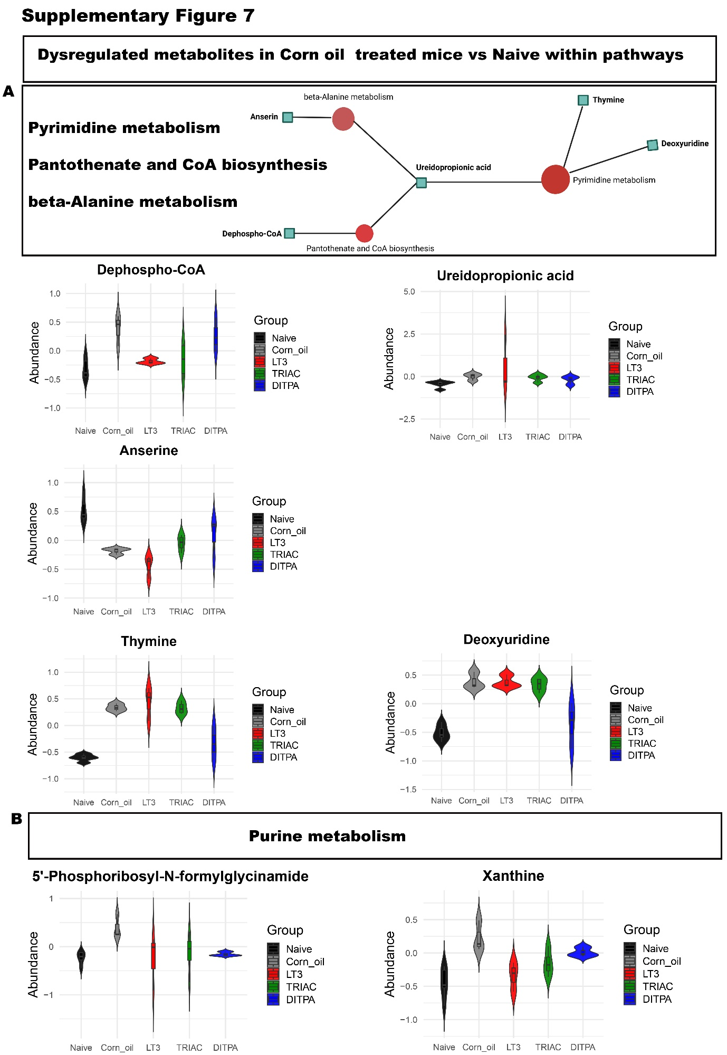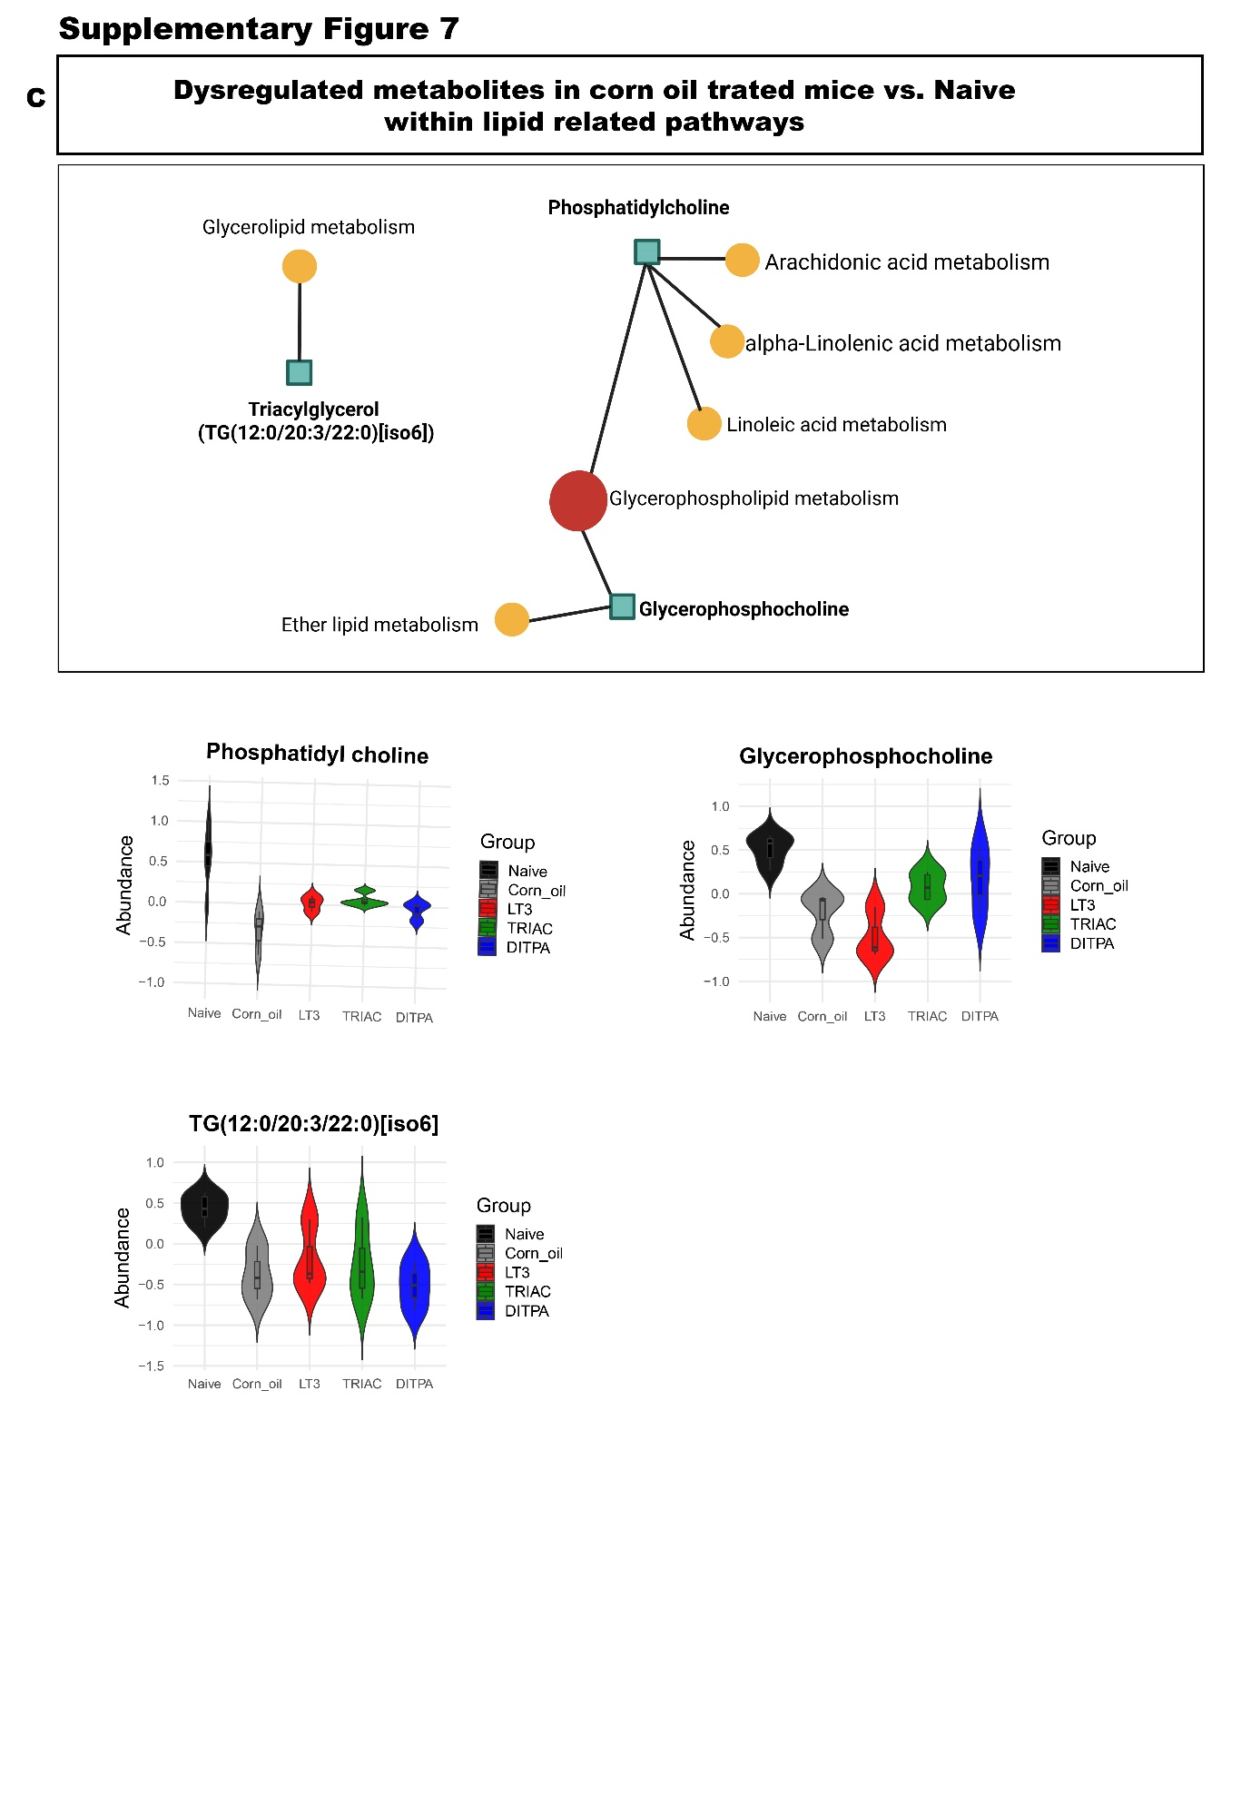

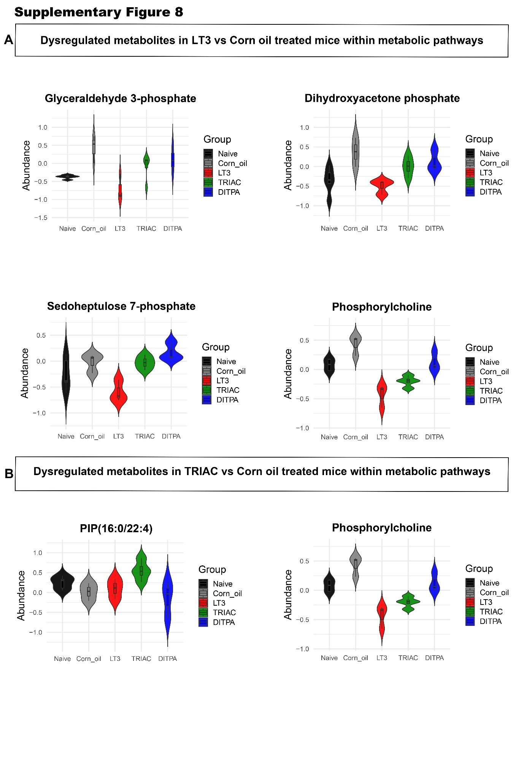
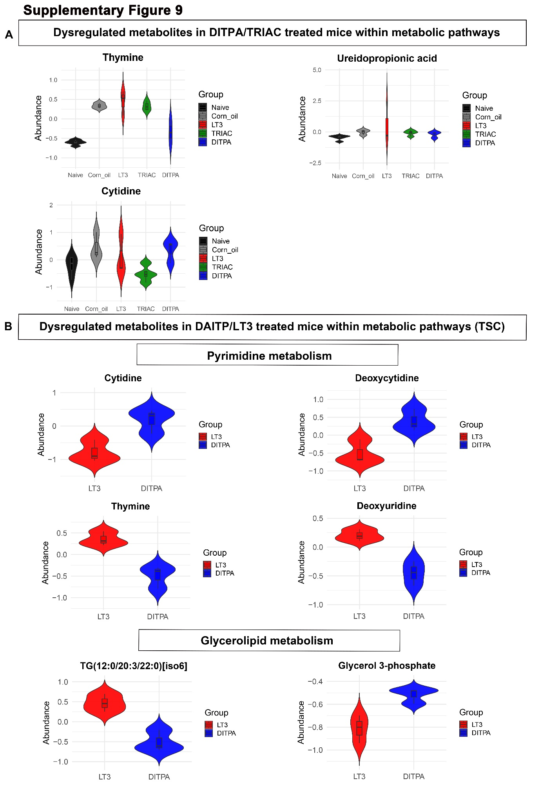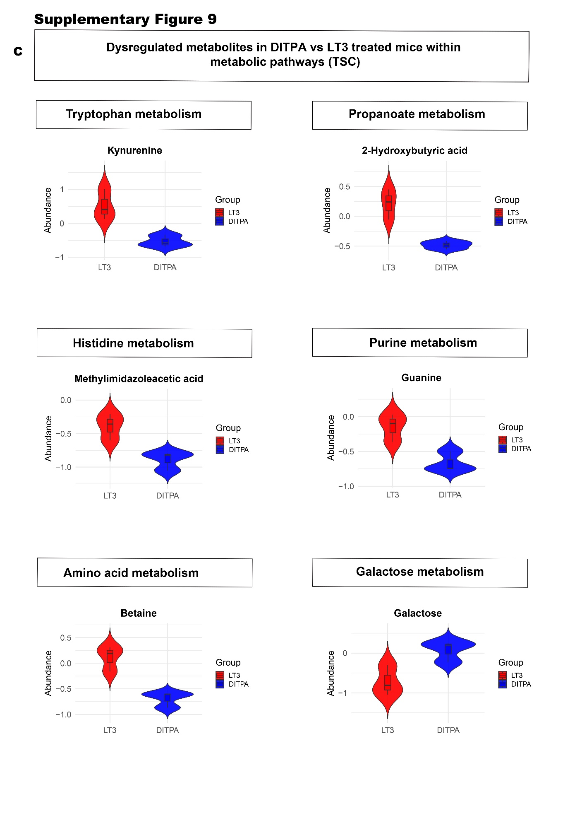

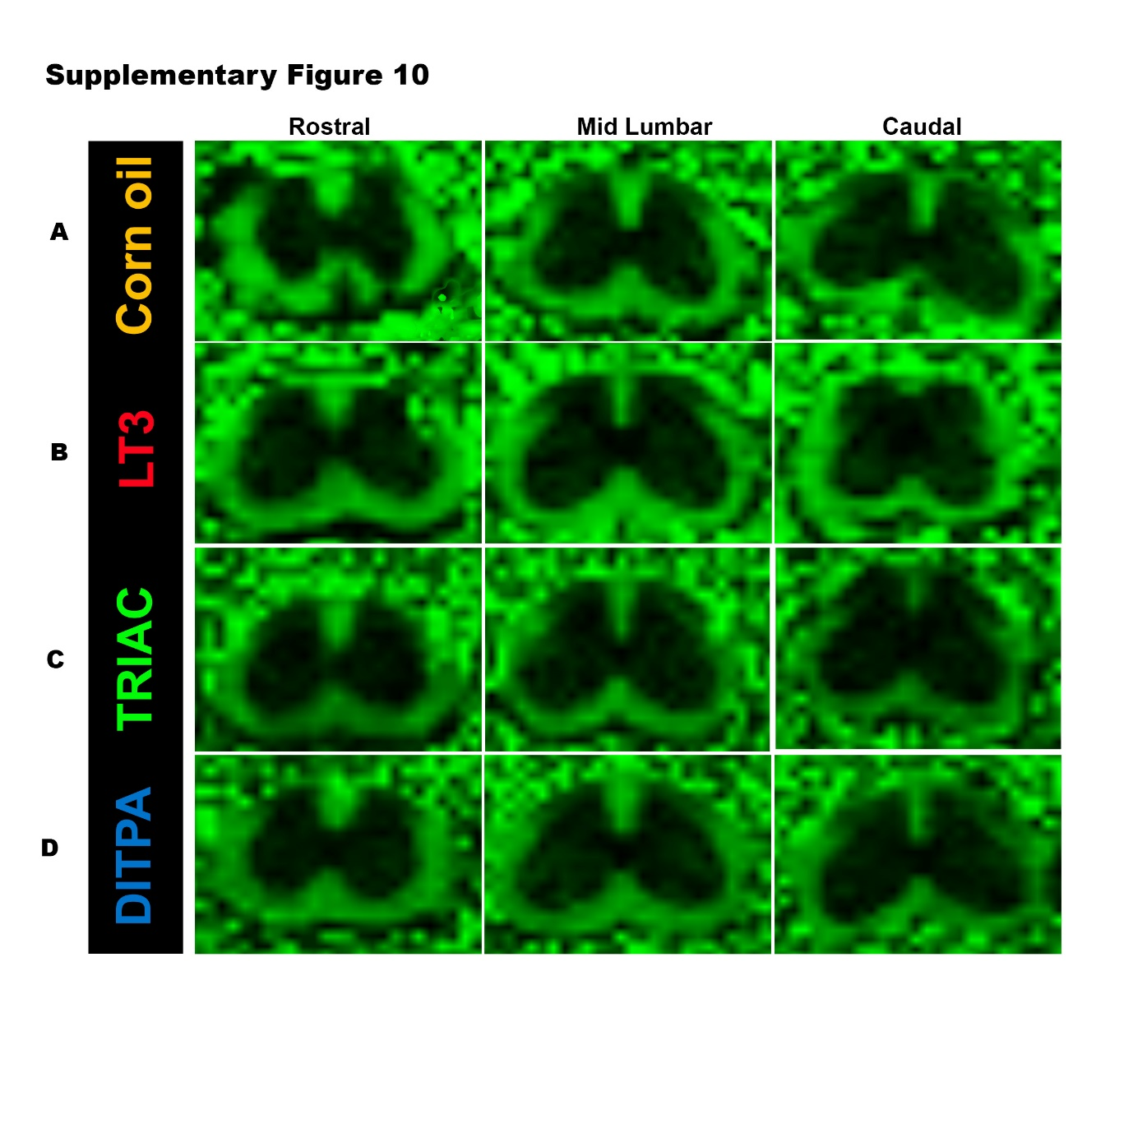

Supplementary Figure 11. Visual outline of the image analysis pipeline
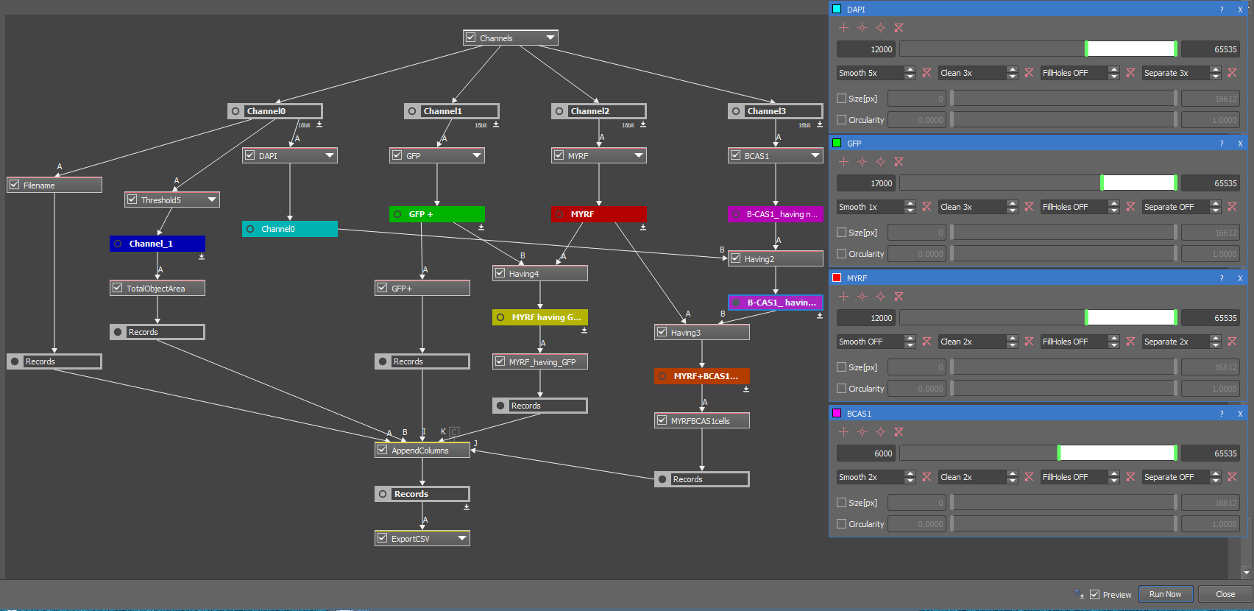

Supplementary Figure Legends
Supplementary Figure 1(A-E). Effects of SLC16A2 knockdown and thyroid hormone analogues on apoptosis and intracellular signalling in hESC-derived oligodendroglial lineage cells.
(A) Flow cytometric analysis of annexin V⁺ cells with and without SLC16A2 knockdown, following 72 h treatment with T3, DITPA, or TRIAC (10 nM) 72 h post–transduction. Data represent the percentage of annexin V⁺ cells. (B) Quantification of annexin V⁺ and caspase–3⁺ HES3–sorted OPCs with and without SLC16A2 knockdown, following 72 h treatment with T3, DITPA or TRIAC (10nM), administered 72 h post–transduction. The data include: (I) Percentage of annexin V⁺ cells, (II) Percentage change (∆) in apoptotic cells from baseline compared to non–targeting shRNA, (III) Percentage of caspase–3⁺ apoptotic cells in the absence of the RGD peptide, and (IV) Percentage of caspase–3⁺ cells in the presence of the RGD peptide in all treated groups. (C) Western blot analysis (10% input) of p–AKT, total AKT (~56 kDa), p–ERK1/2, total ERK1/2 (~41,43 kDa), and actin (~42 kDa, loading control) following 72 h treatment with T3, DITPA or TRIAC treatment (10nM), administered 72 h post–transduction. Densitometric quantification of phosphorylated protein relative to total protein expression is presented in arbitrary units (AU). (D) Western blot analysis (10% input) of p-AKT, total AKT, p-ERK1/2, total ERK1/2, and actin, with additional qualitative analysis of mTOR (~288 kDa) in HES3–derived oligodendroglial lineage cell lysates following 72 h treatment with T3, DITPA or TRIAC (10nM), administered 72 h post–transduction in the presence of the RGD peptide. Data represent the percentage change (∆) in p-AKT normalized to total AKT. (E) Immunoprecipitation of total mTOR from HES3–derived oligodendroglial lineage cell lysates were performed to assess phosphorylated mTOR (~288 kDa) levels following 72 h treatment with T3, DITPA or TRIAC (10nM), administered 72 h post–transduction in the presence of the RGD peptide.
All data are presented as mean ± SEM (n=9 and 4). Statistical analysis: non–parametric one–way ANOVA with post hoc Dunn’s multiple comparisons test (*p≤ 0·05, ** p≤ 0·01, *** p≤ 0·001, **** p≤ 0·0001).
Supplementary Figure 1 (F-L). Analysis of OL differentiation, myelination, and signaling pathways in response to TH analogs and inhibitors.
(F-G) HES3 OPCs as lentivirally transduced to generate MCT8–deficient cells and sorted with O4⁺ marker, were co cultured with rat ganglion cells. 3D–rendered images of the co–cultures show expression of myelin basic protein (MBP, red) and neurofilament protein 200 (NF200, green) expression, counterstained with DAPI, following treatment with T3 (F) or DITPA (G) (10 nM) for 72 h. scale bars = 50 μm. (H) Quantification of MBP⁺ cells, total axon number per well, and the percentage of myelinated axons following treatment with T3, DITPA, or DITPA+T3. Data are presented as mean ± SEM (n = 9–10). (I) Schematic illustration of OL differentiation and development, depicting the progression from neural stem cells to myelinating OLs (i). Gene expression analysis shows that treatment with T3 and DITPA (1 and 20 ng/mL) promotes upregulation of notch1 and down regulation of β–catenin, indicating that DITPA modulates gene expression to enhance OPC differentiation (ii). (J) Assessment of cell viability in hESC-OPCs at stage V of differentiation using the MTT assay. cells were treated for 48 h with PI3K–mTOR inhibitor PI–103 (0–320 nM) and MAPK pathway inhibitor RDEA119 (0–320 nM), in the absence and presence of DITPA. Data are presented as percentage change in viable cells across different concentrations. (K) OLs differentiated from the mouse Oli-neu cell line were treated with increasing concentrations (0–1000 nM) of DITPA and benchmarked against LT3, TRIAC, and the known pro–myelinating small molecule lanthionine ketimine ester (LKE). Flow cytometry was performed to assess cell viability and the expression of OL lineage markers, including PDGFRα (early OPC), BCAS1 (differentiating OLs), MBP (mature myelinating OLs), and integrin αVβ3 (thyroid hormone transporter-associated receptor). (L) Competitive ELISA was performed to validate the binding affinity of DITPA to αVβ3 integrin both in the absence and presence of Cilengitide. The results demonstrate that DITPA binds to αVβ3 integrin, supporting its potential to initiate non–genomic signaling in oligodendroglial lineage cells.
Statistical analysis was performed using one-way ANOVA with Tukey's post-hoc test; (*p≤ 0·05, ** p≤ 0·01, *** p≤ 0·001, **** p≤ 0·0001).
Supplementary Figure 2. Representative images of Luxol Fast Blue and Bielschowsky staining at day 45 post–EAE induction.
Histochemical staining with Luxol Fast Blue (LFB) and Bielschowsky silver was performed on longitudinal, and cross-sections of spinal cords collected 45 days post-EAE induction, to assess myelin and axonal integrity. EAE-induced mice were treated daily via oral gavage with either corn oil (vehicle) or thyroid hormone analogues for 24 days, beginning at day 21 post-induction (corresponding to the peak disease stage). (A) Mice treated with corn oil (vehicle) demonstrate robust demyelination and axon damage. (B) Mice treated with LT3 demonstrate demyelination and axon damage. (C) Mice treated with TRIAC corn oil vehicle demonstrate demyelination and axon damage. (D) Mice treated with DITPA demonstrate minimal demyelination and axon damage.
Supplementary Figure 3. Kaplan–Meier survival analysis of EAE–induced mice treated with TH analogues compared to controls.
Kaplan–Meier survival curves depicting the probability of survival (%) (Y–axis) over time in days post–EAE immunization (X–axis) for mice treated with TH analogues (L–T3, TRIAC, and DITPA) compared to the vehicle control (corn oil) and untreated groups. Survival curve comparisons were performed using the log-rank (Mantel–Cox) test.
Supplementary Figure 4. Longitudinal flow cytometric profiling of peripheral immune cells following EAE induction and TH analogue treatment.
(A–D) Flow cytometric analysis was performed to profile blood immune cell populations at key time points following EAE induction in female C57BL/6 mice. Immune cells were identified using surface markers for T cells (CD3e), monocytes (CD11b), dendritic cells (CD11c), B cells (CD19), and myeloid cells (Ly6G/C). Assessments were conducted at (A) baseline (pre–EAE induction, n = 15–18 per group), (B) day 7 post–EAE induction (pre–onset of disease, n=5–6 per group), (C) peak EAE stage (n = 3–7 per group), and (D) day 30 (end of the experiment in non–recovered mice, n=3–6 per group). Immune cell populations were identified using surface markers for T cells (CD3e), monocytes (CD11b), dendritic cells (CD11c), B cells (CD19), and myeloid cells (LY6G/C). (E) Immune profiles were assessed in recovered mice following treatment with L–T3 (n=4), TRIAC (n=2), and DITPA (n=8). (F) Individual immune cell profiles were evaluated across all time points in mice treated with vehicle control (corn oil), L–T3, TRIAC, and DITPA. Data are presented as mean ± SEM. Statistical analysis was performed using two–way ANOVA Tukey’s post hoc test (*p≤ 0·05, ** p≤ 0·01, *** p≤ 0·001, **** p≤ 0·0001).
Supplementary Figure 5. Metabolic, weight, and biomarker monitoring in EAE–induced mice treated with thyroid hormone analogues.
(A) Metabolic monitoring of adverse effects from drug treatment was conducted in mice using the Paper Towel Method. Stool assessments were conducted in mice treated with vehicle control (corn oil, n=24), L–T3 (n=24), TRIAC (n=24), and DITPA (n=22) by measuring stool number and consistency over a 60–minute period. Stool grades were defined as Grade 1=Normal, Grade 2=Wet, and Grade3= Watery. (B) Body weight was monitored daily in mice following EAE induction with MOG_{33–55}. Both treated and untreated groups were assessed for weight changes. Data are presented as mean ± SEM for the no–drug control (n=11), vehicle control (corn oil, n=24), L–T3 (n=24), TRIAC (n=24), and DITPA (n=22) groups. (C) Blood biomarker assessment was conducted in naïve (healthy controls) and treated EAE–induced mice (vehicle control (corn oil), L–T3, TRIAC, and DITPA) on day 30 (end of the experiment). Liver function markers (Aspartate aminotransferase [AST], Alanine aminotransferase [ALT], Alkaline Phosphatase [ALK.phos], albumin, and Gamma-Glutamyl Transferase [GGT]), thyroid hormones (TSH and T4), blood glucose, and lipid profiles (total cholesterol, triglycerides, HDL, LDL) were measured in serum. Data are presented as mean ± SEM (n=2–7 per group).
Statistical analysis was performed using one-way ANOVA with Tukey’s post hoc test (*p≤ 0·05, ** p≤ 0·01, *** p≤ 0·001, **** p≤ 0·0001).
Supplementary Figure 6 (A-D). Heatmap visualization of dysregulated metabolites identified through metabolomic analysis of the untreated control group (Naïve) and EAE–induced mice treated with corn oil (vehicle) or TH analogues (L–T3, TRIAC, and DITPA).
(A-C) Dysregulated metabolites identified from the volcano plot (p< 0·05 and FC > 1·5) were visualized as heatmaps to compare corn oil (n = 3) with Naïve (n=5, A), L–T3 (n=3, B), and TRIAC (n=4, C) groups. (D) Additionally, expression patterns of DITPA (n=3) were compared against Naïve, corn oil, L–T3, and TRIAC. Data analysis was performed in R (v4·2·1) using the Heatmap, struct, structtoolbox, and ggplot2 packages. All comparisons were performed on lumbosacral spinal cords, except for DITPA/L–T3, which were analysed in thoracic spinal cords.
Supplementary Figure 6 (E-G). Metabolomic profiling and pathway analysis of EAE–induced mice treated with TH analogues.
An untargeted metabolomic approach was used to assess the metabolic profiles of untreated control mice (Naïve, n=5) and EAE–induced mice treated with corn oil (vehicle, n=3) or TH analogues (L–T3; n=3, TRIAC; n=4). Volcano plots (-log10(p–values) versus log2(fold change>1·5)) highlight significant differences in metabolite expression, with upregulated metabolites shown in red and downregulated metabolites in blue. Volcano plot analysis was conducted in R (v4·2·1) using struct, structtoolbox, and ggplot packages. Pathway and enrichment analyses of dysregulated metabolites were conducted using MetaboAnalyst 6.0 with KEGG IDs and the Mus musculus sapiens pathway library. Pathway impact (circle size) represents the combined results of centrality and enrichment analysis, while colour intensity (red to yellow) indicates statistical significance, with red representing the highest significance. Results are presented for corn oil/Naïve (E), L–T3/Corn oil (F), TRIAC/Corn oil (G).
Supplementary Figure 6 (H-K). Metabolomic profiles following DITPA administration compared to control and daily administration of TH analogues (L–T3 and TRIAC).
An untargeted metabolomic approach was employed to compare the metabolic profiles of DITPA–treated mice (n=3) with untreated control mice (Naïve) (n=5, H), EAE–induced mice treated with corn oil (vehicle) (n=3, I), and EAE–induced mice treated with another thyroid hormone analogues, including L–T3 (n=3, J) and TRIAC (n=4, K). Principal Component Analysis (PCA) was performed to visualize multivariate variance between groups, while univariate analyses, including t-tests (p < 0·05) and volcano plots (-log10(p–values) versus log2(fold change>1·5), identified significant differences in metabolite expression.
Data analysis was carried out in R (v4·2·1) using struct, structtoolbox, and ggplot packages. Pathway and enrichment analyses of dysregulated metabolites were performed using MetaboAnalyst 6.0, employing KEGG IDs and the Mus musculus sapiens pathway library to identify significantly enriched metabolic pathways. Pathway impact (circle size) represents the combined results of centrality and enrichment analysis, while colour intensity (red to yellow) denotes statistical significance, with red indicating the highest significance.
Supplementary Figure 7 (A-B). Metabolite alterations and pathway associations in LSSC of EAE–induced mice treated with Corn oil versus Naïve controls
Violin plots illustrate the distribution and density of abundance values for metabolites that were significantly altered in LSSC between EAE–induced mice treated with corn oil (n=3) and Naïve as controls (n=5), mapped to their associated metabolic pathways. Significantly dysregulated metabolites were identified through volcano plot analysis using p value < 0·05 and FC > 1·5. In each plot, the violin outline represents the kernel density estimate, and the embedded boxplot denotes the interquartile range and median. Plots were generated in R (v4·2·1) using the ggplot2 package. The pathway enrichment network in panel A displays enriched metabolic pathways, with circle size indicating pathway impact and colour intensity (yellow to red) representing statistical significance, where deeper red corresponds to higher significance.
Figure 7 (C). Significantly altered metabolites and pathway enrichment in LSSC of EAE–induced mice treated with Corn oil versus Naïve controls
Violin plots illustrate the distribution and density of abundance values for metabolites that were significantly altered in LSSC between EAE–induced mice treated with corn oil (n=3) and Naïve as controls (n=5), mapped to their associated metabolic pathways. Significantly dysregulated metabolites were identified through volcano plot analysis using p<0·05 and FC > 1·5. In each plot, the violin outline represents the kernel density estimate, and the embedded boxplot denotes the interquartile range and median. Plots were generated in R (v4·2·1) using the ggplot2 package. The pathway enrichment network in panel A displays enriched metabolic pathways, with circle size indicating pathway impact and colour intensity (yellow to red) representing statistical significance, where deeper red corresponds to higher significance.
Supplementary Figure 8 (A-B). Significantly altered metabolites in EAE-induced mice treated with LT3, or TRIAC compared to Corn oil
Violin plots illustrate the distribution and density of abundance values for metabolites that were significantly altered in LSSC between EAE-induced mice treated with LT3 (n = 3), TRIAC (n = 4), and corn oil as vehicle controls (n = 3), mapped to their associated metabolic pathways. Significantly dysregulated metabolites were identified through volcano plot analysis using p<0·05 and FC > 1·5. In each plot, the violin outline represents the kernel density estimate, and the embedded boxplot denotes the interquartile range and median. Plots were generated in R (v4·2·1) using the ggplot2 package.

Supplementary Figure 9 (A-B). Significantly altered metabolites in EAE–induced mice treated with DITPA compared with TRIAC, and with LT3
Violin plots illustrate the distribution and density of abundance values for metabolites that were significantly altered in (A) LSSC between EAE–induced mice treated with DITPA (n=3) compared with TRIAC (n=4) and in TSC (B) EAE–induced mice treated with DITPA (n=3) compared with LT3 (n=3) mapped to their associated metabolic pathways. Significantly dysregulated metabolites were identified through volcano plot analysis using p<0·05 and FC > 1·5. In each plot, the violin outline represents the kernel density estimate, and the embedded boxplot denotes the interquartile range and median. Plots were generated in R (v4·2·1) using the ggplot2 package.
Supplementary Figure 9 C. Significantly altered metabolites in EAE–induced mice treated with DITPA compared LT3 (TSC).
Violin plots illustrate the distribution and density of abundance values for metabolites that were significantly altered in EAE–induced mice treated with DITPA (n=3) compared with LT3 (n=3) mapped to their associated metabolic pathways. Significantly dysregulated metabolites were identified through volcano plot analysis using p<0·05 and FC > 1·5. In each plot, the violin outline represents the kernel density estimate, and the embedded boxplot denotes the interquartile range and median. Plots were generated in R (v4·2·1) using the ggplot2 package.
Supplementary Figure 10. T2-Weighted coronal MRI images of lumbosacral spinal cord in EAE–induced mice treated with TH analogs, acquired using MRtrix Software.
T2–weighted coronal MRI images of lumbosacral spinal cord sections—including rostral, mid–lumbar, and caudal regions in EAE–induced mice treated with DITPA, TRIAC, L–T3, or vehicle (corn oil), acquired using MRtrix software.
Supplementary Figure 11. Visual outline of the image analysis pipeline.

Supplementary Tables.

Supplementary Table 1. Dysregulated metabolites in DITPA/Corn oil (LSSC)
Dysregulated metabolites (DITPA/Corn oil)  (LSSC) | KEGG | Fold Change | p-value | Regulation status
3-Demethylubiquinol-9 | NA | 1·60 | 0·04 | Upregulated
Homostachydrine | C08283 | 0·60 | 0·01 | Downregulated
Araliacerebroside | NA | 0·39 | 0·01 | Downregulated
Asp/Asp/Asp/Pro/Gln | NA | 0·42 | 0·02 | Downregulated
Methionine sulfoxide | C02989 | 0·37 | 0·02 | Downregulated
D-Desosamine | NA | 0·48 | 0·03 | Downregulated
Orotic acid | C00295 | 0·53 | 0·04 | Downregulated
alpha-D-Glucose 1,6-bisphosphate | C01231 | 0·39 | 0·04 | Downregulated
Histidine trimethylbetaine | C05575 | 0·44 | 0·055 | Downregulated
5'-Phosphoribosyl-N-formylglycinamide | C04376 | 0·64 | 0·056 | Downregulated
Phosphoribosylformimino-AICA-phosphate | C04896 | 0·41 | 0·056 | Downregulated
Thymine | C00178 | 0·53 | 0·058 | Downregulated

Supplementary Table 2. Pathway analysis- DITPA/Corn oil (LSSC).
Pathway analysis- DITPA/Corn oil (LSSC) | Total | Expected | Hits | p-value | Impact
Pyrimidine metabolism | 39 | 0·1 | 2 | 0·004 | 0·08
Starch and sucrose metabolism | 15 | 0·04 | 1 | 0·04 | 0·00
Purine metabolism | 71 | 0·2 | 1 | 0·17 | 0·04

Supplementary Table 3. Dysregulated metabolites in DITPA/Naïve (LSSC).
Dysregulated metabolites (DITPA/Naïve)  (LSSC) | KEGG | Fold Change | p-value | Regulation status
1-(eicosatetraenoyl)-sn-glycero-3-phospho-(1'-sn-glycerol) | NA | 1·54 | 2·75E-04 | Upregulated
D-Desosamine | NA | 2·66 | 6·86E-04 | Upregulated
N5-Acetyl-N5-hydroxy-L-ornithine | NA | 2·28 | 1·03E-03 | Upregulated
2-Amino-4-methyl-5-hydroxyethylthiazole | NA | 1·63 | 5·31E-03 | Upregulated
Prolinylglycine | NA | 2·63 | 6·06E-03 | Upregulated
Xanthine | C00385 | 1·51 | 9·52E-03 | Upregulated
alpha-Dimorphecolic acid | C14767 | 1·95 | 1·13E-02 | Upregulated
Glycyl-Arginine | NA | 1·65 | 1·27E-02 | Upregulated
beta-Aspartyl-L-threonine | NA | 1·64 | 1·32E-02 | Upregulated
4-Oxoproline | C01877 | 1·74 | 1·46E-02 | Upregulated
Pentaethylene glycol | NA | 1·71 | 2·05E-02 | Upregulated
Glutamylarginine | NA | 2·98 | 2·52E-02 | Upregulated
Selenocysteine | C05688 | 1·61 | 2·62E-02 | Upregulated
Candicinolide | NA | 1·52 | 2·80E-02 | Upregulated
8-Methylmenaquinone-8 | NA | 1·51 | 3·07E-02 | Upregulated
beta-Alanyl-L-arginine | C05340 | 3·83 | 3·82E-02 | Upregulated
PA (18:1/16:0) | NA | 1·82 | 3·99E-02 | Upregulated
Dihydro-4-mercapto-3(2H)-furanone | NA | 1·66 | 4·19E-02 | Upregulated
Ala/Ala/Ser | NA | 1·82 | 4·61E-02 | Upregulated
Trp/Asp/Asp | NA | 1·52 | 4·64E-02 | Upregulated
gamma-Glutamyl-L-putrescine | C15699 | 2·84 | 4·80E-02 | Upregulated
Cystine | C00491 | 1·65 | 4·92E-02 | Upregulated
Asp/Pro/Ser/Ser | NA | 1·67 | 5·00E-02 | Upregulated
Dephospho-CoA | C00882 | 1·50 | 5·00E-02 | Upregulated
2-(4-Pyridyl) ethanesulfonate | NA | 1·68 | 5·00E-02 | Upregulated
Ectoine | C06231 | 0·29 | 2·79E-05 | Downregulated
gamma-Glutamylalanine | C03740 | 0·60 | 1·51E-04 | Downregulated
Adenosine triphosphate | C00002 | 0·14 | 9·15E-04 | Downregulated
Phosphoenolpyruvic acid | C00074 | 0·48 | 1·16E-03 | Downregulated
Sorbitol-6-phosphate | C01096 | 0·63 | 2·12E-03 | Downregulated
Oxoglutaric acid | C00026 | 0·44 | 5·82E-03 | Downregulated
N-Undecanoylglycine | NA | 0·12 | 6·19E-03 | Downregulated
FA (18:3) | NA | 0·37 | 6·63E-03 | Downregulated
Lysylglycine | NA | 0·30 | 7·87E-03 | Downregulated
FA hydroxy (12:1) | NA | 0·38 | 8·76E-03 | Downregulated
Theanine | C01047 | 0·48 | 1·18E-02 | Downregulated
3-Nitrotyrosine | NA | 0·59 | 1·26E-02 | Downregulated
Araliacerebroside | NA | 0·33 | 1·30E-02 | Downregulated
Met/Met/His | NA | 0·64 | 1·54E-02 | Downregulated
TG (12:0/20:3/22:0) [iso6] | C00422 | 0·39 | 1·71E-02 | Downregulated
NADPH | C00005 | 0·30 | 1·89E-02 | Downregulated
N, N-Dihydroxytrihomomethionine | NA | 0·61 | 2·00E-02 | Downregulated
Hydroxymethylphosphonate | C06455 | 0·30 | 2·13E-02 | Downregulated
Phosphatidylcholine | C00157 | 0·58 | 2·34E-02 | Downregulated
Mannosamine | C03570 | 0·39 | 2·42E-02 | Downregulated
Ononin | C10509 | 0·66 | 2·53E-02 | Downregulated
Asp/Asp/Asp/Pro/Gln | NA | 0·65 | 3·19E-02 | Downregulated
Rhamnose | C00507 | 0·42 | 3·59E-02 | Downregulated
D-Xylose | C00181 | 0·37 | 3·89E-02 | Downregulated
LysoPC (14:0/0:0) | C04230 | 0·60 | 4·00E-02 | Downregulated
1-Deoxynojirimycin | C16843 | 0·49 | 4·01E-02 | Downregulated
Phosphocreatine | C02305 | 0·12 | 4·03E-02 | Downregulated
Ribosyl-L-homocysteine | C03539 | 0·56 | 4·10E-02 | Downregulated
Fenugreekine | NA | 0·32 | 4·29E-02 | Downregulated
Cysteinylhydroxyproline | NA | 0·52 | 4·60E-02 | Downregulated
FA (13:2) tridecadienoic acid | NA | 0·36 | 4·69E-02 | Downregulated
Enol-phenylpyruvate | C02763 | 0·33 | 4·78E-02 | Downregulated
Uridine 5'-diphosphate | C00015 | 0·25 | 5·00E-02 | Downregulated
PE (43:1) | NA | 0·62 | 5·00E-02 | Downregulated
ADP | C00008 | 0·47 | 5·00E-02 | Downregulated
NADH | C00004 | 0·35 | 5·00E-02 | Downregulated
1-Oleoylglycerophosphoserine | NA | 0·50 | 5·00E-02 | Downregulated
Fluoroacetic acid | C06108 | 0·59 | 5·00E-02 | Downregulated

Supplementary Table 4· Pathway analysis- DITPA/Naïve (LSSC).
Pathway analysis- DITPA/Naïve (LSSC) | Total | Expected | Hits | p-value | Impact
Citrate cycle (TCA cycle) | 20 | 0·23 | 2 | 0·02 | 0·06
Glutathione metabolism | 28 | 0·33 | 2 | 0·04 | 0·05
Purine metabolism | 71 | 0·83 | 3 | 0·05 | 0·05
Linoleic acid metabolism | 5 | 0·06 | 1 | 0·06 | 0·00
Glycerophospholipid metabolism | 36 | 0·42 | 2 | 0·06 | 0·11
Phenylalanine metabolism | 10 | 0·12 | 1 | 0·11 | 0·00
alpha-Linolenic acid metabolism | 13 | 0·15 | 1 | 0·14 | 0·00
Arginine biosynthesis | 14 | 0·16 | 1 | 0·15 | 0·00
Butanoate metabolism | 15 | 0·17 | 1 | 0·16 | 0·00
Glycerolipid metabolism | 16 | 0·19 | 1 | 0·17 | 0·01
Pentose and glucuronate interconversions | 19 | 0·22 | 1 | 0·20 | 0·07
Selenocompound metabolism | 20 | 0·23 | 1 | 0·21 | 0·07
Pantothenate and CoA biosynthesis | 20 | 0·23 | 1 | 0·21 | 0·19
beta-Alanine metabolism | 21 | 0·24 | 1 | 0·22 | 0·00
Pyruvate metabolism | 23 | 0·27 | 1 | 0·24 | 0·00
One carbon pool by folate | 26 | 0·30 | 1 | 0·26 | 0·00
Glycolysis or Gluconeogenesis | 26 | 0·30 | 1 | 0·26 | 0·10
Lipoic acid metabolism | 28 | 0·33 | 1 | 0·28 | 0·00
Alanine, aspartate and glutamate metabolism | 28 | 0·33 | 1 | 0·28 | 0·05
Cysteine and methionine metabolism | 33 | 0·38 | 1 | 0·32 | 0·00
Arginine and proline metabolism | 36 | 0·42 | 1 | 0·35 | 0·00
Pyrimidine metabolism | 39 | 0·45 | 1 | 0·37 | 0·05
Arachidonic acid metabolism | 43 | 0·50 | 1 | 0·40 | 0·00

Supplementary Table 5. Dysregulated metabolites in Corn oil/Naive (LSSC).
Dysregulated metabolites (Corn oil/Naive)  (LSSC) | KEGG | Fold Change | p-value | Regulation status
Thymine | C00178 | 2·52 | 4·89E-05 | Upregulated
Garcinia acid | NA | 1·96 | 2·22E-04 | Upregulated
D-Desosamine | NA | 5·51 | 4·72E-04 | Upregulated
Deoxyuridine | C00526 | 2·20 | 8·27E-04 | Upregulated
Homostachydrine | C08283 | 2·23 | 8·86E-04 | Upregulated
Targinine | C03884 | 1·66 | 2·02E-03 | Upregulated
N-Acetylfelinine | NA | 2·61 | 2·39E-03 | Upregulated
3-Hydroxy-2-methylpyridine-5-carboxylate | C01270 | 1·54 | 4·67E-03 | Upregulated
Thr/Ala/Ala | NA | 1·83 | 7·96E-03 | Upregulated
gamma-Glutamyl-L-putrescine | C15699 | 4·71 | 1·02E-02 | Upregulated
Histidine trimethylbetaine | C05575 | 3·37 | 1·12E-02 | Upregulated
Xanthine | C00385 | 1·90 | 1·32E-02 | Upregulated
Prolylglycine | NA | 3·51 | 1·45E-02 | Upregulated
2-Hydroxy-tricosanoic acid | NA | 1·54 | 1·68E-02 | Upregulated
2-(4-Pyridyl) ethanesulfonate | NA | 2·04 | 1·92E-02 | Upregulated
Gluconolactone | C00198 | 4·95 | 2·29E-02 | Upregulated
Eicosenoic acid | C16526 | 1·60 | 2·45E-02 | Upregulated
Dephospho-CoA | C00882 | 1·62 | 2·60E-02 | Upregulated
Farnesyl phosphate | C20121 | 2·70 | 2·97E-02 | Upregulated
5'-Phosphoribosyl-N-formylglycinamide | C04376 | 1·65 | 3·05E-02 | Upregulated
2-Amino-4-methyl-5-hydroxyethylthiazole | NA | 1·93 | 3·25E-02 | Upregulated
Phosphoribosylformimino AICAR-phosphate | C04896 | 3·10 | 3·49E-02 | Upregulated
Ala/Ala/Ser | NA | 3·01 | 3·55E-02 | Upregulated
DL-2-Aminooctanoic acid | NA | 8·07 | 3·60E-02 | Upregulated
12a-Hydroxyerythynone | NA | 1·57 | 3·69E-02 | Upregulated
Ala-Asp-Gly | NA | 1·85 | 3·95E-02 | Upregulated
Ureidopropionic acid | C02642 | 1·76 | 4·03E-02 | Upregulated
D-galactopyranosyl trimethylammonium bromide | NA | 7·15 | 4·04E-02 | Upregulated
2-Acetyl-4,5-dihydrothiazole | NA | 3·55 | 4·11E-02 | Upregulated
Homocitric acid | C01251 | 1·59 | 4·52E-02 | Upregulated
PG (22:6/20:4) | NA | 1·66 | 4·61E-02 | Upregulated
Tiglic acid | C08279 | 3·94 | 4·86E-02 | Upregulated
Lorazepam | NA | 1·53 | 4·99E-02 | Upregulated
N-Acetyl-L-methionine | C02712 | 0·09 | 7·42E-05 | Downregulated
LysoPE(18:1) | NA | 0·66 | 8·08E-04 | Downregulated
Anserin | C01262 | 0·58 | 1·28E-03 | Downregulated
Sorbitol-6-phosphate | C01096 | 0·62 | 2·03E-03 | Downregulated
Coelenterazine cp | NA | 0·66 | 5·39E-03 | Downregulated
(4S,5R)-2-amino-4,5,6-trihydroxyhex-2-enoate | NA | 0·57 | 8·24E-03 | Downregulated
N-Undecylbenzenesulfonic acid | NA | 0·64 | 8·96E-03 | Downregulated
Ala/Leu/Gly/Pro | NA | 0·64 | 9·52E-03 | Downregulated
PC (18:0/24:1)- Phosphatidyl choline | C00157 | 0·46 | 1·02E-02 | Downregulated
Repenol | NA | 0·66 | 1·02E-02 | Downregulated
2-Dodecylbenzenesulfonic acid | NA | 0·62 | 1·17E-02 | Downregulated
Pro/Gly/Pro/Pro | NA | 0·66 | 1·19E-02 | Downregulated
PE (43:1) | NA | 0·61 | 1·22E-02 | Downregulated
PC (15:1) | NA | 0·65 | 1·50E-02 | Downregulated
1-Oleoylglycerophosphoserine | NA | 0·39 | 2·07E-02 | Downregulated
CDP-ribitol | C00789 | 0·62 | 2·20E-02 | Downregulated
Glycerophosphocholine | C00670 | 0·53 | 2·46E-02 | Downregulated
FA (18:3) | NA | 0·28 | 2·49E-02 | Downregulated
Ribosyl-L-homocysteine | C03539 | 0·55 | 2·60E-02 | Downregulated
5-Chloro-1,3-dihydro-1-(4-piperidinyl)-2H-benzimidazol-2-one | NA | 0·26 | 2·87E-02 | Downregulated
TG (12:0/20:3/22:0) [iso6] | C00422 | 0·45 | 3·66E-02 | Downregulated
9'-Carboxy-alpha-chromanol | NA | 0·53 | 4·80E-02 | Downregulated

Supplementary Table 6. Pathway analysis- Corn oil/Naïve (LSSC).
Pathway analysis- Corn oil/Naïve (LSSC) | Total | Expected | Hits | p-value | Impact
Pyrimidine metabolism | 39 | 0·30 | 3 | 0·003 | 0·09
Pantothenate and CoA biosynthesis | 20 | 0·16 | 2 | 0·01 | 0·23
beta-Alanine metabolism | 21 | 0·16 | 2 | 0·01 | 0·10
Glycerophospholipid metabolism | 36 | 0·28 | 2 | 0·03 | 0·14
Linoleic acid metabolism | 5 | 0·04 | 1 | 0·04 | 0·00
alpha-Linolenic acid metabolism | 13 | 0·10 | 1 | 0·10 | 0·00
Purine metabolism | 71 | 0·55 | 2 | 0·10 | 0·07
Glycerolipid metabolism | 16 | 0·12 | 1 | 0·12 | 0·01
Histidine metabolism | 16 | 0·12 | 1 | 0·12 | 0·05
Mannose type O-glycan biosynthesis | 17 | 0·13 | 1 | 0·12 | 0·06
Pentose and glucuronate interconversions | 19 | 0·15 | 1 | 0·14 | 0·00
Ether lipid metabolism | 20 | 0·16 | 1 | 0·15 | 0·00
Pentose phosphate pathway | 23 | 0·18 | 1 | 0·17 | 0·00
Arachidonic acid metabolism | 43 | 0·33 | 1 | 0·29 | 0·00

Dysregulated metabolites (LT3/Corn oil)  (LSSC) | KEGG | Fold Change | p-value | Regulation status
N-Acetyl-L-methionine | C02712 | 18·47 | 2·10E-04 | Upregulated
gamma-L-Glutamyl-L-pipecolic acid | NA | 3·29 | 2·78E-03 | Upregulated
N-Oleoylethanolamine | NA | 1·52 | 9·90E-03 | Upregulated
PI (22:6) | NA | 1·67 | 3·26E-02 | Upregulated
N4-Acetylaminobutanal | C05936 | 2·85 | 3·63E-02 | Upregulated
2-Oxoarginine | C03771 | 1·58 | 4·07E-02 | Upregulated
N2-gamma-Glutamylglutamine | C05283 | 1·81 | 4·65E-02 | Upregulated
Araliacerebroside | NA | 0·35 | 9·37E-04 | Downregulated
Homostachydrine | C08283 | 0·43 | 3·42E-03 | Downregulated
Phosphorylcholine | C00588 | 0·58 | 4·48E-03 | Downregulated
Dasatinib | NA | 0·57 | 1·05E-02 | Downregulated
D-Desosamine | NA | 0·43 | 1·39E-02 | Downregulated
alpha-D-Glucose 1,6-bisphosphate | C01231 | 0·26 | 1·52E-02 | Downregulated
Hydroxyprolyl-Isoleucine | NA | 0·37 | 1·66E-02 | Downregulated
gamma-Glutamyl-L-putrescine | C15699 | 0·30 | 1·76E-02 | Downregulated
2-(4-Pyridyl) ethanesulfonate | NA | 0·44 | 1·77E-02 | Downregulated
Phosphoribosylformimino-AICAR-phosphate | C04896 | 0·21 | 1·80E-02 | Downregulated
Cefclidin | C11202 | 0·61 | 1·82E-02 | Downregulated
N-Acetylfelinine | NA | 0·45 | 2·05E-02 | Downregulated
Glyceraldehyde 3-phosphate | C00118 | 0·30 | 2·06E-02 | Downregulated
Sedoheptulose 7-phosphate | C05382 | 0·62 | 2·24E-02 | Downregulated
6-[2-(carboxymethyl)-3,5-dihydroxy-6-(3-methylbut-2-en-1-yl) phenoxy]-3,4,5-trihydroxyoxane-2-carboxylic acid | NA | 0·54 | 2·49E-02 | Downregulated
gamma-Aminobutyryl-lysine | NA | 0·65 | 3·02E-02 | Downregulated
Lysylvaline | NA | 0·27 | 3·02E-02 | Downregulated
Ala/Leu/Al/Asn | NA | 0·61 | 3·08E-02 | Downregulated
2-N-Acetamidomethyl phosphonate | NA | 0·58 | 3·17E-02 | Downregulated
9,10-Dibromo-stearic acid | NA | 0·26 | 3·34E-02 | Downregulated
(2,6-anhydro-3-deoxy-D-arabino-heptulopyranosid) onate 7-phosphate | NA | 0·55 | 3·50E-02 | Downregulated
2-{[hydroxy(4-hydroxy-3,5-dimethoxyphenyl) methylidene] amino} acetic acid | NA | 0·19 | 3·57E-02 | Downregulated
Xanthine | C00385 | 0·59 | 3·57E-02 | Downregulated
Isoleucylproline | NA | 0·27 | 3·59E-02 | Downregulated
Ala/Cys/Cys/Cys/Ser | NA | 0·50 | 3·64E-02 | Downregulated
Cys/Cys/Asp/Pro/Pro | NA | 0·61 | 3·72E-02 | Downregulated
Dihydroxyacetone phosphate | C00111 | 0·45 | 3·74E-02 | Downregulated
Hexose phosphate | C02965 | 0·12 | 3·80E-02 | Downregulated
2-Amino-4-methyl-5-hydroxyethylthiazole | NA | 0·55 | 4·40E-02 | Downregulated
Cys/Cys/Gln/Pro | NA | 0·67 | 4·48E-02 | Downregulated
2-Acetyl-4,5-dihydrothiazole | NA | 0·30 | 4·49E-02 | Downregulated
Ala/Asp/Gly | NA | 0·53 | 4·65E-02 | Downregulated
D, L-Selenocysteine | NA | 0·55 | 4·84E-02 | Downregulated

Supplementary Table 7. Dysregulated metabolites in LT3/Corn oil (LSSC).

Supplementary Table 8. Pathway analysis LT3/Corn oil (LSSC)
Pathway analysis LT3-Corn oil (LSSC) | Total | Expected | Hits | p-value | Impact
Fructose and mannose metabolism | 18 | 0·09 | 2 | 0·003 | 0·04
Pentose phosphate pathway | 23 | 0·12 | 2 | 0·006 | 0·23
Glycolysis or Gluconeogenesis | 26 | 0·13 | 2 | 0·007 | 0·08
Inositol phosphate metabolism | 30 | 0·16 | 2 | 0·01 | 0·00
Glycerophospholipid metabolism | 36 | 0·19 | 2 | 0·01 | 0·03
D-Amino acid metabolism | 15 | 0·08 | 1 | 0·08 | 0·00
Starch and sucrose metabolism | 15 | 0·08 | 1 | 0·08 | 0·00
Glycerolipid metabolism | 16 | 0·08 | 1 | 0·08 | 0·00
Arginine and proline metabolism | 36 | 0·19 | 1 | 0·17 | 0·02
Purine metabolism | 71 | 0·37 | 1 | 0·31 | 0·03

Supplementary Table 9. Dysregulated metabolites in TRIAC/Corn oil (LSSC).
Dysregulated metabolites (TRIAC/Corn oil)  (LSSC) | KEGG | Fold Change | p-value | Regulation status
3-Demethylubiquinol-9 | NA | 1·72 | 4·02E-03 | Upregulated
Co-[-(2-methyladenin-9-yl)]-Co-adenosylcobamide 5'-phosphate | NA | 1·55 | 4·51E-03 | Upregulated
Ala/Cys/Asn/Ser/Thr | NA | 1·53 | 4·80E-03 | Upregulated
Coelenterazine cp | NA | 1·69 | 5·21E-03 | Upregulated
2-Palmitoylglycerophosphocholine | NA | 5·39 | 1·45E-02 | Upregulated
PA(O-36:2) | NA | 1·50 | 2·63E-02 | Upregulated
16-Bromo-hexadecatrien-5,13-diynoic acid | NA | 1·55 | 3·06E-02 | Upregulated
Erythrulose 1-phosphate | C03394 | 1·93 | 3·19E-02 | Upregulated
PIP (16:0/22:4) | C00626 | 1·70 | 3·28E-02 | Upregulated
Orange I | NA | 1·59 | 3·82E-02 | Upregulated
3-Phosphonopyruvate | C02798 | 1·94 | 3·94E-02 | Upregulated
Triethylene glycol | NA | 1·56 | 3·99E-02 | Upregulated
Araliacerebroside | NA | 0·37 | 3·35E-04 | Downregulated
3-Hydroxy-2-methylpyridine-5-carboxylate | C01270 | 0·51 | 4·39E-03 | Downregulated
Erucic acid | C08316 | 0·64 | 7·04E-03 | Downregulated
Phosphorylcholine | C00588 | 0·64 | 1·02E-02 | Downregulated
Histidine trimethylbetaine | C05575 | 0·34 | 2·11E-02 | Downregulated
2-(4-pyridyl) ethanesulfonate | NA | 0·48 | 2·17E-02 | Downregulated
Methionine sulfoxide | C02989 | 0·46 | 2·23E-02 | Downregulated
gamma-Aminobutyryl-lysine | NA | 0·63 | 2·70E-02 | Downregulated
gamma-Glutamyl-L-putrescine | C15699 | 0·40 | 2·88E-02 | Downregulated
Farnesyl phosphate | C20121 | 0·45 | 3·01E-02 | Downregulated
Eicosadienoic acid | C16525 | 0·65 | 3·68E-02 | Downregulated
2-Amino-4-methyl-5-hydroxyethylthiazole | NA | 0·54 | 3·78E-02 | Downregulated
4-Nitrophenol-alpha-D-galactopyranoside | C04452 | 0·30 | 3·98E-02 | Downregulated
Hydroxyprolyl-Isoleucine | NA | 0·49 | 4·02E-02 | Downregulated
Phosphoribosylformimino-AICAR-P | C04896 | 0·40 | 4·35E-02 | Downregulated

Supplementary Table 10. Pathway analysis TRIAC/Corn oil (LSSC)
Pathway analysis TRIAC/Corn oil (LSSC) | Total | Expected | Hits | p-value | Impact
Phospholipid Biosynthesis | 25 | 0·07 | 2 | 0·002 | 0·03
Phosphatidylcholine Biosynthesis | 18 | 0·05 | 1 | 0·05 | 0·17
Sphingolipid Metabolism | 36 | 0·11 | 1 | 0·10 | 0·00
Methionine Metabolism | 39 | 0·12 | 1 | 0·10 | 0·00

Supplementary Table 11. Dysregulated metabolites in DITPA/TRIAC (LSSC).
Dysregulated metabolites (DITPA/TRIAC)  (LSSC) | KEGG | Fold Change | p-value | Regulation status
1-(eicosatetraenoyl)-sn-glycero-3-phospho-(1'-sn-glycerol) | NA | 1·53 | 5·89E-03 | Upregulated
SM(d18:1/18:0) | C00550 | 1·58 | 7·95E-03 | Upregulated
2-Amino-4-methyl-5-hydroxyethylthiazole | NA | 1·57 | 8·48E-03 | Upregulated
N-(2-hydroxy-tetracosanoyl)-1-beta-glucosyl-hexadecasphingadienine | NA | 1·52 | 1·46E-02 | Upregulated
Pentaethylene glycol | NA | 1·69 | 1·77E-02 | Upregulated
gamma-Aminobutyryl-lysine | NA | 1·77 | 2·28E-02 | Upregulated
Theanine | C01047 | 1·98 | 3·32E-02 | Upregulated
FA (19:1) | NA | 1·83 | 3·47E-02 | Upregulated
Cytidine | C00475 | 2·49 | 4·27E-02 | Upregulated
GlcCer(d18:1/23:0) | NA | 1·53 | 5·00E-02 | Upregulated
Heptaethylene glycol | NA | 2·89 | 5·00E-02 | Upregulated
2-(4-pyridyl)ethanesulfonate | NA | 1·72 | 5·00E-02 | Upregulated
Ophthalmic acid | C21016 | 0·40 | 1·29E-04 | Downregulated
Ureidopropionic acid | C02642 | 0·15 | 3·10E-03 | Downregulated
Phosphoenolpyruvic acid | C00074 | 0·53 | 3·23E-03 | Downregulated
Met/Met/His | NA | 0·46 | 6·49E-03 | Downregulated
2,3-dihydro-3-hydroxy-anthranilate | NA | 0·45 | 7·27E-03 | Downregulated
gamma-L-Glutamyl-L-pipecolic acid | NA | 0·56 | 8·38E-03 | Downregulated
Asp/Asp/Asp/Pro/Gln | NA | 0·57 | 1·14E-02 | Downregulated
2-Palmitoylglycerophosphocholine | NA | 0·17 | 1·46E-02 | Downregulated
Allantoin | C02350 | 0·50 | 1·72E-02 | Downregulated
Homo-L-arginine | C01924 | 0·56 | 2·14E-02 | Downregulated
2-(Methylamino)benzoic acid | C03005 | 0·67 | 2·96E-02 | Downregulated
Aminoadipic acid | C00956 | 0·37 | 3·05E-02 | Downregulated
Adenosine triphosphate | C00002 | 0·33 | 3·67E-02 | Downregulated
Cysteinyl-Hydroxyproline | NA | 0·55 | 3·96E-02 | Downregulated
Hydroxymethylphosphonate | C06455 | 0·49 | 4·45E-02 | Downregulated
4-Amino-4-deoxy-L-arabinose | C20931 | 0·63 | 4·88E-02 | Downregulated
N-Undecanoylglycine | NA | 0·65 | 4·99E-02 | Downregulated
Homostachydrine | C08283 | 0·45 | 5·00E-02 | Downregulated
NADPH | C00005 | 0·35 | 5·00E-02 | Downregulated
Thymine | C00178 | 0·55 | 5·00E-02 | Downregulated
DL--hydroxynorvaline | NA | 0·65 | 5·00E-02 | Downregulated

Supplementary Table 12. Pathway analysis- DITPA/TRIAC (LSSC)
Pathway analysis- DITPA/TRIAC (LSSC) | Total | Expected | Hits | p-value | Impact
Pyrimidine metabolism | 39 | 0·25 | 3 | 0·002 | 0·06
Purine metabolism | 71 | 0·46 | 2 | 0·07 | 0·01
Citrate cycle (TCA cycle) | 20 | 0·13 | 1 | 0·12 | 0·00
Pantothenate and CoA biosynthesis | 20 | 0·13 | 1 | 0·12 | 0·04
beta-Alanine metabolism | 21 | 0·14 | 1 | 0·13 | 0·10
Pyruvate metabolism | 23 | 0·15 | 1 | 0·14 | 0·00
One carbon pool by folate | 26 | 0·17 | 1 | 0·16 | 0·00
Glycolysis or Gluconeogenesis | 26 | 0·17 | 1 | 0·16 | 0·10
Glutathione metabolism | 28 | 0·18 | 1 | 0·17 | 0·03
Lysine degradation | 30 | 0·19 | 1 | 0·18 | 0·11
Sphingolipid metabolism | 32 | 0·21 | 1 | 0·19 | 0·00
Cysteine and methionine metabolism | 33 | 0·21 | 1 | 0·19 | 0·00

Supplementary Table 13. Dysregulated metabolites in DITPA/LT3 (TSC).
Dysregulated metabolites (DITPA/LT3)  (TSC) | KEGG | Fold Change | p-value | Regulation status
Tetraethylene glycol | NA | 14·35 | 7·49E-04 | Upregulated
Triethylene glycol | NA | 5·82 | 2·21E-03 | Upregulated
Agaritinal | NA | 2·05 | 2·72E-03 | Upregulated
N-Acetyl-b-glucosaminylamine | C01239 | 2·07 | 3·67E-03 | Upregulated
Ptilosaponoside A | NA | 2·24 | 1·04E-02 | Upregulated
D-Desosamine | NA | 2·00 | 1·94E-02 | Upregulated
Ala/Asp/Pro/Ser | NA | 1·60 | 1·99E-02 | Upregulated
Pentaethylene glycol | NA | 20·15 | 2·49E-02 | Upregulated
Secobarbital | NA | 1·50 | 2·60E-02 | Upregulated
Deoxycytidine | C00881 | 2·17 | 2·61E-02 | Upregulated
Cytidine | C00475 | 2·97 | 2·72E-02 | Upregulated
3-Sulfopropanoate | NA | 1·77 | 2·74E-02 | Upregulated
FA (13:2) tridecadienoic acid | NA | 1·71 | 3·01E-02 | Upregulated
Glycerol 3-phosphate | C00093 | 1·52 | 3·26E-02 | Upregulated
Nicotinamide N-oxide | NA | 2·29 | 3·34E-02 | Upregulated
N-Acetylfelinine | NA | 2·00 | 3·48E-02 | Upregulated
5-Methylbarbiturate | C05281 | 1·68 | 3·96E-02 | Upregulated
Theanine | C01047 | 2·07 | 4·32E-02 | Upregulated
Galactose | C00124 | 2·49 | 4·74E-02 | Upregulated
PE-NMe(20:3/24:1) | NA | 1·54 | 4·75E-02 | Upregulated
N3-Hydroxypropylcytosine | NA | 1·77 | 4·81E-02 | Upregulated
3-Nitrotyrosine | NA | 1·55 | 4·84E-02 | Upregulated
Pro/Gly/Pro/Pro | NA | 2·88 | 4·84E-02 | Upregulated
beta-Aspartyl-L-alanine | NA | 0·66 | 2·47E-05 | Downregulated
Fenugreekine | NA | 0·47 | 8·80E-04 | Downregulated
NADH | C00004 | 0·54 | 2·03E-03 | Downregulated
Met/Met/His | NA | 0·24 | 2·44E-03 | Downregulated
1-Deoxy-D-altro-heptulose 7-phosphate | C04359 | 0·32 | 3·51E-03 | Downregulated
Cys/Cys/Asp/Lys/Gln | NA | 0·65 | 6·25E-03 | Downregulated
TG(12:0/20:3/22:0)[iso6] | C00422 | 0·41 | 8·68E-03 | Downregulated
12-Hydroxy-12-octadecanoylcarnitine | NA | 0·48 | 8·87E-03 | Downregulated
N-Acetyl-L-methionine | C02712 | 0·03 | 9·91E-03 | Downregulated
gamma-L-Glutamyl-L-pipecolic acid | NA | 0·26 | 1·07E-02 | Downregulated
Hydroxymethylphosphonate | C06455 | 0·65 | 1·23E-02 | Downregulated
Betaine | C00719 | 0·43 | 1·30E-02 | Downregulated
Thymine | C00178 | 0·48 | 1·33E-02 | Downregulated
Asp/Asp/Asp/Pro/Gln | NA | 0·40 | 1·81E-02 | Downregulated
Deoxyuridine | C00526 | 0·65 | 1·88E-02 | Downregulated
alpha-Amino-gamma-oxalylaminobutyric acid | C08266 | 0·60 | 1·94E-02 | Downregulated
Ile/Lys/Pro | NA | 0·57 | 2·34E-02 | Downregulated
beta-Aspartyl-L-threonine | NA | 0·58 | 2·57E-02 | Downregulated
Guanine | C00242 | 0·58 | 2·62E-02 | Downregulated
Methylimidazoleacetic acid | C05828 | 0·46 | 2·68E-02 | Downregulated
N-Palmitoyl threonine | NA | 0·30 | 2·92E-02 | Downregulated
(4,5-Dihydro-2-methyl-3-furanyl) ethanethioate | NA | 0·35 | 3·09E-02 | Downregulated
2-Hydroxybutyric acid | C05984 | 0·61 | 3·39E-02 | Downregulated
N5-Acetyl-N5-hydroxy-L-ornithine | NA | 0·54 | 3·88E-02 | Downregulated
Kynurenine | C00328 | 0·34 | 4·15E-02 | Downregulated
Glucosylsphingosine | C03108 | 0·54 | 4·34E-02 | Downregulated
9,12-Hexadecadienoylcarnitine | NA | 0·57 | 4·52E-02 | Downregulated
Linoelaidyl carnitine | NA | 0·43 | 4·60E-02 | Downregulated
3-Hydroxy-9-hexadecenoylcarnitine | NA | 0·33 | 4·68E-02 | Downregulated
5'-Chloro-5'-deoxyadenosine | NA | 0·46 | 4·79E-02 | Downregulated
Stearoylcarnitine | NA | 0·65 | 4·92E-02 | Downregulated
Eicoseneoylcarnitine | NA | 0·60 | 4·95E-02 | Downregulated

Supplementary Table 14. Pathway analysis-DITPA/LT3 (TSC)
Pathway analysis-DITPA/LT3 (TSC) | Total | Expected | Hits | p-value | Impact
Pyrimidine metabolism | 39 | 0·33 | 4 | 0·0002 | 0·09
Glycerolipid metabolism | 16 | 0·13 | 2 | 0·0074 | 0·06
Histidine metabolism | 16 | 0·13 | 1 | 0·13 | 0·00
Propanoate metabolism | 22 | 0·19 | 1 | 0·17 | 0·00
One carbon pool by folate | 26 | 0·22 | 1 | 0·20 | 0·08
Galactose metabolism | 27 | 0·23 | 1 | 0·21 | 0·36
Sphingolipid metabolism | 32 | 0·27 | 1 | 0·24 | 0·00
Glycine, serine and threonine metabolism | 34 | 0·29 | 1 | 0·25 | 0·05
Glycerophospholipid metabolism | 36 | 0·30 | 1 | 0·27 | 0·08
Tryptophan metabolism | 41 | 0·35 | 1 | 0·30 | 0·09
Purine metabolism | 71 | 0·60 | 1 | 0·46 | 0·01

References
1 Lee, J. Y. et al. Overcoming Monocarboxylate Transporter 8 (MCT8)-Deficiency to Promote Human Oligodendrocyte Differentiation and Myelination. EBioMedicine 25, 122-135 (2017). https://doi.org:10.1016/j.ebiom.2017.10.016
2 Petratos, S. et al. Limiting multiple sclerosis related axonopathy by blocking Nogo receptor and CRMP-2 phosphorylation. Brain 135, 1794-1818 (2012). https://doi.org:10.1093/brain/aws100
3 Goulburn, A. L. et al. A Targeted NKX2.1 Human Embryonic Stem Cell Reporter Line Enables Identification of Human Basal Forebrain Derivatives. STEM CELLS 29, 462-473 (2011). https://doi.org:https://doi.org/10.1002/stem.587
4 Lee, J. Y. et al. Limiting Neuronal Nogo Receptor 1 Signaling during Experimental Autoimmune Encephalomyelitis Preserves Axonal Transport and Abrogates Inflammatory Demyelination. The Journal of Neuroscience 39, 5562 (2019). https://doi.org:10.1523/JNEUROSCI.1760-18.2019
5 PETRATOS, S., AZARI, M. F., Lee, J. Y. & Kim, M. Y. (Google Patents, 2016).
6 Percie du Sert, N. et al. Reporting animal research: Explanation and elaboration for the ARRIVE guidelines 2.0. PLOS Biology 18, e3000411 (2020). https://doi.org:10.1371/journal.pbio.3000411
7 Vincelette, J. et al. Gait analysis in a murine model of collagen-induced arthritis. Arthritis Research & Therapy 9, R123 (2007). https://doi.org:10.1186/ar2331
8 Yim, S. K., Kim, S. W. & Lee, S. T. Efficient Stool Collection Methods for Evaluating the Diarrhea Score in Mouse Diarrhea Models. In Vivo 35, 2115-2125 (2021). https://doi.org:10.21873/invivo.12481
9 Ruparelia, A. A. et al. The African killifish: A short-lived vertebrate model to study the biology of sarcopenia and longevity. Aging Cell 23, e13862 (2024). https://doi.org:https://doi.org/10.1111/acel.13862
10 Casillas-Espinosa, P. M. et al. Disease-modifying effects of sodium selenate in a model of drug-resistant, temporal lobe epilepsy. eLife 12, e78877 (2023). https://doi.org:10.7554/eLife.78877
11 Stoessel, D. et al. Metabolomics and lipidomics reveal perturbation of sphingolipid metabolism by a novel anti-trypanosomal 3-(oxazolo [4, 5-b] pyridine-2-yl) anilide. Metabolomics 12, 126 (2016).
12 Chambers, M. C. et al. A cross-platform toolkit for mass spectrometry and proteomics. Nature Biotechnology 30, 918-920 (2012). https://doi.org:10.1038/nbt.2377
13 Creek, D. J., Jankevics, A., Burgess, K. E., Breitling, R. & Barrett, M. P. IDEOM: an Excel interface for analysis of LC-MS-based metabolomics data. Bioinformatics 28, 1048-1049 (2012). https://doi.org:10.1093/bioinformatics/bts069
14 Scheltema, R. A., Jankevics, A., Jansen, R. C., Swertz, M. A. & Breitling, R. PeakML/mzMatch: a file format, Java library, R library, and tool-chain for mass spectrometry data analysis. Anal Chem 83, 2786-2793 (2011). https://doi.org:10.1021/ac2000994
15 Pang, Z. et al. MetaboAnalyst 5.0: narrowing the gap between raw spectra and functional insights. Nucleic Acids Research 49, W388-W396 (2021). https://doi.org:10.1093/nar/gkab382
16 Xia, J. & Wishart, D. S. Web-based inference of biological patterns, functions and pathways from metabolomic data using MetaboAnalyst. Nature Protocols 6, 743-760 (2011). https://doi.org:10.1038/nprot.2011.319
17 Ye, S. et al. Nogo receptor-Fc delivered by haematopoietic cells enhances neurorepair in a multiple sclerosis model. Brain Commun 5, fcad108 (2023). https://doi.org:10.1093/braincomms/fcad108
18 Wasserman-Bartov, T. et al. Tsh induces Agrp1 neuron proliferation in Oatp1c1-deficient Zebrafish. Journal of Neuroscience 42, 8214-8224 (2022).
19 Dai, J., Bercury, K. K. & Macklin, W. B. Interaction of mTOR and Erk1/2 signaling to regulate oligodendrocyte differentiation. Glia 62, 2096-2109 (2014). https://doi.org:10.1002/glia.22729
20 Narayanan, S. P., Flores, A. I., Wang, F. & Macklin, W. B. Akt signals through the mammalian target of rapamycin pathway to regulate CNS myelination. The Journal of neuroscience : the official journal of the Society for Neuroscience 29, 6860-6870 (2009). https://doi.org:10.1523/JNEUROSCI.0232-09.2009
21 Dupree, J. L. et al. Lanthionine Ketimine ethyl Ester accelerates Remyelination in a mouse model of multiple sclerosis. ASN neuro 14, 17590914221112352 (2022).
22 Hariharan, S. et al. Assessment of the biological and pharmacological effects of the ανβ3 and ανβ5 integrin receptor antagonist, cilengitide (EMD 121974), in patients with advanced solid tumors. Annals of oncology 18, 1400-1407 (2007).
23 O′ Meara, R. W., Michalski, J.-P. & Kothary, R. Integrin signaling in oligodendrocytes and its importance in CNS myelination. Journal of signal transduction 2011, 354091 (2011).
24 Fumagalli, M., Lecca, D., Abbracchio, M. P. & Ceruti, S. Pathophysiological Role of Purines and Pyrimidines in Neurodevelopment: Unveiling New Pharmacological Approaches to Congenital Brain Diseases. Frontiers in Pharmacology 8 (2017). https://doi.org:10.3389/fphar.2017.00941
25 Ji, P., B Nonnecke, E., Doan, N., Lönnerdal, B. & Tan, B. Excess Iron Enhances Purine Catabolism Through Activation of Xanthine Oxidase and Impairs Myelination in the Hippocampus of Nursing Piglets. The Journal of Nutrition 149, 1911-1919 (2019). https://doi.org:https://doi.org/10.1093/jn/nxz166
26 Cansev, M. Uridine and cytidine in the brain: their transport and utilization. Brain Res Rev 52, 389-397 (2006). https://doi.org:10.1016/j.brainresrev.2006.05.001
27 Sundaram, G., Lim, C. K., Brew, B. J. & Guillemin, G. J. Kynurenine pathway modulation reverses the experimental autoimmune encephalomyelitis mouse disease progression. J Neuroinflammation 17, 176 (2020). https://doi.org:10.1186/s12974-020-01844-y
28 Mangalam, A. et al. Profile of Circulatory Metabolites in a Relapsing-remitting Animal Model of Multiple Sclerosis using Global Metabolomics. J Clin Cell Immunol 4 (2013). https://doi.org:10.4172/2155-9899.1000150
29 Zahoor, I., Rui, B., Khan, J., Datta, I. & Giri, S. An emerging potential of metabolomics in multiple sclerosis: a comprehensive overview. Cellular and Molecular Life Sciences 78, 3181-3203 (2021). https://doi.org:10.1007/s00018-020-03733-2
30 Essawy, A. E., Bekheet, G. J., Abdel Salam, S., Alhasani, R. H. & Abd Elkader, H.-T. A. E. Betaine alleviates deficits in motor behavior, neurotoxic effects, and neuroinflammatory responses in a rat model of demyelination. Toxicology Reports 14, 101974 (2025). https://doi.org:https://doi.org/10.1016/j.toxrep.2025.101974
31 Singhal, N. K. et al. Betaine restores epigenetic control and supports neuronal mitochondria in the cuprizone mouse model of multiple sclerosis. Epigenetics 15, 871-886 (2020). https://doi.org:10.1080/15592294.2020.1735075
32 Aguer, C. et al. Acylcarnitines: potential implications for skeletal muscle insulin resistance. Faseb j 29, 336-345 (2015). https://doi.org:10.1096/fj.14-255901

