Supplemental figure：
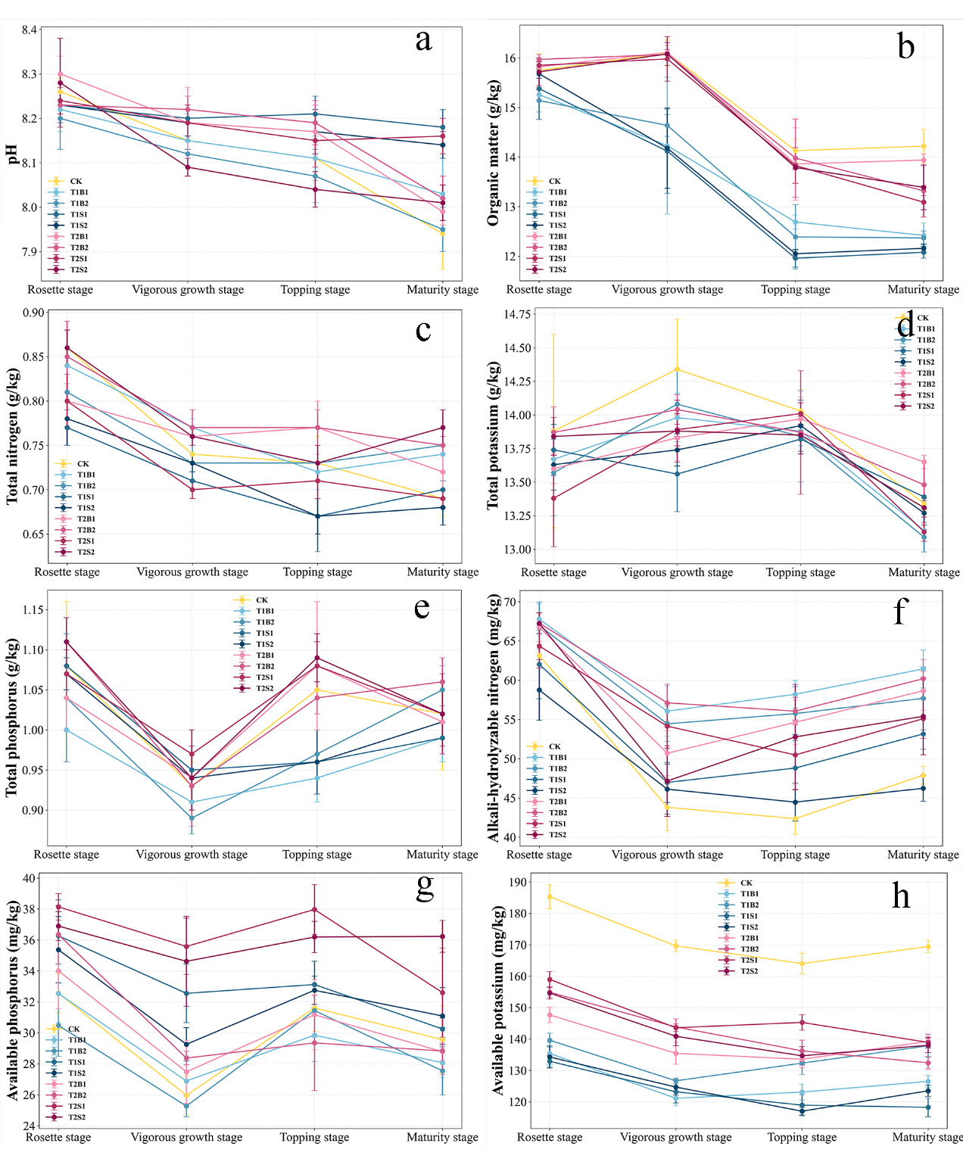
Fig. A.1 Effects of intercropping on soil nutrients and pH. The figure displays the variations in eight soil indicators measured at the Rosette stage, Vigorous growth stage, Topping stage, and Maturity stage: (a) Soil pH; (b) Organic matter content (g/kg); (c) Total nitrogen content (g/kg); (d) Total potassium content (g/kg); (e) Total phosphorus content (g/kg); (f) Alkali-hydrolyzable nitrogen content (mg/kg); (g) Available phosphorus content (mg/kg); (h) Available potassium content (mg/kg).

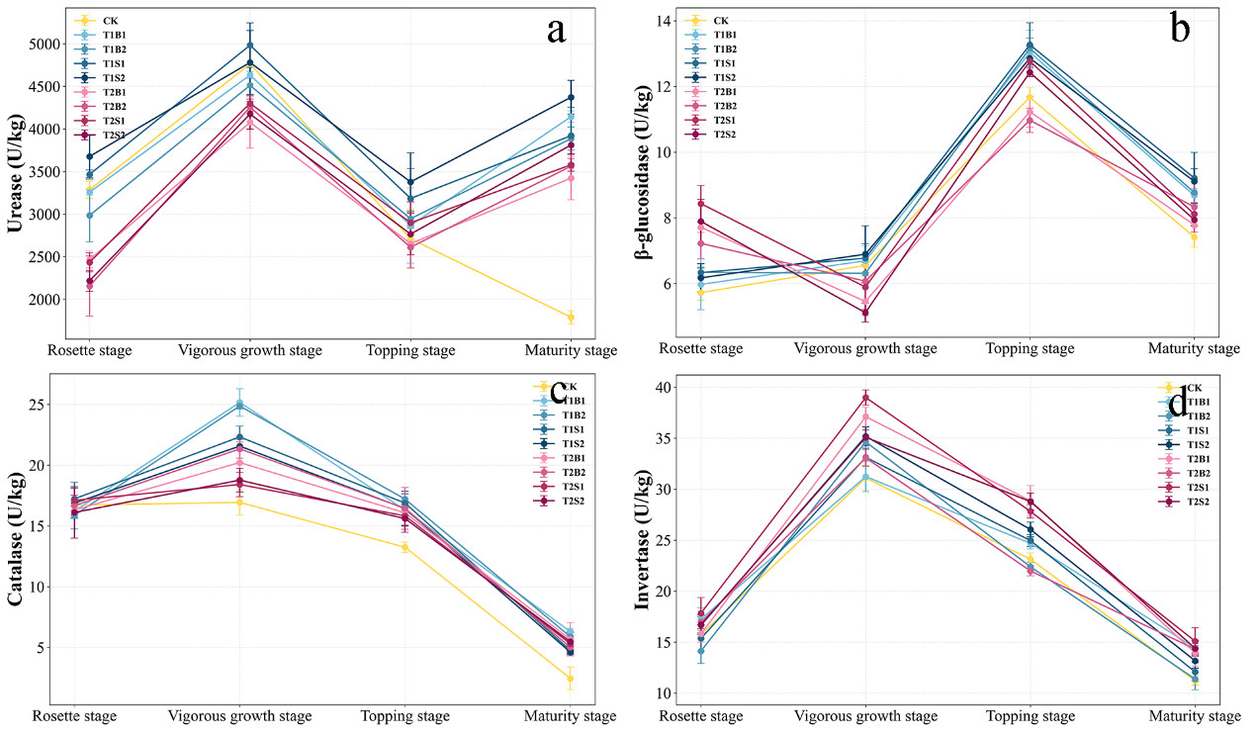
Fig. A.2 Effects of intercropping on soil enzyme activities. The figure illustrates the fluctuations of four key soil enzymes across the Rosette, Vigorous growth, Topping, and Maturity stages: (a) Urease activity (U/kg); (b) β-glucosidase activity (U/kg); (c) Catalase activity (U/kg); (d) Invertase activity (U/kg).

