Supplementary material

Continents regionalization
For the purposes of regional reporting and visualization, North America and Central America were aggregated into a single continental region. Consequently, results for Belize, Costa Rica, El Salvador, Guatemala, Honduras, Nicaragua, and Panama are included within the North American continental category.

Definition of growing season regions
To account for global heterogeneity in agricultural timing, we stratified the production areas – defined as non-zero harvested regions in MapSPAM – into areas characterized by either one or two growing seasons¹. This stratification ensured that the calculation of extreme agricultural drought time series was synchronized with local crop calendars.
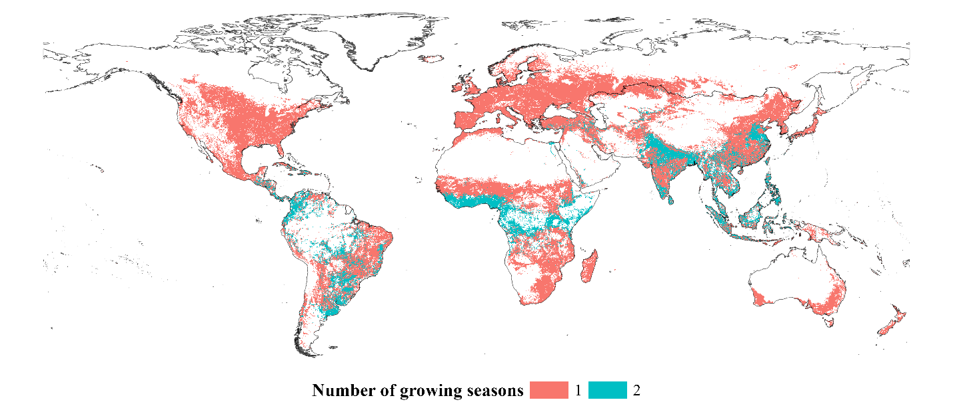
Figure S 1. Global distribution of agricultural production regions by growing season frequency. Spatial distribution (0.25° resolution) of areas characterized by one (red) or two (blue) growing seasons.

Crop categorization and standardization
Global agricultural datasets are often dominated by a small number of major staples. To ensure that all crop types contribute equitably to the diversity analysis across different geographies, we utilized the crop classification framework from the World Resources Institute (https://github.com/wri/MAPSPAM). This approach allowed us to standardize the presence of distinct crop classes at each location, regardless of their total production volume.

Table S 1. Categorization of MapSPAM crops. Crops are grouped into ten functional classes (e.g., cereals, fruits, pulses). Only crops intended for food consumption were included in the diversity calculations to ensure relevance to food security and nutrition.
Crops | Class | Type
Wheat, Rice, Maize, Barley, Pearl millet, Small millet, Sorghum, Other cereals | Cereals | Food
Potato, Sweet potato, Yams, Cassava, Other roots | Roots & tubers or starchy roots | Food
Bean, Chickpea, Cowpea, Pigeon pea, Lentil, Other pulses | Pulses | Food
Soybean, Groundnut, Coconut | Oil crops | Food
Oil palm, Sunflower, Rapeseed, Sesame seed, Other oil crops | Oil crops | Non-food
Sugar cane, Sugar beet | Sugar crops | Non-food
Cotton, Other fibres crops | Fibre crops | Non-food
Arabica coffee, Robusta coffee, Cocoa, Tea, Tobacco | Stimulant | Non-food
Banana, Plantain, Tropical fruit, Temperate fruit | Fruits | Food
Vegetables | Vegetables | Food
Rest of crops | Rest of crops | Non-food

Standardization of livestock units
Because livestock species vary significantly in biomass and resource requirements, raw animal counts were converted into Livestock Units (LSU). The LSU serves as a standardized reference – conventionally the grazing equivalent of one adult dairy cow – applying specific coefficients based on the nutritional and metabolic requirements of each species (e.g., cattle, poultry, sheep). This transformation allows for a comparable metric of production intensity rather than simple numerical abundance.

Table S 2. Livestock unit (LSU) conversion coefficients. Coefficients represent nutritional equivalents relative to a bovine standard, adapted from Eurostat (2023). For animal categories with multiple sub-types, average coefficients were applied before aggregating into total LSU per location.
Animal | Coefficient ² | Adapted coefficient (average)
Buffaloes | 1 | 1
Cattle | 1 | 1
Chickens | Broilers: 0.007  Laying hens: 0.014 | 0.0105
Ducks | 0.01 | 0.01
Goats | 0.1 | 0.1
Pigs | Piglets: 0.027  Breeding sows: 0.5 | 0.2635
Sheep | 0.1 | 0.1

SPEI drought categories
To quantify the evolution of drought severity, we utilized the standardized SPEI classification³. This allowed for a consistent calculation of drought frequency – specifically the number of years a cluster experienced various levels of water deficit – providing a key metric for temporal characterization.

Table S 3. SPEI categories.
Drought category | SPEI
No drought | SPEI > -0.5
Mild | -1 < SPEI ≤ -0.5
Moderate | -1.5 < SPEI ≤ -1
Severe | -2 < SPEI ≤ -1.5
Extreme | SPEI ≤ -2

Characterization of extreme drought clusters
Drought clusters were characterized across three dimensions: transboundary extent, intensification, and temporal severity (Figure S 2).
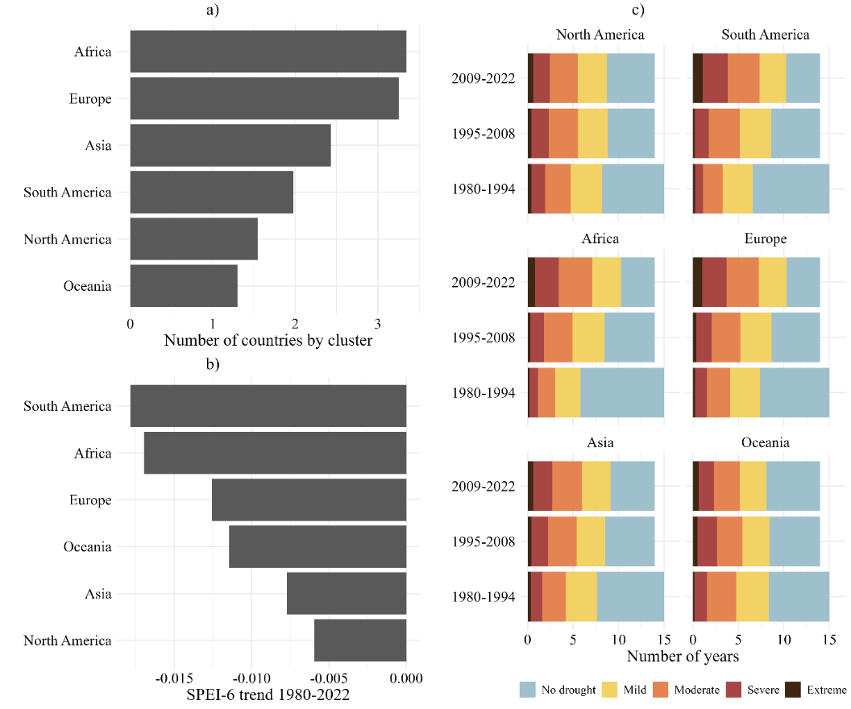
Figure S 2. Characterization of extreme drought clusters by extent, intensification, and severity. (a) Transboundary extent, defined by the average number of countries spanned by a single cluster. (b) Drought intensification, representing the median time-series slope per continent; more negative values denote more rapid intensification. (c) Drought severity, representing the median frequency of years in specific categories across three ~14-year periods (1980–1994, 1995–2008, and 2009–2022).

The transboundary extent is highest in Africa and Europe, where clusters span an average of three countries (Figure S 2 a). Notably, one European/Middle Eastern cluster encompasses 13 sovereign nations. Conversely, North America and Oceania exhibit the lowest country-per-cluster ratios, reflecting the vast territorial size of individual nations (e.g., USA, Canada, Australia) and the geographic isolation of island territories.
Drought intensification exhibits significant continental heterogeneity (Figure S 2 b). South America and Africa show the highest rates of intensification, indicating that extremes have worsened more rapidly in these regions than elsewhere. While the incidence of mild and moderate droughts has remained relatively stable, severe and extreme droughts have become increasingly prevalent. Between the 1980–1994 and 2009–2022 periods, the frequency of “non-drought” years declined markedly, most prominently in Europe, Africa, and South America (Figure S 2 c).

Economic exposure hotspots
To complement the diversity analysis, we evaluated exposure based on the economic value of crop production (Figure S 3) and total livestock units (Figure S 4). Compared to the diversity-based hotspots, the economic analysis reveals 39 economic-value hotspots (21 for crops and 36 for livestock, with 18 joint crop-livestock clusters overlapping) as well as an expansion of high-risk areas in the Northeastern United States, Colombia, Argentina, and China. In contrast, Africa shows a reduction in the number of economic hotspots relative to diversity hotspots, likely reflecting differences in market valuation versus species richness.
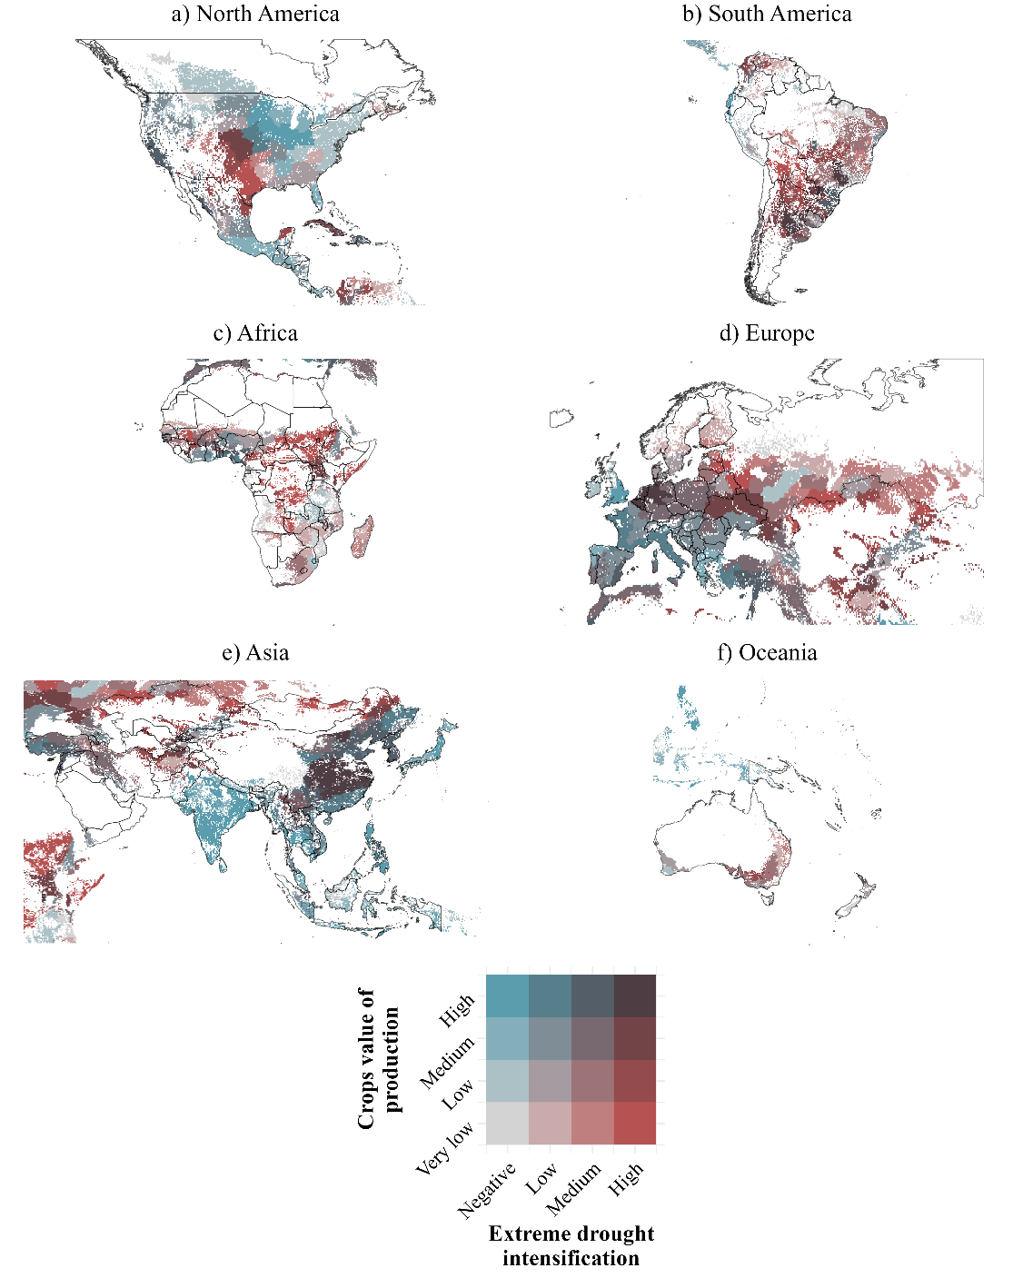
Figure S 3. Exposure of crop production value to extreme drought. Bivariate mapping of crop production value (blue) and drought intensification (red). Hotspots (dark brown) represent high-value regions facing significant drought trends.

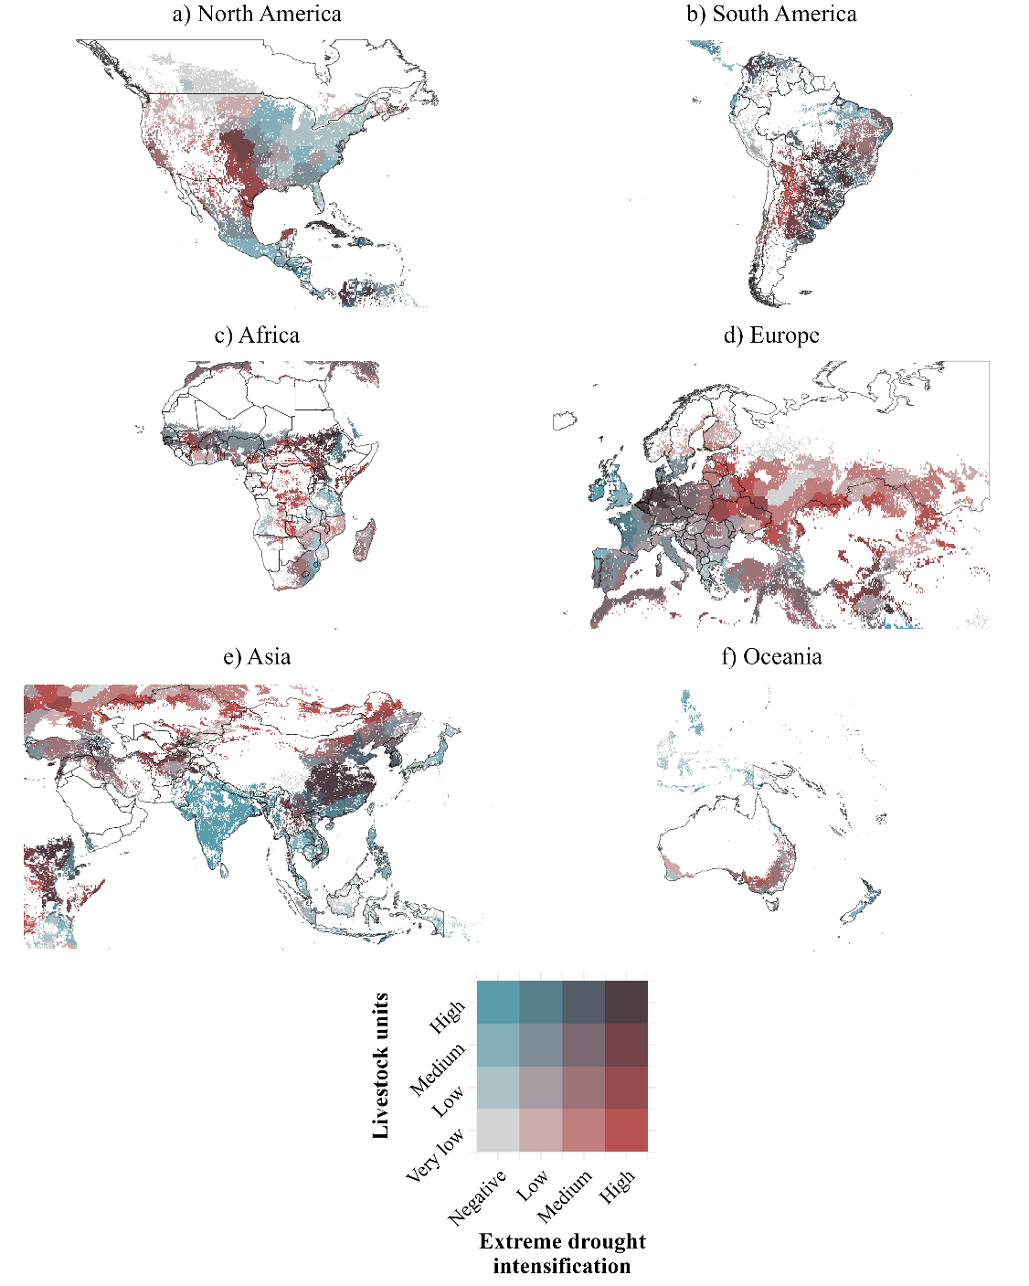
Figure S 4. Exposure of total livestock units to extreme drought. Bivariate mapping of total LSU (blue) and drought intensification (red). Emerging hotspots are visible in the Central US and across major cattle production zones in South America (Colombia, Venezuela, and Brazil).

Agricultural distribution within hotspots
The specific median values for crop and livestock counts utilized in the main manuscript’s distribution analysis (Figure 4 and Figure 5) share detailed in the Table S 4 and Table S 5.
Table S 4. Median crop distribution within diversity hotspots by continent. Data represent median richness counts and percentage composition by class.
Crop/Continent | North America | South America | Africa | Europe | Asia
Cereals | 3 (14%) | 3 (20%) | 3 (14%) | 6 (32%) | 4 (21%)
Fibres | 1 (5%) | 1 (7%) | 1 (5%) | 0.5 (3%) | 1 (5%)
Fruits | 4 (19%) | 2 (13%) | 4 (19%) | 2 (11%) | 2 (10%)
Oilcrops | 2 (10%) | 3.5 (23%) | 3 (14%) | 4 (22%) | 3.5 (18%)
Pulses | 1 (5%) | 1.5 (10%) | 2 (9%) | 2 (11%) | 3 (15%)
Rest of crops | 0 (0%) | 1 (7%) | 1 (5%) | 1 (5%) | 1 (5%)
Roots, tubers or starchy roots | 5 (24%) | 2 (13%) | 4 (19%) | 1 (5%) | 2 (10%)
Stimulant | 3 (14%) | 0 (0%) | 1.5 (7%) | 0 (0%) | 1 (5%)
Sugar crops | 1 (5%) | 0.5 (3%) | 1 (5%) | 1 (5%) | 1 (5%)
Vegetables | 1 (5%) | 0.5 (3%) | 1 (5%) | 1 (5%) | 1 (5%)
Total crops per continent | 21 | 15 | 21.5 | 18.5 | 19.5

Table S 5. Median livestock unit distribution within economic hotspots by continent. Data represent median LSU and percentage composition per species type.
Animal/Continent | North America | South America | Africa | Europe | Asia
Buffaloes | 0 (0%) | 1 (0%) | 0 (0%) | 0 (0%) | 313 (6.8%)
Cattle | 3343 (81.9%) | 3782.5 (99.3%) | 3761 (93%) | 2112 (65.7%) | 1338 (29.2%)
Chickens | 259 (6.3%) | 4 (0.1%) | 56 (1.4%) | 151 (4.7%) | 654 (14.3%)
Ducks | 4 (0.1%) | 0 (0%) | 1 (0%) | 3 (0.1%) | 53 (1.2%)
Goats | 41 (1%) | 1 (0%) | 178 (4.4%) | 2 (0.1%) | 121 (2.6%)
Pigs | 352 (8.6%) | 14.5 (0.4%) | 1 (0%) | 921 (28.6%) | 2085 (45.6%)
Sheep | 82 (2%) | 7.5 (0.2%) | 49 (1.2%) | 28 (0.9%) | 11 (0.2%)
Total LSU per continent | 4081 | 3810.5 | 4046 | 3217 | 4575

Food production and economic value exposure hotspots
Tables provided in separate files.

References
1. Joint Research Centre. Phenology dataset. GEO Knowledge Hub https://gkhub.earthobservations.org/records/z92cv-v6s48 (2022).
2. Eurostat. Glossary:Livestock unit (LSU). https://ec.europa.eu/eurostat/statistics-explained/index.php?title=Glossary:Livestock_unit_(LSU) (2023).
3. Ghebrehiwot, A. A. & Kozlov, D. V. Statistical and spatial variability of climate data in the Mareb-Gash river basin in Eritrea. Vestn. MGSU 85–99 (2020) doi:10.22227/1997-0935.2020.1.85-99.

