Effectiveness and Safety of Exercise Therapy for Non-Dialysis-Dependent Chronic Kidney Disease: A Systematic Review and Meta-Analysis
Shuhei Nakajima¹, Toshiaki Usui¹, Akihisa Hattori, Shun Ishibashi, Takuya Harada, Tadashi Sofue, Naohiko Fujii, Masakazu Saitoh, Ichiei Narita, Kunihiro Yamagata¹ Junichi Hoshino, Susumu Toda^{9*}.
1. Department of Nephrology, Faculty of Medicine, University of Tsukuba, Tsukuba, Ibaraki, Japan. 9. Department of Nephrology, Kameoka Hospital, Kameoka, Kyoto, Japan. * Corresponding author
Supplemental Figure 3 – 1 ~ 25: Funnel Plot
Supplemental Figure 3 - 1 ~ 2. Funnel plot of kidney function
SF3 – 1: Estimated glomerular filtration rate (mL/min/1.73m²); SF3 – 2: proteinuria
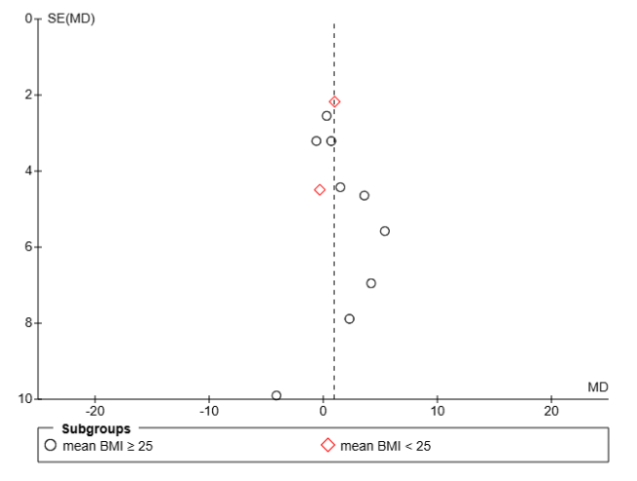  SF3 – 1: Estimated glomerular filtration rate (mL/min/1.73m²) | 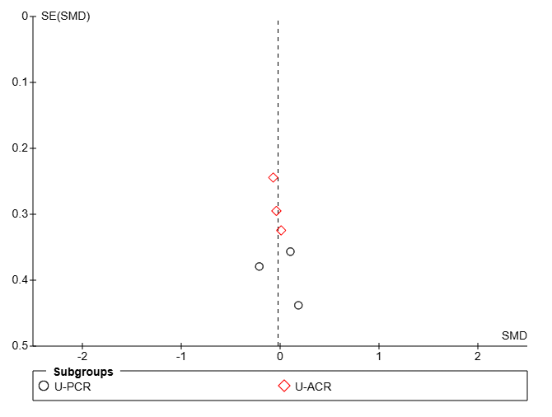  SF3 – 2: proteinuria
Supplemental Figure 3 – 3 ~ 6 Funnel plot of physical function
SF3 – 3: peak VO2 (mL/kg/min); SF3 – 4: Six-minute walk distance test (m); SF3 – 5: Hand grip strength (kg); SF3 – 6: Sit to stand test
SF3 – 3: peak VO2 (mL/kg/min)  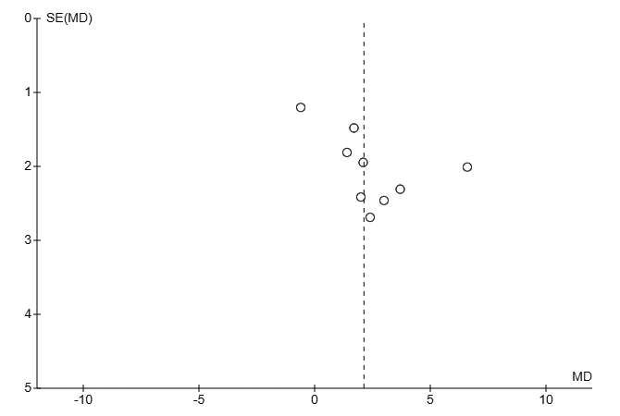 | SF3 – 4: 6MWT (m)  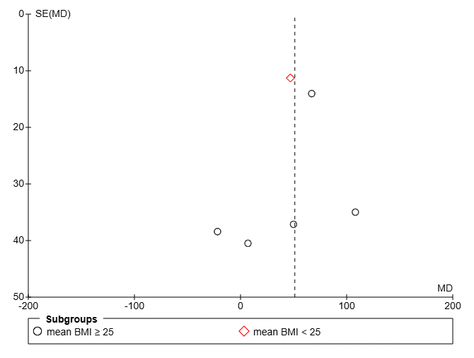
SF3 – 5: Handgrip strength (kg)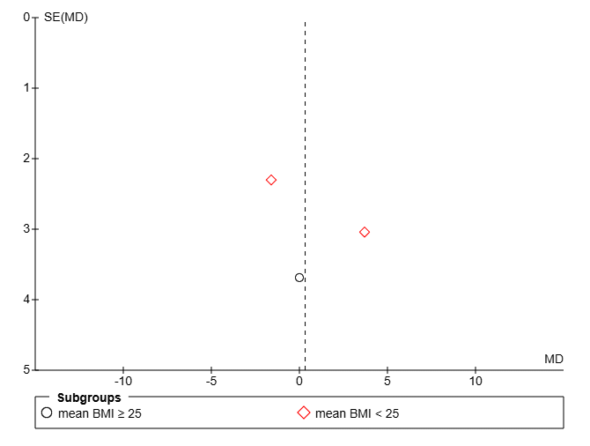 | SF3 – 6: Sit to stand test  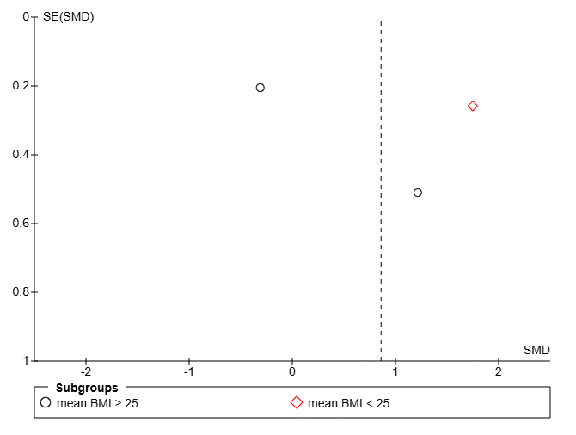

Supplemental Figure 3 – 7 ~ 19 Health-Related Quality of Life
SF3 – 7: Burden of kidney disease; SF3 – 8: Effect of kidney disease; SF3 – 9: Symptoms/Problems; SF3 – 10: Physical Component Summary; SF3 – 11: Mental Component Summary; SF3 – 12: Physical function; SF3 – 13: General health; SF3 – 14: Role emotional; SF3 – 15: Role physical; SF3 – 16: Vitality; SF3 – 17: Mental health; SF3 – 18: Bodily pain; SF3 – 19: Social functioning.
SF3 – 7: Burden of kidney disease 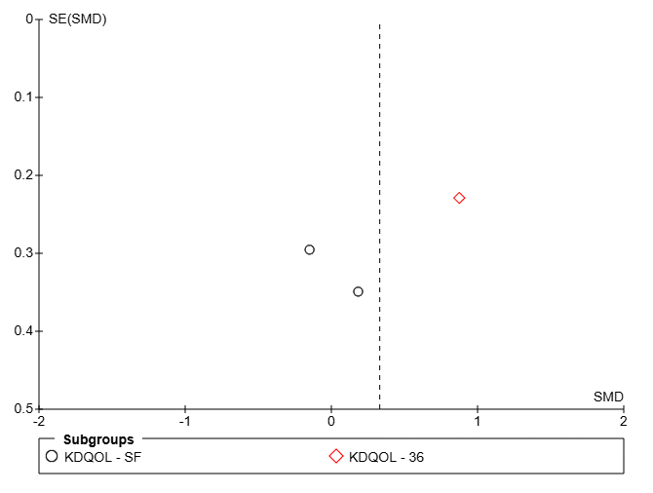 | SF3 – 8: Effect of kidney disease 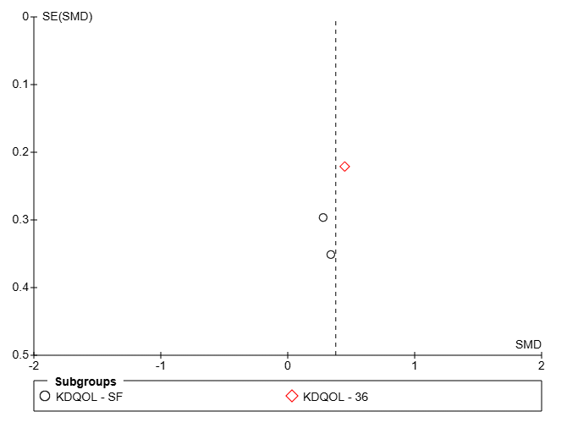
SF3 – 9: Symptoms/Problems 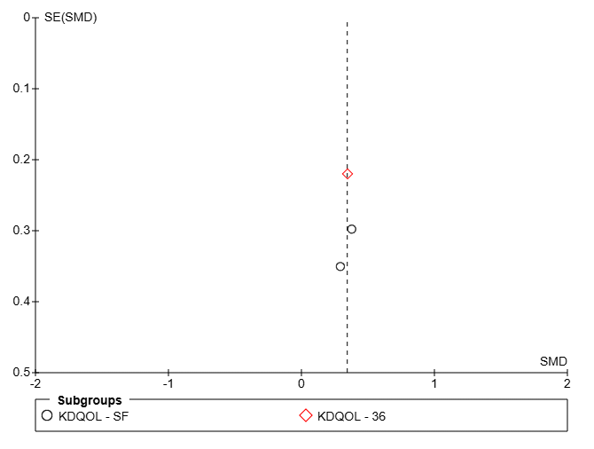 | SF3 – 10: Physical Component Summary 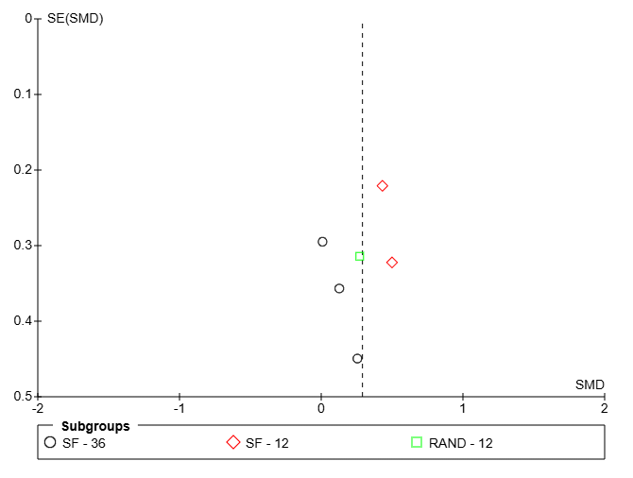
SF3 – 11: Mental Component Summary 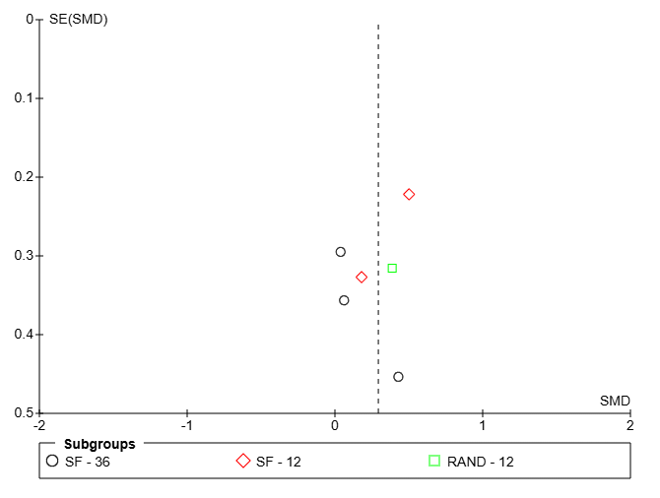 | SF3 – 12: Physical function 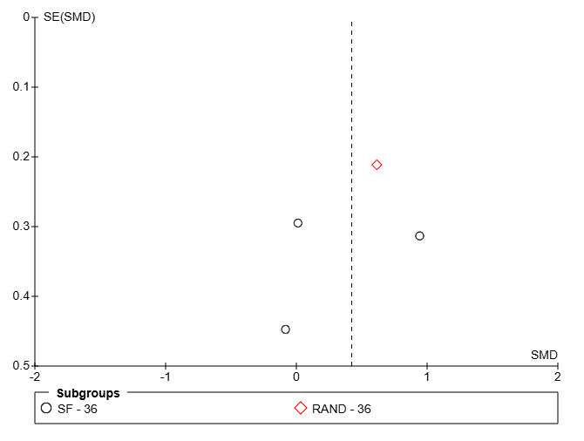
SF3 – 13: General health 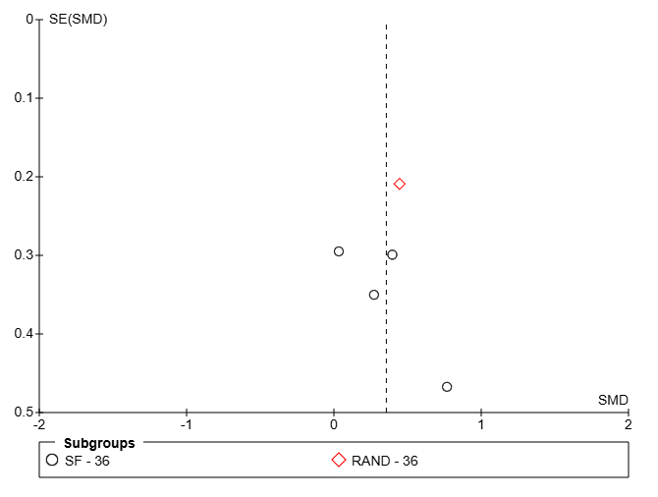 | SF3 – 14: Role emotional 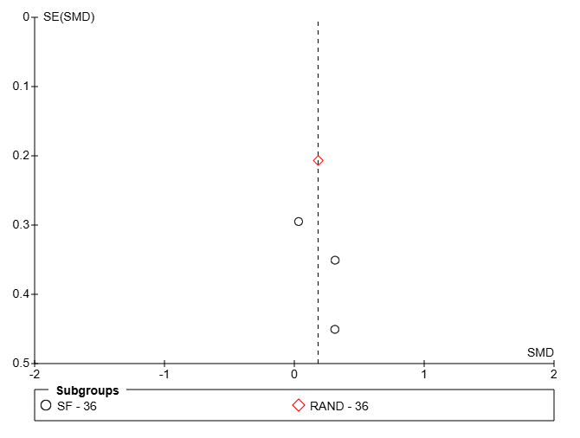
SF3 – 15: Role physical 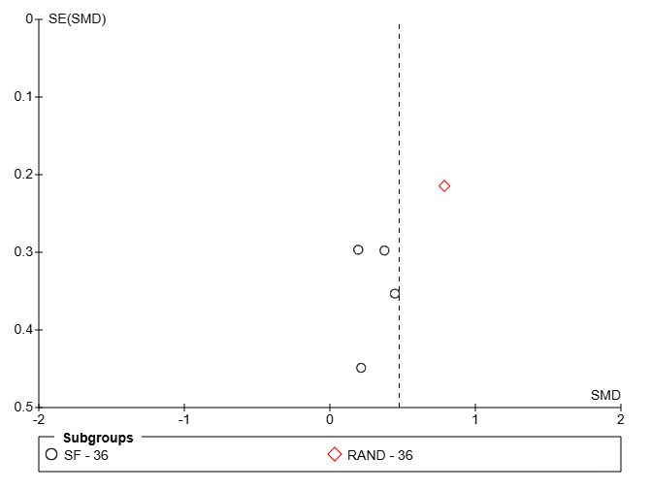 | SF3 – 16: Vitality 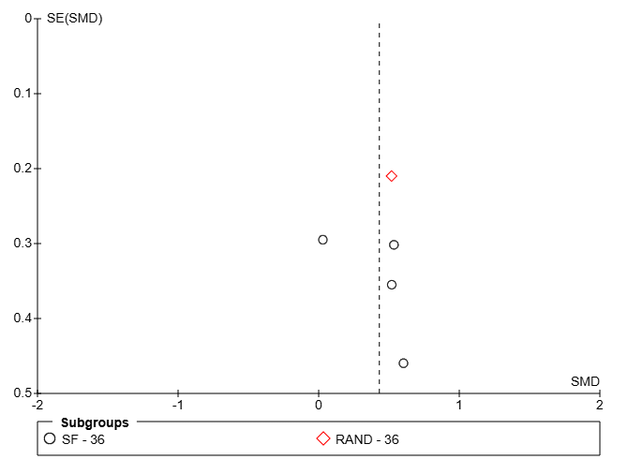
SF3 – 17: Mental health 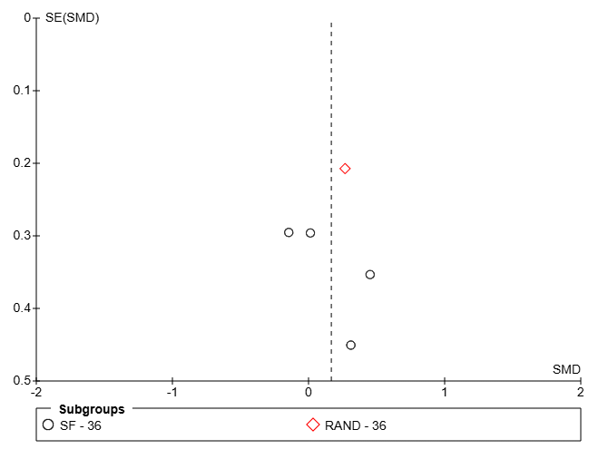 | SF3 – 18: Bodily pain 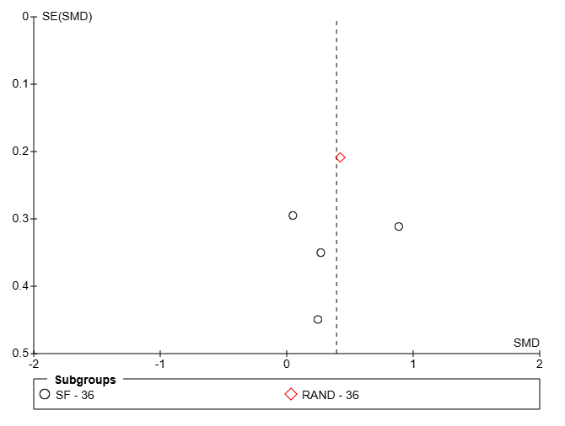
SF3 – 19: Social functioning 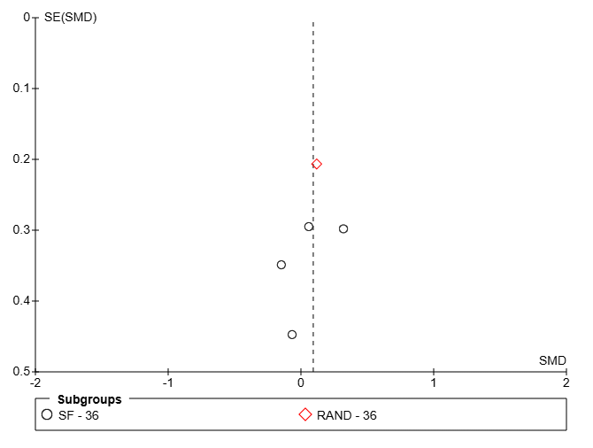

Supplemental Figure 3 – 20 ~ 25 Funnel plot of metabolic profiles
SF3 – 20: body mass index (kg/m²); SF3 – 21: total cholesterol (mg/dL); SF3 – 22: low density lipoprotein cholesterol (mg/dL); SF3 – 23: high density lipoprotein cholesterol (mg/dL); SF3 – 24: triglyceride (mg/dL); SF3 – 25: hemoglobin A1c (%).

SF3 – 20: body mass index (kg/m²)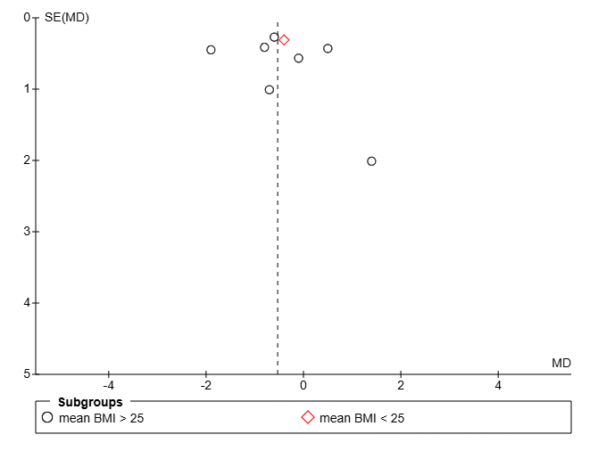 | SF3 – 21: total cholesterol (mg/dL)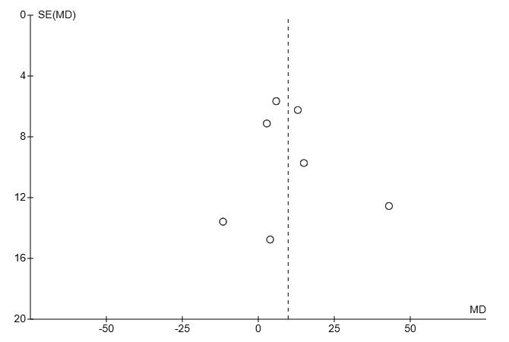
SF3 – 22: low density lipoprotein cholesterol (mg/dL)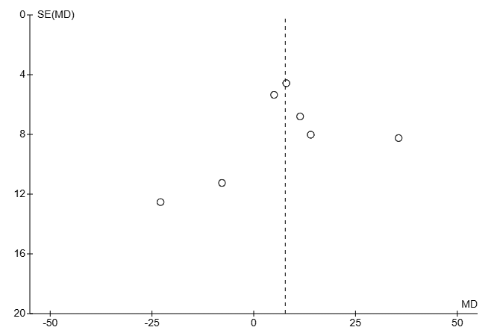 | SF3 – 23: high density lipoprotein cholesterol  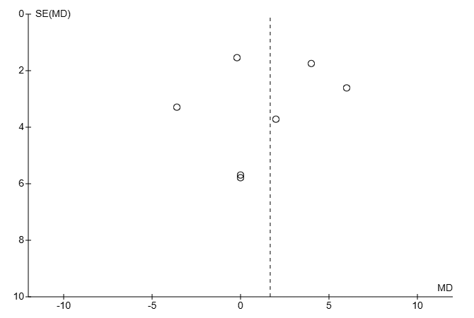
SF3 – 24: triglyceride (mg/dL)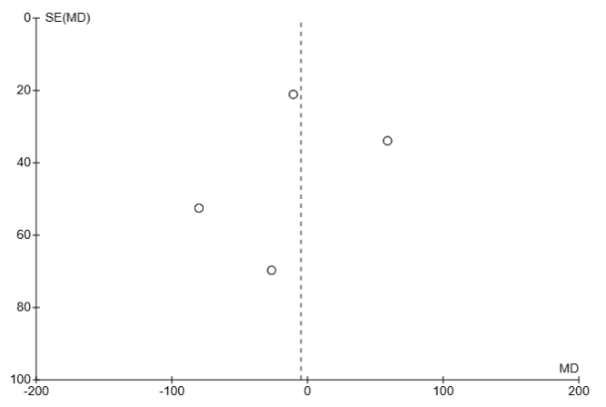 | SF3 – 25: hemoglobin A1c (%)