Supplementary Information: A Spatial Probability Model for the Arrival and Establishment of Coconut Rhinoceros Beetle
Sulav Paudel^{1*}, John M. Kean¹, Craig B. Phillips¹, Sarah Mansfield¹ & Sean D.G. Marshall¹
¹ Bioeconomy Science Institute, Tuhiuraki, 19 Ellesmere Junction Road, Lincoln 7608, New Zealand
* Corresponding author: sulav.paudel@agresearch.co.nz
ORCID ID: 0000-0002-7562-2846
Figure S1. Key predictor variables used in the coconut rhinoceros beetle (CRB) risk model for Vanuatu. (A) Coconut palm distribution, (B) Elevation Suitability, (C) Population density, (D) Proximity to ports, and (E) Proximity to roads.
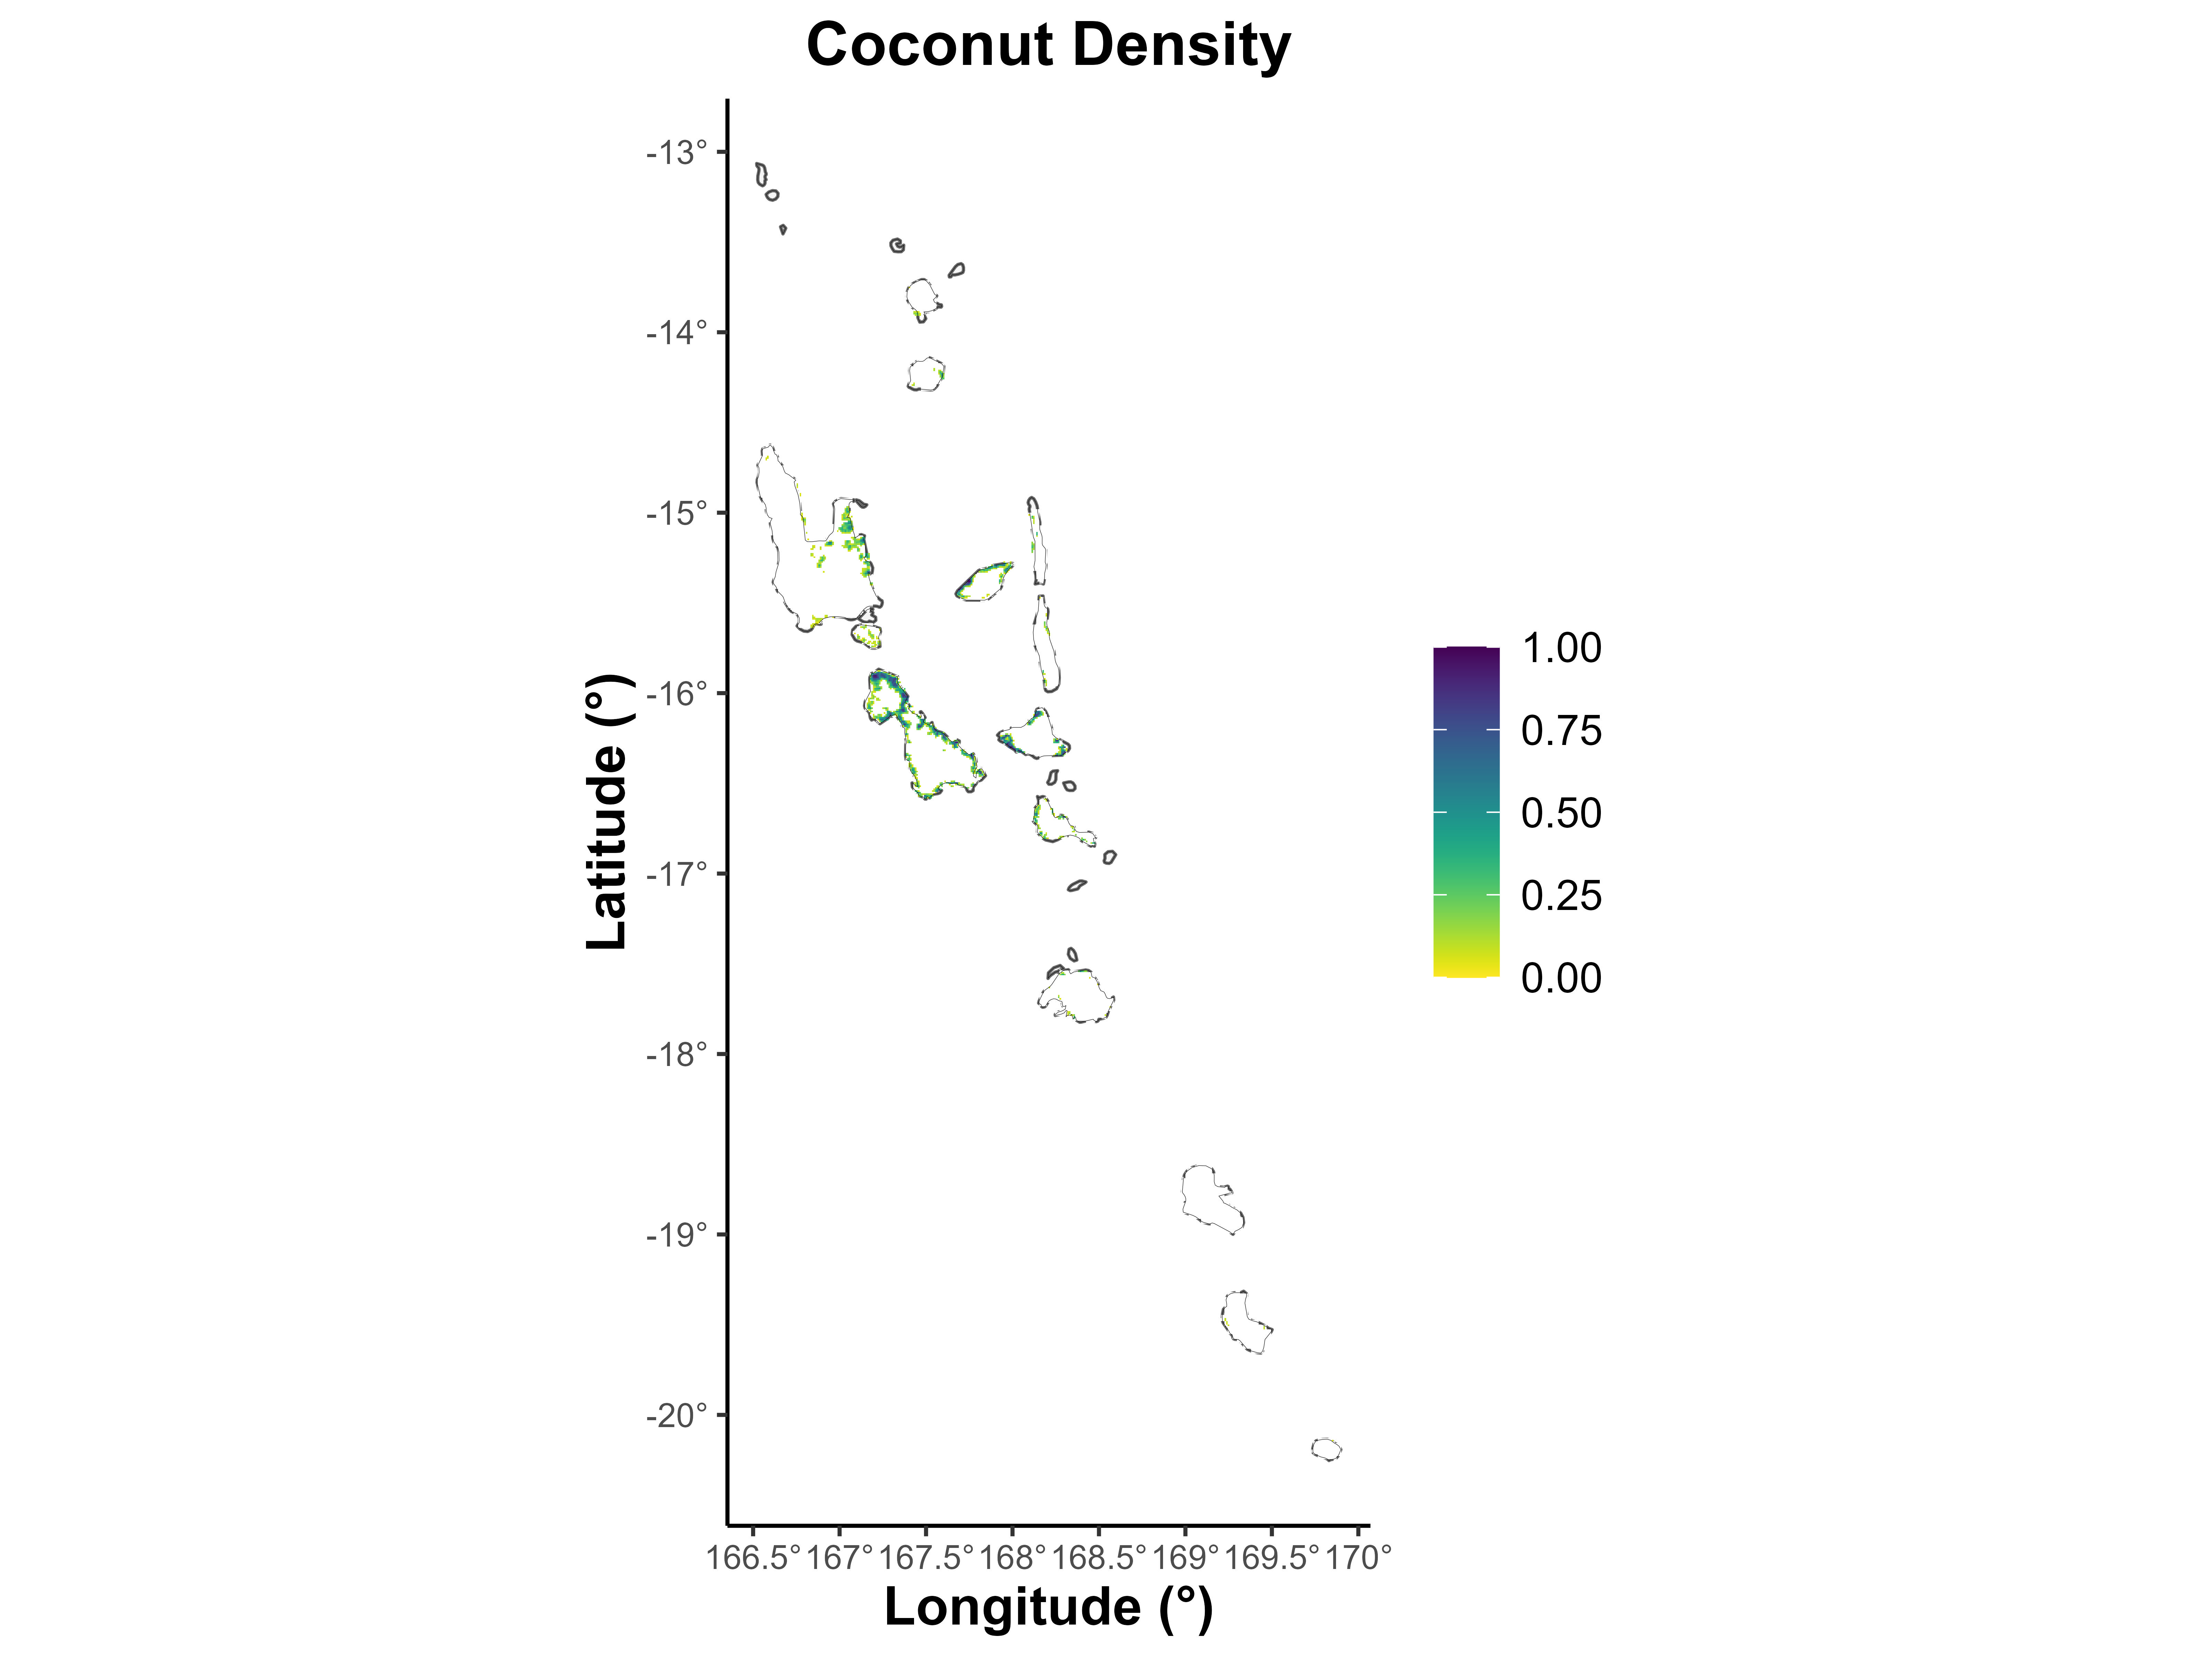

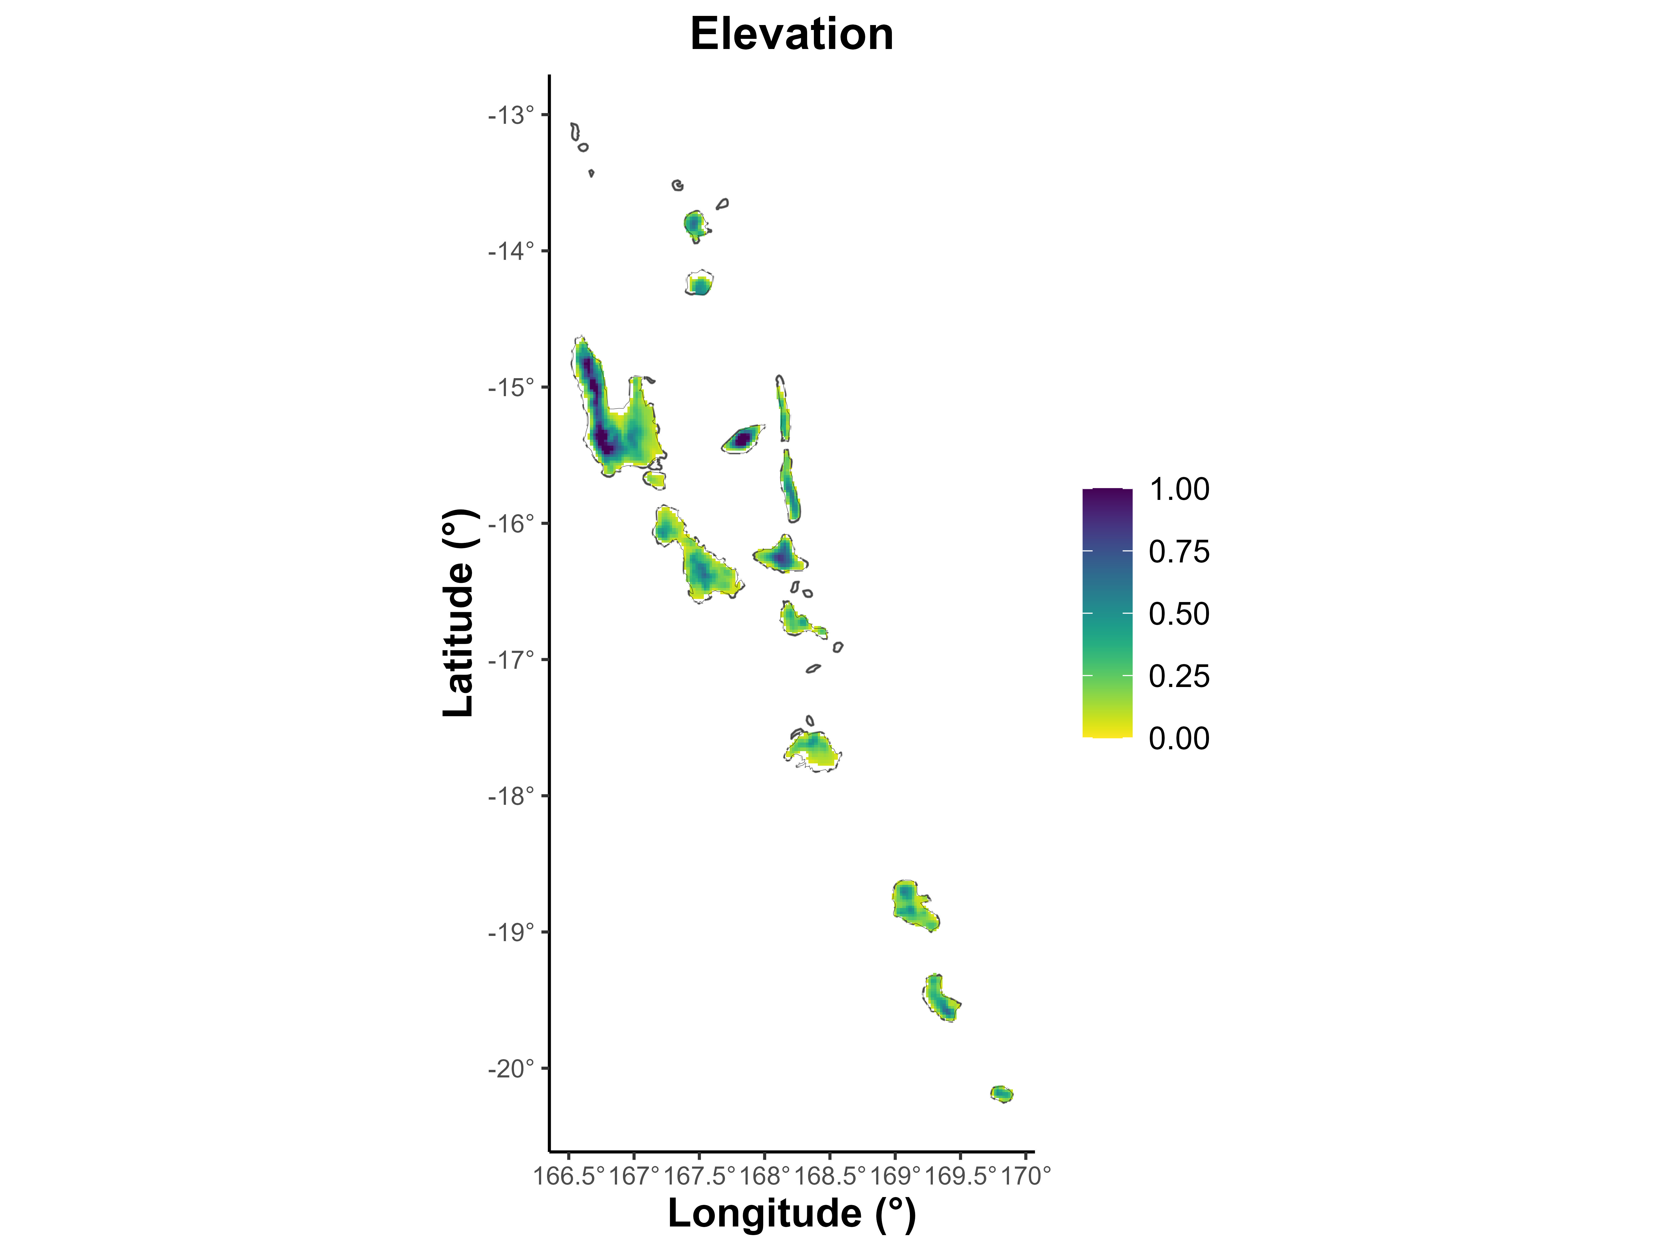

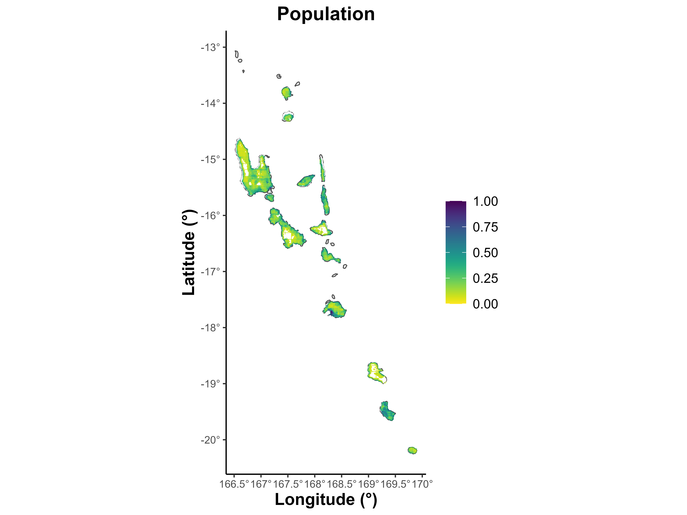

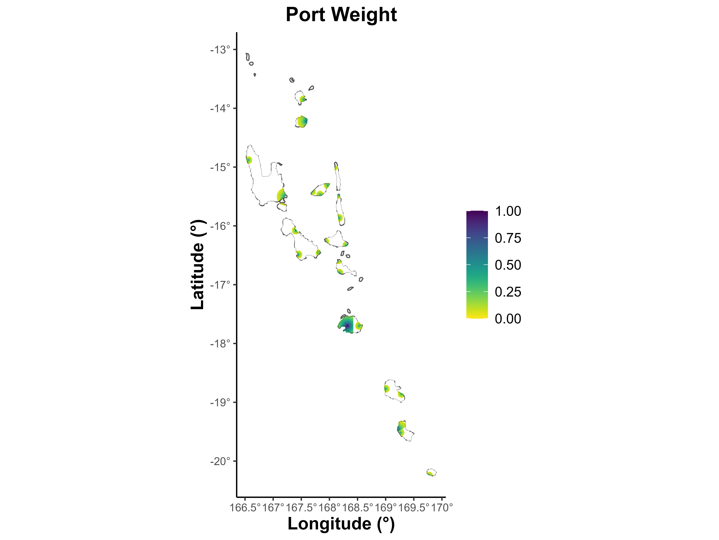

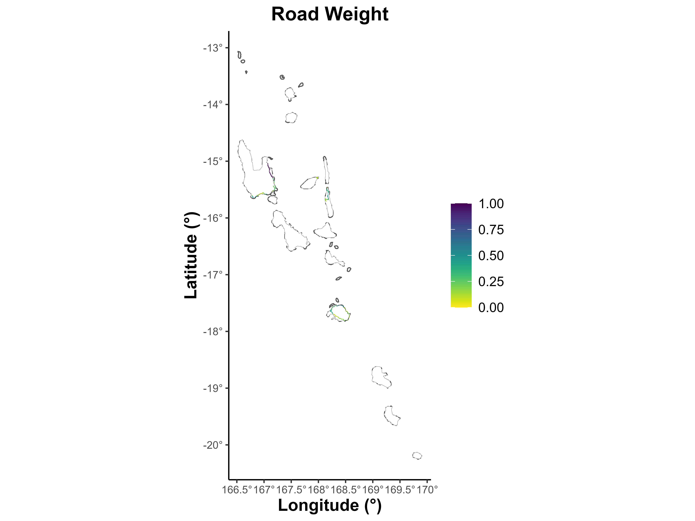

Figure S2. Key predictor variables used in the coconut rhinoceros beetle (CRB) risk model for Solomon Islands. (A) Coconut palm Density, (B) Elevation Suitability, (C) Population density, (D) Port Weight, and (E) Road Weight.
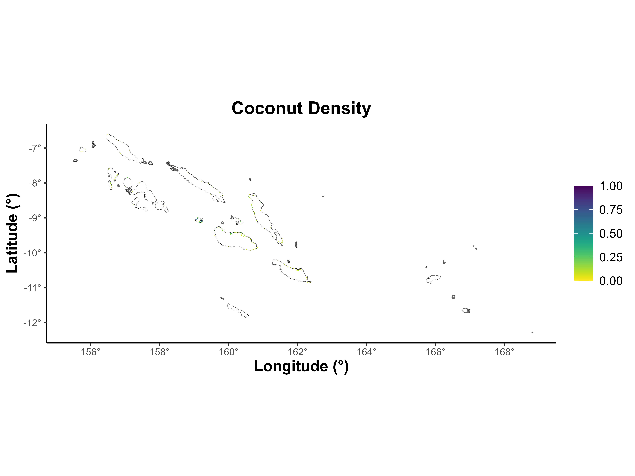

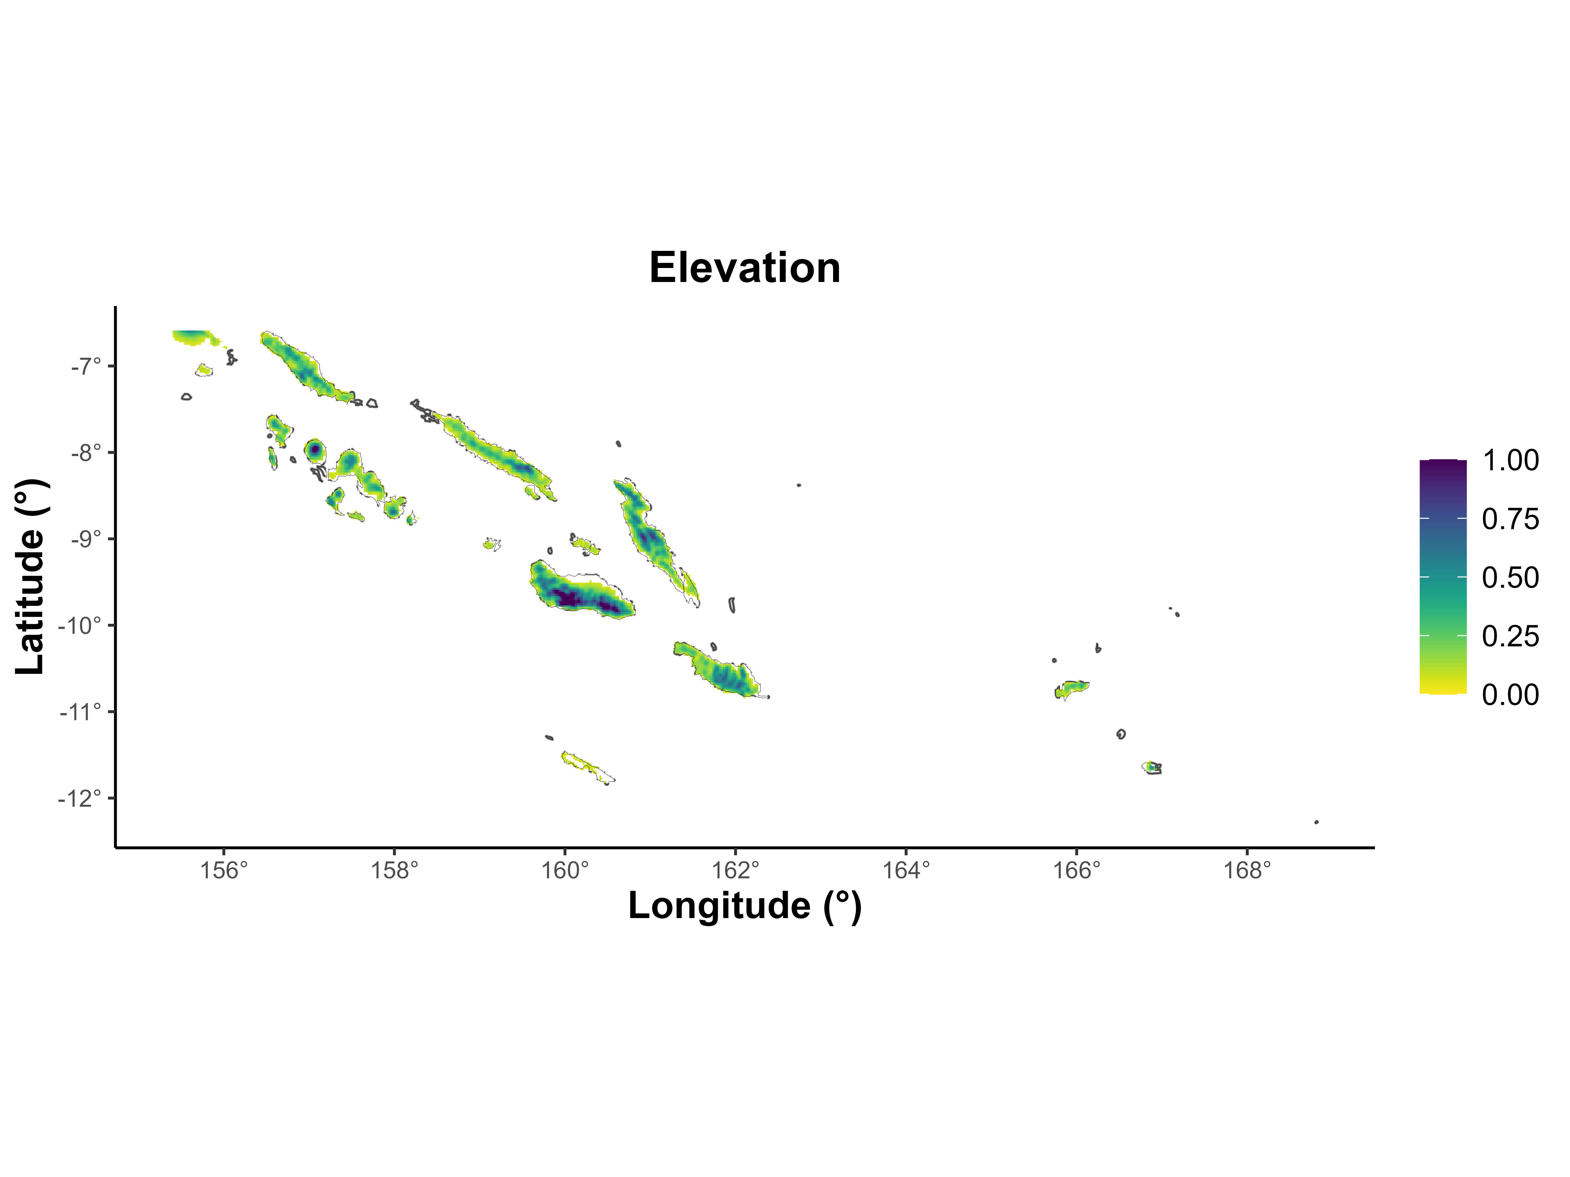

Figure S3. Key predictor variables used in the coconut rhinoceros beetle (CRB) risk model for Mexico. (A) Coconut palm distribution, (B) Elevation Suitability, (C) Population density, (D) Proximity to ports, and (E) Proximity to roads.

Figure S4: Distribution of the variables used to compute the CRB_Invasion score across Mexico, Solomon Islands, and Vanuatu

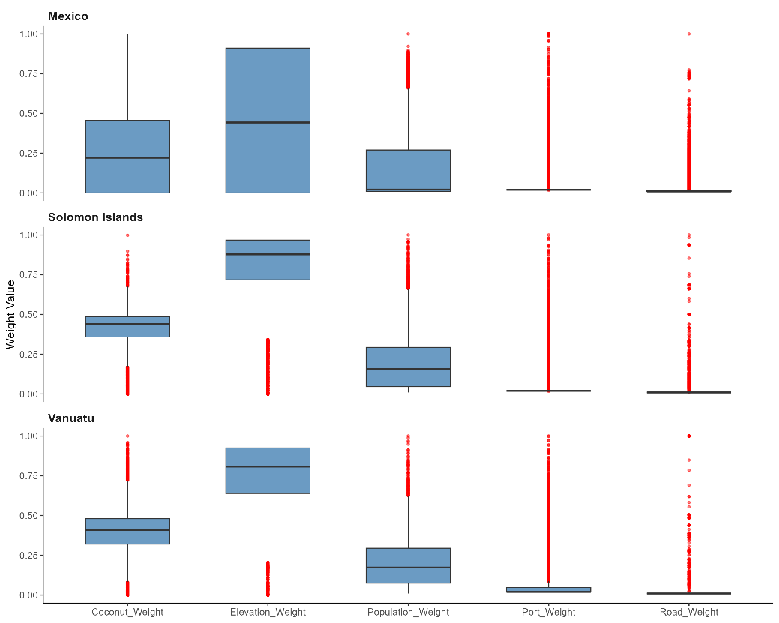

Figure S5: Precision–Recall (PR) curve for the CRB model in Vanuatu, Solomon Islands and Mexico.

Table S1: Historical CRB Invasions and Associated Pathways
Pathway Type | Country (Island/Province/Atoll) | References
Ports and Airports | Samoa (Upolu), Tonga, Fiji (Suva), Guam, Solomon Islands (Honiara, Munda), Papua New Guinea (Port Moresby), Vanuatu (Efate), Mexico (Nayarit) | Jepson 1912; Marshall et al. 2023; Jiménez Quiroz et al. 2017; Paudel et al. 2022; Jackson et al. 2025; Hoffman et al. 2025
Human-Assisted Spread | Palau, Papua New Guinea (New Britain), Solomon Islands (Guadalcanal, Malaita, Ontong Java Atoll), Mauritius, Réunion, United States (Hawai‘i: O‘ahu, Kaua‘i, Maui), Marshall Islands (Majuro) | Bedford 1980; EPPO 2013; Moore 2007; Marshall et al. 2023
Military or Trade Cargo | Palau, British Indian Ocean Territory (Diego Garcia), Papua New Guinea (New Britain) | Gressitt 1953; Catley 1969
Compost/Green Waste | United States (Hawai‘i: Maui, Hawai‘i Island), Guam | HDOA 2023; Moore 2007
Short-Distance Natural Spread | American Samoa, Tokelau, Papua New Guinea (Central Province, Gulf Province), Solomon Islands (Guadalcanal) | CABI/EPPO 1998; Marshall et al. 2023

Table S2: Potential high-risk Biosecurity Surveillance Sites for currently uninfested Pacific Island Countries and Territories (PICTs)
PICTs | CRB Incursion status | High risk surveillance sites
Cook Islands | Absent | Rarotonga International Airport; Port of Avatiu (Rarotonga)
French Polynesia | Absent | Faa'a International Airport (Tahiti); Port of Papeete
Federated States of Micronesia | Absent | Pohnpei, Chuuk, Yap, or Kosrae Int'l Airports; Ports of Pohnpei, Weno, or Tomil
Kiribati | Absent | Bonriki International Airport (Tarawa); Port of Betio (Tarawa)
Nauru | Absent | Nauru International Airport; Port of Aiwo
Pitcairn Islands | Absent | Bounty Bay; Port at Mangareva (French Polynesia)
Tuvalu | Absent | Funafuti International Airport; Port of Funafuti
Niue | Absent | Niue International Airport (Hanan); Alofi Wharf

