Supplementary Information of “Energy intensities and greenhouse gas emissions of global liquefied natural gas supply chain pipeline networks”
Zemin Eitan Liu^{1†*}, Diego Moya^{2†*}, Wennan Long^{3†}, Muhammad Y. Jabbar², Reem Aldahlawi³, Zhenlin Chen⁴, Wei Mao², Amjaad Al-Qahtani⁵, Xin He³, Mohammad S. Masnadi^{1*}, Liang Jing²
¹Department of Chemical and Petroleum Engineering, University of Pittsburgh, Pittsburgh, PA 15261, USA.
²Energy Sustainability Analysis, Technology Strategy and Planning Department, Saudi Aramco, Dhahran, Saudi Arabia.
³Global Technology Assessment, Aramco Research Center–Detroit, Aramco Americas, Novi, MI, USA
⁴Department of Energy Science and Engineering, Stanford University, 14 Stanford, 94305, CA, USA.
⁵Carbon Capture Sequestration Department, Saudi Aramco, Dhahran, Saudi Arabia.
∗Corresponding author: Zemin Eitan Liu: eitanliuzm@pitt.edu; Diego Moya: diego.moyapinta@aramco.com; Mohammad S. Masnadi: m.masnadi@pitt.edu
†These authors contributed equally to this work.

Summary
The Supplementary Figures (maps and charts) characterise carbon-intensity (CI), energy use and methane leakage across the global field-to-processing-to-LNG (FF–PP–LNG) pipeline system. Figure SI-1 dissects the United States network, down to state-scale corridors such as Sabine Pass, illustrating how daily throughput and CI vary spatially. Figure SI-2 extends the mapping to 20 LNG-exporting nations, overlaying compressor-station hotspots to reveal worldwide infrastructure heterogeneity. Figures SI-3 and SI-4 quantify performance: for FF–PP and PP–LNG segments respectively they rank route-level CO₂-eq emissions, electricity demand and line length, benchmarked against a global volume-weighted average of 171 kt CO₂-eq. Donut plots expose each country’s share of the pipeline-stage footprint, while inset views spotlight ultra-low-emission routes that collectively supply sizeable LNG volumes. Figures SI-5 and SI-6 add methane dimensions using satellite-derived AI/ML estimates, contrasting low, average and high leakage archetypes for long U.S. feeders, Qatari trunklines and Australian collectors. Figure SI-7 presents scenario analysis: inefficient low-load operation inflates absolute CO₂, whereas capacity optimisation and policy-driven decarbonisation lower CI for both pipeline legs. Together the images underscore the wide variability and abatement potential in mid-stream gas infrastructure, offering granular evidence for portfolio risk assessment, carbon-pricing design and targeted mitigation of CO₂ and CH₄ along LNG export chains.
The Supplementary Methods describe the integrated modelling framework used to quantify energy use, carbon emission and methane emissions in global LNG transmission. The ATP3 model computes supply–demand balancing using entropy-weighted allocation (Eqs. 1–5), geodesic distances (Eq. 6), and shortest paths from Dijkstra’s algorithm, optimising flows through minimum-cost transport equations (Eqs. 7–8). PipeWiser extends this by combining thermodynamics, hydraulics, and emissions accounting. Segment-level pressure drops are derived from friction and elevation effects (Eqs. 16–26), with updated exit pressures, temperatures, and flows (Eqs. 27–29). Compression work, energy demand, and CO₂ emissions are estimated via isentropic work (Eq. 30), Joule–Thomson enthalpy (Eq. 31), efficiency adjustments (Eqs. 32–33), grid factors (Eq. 34), and normalisation to LNG throughput for carbon intensity (Eq. 35). Assumptions include steady-state, adiabatic compression, uniform gas composition, and burial depth for heat-transfer calculations (Eqs. 9–15). Methane emissions are captured by the MEEM framework: equipment-level bottom-up factors (Eqs. 36–42) and three complementary superemitter methods (satellite plume conversion (Eqs. 43–48), basin similarity (Eqs. 49–51), and neural-network predictions (Eq. 52)) with integrated estimates (Eqs. 53–54). Finally, a satellite-driven ML workflow predicts segment intensities where detections are sparse, aggregates routes (FF–PP and PP–LNG), clusters them into archetypes using PCA and K-means, and benchmarks results against independent methane assessments.

Supplementary Figures
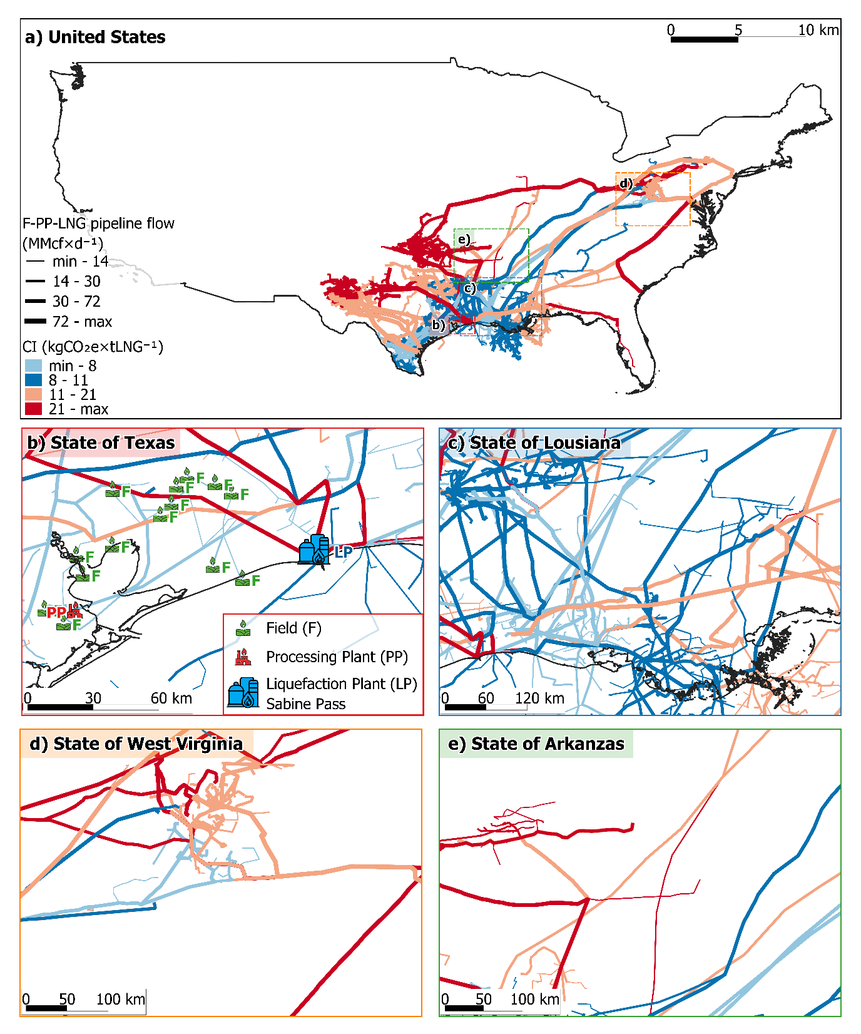
Figure SI-1. USA natural gas pipeline network from production fields to processing plants and liquefaction terminals (FF-to-PP-to-LNG). Line thickness represents daily throughput, and colours denote carbon-intensity bands. a) National FF–PP–LNG supply chain. b) Sabine Pass corridor highlighted with a particular PP and FFs. c–e) Detailed views of selected states, illustrating regional infrastructure complexity and heterogeneity.

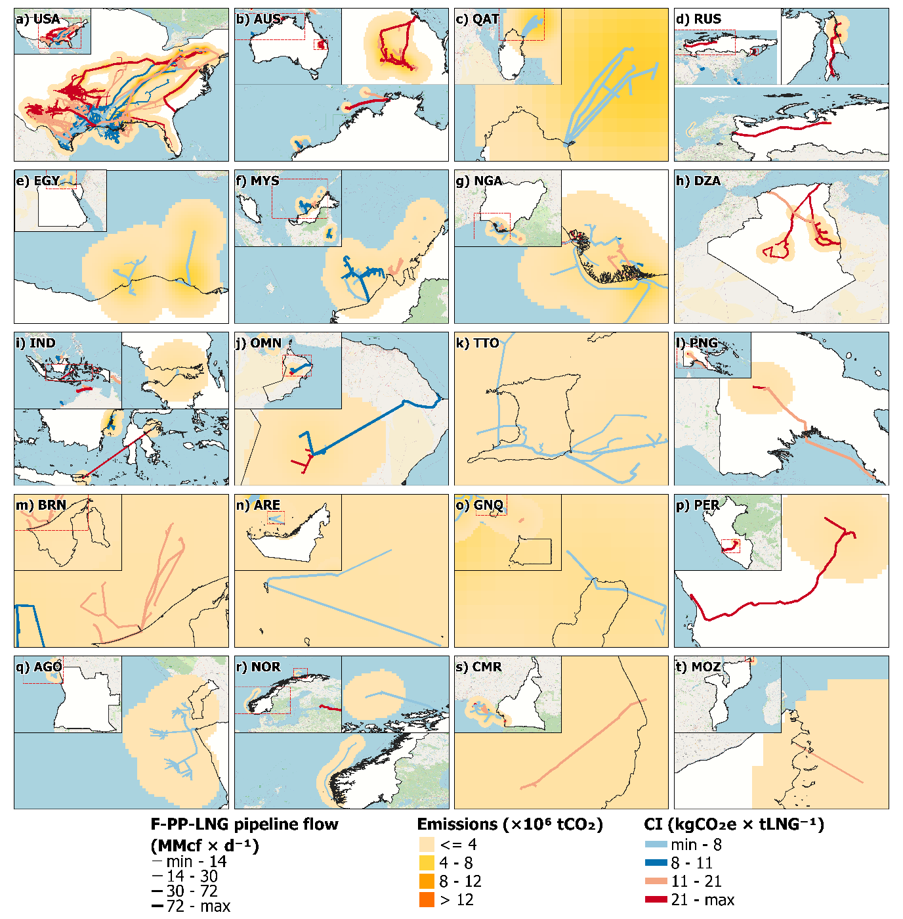
Figure SI-2. Global FF–PP–LNG transmission pipeline network across 20 LNG-exporting countries. Line thickness indicates daily gas throughput, and colours denote carbon-intensity bands. This map captures the complexity and heterogeneity of mid-stream infrastructure worldwide. Figure SI-2 presents rasterised overlayed hotspots from compressor-station emissions.

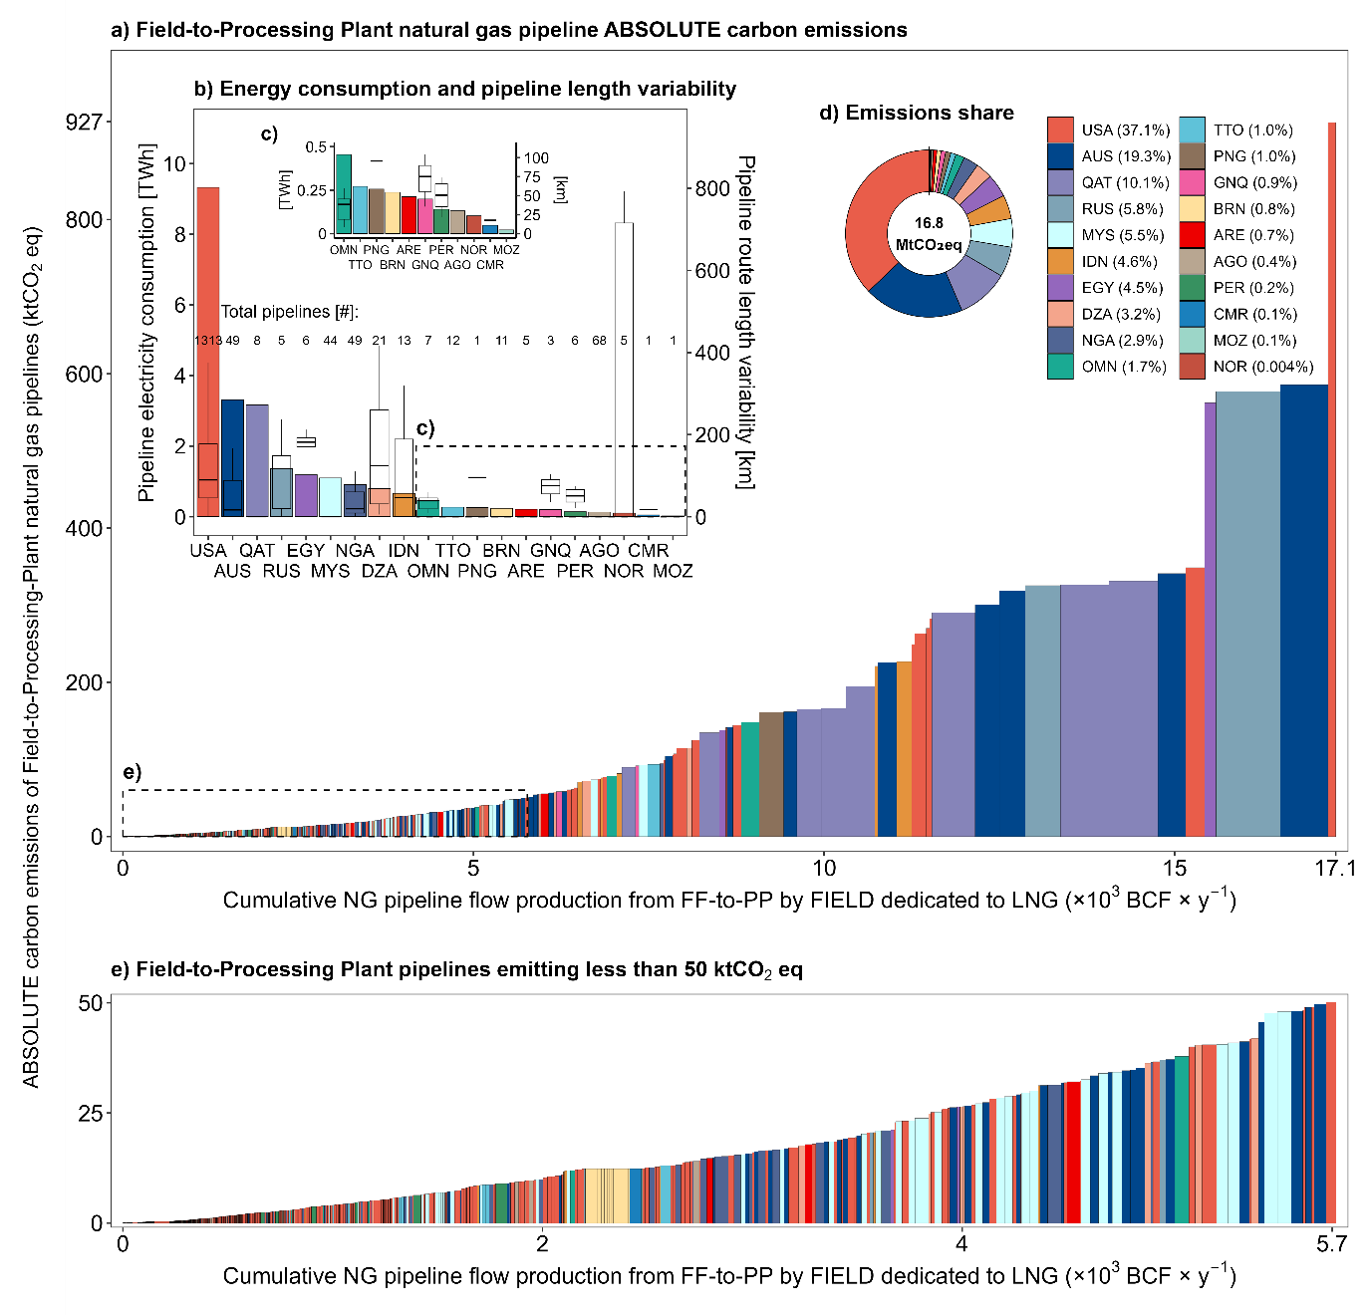
Figure SI-3. Carbon emissions, energy use, and infrastructure length variability in natural gas pipelines transporting LNG-dedicated volumes from production fields to processing plants. (a) Annual field-level pipeline emissions (ktCO₂eq), sorted by cumulative LNG production, with bar heights representing route-level emissions and colour indicating producing country. A dashed blue line marks the global volume-weighted average of 171 ktCO₂eq; key for benchmarking asset emissions, emission budgets and portfolio climate risk when setting carbon prices. (b) National-level comparison of total pipeline electricity consumption (TWh), with boxplots representing route-level length distributions per country (km). (c) Zoomed-in view of panel (b), highlighting countries with the lowest total electricity consumption. (d) Country-wise share of total field-to-processing plant pipeline emissions, represented as a donut chart with percentage values and ISO3 country codes. (e) Focus on low-emitting routes (<50 ktCO₂eq), showing their cumulative contribution to LNG supply and highlighting route-level emission performance across producing countries.

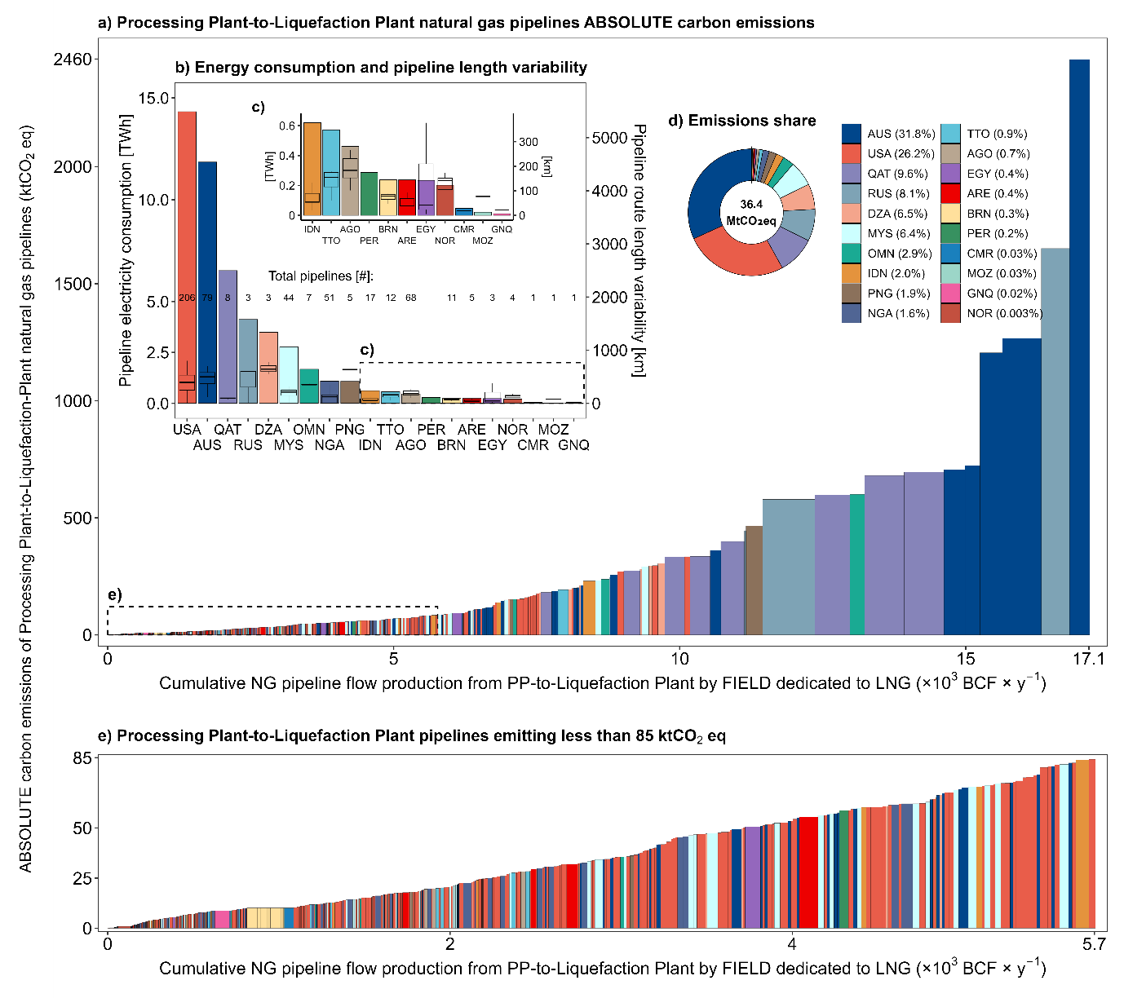
Figure SI-4. Carbon emissions, energy use, and infrastructure length variability in natural gas pipelines transporting LNG-dedicated volumes from processing plants to liquefaction plants. (a) Annual field-level pipeline emissions (ktCO₂eq), sorted by cumulative LNG production, with bar heights representing route-level emissions and colour indicating producing country. A dashed blue line marks the global volume-weighted average of 171 ktCO₂eq; key for benchmarking asset emissions, emission budgets and portfolio climate risk when setting carbon prices. (b) National-level comparison of total pipeline electricity consumption (TWh), with boxplots representing route-level length distributions per country (km). (c) Zoomed-in view of panel (b), highlighting countries with the lowest total electricity consumption. (d) Country-wise share of total processing plant-to-liquefaction plant pipeline emissions, represented as a donut chart with percentage values and ISO3 country codes. (e) Focus on low-emitting routes (<85 ktCO₂eq), showing their cumulative contribution to LNG supply and highlighting route-level emission performance across producing countries.

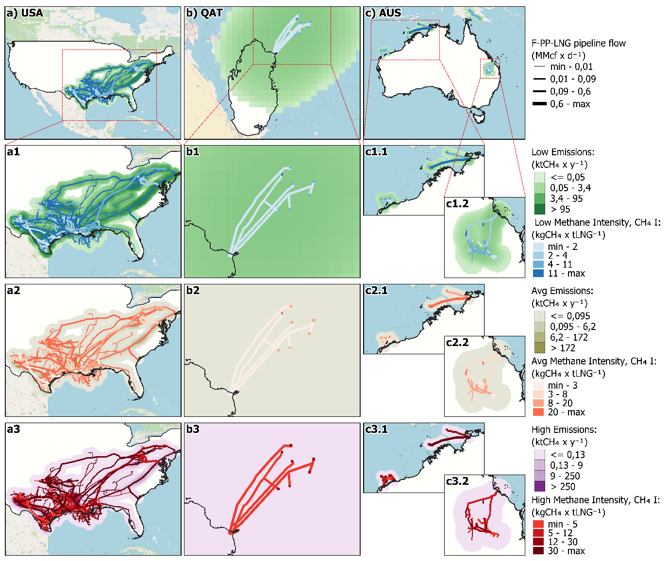
Figure SI-5. Low, average and high methane emissions and intensity profiles, derived from satellite observations and AI/ML models, for FF–LNG pipeline archetypes versus cumulative flow (×10³ Bcf y⁻¹) in selected countries: (a1) USA ultra-long feeders, (b1) Qatar high-throughput trunklines and (c1) Australia regional collectors. Rasterised overlayed hotspots show methane emissions across FF-LNG pipelines in terms of flaring, fugitives and venting

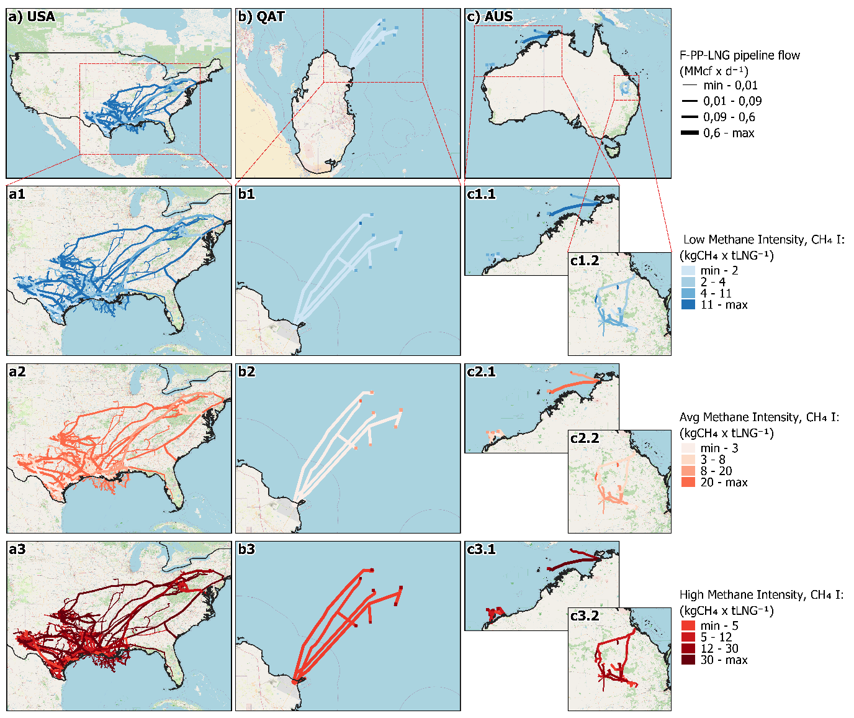
Figure SI-6. Low, average and high methane intensity profiles, derived from satellite observations and AI/ML models, for FF–LNG pipeline archetypes versus cumulative flow (×10³ Bcf y⁻¹) in selected countries: (a1) USA ultra-long feeders, (b1) Qatar high-throughput trunklines and (c1) Australia regional collectors.
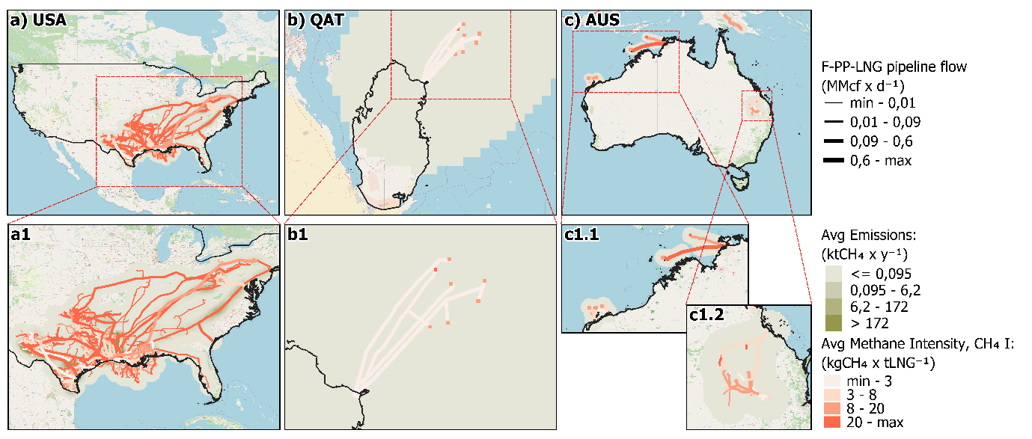
Figure SI-7. Average methane emissions and intensity profiles, derived from satellite observations and AI/ML models, for FF–LNG pipeline archetypes versus cumulative flow (×10³ Bcf y⁻¹) in selected countries: (a1) USA ultra-long feeders, (b1) Qatar high-throughput trunklines and (c1) Australia regional collectors. Rasterised overlayed hotspots show methane emissions across FF-LNG pipelines in terms of flaring, fugitives and venting. Figures SI-5 and SI-6 present the low- and high-end estimates for methane emissions and methane intensity, respectively.

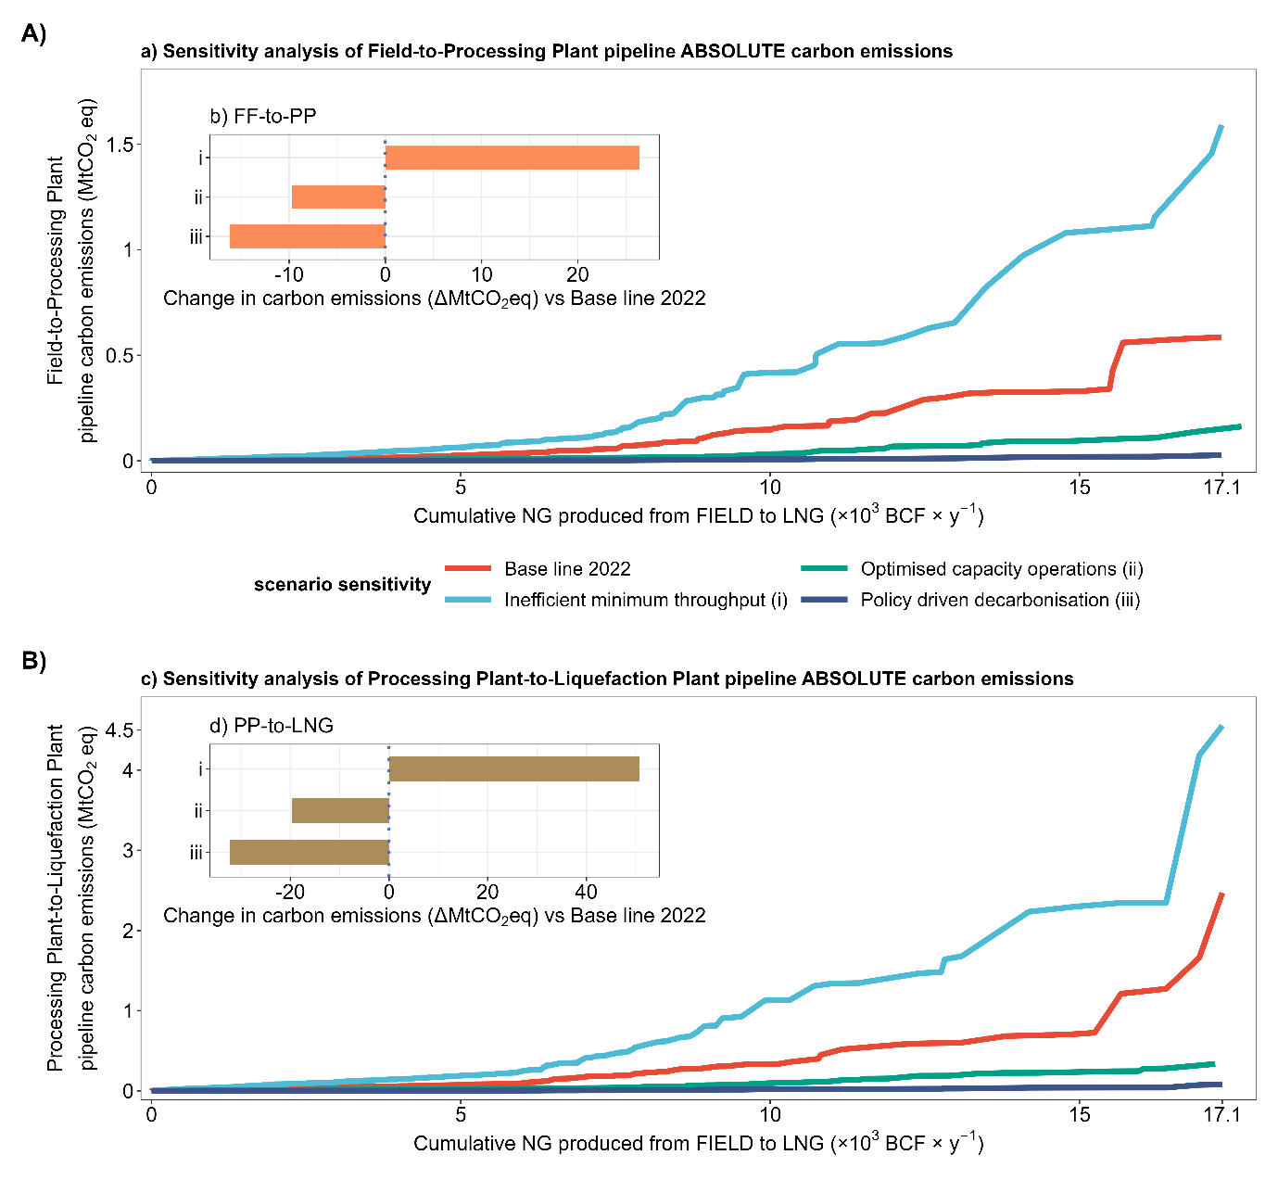
Figure SI-7. Sensitivity of pipeline absolute CO₂ emissions to operational scenarios for (A) field-to-processing (FF–PP) and (B) processing-to-liquefaction (PP–LNG) segments, plotted against cumulative global flow (×10³ Bcf y⁻¹). Coloured lines compare the 2022 baseline (blue) with “inefficient minimum throughput” (red), “optimised capacity operations” (green) and “policy-driven decarbonisation” (purple) scenarios. Inset panel (b) shows absolute FF–PP CI changes (Δ Mt CO₂-eq) for scenarios i–iii relative to baseline, while inset (d) details segment-level CI shifts for PP–LNG routes.

Supplementary Methods

The ATP3 model
The equations applied for the Algorithm for Transportation Pathways and Patterns through Pipeline network (ATP3; ¹) are presented in Table SI-M1. Supply–demand imbalances are balanced via entropy-weighted allocation, where entropy (Eq. 1), divergence (Eq. 2), and weights (Eq. 3) generate composite scores (Eq. 4) and allocation ratios (Eq. 5). Geodesic distances are calculated using the Haversine formula (Eq. 6). Shortest paths are computed with Dijkstra’s algorithm, while flows are optimised as a minimum-cost transportation problem (Eqs. 7–8).
Table SI-M1: Equations and variables used to estimate the entropy-weighted supply allocation.
Eq. # | Eq. | Where | Ref
Eq. 1 | $$E_{j} = -k \sum_{i=1}^{n}{p_{ij}\ln\left(p_{ij}+ε\right) }$$  $$k= \frac{1}{\ln{n}}$$ | $E_{j}$ is the entropy indicator  $p_{ij}$ is the proportion of indicator j for supply point i  $n$ is the total number of supply points  $ε$ is a small constant to avoid singularity | ¹
Eq. 2 | $${d_{j}=1-E}_{j}$$ | $d_{j}$ is the indicator divergence values
Eq. 3 | $$w_{j} = \frac{d_{j}}{\sum_{m=1}^{M}{d_{m}}}$$ | $w_{j}$ is the entropy-based weights  $M$ is the total number of indicators
Eq. 4 | $$s_{i}= \sum_{j=1}^{M}{{w_{j} p}_{ij}}$$ | $s_{i}$ is the composite EWM score for each supply point
Eq. 5 | $$ρ_{i} = \frac{min⁡(s_{i} B \sum_{i=1}^{n}{Q_{i}})}{Q_{i}}$$ | $ρ_{i}$ is the allocation ratio for each supply point  $\sum_{i=1}^{n}{Q_{i}}$ is the total supply flow  $B$ denotes the predefined baseline proportion goes to demand
Eq. 6 | $$\left\{\begin{aligned}a=\sin^{2}\left(\frac{∆lat}{2}\right)+\cos\left({lat}_{i}\right) \cos\left({lat}_{j}\right)\sin^{2}\left(\frac{∆lon}{2}\right), \\ c=2atan2\left(\sqrt{a}, \sqrt{1-a}\right), \\ d_{ij}= {c R}_{Earth} \end{aligned}\right.$$ | $∆lat$ and $∆lat$ denote the differences in latitude and longitude between nodes $n_{i}$ and $n_{j}.$  ${c R}_{Earth}$ is the Earth’s radius (set to 3960 miles in this study).
Eq. 7 | $$min:J= \sum_{i, j}^{n,M}{{w_{ij} x}_{ij}}$$ | $w_{ij}$ represents the cost of transporting gas from source $i$ to sink $j$,  ${ x}_{ij}$ is the capacity of gas transported.
Eq. 8 | $$s.t.\left\{\begin{aligned}\sum_{j}{x_{ij} ≤ s_{i} ∀i} \\ \sum_{i}{x_{ij}= d_{j} ∀j } \\ \end{aligned}\right.$$ | $s_{i}$ represents the supply of node $i$; $d_{j}$ denotes the demand of node $j$.

The PipeWiser model
Estimating energy use, CO₂ emissions and carbon intensity (CI) in global natural gas pipelines requires combining geospatial climate, terrain, thermodynamics and fluid mechanics with greenhouse-gas accounting. PipeWiser ² models segment-level pressure drops, compressor duty and energy requirements using real-gas behaviour, Reynolds-number regimes and Joule–Thomson effects. Resulting energy inputs are converted to CO₂ using region-specific emission factors and normalised to compute CI for field-to-processing (FF–PP) and processing-to-liquefaction (PP–LNG) segments. Methane emissions from venting, flaring and leaks are quantified via satellite plume data, geospatial clustering and machine learning, producing route-resolved CH₄ intensities. This bottom-up, data-rich framework underpins the PipeWiser AI–ML platform. PipeWiser methodology assumes non-ideal gas behaviour by estimating a compressibility factor (Z) for natural gas at inlet conditions and applying it throughout each pipeline segment to recalculate gas properties dynamically. Compression is treated as adiabatic and isentropic, meaning reversible with no heat exchange between the gas and its surroundings, and heat transfer between the gas and pipeline wall is neglected. Steady-state flow is assumed, so all gas properties (pressure, temperature, density) remain constant over time for each segment, and gas composition is held uniform along the entire network. Emissions are reported using the Global Warming Potential over a 100-year time horizon (GWP100) based on values from the IPCC Sixth Assessment Report (AR6). All energy-related metrics are calculated using the lower heating value (LHV) of natural gas, standardised at 55 GJ per tonne of LNG.
Required operating pressures draw on three literature sources: China’s large-diameter transmission network at 6.8–9.85 MPa ³, global transmission pipelines at 6.7–12 MPa ⁴, and U.S. interstate mains at 5.8–10.34 MPa ⁵. Their respective maxima (9.85, 12, 10.34 MPa) are averaged to define a design pressure of 10.73 MPa. Practical engineering guidelines place compressor-station spacing between 120 km and 160 km ⁶, and a midpoint distance of 140 km for all segments is adopted to initiate the calculations. Model calibration identified implausibly large pressure drops due to initial-condition assumptions. Drops exceeding the 75th percentile (26 MPa) are capped at the median value of 19.5 MPa to mitigate outlier effects on energy estimates. Ambient fluid temperatures are set to each country’s annual average based on ⁷ and ⁸, and pipeline wall thickness is specified per ASME B31.8-2003 Table 842.214 for buried mains (2.5 m depth), enabling heat-transfer calculations ⁹, Table SI-M2.

Table SI-M2: Grouped standard ASME B31.8-2003, Table 842.214 ⁹, assuming that the pipeline is buried at a depth of 8 ft (2.5 m approximately).
Pipe size (in) | Thickness (in)
<6 | 0.3
6-12 | 0.37
12-18 | 0.38
>18 | 0.44

Following a comprehensive energy-and-big-data evaluation method ¹⁰, the system boundary for thermal, hydraulic and emissions calculations was defined by an average inlet pressure of 6.5 MPa and temperature of 19.85 °C, with volumetric flow rates taken from the nearest production site data ¹¹. Geospatial pipeline topology and specifications were sourced from the World Atlas of Pipelines ¹², while dynamic flow volumes were retrieved from Kpler ¹³, providing trade-validated throughput estimates. Field-level production profiles and processing plant capacities were compiled from Wood Mackenzie ¹⁴, with upstream–midstream linkages validated through Rystad Energy UCube ¹⁵. Methane flaring was benchmarked using the World Bank GGFR dataset ¹⁶, and country-level grid emission factors were sourced from IRENA ¹⁷. These complementary datasets were harmonised in a geospatial–thermodynamic modelling framework to ensure traceability and consistency.

Table SI-M3 compiles the governing equations used to estimate thermal profiles and heat transfer in natural gas transmission pipelines. Eq. 9 expresses the gas temperature inside the pipe as a function of the pipe surface temperature, environmental conditions, wall thickness, conductivity, and convective heat transfer coefficient. Eq. 10 defines the heat transfer rate between the gas and the pipe wall, while Eq. 11 gives the pipe surface area as a function of radius and length. Eqs. 12 and 13 link gas-to-pipe and wall conduction fluxes, ensuring continuity of heat transfer, with Eq. 14 consolidating both processes. Finally, Eq. 15 provides a rearranged solution for gas temperature that integrates convective and conductive effects simultaneously.
Table SI-M3: Equations and variables used to estimate thermal profile and heat transfer properties.
Eq. # | Eq. | Where | Ref
Eq. 9 | $$T_{f}= T_{s}+ \left(T_{s}- T_{i}\right)* {\left(\frac{h*d}{k}\right)}^{-1}$$ | $T_{f}$is the temperature of the gas (in Kelvin)  $T_{i}$ is the temperature on the outer side (surrounding environment) (in K)  $T_{s}$ is the temperature of the pipe surface (in K)  $t$ is the thickness of the pipe  $h$ represents the convective heat transfer coefficient (W/m²·K)  $k$ is the thermal conductivity of the material (W/(m·K)) | ¹¹
Eq. 10 | $$Q=h*A (T_{s}- T_{f})$$ | $Q$ is the rate of heat transfer (in Watts)  $h$ is the convective heat transfer coefficient (in W/m²·K)  $A$ is the surface area of the pipe (in m²)  $T_{s}$​ is the temperature of the pipe surface (in Kelvin)  $T_{f}$is the temperature of the gas (in Kelvin) | ¹⁸, ¹⁹, ²⁰, ²¹
Eq. 11 | $$A=2* π*r*L$$ | $r$ is the radius of the pipe (in meters)  $L$ is the length of the pipe (in meters)
Eq. 12 | $$Q_{gas to pipe }= Q_{pipe wall}$$  $$Q_{gas to pipe }= h*A (T_{s}- T_{f})$$ | $Q_{gas to pipe }$​is the heat transfer rate from the gas to the pipe wall (W).  $Q_{pipe wall}$​ is the heat transfer rate through the pipe wall (W).
Eq. 13 | $$Q_{pipe wall}=\frac{k*A* (T_{f}- T_{i})}{d}$$ | $A$ is the surface area (in meters) | ¹⁸
Eq. 14 | $$h*A \left(T_{s}- T_{f}\right)= \frac{k*A* \left(T_{f}- T_{i}\right)}{d}$$ | $k$ is the thermal conductivity of the pipe material; k = 36 (W/m*K)  $T_{i}$ is the initial temperature of the surrounding environment (in K)  $d$ is the thickness of the pipe wall (in meters, m). | ²²
Eq. 15 | $$T_{f}= \left(\frac{d*h}{k}*T_{s}+ T_{i}\right)* {\left(1+\frac{h*d}{k}\right)}^{-1}$$ | $T_{f}$is the temperature of the gas (in Kelvin)

Table SI-M4 presents the equations used to derive fluid properties and classify flow regimes in pipeline segments. Eq. 16 calculates the pressure drop due to friction as a function of density, velocity, pipe length and diameter, with the friction factor determined by Eq. 17, via the Lee, et al. ²³. The Reynolds number, expressed in Eq. 18, distinguishes laminar, transitional, and turbulent regimes, providing the basis for regime-specific friction factor selection from ³. Gas viscosity is estimated using the Lee correlation, where Eq. 19 defines viscosity as an exponential function of density and cross-sectional area, with coefficients given by Eqs. 20–22. Together, these equations enable accurate characterisation of gas flow regimes and frictional pressure losses across diverse operating conditions.
Table SI-M4: Equations and variables used to estimate fluid properties and determine flow regime.
Eq. # | Eq. | Where | Ref
Eq. 16 | $$ΔP_{f}=\frac{f*L* ρ* ν^{2}}{2D_{i}}$$ | $f$ is the friction factor between point 1 and 2  $L$ in the length of the pipe segment between point 1 and 2  $ρ$ is the density of the gas between point 1 and 2  $ν$ is the velocity of the gas between point 1 and 2 | ²⁴
Eq. 17 | $$f=\left\{\begin{aligned}Turbulen flow, f=0.00958* D_{i}^{-0.2} \\ Laminar flow, &f=\frac{64}{Re}\end{aligned}\right.$$ | $D_{i}$ is the internal pipe diameter between point 1 and 2  $Re$ is the Reynolds number between point 1 and 2 (Eq. 10) | ²⁴, ³
Eq. 18 | $$Re=\frac{ρ* ν*D_{i} }{μ}$$  For Re<2000, the flow is laminar.  For 2000<Re<4000, the flow is transitional.  For Re>4000, the flow is turbulent. | $μ$ is the dynamic viscosity of the gas, kg/(m*s)  Results until this step are in line with ²⁵.
Eq. 19 | $$μ= L_{1}*exp\left[L_{2}{\left(\frac{ρ}{A}\right)}^{L_{3}}\right]$$ | $A$ is the cross-section area of the pipe between point 1 and 2 | ²³
Eq. 20 | $$L_{1}= {10}^{-4}* \frac{\left(7.77+0.0063*M\right)* T_{f}^{1.5} }{122.4+12.9*M+T_{f}}$$ | $M$ is the molecular weight of the gas | ²³
Eq. 21 | $$L_{2}=2.57+\frac{1914.5}{T_{f}}+0.0095*M$$ | $L_{1}, L_{2} and L_{3}$ are Lee correlation factors | ²³
Eq. 22 | $$L_{3}=1.11+0.04* L_{2}$$ |  | ²³

Hydraulic pressure-drop calculations determine how gas pressure evolves along each pipeline segment by accounting for both frictional and elevation effects. Frictional losses are derived from the Darcy–Weisbach formulation (Eq. 16, Table SI-M4), while hydrostatic losses are captured with Eq. 25 (Table SI-M5). Gas density is computed via a compressibility-adjusted ideal-gas law (Eq. 23), with compressibility factor Z obtained empirically as a function of pressure (Eq. 24). These components are combined in Eq. 26 to yield the total pressure drop (Pdrop). Exit pressure and temperature are then updated using Eqs. 27–28, which incorporate compressibility effects, before volumetric flow is recalculated through Eq. 29. Together, Eqs. 16 and 23–29 provide a coherent framework for quantifying pressure losses and flow adjustments, ensuring accurate estimation of compressor-station requirements along nominal 140 km intervals, consistent with reference practice ⁶.
Table SI-M5: Equations and variables used to estimate pressure drops.
Eq. # | Eq. | Where | Ref
Eq. 23 | $$ρ= \frac{P_{1}*M}{Z*R* T_{f}}$$ | $P_{1}$ is the pressure in the pipeline, MPa  $T_{f}$ is the temperature in the gas, C, needs conversion to K  $R$ is the specific gas constant for natural gas, 8.314 m3*Pa/(K.mol)  $M$ is the molar mass of the gas, 0.01604 [kg/mol]; assumed the one from Methane, though for natural gas it can be assumed 20.3 Kg/kmol  $Z$ is the compressibility factor | ²⁴,
Eq. 24 | $$Z= \frac{100}{100+1.734* P_{1}^{1.15}}$$ | $P_{1}$is the absolute pressure in each pipeline section, MPa. | ²⁶
Eq. 25 | $$ΔP_{h}= ρ*g*Δh$$ | $ρ$ is the density of the gas (in kg/m³ or lb/ft³).  $g$ is the acceleration due to gravity (in meters per second squared, m/s²).  $Δh$ is the change in height or elevation (in meters).
Eq. 26 | $$P_{drop}= ΔP_{f}+ ΔP_{h}$$ | $ΔP_{f}$ is the pressure loss due to friction between point 1 and 2  $ΔP_{h}$ is the pressure loss due to elevation between point 1 and 2
Eq. 27 | $$T_{2}= \frac{P_{2}* T_{1}}{Z* P_{1}}$$ | T1 and T2 are the initial and final temperatures
Eq. 28 | $$P_{2}= \left|P_{1}-P_{drop}\right|$$ | $P_{drop}$ is the pressure dropped between point 1 and 2  P1 and P2 are the initial and final pressures.  Results until this step are in line with ²⁷.
Eq. 29 | $$V_{2}= \frac{V_{1}* P_{1}* T_{1}}{Z* P_{2}* T_{2}}$$ | $V_{1}$ is the initial volumetric flow rate in point 1  $P_{2}$ is the pressure in point 2  $T_{1} and T_{2}$are the initial and final temperatures at point 1 and 2, respectively | ²⁸

The final step estimates compressor work, energy requirements and associated GHG emissions. Equation 30 integrates isentropic compression work (Wc) across each segment’s volume change, while Eq. 31 applies the Joule–Thomson enthalpy change (ΔH) at over-pressure relief or reduction stations. Wc is then converted to energy input (Ec) using the assumed compressor efficiency (ηc = 75 %, Eqs. 32–33). Equation 34 multiplies Ec by the national grid emission factor to compute CO₂-equivalent emissions, which are subsequently normalised to LNG throughput in Eq. 35 to obtain carbon intensity (CI) expressed as tCO₂e tLNG⁻¹ or kgCO₂e MJLNG⁻¹. Collectively, Eqs. 30–35 link hydraulic pressure dynamics to energy demand and emissions outcomes, providing a consistent framework to evaluate climate-relevant performance of global LNG transmission pathways (Table SI-M6).
Table SI-M6: Equations and variables used to estimate compression work, energy and emissions.
Eq. # | Eq. | Where | Ref
Eq. 30 | $$W_{c}= \int_{V_{1}}^{V_{2}}{Z*P*dV}$$  $$W_{c}=Z* P_{1}*(V_{2}-V_{1})$$ | $W_{c}$ is the total volumetric work by the compressor  $Z$ is the compressibility factor of the gas from point 1 to point 2  $P_{1}$ is the pressure in point 1  $V_{2} and V_{1}$are the volumes at point 2 and 1, respectively
Eq. 31 | $$ΔH=\int_{P1}^{P2}{VdP}= Z*V*(P2-P1)$$ | $ΔH$ is the enthalpy change across the JT valve  $V$ is the specific volume of the gas | ²⁹
Eq. 32 | $$E_{c}= W_{c}* η_{c}^{-1}$$ | $η_{c}$ is the efficiency of the compressor
Eq. 33 | $$W_{c}= E_{c}* η_{c}$$ | $W_{c}$ is the work of the compressor  $E_{c}$ is the energy required to run the compressor
Eq. 34 | $${CO}_{2e}= E_{c}* {Grid}_{ef}$$ | $E_{c}$ is the energy consumption by compressors  ${Grid}_{ef}$ is the emission factor of the grid for each country
Eq. 35 | $$CI=\frac{{CO}_{2e}}{{LNG}_{p}};[\frac{t{CO}_{2e}}{tLNG}; \frac{kg{CO}_{2e}}{{MJ}_{LNG}}]$$ | ${CO}_{2e}$ are the equivalent CO2 emissions in the pipeline.  ${LNG}_{p}$ is the annual production of LNG in the pipeline.

A dedicated geospatial algorithm enables segment-level quantification of hydraulic behaviour, thermodynamic properties, energy requirements and emissions across global field-to-processing (FF–PP) and processing-to-liquefaction (PP–LNG) pipelines. It processes spatial inputs—including coordinates, diameters, elevation profiles and flow rates—through modular routines that validate data, derive geometries, interpolate terrain and compute inter-point distances. Thermodynamic calculations incorporate compressibility (Z), density, viscosity and Reynolds numbers to estimate gas velocities and frictional plus elevation-induced pressure drops (Eqs. 16–24). Energy balances then determine compressor work (Eq. 30), efficiency-adjusted inputs (Eqs. 32–33) and resulting CO₂-eq emissions (Eq. 34), which are normalised by LNG throughput to compute carbon intensity (Eq. 35). Outputs include total route length, elevation changes, pressure profiles, compressor requirements, cumulative energy demand, emissions and CI benchmarks. Rigorous outlier controls ensure consistency, while aggregation across 20 exporting nations delivers robust country-level validation. This end-to-end framework supports efficiency benchmarking, optimisation and environmental assessment of global LNG transmission networks.

The MEEM model
The Methane Emissions Estimation Model (MEEM) applies a dual framework to quantify superemitter (≥100 kg CH₄ h⁻¹) and non-superemitter emissions. Superemitter emissions are derived through three complementary approaches: (i) a satellite–literature synthesis combining TROPOMI and EMIT detections with intermittency factors; (ii) a basin-similarity method transferring empirically derived ratios from US basins to international fields; and (iii) a deep neural network trained on 2,252 US fields to predict large releases. Ensemble integration of these methods provides annualised estimates with widened uncertainty ranges. Non-superemitter emissions follow an updated bottom-up approach based on Rutherford ³⁰, with a refined gas-to-oil ratio (GOR) threshold (10,000 scf bbl⁻¹) distinguishing field types. Table SI-M7 summarises the governing equations: Eq. 36 formulates equipment-level emissions using emission and activity factors; Eq. 37 classifies fields as oil or gas; Eq. 38 totals emissions across wells and equipment; Eqs. 39–40 apply log–log scaling for emissions and uncertainty with producer counts; Eq. 41 aggregates equipment contributions at process level; and Eq. 42 imposes a methane mass-balance cap. Together, these equations enable consistent, scalable integration of component-level measurements into process- and field-level methane inventories.
Table SI-M7: Equations for equipment-level methane estimation and process integration (non-superemitter framework). Eqs. 36–40 define the equipment-level emissions formulation, GOR-based field classification, totalisation across wells/equipment, and log–log scaling of emissions and uncertainty; Eq. 41 aggregates component sources to the separation process; Eq. 42 imposes a process-level mass-balance cap. “Where” defines symbols; “Ref” lists methodological sources.
Eq. # | Eq. | Where | Ref
Eq. 36 | $$E_{i,j}={EF}_{i}×{AF}_{i}×I_{i,j}$$ | $E_{i,j}$: emission rate  ${EF}_{i}$: emissions factor for equipment i  ${AF}_{i}$: activity factor;  $I_{i,j}$: indicator (1 if equipment i is present at well site j, else 0). | ³⁰
Eq. 37 | $$Field type= \left\{\begin{aligned}Gas fields, if GOR>10000 \\ Oil fields, if GOR≤10000\end{aligned}\right.$$ | GOR: gas-to-oil ratio (scf/bbl); threshold used to classify field type. | ³⁰
Eq. 38 | $$E_{total}= \sum_{j=i}^{N_{wells}}{\sum_{i=1}^{N_{equipment}}{E_{i,j}}}$$ | $E_{total}$: total emissions;  $N_{wells}$: number of wells; $N_{equipment}$: number of equipment types. | —
Eq. 39 | $$\log_{10}\left(E\right)=m\log_{10}\left(P\right)+b$$ | $E$: equipment emission rate (kg CH₄/day);  P: producer count;  m,b: slope and intercept from fit. | —
Eq. 40 | $$\log_{10}\left(U\right)=m\log_{10}\left(P\right)+b$$ | U: emission uncertainty (P97.5 − P2.5); | —
Eq. 41 | $$E_{separation}=E_{separator}+E_{pneumatic}+E_{meter}$$ | Aggregated process-level emissions for separation from component sources. | ³¹
Eq. 42 | E_process = min( E_equipment , F_(CH_4) )  $$E_{process}=min⁡(E_{equipment}, F_{{CH}_{4}})$$ | $E_{process}$: final process emission; $E_{equipment}$: combined equipment emissions;  $F_{{CH}_{4}}$: methane flow into process. | ³¹

Methane emissions from additional processes, such as acid gas removal (AGR), flaring and gathering systems, are included alongside component fugitives. AGR and gathering emissions are modelled with OPGEE formulations ³¹, while flaring assumes a 7% methane slip from incomplete combustion and unlit/extinguished flares, consistent with aircraft survey evidence but higher than governmental defaults. Superemitter emissions (≥100 kg CH₄ h⁻¹) are captured through a three-pronged framework: (i) satellite-plume processing from TROPOMI and EMIT, converting detections into field-level emissions by averaging, merging within 3.5 km, and production-weighted allocation (Eqs. 43–48; Table SI-M8); (ii) basin-similarity mapping that transfers superemitter-to-non-superemitter ratios from ~1 million U.S. site measurements, based on feature standardisation and Euclidean distance (Eqs. 49–51); and (iii) a neural network trained on 2,249 U.S. fields with a weighted loss prioritising high-emission cases (Eq. 52). Outputs are statistically integrated across applicable methods using field- and country-specific sampling rules (Eqs. 53–54). Table SI-M8 summarises the governing equations, from plume averaging and great-circle separation to allocation, basin mapping, neural-network training, and ensemble integration, ensuring transparency and comparability of superemitter estimates.
Table SI-M8: Equations for satellite-plume processing, allocation, and integration. Eqs. 43–48 define the conversion from point detections to field-level emissions (averaging, 3.5 km great-circle merging, and production-weighted allocation); Eqs. 49–51 cover feature standardisation and basin-similarity mapping from non-super to superemitter rates; Eq. 52 is the custom weighted loss used in model training; and Eqs. 53–54 specify the integrated sampling rules and country-specific method set. “Where” defines symbols; “Ref” lists methodological sources.
Eq. # | Eq. | Where | Ref
Eq. 43 | $${\overline{E}}_{x,y}=\frac{1}{n}\sum_{i=1}^{n}{E_{i},}$$ | ${\overline{E}}_{x,y}$: mean emission at location (x,y) from n detections $E_{i}$ | ³²
Eq. 44 | $${\overline{L}}_{x,y}=\frac{1}{n}\sum_{i=1}^{n}{L_{i},}$$ | ${\overline{L}}_{x,y}$: mean lower uncertainty bound. | ³²
Eq. 45 | $${\overline{H}}_{x,y}=\frac{1}{n}\sum_{i=1}^{n}{H_{i},}$$ | ${\overline{H}}_{x,y}$mean upper uncertainty bound. | ³²
Eq. 46 | $$d=R_{earth}arccos⁡(sin∅_{1}sin∅_{2}+cos∅_{1}cos∅_{2}cos⁡(∆λ))$$ | $d$: great-circle distance;  $R_{earth}$ = 6371 km;  $∅$: latitude (rad);  $λ$: longitude (rad). | ³³
Eq. 47 | $$E_{f}=E_{p}×\frac{Q_{f}}{\sum_{i}{Q_{i}}}$$ | $E_{f}$: emissions allocated to field f;  $E_{p}$: plume emission;  $Q_{f}$: gas production of field f;  $\sum_{i}{Q_{i}}$: total production within radius. | ³²
Eq. 48 | $$E_{f,c}=E_{p}×\frac{Q_{f}}{\sum_{j}{Q_{i,c}}}$$ | $E_{f,c}$: emission to field f in country c; $\sum_{j}{Q_{i,c}}$: total country production. | ³²
Eq. 49 | $$z_{i}=\frac{x_{i}-μ}{σ}$$ | $z_{i}$: Standardization of feature $x_{i}$ with mean $μ$ and standard deviation $σ$. | ³⁴
Eq. 50 | $$d\left(f_{1},f_{2}\right)=\sqrt{\sum_{i=1}^{n}{{(z_{1i}-z_{2i})}^{2}}}$$ | $d$ : Euclidean distance in standardized feature space between fields $f_{1}$and $f_{2}$ across n features. | ³⁴
Eq. 51 | $$E_{super}=\frac{E_{non-super}}{r_{basin}}$$ | $E_{super}$: superemitter emissions from non-superemitter rate, $E_{non-super}$, using basin ratio $r_{basin}$. | ³⁴
Eq. 52 | $$L_{weighted}=\frac{1}{n}\sum_{i=1}^{n}{{\left(y_{i}-{\hat{y}}_{i}\right)}^{2}(1+|y_{i}|)}$$ | $L_{weighted}:$Custom training loss  $y_{i}$: true superemitter value  ${\hat{y}}_{i}$: predicted value | ³⁵
Eq. 53 | $$S_{f,c}=\left\{S_{f,m,c} | m∈M_{f}\right\}$$ | $S_{f,c}$: set of samples for field f at confidence level c;  $S_{f,m,c}$: estimate from method m;  $M_{f}$: applicable methods. | ³⁵
Eq. 54 | $$M_{f}= \left\{\begin{aligned}\left\{NN, \right.\left.US Similarity\right\}, if field f in Papua New Guinea \\ \left\{Literature \&Satellite, NN, \right.\left.US Similarity\right\}, otherwise\end{aligned}\right.$$ | Method set used per field  PNG excludes literature–satellite;  others use all three. | ³⁵

A satellite-driven machine-learning framework integrates plume detections with pipeline attributes to map methane leaks at the segment scale. Hotspot plumes are clustered along pipeline geometries using geospatial K-means with DBSCAN validation, while engineered features (length, diameter, elevation, flow, pressure, temperature, compressor count) are reduced through principal-component analysis. Ensemble models, such as random forests, gradient boosting, and neural networks, are trained on satellite-measured and ground-validated emissions to predict fluxes where detections are sparse, producing low, average, and high segment intensities. Routes are assembled in two stages (FF–PP and PP–LNG) with throughput and distance aggregated to an LNG basis using 55,000 MJ t⁻¹. Energy normalisation ensures comparability across heterogeneous gas qualities ^{36,37}. Satellite plume quantification applies integrated mass enhancement and cross-sectional flux methods, compositing repeated detections to treat intermittency and attributing fluxes to pipelines by proximity and throughput ³⁸. Persistent-source emphasis and conservative priors address undetected segments ³⁹. Dimensionality reduction via PCA and K-means clustering partitions routes into ultra-long feeders, regional collectors, and high-throughput trunklines [78]. Cluster validation employs elbow and silhouette diagnostics [79]. PCA preserves variance and mitigates artefacts in infrastructure classification [80]. Aggregation yields stage- and route-level, volume-weighted intensities, benchmarked against independent methane assessments [81]. This provides a plausibility envelope for intermittency-aware estimates [82].

Dimensionality reduction and archetype clustering
To summarise heterogeneity across thousands of routes, a five-variable matrix was formed per route (total length, PP-to-LNG flow, and low/average/high CH₄ intensities) and principal component analysis (PCA) was applied to centred and scaled variables ⁴⁰. The first two principal components captured the dominant covariation among distance, throughput, and intensity. K-means clustering (Hartigan–Wong algorithm, nstart = 50) was then performed on the PC scores, with the number of clusters selected using complementary diagnostics (elbow and mean silhouette width) ⁴¹. The resulting partitions were interpreted as infrastructure archetypes, ultra-long feeders, regional collectors, and high-throughput trunklines, by contrasting centroids in distance, flow, and volume-weighted intensities. Cluster labels were propagated back to the route table for stratified aggregation and figure faceting. PCA provided an interpretable, variance-preserving embedding for correlated infrastructure metrics, while silhouette analysis mitigated spurious partitions in elongated or partially overlapping groups ⁴².

Aggregation and benchmarking
Country- and global-level methane intensities were computed as volume-weighted means across routes, first within stage (FF-to-PP, PP-to-LNG) and then summed to a route-total CH₄ intensity. Production-dominant routes and high-intensity outliers were highlighted directly on cumulative-volume plots, enabling concurrent assessment of abatement leverage (large volumes) and risk (high g CH₄ MJ⁻¹) ⁴³. For external consistency, stage- and route-level statistics were compared against independent assessments of oil-and-gas methane emissions that exhibit heavy-tailed distributions and systematically exceed inventory values; this benchmarking provides a plausibility envelope for remotely sensed, intermittency-aware estimates ⁴⁴. All figures report LNG-basis units and include global volume-weighted reference lines to aid cross-archetype interpretation. Taken together, the workflow links satellite-constrained fluxes to route-resolved intensities, clusters infrastructure into policy-relevant archetypes, and aggregates results with transparent weighting and outlier control.

References
1 Liu, Z. E. et al. Algorithm for Transportation Pathways and Patterns through Pipeline network - A case study in California (under review). Engineering (2025).
2 Moya-Pinta, D. A. System and Method for Sustainability, Evaluation, Design and Optimization of Natural Gas Transmission Networks Operations, Application No. 19/192,839. (United States Patent and Trademark Office, 2025).
3 Xu, S. et al. Life cycle assessment of carbon emission from natural gas pipelines. Chemical Engineering Research and Design 185, 267-280 (2022). https://doi.org/https://doi.org/10.1016/j.cherd.2022.07.018
4 Molnar, G. in The Palgrave handbook of international energy economics 23-57 (Springer International Publishing Cham, 2022).
5 US, N. The Transportation of Natural Gas, <http://naturalgas.org/naturalgas/transport/.> (2013).
6 Ruan, Y. et al. A procedure to design the mainline system in natural gas networks. Applied Mathematical Modelling 33, 3040-3051 (2009). https://doi.org/https://doi.org/10.1016/j.apm.2008.10.008
7 Ficco, G., Cassano, M., Cortellessa, G., Zuena, F. & Dell’Isola, M. On the Reliability of Temperature Measurements in Natural Gas Pipelines. Sensors 23, 3121 (2023).
8 Kaggle. Mean temperature for countries by year 2014 - 2022, <https://www.kaggle.com/datasets/palinatx/mean-temperature-for-countries-by-year-2014-2022?resource=download > (2024).
9 ASME. ASME B31.8: Gas Transmission and Distribution Piping Systems, <https://law.resource.org/pub/us/cfr/ibr/002/asme.b31.8.2003.pdf> (2003).
10 Fan, M.-w., Ao, C.-c. & Wang, X.-r. Comprehensive method of natural gas pipeline efficiency evaluation based on energy and big data analysis. Energy 188, 116069 (2019). https://doi.org/https://doi.org/10.1016/j.energy.2019.116069
11 Muhammad Jabbar, L. J. (ed Liang Jing Muhammad Jabbar) (2023).
12 Gulf Energy. Energy Web Atlas Launches World Pipeline Dataset, <https://gulfenergyinfo.com/gulf-news/2018/08/energy-web-atlas-launches-world-pipeline-dataset> (2023).
13 Kpler. Intelligence tools for trade, <https://www.kpler.com/?igaag=178583598937&igaat=&igacm=22658292395&igacr=757299545161&igakw=kpler&igamt=p&igant=g&utm_campaign=search-brand&utm_source=google&utm_medium=cpc&utm_term=kpler&gad_source=1&gad_campaignid=22658292395&gbraid=0AAAAAC-Xw1hXM5pXQRKpdsyDZuX0n1JJX&gclid=Cj0KCQjws4fEBhD-ARIsACC3d29Ya_q9FYkDMq5aB5lnS3K09wlUVOswHIiZvjZF8ObPoTz8zk1Z6G0aApM3EALw_wcB> (2023).
14 Wood Mackenzie. Global Gas & LNG Assets, <https://www.woodmac.com/industry/gas-and-lng/global-gas-and-lng-assets/> (2023).
15 Rystad Energy. Navigate 2024 with our latest developments in the gas and LNG portfolio, <https://www.rystadenergy.com/updates-gas-lng-portfolio> (2023).
16 World Bank Group. 2023/2024 Global Gas Flaring Tracker Report, <https://www.worldbank.org/en/programs/gasflaringreduction/publication/2024-global-gas-flaring-tracker-report#:~:text=The%20latest%20Global%20Gas%20Flaring,the%20global%20average%20flaring%20intensity.> (2023).
17 IRENA. Statistical Yearbooks, Energy Profile, <https://www.irena.org/Data/Statistical-publications/Yearbooks> (2023).
18 Vollmer, M. Newton's law of cooling revisited. European Journal of Physics 30, 1063 (2009).
19 Edge, E. Overall heat transer coefficient table charts and equations, <https://www.engineersedge.com/thermodynamics/overall_heat_transfer-table.htm> (2023).
20 Chiavazzo, E., Ventola, L., Calignano, F., Manfredi, D. & Asinari, P. A sensor for direct measurement of small convective heat fluxes: Validation and application to micro-structured surfaces. Experimental Thermal and Fluid Science 55, 42-53 (2014).
21 Ranjbarnodeh, E., Serajzadeh, S., Kokabi, A. H. & Fischer, A. Effect of welding parameters on residual stresses in dissimilar joint of stainless steel to carbon steel. Journal of Materials Science 46, 3225-3232 (2011). https://doi.org/10.1007/s10853-010-5207-8
22 Isachenko, V. P., Osipova, V. A. & Sukomel, A. S. Heat transfer. (Nirali Prakashan, 1980).
23 Lee, A. L., Gonzalez, M. H. & Eakin, B. E. The viscosity of natural gases. Journal of petroleum technology 18, 997-1000 (1966).
24 Green, D. W. Perry’s chemical engineers’. Handbook–seventh Edition–Sections, 5-12 (2008).
25 Moshfeghian, M. Variation of Natural Gas Viscosity with Temperature, Pressure, and Relative Density, <https://www.petroskills.com/en/blog/entry/dec2022-totm> (2022).
26 Li, J. & Yu, B. in Sustainable Natural Gas Reservoir and Production Engineering Vol. 1 (eds David A. Wood & Jianchao Cai) 1-28 (Gulf Professional Publishing, 2022).
27 Desgranges, C. & Delhommelle, J. A Mole of Chemistry: An Historical and Conceptual Approach to Fundamental Ideas in Chemistry. (CRC Press, 2020).
28 Çengel, Y. A. & Boles, M. A. Thermodynamics: An Engineering Approach. (McGraw-Hill Higher Education, 2006).
29 Jeong, K. et al. A Joule-Thomson Loop to Study High-Pressure Fluid Expansion. Energy & Fuels (2024).
30 Rutherford, J. S. Closing the methane gap in US oil and natural gas production emissions inventories. (2021). https://doi.org/10.1038/s41467-021-25017-4.
31 El-Houjeiri, H. M. & Brandt, A. R. Oil Production Greenhouse Gas Emissions Estimator (OPGEE). (2012).
32 Lauvaux, T. et al. Global assessment of oil and gas methane ultra-emitters. Science 375, 557-561 (2022). https://doi.org/https://doi.org/10.1126/science.abj4351
33 Winarno, E., Hadikurniawati, W. & Rosso, R. N. in 2017 International Conference on Innovative and Creative Information Technology (ICITech). 1-4 (IEEE).
34 Sherwin, E. D. US oil and gas system emissions from nearly one million aerial site measurements. (2024). https://doi.org/10.1038/s41586-024-07117-5.
35 Masnadi, M. S. et al. Global carbon intensity of LNG value chain amid intensifying energy security and climate trade-offs (Under Review). (2025). https://doi.org/https://doi.org/10.21203/rs.3.rs-7255872/v1
36 International Group of LNG Importers. LNG Custody Transfer Handbook. 6 edn, (International Group of LNG Importers (GIIGNL), 2021).
37 International Organization for Standardization. Natural gas—Calculation of calorific values, density, relative density and Wobbe index. ISO 6976:2016 (2016).
38 Duren, R. M. California’s methane super-emitters. Nature 575, 180-184 (2019).
39 Varon, D. J. Quantifying methane point sources from fine-scale satellite observations. Atmospheric Measurement Techniques 11, 5673-5686 (2018).
40 Jolliffe, I. T. & Cadima, J. Principal component analysis: a review and recent developments. Philosophical Transactions of the Royal Society A: Mathematical, Physical and Engineering Sciences 374, 20150202 (2016).
41 Hartigan, J. A. & Wong, M. A. Algorithm AS 136: A k-means clustering algorithm. Journal of the Royal Statistical Society: Series C (Applied Statistics) 28, 100-108 (1979).
42 Rousseeuw, P. J. Silhouettes: a graphical aid to the interpretation and validation of cluster analysis. Journal of Computational and Applied Mathematics 20, 53-65 (1987).
43 Alvarez, R. A. Assessment of methane emissions from the U.S. oil and gas supply chain. Science 361, 186-188 (2018).
44 Brandt, A. R. Methane leaks from North American natural gas systems. Science 343, 733-735 (2014).

