Supplementary Tables
SDoH survey items | Percent missing
Education | 0.00
Housing Instability | 0.00
Percent Poverty Threshold | 0.00
Health Coverage | 0.03
Health Literacy | 0.09
Spiritual Experiences | 0.40
Food Insecurity | 0.43
Own Home | 0.74
Physical Disorder | 1.02
Medical Discrimination | 1.08
Social Cohesion | 1.29
Loneliness | 1.38
Everyday Discrimination | 1.65
Worried Pay | 1.98
Social Support | 2.42
Walkability | 2.51
Social Disorder | 2.63
Respect | 3.07
Housing Quality | 4.12
Stress | 4.28
Can't afford care | 8.43
Crime | 9.65
Delayed Care | 11.48
Healthcare Utilization | 17.96
Supplementary Table 1: Missingness of Individual-level SDoH survey items

Supplementary Table 2
Supplementary Table 2 (S1): Area-level SDoH across all cohorts
Supplementary Table 2 (S2): Demographic data by SIRE across all cohorts
Supplementary Table 2 (S3): Case control demographics in Individual Cohort
Supplementary Table 2 (S4): Case control demographics in SES Cohort

Supplementary Table 3
Supplementary Table 3 (S1): CFA model fit statistics for each SDoH domain and composite SDoH measure.
Supplementary Table 3 (S2): CFA model parameter estimates for ES
Supplementary Table 3 (S3): CFA model parameter estimates for HCAU
Supplementary Table 3 (S4): CFA model parameter estimates for NBD
Supplementary Table 3 (S5): CFA model parameter estimates for SCC
Supplementary Table 3 (S6): CFA model parameter estimates for SDOH

Supplementary Table 4
Supplementary Table 4 (S1): Disease SDOH association effect sizes from SEM
Supplementary Table 4 (S2): Median of SDOH association effect sizes across diseases
Supplementary Table 4 (S3): Disease SDOH association effect sizes in stratified analysis with heterogeneity statistics

Supplementary Table 5
Supplementary Table 5 (S1): PsRS EN summary results in Individual cohort
Supplementary Table 5 (S2): Logistic regression summary results in Individual cohort
Supplementary Table 5 (S3): AUC pair-wise comparisons in Individual cohort
Supplementary Table 5 (S4): PsRS EN summary results in SES cohort
Supplementary Table 5 (S5): Logistic regression summary results in SES cohort
Supplementary Table 5 (S6): AUC pair-wise comparisons in SES cohort
Supplementary Table 5 (S7): Stratified EN summary results in SES cohort
Supplementary Table 5 (S8): Stratified logistic regression summary results in SES cohort
Supplementary Table 5 (S9): AUC pair-wise comparisons of stratified results

Supplementary Table 6
Supplementary Table 6 (S1): PheWAS results in Individual Cohort across 13 predictors
Supplementary Table 6 (S2): PheWAS results in SES Cohort across 9 predictors

Group | Individual Cohort (n=54,313) | SES Cohort (n=125,295)
Circulatory system | 73 / 126 (57.94) | 107 / 151 (70.86)
Endocrine/ metabolic | 71 / 106 (66.98) | 96 / 129 (74.42)
Genitourinary | 75 / 131 (57.25) | 112 / 154 (72.73)
Neoplasms | 31 / 83 (37.35) | 48 / 108 (44.44)
Respiratory | 45 / 67 (67.16) | 65 / 79 (82.82)
Total: | 295 / 513 (57.50) | 428 / 621 (68.92)
Supplementary Table 7: Proportion of Significant Phecodes in Targeted PheWAS by Cohort
For each cohort and phecode grouping, the number of significant phecodes is reported over the number of total phecodes. Only phecodes with at least 100 cases were sufficiently powered to test for these associations, resulting in more total phecodes in the larger cohorts. The percentage of significant phecodes is reported in parenthesis. The Individual Cohort tested for associations across 13 SDoH metrics (5 domains, 1 composite score, and 7 area-level metrics) and the SES Cohort 9 (percentage of poverty threshold, education, and 7 area-level metrics).

Supplementary Figures
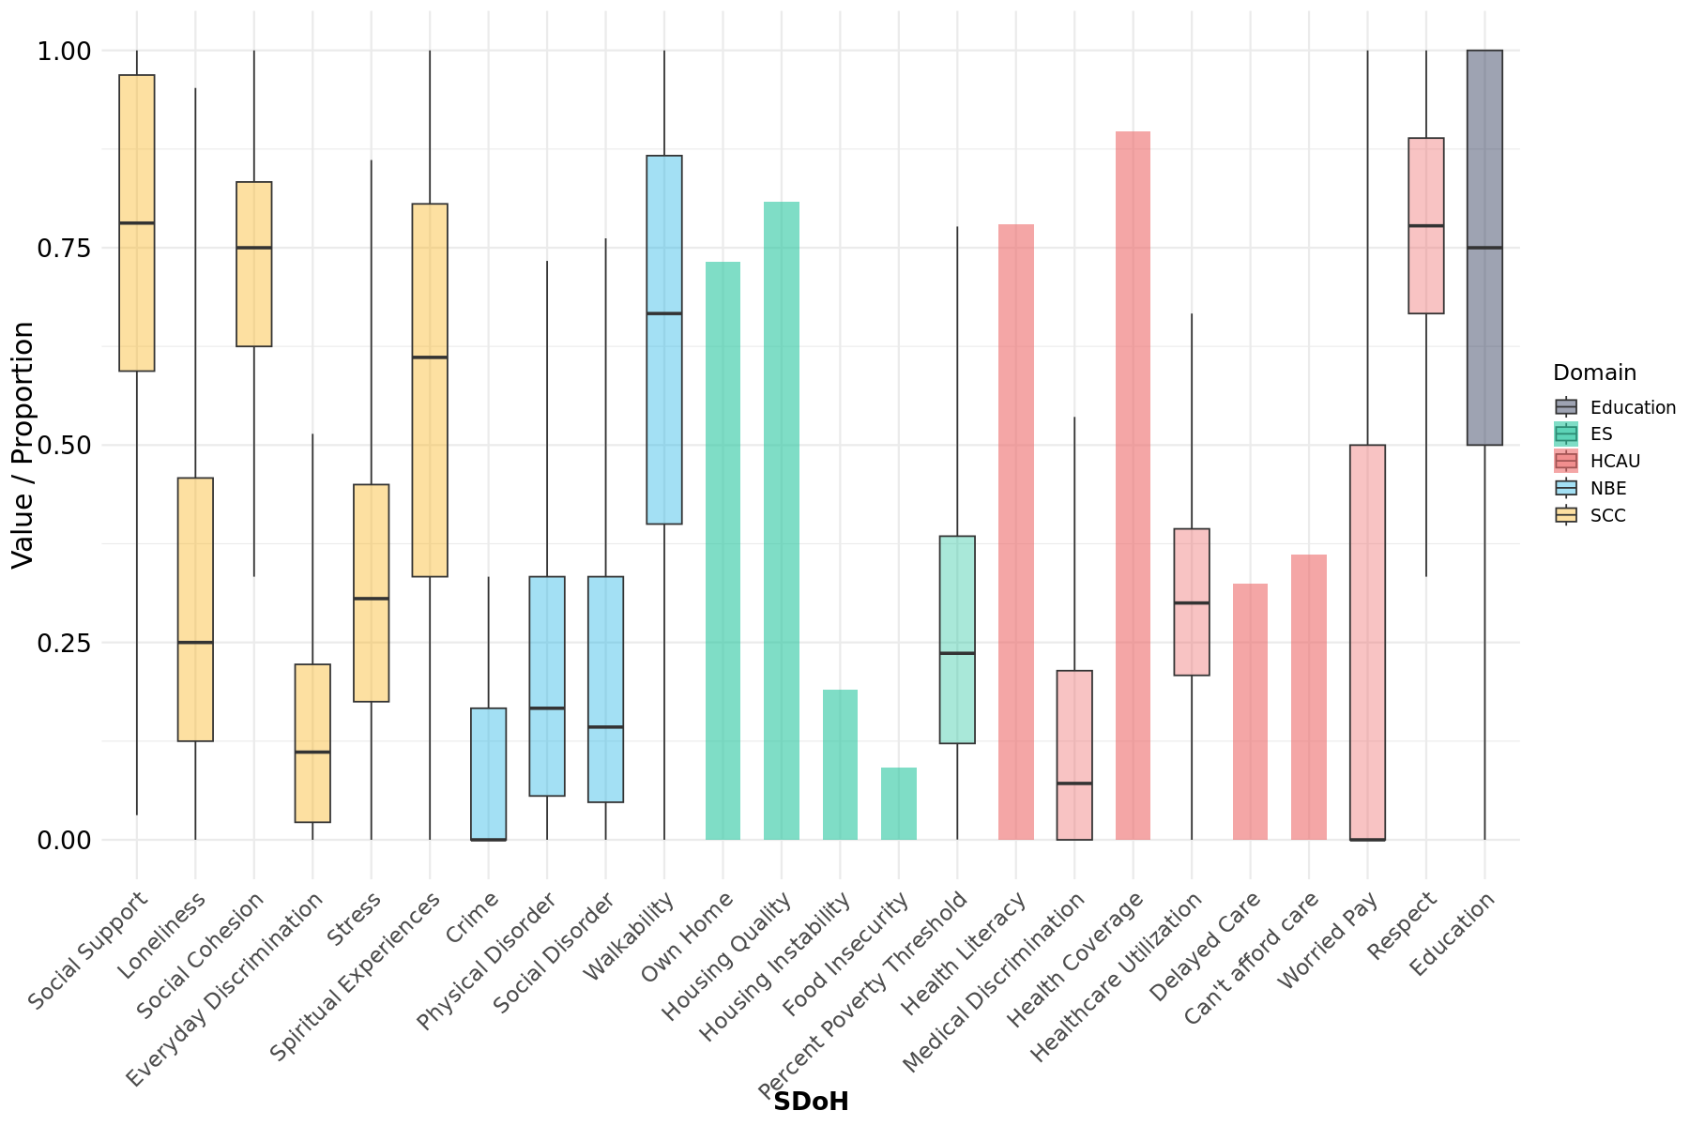
Figure 1: Distribution of Individual-level SDoH
Box plots depicting the distribution of individual-level SDoH in the Individual Cohort. Binary variables are represented as bar chart proportions. SDoH are color coded by HP2030 domain.
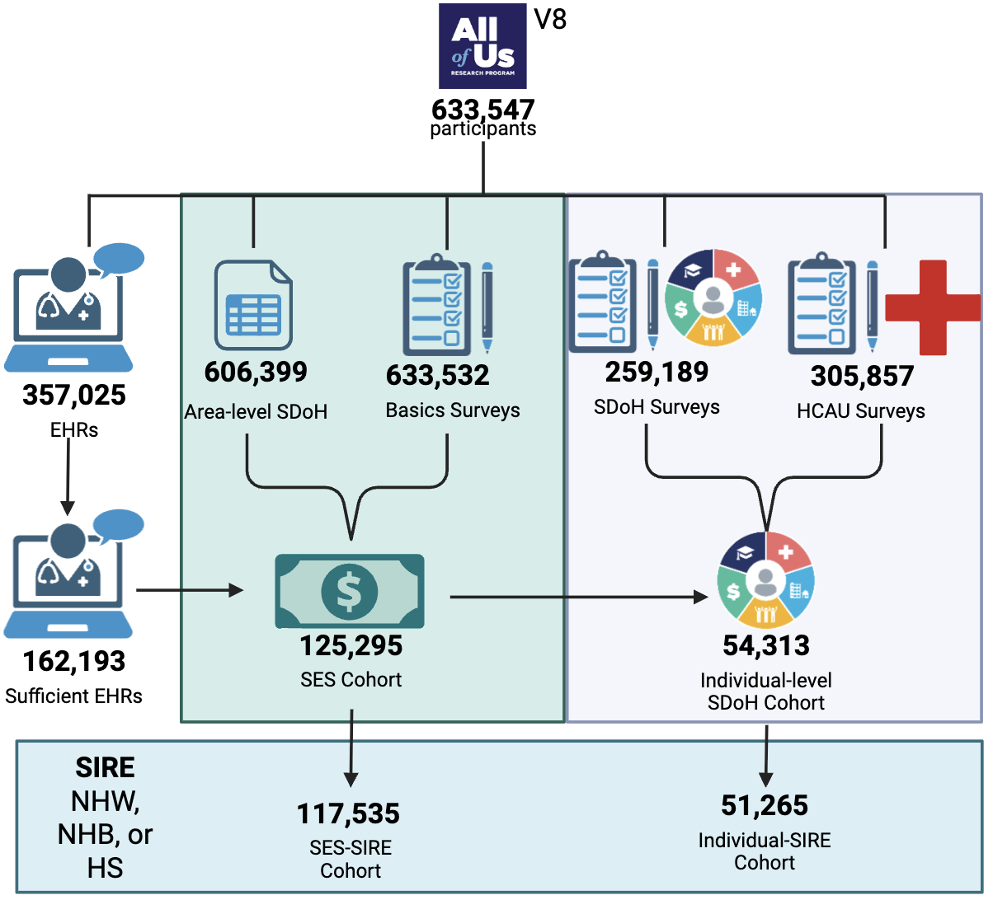
Figure 2: Study Participant Flow Chart
Version Release 8 (V8) of the All of Us Research Program contains data on 633,547 participants. Of those, 357,025 have linked Electronic Health Records (EHRs) and 162,193 meet the criteria for being “sufficient” based on having at least three entries and being at least three years long to meet “medical home” definition. 633,537, 259,189, and 305,857 participants filled out the basics, SDoH, and HCAU surveys respectively. Income data was divided by the corresponding poverty threshold based on location, size of household, and month/year of survey to get the percentage of the poverty threshold. 125,295 individuals had this data in addition to education to make up the SES cohort. Of these, 54,697 filled out the Individual-Level SDoH survey with at least 60% completeness for each domain. Of the Individual and SES Cohorts, 51,265 and 117,535 self-identified as non-Hispanic White (NHW), non-Hispanic Black (NHB), or Hispanic (HS),respectively, to make up the Individual-SIRE and SES-SIRE subcohorts.
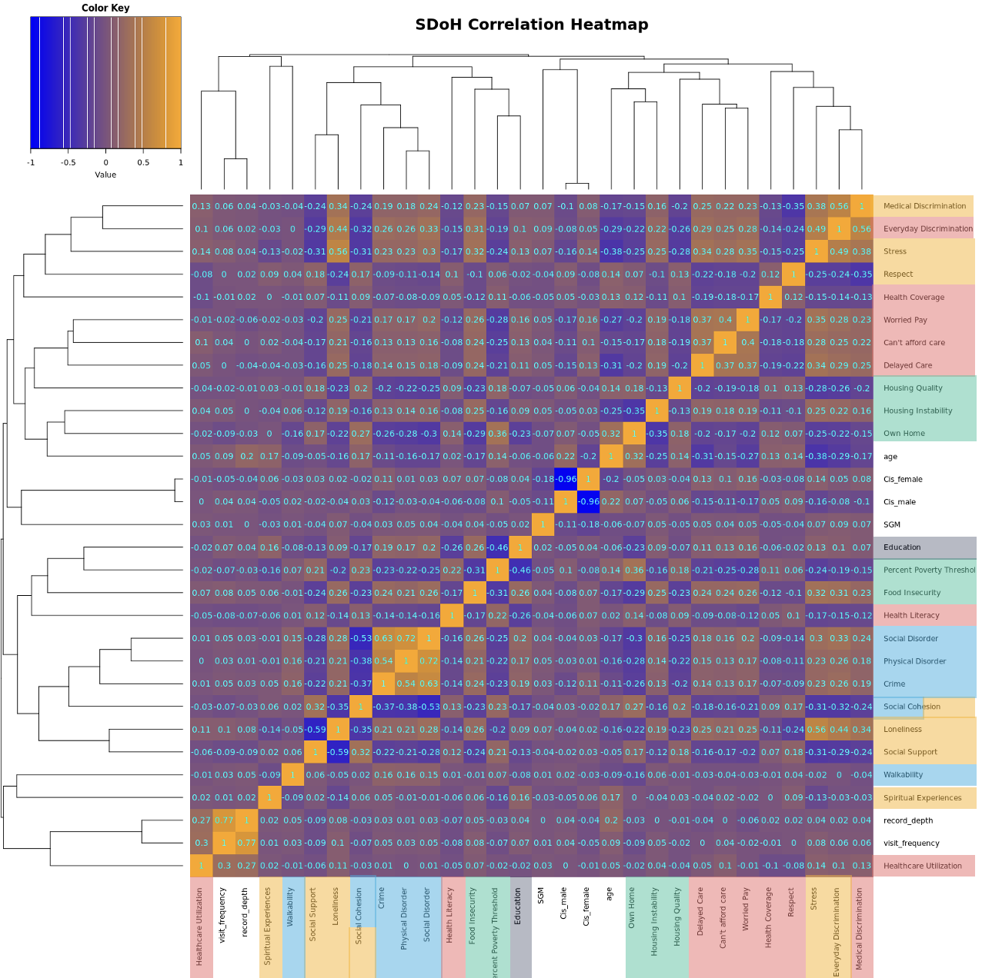Figure 3: Correlation Heatmap of Social Determinants of Health and Covariates Included in Study
Each cell represents the Pearson correlation coefficient between two domain-level composite variables derived from the All of Us survey data. Orange indicates positive correlations, while blue indicates negative correlations. Items are colored by HP2030 domain.

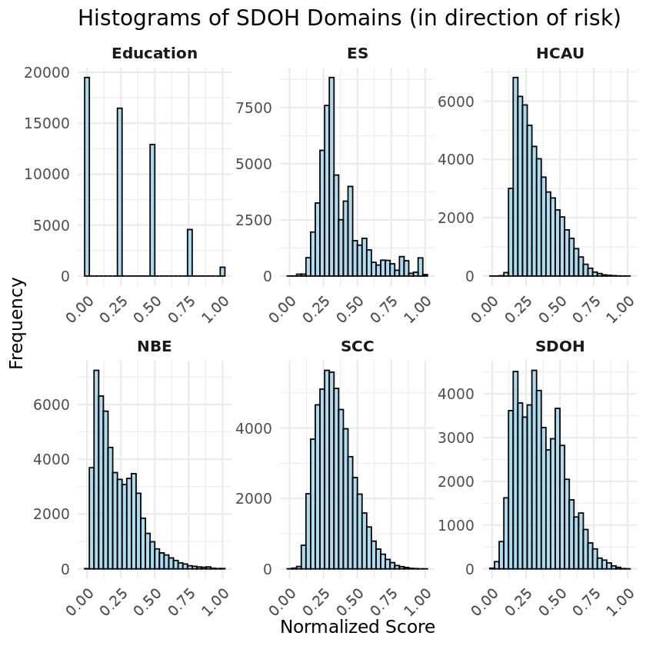
Figure 4: Histograms of SDoH Domains
Normalized domain scores derived from CFA for each latent SDoH domain, as well as an overall SDoH score. Scores have been rescaled to a 0–1 range for direct comparison across domains and directionally aligned so that higher values consistently indicate greater social disadvantage or risk. For interpretability, this means that, for example, a higher HCAU score reflects lower access to healthcare. The NBE domain did not require flipping. For the education domain, a score of 1 corresponds to having less than a high school education, while a score of 0 reflects a college degree or higher.
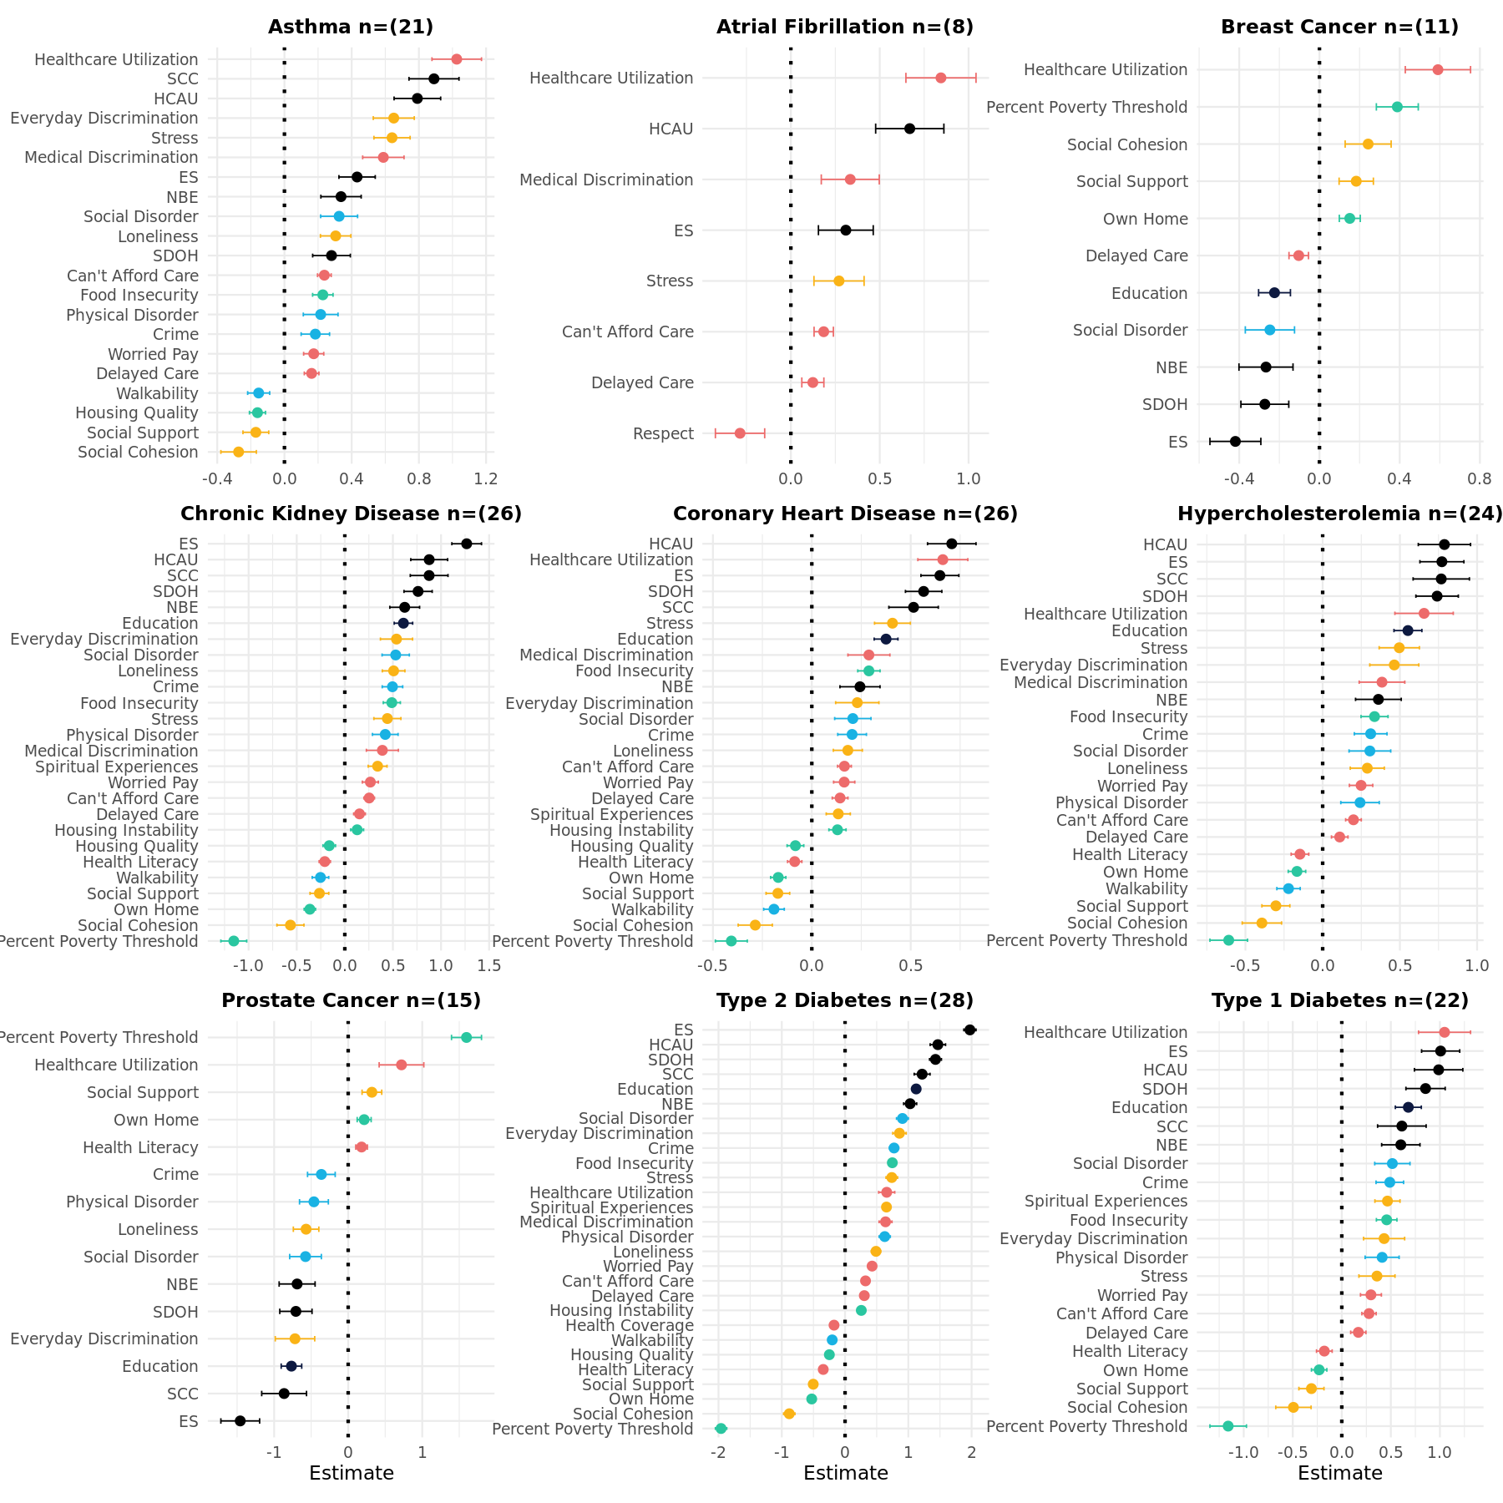
Figure 5: Significant Associations Between Individual-level SDoH and Disease Outcomes
Each panel displays the estimate and standard error for each SDoH significantly associated with the disease (Bonferroni corrected p-value < (.05/(29 tested variables*9 disease outcomes))). The number of significant associations is in parenthesis in the title of each disease. Each panel is ordered independently by strength of association. Domains are colored by type in accordance with the HP2030 coloring in Figure 1, and with black indicating domain-level factor scores derived from CFA. Domains are in the direction of risk. Imputed individual component predictors were used to maintain a consistent sample. Within each disease, domains are ordered from highest to lowest estimated effect size. Points indicate the magnitude and direction of association; horizontal lines represent 95% confidence intervals. The dotted vertical line at zero marks the null effect.
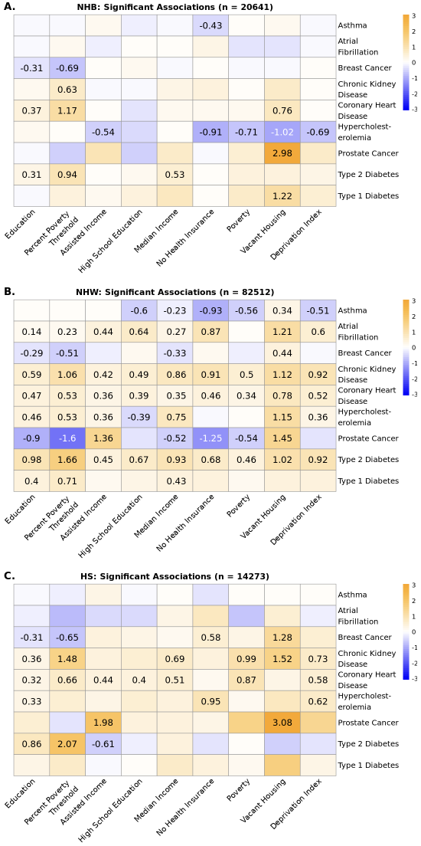
Figure 6: Heatmaps of Significant Associations by SIRE
Heatmap displaying the estimates from SEMs assessing the relationship between SDoH metrics and nine chronic conditions in the SES Cohort in the NHB population (A), the NHW population (B), and the HS population (C). Only statistically significant associations at the Bonferroni corrected significance threshold of 6.17E-04 (.05/81) are annotated with effect sizes. Negative values indicate that higher levels in a specific SDoH risk are associated with reduced probability of disease. Heatmaps are on the same scale to facilitate direct comparison between individual-level and area-level SDoH associations.
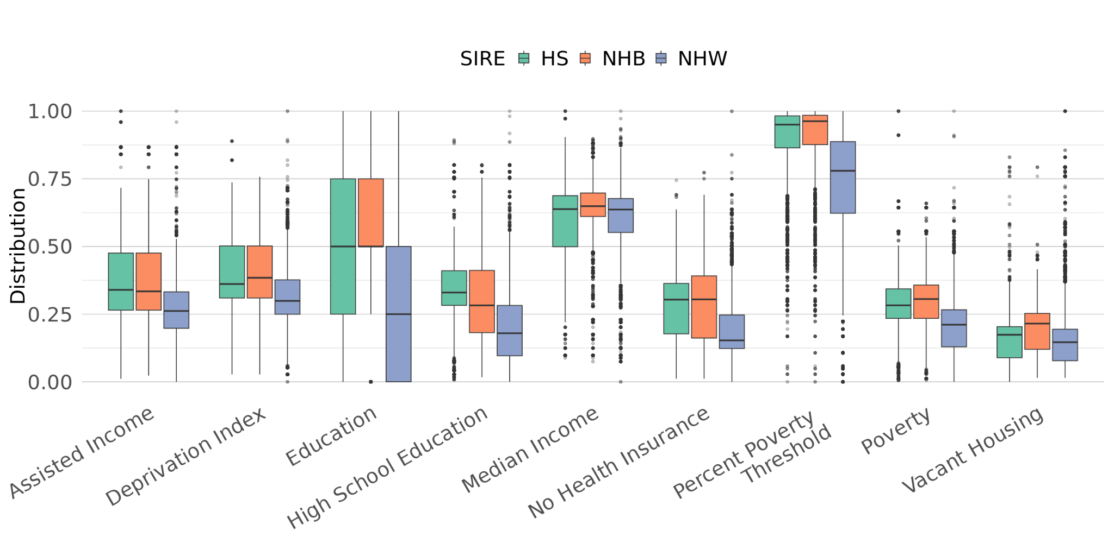
Figure 7: Distributions of SDoH in SES-SIRE Cohort across SIRE
Box plots of SDoH metrics in the SES-SIRE Cohort stratified by SIRE. Boxes are color-coded by SIRE. All values were min-max normalized to a scale of 0-1 and flipped into the direction of increased risk to facilitate direct comparison.

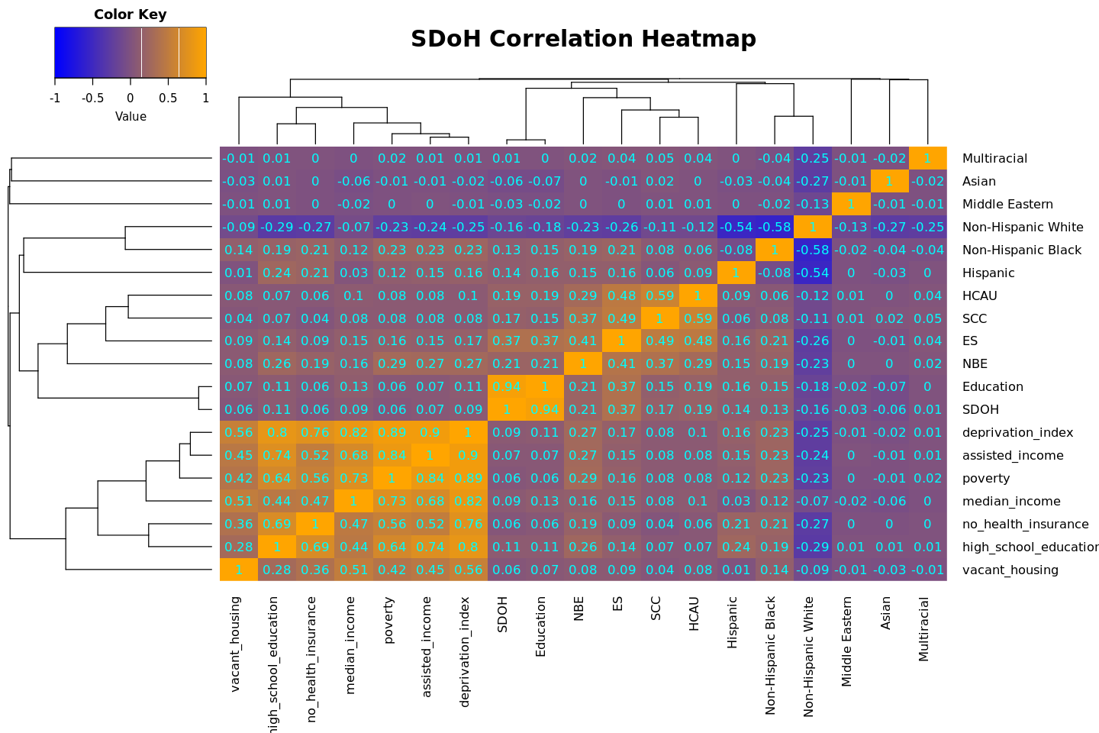
Figure 8: SDoH Correlation Heatmap with SIRE
Correlation heatmap of individual- and areal-level SDoH with SIRE. Each cell represents the Pearson correlation coefficient. Orange indicates positive correlations, while blue indicates negative correlations.

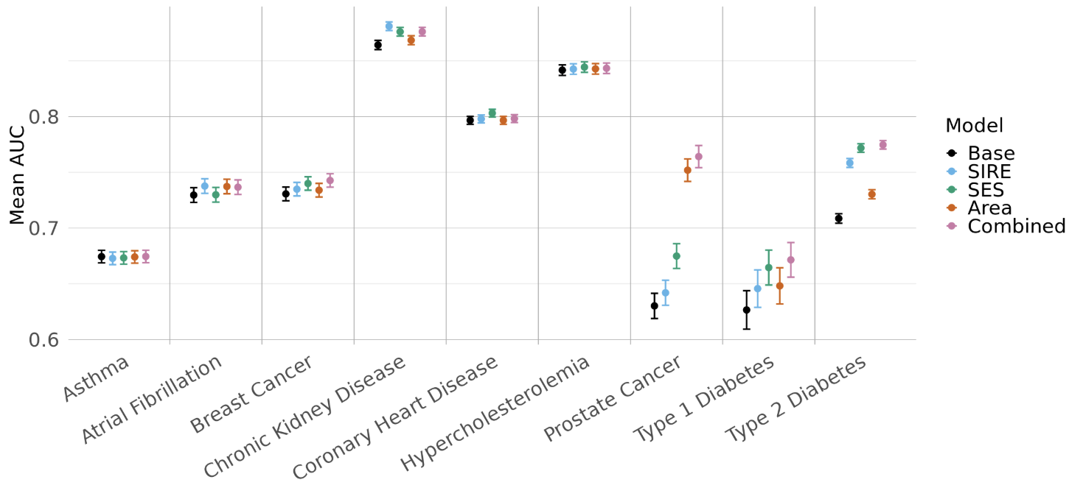 Figure 9: Mean AUC of SDoH and non-SDoH Elastic Net Models Across Nine Chronic Conditions in SES Cohort
Dot plot showing the mean AUC and corresponding 95% confidence intervals from logistic regression models. All models were run in the SES-SIRE Cohort. The x-axis is organized by disease. Each dot is color coded by model type. The Base model includes age, age2, and Sex/Gender, visit frequency, and record depth. Except for SIRE, the additional models include PsRS constructed from elastic net models, as in the methods. The SIRE model included terms for NHB, NHW, and HS.

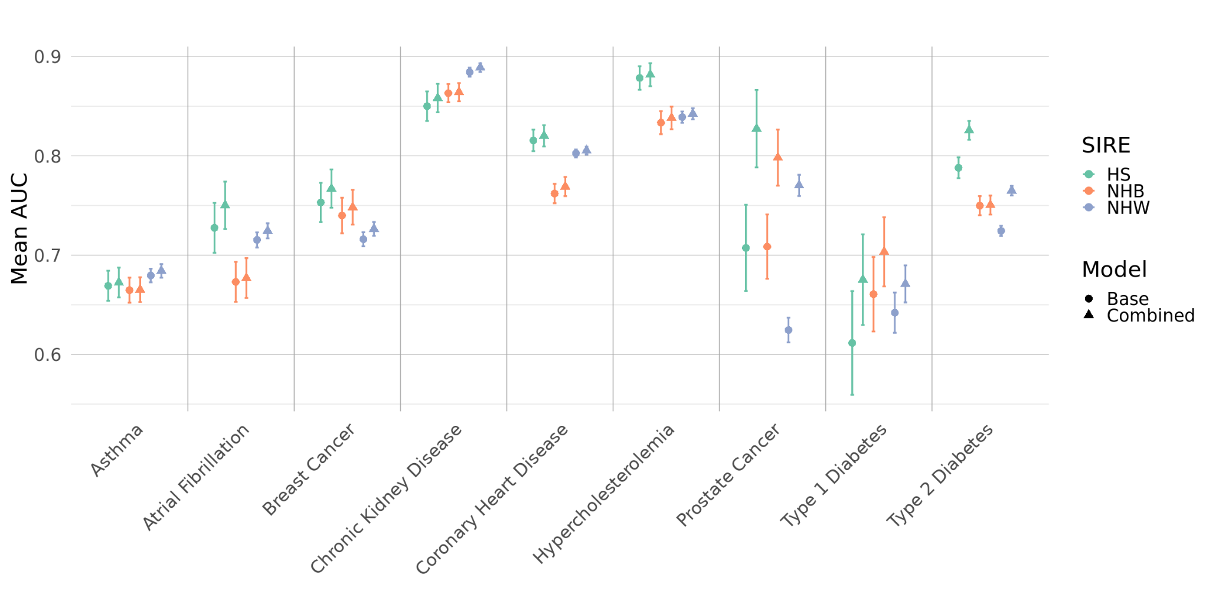
Figure 10: Comparison of model performance across SIRE for Nine Chronic in SES Cohort
Dot plot showing the mean AUC and corresponding 95% confidence intervals from logistic regression models. The x-axis lists the nine chronic conditions, while each point represents a different model type and SIRE. Models are color coded by SIRE and shapes are used to delineate model types.

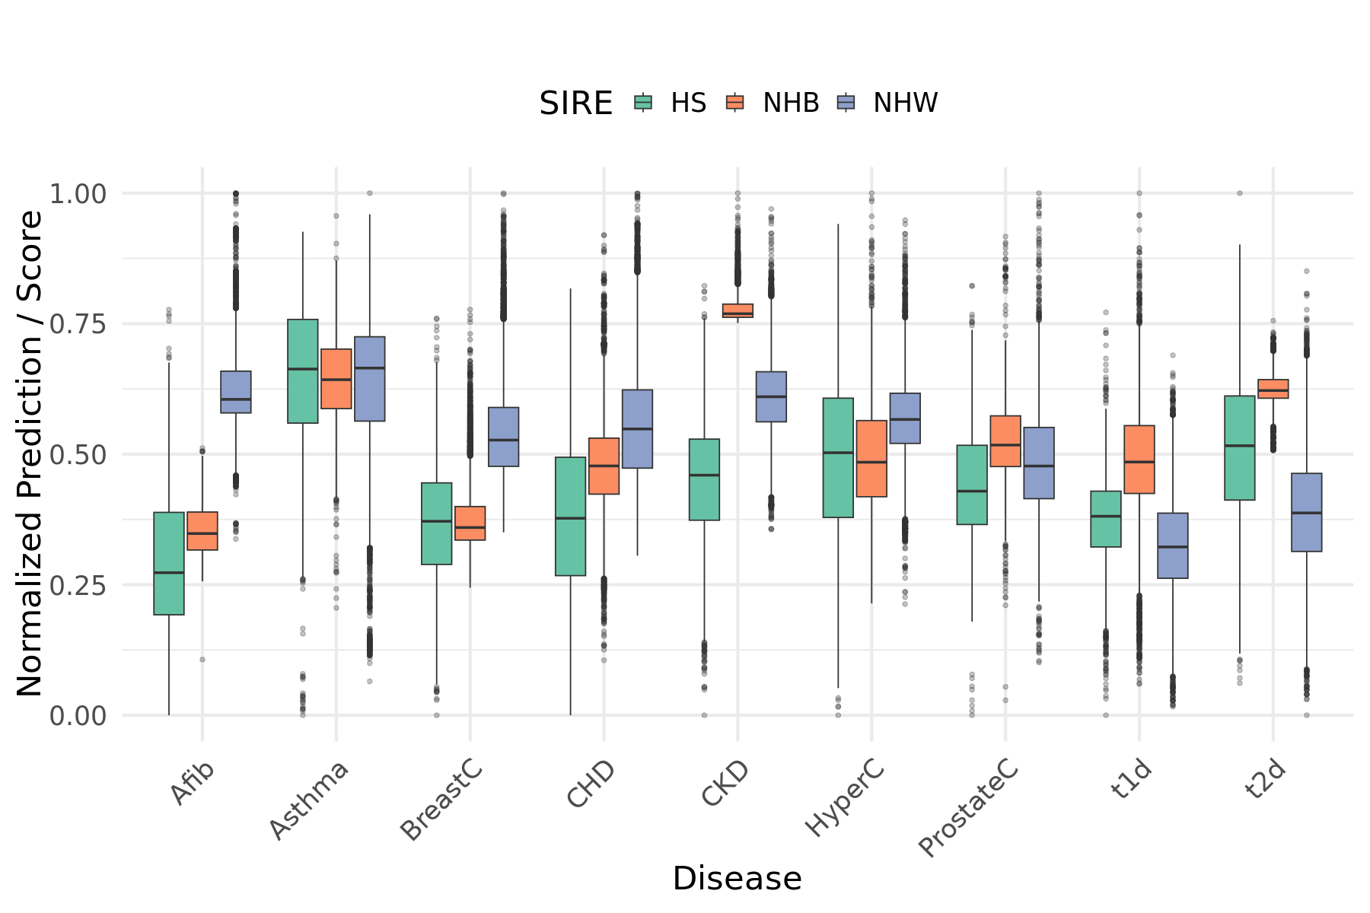
Figure 11: Normalized distributions of stratified Combined PsRS across diseases
Box plots of Combined PsRS stratified by SIRE across diseases. Combined PsRS were calculated independently in stratified analyses and then were min-max normalized to a 0-1 scale by disease across all populations. Boxes are colored by SIRE.

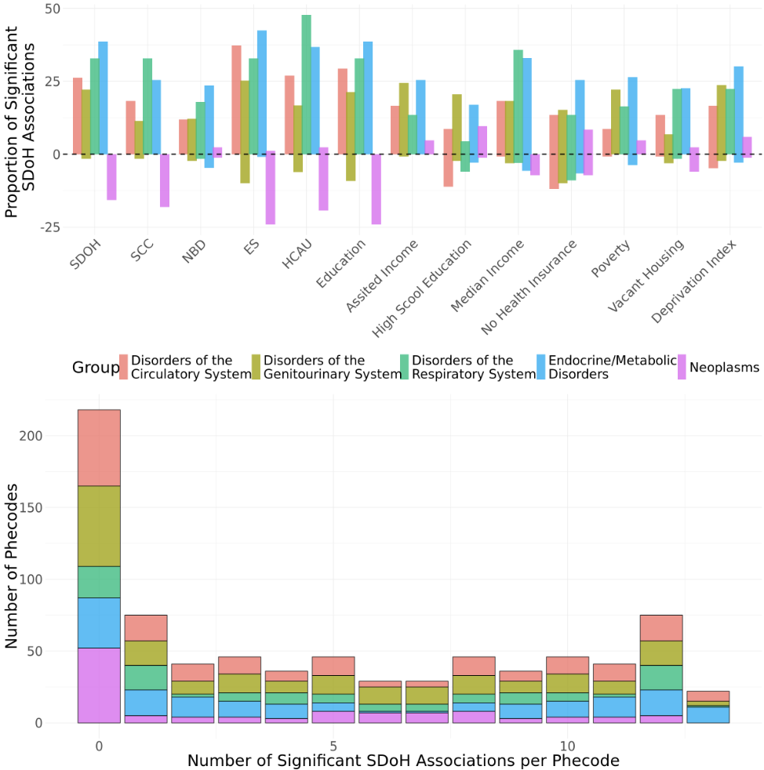
Figure 12: Targeted Phenome-Wide Association Study of SDOH in Individual Cohort
A. Box plot showing the proportion of significant SDoH associations for each disease group. The y-axis represents the proportion of significant associations, split into positive (above the x-axis, associated with increased disease prevalence) and negative (below the x-axis, associated with decreased disease prevalence) effects. Boxes are grouped by SDoH category and color-coded by disease group. B. Histogram showing the distribution of significant SDoH associations across phecodes. The x-axis indicates the number of SDoH significantly associated with each phecode (maximum SDoH tested = 13), while the y-axis shows the count of phecodes with that number of associations. The colors correspond to the same group colors in panel A.
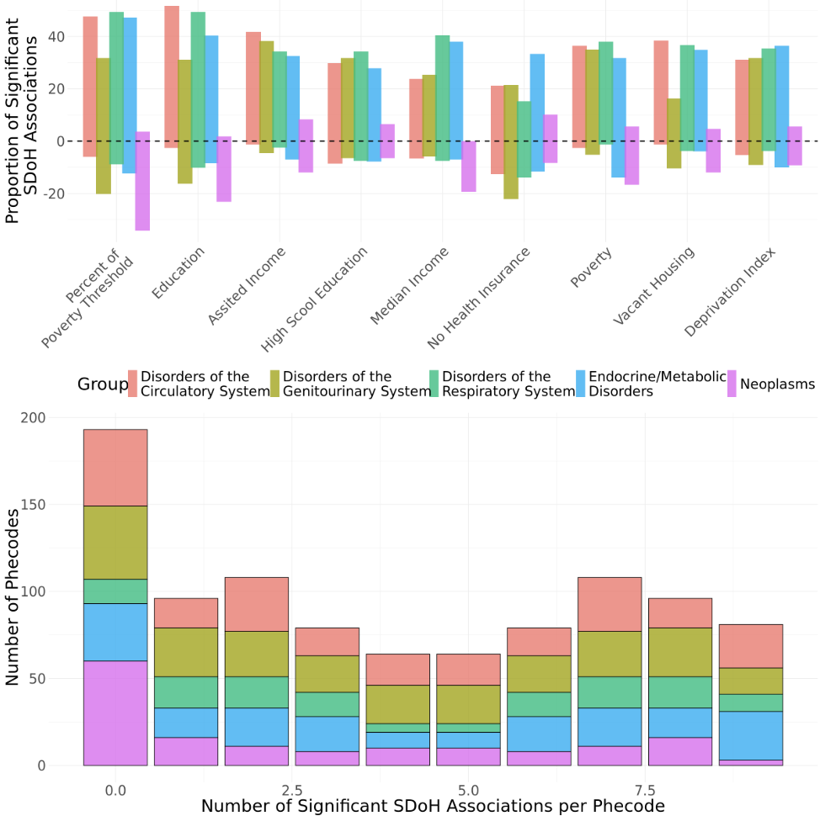
Figure 13: Targeted Phenome-Wide Association Study of SDOH in SES Cohort
A. Box plot showing the proportion of significant SDoH associations for each disease group. The y-axis represents the proportion of significant associations, split into positive (above the x-axis, associated with increased disease prevalence) and negative (below the x-axis, associated with decreased disease prevalence) effects. Boxes are grouped by SDoH category and color-coded by disease group. B. Histogram showing the distribution of significant SDoH associations across phecodes. The x-axis indicates the number of SDoH significantly associated with each phecode (maximum SDoH tested = 9), while the y-axis shows the count of phecodes with that number of associations.

