Supplementary Materials for

How artemisinin resistance slows malaria parasite clearance?

Mallorie Dépond¹†, Manel Ouji²†, Chanaki Amaratunga^{3a,b}†, Lucie Paloque²†, Lucia Angella¹, Charlotte Chambrion¹, Aissatou B. Diallo¹, Sokunthea Sreng⁴, Aurélie Fricot¹, Camille Petitfils⁵, Sivanna Mao⁴, Chantha Sopha⁴, Baramey Sam^{4X}, Sylvestre Biligui⁶, Jérôme Cros⁷, Philippe J Guerin⁸, Béatrice Aussilhou⁷, Safi Dokmak⁷, Alain Sauvanet⁷, Seila Suon⁴, Jean-Michel Augereau², Frédérick Gay⁶, Rick M. Fairhurst^{3b}, Pierre Buffet^{1,9}‡, Nicolas Cénac⁵‡, Françoise Benoit-Vical²*‡, Papa Alioune Ndour¹*‡

*Corresponding authors: P.A.N.: ndourmail@yahoo.fr, F.B.V.: Francoise.Vical@inserm.fr

†These authors contributed equally to this work.
‡ P.B., N.C., F.B.V. and P.A.N. share senior authorship.
x this author is deceased

The PDF file includes:

Materials and Methods
Figs. S1 to S7
Tables S1 to S4

Materials and Methods

Clinical samples and ethical approvals
For clearance and pitting, a prospective study was conducted between September 2012 and February 2014 in collaboration with the National Center for Parasitology, Entomology and Malaria Control (Cambodia) and the Laboratory of Malaria and Vector Research, National Institute of Allergy and Infectious Diseases (NIH) in Cambodia in the provinces of Ratanakiri, Preah Vihear, and Pursat (NCT01736319). The 88 patients recruited in this study were aged 2-58 years and had acute uncomplicated P. falciparum malaria. Patients were treated at 0 h, 24 h, and 48 h with Duo-Cotecxin tablets (Holley Pharmaceutical, Beijing, China), each containing dihydroartemisinin 40 mg and piperaquine 320 mg, according to bodyweight (<10 kg, half a tablet; 10–19 kg, one tablet; 20–29 kg, one and a half tablets; 30–39 kg, two tablets; ≥40 kg, three tablets) per the manufacturer's recommendation. Blood samples were collected at the time of admission and, when possible, every 2 hours for parasitemia and pitting determination. The protocol was approved by the Cambodian National Ethics Committee for Health Research and the National Institute of Allergy and Infectious Diseases institutional review board. Patients or parents of children younger than 18 years provided written informed consent.
For quantification of fatty acid metabolites, blood samples were collected between 2017 and 2021 from 22 patients with imported severe malaria in France. Severe cases were defined by a positive blood smear with asexual forms of P. falciparum associated with at least one of the WHO’s severity criteria. All the patients included were involved in the national surveillance program of the National Reference Center for Malaria and were treated with intravenous artesunate (2.4 mg/kg, Guilin Pharmaceutical) followed by an ACT, or other artemisinin derivatives. The French study was authorized by the French National Commission for Data Protection and Liberties (declaration number 1223103) and based to the French law (article L1221-1.1 of the French Public Health Code) and (article L1211-2 of the French Public Health Code).
For spleen experiments, human spleens were retrieved through the Spleenvivo protocol approved by the “Ile-de-France II” Institutional Review Board on 4 September 2017 (#CPP 2015-02-05 SM2 DC).

Parasite clearance and red blood cell pitting analysis
In Cambodia, parasitaemia and pitting levels in peripheral blood were determined using the EMIF (Erythrocyte Membrane Immuno Fluorescence) method as previously described (6). Briefly, P. falciparum-infected red blood cells (iRBCs) from patients were washed with Tris-buffered Hanks ’solution (TBH) and deposited on 8-well Immuno-Fluorescence Assay (IFA) slides treated with coating buffer (pH 9.6; 1.59 g/L Na2- CO3, 2.93 g/L NaHCO3, and 200 mg/L NaN3). The slides were then washed, fixed with 1% glutaraldehyde, and kept at −20°C until staining as described above and images were acquired on a Leica DMI3000 microscope, using a Leica DFC310FX camera controlled by LAS Superposition Images software (Leica Microsystèmes, Nanterre, France).
In Paris, parasite clearance and pitting by spleen were determined by flow cytometry. For both methods, samples were briefly fixed with 1 % glutaraldehyde in 1 X phosphate-buffered saline (PBS) and then permeabilized with Triton X-100 (Sigma-Aldrich) for 30 minutes at room temperature (RT). Then, to stain parasitic protein RESA, samples were incubated for 25 minutes with polyclonal hyperimmune serum (6) at 1:10 in 1 % PBS/AlbuMAX II (Life Technologies); washed twice in 1 X PBS and incubated again with a secondary antibody (goat anti-human immunoglobulin G) coupled to FITC for 25 minutes. Parasite nuclei were stained with 10 g/mL Hoechst 33342 (Molecular Probes) before analysis. Parasitized RBCs were positive for both fluorophores whereas pitted RBCs were only stained by FITC (due to the persistence of P. falciparum RESA proteins in the RBC after pitting). Parasite clearance half-life (slope half-life measured by WWARN) is a measure of the parasite clearance rate derived from the linear segment of the log parasitaemia–time curve (parasite clearance half-life = log2 divided by the parasite clearance rate).
Genotyping of Pfkelch13
Plasmodium DNA was extracted from blood samples with the Qiagen Mini blood kit or the Roche High Pure PCR template preparation kit, according to the manufacturer instructions. Pfkelch13 gene was genotyped as described in “PCR and sequencing for genotyping of candidate Plasmodium falciparum artemisinin resistance SNPs in the Kelch 13 gene v1.0. Pasteur Institute of Cambodia – Pasteur Institute, Paris Procedure” (available on WWARN website). Sanger sequencing of the PCR products was carried out by Eurofins or Genoscreen companies. DNA sequences were analysed by alignment, using ApE or MEGA11 software, against the reference sequence (PF3D7_1343700).
P. falciparum strains/isolates and culture
Seven different P. falciparum parasite strains were used in this study: 3 laboratory strains namely FcB1-Columbia (ART-sensitive), F32-TEM (ART-sensitive) and its twin ART-resistant F32-ART (with the K13 mutation M476I) (27); 4 field isolates namely SMT010 (ART-sensitive, from Mali) (34), IPC3592 (ART-sensitive), IPC6610 (ART-resistant, K13 R539T) and IPC8262 (ART-resistant, K13 C580Y), the last 3 from Cambodia. Laboratory strains were cultured, according to the Trager and Jensen method (37), in erythrocytes from healthy donors (French blood bank, Etablissement Français du Sang) in RPMI 1640 medium (Life Technologies) supplemented with 5 % decomplemented human serum (French blood bank) at 37°C and 5 % CO₂ in humid atmosphere. For field isolates and/or specific experiments (spleen perfusion, deformability assessment) the culture media was supplemented with 0.055 % hypoxanthine, 5.5 % Albumax II (Thermo Fisher), 1 mM L-Glutamine (Merck), and 11 µg/mL gentamicin (Merck) and cultures grown with 5 % O₂, 5 % CO₂, and 90 % N₂.
Parasite synchronisation
Experiments were performed either on asexual ring forms of parasites aged between 0 and 24h obtained by 5% D-sorbitol treatment, or on asexual ring forms of parasites aged between 0 and 6-7 h, or 0 and 18-20 h. To obtain parasites at different ages, asexual mature forms (trophozoites/schizonts) were enriched by magnetic columns (VarioMACS Separator, Miltenyi) and then cultured for 6-7 h or 18-20 h to allow reinvasion and all remaining mature forms were removed by a 5% D-sorbitol treatment (Sigma Aldrich) for 10 minutes followed by washing with RPMI 1640.
Human spleen retrieval and perfusion
Human spleens were retrieved in patients who underwent left spleno-pancreatectomy for pancreatic disease (proven/suspected neuroendocrine tumor or adenocarcinoma). Medical and surgical care were not altered, and written consent was obtained from all patients. The spleens were macroscopically and microscopically normal in all cases after examination of the spleen appearance by the pathologist during a 30-minute period of warm ischemia. After the surgical procedure, the main splenic artery was cannulated. Spleens were rinsed with Krebs solution (1 X Krebs-Henseleit buffer powder, (Sigma Aldrich) supplemented with 1 L milliQ water, 2 g glucose, 2.1 g sodium bicarbonate, 0.175 g dehydrated calcium chloride) containing 1 % AlbuMAX II (Gibco). The spleens remained in this solution during transport to the laboratory where spleens were placed in a device allowing ex vivo perfusion as previously described (7).
These experiments were performed with F32-ART and F32-TEM parasites, synchronized at the ring stage (0-20 hours) by a MACS/D-sorbitol treatment. Parasites were then treated with 1 µM artesunate (AS) for at least 6 hours. Prior to perfusion, each culture at 2.5 % haematocrit was stained in 1 X PBS with different cell tracers (FarRed CellTrace 1:460 for F32-TEM and CellTrace Violet 1:300 for F32-ART, Life technologies) for 30 min at RT with shaking in the dark. The cells were then washed twice in 1 X PBS. The 2 cultures were combined and diluted in 20 mL of Krebs/0.5% AlbuMAX II media with fresh RBCs from the same blood donor used for culture to obtain a final 50 % haematocrit, prior to being perfused in the spleen for 1 to 3 hours. Samples collected during spleen perfusion were fixed with PBS 0.8 % glutaraldehyde and then incubated with 1:10 polyclonal human hyperimmune serum in 1 X PBS / 1% AlbuMAX II / Triton X-100 suspension at RT for 25 min. Samples were then washed twice and incubated for 25 min at RT with Dylight 755 (goat anti-human immunoglobulin G, Thermofisher) secondary antibody diluted 1:100. Parasite nuclei were stained with SYBR Green (Thermofisher) at 1:10000. Samples were then washed twice before going through a Canto II flow cytometer (BD). The data were analysed using Flow Jo V10.4 software for the determination, for each strain, of the parasitaemia, clearance and pitting rates. In parallel, at the end of the spleen perfusion, some of the perfused blood was placed back in normal culture media with fresh RBCs. The cultures’ parasitaemia was monitored for recrudescence every 3 days, and blood samples were then collected for DNA extraction and Pfk13 gene Sanger sequencing to determine the presence of each strain according to their k13 genotype.
As control, F32-ART and F32-TEM parasites, synchronized at the ring stage by a D-sorbitol treatment, were distributed either alone or mixed in equal proportion (0.5% each) at 2% haematocrit in a 6-well plate. Parasites were then treated with 1 µM AS for 6, 20 or 30 hours. Samples were then washed and put back in normal culture medium without any drug. The mixed cultures were maintained for three weeks, and parasitemia was monitored until parasite recrudescence.
Morphological analysis by Flow Imaging
At least 100,000 RBCs were acquired by flow imaging (Amnis ImageStream, EMD Millipore). IDEAS 6.2 software was used to differentiate uninfected, infected and pitted RBCs. The circularity of the recorded cells net and front views were assessed as described in Roussel et al. (38).
SLO storage and testing
Streptolysin-O (SLO, Sigma-Aldrich S5265-25KU) was dissolved in 1 mL 1 X PBS (Gibco 14190-094). Four vials were mixed together, aliquoted and stored at -80°C. DiThioThreitol (DTT, Sigma-Aldrich D9779) at 1 M in sterile HEPES was stored at -20°C. SLO haemolytic activity was measured on both fresh healthy and parasitized RBCs. SLO was activated by adding 0.1 volume of 1 M DTT and incubating the mix at RT for 15 min. The RBC samples were incubated with 6 different SLO concentrations (0 U / 20 U / 40 U / 60 U / 80 U / 120 U) at 37°C for 30 min. After centrifugation for 3 min at 2500 g, supernatants were harvested and pellets were washed with 25 mL 1 X PBS/5 % BSA. As a control, blood smears were made from pellets and subsequently coloured with Giemsa stain. Haemolysis was measured from supernatants by Plasma/Low Hb Photometer (HemoCue). The amount of SLO that lyse half of the RBCs was referred to as 1 Haemolytic Unit (HU). Based on haemolysis, HU was calculated and 20 HU/200 µL sample was used for experiments.
Deformability assessment
Infected RBCs ‘deformability was assessed by ektacytometry via the Laser Optical Rotational Red Cell Analyser (LORRCA, RR Mechatronics) before and after SLO treatment, allowing the removal of uninfected RBCs from the culture. RBCs infected with F32-TEM or F32-ART strains synchronized at the ring-stage (0-20 hours) by MACS/D-sorbitol treatment, before and after treatment with 1µM AS, were enriched with SLO. Briefly, the cultures were centrifuged at 300 g for 5 min and washed twice with 1 X PBS. 40 µL and 400 µL of each pellet were added to 160 µL and 1600 µL of 1 X PBS respectively, to obtain 20 % haematocrit. The 40 µL pellets (hereafter ''pre-SLO'') were stored at 4°C as a control. An adequate number of SLO aliquots were thawed, mixed and activated by adding 0.1 volume of 1 M DTT and incubating the mixture at RT for 15 min. Each 400 µL pellet was mixed with 40 Haemolytic Unit (HU) of activated SLO (105.6 µL of activated SLO per 400 µL of pellet dissolved in 1 X PBS). Samples were shaken by hand for 6 min, allowing the lytic action of the SLO. The process was stopped by washing with 20 mL of 1 X PBS/5 % BSA twice followed by one wash with 20 mL of 1 X PBS/ 1 % BSA (centrifugation at 2500 g for 3 min). Blood smears were taken and stained with Giemsa reagent to assess the efficiency of the procedure. The entire volume was then transferred to a new tube and mixed with 160 µL of 1 X PBS (hereafter ''post-SLO''). 12.5 μL of pelleted pre-SLO and post-SLO samples were added to 2.5 mL of polyvinylpyrrolidone (PVP) polymers (Elon ISO, QRR 030901, RR Mechatronics), and the elongation index (EI) of RBCs was measured by ektacytometry. The deformability curve was obtained under shear stresses from 0.3 to 30 Pa by Laser Optical Rotational Red Cell Analyser (LORRCA, RR Mechatronics).
Fatty acid quantification
Concentration of fatty acid in RBCs infected by P. falciparum resistant (F32-ART) or sensitive (F32-TEM) to artemisinin was determined by gas chromatography linked to a flame ionization detector at different parasite stages. Experiments were conducted with parasitemia between 1 and 3 %.
Lipids from red blood cells were extracted according to Bligh and Dyer (39) in dichloromethane/methanol/water (2.5 :2.5 :2.1, v/v/v), in the presence of the internal standards heptadecanoate acid (2 µg for free fatty acid (FFA)) or glyceryl triheptadecanoate (2 µg for total fatty acid (TFA)). For FFA analysis, the lipid extracts were directly methylated in boron trifluoride methanol solution 14 % (SIGMA, 1 mL) and heptane (1 mL) at RT for 10 min. For TFA analysis, the lipid extracts were hydrolysed in KOH (0.5 M in methanol) at 50°C for 30’, and transmethylated in boron trifluoride methanol solution 14 % (SIGMA, 1 mL) and heptane (1 mL) at 80°C for 1 hour. After addition of water (1 mL) to the crude, FFA or TFA were extracted with heptane (3 mL), evaporated to dryness and dissolved in ethyl acetate (20 µL). FAME (1 µL) were analyzed by gas-liquid chromatography (40) on a Clarus 600 Perkin Elmer system using a Famewax RESTEK fused silica capillary columns (30 m x 0.32 mm i.d, 0.25 µm film thickness). Oven temperature was programmed from 110°C to 220°C at a rate of 2°C per min and the carrier gas was hydrogen (0.5 bar). The injector and the detector were at 225°C and 245°C respectively.
Hydroxylated polyunsaturated fatty acids metabolites quantification
Red blood cells were crushed with a FastPrep-24 Instrument (MP Biomedicals) in 500 µL of HBSS (Invitrogen) and 5 µL of internal standard (5-HETE-d8 at 400 ng/mL in MeOH). After two crush cycles (6.5 m/s, 30 s), 10 µL was withdrawn for protein quantification and 300 µL of cold methanol was added. Samples were centrifuged at 1000 g for 15 min at 4°C. Supernatants were collected, adjusted to 2 mL in H₂O, and submitted to solid-phase extraction of lipids using HLB plate (OASIS® HLB mg, 96-well plate, Waters, Saint-Quentin-en-Yvelines, France), as previously described (ref doi: 10.1016/j.jchromb.2013.06.014). Briefly, after plate conditioning, the sample was loaded at a flow rate of 0.1 mL/min. After complete loading, the plate was washed with H2O/MeOH (90:10, 750 µL), and lipid mediators were eluted with MeOH (500 µL). The solvent was evaporated under nitrogen, and samples were dissolved with MeOH and stored at −80°C for LC-MS/MS measurements. 9-HODE, 13-HODE, 15-HETE, 12-HETE, 8-HETE and 5-HETE were quantified. To simultaneously separate 8 lipids of interest and three deuterated internal standards, LC-MS/MS analysis was performed on an ultrahigh-performance liquid chromatography system (UHPLC; Agilent LC1290 Infinity) coupled to an Agilent 6460 triple quadrupole MS (Agilent Technologies) equipped with electrospray ionization operating in negative mode. Reverse-phase UHPLC was performed using a ZorBAX SB-C18 column (Agilent Technologies) with a gradient elution. The mobile phases consisted of water, acetonitrile (ACN), and formic acid (FA) [75:25:0.1 (v/v/v)] (solution A) and ACN and FA [100:0.1 (v/v)] (solution B). The linear gradient was as follows: 0 % solution B at 0 min, 85 % solution B at 8.5 min, 100 % solution B at 9.5 min, 100 % solution B at 10.5 min, and 0 % solution B at 12 min. The flow rate was 0.35 mL/min. The autosampler was set at 5°C, and the injection volume was 5 µL. Data were acquired in multiple reaction monitoring (MRM) mode with optimized conditions. Peak detection, integration, and quantitative analysis were performed with MassHunter Quantitative analysis software (Agilent Technologies). For each standard, calibration curves were built using 10 solutions at concentrations ranging from 0.95 to 500 ng/mL. A linear regression with a weight factor of 1/X was applied for each compound. The limit of detection (LOD) and the limit of quantification (LOQ) were determined for the 8 compounds using signal-to-noise (S/N) ratios. The LOD corresponded to the lowest concentration leading to an S/N value >3, and LOQ corresponded to the lowest concentration leading to an S/N value >10. All values less than the LOQ were not considered. Blank samples were evaluated, and their injection showed no interference (no peak detected), during the analysis.
Statistical analysis
Data are presented as means ± SEM. Statistical analyses were performed using GraphPad Prism 6.0 and 8.0 software (GraphPad, San Diego, CA). For parasite clearance and morphology experiments, variables were compared by student's t test. For lipid quantification, comparisons between groups were performed by Mann-Whitney test. Multiple comparisons within groups were performed by Kruskal-Wallis test, followed by Dunn’s multiple comparisons post-test or by two-way Anova followed by Tukey’s multiple comparisons post-test. Statistical significance was accepted at p < 0.05.
Chemicals
13-Hydroxyoctadecadienoic acid (13-HODE), 9-HODE, 5-Hydroxyeicosatetraenoic acid (5-HETE), 8-HETE, 12-HETE, 15-HETE and 5-HETE deuterated (5-HETE-d8) were purchased from Cayman Chemical (Ann Arbor, MI, USA). Methanol (MeOH; HPLC gradient Grade), methyl formate (MeFor; Reagent Grade), acetonitril (ACN; HPLC gradient Grade), formicacid (FA), hydrochloric acid (HCl), phosphate buffer sodium (PBS) was from Sigma–Aldrich (Saint Quentin Fallavier, France), artesunate (AS) was from MR4 (BEI Ressources), and dihydroartemisinin (DHA) was synthetized in our lab.

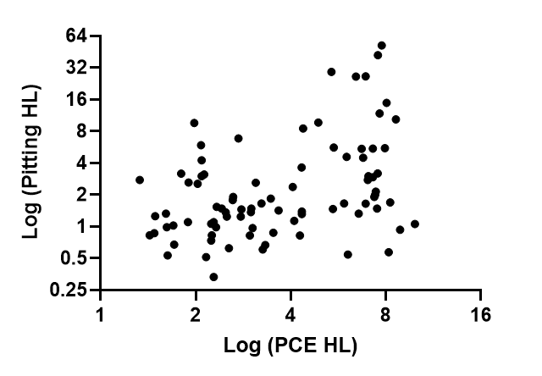

Fig. S1. Correlation between parasite clearance and pitting.
Correlation between parasite clearance half-life (HL) and pitting HL: (r=0.32, p = 0.002). Data from 88 patients in three Cambodian regions.

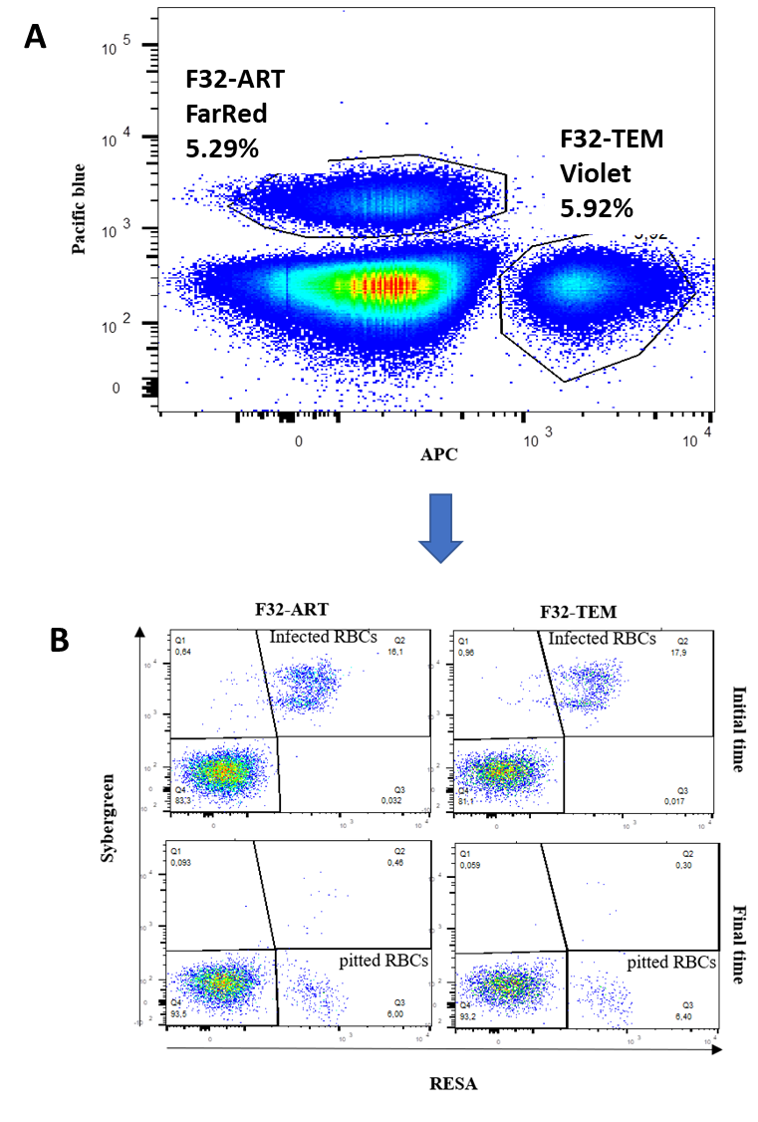

Fig. S2.
RBCs labelling and gating strategy. (A) RBCs (red blood cells) infected with artemisinin-sensitive F32-TEM and -resistant F32-ART parasites treated with artesunate (AS) were then labelled with CellTrace (Violet and FarRed, respectively), mixed, diluted in unlabelled healthy RBCs and perfused into the spleen. (B) RESA protein were labelled using human hyperimmune antibody and parasite DNA was labelled using SYBR Green. Infected RBCs (DNA⁺ RESA⁺) and pitted RBCs (DNA⁻ RESA⁺) were then quantified for each strain and for each time point (before and after splenic perfusion) using flow cytometry.

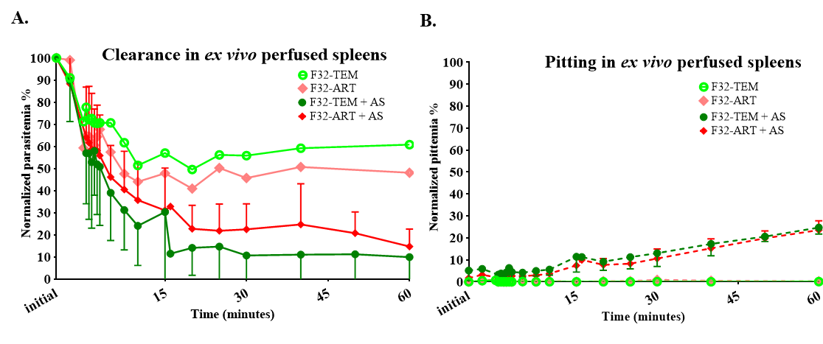Fig. S3.
Clearance/pitting in ex vivo perfused spleens. (A) Parasite clearance and (B) Pitting rate were determined over time during spleen perfusion. Artesunate(AS)-treated RBCs infected by F32-TEM (dark green curves) or F32-ART (dark red curves) parasites were stained with different CellTrace fluorophores (Violet and FarRed, respectively) before mixing them and performing spleen perfusions. Five experiments were performed, on five spleens, and data are expressed as mean ± SEM. A control experiment was carried out with one (sixth) spleen perfused with no artesunate (AS) treatment RBCs infected by artemisinin-sensitive (light green curve) and -resistant (light red curve) parasites.

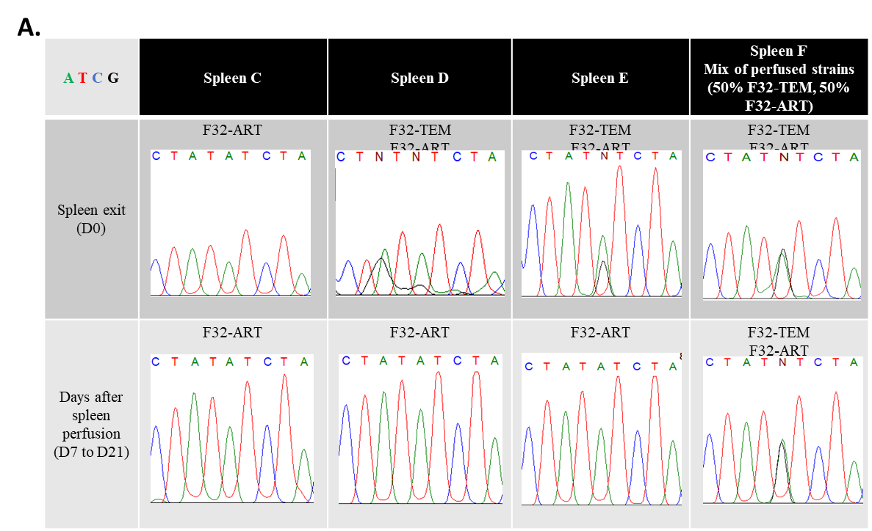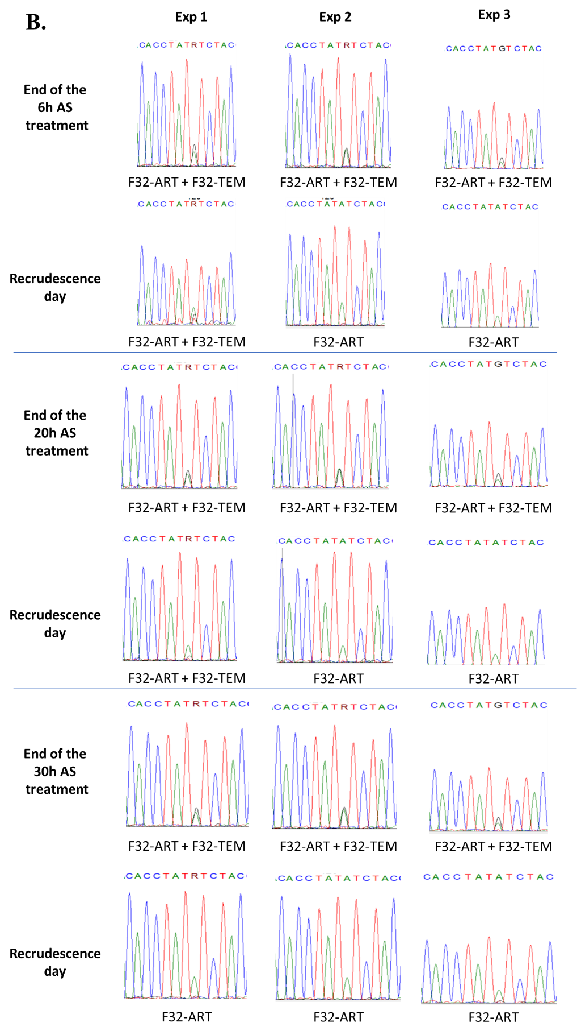
Fig. S4.
K13 sequencing. (A) K13 sequencing after ex vivo splenic perfusions. Infected RBCs collected from the circuit reservoir at the end of perfusion were incubated in fresh drug-free complete culture medium. Blood smears followed by Giemsa staining were taken every 3 days until recrudescence was observed (D5 for spleen C, D6 for spleen D, and D14 for spleen E). Sequencing of the pfk13 gene was performed to determine which strains were present in AS-treated culture or for control (without artesunate treatment: spleen F). F32-ART parasites carry the mutation M476I on the pfk13 gene. (B) K13 sequencing after in vitro recrudescence experiments. Mixed parasite cultures (0.5% each) were incubated in fresh drug-free complete culture medium at the end of a 1 µM AS exposure for 6h, 20h or 30h. Blood smears followed by Giemsa staining were taken every 3 days until recrudescence was observed. At the end of the treatment, and at the recrudescence day, sequencing of the pfk13 gene was performed to determine which strains were present in AS-treated culture in three independent experiment (Exp 1 to 3). F32-ART parasites carry the mutation M476I on the pfk13 gene.

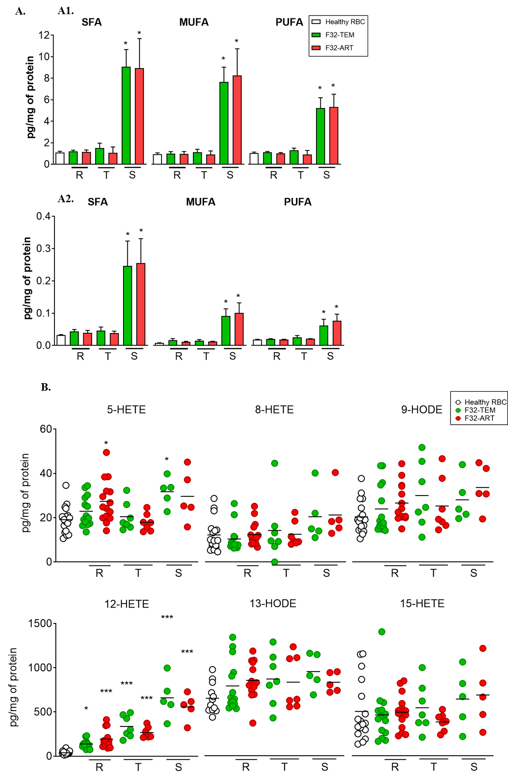

Fig. S5.
Quantification of hydroxylated polyunsaturated fatty acids in RBCs infected by artemisinin-sensitive (F32-TEM) or artemisinin-resistant (F32-ART) P. falciparum parasites. (A) Quantification of (A1) total saturated fatty acids (SFA), mono-unsaturated fatty acids (MUFA) and poly-unsaturated fatty acids (PUFA), and (A2) free SFA, MUFA and PUFA extract from uninfected red blood cells (white bars) or red blood cells infected by artemisinin-sensitive (F32-TEM, green bars) or by artemisinin-resistant (F32-ART, red bars) Plasmodium falciparum parasites. Quantification was performed at the ring (R), trophozoite (T) and schizont (S) stages of the parasite. Data are expressed as mean ± SEM, n=3-5 independent parasite cultures per conditions. Statistical analysis was performed using Kruskal-Wallis test, followed by Dunn’s post-test. *p < 0.05, significantly different from control. (B) 5-HETE, 8-HETE, 12-HETE, 15-HETE, 9-HODE and 13-HODE extract from healthy RBCs (white circles) or infected by artemisinin-sensitive (F32-TEM, green circles) or by artemisinin-resistant (F32-ART, Red circles) Plasmodium falciparum parasites. Quantification was performed at the ring (R), trophozoite (T) and schizont (S) stage of the parasite. Data are expressed as scatter dot plot with mean, n=5-14 independent parasite cultures per conditions. Statistical analysis was performed using Kruskal-Wallis test, followed by Dunn’s post-test. *p<0.05, ***p<0.001 significantly different from control.

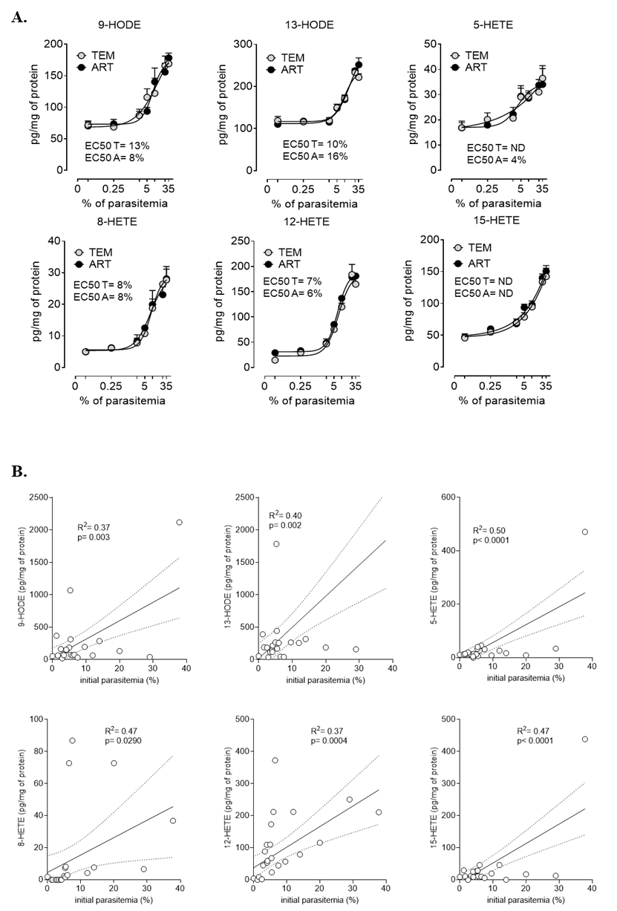

Fig. S6.
Quantification of hydroxylated polyunsaturated fatty acids regarding parasitemia. (A) Quantification of 9-HODE, 13-HODE, 5-HETE, 8-HETE, 12-HETE or 15-HETE was performed in red blood cells infected with different percentage of parasitemia (from 0.025% to 35%) of Pfk13-wt (F32-TEM, gray circles) or Pfk13 mutants (F32-ART, black circles) Plasmodium falciparum parasites. Data are mean ± SEM; n = 5. Variable slopes were obtained by using a 4 parameters logistic regression and the EC₅₀ calculated is indicated on each graph for F32-TEM (T) and F32-ART (A); ND: not determined. (B) Correlation between the concentration of 9-HODE, 13-HODE, 5-HETE, 8-HETE, 12-HETE or 15-HETE in red blood cell membranes from 22 patients infected by Plasmodium falciparum and the percentage of initial parasitemia. Data are represented as aligned dot plots with mean and errors linear regression lines and the coefficient of correlation R² was calculated. The significance of each correlation is indicated on each graphic by the p-value.

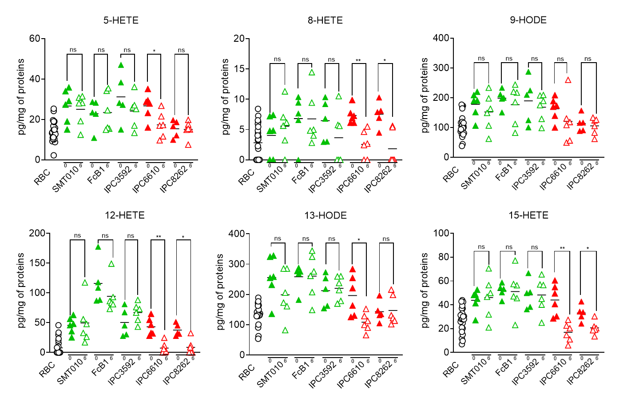

Fig. S7.
Quantification of hydroxylated fatty acids, 9-HODE, 13-HODE, 5-HETE, 8-HETE, 12-HETE and 15-HETE in uninfected red blood cells (white circles) or infected with artemisinin-sensitive strains (SMT010 from Sotuba, Mali; FcB1-Columbia lab strain; IPC3592 from Cambodia, green triangles) or with artemisinin-resistant strain (IPC6610 and IPC8262 from Cambodia, red triangles) without (0 hour) and after (6 hours) treatment with dihydroartemisinin (DHA, 700 nM). Data are as scatter dot plot with mean; n = 5-6 independent experiments. Statistical analysis was performed using Mann-Whitney test.
* p < 0.05, ** p < 0.01, compared to 0 hours after DHA.

N° Patient | Site | Slope half life (hours) | Parasite clearance time (hours) | K13 genotype | Age | Sex | Recrudescent Episode? | Recrudescence day | Recrudescent Pf Density
163-KH1-077 | Pursat | 1,43 | 30 | WT | 19 | Female | No |  | .
163-KH1-030 |  | 1,49 | 30 | WT | 17 | Female | No |  | .
163-KH1-035 |  | 1,71 | 30 | WT | 31 | Male | No |  | .
163-KH1-034 |  | 2,13 | 36 | WT | 25 | Male | No |  | .
163-KH1-075 |  | 2,49 | 36 | WT | 55 | Male | No |  | .
163-KH1-021 |  | 3 | 48 | WT | 23 | Male | No |  | .
163-KH1-054 |  | 3,46 | 42 | WT | 48 | Male | No |  | .
163-KH1-062 |  | 3,52 | 84 | WT | 22 | Male | Yes | 21 | 41490
163-KH1-027 |  | 4,1 | 54 | WT | 18 | Male | No |  | .
163-KH1-006 |  | 4,32 | 60 | C580Y | 18 | Male | Yes | 35 | 3406
163-KH1-016 |  | 4,34 | 60 | Y493H | 31 | Male | No |  | .
163-KH1-015 |  | 4,38 | 66 | C580Y | 23 | Male | No |  | .
163-KH1-057 |  | 5,38 | 78 | C580Y | 24 | Male | Yes | 28 | 670
163-KH1-109 |  | 5,44 | 72 | WT | 23 | Male | No |  | .
163-KH1-055 |  | 5,47 | 84 | Y493H | 34 | Male | Yes | 28 | 9773
163-KH1-072 |  | 5,9 | 84 | C580Y | 28 | Male | Yes | 14 | 696
163-KH1-040 |  | 6,01 | 96 | C580Y | 25 | Male | Yes | 35 | 22863
163-KH1-032 |  | 6,07 | 84 | Y493H | 35 | Female | Yes | 21 | 3881
163-KH1-018 |  | 6,43 | 102 | C580Y | 29 | Male | No |  | .
163-KH1-052 |  | 6,71 | 90 | R539T | 15 | Male | No |  | .
163-KH1-043 |  | 6,78 | 72 | Y493H | 47 | Male | No |  | .
163-KH1-107 |  | 6,91 | 90 | Y493H, C580Y | 32 | Male | No |  | .
163-KH1-039 |  | 6,91 | 90 | Y493H | 28 | Male | No |  | .
163-KH1-086 |  | 7,04 | 96 | C580Y | 27 | Male | Yes | 21 | 1263
163-KH1-093 |  | 7,28 | 96 | C580Y | 29 | Male | No |  | .
163-KH1-060 |  | 7,28 | 102 | Y493H | 20 | Male | Yes | 35 | 9160
163-KH1-022 |  | 7,36 | 78 | C580Y | 58 | Female | No |  | .
163-KH1-036 |  | 7,5 | 102 | C580Y | 31 | Male | No |  | .
163-KH1-038 |  | 7,55 | 90 | C580Y | 39 | Male | No |  | .
163-KH1-049 |  | 7,65 | 96 | C580Y | 46 | Male | No |  | .
163-KH1-100 |  | 7,76 | 78 | C580Y | 45 | Male | Yes | 21 | 1578
163-KH1-013 |  | 7,88 | 96 | C580Y | 45 | Male | No |  | .
163-KH1-005 |  | 7,97 | 84 | C580Y | 26 | Male | No |  | .
163-KH1-033 |  | 8,26 | 96 | C580Y | 12 | Male | Yes | 21 | 4689
163-KH1-081 |  | 8,61 | 96 | C580Y | 22 | Male | Yes | Self-referral D18 | 222
163-KH1-047 |  | 8,87 | 114 | C580Y | 37 | Male | Yes | 14 | 186
163-KH2-054 | Preah Vihear | 1,33 | 30 | WT | 22 | Male | No |  | .
163-KH2-050 |  | 1,48 | 24 | WT | 9 | Male | No |  | .
163-KH2-023 |  | 1,61 | 30 | WT | 40 | Female | No |  | .
163-KH2-048 |  | 1,63 | 30 | WT | 31 | Male | No |  | .
163-KH2-028 |  | 1,7 | 30 | WT | 15 | Male | No |  | .
163-KH2-040 |  | 1,89 | 36 | WT | 19 | Male | No |  | .
163-KH2-051 |  | 2,09 | 42 | WT | 17 | Male | No |  | .
163-KH2-009 |  | 2,24 | 54 | WT | 45 | Female | No |  | .
163-KH2-043 |  | 2,28 | 42 | WT | 33 | Male | No |  | .
163-KH2-020 |  | 2,33 | 42 | WT | 24 | Female | No |  | .
163-KH2-062 |  | 2,51 | 36 | WT | 18 | Male | No |  | .
163-KH2-060 |  | 2,63 | 54 | WT | 55 | Male | No |  | .
163-KH2-005 |  | 2,73 | 54 | WT | 31 | Male | No |  | .
163-KH2-035 |  | 2,99 | 48 | WT | 13 | Male | No |  | .
163-KH2-037 |  | 3,03 | 48 | WT | 22 | Male | No |  | .
163-KH2-055 |  | 3,1 | 42 | WT | 23 | Male | No |  | .
163-KH2-033 |  | 4,06 | 54 | WT | 14 | Female | No |  | .
163-KH2-063 |  | 4,9 | 54 | C580Y | 22 | Male | No |  | .
163-KH2-042 |  | 6,56 | 72 | C580Y | 26 | Male | Yes | 42 | 13435
163-KH2-038 |  | 7,01 | 102 | C580Y | 27 | Male | Yes | 21 | 3400
163-KH2-065 |  | 7,4 | 84 | C580Y | 28 | Male | No |  | .
163-KH2-039 |  | 7,43 | 90 | C580Y | 32 | Male | Yes | Self-referral D39 | 190
163-KH2-031 |  | 7,54 | 84 | C580Y | 18 | Male | Yes | Self-referral D18 | 2351
163-KH2-052 |  | 7,94 | 90 | C580Y | 32 | Male | Yes | 35 | 6080
163-KH2-064 |  | 8,04 | 84 | C580Y | 43 | Male | No |  | .
163-KH2-010 |  | 8,17 | 108 | Y493H | 31 | Male | No |  | .
163-KH2-061 |  | 9,87 | 120 | WT | 45 | Male | Yes | 21 | 6772
163-KH3-003 | Ratanakiri | 1,62 | 30 | WT | 16 | Female | No |  | .
163-KH3-002 |  | 1,8 | 30 | WT | 25 | Male | No |  | .
163-KH3-019 |  | 1,9 | 30 | WT | 14 | Female | No |  | .
163-KH3-048 |  | 1,98 | 36 | WT | 7 | Male | No |  | .
163-KH3-064 |  | 2,03 | 36 | WT | 12 | Male | No |  | .
163-KH3-063 |  | 2,08 | 30 | WT | 4 | Female | No |  | .
163-KH3-036 |  | 2,09 | 30 | WT | 19 | Male | No |  | .
163-KH3-004 |  | 2,16 | 36 | WT | 19 | Male | No |  | .
163-KH3-032 |  | 2,24 | 30 | WT | 21 | Male | No |  | .
163-KH3-018 |  | 2,25 | 30 | WT | 19 | Female | No |  | .
163-KH3-043 |  | 2,28 | 36 | WT | 4 | Male | No |  | .
163-KH3-025 |  | 2,32 | 36 | WT | 11 | Female | No |  | .
163-KH3-030 |  | 2,55 | 30 | WT | 29 | Male | No |  | .
163-KH3-022 |  | 2,62 | 36 | WT | 18 | Male | No |  | .
163-KH3-062 |  | 2,78 | 42 | WT | 10 | Female | Yes | Self-referral D39 | 19104
163-KH3-005 |  | 2,79 | 36 | WT | 13 | Female | No |  | .
163-KH3-055 |  | 2,97 | 54 | WT | 12 | Female | No |  | .
163-KH3-035 |  | 3,23 | 48 | WT | 40 | Male | No |  | .
163-KH3-054 |  | 3,26 | 48 | WT | 53 | Male | No |  | .
163-KH3-065 |  | 3,32 | 48 | WT | 4 | Female | No |  | .
163-KH3-046 |  | 3,42 | 36 | WT | 15 | Male | No |  | .
163-KH3-050 |  | 3,66 | 48 | WT | 3 | Female | Yes | 63 | 609
163-KH3-056 |  | 4,28 | 66 | WT | 8 | Female | No |  | .
163-KH3-047 |  | 4,33 | 54 | WT | 25 | Female | No |  | .
163-KH3-037 |  | 4,34 | 60 | WT | 4 | Male | No |  | .

Table S1.
K13 genotype of Plasmodium falciparum infections from Cambodian patients. Representation of K13 genotyping results of P. falciparum infections from 88 patients according to the region including Ratanakiri, Preah Vihear and Pursat. WT represents patients with a Pf13-wild type P. falciparum profiles and the other codes indicate the presence of P. falciparum with K13 mutation. Lines in red represent slope half-life <5h with Pfk13 mutation or slope half-life >5h in Pfk13-WT genotype.

FA | RBCs | F32-ART Ring | F32-TEM Ring | F32-ART  Tropho. | F32-TEM  Tropho. | F32-ART  Schizont | F32-TEM  Schizont
C14:0 | 0.01 ± 0.002 | 0.01 ± 0.006 | NQ | NQ | NQ | 0.08 ± 0.08 | 0.13 ± 0.01
C16:0 | 0.6 ± 0.1 | 0.7 ± 0.1 | 0.7 ± 0.1 | 0.7 ± 0.4 | 0.9 ± 0.4 | 6.6 ± 2.1 | 6.7 ± 1.1
C18:0 | 0.5 ± 0.04 | 0.5 ± 0.05 | 0.5 ± 0.05 | 0.4 ± 0.1 | 0.6 ± 0.08 | 2.3 ± 0.6 | 2.2 ± 0.04
C16:1 n-7 | 0.04 ± 0.01 | 0.04 ± 0.01 | 0.03 ± 0.01 | 0.03 ± 0.001 | 0.04 ± 0.01 | 0.30 ± 0.13 | 0.28 ± 0.03
C18:1 n-9 | 0.80 ± 0.1 | 0.82 ± 0.19 | 0.85 ± 0.16 | 0.79 ± 0.31 | 0.97 ± 0.23 | 7.2 ± 2.1 | 6.6 ± 1.1
C18:1 n-7 | 0.08 ± 0.01 | 0.08 ± 0.02 | 0.08 ± 0.02 | 0.08 ± 0.02 | 0.07 ± 0.01 | 0.64 ± 0.15 | 0.66 ± 0.18
C22:1 n-9 | 0.03 ± 0.004 | 0.03 ± 0.008 | 0.03 ± 0.006 | 0.02 ± 0.002 | 0.03 ± 0.002 | 0.11 ± 0.01 | 0.11 ± 0.03
C18:2 n-6 | 0.3 ± 0.03 | 0.3 ± 0.03 | 0.3 ± 0.02 | 0.3 ± 0.1 | 0.4 ± 0.1 | 2.8 ± 0.7 | 2.9 ± 0.5
C20:2 n-6 | 0.01 ± 0.002 | 0.01 ± 0.001 | 0.01 ± 0.002 | 0.01 ± 0.003 | 0.02 ± 0.007 | 0.07 ± 0.002 | 0.07 ± 0.01
C20:3 n-6 | 0.05 ± 0.004 | 0.04 ± 0.004 | 0.05 ± 0.003 | 0.04 ± 0.01 | 0.06 ± 0.01 | 0.2 ± 0.04 | 0.2 ± 0.06
C20:4 n-6 | 0.4 ± 0.03 | 0.4 ± 0.3 | 0.4 ± 0.02 | 0.4 ± 0.1 | 0.5 ± 0.07 | 1.4 ± 0.3 | 1.3 ± 0.2
C20:5 n-3 | 0.02 ± 0.003 | 0.02 ± 0.001 | 0.03 ± 0.001 | 0.02 ± 0.009 | 0.03 ± 0.006 | 0.1 ± 0.05 | 0.1 ± 0.07
C22:4 n-6 | 0.08 ± 0.007 | 0.07 ± 0.007 | 0.08 ± 0.009 | 0.06 ± 0.01 | 0.08 ± 0.003 | 0.1 ± 0.006 | 0.1 ± 0.01
C22:5 n-3 | 0.05 ± 0.006 | 0.06 ± 0.001 | 0.06 ± 0.005 | 0.04 ± 0.01 | 0.06 ± 0.009 | 0.08 ± 0.03 | 0.08 ± 0.01
C22:6 n-3 | 0.1 ± 0.01 | 0.1 ± 0.009 | 0.1 ± 0.008 | 0.1 ± 0.04 | 0.1 ± 0.007 | 0.4 ± 0.07 | 0.3 ± 0.06

Table S2.
Relative concentration of total fatty acids per mg of proteins in red blood cells (RBCs) uninfected or infected by Plasmodium falciparum at ring, trophozoite and schizont stages.
FA: fatty acid, F32-ART: artemisinin-resistant P. falciparum strain (Pfk13-mut), F32-TEM: artemisinin-sensitive P. falciparum strain (Pfk13-wt), Tropho.: trophozoite, NQ: not quantifiable

FA | RBCs | F32-ART Ring | F32-TEM Ring | F32-ART  Tropho. | F32-TEM  Tropho. | F32-ART  Schizont | F32-TEM  Schizont
C16:0 | 0.02 ± 0.001 | 0.02 ± 0.005 | 0.03 ± 0.004 | 0.02 ± 0.005 | 0.03 ± 0.009 | 0.18 ± 0.06 | 0.18 ± 0.06
C18:0 | 0.01 ± 0.001 | 0.01 ± 0.003 | 0.01 ± 0.002 | 0.01 ± 0.001 | 0.01 ± 0.002 | 0.07 ± 0.02 | 0.06 ± 0.02
C16:1 n-7 | 0.001 ± 0.0001 | 0.001 ± 0.0001 | 0.001 ± 0.0001 | 0.001 ± 0.0001 | 0.001 ± 0.0001 | 0.007 ± 0.004 | 0.006 ± 0.004
C18:1 n-9 | 0.005 ± 0.0003 | 0.009 ± 0.001 | 0.01 ± 0.004 | 0.01 ± 0.001 | 0.01 ± 0.003 | 0.08 ± 0.02 | 0.07 ± 0.02
C18:2 n-6 | 0.003 ± 0.001 | 0.004 ± 0.0005 | 0.005 ± 0.0002 | 0.005 ± 0.0005 | 0.006 ± 0.002 | 0.04 ± 0.01 | 0.04 ± 0.003
C20:4 n-6 | 0.008 ± 0.0007 | 0.008 ± 0.0006 | 0.008 ± 0.001 | 0.008 ± 0.0001 | 0.008 ± 0.0005 | 0.02 ± 0.008 | 0.02 ± 0.01
C20:5 n-3 | 0.02 ± 0.003 | 0.02 ± 0.001 | 0.03 ± 0.001 | 0.02 ± 0.009 | 0.03 ± 0.006 | 0.15 ± 0.08 | 0.15 ± 0.07
C22:5 n-3 | 0.002 ± 0.0003 | 0.002 ± 0.0001 | 0.002 ± 0.0001 | 0.002 ± 0.0001 | 0.004 ± 0.002 | 0.003 ± 0.0001 | 0.001 ± 0.0009
C22:6 n-3 | 0.003 ± 0.0003 | 0.002 ± 0.0003 | 0.002 ± 0.0001 | 0.004 ± 0.0001 | 0.004 ± 0.0004 | 0.01 ± 0.008 | 0.003 ± 0.0001

Table S3.
Relative concentration of free fatty acids per mg of proteins in red blood cells (RBCs) uninfected or infected by Plasmodium falciparum at ring, trophozoite and schizont stages. FA: fatty acid, F32-ART: artemisinin-resistant P. falciparum strain (Pfk13-mut), F32-TEM: artemisinin-sensitive P. falciparum strain (Pfk13-wt), Tropho: trophozoite.

FA | RBCs | F32-ART ring  DHA 0h | F32-TEM ring  DHA 0h | F32-ART ring  DHA 6h | F32-TEM ring  DHA 6h
Total SFA | 1.1 ± 0.1 | 1.1 ± 0.2 | 1.2 ± 0.1 | 1.1 ± 0.4 | 1.5 ± 0.4
Total MUFA | 0.9 ± 0.1 | 0.9 ± 0.2 | 1.0 ± 0.2 | 0.9 ± 0.3 | 1.1 ± 0.3
Total PUFA | 1.0 ± 0.1 | 1.1 ± 0.1 | 1.1 ± 0.1 | 0.9 ± 0.3 | 1.3 ± 0.2
Free SFA | 0.03 ± 0.002 | 0.04 ± 0.008 | 0.04 ± 0.006 | 0.04 ± 0.006 | 0.04 ± 0.01
Free MUFA | 0.01 ± 0.004 | 0.01 ± 0.002 | 0.02 ± 0.005 | 0.01 ± 0.001 | 0.01 ± 0.004
Free PUFA | 0.02 ± 0.003 | 0.02 ± 0.001 | 0.02 ± 0.001 | 0.02 ± 0.001 | 0.02 ± 0.005

Table S4.
Relative concentration of total and free fatty acids per mg of proteins in red blood cells (RBCs) uninfected or infected by Plasmodium falciparum at ring stage before and after 6h of dihydroartemisinin (DHA) exposure. FA: fatty acid, SFA: saturated fatty acid, MUFA: monounsaturated fatty acid, PUFA: polyunsaturated fatty acid, F32-ART: artemisinin-resistant P. falciparum strain (Pfk13-mut), F32-TEM: artemisinin-sensitive P. falciparum strain (Pfk13-wt).

