Supplementary information:

Assessment of mechanical and environmental performance of mortar with Coconut Shell Ashes as Supplementary Cementitious Material
Nicolas Bertoldo¹*, Nicola Cefis², Enrico Paris³, Francesco Gallucci³, Giovanni Dotelli¹
¹Department of Chemistry, Materials and Chemical Engineering ”Giulio Natta”, Politecnico di Milano, Piazza Leonardo Da Vinci 32, Milan, 20133, Italy.
²Department of Civil and Environmental Engineering, Politecnico di Milano, Piazza Leonardo Da Vinci 32, Milan, 20133, Italy.
³CREA-IT Council for Agricultural Research and Economics, via della Pascolare 16, Monterotondo, 00015, Italy.
*Corresponding author(s). E-mail(s): nicolas.bertoldo@polimi.it;
Contributing authors: nicola.cefis@polimi.it; enrico.paris@crea.gov.it; francesco.gallucci@crea.gov.it; giovanni.dotelli@polimi.it;

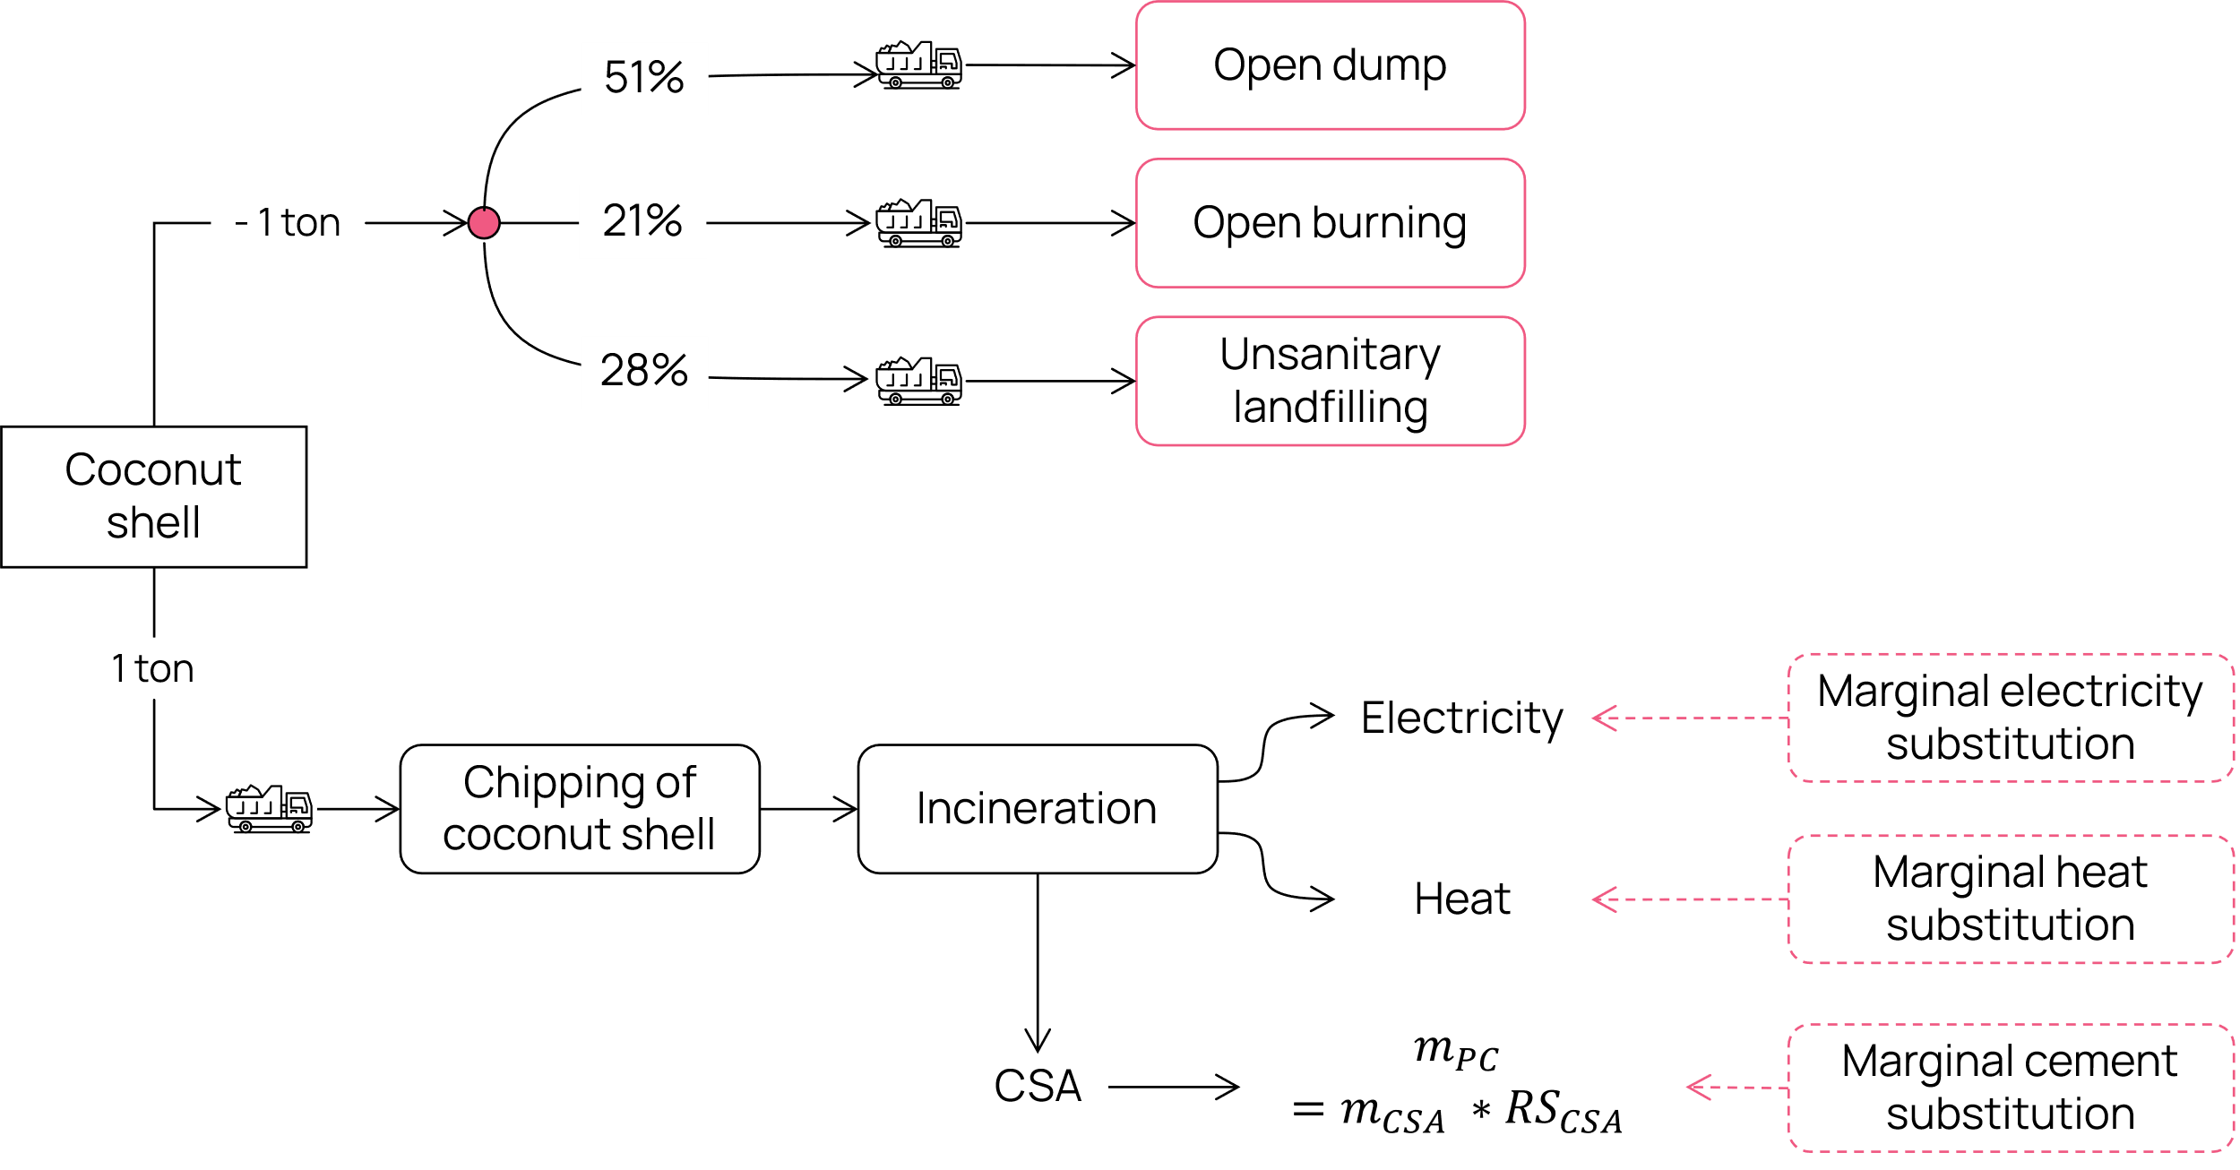
Figure SI 1: System boundary of the LCA study. The boxes with the continuous red border represent the current waste treatment process, while the boxes with a dashed red border represent avoided processes. m_{PC} = mass of Portland Cement, m_{CSA} = mass of CSA, RS_{CSA} = relative strength of mortar with CSA.

Mechanical strength results
Table SI 1: Compressive strength test results (MPa)
Hydration time | Reference | 5% CSA | 10% CSA
7 days | 42.8 | 31.7 | 27.8
7 days | 42.2 | 31 | 28.4
7 days | 42.2 | 33.2 | 29.1
7 days | 41.5 | 31.8 | 28.9
14 days | 45.3 | 36.3 | 32.3
14 days | 40.5 | 36 | 34.1
14 days | 45.7 | 37.3 | 30.6
14 days | 41.5 | 35.6 | 34.3
28 days | 46.1 | 38 | 36.7
28 days | 44.6 | 35.9 | 36.7
28 days | 45.2 | 35.7 | 35.5
28 days | 44.5 | 37.6 | 36.7

Table SI 2: Flexural strength test results (MPa)
Hydration time | Reference | 5% CSA | 10% CSA
7 days | 6.6 | 6 | 5.4
7 days | 6.8 | 6.4 | 5.1
14 days | 7.8 | 6.3 | 6.8
14 days | 6.3 | 5.9 | 5.2
28 days | 7.7 | 6.4 | 5.4
28 days | 8.5 | 6.3 | 6.2

Life Cycle Inventories
Table SI 3: Inventory of the current treatment of 1 kg of coconut shell in India
Exchange | Amount | Unit | Type
Coconut shell waste | -1 | kg | production
market for transport, freight, lorry, unspecified | 7.70E-02 | t*km | technosphere
treatment of waste wood, untreated, open dump, wet infiltration class (500mm) | -0.505 | kg | technosphere
treatment of waste wood, untreated, open burning | -2.84E-01 | kg | technosphere
treatment of waste wood, untreated, unsanitary landfill, wet infiltration class (500mm) | -0.211 | kg | technosphere

Table SI 4: Inventory of chipping 1kg of coconut shell waste
Exchange | Amount | Unit | Type
chipping of coconut shell waste | 1 | kg | production
market for chipper, stationary, electric - GLO | 5.30E-08 | unit | technosphere
market for electricity, medium voltage -IN-Southern grid | 0.02 | kWh | technosphere
market for lubricating oil - RoW | 2.04E-06 | kg | technosphere
market for steel, low-alloyed, hot rolled - GLO | 4.08E-06 | kg | technosphere

Table SI 5: Inventory of the incineration of 1 kg of coconut shell waste
Exchange | Amount | Unit | Type
coconut shell waste | 1 | kg | production
market for transport, freight, lorry, unspecified, 100 km | 0.1 | t*km | technosphere
Carbon dioxide, non-fossil | 2.407820147 | kg | biosphere
Carbon monoxide, non-fossil | 0.008638069 | kg | biosphere
Nitrogen oxides | 0.00399 | kg | biosphere
Sulfur dioxide | 0.0000838 | kg | biosphere
Particulate Matter, > 10 um | 5.77849E-05 | kg | biosphere
Particulate Matter, < 2.5 um | 0.001559666 | kg | biosphere
1,1,2-Trichloroethane | 2.1566E-12 | kg | biosphere
Benzene | 8.8725E-12 | kg | biosphere
Carbon tetrachloride | 2.38E-14 | kg | biosphere
Naphthalene | 3.273E-13 | kg | biosphere
Tetrachloroethylene | 5.7E-15 | kg | biosphere
Toluene | 3.4148E-11 | kg | biosphere
Styrene | 1.828E-13 | kg | biosphere
o-Dichlorobenzene | 6.19462E-13 | kg | biosphere
Butadiene | 1.31394E-12 | kg | biosphere
market for ammonia, anhydrous, liquid | 1.5252E-07 | kg | technosphere
market for chemical, organic | 0.00010881 | kg | technosphere
market for chlorine, liquid | 6.1008E-06 | kg | technosphere
market for dust collector, electrostatic precipitator, for industrial use | 9.68702E-09 | unit | technosphere
market for furnace, wood chips, with silo, 5000kW | 9.68702E-09 | unit | technosphere
market for heat and power co-generation unit, organic Rankine cycle, 1000kW electrical | 9.68702E-09 | unit | technosphere
market for lubricating oil | 0.000061008 | kg | technosphere
market for municipal solid waste | -0.000061008 | kg | technosphere
market for sodium chloride, powder | 0.00007626 | kg | technosphere
market for waste mineral oil | -0.000061008 | kg | technosphere
market for wastewater, average | -1.46382E-05 | m³ | technosphere
market for water, decarbonised | 0.0146382 | kg | technosphere

Life Cycle Impact Assessment
Table SI 6: LCA results for the assessed impact categories of the EF 3.1. impact assessment method
Stage | acidification | climate change | ecotoxicity: freshwater | energy resources: non-renewable | eutrophication: freshwater | eutrophication: marine | eutrophication: terrestrial | human toxicity: carcinogenic
Chipping of coconut shell | 0.000108 | 0.024286 | 0.053526 | 0.286304 | 1.8E-05 | 2.35E-05 | 0.000231 | 3.09E-12
Incineration of coconut shell | 0.003148 | 0.022781 | 0.078416 | 0.294124 | 5.41E-06 | 0.001584 | 0.017337 | 1.01E-11
Marginal cement substitution | -2.7E-05 | -0.00813 | -0.00964 | -0.04466 | -1.6E-06 | -8.4E-06 | -9.4E-05 | -3.1E-12
Marginal electricity substitution | -0.00366 | -0.81532 | -1.70971 | -9.71476 | -0.00061 | -0.00079 | -0.00779 | -8.7E-11
Marginal heat substitution | -0.00936 | -0.94789 | -3.08717 | -5.01235 | -0.00208 | -0.00148 | -0.01289 | -2.9E-10
Transport of coconut shell waste | -5E-05 | -0.0121 | -0.02428 | -0.1706 | -1.2E-06 | -2E-05 | -0.00022 | -3.1E-12
Transport of coconut shell waste to incinerator plant | 6.53E-05 | 0.015715 | 0.03153 | 0.221557 | 1.61E-06 | 2.62E-05 | 0.000286 | 3.98E-12
Treatment of coconut shell, open burning | -0.00044 | -0.05425 | -0.12231 | 0 | -1.5E-06 | -0.00022 | -0.00243 | -2.8E-10
Treatment of coconut shell, open dump | -1.7E-07 | -0.04192 | -0.02269 | 0 | -3.8E-06 | -0.00017 | -4.4E-08 | -1E-13
Treatment of coconut shell, unsanitary landfill | -9E-06 | -0.02587 | -0.01045 | -0.01352 | -1.6E-06 | -7.4E-05 | -4.7E-05 | -1.5E-13

Stage | human toxicity: non-carcinogenic | ionising radiation: human health | land use | material resources: metals/minerals | ozone depletion | particulate matter formation | photochemical oxidant formation: human health | water use
Chipping of coconut shell | 1.53E-10 | 0.000865 | 0.06312 | 8.04E-09 | 8.24E-11 | 3.62E-10 | 6.28E-05 | 0.003948
Incineration of coconut shell | 1.96E-10 | -0.0001 | 0.206361 | -1.5E-07 | 1.11E-08 | 3.81E-07 | 0.00412 | 0.003082
Marginal cement substitution | -5.1E-11 | -1.5E-05 | -0.04275 | -2.7E-08 | -1.3E-11 | -2.3E-10 | -2.4E-05 | -0.00026
Marginal electricity substitution | -5E-09 | -0.03034 | -2.10893 | -7.4E-07 | -2.4E-09 | -1.1E-08 | -0.0021 | -0.12997
Marginal heat substitution | -1.3E-08 | 0.146761 | -36.1968 | 8.89E-07 | 5.42E-11 | -2.9E-08 | -0.00319 | -0.58459
Transport of coconut shell waste | -1.2E-10 | -4.7E-05 | -0.1316 | -2.3E-08 | -1.7E-10 | -1.1E-09 | -7.7E-05 | -0.00087
Transport of coconut shell waste to incinerator plant | 1.51E-10 | 6.05E-05 | 0.170915 | 3.05E-08 | 2.26E-10 | 1.47E-09 | 0.0001 | 0.001135
Treatment of coconut shell, open burning | -7.7E-09 | 0 | 0 | 0 | 0 | -3E-10 | -0.0012 | -0.00702
Treatment of coconut shell, open dump | -8.4E-11 | 0 | -0.47286 | 0 | 0 | -1.2E-13 | -1.6E-05 | 0
Treatment of coconut shell, unsanitary landfill | -4.9E-11 | -6.9E-08 | -0.10738 | 1.74E-09 | -1.6E-11 | -2.6E-10 | -2.3E-05 | -2.6E-05

