eMaterials
Figure S1. Distribution of the PRS_{AD} in the main cohort.
Table S1. Demographic information per PRS_{AD}
Table S2. Demographic information for the EMIF-AD cohort at baseline.
Table S3. Likelihood ratio test results between age and age by APOE interaction models
Figure S2. Comparison between GAM and GAMLSS.
Table S4. Likelihood ratio test results between age and age by APOE interaction models, with APOE as an ordinal variable
Figure S3. Plasma concentrations over age, stratified by APOE ε4 carriership.
Table S5. Likelihood ratio test results between age and age by APOE interaction models within a non-related subset of the population
Table S6. Likelihood ratio test results between age and age by APOE interaction models in males and females
Figure S4. Comparison between GAM and GAMLSS in males
Figure S5. Comparison between GAM and GAMLSS in females
Table S7. Likelihood ratio test results between age and age by APOE interaction models, stratified by sex, with APOE as an ordinal variable
Figure S6. Plasma concentrations over age in males, stratified by APOE ε4 carriership
Figure S7. Plasma concentrations over age in females, stratified by APOE ε4 carriership
Table S8. Likelihood ratio test results between age and age by PRS_{AD} interaction models, without adjusting for APOE
Table S9. Likelihood ratio test results between age and age by PRS_{AD} interaction models, adjusting for APOE
Table S10. Likelihood ratio test results between age and age by PRS_{AD} interaction models in males and females, without adjusting for APOE
Table S11. Likelihood ratio test results between age and age by PRS_{AD} interaction models in males and females, adjusting for APOE
Figure S8. Concentrations of biomarkers over age, stratified by PRS_{AD}
Figure S9. Concentrations of plasma biomarkers over age in males and females, stratified by PRS_{AD}
Table S12. Likelihood ratio test results between age and age by PRS_{AD} interaction models within a non-related subset of the population, without adjusting for APOE
Figure S10. Biomarker concentrations over age in the NTR and EMIF-AD sub-cohorts, by APOE ε4
Figure S11. Biomarker concentrations over age in the NTR and EMIF-AD sub-cohorts with underlying longitudinal population, by APOE ε4
Table S13. Comparison of APOE ε4 carriership LMMs in the EMIF-AD cohort
Figure S12. Biomarker concentrations over age in the NTR and EMIF-AD sub-cohorts, by APOE ε4 and Aβ PET status
Table S14. Comparison of APOE ε4 carriership and Aβ PET LMMs in the EMIF-AD cohort
Figure S13. Quality of p-tau217 duplicate measurements
Figure S14. Workflow of the statistical analysis in the main cohort

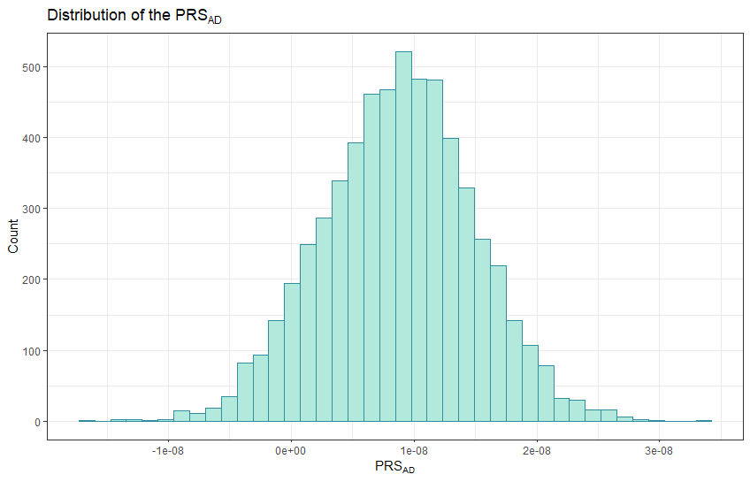
Figure S1. Distribution of the PRS_{AD} in the main cohort. The PRS_{AD} was distributed close to normally and was not transformed for analysis.

Table S1. Demographic information per PRS_{AD} group.
 | Low PRS_{AD} | Medium PRS_{AD} | High PRS_{AD} | Group difference
n | 1971 | 1971 | 1971
Age [year]  Mean [range] | 49.6 [30 – 80] | 49.8 [30 – 80] | 50.0 [30 – 80] | 0.68±
APOE ε4 carrier  Carriers (%) | 589 (29.8%) | 561 (28.6%) | 615 (31.1%) | 0.17±
Sex  Female (%) | 1278 (64.9%) | 1256 (63.7%) | 1259 (64.1%) | 0.73*
BMI  Mean (SD) | 25.8 (4.2) | 25.6 (4.1) | 25.7 (4.3) | 0.63
eGFR  Mean (SD) | 81.3 (14.7) | 81.3 (14.4) | 81.1 (14.8) | 0.92
p-tau217 pg/mL  Mean (SD) | 0.029 (0.021) | 0.031 (0.022) | 0.031 (0.026) | 0.03±
Aβ-42/40  Mean (SD) | 0.067 (0.018) | 0.067 (0.020) | 0.067 (0.016) | 0.53±
NfL pg/mL  Mean (SD) | 9.72 (8.26) | 9.91 (9.81) | 10.1 (10.8) | 0.46±
GFAP pg/mL  Mean (SD) | 65.7 (37.9) | 68.3 (52.0) | 70.8 (72.4) | 0.02±
± ANOVA, followed by Tukey HSD test if significant ; * Chi-square
Aβ-42/40: amyloid-β-42/40; GFAP: glial fibrillary acidic protein; NfL: neurofilament light; p-tau217: phosphorylated tau-217; PRS_{AD}: Alzheimer’s disease polygenic risk score.

Table S2. Demographic information for the EMIF-AD cohort at baseline.
 | ε4 non-carriers | ε4 carriers | Group difference
n | 135 | 66
Age [year]  Mean [range] | 72.2 [61 – 94] | 67.5 [60 – 83] | < 0.001±
Sex [-]  Female (%) | 86 (63.7%) | 30 (45.5%) | 0.02*
MMSE score  Median [range] | 29 [24 – 30] | 29 [25 – 30] | 0.30±
Aβ PET status  Aβ+, % | 20 (14.8%) | 26 (39.4%) | < 0.001*
p-tau217 [pg/mL]  Mean (SD) | 0.041 (0.024) | 0.047 (0.031) | 0.14±
Aβ-42/40 [-]  Mean (SD) | 0.061 (0.011) | 0.060 (0.012) | 0.63±
NfL [pg/mL]  Mean (SD) | 18.0 (9.52) | 15.4 (10.7) | 0.09±
GFAP [pg/mL]  Mean (SD) | 115 (55.6) | 112 (71.0) | 0.79±
± t-test ; * Chi-square
Aβ-42/40: amyloid-β-42/40; GFAP: glial fibrillary acidic protein; NfL: neurofilament light; p-tau217: phosphorylated tau-217.

Table S3. Likelihood ratio test results between age and age by APOE interaction models.
Biomarker | Predictor | Deviance | df | LRT | p
p-tau217 | Age | -33357.0 | 36.4
p-tau217 | Age + APOE | -33374.4 | 37.5 | 17.5 | < 0.001
p-tau217 | Age + APOE + Age * APOE | -33424.8 | 43.4 | 50.3 | < 0.001
Aβ-42/40 | Age | -33559.7 | 31.1
Aβ-42/40 | Age + APOE | -33578.7 | 32.2 | 20.0 | < 0.001
Aβ-42/40 | Age + APOE + Age * APOE | -33612.9 | 36.9 | 33.2 | < 0.001
NfL | Age | 29751.3 | 44.5
NfL | Age + APOE | 29751.2 | 45.5 | 0.06 | 0.81
NfL | Age + APOE + Age * APOE | 29747.6 | 51.8 | 3.65 | 0.76
GFAP | Age | 53659.1 | 38.5
GFAP | Age + APOE | 53657.8 | 39.5 | 1.26 | 0.26
GFAP | Age + APOE + Age * APOE | 53639.3 | 45.9 | 18.5 | 0.007
All models include principal components 1 to 20 as additional predictors and are adjusted for body mass index and estimated glomerular filtration rate.
APOE is modelled as a binary variable: APOE ε4 non-carrier (0) or APOE ε4 carrier (1).
The Age + APOE model is compared to the Age model. The Age + APOE + Age * APOE model is compared to the Age + APOE model. Age * APOE indicates an interaction effect between age and APOE.

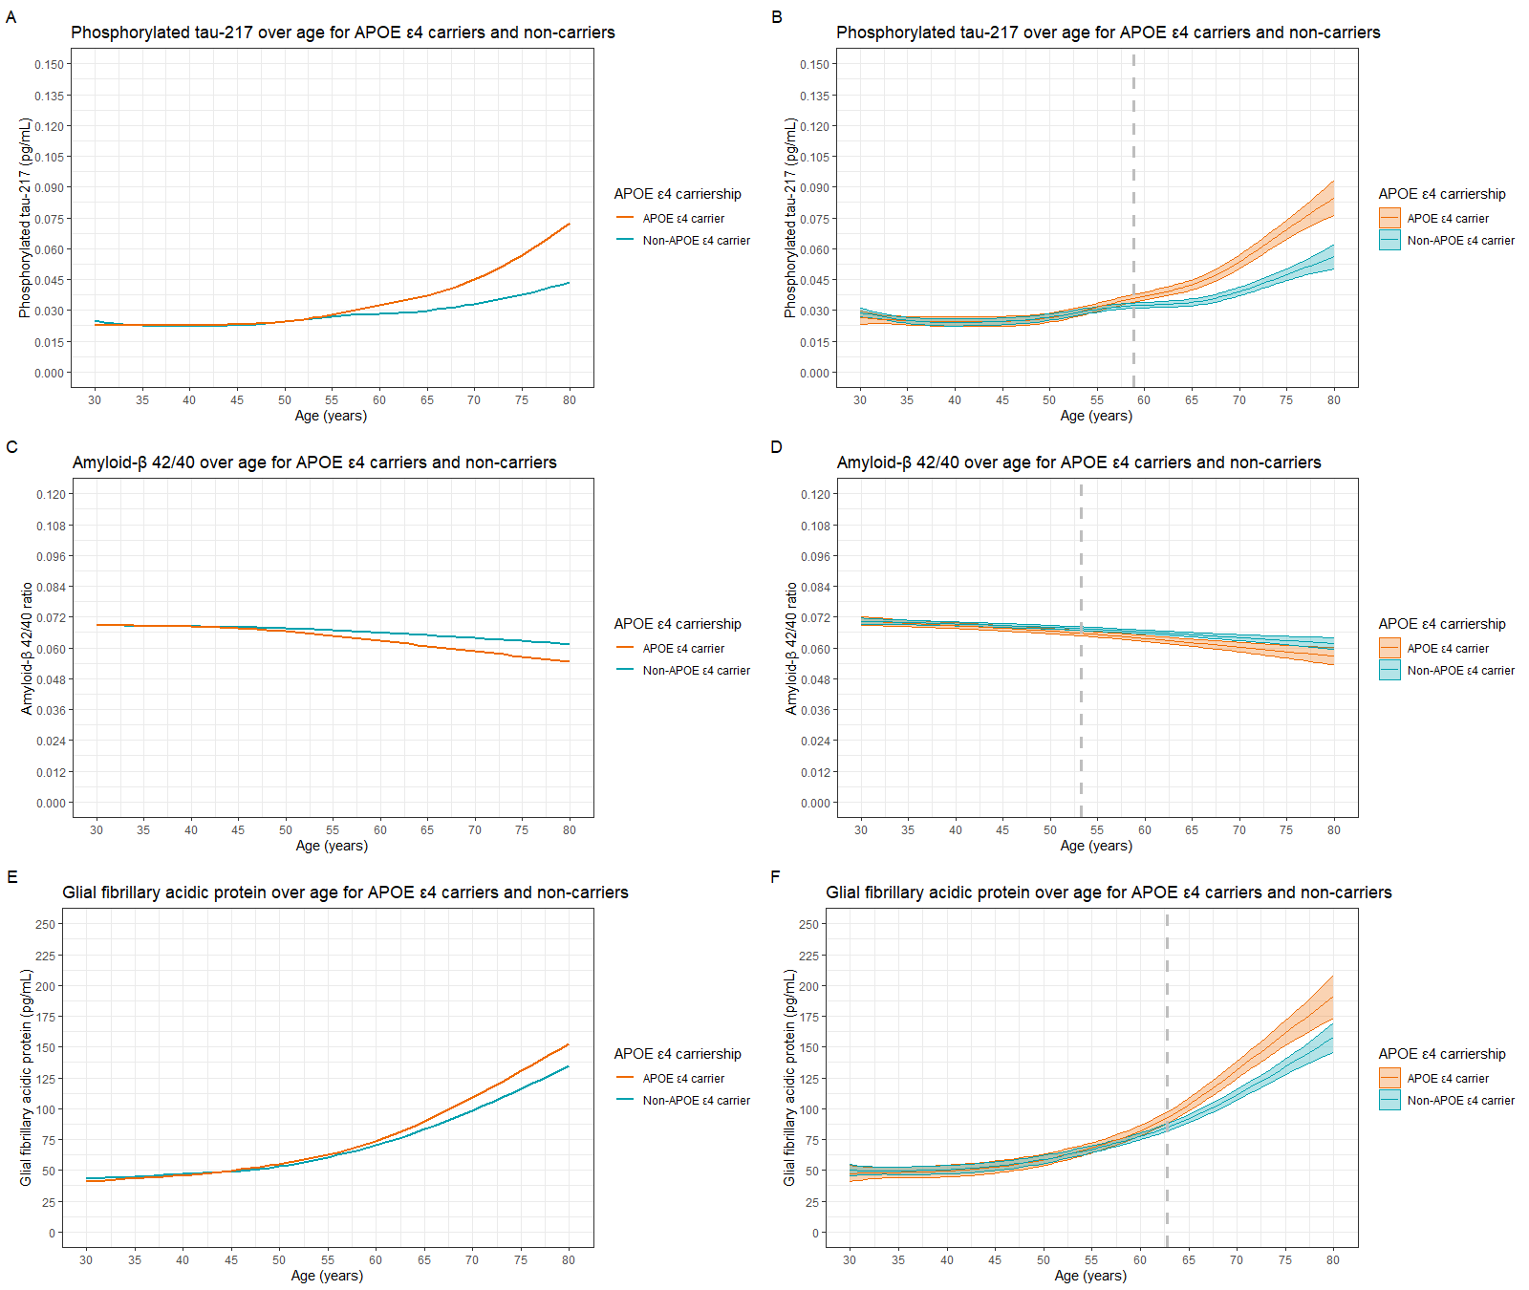
Figure S2. Comparison between GAMLSS (left) and GAM (right) approach. The GAMLSS approach was used as the basis for the main results. Grey vertical dashed lines represent the age at which the biomarker concentrations begin to significantly differ between APOE ε4 carriers and non-carriers. A and B = Phorphorylated-tau-217 over age. C and D = Amyloid-β-42/40 over age. E and F = Glial fibrillary acidic protein over age. Results for neurofilament light are not shown as no differences in concentrations were found between APOE ε4 carriers and non-carriers.

Table S4. Likelihood ratio test results between age and age by APOE interaction models, with APOE as an ordinal variable
Biomarker | Predictor | Deviance | df | LRT | p
p-tau217 | Age | -33357.0 | 36.4
p-tau217 | Age + APOE | -33382.1 | 38.5 | 25.1 | < 0.001
p-tau217 | Age + APOE + Age * APOE | -33441.8 | 47.6 | 59.7 | < 0.001
Aβ-42/40 | Age | -33559.7 | 31.1
Aβ-42/40 | Age + APOE | -33584.2 | 33.2 | 24.6 | < 0.001
Aβ-42/40 | Age + APOE + Age * APOE | -33625.5 | 38.8 | 41.2 | < 0.001
NfL | Age | 29751.3 | 44.5
NfL | Age + APOE | 29747.0 | 46.5 | 4.30 | 0.12
NfL | Age + APOE + Age * APOE | 29734.9 | 55.7 | 12.1 | 0.22
GFAP | Age | 53659.1 | 38.5
GFAP | Age + APOE | 53655.0 | 40.6 | 4.06 | 0.14
GFAP | Age + APOE + Age * APOE | 53630.9 | 49.9 | 24.1 | 0.005
All models include principal components 1 to 20 as additional predictors and are adjusted for body mass index and estimated glomerular filtration rate.
APOE is modelled as a binary variable: APOE ε4 non-carrier (0), heterozygous APOE ε4 carrier (1), or homozygous APOE ε4 carrier (2).
The Age + APOE model is compared to the Age model. The Age + APOE + Age * APOE model is compared to the Age + APOE model. Age * APOE indicates an interaction effect between age and APOE.

Table S5. Likelihood ratio test results between age and age by APOE interaction models within a non-related subset of the population.
Biomarker | Predictor | Deviance | df | LRT | p
p-tau217 | Age | -20589.8 | 35.0
p-tau217 | Age + APOE | -20600.3 | 36.0 | 10.5 | 0.001
p-tau217 | Age + APOE + Age * APOE | -20632.8 | 41.2 | 32.6 | < 0.001
Aβ-42/40 | Age | -20531.6 | 30.8
Aβ-42/40 | Age + APOE | -20551.3 | 31.9 | 19.7 | < 0.001
Aβ-42/40 | Age + APOE + Age * APOE | -20565.4 | 36.3 | 14.1 | 0.009
NfL | Age | 18551.4 | 42.0
NfL | Age + APOE | 18550.7 | 43.0 | 0.72 | 0.40
NfL | Age + APOE + Age * APOE | 18546.1 | 49.1 | 4.60 | 0.61
GFAP | Age | 32978.2 | 34.9
GFAP | Age + APOE | 32977.5 | 35.9 | 0.71 | 0.39
GFAP | Age + APOE + Age * APOE | 32961.6 | 42.6 | 15.9 | 0.02
All models include principal components 1 to 20 as additional predictors and are adjusted for body mass index and estimated glomerular filtration rate.
APOE is modelled as a binary variable: APOE ε4 non-carrier (0) or APOE ε4 carrier (1).
The Age + APOE model is compared to the Age model. The Age + APOE + Age * APOE model is compared to the Age + APOE model. Age * APOE indicates an interaction effect between age and APOE.
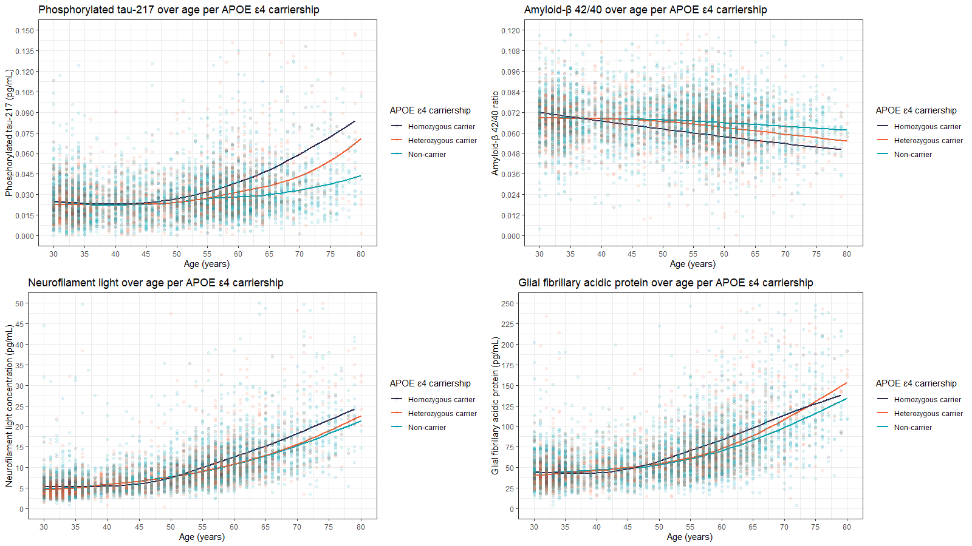
Figure S3. Plasma concentrations over age, stratified by APOE ε4 carriership. A = Phosphorylated-tau-217. B = Amyloid-β-42/40. C = Neurofilament light. D = Glial fibrillary acidic protein.
Table S6. Likelihood ratio test results between age and age by PRS_{AD} interaction models within a non-related subset of the population, without adjusting for APOE.
Biomarker | Predictor | Deviance | df | LRT | p-value
p-tau217 | Age | -20589.8 | 35.0
p-tau217 | Age + PRS_{AD} | -20596.8 | 36.0 | 7.03 | 0.008
p-tau217 | Age + PRS_{AD} + Age * PRS_{AD} | -20596.9 | 37.0 | 0.07 | 0.78
Aβ-42/40 | Age | -20531.6 | 30.8
Aβ-42/40 | Age + PRS_{AD} | -20531.7 | 31.8 | 0.08 | 0.78
Aβ-42/40 | Age + PRS_{AD} + Age * PRS_{AD} | -20532.7 | 33.3 | 1.05 | 0.46
NfL | Age | 18551.4 | 42.0
NfL | Age + PRS_{AD} | 18551.1 | 43.0 | 0.23 | 0.63
NfL | Age + PRS_{AD} + Age * PRS_{AD} | 18550.8 | 44.0 | 0.32 | 0.57
GFAP | Age | 32978.2 | 34.9
GFAP | Age + PRS_{AD} | 32977.7 | 36.0 | 0.57 | 0.46
GFAP | Age + PRS_{AD} + Age * PRS_{AD} | 32977.7 | 37.0 | -0 | NA
All models include principal components 1 to 20 as additional predictors and are adjusted for body mass index and estimated glomerular filtration rate.
PRS_{AD} is modelled as an ordinal variable: low AD genetic risk (0), medium AD genetic risk (1), high AD genetic risk (2).
The Age + PRS_{AD} model is compared to the Age model. The Age + PRS_{AD} + Age * PRS_{AD} model is compared to the Age + PRS_{AD} model. Age * PRS_{AD} indicates an interaction effect between age and PRS_{AD}.
Table S7. Likelihood ratio test results between age and age by APOE interaction models, stratified by sex, with APOE as an ordinal variable.
Biomarker | Sex | Predictor | Deviance | df | LRT | p
p-tau217 | Males | Age | -11862.3 | 32.6
p-tau217 | Males | Age + APOE | -11869.2 | 33.6 | 6.89 | 0.009
p-tau217 | Males | Age + APOE + Age * APOE | -11905.1 | 38.5 | 35.9 | < 0.001
p-tau217 | Females | Age | -21787.9 | 38.6
p-tau217 | Females | Age + APOE | -21796.4 | 39.6 | 8.51 | 0.004
p-tau217 | Females | Age + APOE + Age * APOE | -21806.1 | 43.4 | 9.63 | 0.04
Aβ-42/40 | Males | Age | -12011.0 | 28.2
Aβ-42/40 | Males | Age + APOE | -12021.5 | 29.2 | 10.5 | 0.001
Aβ-42/40 | Males | Age + APOE + Age * APOE | -12036.8 | 33.2 | 15.3 | 0.004
Aβ-42/40 | Females | Age | -21595.6 | 30.7
Aβ-42/40 | Females | Age + APOE | -21606.4 | 31.8 | 10.9 | 0.001
Aβ-42/40 | Females | Age + APOE + Age * APOE | -21622.5 | 36.2 | 16.1 | 0.004
NfL | Males | Age | 11095.7 | 37.0
NfL | Males | Age + APOE | 11093.8 | 38.0 | 1.89 | 0.17
NfL | Males | Age + APOE + Age * APOE | 11088.4 | 43.6 | 5.36 | 0.44
NfL | Females | Age | 18517.9 | 43.9
NfL | Females | Age + APOE | 18517.3 | 44.9 | 0.67 | 0.41
NfL | Females | Age + APOE + Age * APOE | 18516.3 | 50.3 | 0.99 | 0.98
GFAP | Males | Age | 19192.8 | 33.3
GFAP | Males | Age + APOE | 19192.3 | 34.3 | 0.57 | 0.43
GFAP | Males | Age + APOE + Age * APOE | 19177.4 | 40.0 | 14.8 | 0.02
GFAP | Females | Age | 34336.2 | 37.5
GFAP | Females | Age + APOE | 34335.7 | 38.4 | 0.53 | 0.46
GFAP | Females | Age + APOE + Age * APOE | 34330.1 | 44.3 | 5.62 | 0.45
All models include principal components 1 to 20 as additional predictors and are adjusted for body mass index and estimated glomerular filtration rate.
APOE is modelled as a binary variable: APOE ε4 non-carrier (0) or APOE ε4 carrier (1).
The Age + APOE model is compared to the Age model. The Age + APOE + Age * APOE model is compared to the Age + APOE model. Age * APOE indicates an interaction effect between age and APOE.
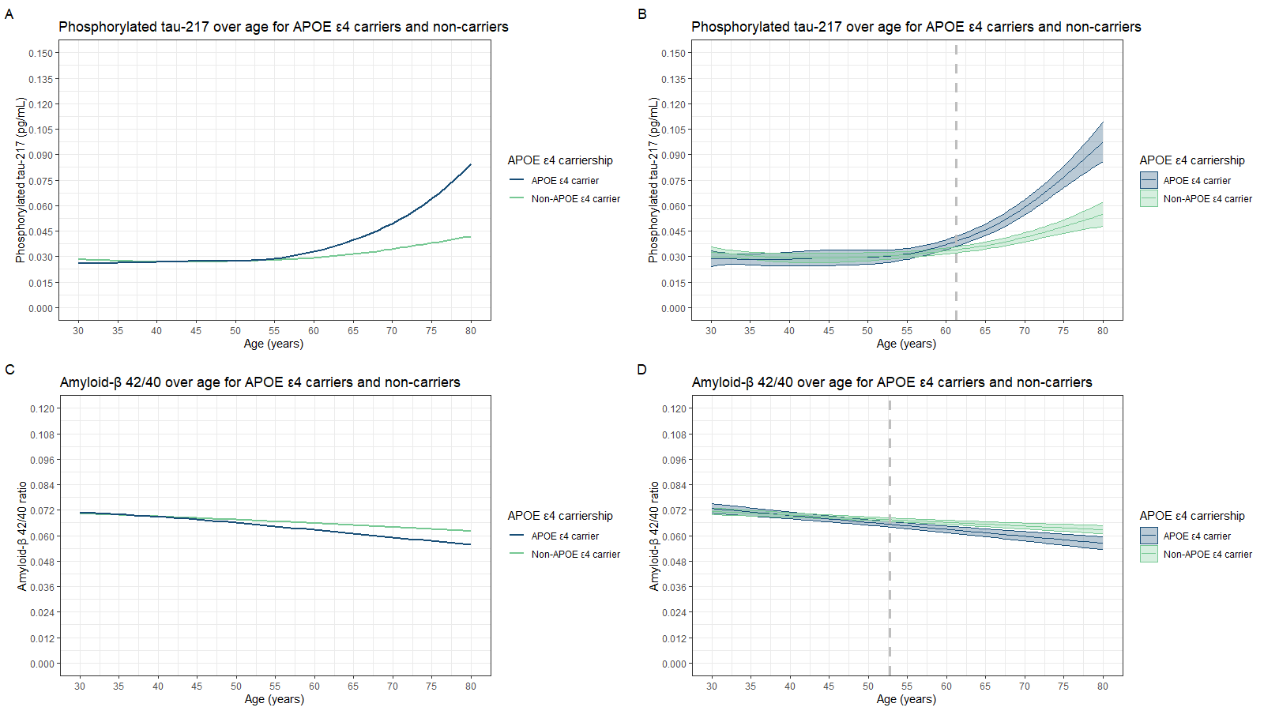
Figure S4. Comparison between GAMLSS (left) and GAM (right) approach. The GAMLSS approach was used as the basis for the main results. Grey vertical dashed lines represent the age at which the biomarker concentrations begin to significantly differ between APOE ε4 carriers and non-carriers. A and B = Phorphorylated-tau-217 over age. C and D = Amyloid-β-42/40 over age. Results for neurofilament light and glial fibrillary acidic protein are not shown as no differences in concentrations were found between APOE ε4 carriers and non-carriers.

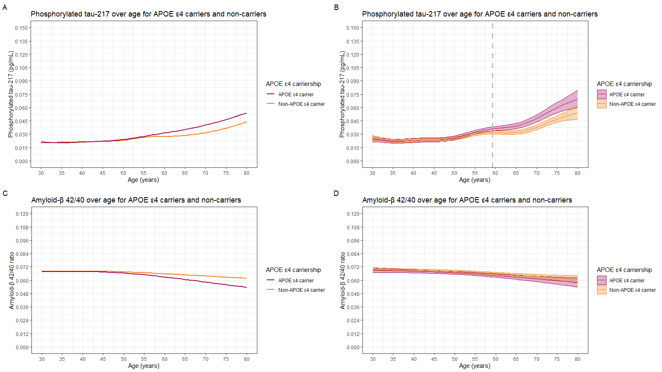
Figure S5. Comparison between GAMLSS (left) and GAM (right) approach. The GAMLSS approach was used as the basis for the main results. Grey vertical dashed lines represent the age at which the biomarker concentrations begin to significantly differ between APOE ε4 carriers and non-carriers. A and B = Phorphorylated-tau-217 over age. C and D = Amyloid-β-42/40 over age. Results for neurofilament light and glial fibrillary acidic protein are not shown as no differences in concentrations were found between APOE ε4 carriers and non-carriers.

Table S8. Likelihood ratio test results between age and age by APOE interaction models in males and females, with APOE as an ordinal variable.
Biomarker | Sex | Predictor | Deviance | df | LRT | p
p-tau217 | Males | Age | -11862.3 | 32.6
p-tau217 | Males | Age + APOE | -11874.3 | 34.6 | 12.0 | 0.002
p-tau217 | Males | Age + APOE + Age * APOE | -11912.6 | 41.7 | 38.3 | < 0.001
p-tau217 | Females | Age | -21787.9 | 38.6
p-tau217 | Females | Age + APOE | -21799.3 | 40.7 | 11.4 | 0.004
p-tau217 | Females | Age + APOE + Age * APOE | -21813.4 | 46.5 | 14.1 | 0.03
Aβ-42/40 | Males | Age | -12011.0 | 28.2
Aβ-42/40 | Males | Age + APOE | -12026.0 | 30.1 | 15.0 | < 0.001
Aβ-42/40 | Males | Age + APOE + Age * APOE | -12044.5 | 35.1 | 18.5 | 0.002
Aβ-42/40 | Females | Age | -21595.6 | 30.7
Aβ-42/40 | Females | Age + APOE | -21607.7 | 32.8 | 12.1 | 0.003
Aβ-42/40 | Females | Age + APOE + Age * APOE | -21638.3 | 38.3 | 20.6 | 0.001
NfL | Males | Age | 11095.7 | 37.0
NfL | Males | Age + APOE | 11079.7 | 39.1 | 15.9 | < 0.001
NfL | Males | Age + APOE + Age * APOE | 11072.9 | 46.7 | 6.77 | 0.51
NfL | Females | Age | 18517.9 | 43.9
NfL | Females | Age + APOE | 18517.3 | 45.9 | 0.67 | 0.71
NfL | Females | Age + APOE + Age * APOE | 18511.0 | 53.9 | 6.29 | 0.62
GFAP | Males | Age | 19192.8 | 33.3
GFAP | Males | Age + APOE | 19190.6 | 35.3 | 2.21 | 0.33
GFAP | Males | Age + APOE + Age * APOE | 19171.9 | 42.0 | 18.8 | 0.007
GFAP | Females | Age | 34336.2 | 37.5
GFAP | Females | Age + APOE | 34334.8 | 39.5 | 1.45 | 0.50
GFAP | Females | Age + APOE + Age * APOE | 34318.5 | 48.7 | 16.2 | 0.07
All models include principal components 1 to 20 as additional predictors and are adjusted for body mass index and estimated glomerular filtration rate.
APOE is modelled as a binary variable: APOE ε4 non-carrier (0), heterozygous APOE ε4 carrier (1), or homozygous APOE ε4 carrier (2).
The Age + APOE model is compared to the Age model. The Age + APOE + Age * APOE model is compared to the Age + APOE model. Age * APOE indicates an interaction effect between age and APOE.

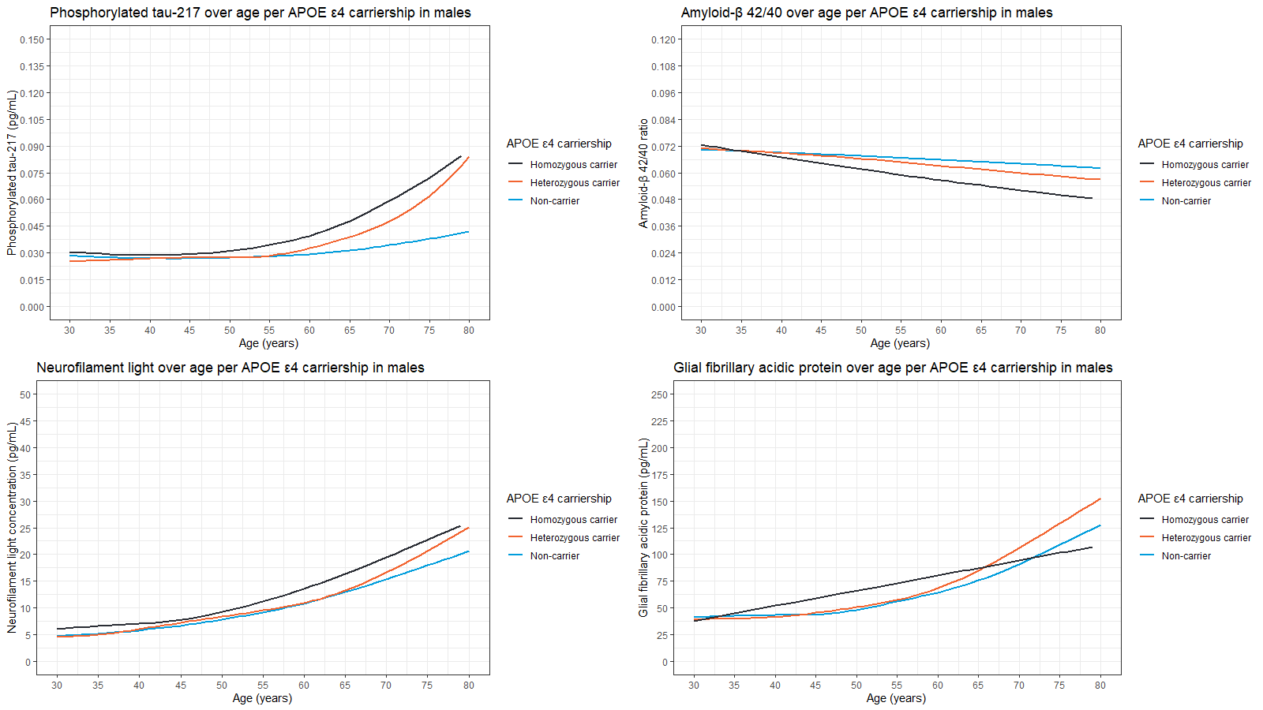
Figure S6. Plasma concentrations over age in males, stratified by APOE ε4 carriership. A = Phosphorylated-tau-217. B = Amyloid-β-42/40. C = Neurofilament light. D = Glial fibrillary acidic protein.
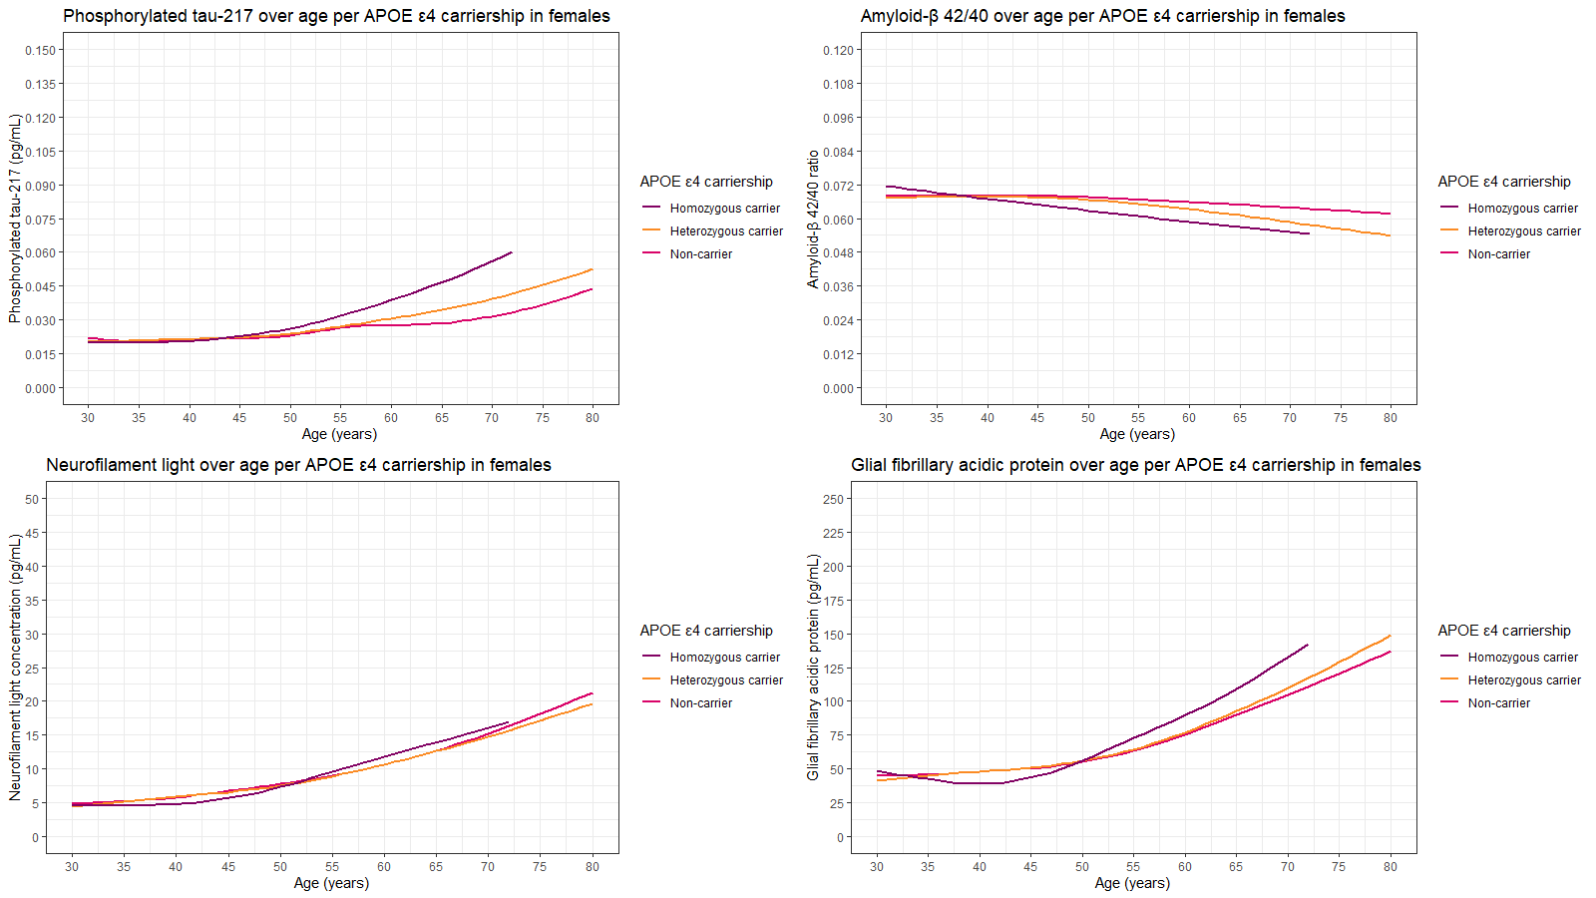
Figure S7. Plasma concentrations over age in males, stratified by APOE ε4 carriership. A = Phosphorylated-tau-217. B = Amyloid-β-42/40. C = Neurofilament light. D = Glial fibrillary acidic protein.
Table S9. Likelihood ratio test results between age and age by PRS_{AD} interaction models, without adjusting for APOE.
Biomarker | Predictor | Deviance | df | LRT | p
p-tau217 | Age | -33357.0 | 36.4
p-tau217 | Age + PRS_{AD} | -33362.9 | 37.5 | 5.93 | 0.02
p-tau217 | Age + PRS_{AD} + Age * PRS_{AD} | -33364.6 | 38.5 | 1.72 | 0.21
Aβ-42/40 | Age | -33559.7 | 31.1
Aβ-42/40 | Age + PRS_{AD} | -33560.8 | 32.1 | 1.11 | 0.30
Aβ-42/40 | Age + PRS_{AD} + Age * PRS_{AD} | -33560.9 | 33.6 | 0.13 | 0.86
NfL | Age | 29751.3 | 44.5
NfL | Age + PRS_{AD} | 29749.0 | 45.5 | 2.27 | 0.13
NfL | Age + PRS_{AD} + Age * PRS_{AD} | 29749.0 | 46.5 | 0.03 | 0.87
GFAP | Age | 53659.1 | 38.5
GFAP | Age + PRS_{AD} | 53659.0 | 39.5 | 0.09 | 0.77
GFAP | Age + PRS_{AD} + Age * PRS_{AD} | 53657.7 | 40.7 | 1.28 | 0.30
All models include principal components 1 to 20 as additional predictors and are adjusted for body mass index and estimated glomerular filtration rate.
PRS_{AD} is modelled as an ordinal variable: low AD genetic risk (0), medium AD genetic risk (1), high AD genetic risk (2).
The Age + PRS_{AD} model is compared to the Age model. The Age + PRS_{AD} + Age * PRS_{AD} model is compared to the Age + PRS_{AD} model. Age * PRS_{AD} indicates an interaction effect between age and PRS_{AD}.

Table S10. Likelihood ratio test results between age and age by PRS_{AD} interaction models, adjusting for APOE.
Biomarker | Predictor | Deviance | df | LRT | p
p-tau217 | Age + APOE | -33374.44 | 37.5
p-tau217 | Age + APOE + PRS_{AD} | -33379.8 | 38.5 | 5.37 | 0.02
p-tau217 | Age + APOE + PRS_{AD} + Age * PRS_{AD} | -33381.4 | 39.6 | 1.61 | 0.22
Aβ-42/40 | Age + APOE | -33579.7 | 32.2
Aβ-42/40 | Age + APOE + PRS_{AD} | -33580.6 | 33.3 | 0.97 | 0.33
Aβ-42/40 | Age + APOE + PRS_{AD} + Age * PRS_{AD} | -33580.8 | 34.8 | 0.18 | 0.84
NfL | Age + APOE | 29751.2 | 45.5
NfL | Age + APOE + PRS_{AD} | 29749.0 | 46.5 | 2.27 | 0.13
NfL | Age + APOE + PRS_{AD} + Age * PRS_{AD} | 29749.0 | 47.5 | 0.03 | 0.87
GFAP | Age + APOE | 53657.8 | 39.5
GFAP | Age + APOE + PRS_{AD} | 53657.7 | 40.5 | 0.10 | 0.75
GFAP | Age + APOE + PRS_{AD} + Age * PRS_{AD} | 53656.5 | 41.6 | 1.21 | 0.30
All models include principal components 1 to 20 as additional predictors and are adjusted for body mass index and estimated glomerular filtration rate.
PRS_{AD} is modelled as an ordinal variable: low AD genetic risk (0), medium AD genetic risk (1), high AD genetic risk (2).
The Age + APOE + PRS_{AD} model is compared to the Age + APOE model. The Age + APOE + PRS_{AD} + Age * PRS_{AD} model is compared to the Age + APOE + PRS_{AD} model. Age * PRS_{AD} indicates an interaction effect between age and PRS_{AD}.

Table S11. Likelihood ratio test results between age and age by PRS_{AD} interaction models in males and females, without adjusting for APOE.
Biomarker | Sex | Predictor | Deviance | df | LRT | p
p-tau217 | Males | Age | -11862.3 | 32.6
p-tau217 | Males | Age + PRS_{AD} | -11874.6 | 33.5 | 12.3 | < 0.001
p-tau217 | Males | Age + PRS_{AD} + Age * PRS_{AD} | -11877.9 | 35.6 | 3.30 | 0.20
p-tau217 | Females | Age | -21767.9 | 38.6
p-tau217 | Females | Age + PRS_{AD} | -21788.1 | 39.6 | 0.19 | 0.66
p-tau217 | Females | Age + PRS_{AD} + Age * PRS_{AD} | -21790.7 | 40.6 | 0.70 | 0.46
Aβ-42/40 | Males | Age | -12011.0 | 28.2
Aβ-42/40 | Males | Age + PRS_{AD} | -12016.3 | 29.2 | 5.37 | 0.02
Aβ-42/40 | Males | Age + PRS_{AD} + Age * PRS_{AD} | -12016.4 | 30.4 | 0.09 | 0.83
Aβ-42/40 | Females | Age | -21595.6 | 30.7
Aβ-42/40 | Females | Age + PRS_{AD} | -21595.8 | 31.7 | 0.19 | 0.66
Aβ-42/40 | Females | Age + PRS_{AD} + Age * PRS_{AD} | -21596.5 | 32.9 | 0.70 | 0.46
NfL | Males | Age | 11095.7 | 37.0
NfL | Males | Age + PRS_{AD} | 11090.8 | 38.0 | 4.83 | 0.03
NfL | Males | Age + PRS_{AD} + Age * PRS_{AD} | 11085.7 | 39.1 | 5.11 | 0.03
NfL | Females | Age | 18517.9 | 43.9
NfL | Females | Age + PRS_{AD} | 18517.9 | 44.9 | 0.08 | 0.78
NfL | Females | Age + PRS_{AD} + Age * PRS_{AD} | 18515.6 | 45.9 | 2.25 | 0.14
GFAP | Males | Age | 19192.8 | 33.3
GFAP | Males | Age + PRS_{AD} | 19191.6 | 34.3 | 1.23 | 0.27
GFAP | Males | Age + PRS_{AD} + Age * PRS_{AD} | 19191.6 | 35.3 | 0.05 | 0.82
GFAP | Females | Age | 34336.2 | 37.5
GFAP | Females | Age + PRS_{AD} | 34335.6 | 38.5 | 0.64 | 0.43
GFAP | Females | Age + PRS_{AD} + Age * PRS_{AD} | 34333.1 | 39.4 | 2.53 | 0.11
All models include principal components 1 to 20 as additional predictors and are adjusted for body mass index and estimated glomerular filtration rate.
PRS_{AD} is modelled as an ordinal variable: low AD genetic risk (0), medium AD genetic risk (1), high AD genetic risk (2).
The Age + PRS_{AD} model is compared to the Age model. The Age + PRS_{AD} + Age * PRS_{AD} model is compared to the Age + PRS_{AD} model. Age * PRS_{AD} indicates an interaction effect between age and PRS_{AD}.
§A p-value could not be computer because the deviance of the alternative model is larger than the deviance of the null model.
Table S12. Likelihood ratio test results between age and age by PRS_{AD} interaction models in males and females, adjusting for APOE.
Biomarker | Sex | Predictor | Deviance | df | LRT | p
p-tau217 | Males | Age + APOE | -11869.2 | 33.6
p-tau217 | Males | Age + APOE + PRS_{AD} | -11881.0 | 34.5 | 11.8 | < 0.001
p-tau217 | Males | Age + APOE + PRS_{AD} + Age * PRS_{AD} | -11883.9 | 36.5 | 2.93 | 0.22
p-tau217 | Females | Age + APOE | -21796.4 | 39.6
p-tau217 | Females | Age + APOE + PRS_{AD} | -21796.6 | 40.6 | 0.14 | 0.71
p-tau217 | Females | Age + APOE + PRS_{AD} + Age * PRS_{AD} | -21799.2 | 41.7 | 2.66 | 0.12
Aβ-42/40 | Males | Age + APOE | -12021.5 | 29.2
Aβ-42/40 | Males | Age + APOE + PRS_{AD} | -12026.7 | 30.2 | 5.13 | 0.02
Aβ-42/40 | Males | Age + APOE + PRS_{AD} + Age * PRS_{AD} | -12026.7 | 31.3 | 0.03 | 0.90
Aβ-42/40 | Females | Age + APOE | -21606.4 | 31.8
Aβ-42/40 | Females | Age + APOE + PRS_{AD} | -21606.7 | 32.8 | 0.24 | 0.62
Aβ-42/40 | Females | Age + APOE + PRS_{AD} + Age * PRS_{AD} | -21607.3 | 34.1 | 0.65 | 0.51
NfL | Males | Age + APOE | 11093.8 | 38.0
NfL | Males | Age + APOE + PRS_{AD} | 11088.8 | 39.0 | 4.96 | 0.03
NfL | Males | Age + APOE + PRS_{AD} + Age * PRS_{AD} | 11083.5 | 40.1 | 5.35 | 0.02
NfL | Females | Age + APOE | 18517.3 | 44.9
NfL | Females | Age + APOE + PRS_{AD} | 18517.2 | 45.9 | 0.08 | 0.77
NfL | Females | Age + APOE + PRS_{AD} + Age * PRS_{AD} | 18515.0 | 46.9 | 2.24 | 0.14
GFAP | Males | Age + APOE | 19192.3 | 34.3
GFAP | Males | Age + APOE + PRS_{AD} | 19191.0 | 35.3 | 1.23 | 0.27
GFAP | Males | Age + APOE + PRS_{AD} + Age * PRS_{AD} | 19191.0 | 36.3 | 0.06 | 0.80
GFAP | Females | Age + APOE | 34335.7 | 38.4
GFAP | Females | Age + APOE + PRS_{AD} | 34335.0 | 39.5 | 0.68 | 0.41
GFAP | Females | Age + APOE + PRS_{AD} + Age * PRS_{AD} | 34332.4 | 40.4 | 2.57 | 0.11
All models include principal components 1 to 20 as additional predictors and are adjusted for body mass index and estimated glomerular filtration rate.
PRS_{AD} is modelled as an ordinal variable: low AD genetic risk (0), medium AD genetic risk (1), high AD genetic risk (2).
The Age + APOE + PRS_{AD} model is compared to the Age + APOE model. The Age + APOE + PRS_{AD} + Age * PRS_{AD} model is compared to the Age + APOE + PRS_{AD} model. Age * PRS_{AD} indicates an interaction effect between age and PRS_{AD}.

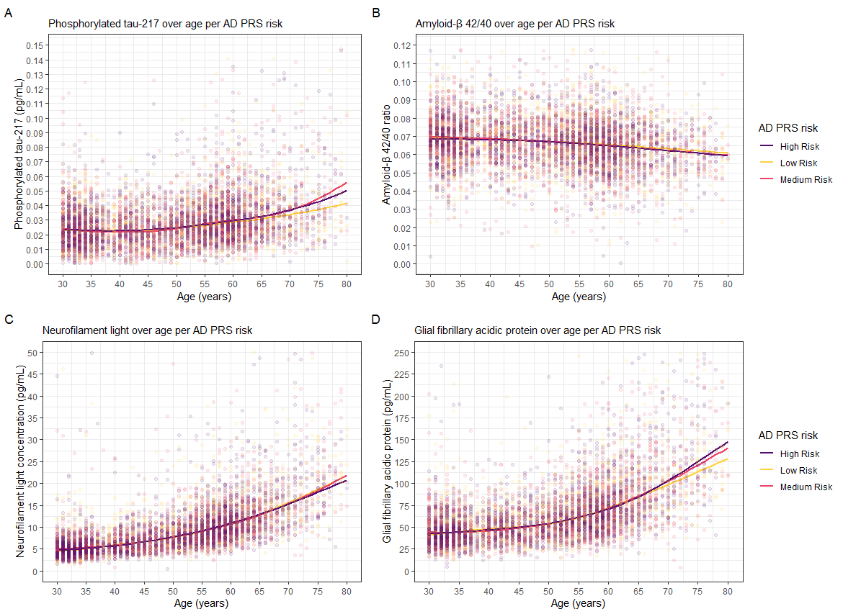
Figure S8. Concentrations of plasma p-tau217 (A), Aβ-42/40 (B), NfL (C), and GFAP (D) over age, stratified by AD genetic risk as defined by the AD polygenic risk score.

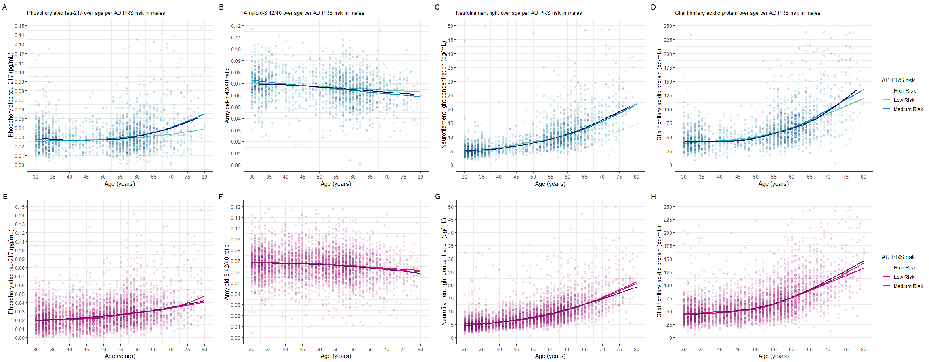
Figure S9. Concentrations of plasma p-tau217, Aβ-42/40, NfL, and GFAP over age in males (top panels) and females (bottom panels), stratified by AD genetic risk as defined by the AD polygenic risk score.. A = p-tau217 in males; B = Aβ-42/40 in males; C = NfL in males; D = GFAP in males; E = p-tau217 in females; F = Aβ-42/40 in females; G = NfL in females; H = GFAP in females.

Table S13. Comparison of APOE ε4 carriership LMMs in the EMIF-AD cohort.
Biomarkers | Group 1 | Group 2 | β intercept (age 60) | p Intercept | β slope | p slope
p-tau217 | Non-carrier | ε4 carrier | -0.48 (0.13) | < 0.001 | 0.006 (0.008) | 0.49
Aβ-42/40 | Non-carrier | ε4 carrier | -0.009 (0.07) | 0.90 | 0.005 (0.004) | 0.14
NfL | Non-carrier | ε4 carrier | 0.20 (0.11) | 0.07 | -0.02 (0.001) | 0.001
GFAP | Non-carrier | ε4 carrier | -0.14 (0.12) | 0.25 | -0.008 (0.005) | 0.15
Aβ-42/40: amyloid-β-42/40; GFAP: glial fibrillary acidic protein; NfL: neurofilament light; p-tau217: phosphorylated tau-217.

Table S14. Comparison of APOE ε4 carriership and Aβ PET LMMs in the EMIF-AD cohort.
Biomarkers | Group 1 | Group 2 | β intercept (age 60) | p Intercept | β slope | p slope
p-tau217 | PET negative, non-carrier | PET positive, non-carrier | 0.45 (0.22) | 0.16 | -0.07 (0.01) | < 0.001
p-tau217 | PET negative, non-carrier | PET negative, ε4 carrier | -0.38 (0.13) | 0.03 | 0.02 (0.01) | 0.07
p-tau217 | PET negative, non-carrier | PET positive, ε4 carrier | -0.63 (0.14) | < 0.001 | -0.03 (0.01) | 0.01
p-tau217 | PET positive, non-carrier | PET negative, ε4 carrier | -0.83 (0.24) | 0.003 | 0.09 (0.01) | < 0.001
p-tau217 | PET positive, non-carrier | PET positive, ε4 carrier | -1.08 (0.24) | < 0.001 | 0.04 (0.01) | 0.07
p-tau217 | PET negative, ε4 carrier | PET positive, ε4 carrier | -0.25 (0.13) | 0.19 | -0.05 (0.01) | < 0.001
Aβ-42/40 | PET negative, non-carrier | PET positive, non-carrier | 0.25 (0.13) | 0.19 | -0.007 (0.007) | 0.69
Aβ-42/40 | PET negative, non-carrier | PET negative, ε4 carrier | -0.05 (0.07) | 0.88 | 0.004 (0.004) | 0.77
Aβ-42/40 | PET negative, non-carrier | PET positive, ε4 carrier | 0.10 (0.08) | 0.62 | 0.007 (0.005) | 0.39
Aβ-42/40 | PET positive, non-carrier | PET negative, ε4 carrier | -0.31 (0.14) | 0.11 | 0.01 (0.007) | 0.38
Aβ-42/40 | PET positive, non-carrier | PET positive, ε4 carrier | -0.15 (0.14) | 0.70 | 0.02 (0.007) | 0.20
Aβ-42/40 | PET negative, ε4 carrier | PET positive, ε4 carrier | 0.15 (0.09) | 0.32 | 0.003 (0.005) | 0.94
NfL | PET negative, non-carrier | PET positive, non-carrier | 0.40 (0.19) | 0.14 | -0.02 (0.01) | 0.29
NfL | PET negative, non-carrier | PET negative, ε4 carrier | 0.25 (0.11) | 0.11 | -0.02 (0.007) | 0.002
NfL | PET negative, non-carrier | PET positive, ε4 carrier | 0.12 (0.12) | 0.75 | -0.01 (0.007) | 0.36
NfL | PET positive, non-carrier | PET negative, ε4 carrier | -0.15 (0.20) | 0.89 | -0.006 (0.01) | 0.95
NfL | PET positive, non-carrier | PET positive, ε4 carrier | -0.28 (0.21) | 0.53 | 0.007 (0.01) | 0.94
NfL | PET negative, ε4 carrier | PET positive, ε4 carrier | -0.13 (0.11) | 0.64 | 0.01 (0.008) | 0.40
GFAP | PET negative, non-carrier | PET positive, non-carrier | 0.03 (0.18) | > 0.99 | -0.01 (0.01) | 0.77
GFAP | PET negative, non-carrier | PET negative, ε4 carrier | -0.02 (0.12) | > 0.99 | -0.005 (0.007) | 0.90
GFAP | PET negative, non-carrier | PET positive, ε4 carrier | -0.35 (0.13) | 0.04 | -0.01 (0.007) | 0.19
GFAP | PET positive, non-carrier | PET negative, ε4 carrier | -0.05 (0.21) | > 0.99 | 0.005 (0.01) | 0.97
GFAP | PET positive, non-carrier | PET positive, ε4 carrier | -0.38 (0.21) | 0.28 | -0.005 (0.01) | 0.98
GFAP | PET negative, ε4 carrier | PET positive, ε4 carrier | -0.33 (0.11) | 0.03 | -0.01 (0.008) | 0.60
Beta estimates are based on log2 transformed data.

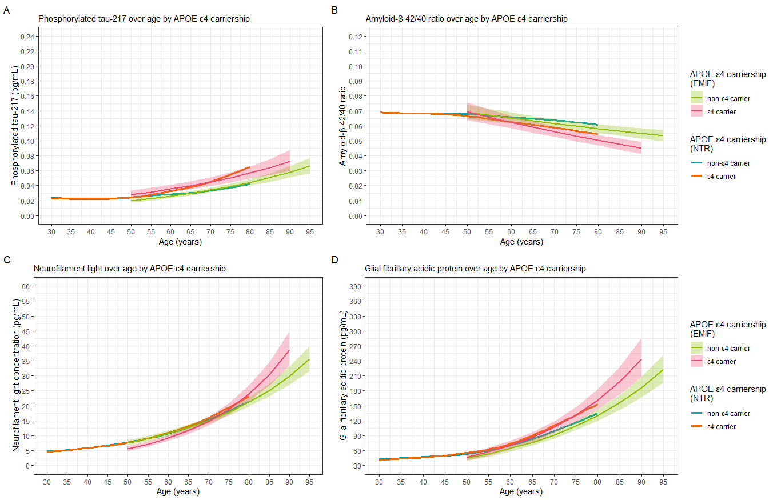
Figure S10. Biomarker concentrations over age in the NTR cohort and EMIF-AD sub-cohort, stratified by APOE ε4 carriership and including confidence intervals for the EMID-AD cohort. A: p-tau217. B: Aβ-42/40. C: NfL. D: GFAP.

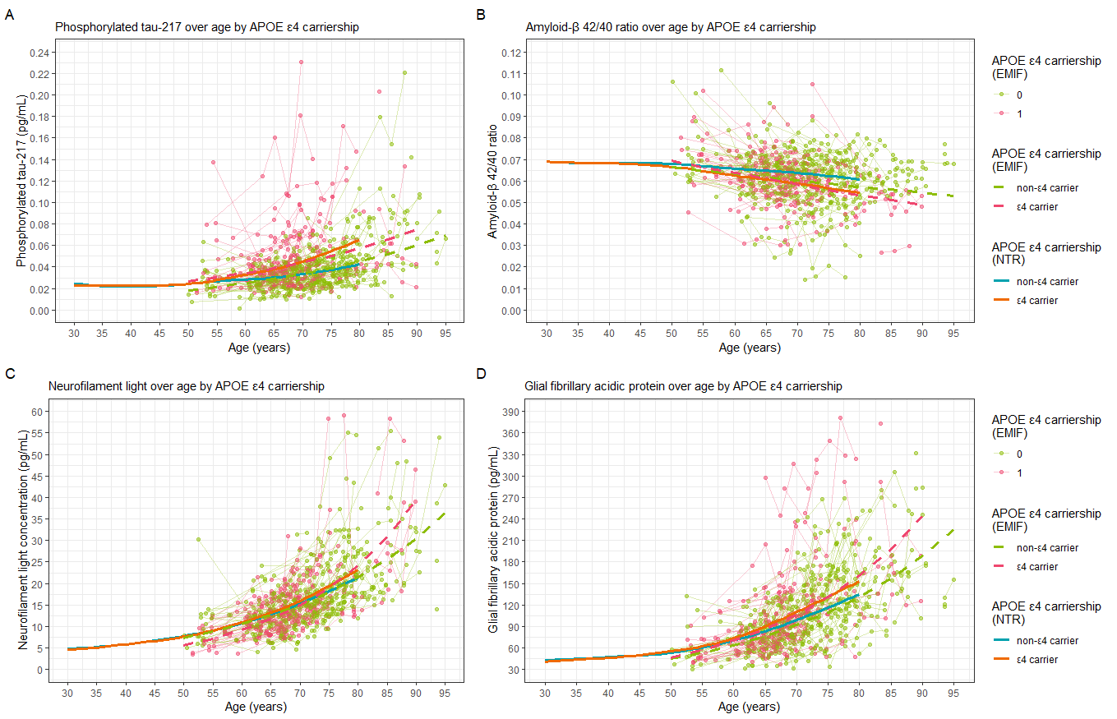
Figure S11. Biomarker concentrations over age in the NTR cohort and EMIF-AD sub-cohort, stratified by APOE ε4 carriership and showing the underlying longitudinal trajectories for the EMID-AD cohort. A: p-tau217. B: Aβ-42/40. C: NfL. D: GFAP.

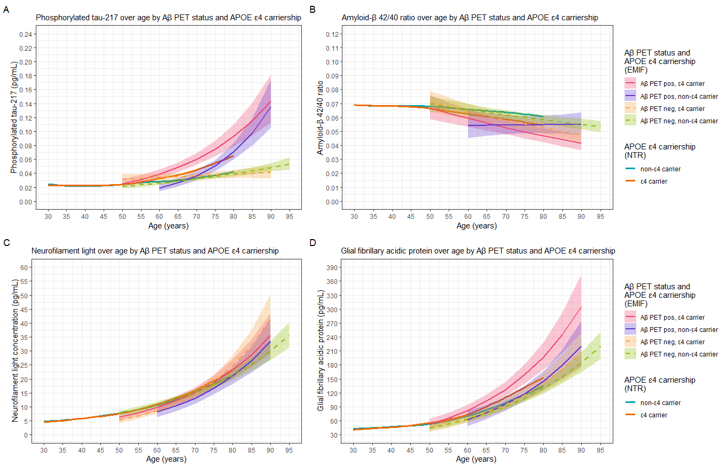
Figure S12. Biomarker concentrations over age in the NTR cohort and EMIF-AD sub-cohort, stratified by APOE ε4 carriership and Aβ status (EMIF-AD only) and including confidence intervals for the EMID-AD cohort. A: p-tau217. B: Aβ-42/40. C: NfL. D: GFAP.

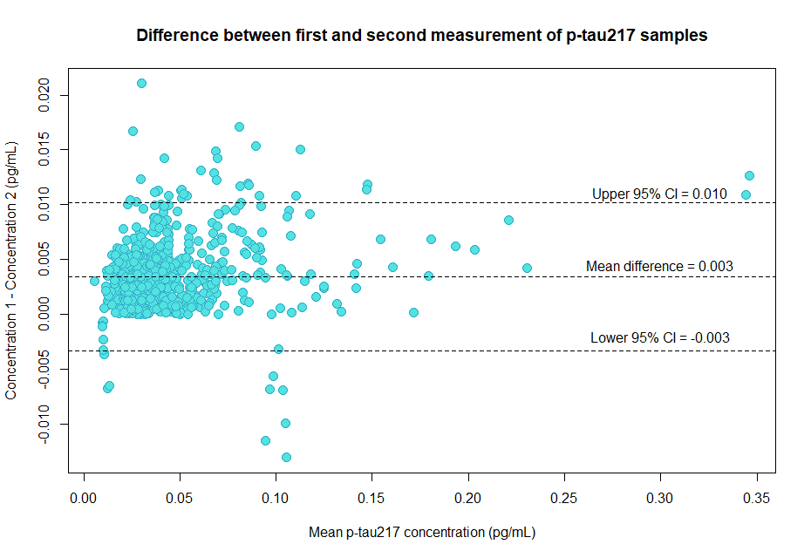
Figure S13. Bland-Altman plot of the difference between the first and second duplicate measurements of p-tau217. The x-axis shows the mean concentrations of the first and second measurement of each sample. The y-axis shows the difference between the first and second concentration. The mean difference in concentrations was 0.003 pg/mL (95% CI = -0.003 – 0.010).

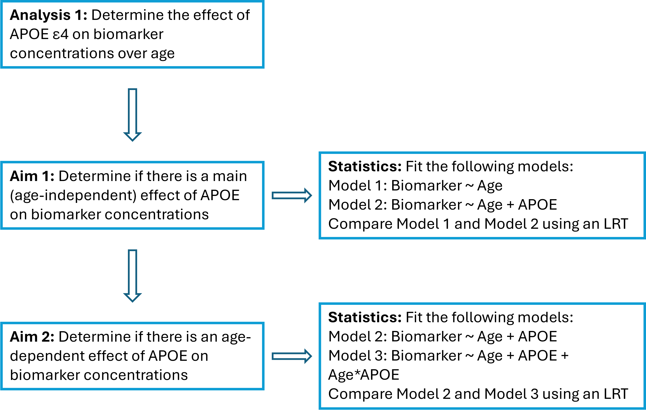
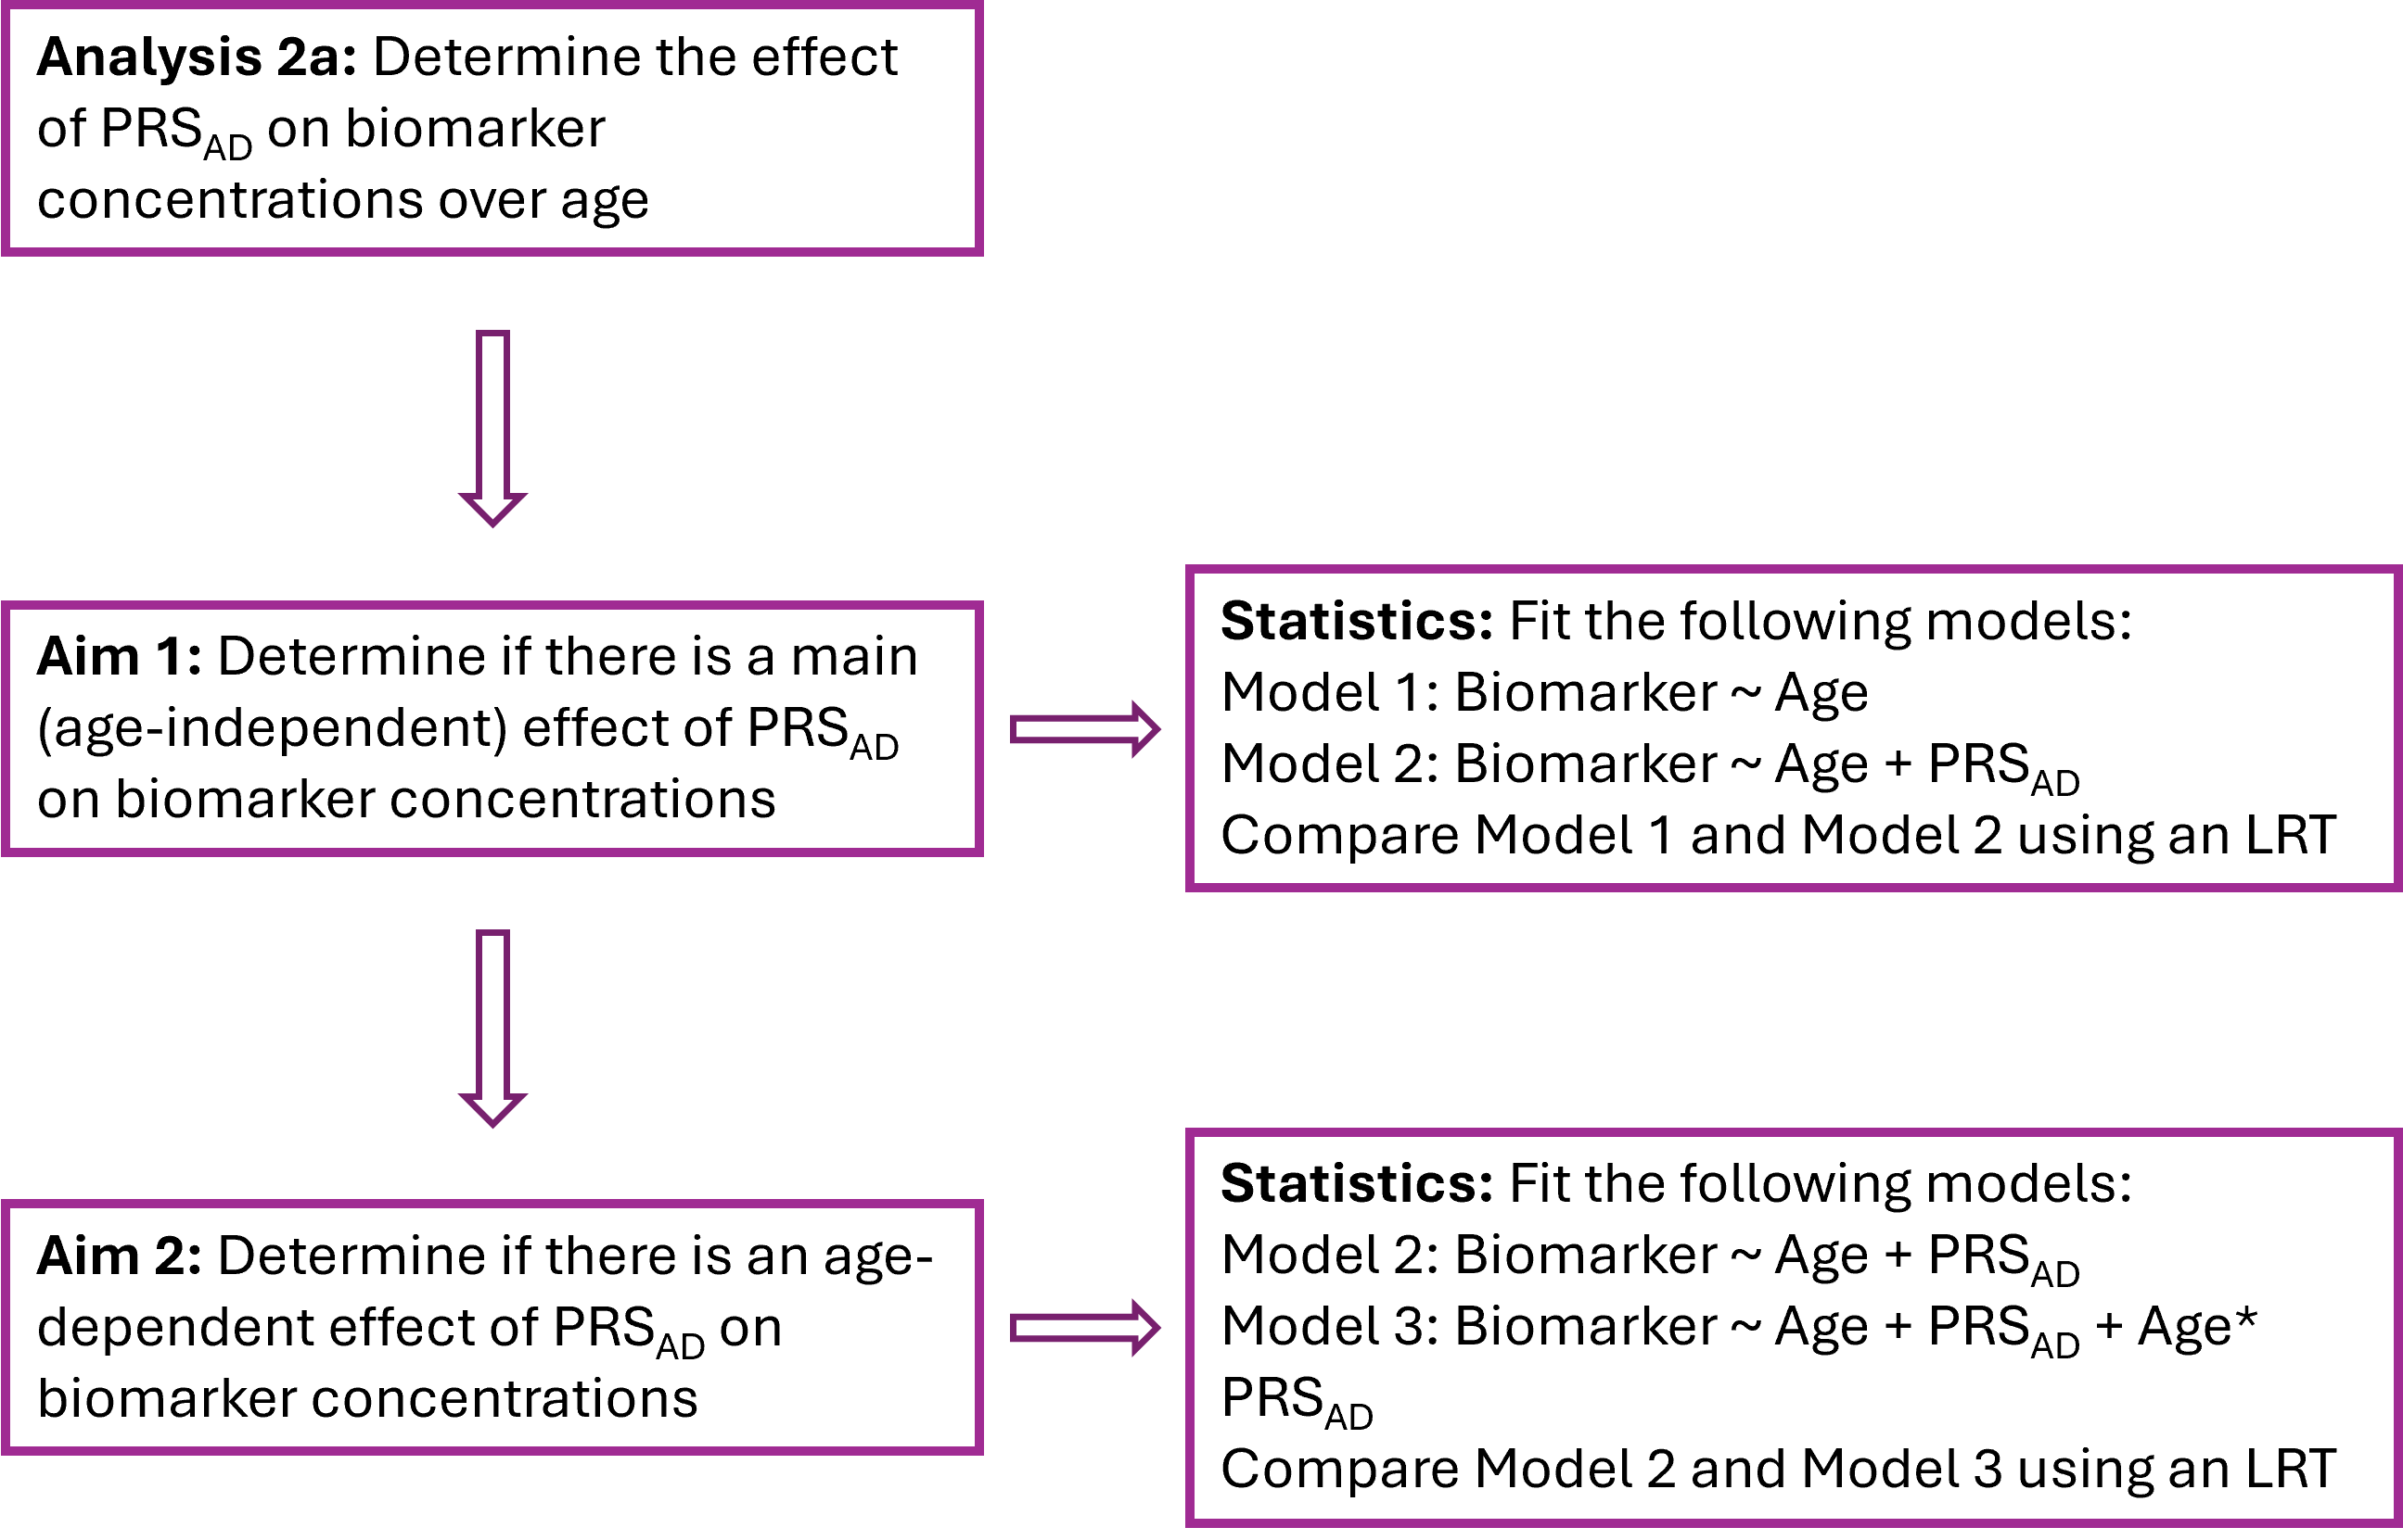
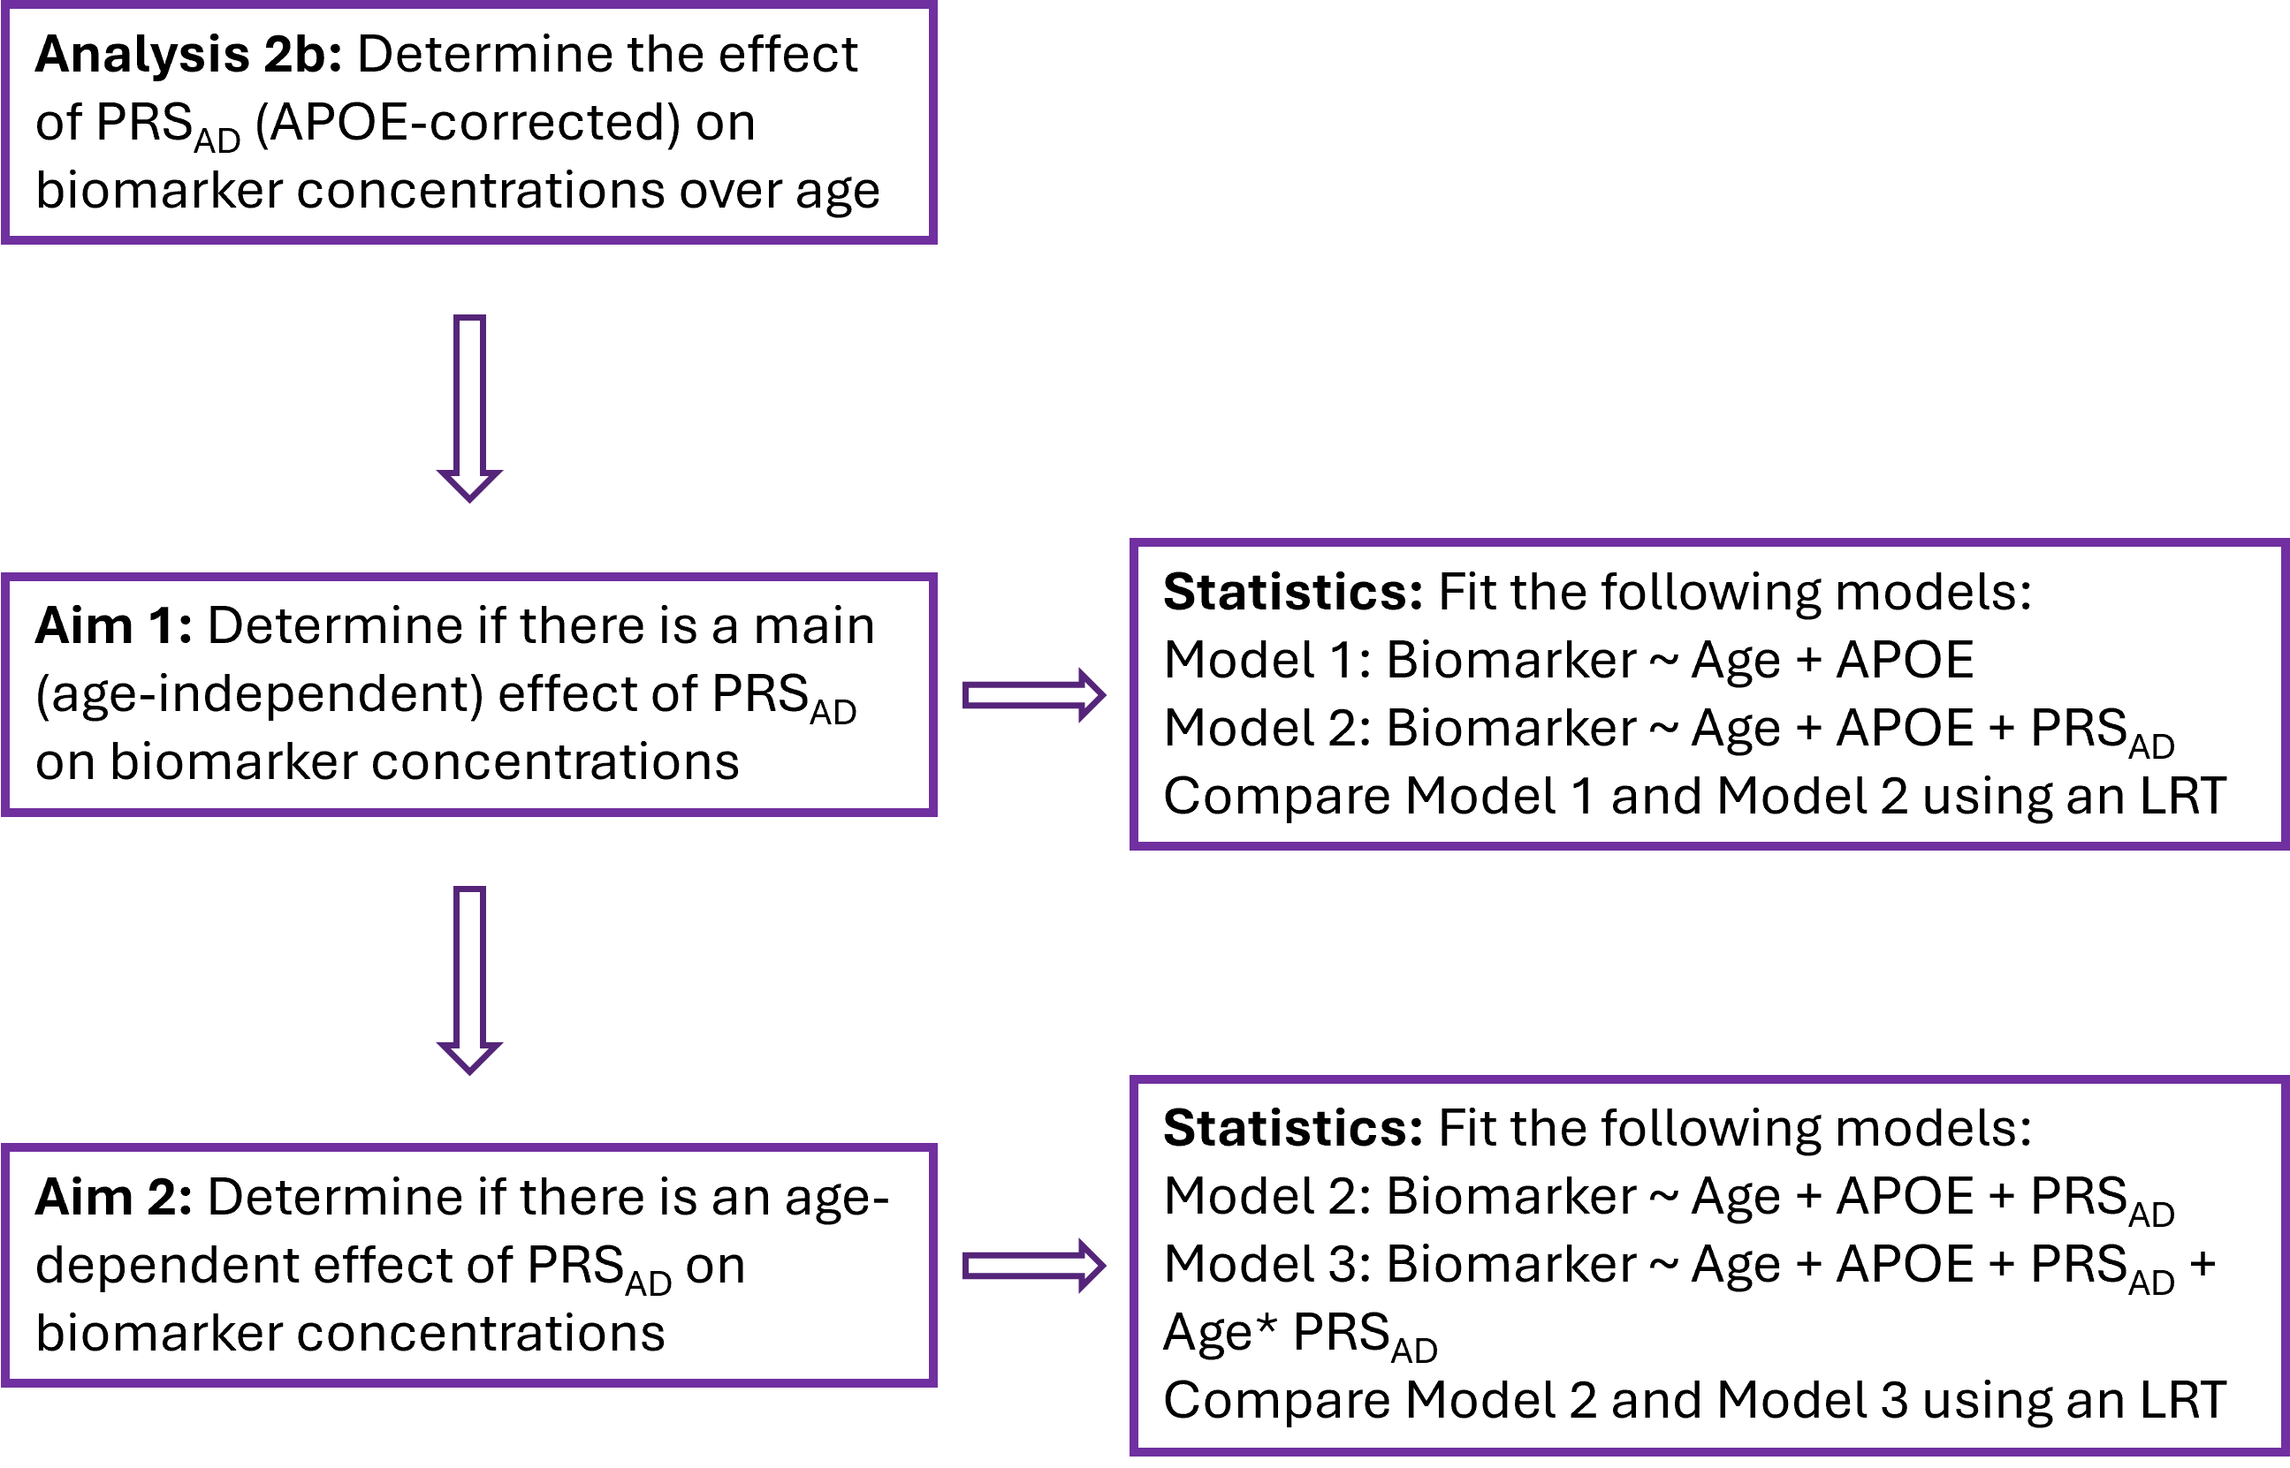

Figure S14. Overview of the main aims and statistical tests in the main cohort. Each analysis (1, 2a, 2b) was first performed in the entire cohort, and then in sex-specific subsets (male only subset and female only subset).

