Supplementary Information
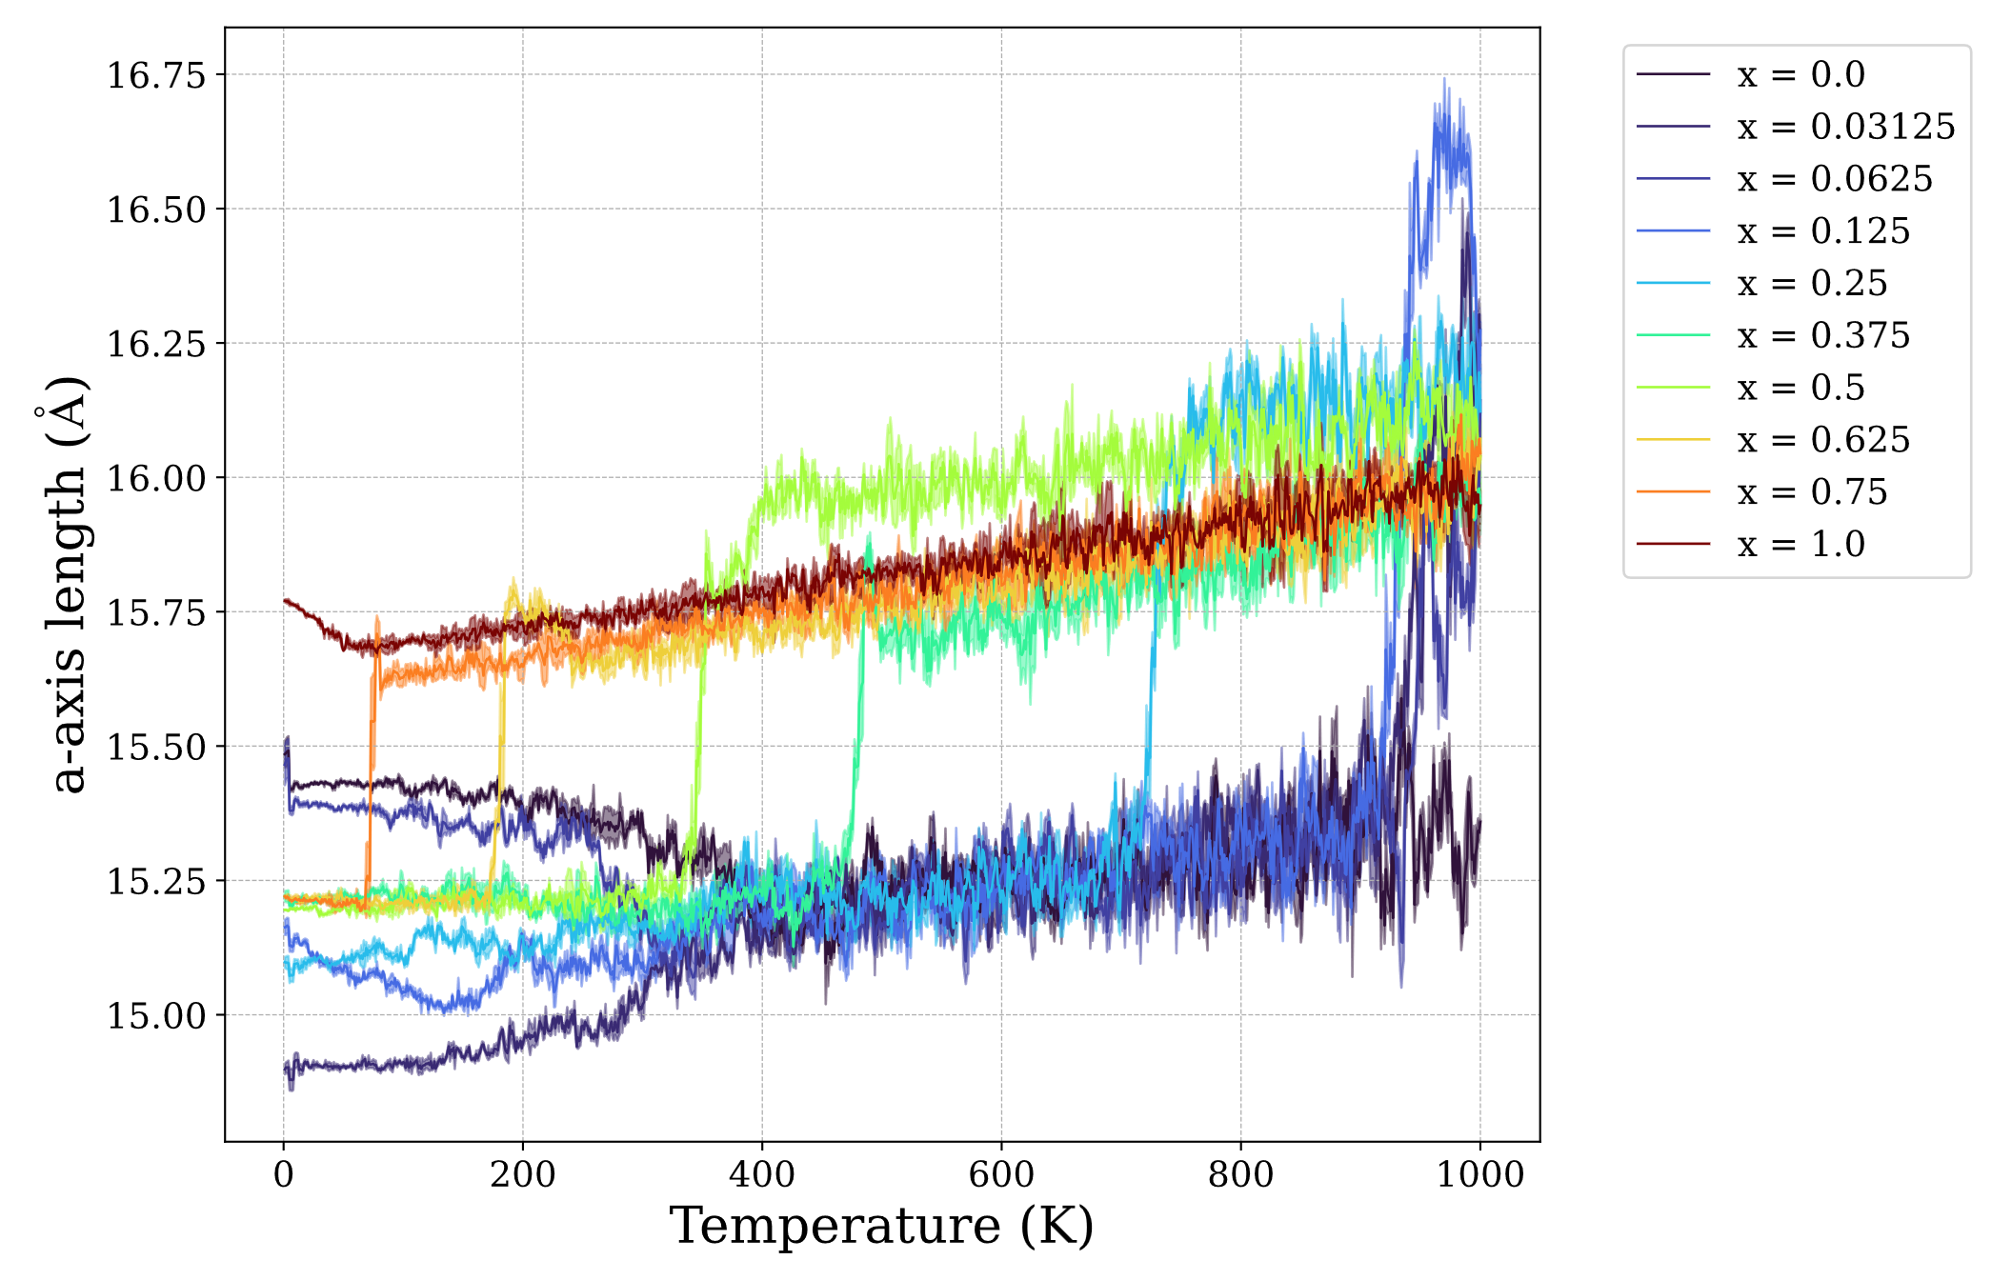
Figure S1. Temperature dependence of the a-axis length of Bi_{1-x}La_{x}CoO₃ calculated by MLFF-MD.
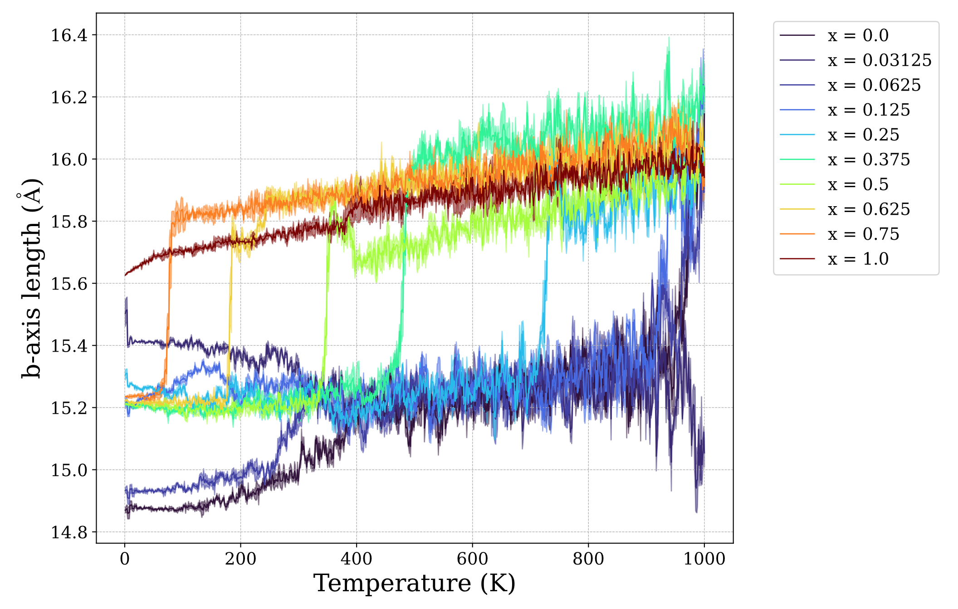
Figure S2. Temperature dependence of the b-axis length of Bi_{1-x}La_{x}CoO₃ calculated by MLFF-MD.

