Emergence of Climate Change in the Tropical Pacific
Jun Ying^{1,2,3*}, Matthew Collins³, Wenju Cai^{4,5,6}, Axel Timmermann^{7,8}, Ping Huang^{9,10}, Dake Chen^{1,2,11}, and Karl Stein^{7,8}
- State Key Laboratory of Satellite Ocean Environment Dynamics, Second Institute of Oceanography, Ministry of Natural Resources, Hangzhou, 310012, China
- Southern Marine Science and Engineering Guangdong Laboratory (Zhuhai), Zhuhai, China
- College of Engineering, Mathematics and Physical Sciences, University of Exeter, Exeter, United Kingdom
- Frontier Science Centre for Deep Ocean Multispheres and Earth System and Physical Oceanography 9 Laboratory, Ocean University of China, Qingdao, China.
- Qingdao National Laboratory for Marine Science and Technology, Qingdao, China.
- Centre for Southern Hemisphere Oceans Research (CSHOR), CSIRO Oceans and Atmosphere, Hobart 12 7004, Australia.
- Center for Climate Physics, Institute for Basic Science (IBS), Busan, South Korea.
- Pusan National University, Busan, South Korea.
- Center for Monsoon System Research, Institute of Atmospheric Physics, Chinese Academy of Sciences, Beijing 100190, China
- State Key Laboratory of Numerical Modeling for Atmospheric Sciences and Geophysical Fluid Dynamics, Institute of Atmospheric Physics, Chinese Academy of Sciences, Beijing, 100190, China
- School of Oceanography, Shanghai Jiao Tong University, Shanghai, China
*Corresponding to: yingjun@sio.org.cn
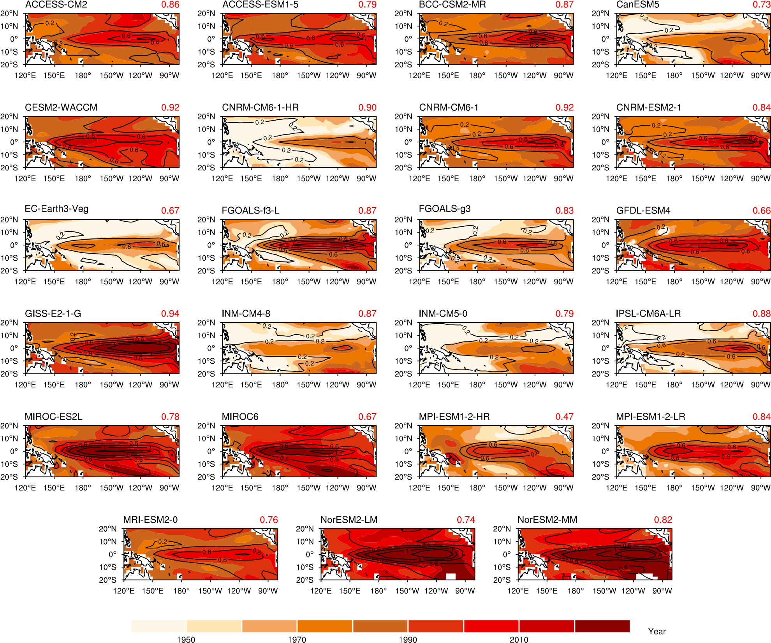
- ToE of annual-mean SST in the tropical Pacific. Shown are based on 23 CMIP6 models under historical and the SSP585 emission scenario. Contours denote the interannual standard deviations of annual-mean SST based on the last 500 years of piControl run, which represents the background noise of natural variability. Red digits on the upper-right corner of each plot are the spatial correlation coefficients between the ToEs and interannual standard deviations of annual-mean SST, which are all statistically significant at the 95% confidence level based on the Student’s t test.

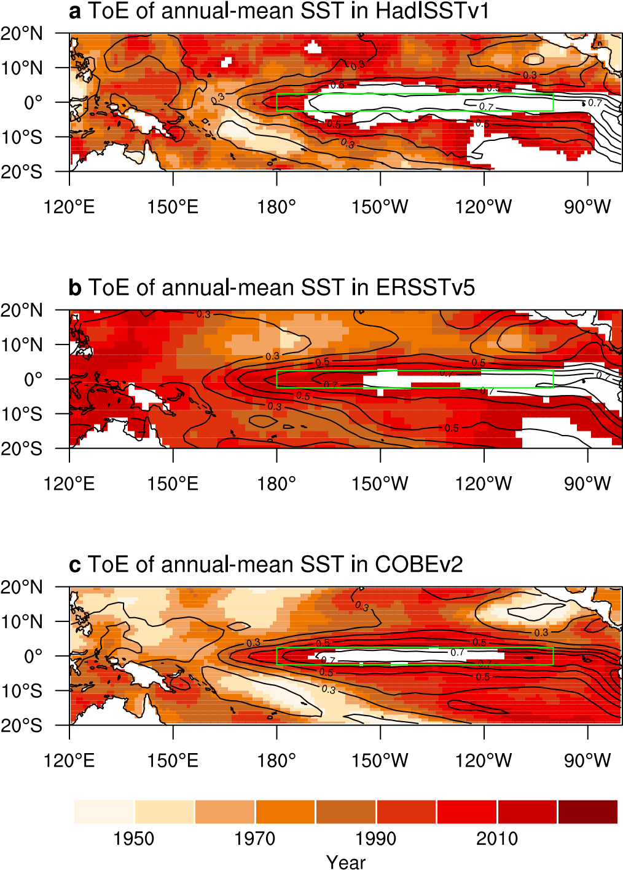
- ToE of observed annual-mean SST in the tropical Pacific. a, ToE of annual-mean SST for HadISSTv1; b and c, The same as a, but for ERSSTv5 (b), and COBEv2 (c). Contours denote the interannual standard deviations of SST (units: K), which represent the background noise of natural variability. The green box in each plot denotes the eastern equatorial Pacific (2.5°S–2.5°N, 180°W–100°W). In white regions, no signal emerges.

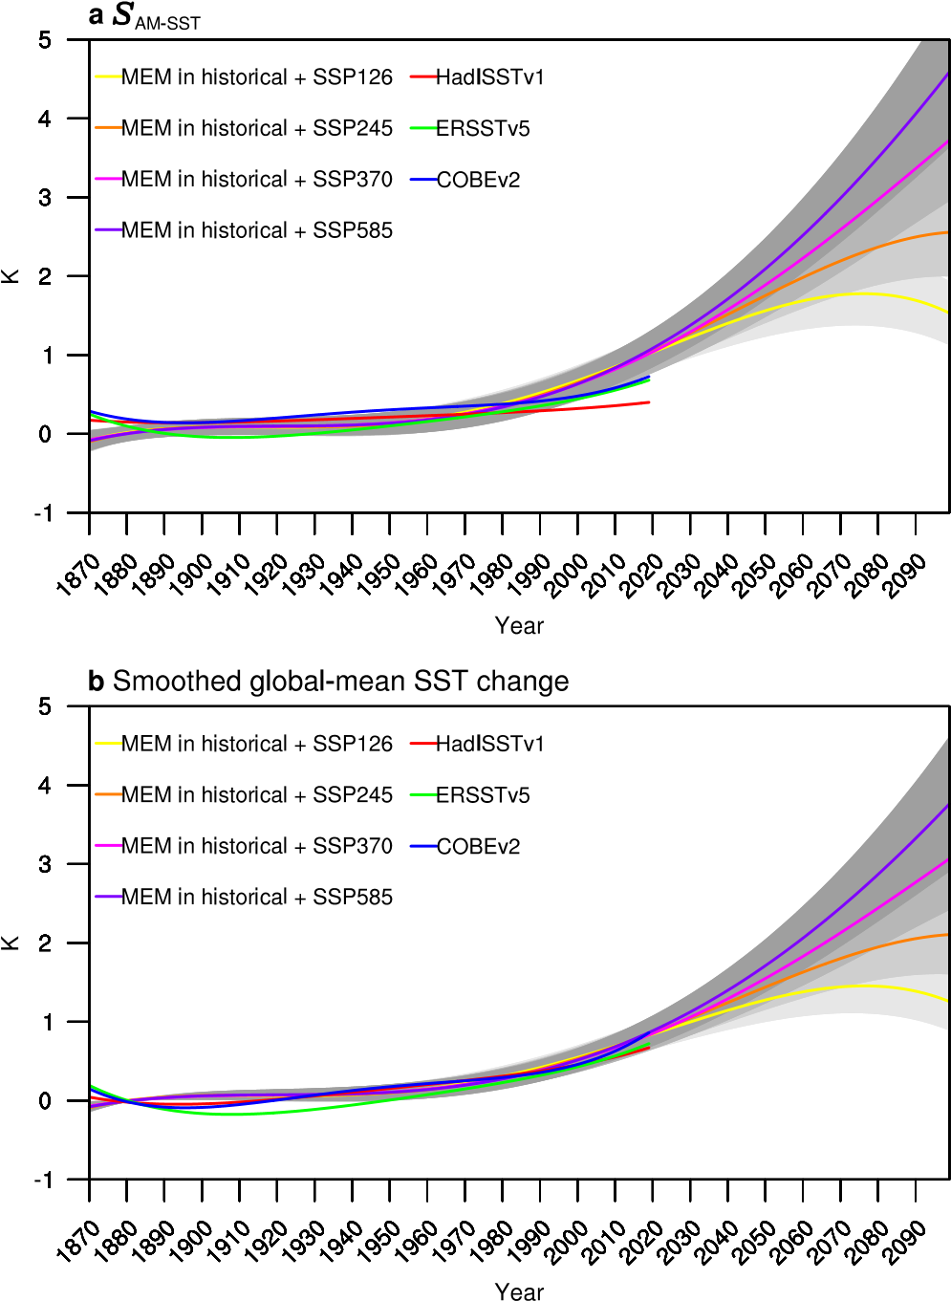
- Signal of annual-mean SST and smoothed global warming SST change. a, Signal of annual-mean SST in the EEP in MEM under historical and four future forcing scenarios and in observations. The shading denotes one inter-model standard deviation, with darker color indicating a higher emission scenario; b, The same as a, but for smoothed global-mean SST change (, see “Signal and noise of annual-mean SST and rainfall” in Methods).
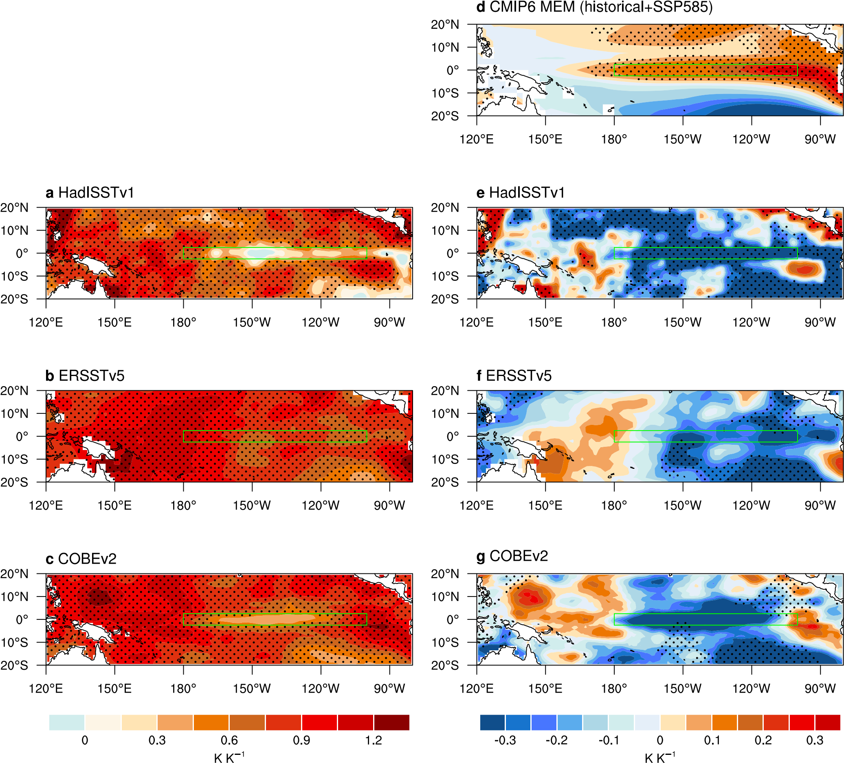
- Response of annual-mean SST to global warming. a–c, Response of annual-mean SST to global warming for HadISSTv1, ERSSTv5 and COBEv2, respectively, calculated by regressing grid-point annual-mean SST change onto the smoothed global warming SST change (see “Signal and noise of annual-mean SST and rainfall” in Methods); d, MEM response of relative SST to global warming under historical and the SSP585 scenario; e–g, The same as a–c, but for relative SST. The green box in each plot denotes the eastern equatorial Pacific (2.5°S–2.5°N, 180°W–100°W). Stippling in a–c and e–g indicates that the regressions are significant above the 95% confidence level based on the Student’s t test, while stippling in d denotes that more than 70% of models have the same sign.
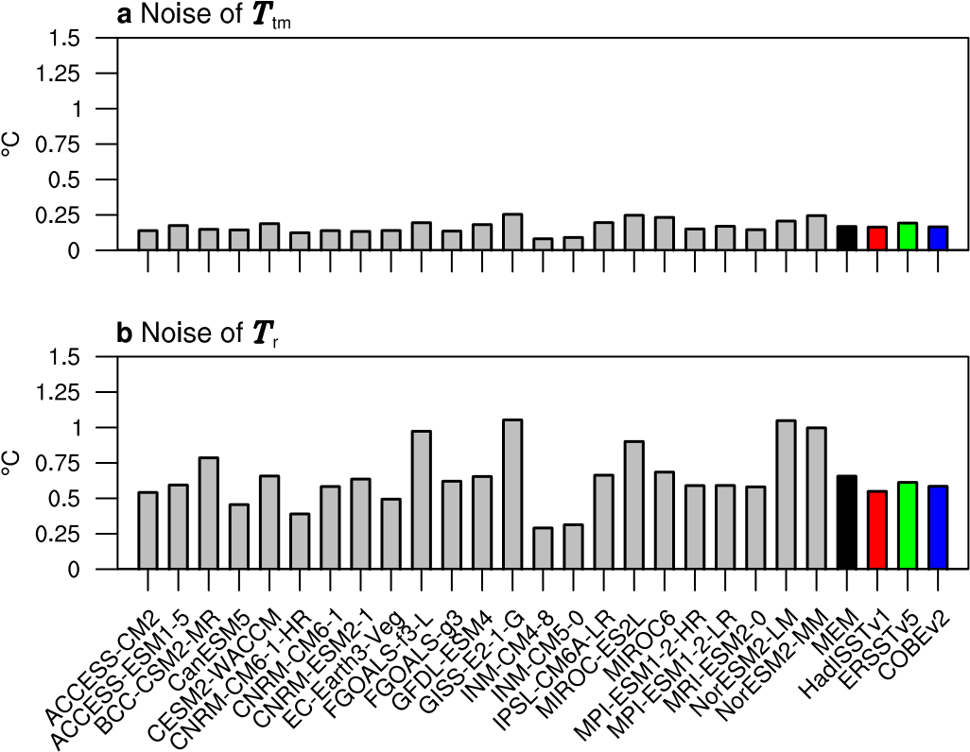
- Noise of tropical-mean and relative SST. a, Noise of tropical-mean SST in 23 individual models, MEM and three observations; b, The same as a, but for relative SST in the EEP (see “Signal and noise of annual-mean SST and rainfall” in Methods).
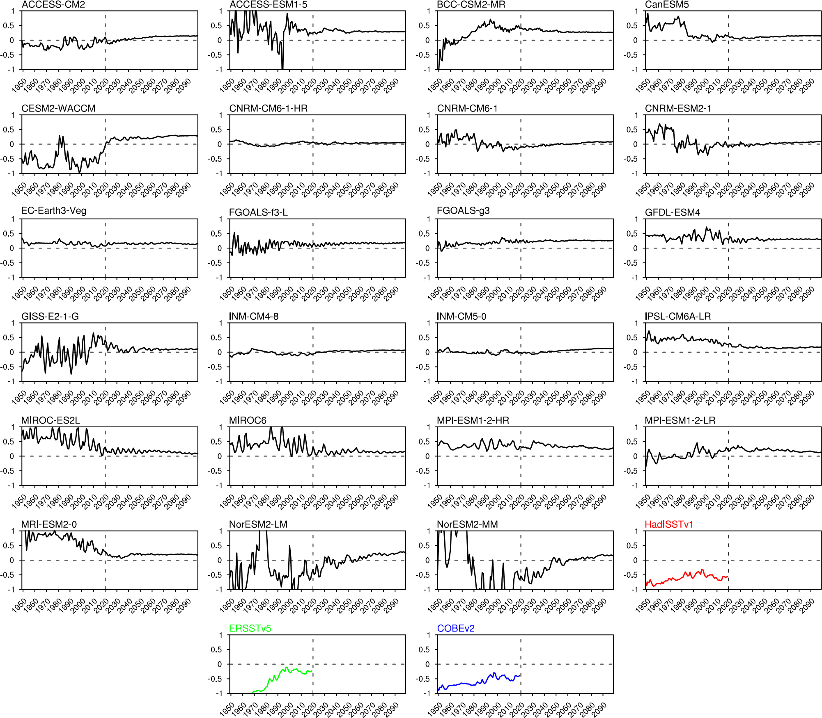
- EEP relative SST response to global warming calculated in increasing length of periods. Shown is for response averaged over the EEP (2.5°S–2.5°N, 180°W–100°W) for 23 CMIP6 models under historical and the SSP585 scenario and in observations (units: K K⁻¹). The x-axis indicates the ending year of a period for calculation of the response, all starting from 1870; for example, when ending in 1949 (the first year shown), the response is calculated over the period from 1870–1949, and when ending in 2050 the response is calculated over the period from 1870–2050.

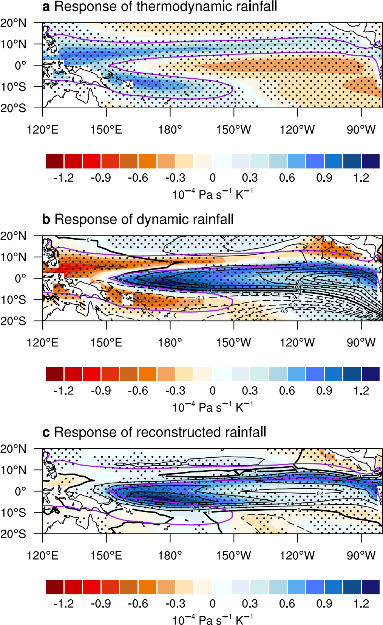
- Decomposition of annual-mean rainfall response to global warming. a–c, MEM Response of thermodynamic component, dynamic component, and their combination, respectively, to global warming under historical and the SSP585 scenario. Black contours in b and c denote the response of relative SST (units: K K⁻¹, with an interval of 0.05 K K⁻¹, zero thickened and negative dashed) and annual-mean rainfall (units: mm day⁻¹ K⁻¹, with an interval of 0.2 mm day⁻¹ K⁻¹, zero thickened and negative dashed) to global warming, respectively. Purple curves denote the 7 mm day⁻¹ contour of rainfall climatology in the reference period. Stippling indicates that more than 70% of models have the same sign.
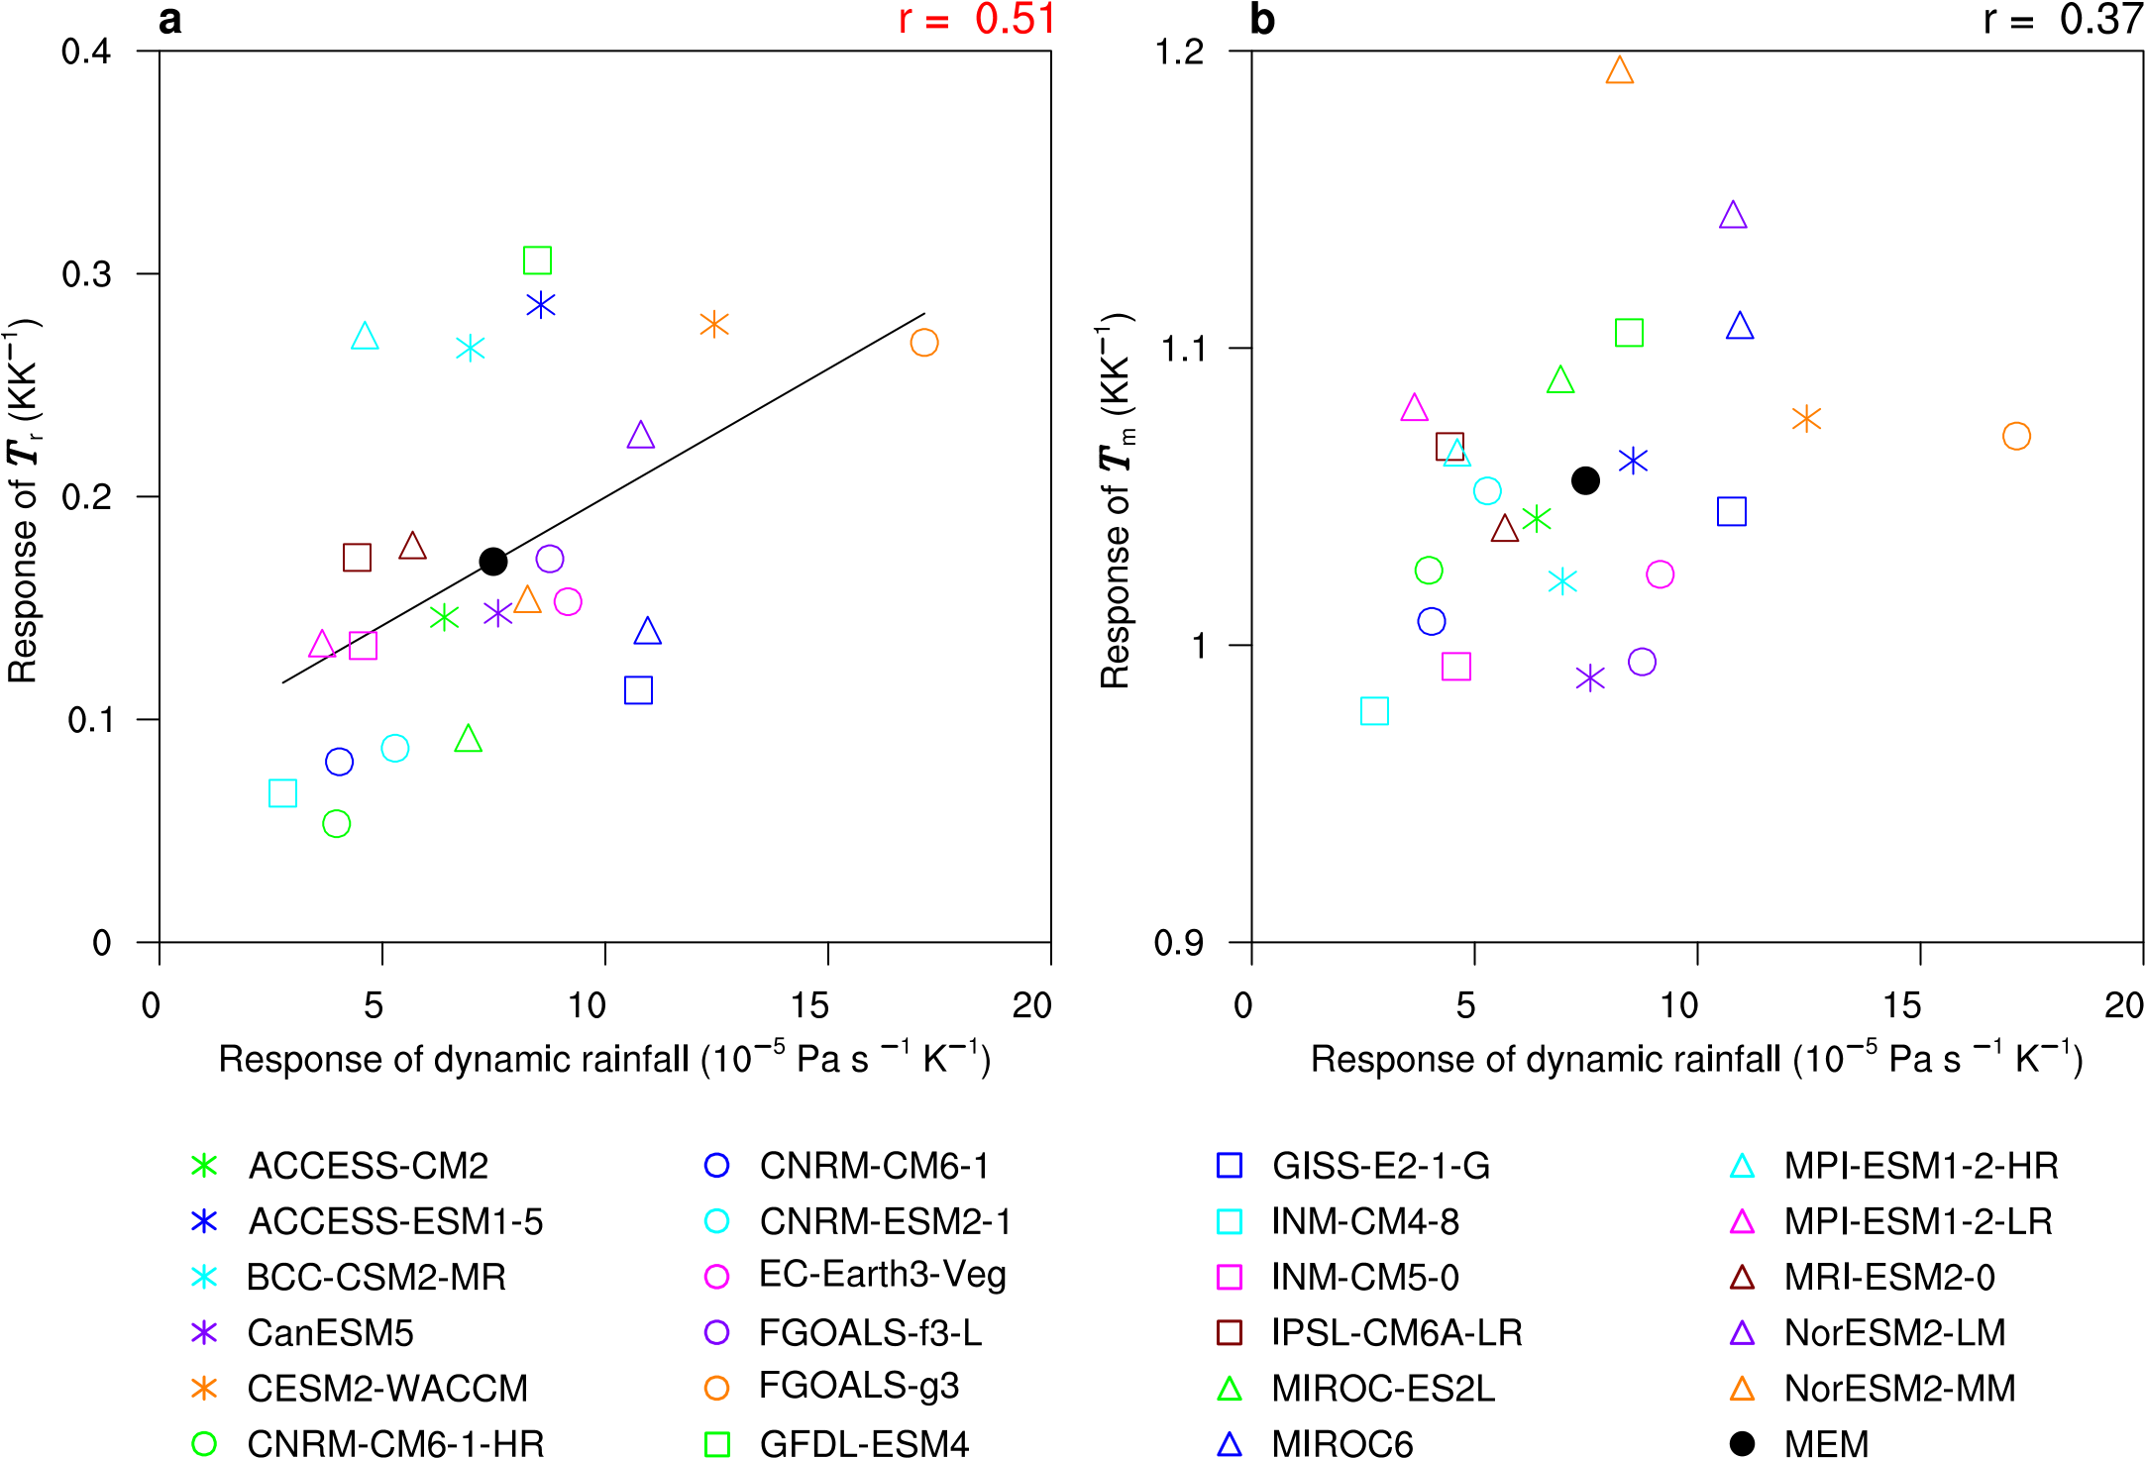
- Inter-model relationship between dynamic rainfall response and annual-mean SST response. a and b, Scatter plots of inter-model responses of dynamic rainfall with responses of relative SST (a) and tropical-mean SST (b) in the EEP under historical and the SSP585 scenario. The solid line in a denotes the linear regression. Digits on the upper-right corner of each plot are the inter-model correlations, with red (black) indicating statistically significant (insignificant) at the 95% confidence level, based on the Student’s t test.
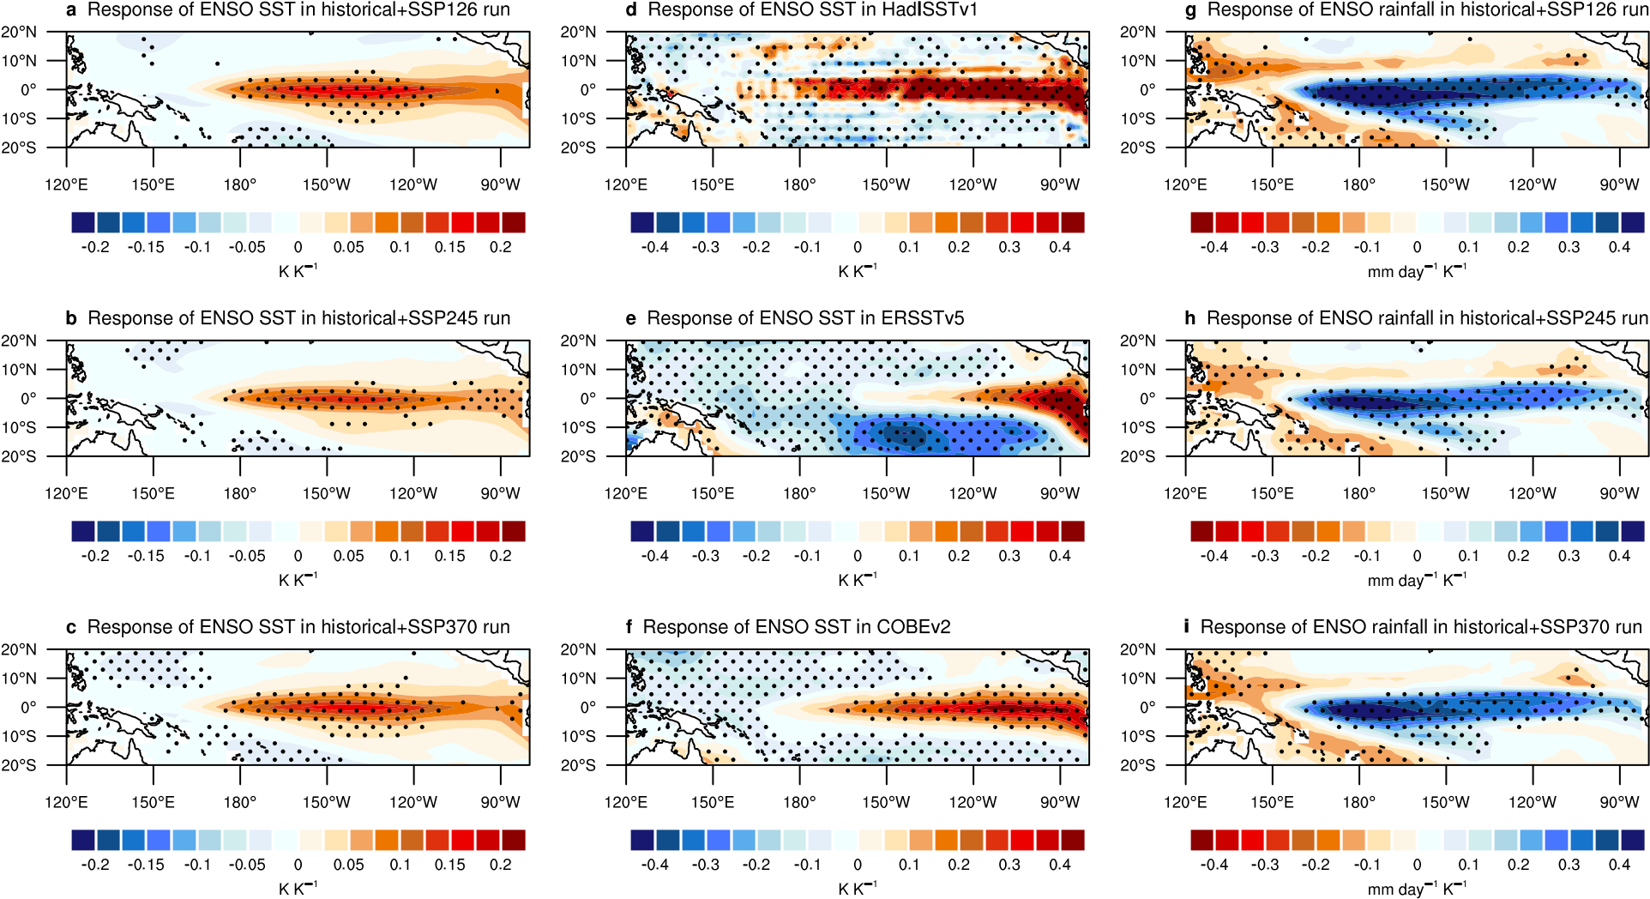
- Responses of ENSO SST and rainfall to global warming. a–c, MEM Responses of ENSO SST under historical and the SSP126 (a), SSP245 (b), and SSP370 (c) scenarios. d–f, The same as a–c, but for HadISSTv1 (d), ERSSTv5 (e) and COBEv2 (f), respectively. g–i, The same as a–c, but for ENSO rainfall. Stippling in a–c and g–i denotes that more than 70% of models have the same sign, while in d–f indicates that the regressions are significant above the 95% confidence level based on the Student’s t test.
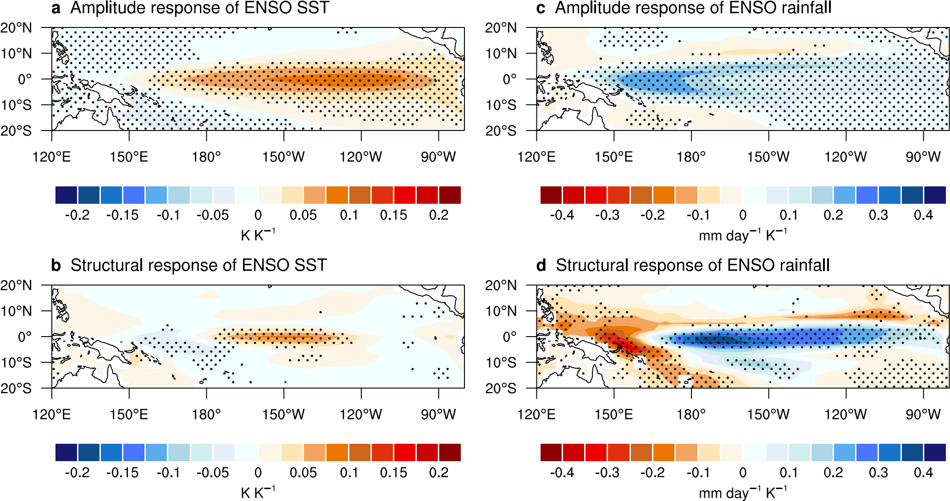
- Amplitude and structural responses of ENSO SST and rainfall to global warming. a, MEM amplitude response of ENSO SST to global warming under historical and the SSP585 scenario, stippling denotes that more than 70% of models have the same sign. b, The same as a, but for MEM structural response. c–d, The same as a–b, but for ENSO rainfall.
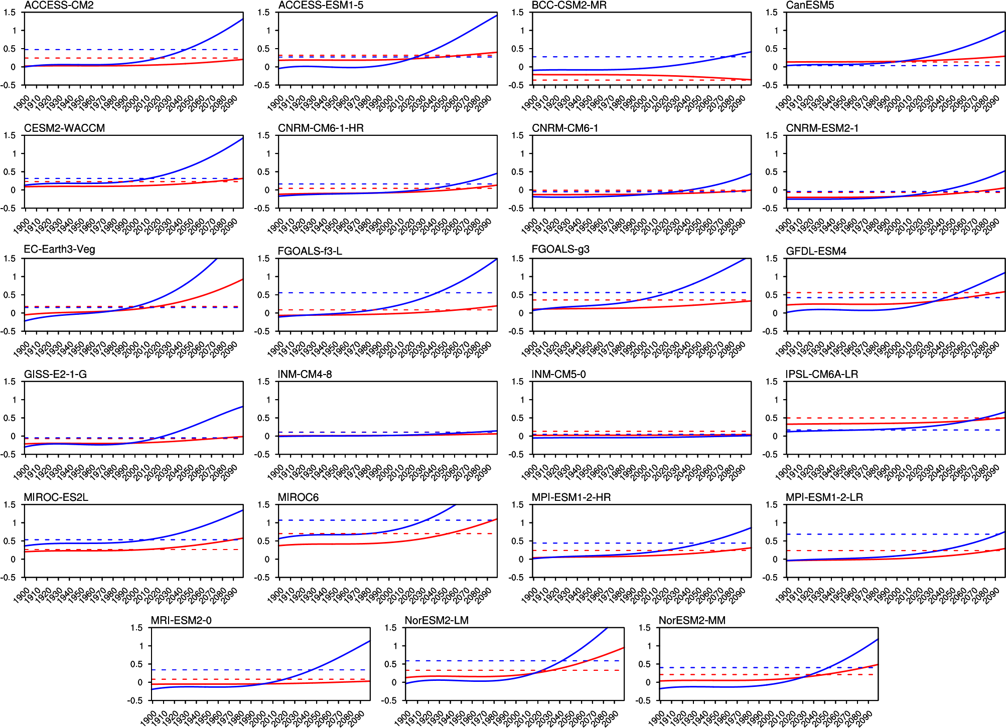
- Signal of ENSO SST and rainfall in the EEP. Signal of ENSO SST (red curves) and rainfall (blue curves) in the EEP in 23 CMIP6 models under historical and the SP585 scenario. The horizontal red (blue) dashed line denotes the threshold value for a detectable signal of ENSO SST (rainfall) (see “ToE of ENSO SST and rainfall” in Methods).

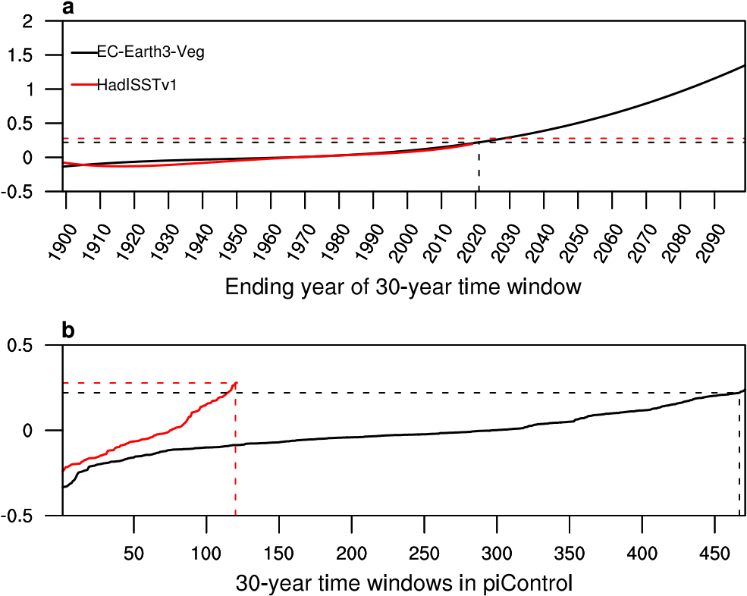
- An example of how to define the ToE of ENSO SST. a, Signal of ENSO SST in a specified grid point at 0°, 120°W, for model EC-Earth3-Veg under historical and the SSP585 scenario (black curve) and HadISSTv1 (red curve), the horizontal dashed lines denote the threshold values for a detectable signal of ENSO SST in EC-Earth3-Veg (0.22, black dashed line) and HadISSTv1 (0.28, red dashed line), while the vertical black dashed line denote the ending year of a 30-year time window for a detectable signal of ENSO SST in EC-Earth3-Veg; b, The change in ENSO SST calculated to compare with the signal of ENSO SST for EC-Earth3-Veg (black curve) and HadISSTv1 (red curve). We rank both the 471 samples of EC-Earth3-Veg and 121 samples of HadISSTv1 from the smallest to the largest. The horizontal black (red) dashed line denotes the 99-percentile value of all the 471 (121) samples in EC-Earth3-Veg (HadISSTv1), while the vertical black (red) dashed line denotes the corresponding order of such value, the 467th (120th) in a sequence of 471 (121) samples, for EC-Earth3-Veg (HadISSTv1).
- The estimated MEM ToE of ENSO SST and rainfall in the EEP. Shown are based on different threshold values. The “–” denotes that there is no detectable signal by the end of this century.
MEM ToEs  Thresholds  and emission scenarios |  | ENSO SST | ENSO rainfall
95% or 5% | SSP126 | 2062 | 2026
95% or 5% | SSP245 | 2067 | 2033
95% or 5% | SSP370 | 2055 | 2031
95% or 5% | SSP585 | 2054 | 2027
97.5% or 2.5% | SSP126 | – | 2033
97.5% or 2.5% | SSP245 | 2085 | 2040
97.5% or 2.5% | SSP370 | 2065 | 2037
97.5% or 2.5% | SSP585 | 2063 | 2033
99% or 1% | SSP126 | – | 2039
99% or 1% | SSP245 | – | 2045
99% or 1% | SSP370 | 2073 | 2042
99% or 1% | SSP585 | 2070 | 2037

