Mechanochromic Phenomenon of Dihydropyrimidine and Chemosensing Detection of Cr⁶⁺ and Mn⁷⁺ in Aqueous Media

Trupti B. Yadavª, Omkar S. Nille^{b}, Sneha R. Bhosaleª, Alfredi A. Moyoª, Sneha V. Koparde^{b}, Govind B. Kolekar^{b}, Tanaji R. Bhosale^{c}, Prashant V. Anbhule^{a,*}
ªMedicinal Chemistry Research Laboratory, Department of Chemistry, Shivaji University, Kolhapur-416004, MS, India.
^{b}Fluorescence Spectroscopy Research Laboratory, Department of Chemistry, Shivaji University, Kolhapur-416004, MS, India.
^{c}Department of Chemistry, D. Y. Patil Agriculture and Technical University, Talsande, 416112, India

Corresponding Author:
Prof. Prashant V. Anbhule
Medicinal Chemistry Research Laboratory,
Department of Chemistry, Shivaji University, Kolhapur,416004, M.S., India
Email: pva_chem@gmail.com

Table of Contents
Sr. No. |  | Contents | Page No.
Characterizations
1 | Text S1. FTIR of TPE-CHO |  |  | S3
2 | Text S2. ¹HNMR of TPE-CHO |  |  | S4
3 | Text S3. ¹³C NMR |  |  | S5
4 | Text S4. HRMS of TPE-CHO |  |  | S6
5 | Text S5. FTIR of A-TPE |  |  | S7
6 | Text S6. ¹HNMR of A-TPE |  |  | S8
7 | Text S7. ¹³C NMR of A-TPE |  |  | S9
8 | Text S8. HRMS OF A-TPE |  |  | S10

FTIR of TPE-CHO:
Fig.S1. IR Spectrum of the 4-(1,2,2-Triphenylvinyl)benzaldehyde

¹H NMR TPE-CHO:
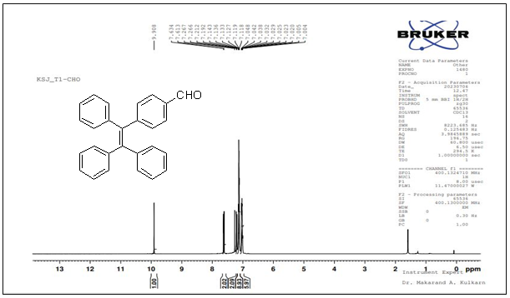

Fig.S2 ¹H NMR Spectrum of 4-(1,2,2-Triphenylvinyl) benzaldehyde

¹³C NMR:

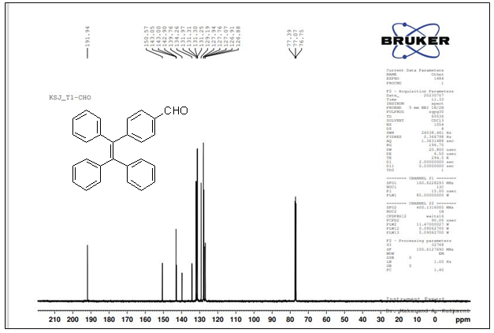
Fig.S3 ¹³C NMR Spectrum of 4-(1,2,2-Triphenylvinyl) benzaldehyde

HRMS of TPE-CHO:

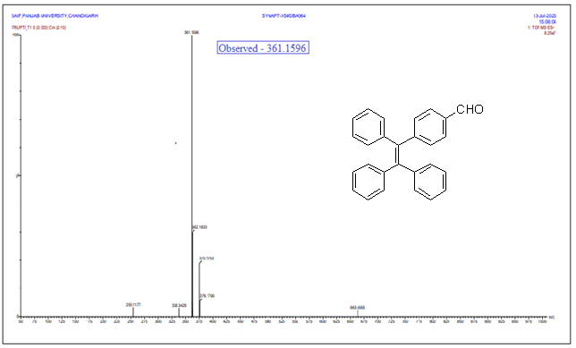
Fig.S4 HRMS spectrum of 4-(1,2,2-Triphenylvinyl) benzaldehyde

FTIR of A-TPE:

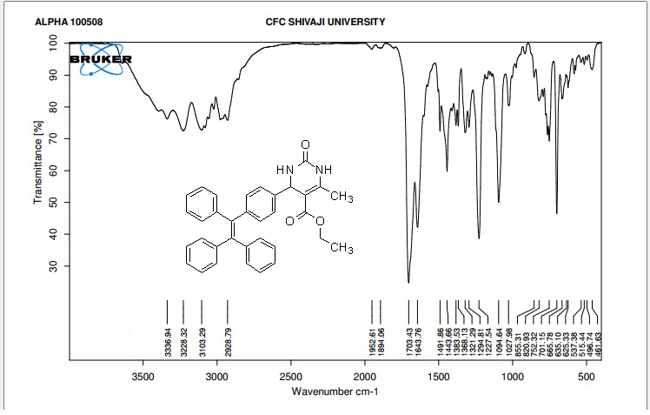
Fig.S5. IR Spectrum of the A-TPE

¹H NMR A-TPE:

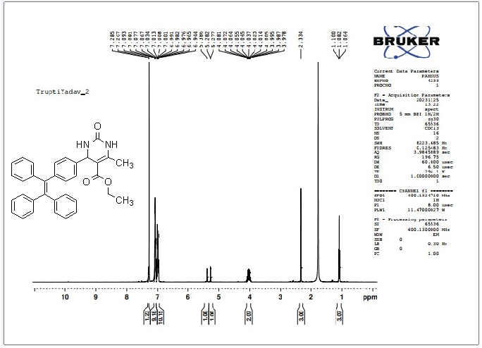
Fig.S6 ¹H NMR Spectrum of the A-TPE

¹³C NMR of A-TPE:

Fig.S7 ¹³C NMR Spectrum of the A-TPE
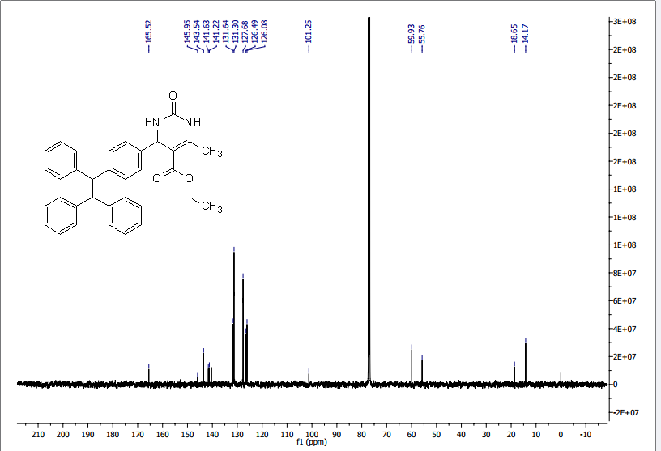

HRMS of A-TPE:
Fig.S8 HRMS Spectrum of A-TPE

