Supplementary information

Intestinal probiotic fungi improve PCOS by sensing metformin signaling and inhibiting gut derived ceramide levels
Pengcheng Wang, Shuang Zhou, Bangjian Dong, Weike Shaoyong, Guangyi Zeng, Meng Li, Chenghao Guo, Jinxin Zhang, Lulu Sun, Lixiang Xue, Kai Wang, Changtao Jiang, Xinyu Qi, Yanli Pang and Jie Qiao

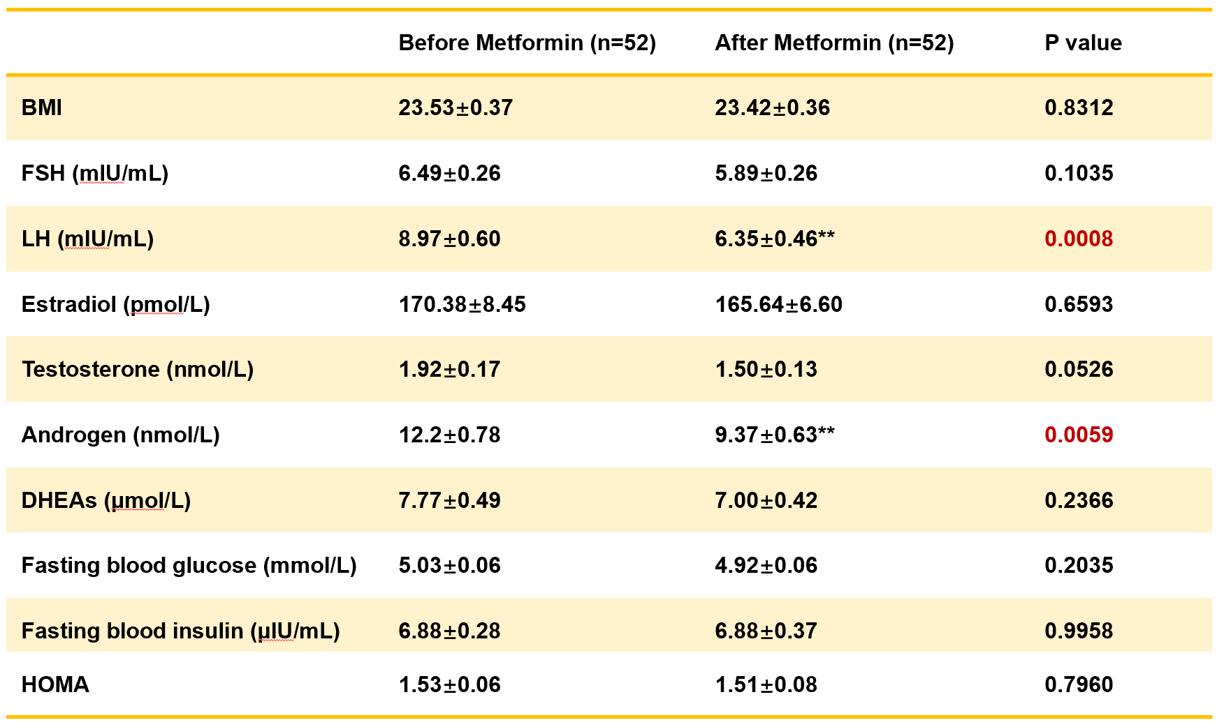
Table S1. Clinical data of PCOS patients with metformin after 12 weeks.
The clinical data characteristics of the PCOS patients before the administration of metformin (the before metformin group) and 12 weeks after perioral metformin administration (1500 mg/day).
All data are presented as the mean ± SEMs. The P values were determined by a two-tailed Mann-Whitney U-test. **P < 0.01 versus the before metformin group.
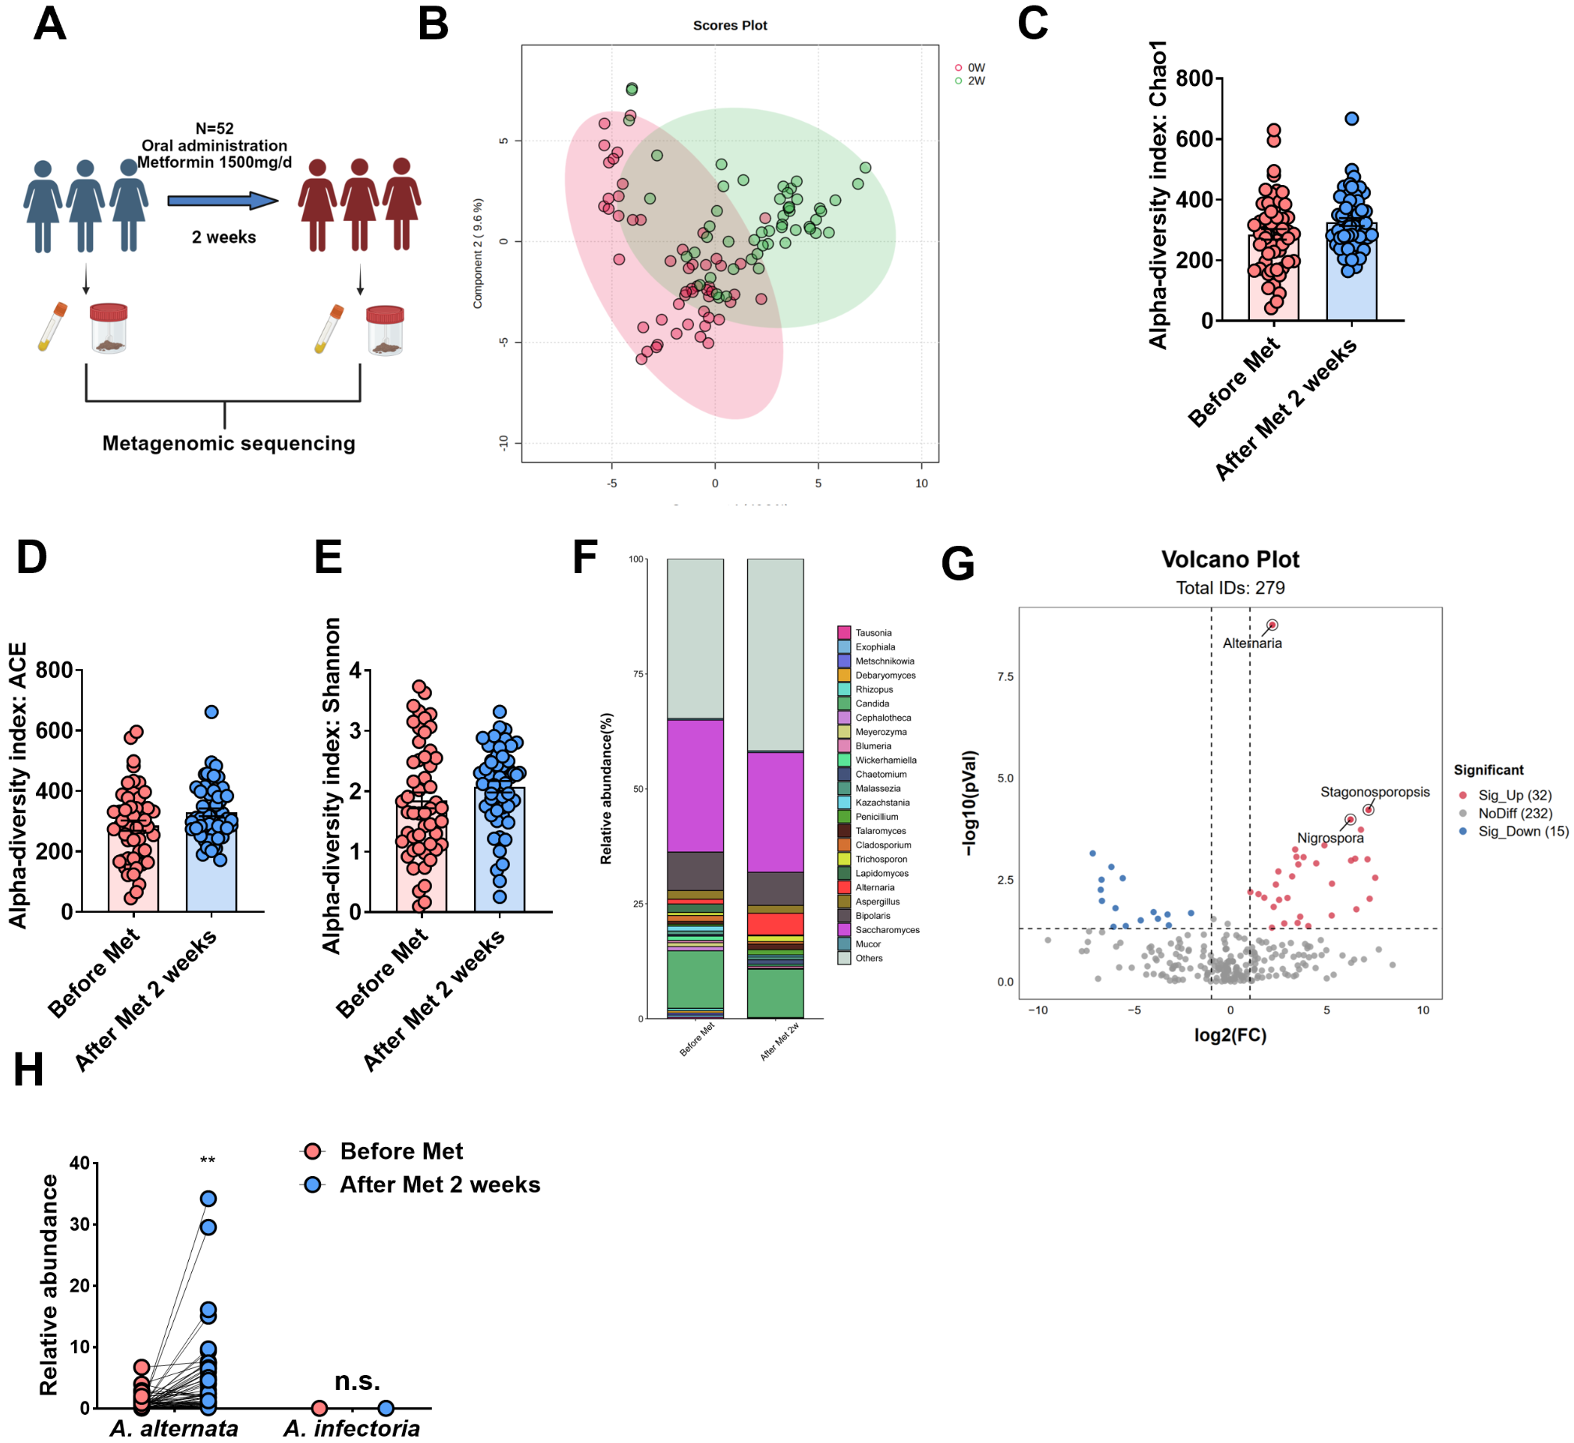
Figure S1. A. alternata is elevated in patients with PCOS after treatment with metformin.
(A) Patients with PCOS treated with metformin. Stool samples were collected before the administration of metformin (the before metformin group) and 2 weeks days after perioral metformin administration (1500 mg/days), clinical information related patients. n = 52.
(B) Partial least squares discriminant analysis (PLS-DA) based on the relative genus abundances. n = 52 individuals/group.
(C-E) α-diversity of the gut mycobiota measured by the Chao1 (D), ACE (E), Shannon indices (F).
(F) Comparison of the relative abundances of the top genera with the most significant differences between groups treated with metformin before and after 2 weeks of treatment. Red, A. alternata.
(G) A volcano plot illustrating the enrichment and depletion patterns of the gut mycobiota before and after the administration of metformin for 2 weeks. n = 52 individuals/group.
(H) Relative abundance of different species in genus of Alternaria based on metagenomics results. n = 52 individuals/group.
All data are presented as the mean ± SEMs. In H, the P values were determined by a two-tailed Mann-Whitney U-test. *P < 0.05, **P < 0.01 versus the Before Met group.
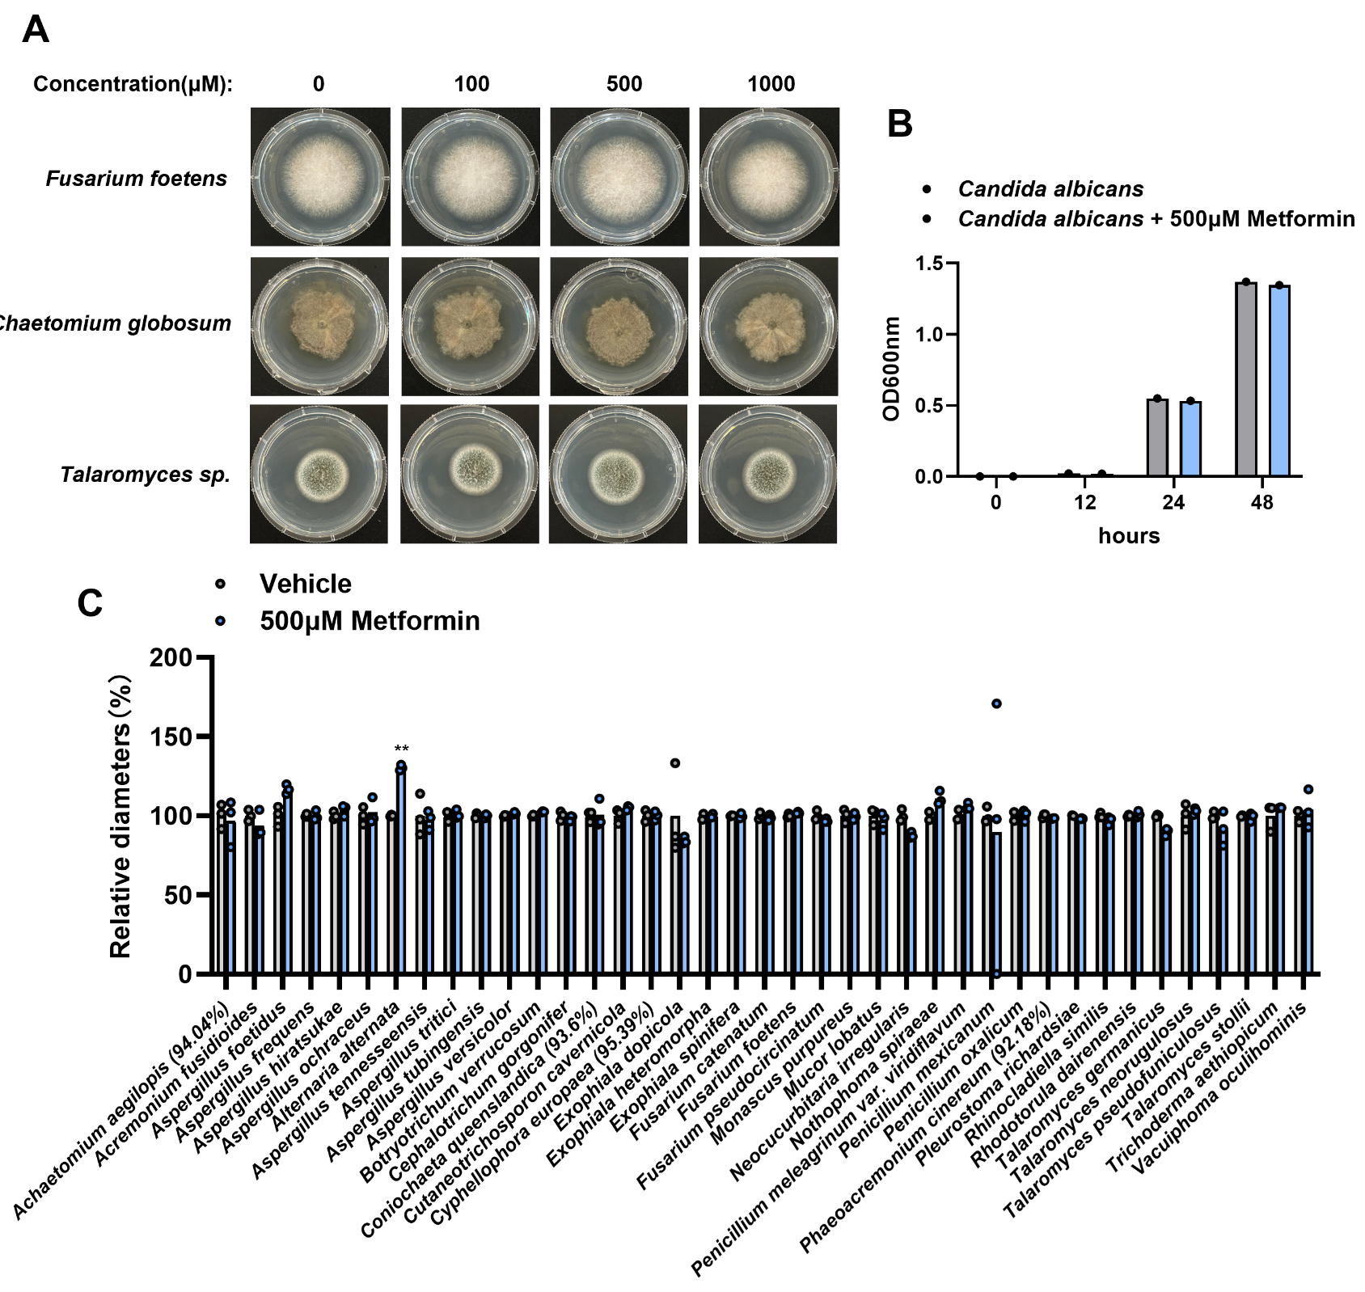
Figure S2. Metformin does not affect the growth of other common commensal strains of fungi.
(A) Fusarium foetens, Chaetomium globusum, Talaromyces sp. was treated with metformin (0, 100, 500, 1000 μM) for 5 days in PDA (Potato Dextrose Agar). (B) Candida albicans was treated with metformin (500 μM) for 2 days in YPD (Yeast Extract Peptone Dextrose). (C) Relative diameters of common commensal strains of fungi was treated with metformin (500 μM) for 5 days in PDA (Potato Dextrose Agar)
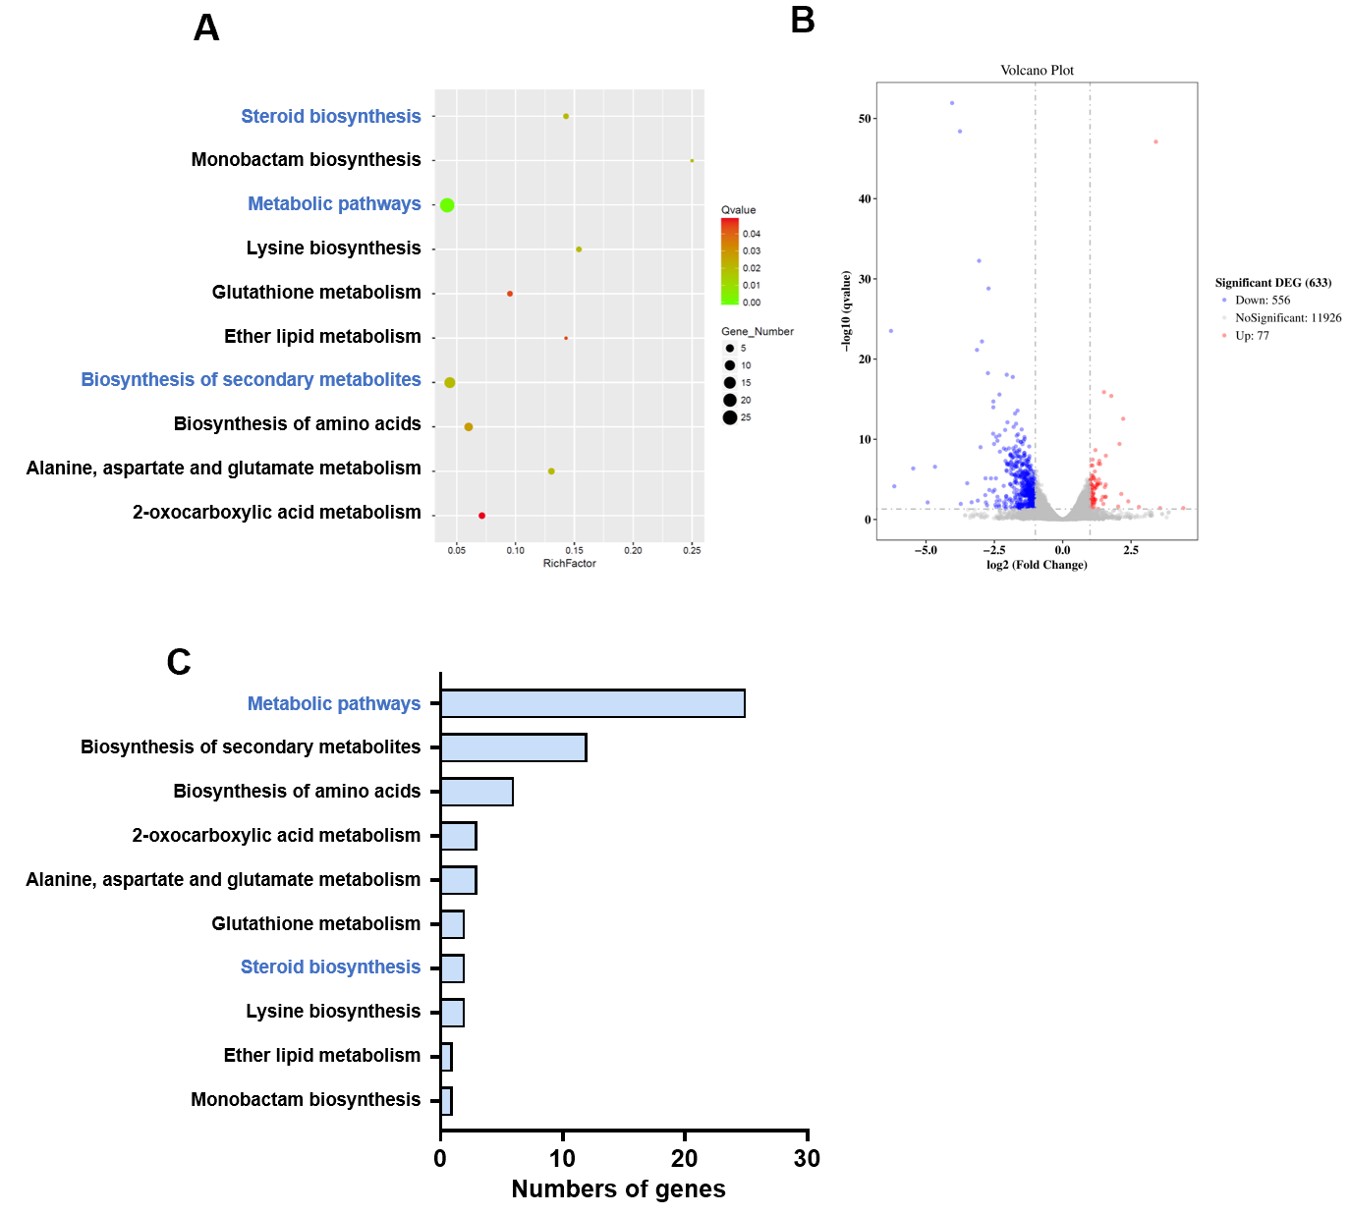
Figure S3. Metformin activates the ergosterol synthesis pathway and promotes fungal growth.
A. alternata was treated with metformin(500μM) for 72 hours in PDB (Potato Dextrose Broth). RNA-seq analysis of the A. alternata cultured under normoxic conditions for one week. (A)KEGG enrichment analysis of the biofunction changes under metformin conditions. (B) Volcano plot analysis. (C) GO terms of analysis of the biofunction changes under metformin conditions.
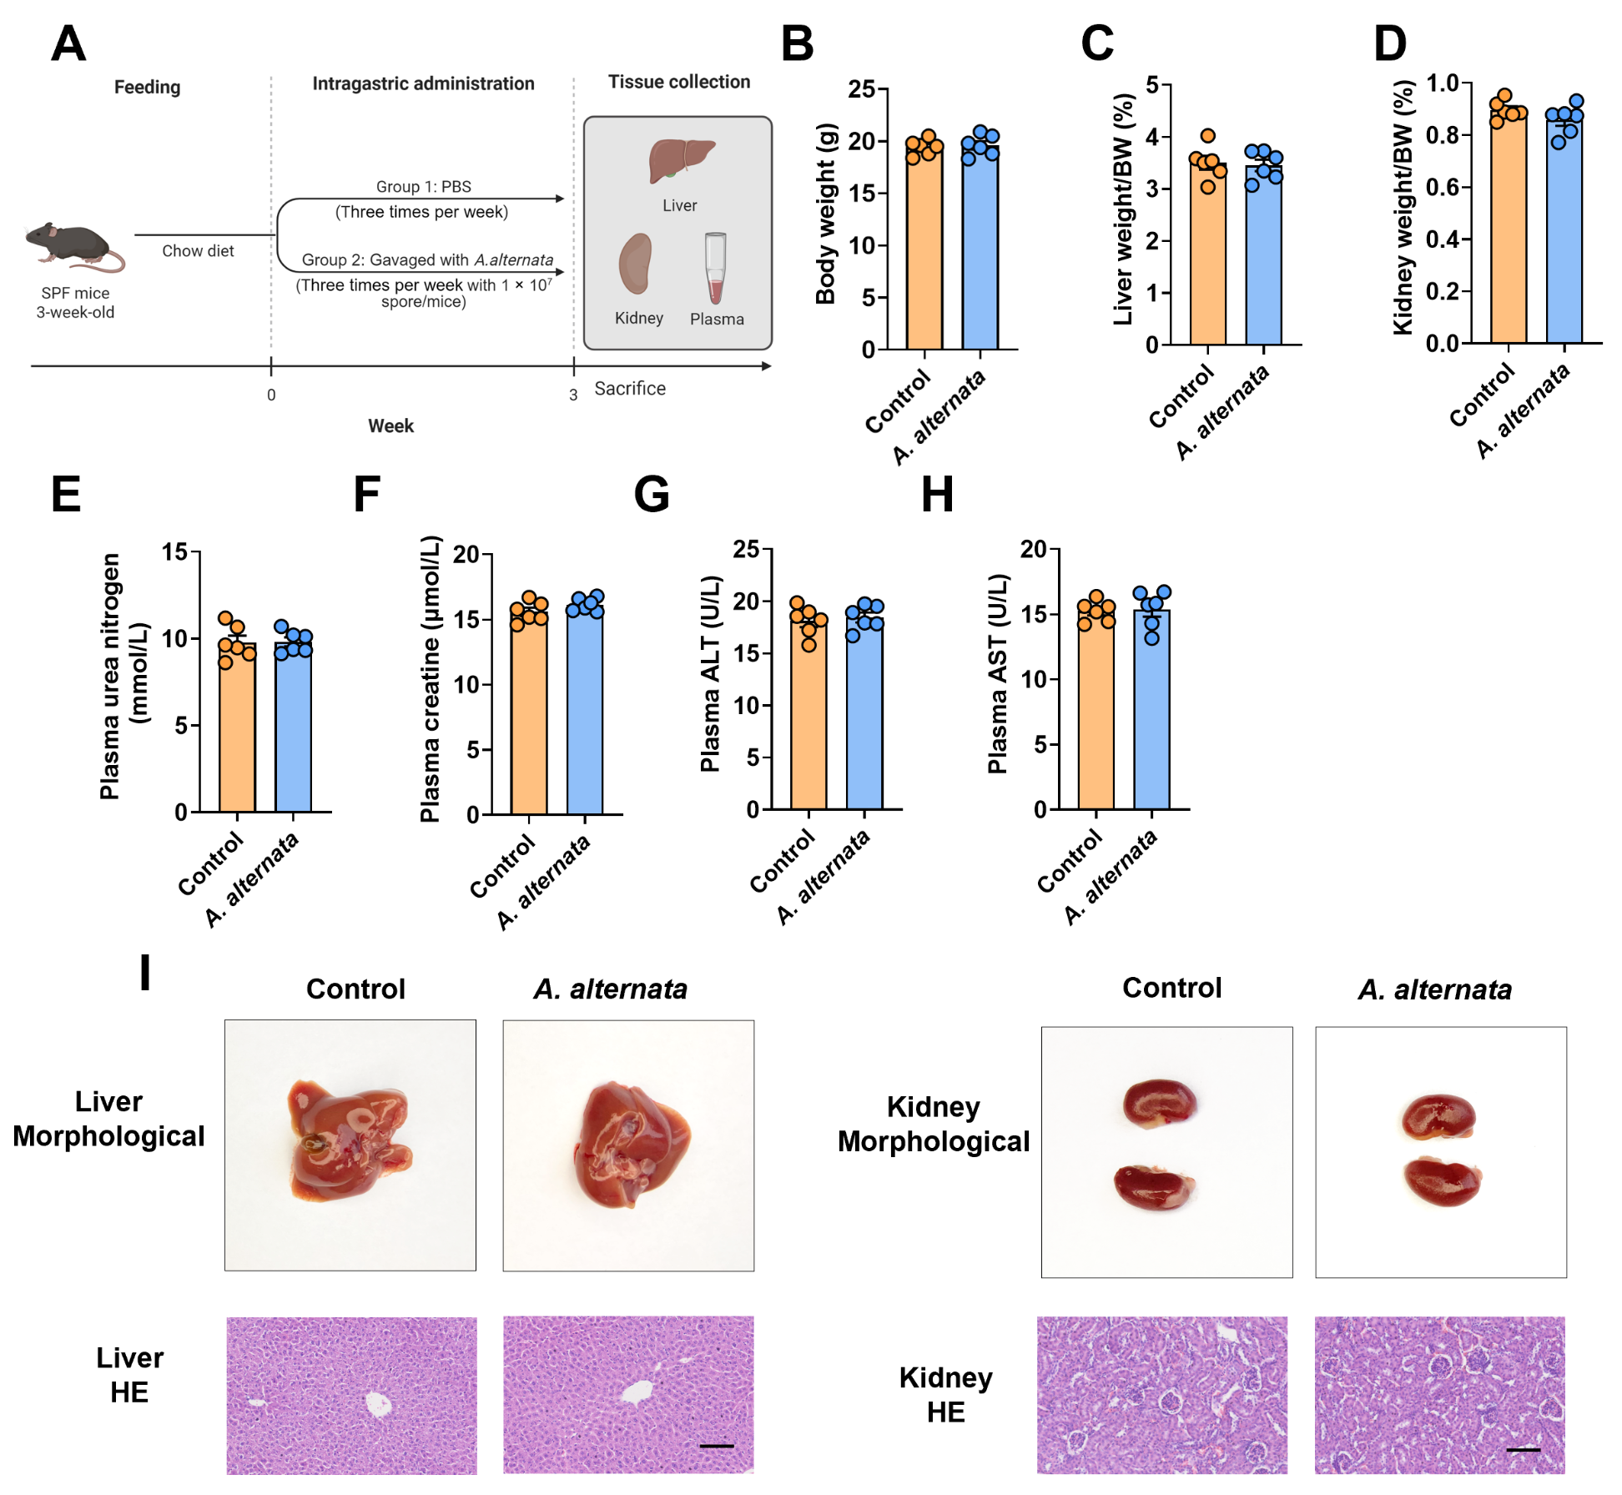
Figure S4. Toxicity analysis of A. alternata in gavaged mice.
(A) Experimental scheme for (B-I), n=6 mice/group. Chow diet fed SPF mice were treated with PBS (Control), A. alternata strain three times per week for 8 weeks. (B) Body weight. (C) Ratios of liver mass to body weight. (D) Ratios of kidney mass to body weight. (E) Plasma urea nitrogen. (F) Plasma creatine levels. (G and H) Plasma ALT (G) and AST (H) levels. (I) Representative morphology (top) and H&E (bottom) staining of the liver (left) and the kidney (right) sections. n = 3 mice per group, 3 images per mouse. Scale bars, 100 μm. All data are presented as the mean ± SEMs.
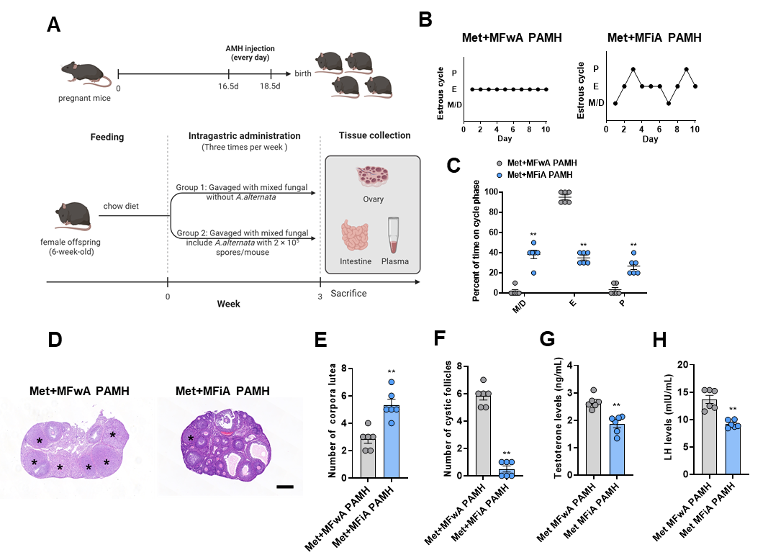
Figure S5. Metformin mediated improvements in PCOS in the PAMH model is dependent on A. alternata. (A) Experimental scheme for (B-H). 3-week-old SPF mice were treated with mixed fungal without A. alternata (Met+MFwA), mixed fungal include A. alternata (Met+MFiA) for 3 weeks of the dietary regimen in PAMH model. For the PAMH model, eight-week-old pregnant C57BL/6 mice were injected daily from embryonic day 16.5–18.5 with 0.12 mg kg⁻¹ d⁻¹ human AMH. 6-week-old female offspring were treated with corresponding fungal for another 3 weeks.
(B) Representative estrous cycles. (n = 6 mice per group). P, proestrus; E, estrus; M, metestrus; D, diestrus.
(C) Quantitative analysis of estrous cycles (n = 6 mice per group).
(D) Hematoxylin and eosin staining of representative ovaries. Scale bar, 200 μm. Images are representative of three independent experiments with similar results.
(E) Quantitative analysis of corpora lutea (n = 6 mice per group).
(F) Quantitative analysis of cystic follicles (n = 6 mice per group).
(G) Plasma testosterone (T) levels (n = 6 mice per group).
(H) Plasma luteinizing hormone (LH) levels (n = 6 mice per group).
All data are presented as the mean ± SEMs.
In C, E, F the P values were determined by a two-tailed Mann-Whitney U-test. In G, H, the P values were determined by Kruskal-Wallis test followed by Dunn’s post hoc test. **P < 0.01 versus the Met+MFwA PAMH group.
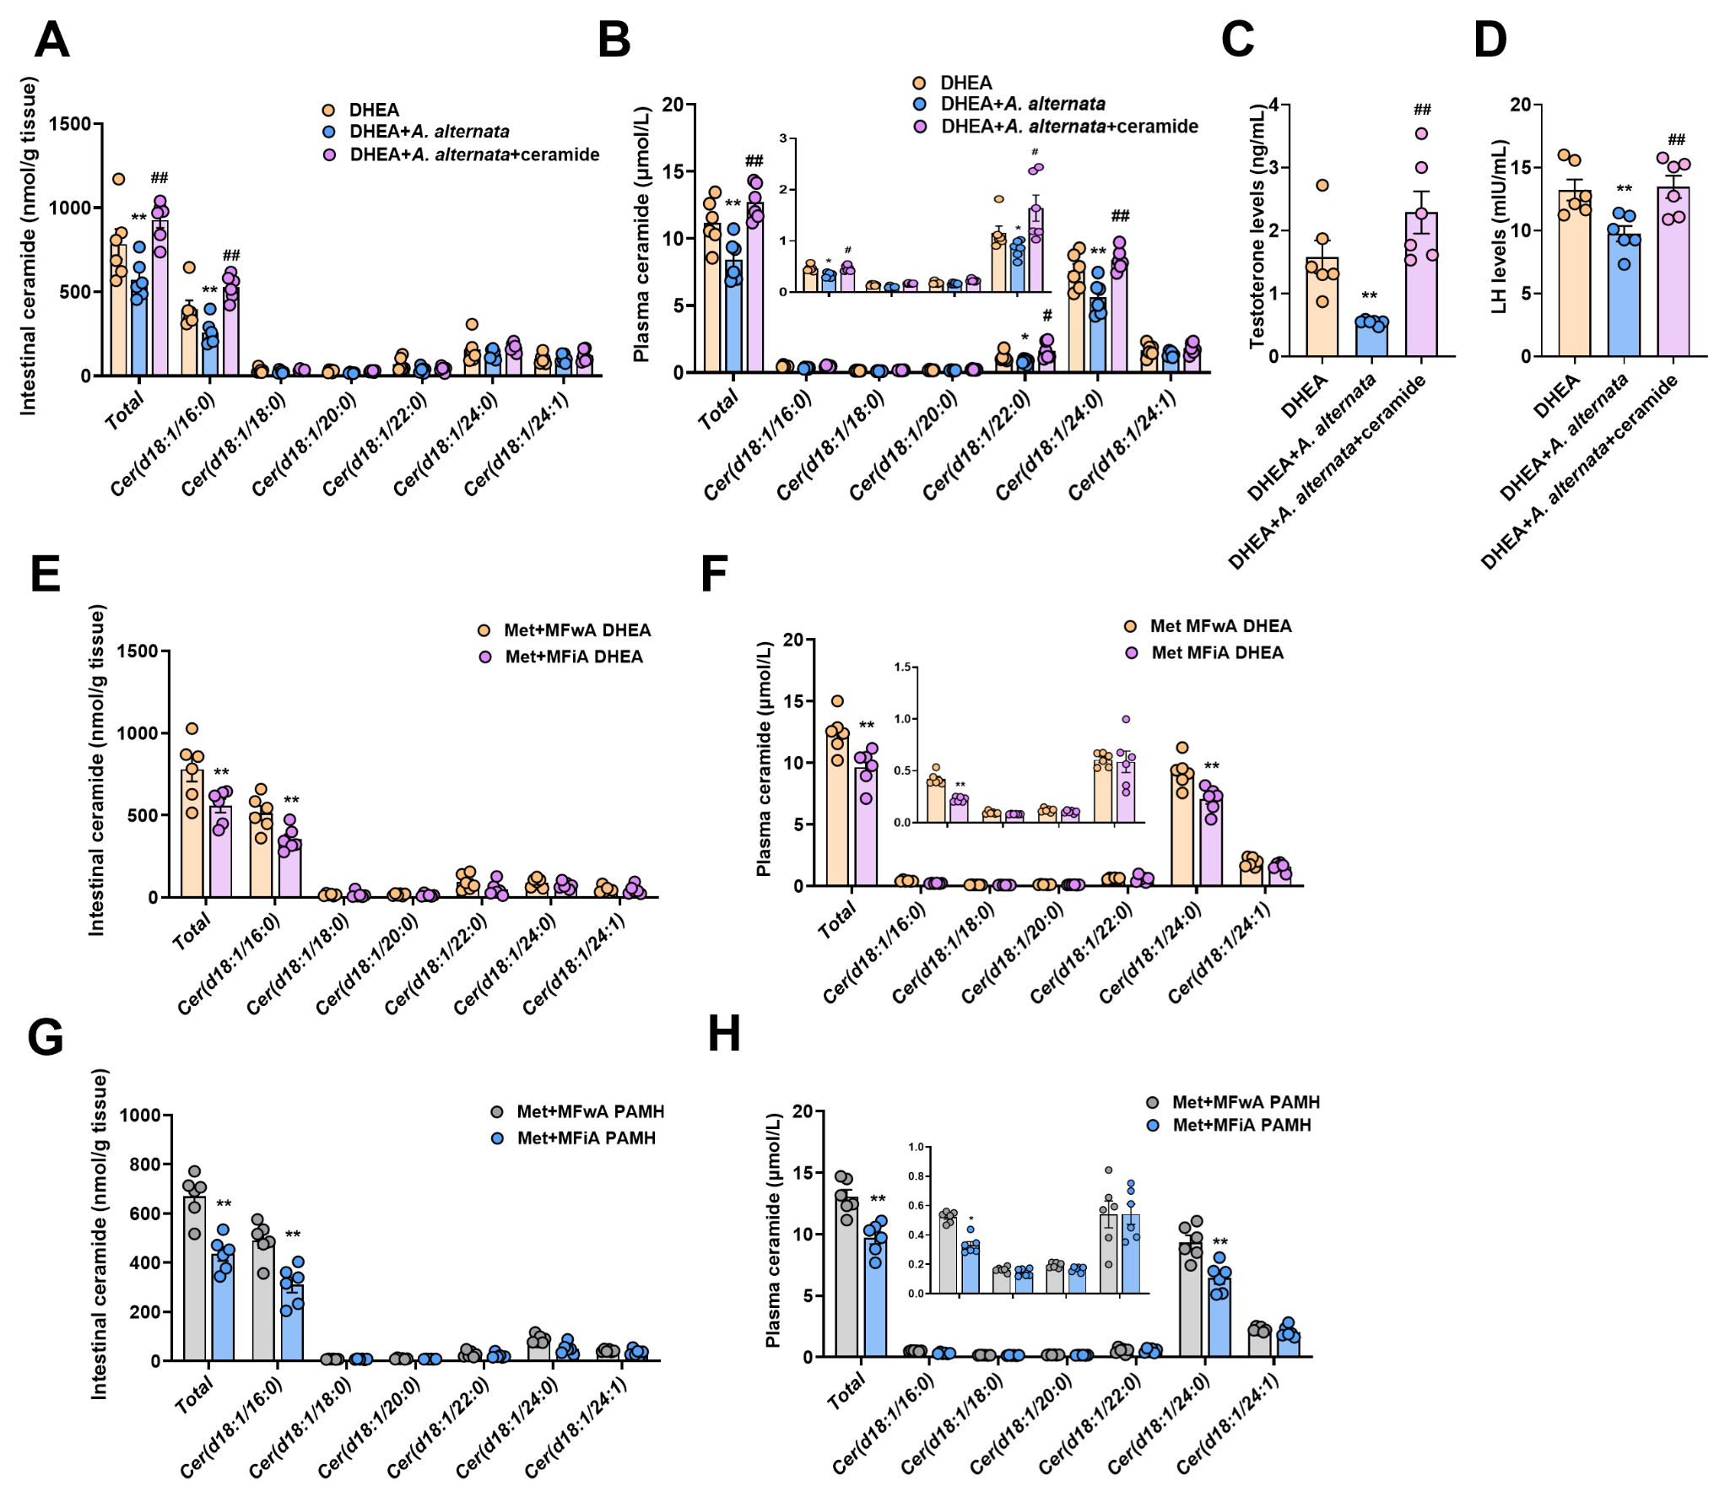
Figure S6. Ceramides promote the occurrence and development of PCOS.
3-week-old SPF mice were treated with DHEA, DHEA+ A. alternata, DHEA+ A. alternata +Ceramide for 3 weeks of the dietary regimen. For the DHEA model, wild-type mice were injected daily with DHEA subcutaneously for 3 weeks; For the DHEA+ A. alternata, wild-type mice were injected daily with DHEA subcutaneously, gavage with A. alternata orally three times per week. For the DHEA+A. alternate+ceramide, wild-type mice were injected daily with DHEA subcutaneously, injected with ceramide intraperitoneally three times per week, gavage with A. alternata orally three times per week.
(A and B) Quantitation of ceramide concentrations in intestinal tissue (A) and plasma (B).
(C) Plasma testosterone (T) (n = 6 mice per group).
(D) Plasma luteinizing hormone (LH) (n = 6 mice per group).
(E and F) Quantitation of ceramide concentrations in intestinal tissue (E) and plasma (F). 3-week-old SPF mice were treated with mixed fungal without A. alternata (Met+MFwA), mixed fungal include A. alternata (Met+MFiA) for 3 weeks of the dietary regimen in DHEA model. For the DHEA model, wild-type mice were injected daily with DHEA subcutaneously for 3 weeks.
(G and H) Quantitation of ceramide concentrations in intestinal tissue (G) and plasma (H). 6-week-old SPF mice were treated with mixed fungal without A. alternata (Met+MFwA), mixed fungal include A. alternata (Met+MFiA) for 3 weeks of the dietary regimen in PAMH model. For the PAMH model, eight-week-old pregnant C57BL/6 mice were injected daily from embryonic day 16.5–18.5 with 0.12 mg kg⁻¹ d⁻¹ human AMH. 6-week-old female offspring were treated with corresponding fungal for another 3 weeks.
All data are presented as the mean ± SEMs.
In A, B, the P values were determined by two-tailed Mann-Whitney U test. In C-G, the P values were determined by Kruskal-Wallis test followed by Dunn’s post hoc test. In H, the P values were determined by one-way ANOVA with Tukey’s post hoc test. **P < 0.01 versus the DHEA group (A-D), the Met+MFwA DHEA group (E, F), the Met+MFwA PAMH group (G, H), ##P < 0.01 versus the DHEA+ A. alternata group.
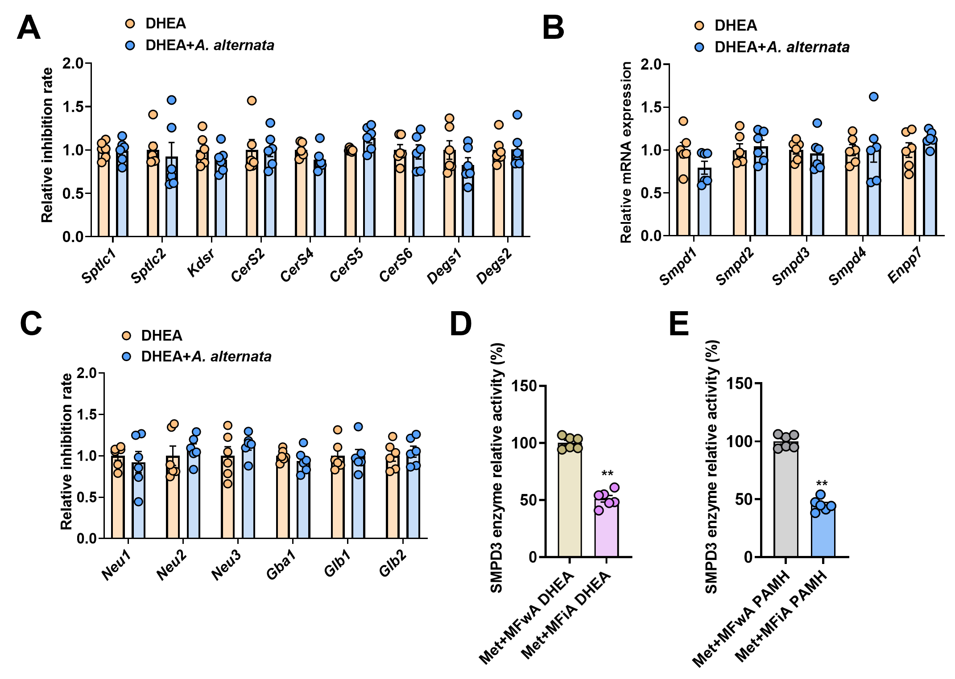
Figure S7. A. alternata does not affect ceramide metabolism pathway-related gene expression.
3-week-old SPF mice were treated with DHEA, DHEA+ A. alternata. For the DHEA model, wild-type mice were injected daily with DHEA subcutaneously for 3 weeks; For the DHEA+ A. alternata, wild-type mice were injected daily with DHEA subcutaneously, gavage with A. alternata orally three times per week.
(A) mRNA expression of de novo synthesis of ceramides related genes. (n = 6 samples per group).
(B) mRNA expression of hydrolysis pathway of sphingomyelin related genes. (n = 6 samples per group). Hydrolysis pathway of sphingomyelin ceramide
(C) mRNA expression of ceramide salvage synthesis pathway related genes. (n = 6 samples per group).
(D) Enzyme activity of nSMase in the DHEA mouse PCOS model.
(E) Enzyme activity of nSMase in the PAMH mouse PCOS model.
All data are presented as the mean ± SEMs. In D, E, the P values were determined by two-tailed Student’s t test. **P < 0.01 versus the control group.
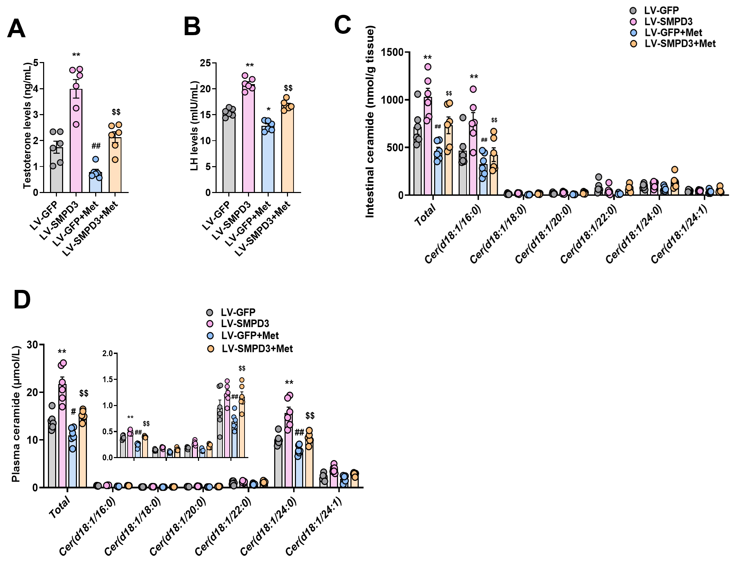
Figure S8. Intestinal specific overexpression of Smpd3 exacerbates PCOS in the metformin-treated DHEA model.
3-week-old SPF mice were injected with LV-GFP or LV-SMPD3, gavaged with or without metformin (1g/L in water) orally, and all mice injected with DHEA subcutaneously for 3 weeks.
(A) Plasma testosterone (T) levels (n = 6 mice per group).
(B) Plasma luteinizing hormone (LH) levels (n = 6 mice per group).
(C and D) Quantitation of ceramide concentrations in intestinal tissue (C) and plasma (D).
All data are presented as the mean ± SEMs.
In A, C, D, the P values were determined by Kruskal-Wallis test followed by Dunn’s post hoc test. In B, the P values were determined by one-way ANOVA with Tukey’s post hoc test. **P < 0.01 versus the LV-GFP group, ##P < 0.01 versus the LV-GFP group, $$P < 0.01 versus the LV-GFP +Met group.
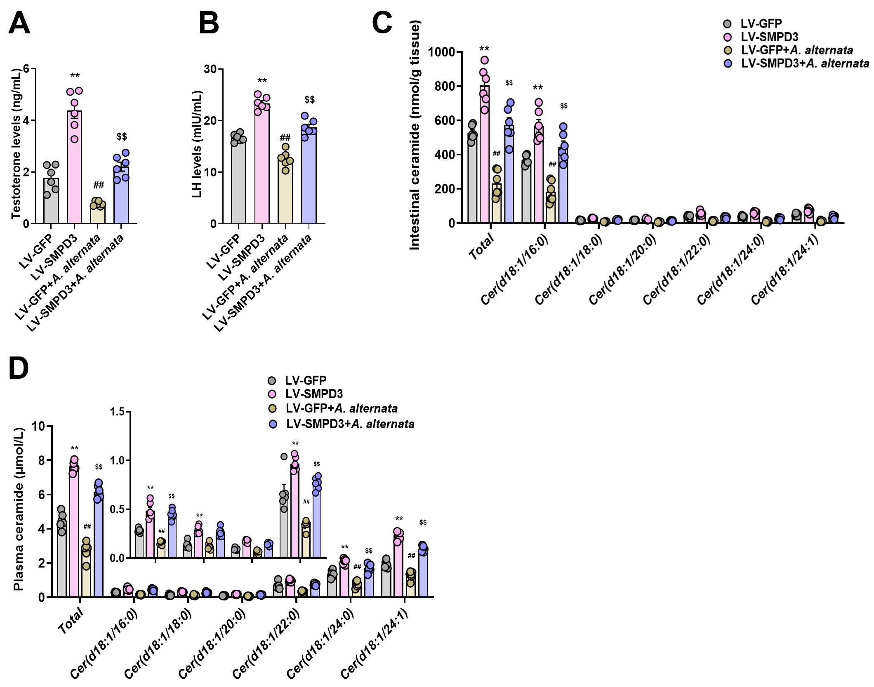
Figure S9. Intestinal specific overexpression of Smpd3 exacerbates PCOS in the A. alternata treated DHEA model.
3-week-old SPF mice were injected with LV-GFP or LV-SMPD3, gavaged with or without A. alternata three times per week, and all mice injected with DHEA subcutaneously for 3 weeks.
(A) Plasma testosterone (T) levels (n = 6 mice per group).
(B) Plasma luteinizing hormone (LH) levels (n = 6 mice per group).
(C and D) Quantitation of ceramide concentrations in intestinal tissue (E) and plasma (F).
All data are presented as the mean ± SEMs.
In A, C, D, the P values were determined by Kruskal-Wallis test followed by Dunn’s post hoc test. In B, the P values were determined by one-way ANOVA with Tukey’s post hoc test. **P < 0.01 versus the LV-GFP group, ##P < 0.01 versus the LV-GFP group, $$P < 0.01 versus the LV-GFP +A. alternata group.
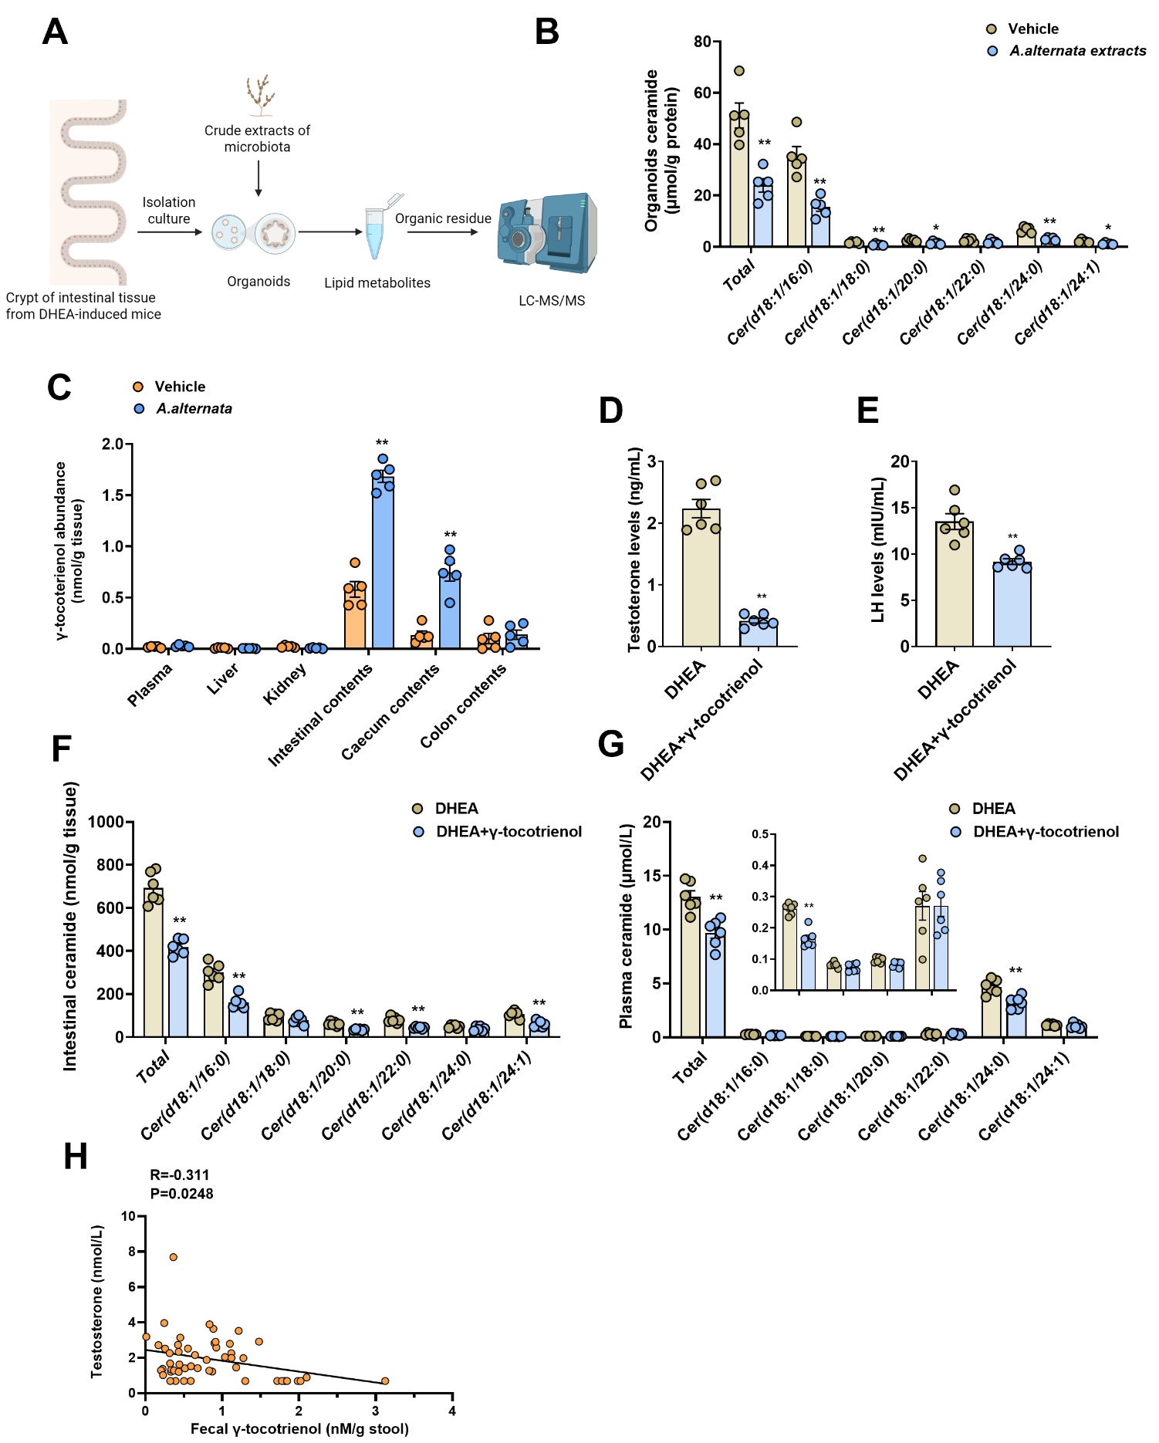
Figure S10. A. alternata secondary metabolite-mediated inhibition of SMPD3 activity.
(A) A schematic diagram showing the process for ceramide detection after A. alternata extract treatment of organoids.
(B) Quantitation of ceramide concentrations in intestinal organoids, after treatment with 100 μg/mL of A. alternata extracts, n = 5 per group.
(C) Quantitative determination of γ- tocotrienol levels in the plasma, liver, kidney, small intestinal contents, cecal contents, colonic contents by mass spectrometry of SPF (C) and SPF mice gavaged with A. alternata, n = 5 mice per group.
(D-H) 3-week-old SPF mice were gavaged with or without A. alternata three times per week, and all mice injected with DHEA subcutaneously for 3 weeks.
(D) Plasma testosterone (T) levels (n = 6 mice per group).
(E) Plasma luteinizing hormone (LH) levels (n = 6 mice per group).
(F and G) Quantitation of ceramide concentrations in intestinal tissue (F) and plasma (G).
(H) Correlative analysis of fecal γ-tocotrienol with plasma testosterone in the PCOS cohort before and after treatment with metformin for 12 weeks. Correlations between variables were assessed by linear regression analysis. Linear correction index R and p values were calculated.
All data are presented as the mean ± SEMs.
In B, C, the P values were determined by two-tailed Mann-Whitney U test. *P < 0.05, **P < 0.01 versus the vehicle group.
In D, F, G, the P values were determined by two-tailed Mann-Whitney U test. In E, the P values were determined by two-tailed Student’s t test. **P < 0.01 versus the DHEA group.

