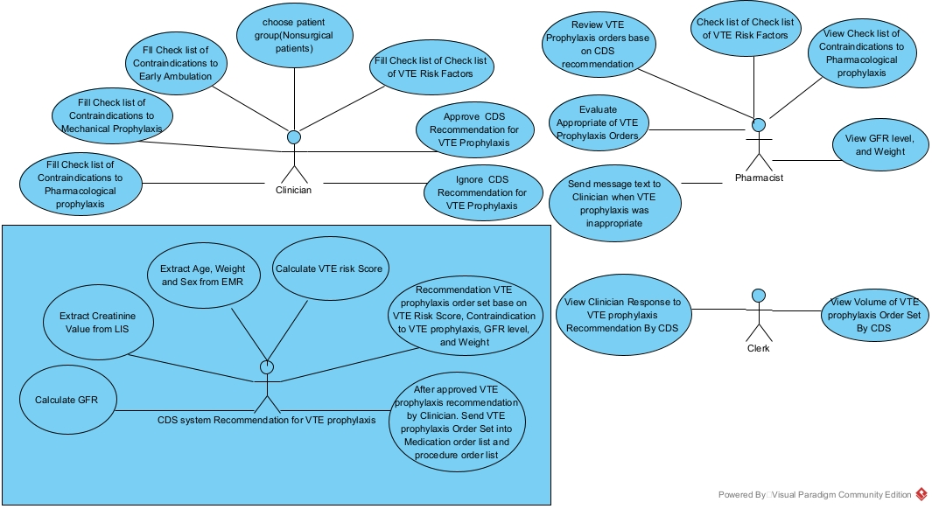
Supplementary File 2: Appendix 2 UML diagram
Diagram 1-use case diagram for CDS recommendation to VTE prophylaxis in nonsurgical patients

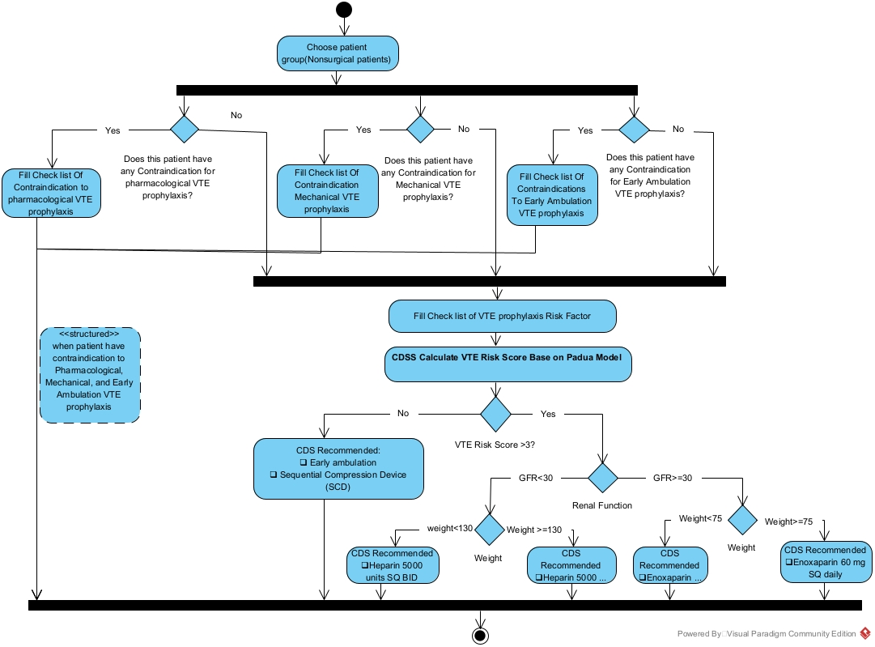
Diagram 2- activity diagram when patient have any contraindication to VTE prophylaxis or Patient not have any continuation to VTE prophylaxis in nonsurgical patients

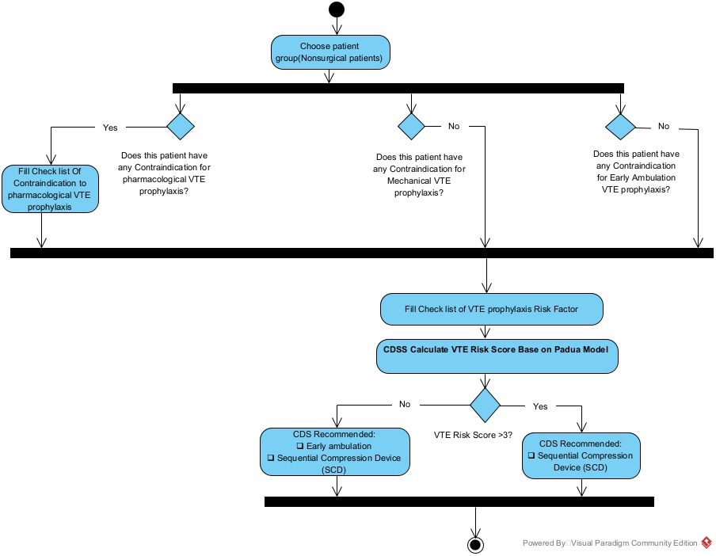

Diagram 3- activity diagram when patient only have contraindication to pharmacological VTE prophylaxis in nonsurgical patients.

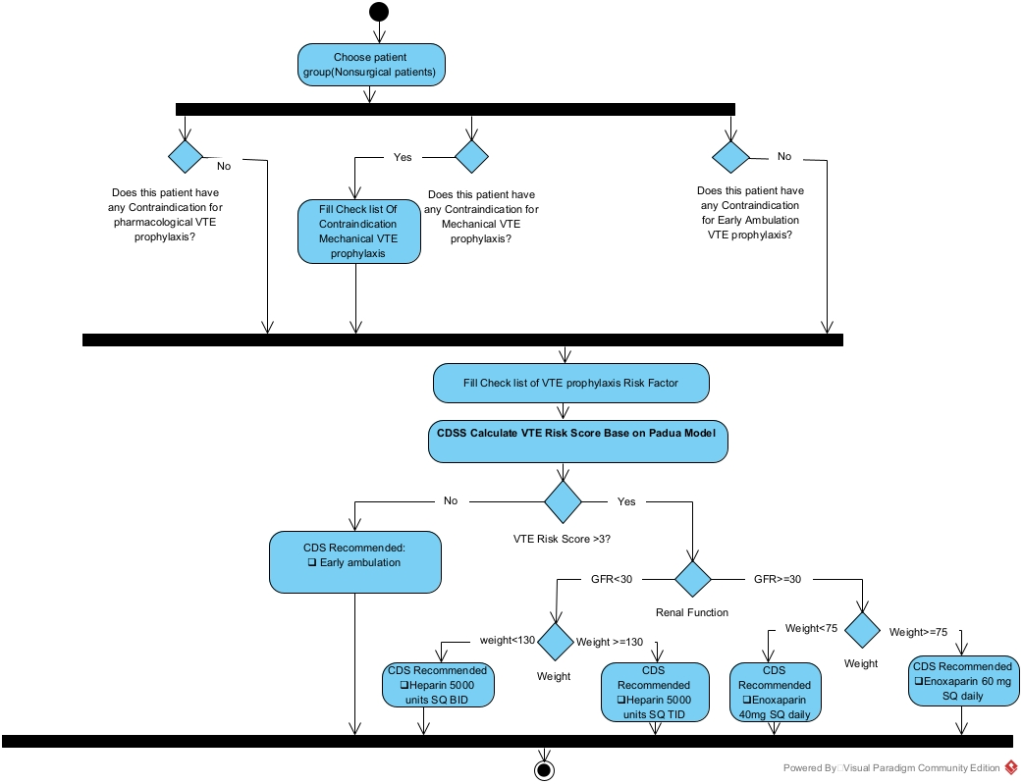
Diagram 4-activity diagram when patient have only contraindication to Mechanical VTE prophylaxis in nonsurgical patients

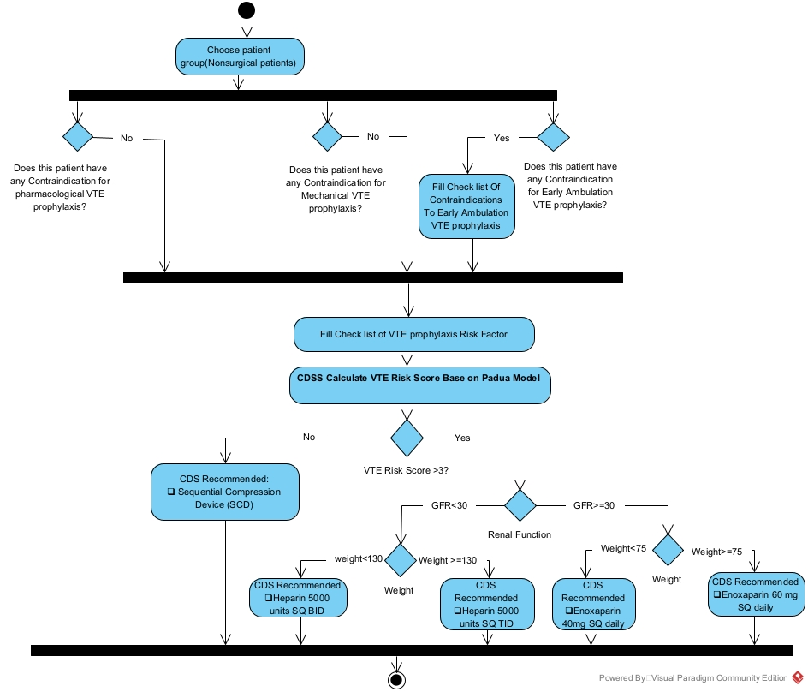
Diagram 5-Activity Diagram When Patient Have only Contraindications To Early Ambulation VTE prophylaxis nonsurgical patient.

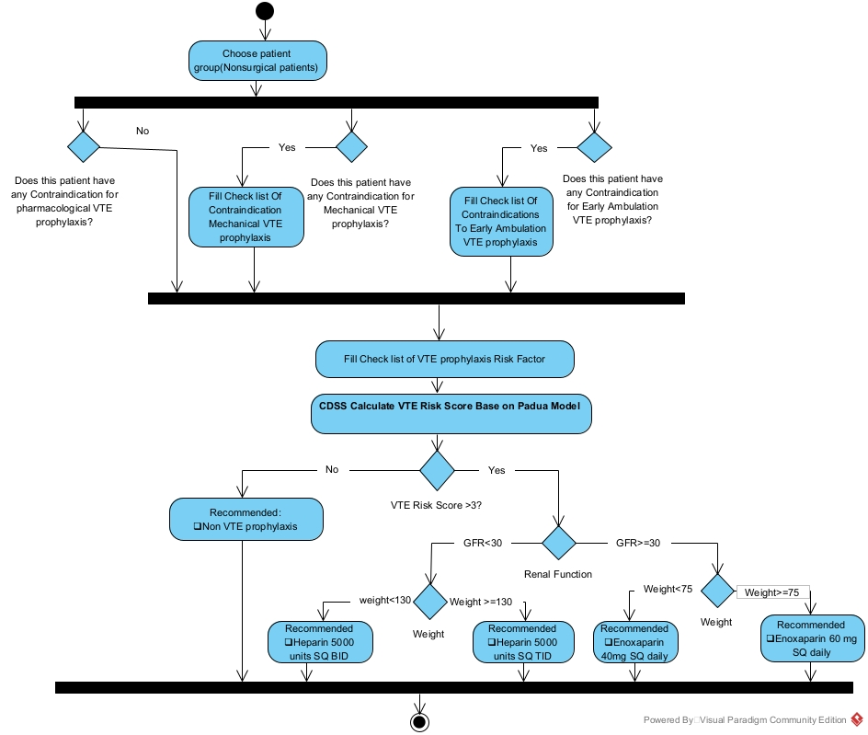
Diagram 6: activity diagram when patient have contraindication to mechanical and early ambulation VTE prophylaxis in nonsurgical patient

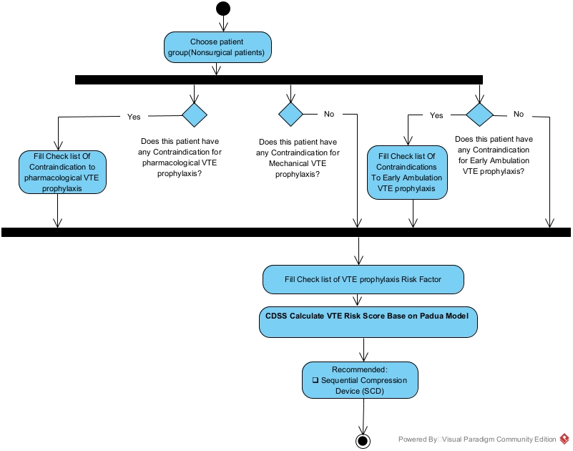
Diagram 7: activity diagram when patient have contraindication to pharmacological and early ambulation VTE prophylaxis in nonsurgical patients

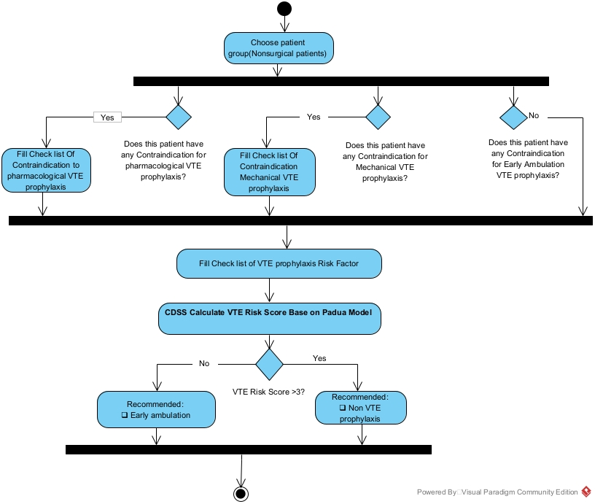
Diagram 9-Activity diagram when patient have contraindication to pharmacological and mechanical VTE prophylaxis in nonsurgical patient

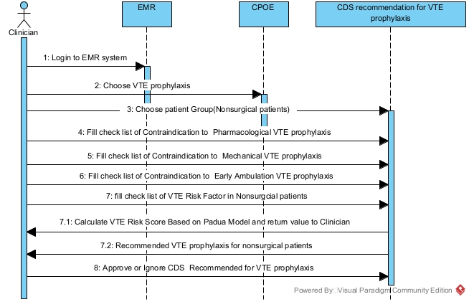
Diagram 8- Sequence diagram for CDS recommendation for VTE prophylaxis in nonsurgical patients

