Megafire attributes and pre-fire structural legacies shape short-term avian responses in an Atlantic-Mediterranean ecotone
Fernando García-Fernández^{1,2*}, Adrián Regos², Miguel Cánibe^{1,3}, María Vidal¹ & Jesús Domínguez^{1*}
¹ Department of Zoology, Genetics and Physical Anthropology, University of Santiago de Compostela, Santiago de Compostela 15705, Spain
² Misión Biolóxica de Galicia-Consejo Superior de Investigaciones Científicas (MBG-CSIC), Santiago de Compostela 15705, Spain
³ Department of Conservation Biology and Global Change, Doñana Biological Station EBD-CSIC, Sevilla 41092, Spain
*Correspondence: Fernando García-Fernández, fernando.garcia4@rai.usc.es

Supplementary Material

Tables

Table S1. UTM coordinates, elevation (m a.s.l.), vegetation type, and fire zone (burned vs. unburned) for each bird point count.
ID | UTM Zone* | X | Y | Elevation | Vegetation Type | Zone
BNQ01 | 29 T | 654485 | 4720539 | 790 | Natural Forest | Unburned
BNQ02 | 29 T | 654638 | 4720397 | 828 | Natural Forest | Unburned
BNQ03 | 29 T | 654776 | 4720244 | 843 | Natural Forest | Unburned
BNQ04 | 29 T | 654937 | 4720127 | 876 | Natural Forest | Unburned
BNQ05 | 29 T | 654858 | 4720521 | 901 | Natural Forest | Unburned
BNQ06 | 29 T | 654951 | 4720312 | 931 | Natural Forest | Unburned
BNQ07 | 29 T | 655117 | 4720186 | 962 | Natural Forest | Unburned
BNQ08 | 29 T | 655322 | 4720117 | 958 | Natural Forest | Unburned
BNQ09 | 29 T | 655326 | 4719005 | 1267 | Natural Forest | Unburned
BNQ10 | 29 T | 655485 | 4720028 | 1020 | Natural Forest | Unburned
BNQ11 | 29 T | 654322 | 4720430 | 783 | Natural Forest | Unburned
BNQ12 | 29 T | 654320 | 4720147 | 794 | Natural Forest | Unburned
BNQ13 | 29 T | 654337 | 4719943 | 827 | Natural Forest | Unburned
BNQ14 | 29 T | 654354 | 4719774 | 857 | Natural Forest | Unburned
BNQ15 | 29 T | 654486 | 4719492 | 894 | Natural Forest | Unburned
BNQ16 | 29 T | 654958 | 4718745 | 1251 | Natural Forest | Unburned
BNQ17 | 29 T | 647824 | 4723226 | 1141 | Natural Forest | Unburned
BNQ18 | 29 T | 647570 | 4723252 | 1108 | Natural Forest | Unburned
BNQ19 | 29 T | 647735 | 4723397 | 1076 | Natural Forest | Unburned
BNQ20 | 29 T | 654763 | 4718813 | 1257 | Natural Forest | Unburned
BNQ21 | 29 T | 658113 | 4719718 | 1110 | Natural Forest | Unburned
BNQ22 | 29 T | 658113 | 4719913 | 1124 | Natural Forest | Unburned
BNQ23 | 29 T | 655451 | 4719236 | 1254 | Natural Forest | Unburned
BNQ24 | 29 T | 657893 | 4720290 | 1164 | Natural Forest | Unburned
BNQ25 | 29 T | 655117 | 4718905 | 1273 | Natural Forest | Unburned
BNQ26 | 29 T | 657405 | 4720235 | 1220 | Natural Forest | Unburned
BNQ27 | 29 T | 657185 | 4720274 | 1259 | Natural Forest | Unburned
BNQ28 | 29 T | 656986 | 4720299 | 1285 | Natural Forest | Unburned
BNQ29 | 29 T | 656780 | 4720300 | 1314 | Natural Forest | Unburned
BNQ30 | 29 T | 656595 | 4720388 | 1337 | Natural Forest | Unburned
BQ01 | 29 T | 644768 | 4714630 | 610 | Natural Forest | Burned
BQ02 | 29 T | 644769 | 4714442 | 567 | Natural Forest | Burned
BQ03 | 29 T | 644801 | 4714180 | 544 | Natural Forest | Burned
BQ04 | 29 T | 644577 | 4714017 | 561 | Natural Forest | Burned
BQ05 | 29 T | 644677 | 4713866 | 533 | Natural Forest | Burned
BQ06 | 29 T | 645233 | 4714089 | 574 | Natural Forest | Burned
BQ07 | 29 T | 638852 | 4713000 | 466 | Natural Forest | Burned
BQ08 | 29 T | 639063 | 4713082 | 469 | Natural Forest | Burned
BQ09 | 29 T | 639265 | 4713039 | 466 | Natural Forest | Burned
BQ10 | 29 T | 639520 | 4713037 | 514 | Natural Forest | Burned
BQ11 | 29 T | 639711 | 4712914 | 526 | Natural Forest | Burned
BQ12 | 29 T | 646031 | 4712499 | 624 | Natural Forest | Burned
BQ13 | 29 T | 645974 | 4712643 | 647 | Natural Forest | Burned
BQ14 | 29 T | 645804 | 4712470 | 585 | Natural Forest | Burned
BQ15 | 29 T | 638997 | 4718355 | 973 | Natural Forest | Burned
BQ16 | 29 T | 640232 | 4718351 | 1109 | Natural Forest | Burned
BQ17 | 29 T | 639799 | 4718326 | 1044 | Natural Forest | Burned
BQ18 | 29 T | 639293 | 4718485 | 1085 | Natural Forest | Burned
BQ19 | 29 T | 639217 | 4718358 | 1055 | Natural Forest | Burned
BQ20 | 29 T | 639015 | 4718109 | 950 | Natural Forest | Burned
BQ21 | 29 T | 638788 | 4718000 | 950 | Natural Forest | Burned
BQ22 | 29 T | 638635 | 4717746 | 955 | Natural Forest | Burned
BQ23 | 29 T | 639953 | 4715394 | 870 | Natural Forest | Burned
BQ24 | 29 T | 640009 | 4715842 | 802 | Natural Forest | Burned
BQ25 | 29 T | 639816 | 4715775 | 756 | Natural Forest | Burned
BQ26 | 29 T | 639721 | 4715621 | 783 | Natural Forest | Burned
BQ30 | 29 T | 639943 | 4712916 | 537 | Natural Forest | Burned
MNQ01 | 29 T | 640671 | 4722712 | 952 | Heathland | Unburned
MNQ02 | 29 T | 640699 | 4722950 | 988 | Heathland | Unburned
MNQ03 | 29 T | 641382 | 4722762 | 997 | Heathland | Unburned
MNQ04 | 29 T | 641461 | 4722378 | 1003 | Heathland | Unburned
MNQ05 | 29 T | 641376 | 4722095 | 1015 | Heathland | Unburned
MNQ06 | 29 T | 641059 | 4723946 | 1081 | Heathland | Unburned
MNQ07 | 29 T | 641011 | 4723744 | 1058 | Heathland | Unburned
MNQ08 | 29 T | 640911 | 4723578 | 1038 | Heathland | Unburned
MNQ09 | 29 T | 640829 | 4723382 | 1026 | Heathland | Unburned
MNQ10 | 29 T | 640761 | 4723164 | 1010 | Heathland | Unburned
MNQ11 | 29 T | 641849 | 4721324 | 989 | Heathland | Unburned
MNQ12 | 29 T | 641887 | 4721527 | 1007 | Heathland | Unburned
MNQ13 | 29 T | 641744 | 4721722 | 1039 | Heathland | Unburned
MNQ14 | 29 T | 641574 | 4721939 | 1044 | Heathland | Unburned
MNQ15 | 29 T | 641222 | 4721968 | 997 | Heathland | Unburned
MNQ21 | 29 T | 647786 | 4717167 | 690 | Heathland | Unburned
MNQ22 | 29 T | 648526 | 4717395 | 793 | Heathland | Unburned
MNQ23 | 29 T | 648758 | 4717441 | 822 | Heathland | Unburned
MNQ24 | 29 T | 649020 | 4717427 | 860 | Heathland | Unburned
MNQ25 | 29 T | 649348 | 4717175 | 882 | Heathland | Unburned
MNQ26 | 29 T | 649296 | 4717440 | 933 | Heathland | Unburned
MNQ27 | 29 T | 649228 | 4717631 | 945 | Heathland | Unburned
MNQ28 | 29 T | 649114 | 4717865 | 977 | Heathland | Unburned
MNQ29 | 29 T | 648219 | 4723104 | 1324 | Heathland | Unburned
MNQ30 | 29 T | 648060 | 4723208 | 1237 | Heathland | Unburned
MQ01 | 29 T | 641260 | 4715299 | 934 | Heathland | Burned
MQ02 | 29 T | 640987 | 4716528 | 968 | Heathland | Burned
MQ03 | 29 T | 641140 | 4716680 | 986 | Heathland | Burned
MQ04 | 29 T | 649587 | 4717085 | 890 | Heathland | Burned
MQ06 | 29 T | 649236 | 4713796 | 1291 | Heathland | Burned
MQ07 | 29 T | 649291 | 4714100 | 1261 | Heathland | Burned
MQ08 | 29 T | 649378 | 4714161 | 1241 | Heathland | Burned
MQ09 | 29 T | 649411 | 4714582 | 1203 | Heathland | Burned
MQ10 | 29 T | 649370 | 4714785 | 1181 | Heathland | Burned
MQ12 | 29 T | 649941 | 4715237 | 1265 | Heathland | Burned
MQ13 | 29 T | 650156 | 4715334 | 1248 | Heathland | Burned
MQ16 | 29 T | 641266 | 4715512 | 897 | Heathland | Burned
MQ20 | 29 T | 640925 | 4716329 | 950 | Heathland | Burned
MQ21 | 29 T | 643910 | 4715649 | 943 | Heathland | Burned
MQ22 | 29 T | 643981 | 4715863 | 939 | Heathland | Burned
MQ24 | 29 T | 642873 | 4717637 | 1127 | Heathland | Burned
MQ26 | 29 T | 642626 | 4717025 | 993 | Heathland | Burned
MQ27 | 29 T | 642825 | 4717056 | 1033 | Heathland | Burned
MQ28 | 29 T | 643021 | 4717078 | 1036 | Heathland | Burned
MQ29 | 29 T | 643165 | 4717228 | 1092 | Heathland | Burned
MQ30 | 29 T | 642984 | 4717442 | 1119 | Heathland | Burned
MQ31 | 29 T | 646888 | 4718331 | 924 | Heathland | Burned
MQ32 | 29 T | 646923 | 4718524 | 951 | Heathland | Burned
MQ33 | 29 T | 646952 | 4718719 | 1002 | Heathland | Burned
MQ34 | 29 T | 646887 | 4718916 | 1011 | Heathland | Burned
MQ35 | 29 T | 646702 | 4719032 | 1014 | Heathland | Burned
PNQ01 | 29 T | 641287 | 4708854 | 862 | Pine Plantation | Unburned
PNQ02 | 29 T | 641397 | 4709025 | 855 | Pine Plantation | Unburned
PNQ03 | 29 T | 641533 | 4709179 | 864 | Pine Plantation | Unburned
PNQ04 | 29 T | 641737 | 4709270 | 872 | Pine Plantation | Unburned
PNQ05 | 29 T | 642069 | 4709446 | 885 | Pine Plantation | Unburned
PNQ06 | 29 T | 641891 | 4709114 | 878 | Pine Plantation | Unburned
PNQ07 | 29 T | 641969 | 4708911 | 878 | Pine Plantation | Unburned
PNQ08 | 29 T | 642198 | 4708950 | 869 | Pine Plantation | Unburned
PNQ09 | 29 T | 642299 | 4709369 | 873 | Pine Plantation | Unburned
PNQ10 | 29 T | 642264 | 4709159 | 871 | Pine Plantation | Unburned
PNQ11 | 29 T | 641792 | 4709559 | 884 | Pine Plantation | Unburned
PNQ12 | 29 T | 641941 | 4709721 | 861 | Pine Plantation | Unburned
PNQ13 | 29 T | 641570 | 4709653 | 922 | Pine Plantation | Unburned
PNQ14 | 29 T | 641438 | 4709497 | 913 | Pine Plantation | Unburned
PNQ15 | 29 T | 641361 | 4709296 | 889 | Pine Plantation | Unburned
PNQ16 | 29 T | 647801 | 4722840 | 1281 | Pine Plantation | Unburned
PNQ18 | 29 T | 636873 | 4714627 | 671 | Pine Plantation | Unburned
PNQ19 | 29 T | 636610 | 4714588 | 658 | Pine Plantation | Unburned
PNQ20 | 29 T | 647999 | 4722878 | 1294 | Pine Plantation | Unburned
PNQ26 | 29 T | 636235 | 4715036 | 687 | Pine Plantation | Unburned
PNQ27 | 29 T | 635864 | 4714480 | 631 | Pine Plantation | Unburned
PNQ28 | 29 T | 636067 | 4714499 | 647 | Pine Plantation | Unburned
PNQ29 | 29 T | 636106 | 4714272 | 596 | Pine Plantation | Unburned
PNQ30 | 29 T | 636285 | 4714498 | 632 | Pine Plantation | Unburned
PQ01 | 29 T | 643894 | 4714896 | 885 | Pine Plantation | Burned
PQ02 | 29 T | 643735 | 4714433 | 873 | Pine Plantation | Burned
PQ03 | 29 T | 643742 | 4714643 | 867 | Pine Plantation | Burned
PQ04 | 29 T | 643645 | 4714190 | 870 | Pine Plantation | Burned
PQ05 | 29 T | 643654 | 4713996 | 838 | Pine Plantation | Burned
PQ06 | 29 T | 643308 | 4712708 | 665 | Pine Plantation | Burned
PQ07 | 29 T | 643845 | 4713607 | 831 | Pine Plantation | Burned
PQ08 | 29 T | 643319 | 4712895 | 710 | Pine Plantation | Burned
PQ09 | 29 T | 643534 | 4712883 | 685 | Pine Plantation | Burned
PQ10 | 29 T | 644086 | 4714895 | 891 | Pine Plantation | Burned
PQ11 | 29 T | 644575 | 4715411 | 839 | Pine Plantation | Burned
PQ12 | 29 T | 648007 | 4713879 | 1144 | Pine Plantation | Burned
PQ13 | 29 T | 648141 | 4712594 | 1187 | Pine Plantation | Burned
PQ14 | 29 T | 643419 | 4713716 | 1188 | Pine Plantation | Burned
PQ15 | 29 T | 649728 | 4715115 | 1267 | Pine Plantation | Burned
PQ21 | 29 T | 642394 | 4712162 | 580 | Pine Plantation | Burned
PQ22 | 29 T | 642550 | 4712272 | 604 | Pine Plantation | Burned
PQ23 | 29 T | 642854 | 4712433 | 638 | Pine Plantation | Burned
PQ24 | 29 T | 643056 | 4712452 | 644 | Pine Plantation | Burned
PQ25 | 29 T | 643262 | 4712500 | 640 | Pine Plantation | Burned
PQ26 | 29 T | 646764 | 4712027 | 1017 | Pine Plantation | Burned
PQ27 | 29 T | 647345 | 4712763 | 1020 | Pine Plantation | Burned
PQ28 | 29 T | 647493 | 4712976 | 1030 | Pine Plantation | Burned
PQ29 | 29 T | 647647 | 4713263 | 1051 | Pine Plantation | Burned
PQ30 | 29 T | 648052 | 4713591 | 1133 | Pine Plantation | Burned
SNQ01 | 29 T | 642731 | 4720752 | 661 | Chestnut Woodland | Unburned
SNQ03 | 29 T | 642576 | 4720430 | 715 | Chestnut Woodland | Burned
SNQ04 | 29 T | 650500 | 4721421 | 603 | Chestnut Woodland | Unburned
SNQ05 | 29 T | 642550 | 4721387 | 674 | Chestnut Woodland | Unburned
SNQ06 | 29 T | 642739 | 4721736 | 656 | Chestnut Woodland | Unburned
SNQ07 | 29 T | 645554 | 4720275 | 720 | Chestnut Woodland | Unburned
SNQ08 | 29 T | 645512 | 4720070 | 694 | Chestnut Woodland | Unburned
SNQ09 | 29 T | 645432 | 4719907 | 686 | Chestnut Woodland | Unburned
SNQ10 | 29 T | 645246 | 4719943 | 738 | Chestnut Woodland | Unburned
SNQ11 | 29 T | 645469 | 4720432 | 780 | Chestnut Woodland | Unburned
SNQ12 | 29 T | 648021 | 4716257 | 603 | Chestnut Woodland | Unburned
SNQ13 | 29 T | 647826 | 4716288 | 587 | Chestnut Woodland | Unburned
SNQ14 | 29 T | 647599 | 4716271 | 634 | Chestnut Woodland | Unburned
SNQ15 | 29 T | 647725 | 4716131 | 654 | Chestnut Woodland | Unburned
SNQ16 | 29 T | 647417 | 4716106 | 664 | Chestnut Woodland | Unburned
SNQ17 | 29 T | 650451 | 4721641 | 652 | Chestnut Woodland | Unburned
SNQ18 | 29 T | 650231 | 4722082 | 794 | Chestnut Woodland | Unburned
SNQ19 | 29 T | 650139 | 4722267 | 770 | Chestnut Woodland | Unburned
SNQ20 | 29 T | 650018 | 4722096 | 860 | Chestnut Woodland | Unburned
SNQ21 | 29 T | 654305 | 4720950 | 744 | Chestnut Woodland | Unburned
SNQ22 | 29 T | 654459 | 4720783 | 768 | Chestnut Woodland | Unburned
SNQ23 | 29 T | 654690 | 4720766 | 808 | Chestnut Woodland | Unburned
SNQ24 | 29 T | 653781 | 4720969 | 723 | Chestnut Woodland | Unburned
SNQ25 | 29 T | 653501 | 4720954 | 697 | Chestnut Woodland | Unburned
SNQ26 | 29 T | 651765 | 4722246 | 617 | Chestnut Woodland | Unburned
SNQ27 | 29 T | 651696 | 4722695 | 743 | Chestnut Woodland | Unburned
SNQ28 | 29 T | 651452 | 4723064 | 760 | Chestnut Woodland | Unburned
SNQ29 | 29 T | 651505 | 4723272 | 784 | Chestnut Woodland | Unburned
SNQ30 | 29 T | 651354 | 4723687 | 811 | Chestnut Woodland | Unburned
SQ01 | 29 T | 641458 | 4713812 | 585 | Chestnut Woodland | Burned
SQ02 | 29 T | 641282 | 4713577 | 596 | Chestnut Woodland | Burned
SQ03 | 29 T | 641109 | 4713371 | 613 | Chestnut Woodland | Burned
SQ04 | 29 T | 640947 | 4713247 | 604 | Chestnut Woodland | Burned
SQ05 | 29 T | 640802 | 4713122 | 602 | Chestnut Woodland | Burned
SQ06 | 29 T | 640722 | 4712964 | 593 | Chestnut Woodland | Burned
SQ07 | 29 T | 640610 | 4712801 | 585 | Chestnut Woodland | Burned
SQ08 | 29 T | 641143 | 4713195 | 645 | Chestnut Woodland | Burned
SQ09 | 29 T | 645295 | 4713887 | 558 | Chestnut Woodland | Burned
SQ10 | 29 T | 645430 | 4713731 | 554 | Chestnut Woodland | Burned
SQ11 | 29 T | 645619 | 4713654 | 514 | Chestnut Woodland | Burned
SQ12 | 29 T | 645492 | 4713924 | 465 | Chestnut Woodland | Burned
SQ13 | 29 T | 645149 | 4712509 | 542 | Chestnut Woodland | Burned
SQ14 | 29 T | 645333 | 4712470 | 527 | Chestnut Woodland | Burned
SQ15 | 29 T | 645512 | 4712567 | 534 | Chestnut Woodland | Burned
SQ16 | 29 T | 644922 | 4712651 | 552 | Chestnut Woodland | Burned
SQ17 | 29 T | 646260 | 4713003 | 646 | Chestnut Woodland | Burned
SQ18 | 29 T | 643808 | 4712371 | 504 | Chestnut Woodland | Burned
SQ19 | 29 T | 643620 | 4712398 | 508 | Chestnut Woodland | Burned
SQ20 | 29 T | 643718 | 4712068 | 483 | Chestnut Woodland | Burned
SQ21 | 29 T | 643651 | 4711882 | 456 | Chestnut Woodland | Burned
SQ22 | 29 T | 643841 | 4711912 | 467 | Chestnut Woodland | Burned
SQ23 | 29 T | 644056 | 4712105 | 453 | Chestnut Woodland | Burned
SQ24 | 29 T | 643098 | 4711587 | 411 | Chestnut Woodland | Burned
SQ25 | 29 T | 643265 | 4711477 | 422 | Chestnut Woodland | Burned
SQ26 | 29 T | 643498 | 4711417 | 455 | Chestnut Woodland | Burned
SQ27 | 29 T | 640151 | 4712756 | 539 | Chestnut Woodland | Burned
SQ28 | 29 T | 643991 | 4712692 | 553 | Chestnut Woodland | Burned
SQ29 | 29 T | 642765 | 4720558 | 645 | Chestnut Woodland | Burned
*ETRS 89

Table S2. Functional trait classification of all bird species recorded during the survey. Each species was assigned to multiple trait categories based on five ecologically relevant axes: dietary guild, habitat breadth, habitat selection, foraging stratum, and cavity-nesting behaviour. Presence within a given category is indicated by “1”, absence by “0”. Further methodological details are available in Text S1.
COLUMN | TRAIT CATEGORY | DESCRIPTION
Insectivores, Frugivores, Granivores, Omnivores | Dietary guild | Main diet type(s) used by the species
HB 1, HB 2, HB 3 | Habitat breadth | HB 1 = habitat specialists (1–2 habitats); HB 2 = intermediate (3–4); HB 3 = generalists (≥5)
F_spec, F_fac, Shr, Open | Habitat selection | F_spec = forest specialists; F_fac = facultative forest species; Shr = shrubland species; Open = open-habitat species
Can_f, Shr_f, Grou_f | Foraging stratum | Can_f = canopy foragers; Shr_f = understorey/shrub layer foragers; Grou_f = ground foragers
Cav_nest, Exc, NonExc | Cavity-nesting behaviour | Cav_nest = Cavity nesters; Exc = excavators; NonExc = non-excavators.

SPECIES | Insectivores | Frugivores | Granivores | Omnivores | HB 1 | HB 2 | HB 3 | F_spec | F_fac | Shr | Open | Can_f | Shr_f | Grou_f | Cav_nest | Exc | NonExc
Aegithalos caudatus | 1 | 0 | 0 | 0 | 0 | 1 | 0 | 0 | 1 | 0 | 0 | 1 | 1 | 0 | 0 | 0 | 0
Alauda arvensis | 1 | 0 | 1 | 0 | 1 | 0 | 0 | 0 | 0 | 0 | 1 | 0 | 0 | 1 | 0 | 0 | 0
Alectoris rufa | 0 | 0 | 1 | 0 | 1 | 0 | 0 | 0 | 0 | 1 | 1 | 0 | 0 | 1 | 0 | 0 | 0
Anthus campestris | 1 | 0 | 1 | 0 | 1 | 0 | 0 | 0 | 0 | 0 | 1 | 0 | 0 | 1 | 0 | 0 | 0
Anthus spinoletta | 1 | 0 | 0 | 0 | 1 | 0 | 0 | 0 | 0 | 0 | 1 | 0 | 0 | 1 | 0 | 0 | 0
Anthus trivialis | 1 | 0 | 0 | 0 | 0 | 1 | 0 | 0 | 1 | 1 | 0 | 0 | 0 | 1 | 0 | 0 | 0
Carduelis carduelis | 1 | 0 | 1 | 0 | 0 | 0 | 1 | 0 | 1 | 0 | 0 | 1 | 1 | 1 | 0 | 0 | 0
Certhia brachydactyla | 1 | 0 | 0 | 0 | 1 | 0 | 0 | 1 | 0 | 0 | 0 | 1 | 1 | 0 | 1 | 0 | 1
Chloris chloris | 0 | 0 | 1 | 0 | 0 | 1 | 0 | 0 | 1 | 0 | 0 | 1 | 1 | 1 | 0 | 0 | 0
Columba palumbus | 0 | 1 | 1 | 0 | 0 | 0 | 1 | 0 | 1 | 0 | 0 | 1 | 0 | 1 | 0 | 0 | 0
Corvus corone | 1 | 0 | 1 | 1 | 0 | 0 | 1 | 0 | 1 | 0 | 0 | 0 | 0 | 1 | 0 | 0 | 0
Coturnix coturnix | 0 | 0 | 1 | 0 | 1 | 0 | 0 | 0 | 0 | 0 | 1 | 0 | 0 | 1 | 0 | 0 | 0
Cuculus canorus | 1 | 0 | 0 | 0 | 0 | 1 | 0 | 0 | 1 | 1 | 0 | 1 | 1 | 0 | 0 | 0 | 0
Cyanistes caeruleus | 1 | 1 | 1 | 0 | 0 | 1 | 0 | 0 | 1 | 0 | 0 | 1 | 1 | 1 | 1 | 0 | 1
Dendrocopos major | 1 | 1 | 1 | 1 | 1 | 0 | 0 | 1 | 0 | 0 | 0 | 1 | 1 | 0 | 1 | 1 | 0
Emberiza calandra | 1 | 0 | 1 | 0 | 1 | 0 | 0 | 0 | 0 | 0 | 1 | 0 | 0 | 1 | 0 | 0 | 0
Emberiza cia | 0 | 0 | 1 | 0 | 0 | 1 | 0 | 0 | 1 | 1 | 0 | 0 | 0 | 1 | 0 | 0 | 0
Emberiza cirlus | 1 | 0 | 1 | 0 | 0 | 1 | 0 | 0 | 1 | 0 | 0 | 0 | 0 | 1 | 0 | 0 | 0
Emberiza citrinella | 1 | 0 | 1 | 0 | 0 | 1 | 0 | 0 | 1 | 1 | 1 | 0 | 0 | 1 | 0 | 0 | 0
Erithacus rubecula | 1 | 1 | 1 | 0 | 0 | 0 | 1 | 0 | 1 | 0 | 0 | 0 | 0 | 1 | 0 | 0 | 0
Fringilla coelebs | 1 | 1 | 1 | 0 | 0 | 1 | 0 | 0 | 1 | 0 | 0 | 1 | 1 | 1 | 0 | 0 | 0
Galerida cristata | 1 | 0 | 1 | 0 | 1 | 0 | 0 | 0 | 0 | 0 | 1 | 0 | 0 | 1 | 0 | 0 | 0
Garrulus glandarius | 1 | 0 | 1 | 1 | 0 | 1 | 0 | 0 | 1 | 0 | 0 | 1 | 0 | 1 | 0 | 0 | 0
Hippolais polyglotta | 1 | 0 | 0 | 0 | 0 | 0 | 1 | 0 | 1 | 1 | 0 | 1 | 1 | 0 | 0 | 0 | 0
Linaria cannabina | 0 | 0 | 1 | 0 | 0 | 1 | 0 | 0 | 0 | 1 | 1 | 0 | 0 | 1 | 0 | 0 | 0
Lophophanes cristatus | 1 | 0 | 1 | 0 | 1 | 0 | 0 | 1 | 0 | 0 | 0 | 1 | 1 | 0 | 1 | 1 | 0
Loxia curvirostra | 1 | 1 | 1 | 0 | 1 | 0 | 0 | 1 | 0 | 0 | 0 | 1 | 0 | 0 | 0 | 0 | 0
Lullula arborea | 1 | 0 | 1 | 0 | 0 | 1 | 0 | 0 | 1 | 1 | 0 | 0 | 0 | 1 | 0 | 0 | 0
Muscicapa striata | 1 | 1 | 0 | 0 | 0 | 1 | 0 | 1 | 0 | 0 | 0 | 1 | 0 | 0 | 0 | 0 | 0
Oriolus oriolus | 1 | 1 | 0 | 0 | 1 | 0 | 0 | 0 | 1 | 0 | 0 | 1 | 0 | 0 | 0 | 0 | 0
Parus major | 1 | 0 | 1 | 0 | 0 | 0 | 1 | 0 | 1 | 0 | 0 | 1 | 1 | 1 | 1 | 0 | 1
Periparus ater | 1 | 0 | 1 | 0 | 0 | 1 | 0 | 0 | 1 | 0 | 0 | 1 | 1 | 1 | 1 | 0 | 1
Phoenicurus ochruros | 1 | 1 | 0 | 0 | 0 | 1 | 0 | 0 | 0 | 0 | 1 | 0 | 1 | 1 | 0 | 0 | 0
Phylloscopus bonelli | 1 | 0 | 0 | 0 | 1 | 0 | 0 | 1 | 0 | 0 | 0 | 1 | 0 | 0 | 0 | 0 | 0
Phylloscopus ibericus | 1 | 1 | 0 | 0 | 0 | 1 | 0 | 0 | 1 | 0 | 0 | 1 | 1 | 0 | 0 | 0 | 0
Picus sharpei | 1 | 0 | 0 | 0 | 0 | 1 | 0 | 0 | 1 | 0 | 0 | 1 | 1 | 1 | 1 | 1 | 0
Poecile palustris | 1 | 1 | 1 | 0 | 1 | 0 | 0 | 1 | 0 | 0 | 0 | 1 | 1 | 1 | 1 | 0 | 1
Prunella modularis | 1 | 0 | 1 | 0 | 0 | 1 | 0 | 0 | 1 | 1 | 0 | 0 | 1 | 1 | 0 | 0 | 0
Pyrrhula pyrrhula | 1 | 1 | 1 | 0 | 0 | 1 | 0 | 0 | 1 | 0 | 0 | 1 | 1 | 1 | 0 | 0 | 0
Regulus ignicapilla | 1 | 0 | 0 | 0 | 0 | 1 | 0 | 1 | 0 | 0 | 0 | 1 | 0 | 0 | 0 | 0 | 0
Regulus regulus | 1 | 0 | 0 | 0 | 1 | 0 | 0 | 1 | 0 | 0 | 0 | 1 | 1 | 1 | 0 | 0 | 0
Saxicola rubicola | 1 | 0 | 0 | 0 | 0 | 1 | 0 | 0 | 0 | 1 | 1 | 0 | 0 | 1 | 0 | 0 | 0
Serinus serinus | 0 | 0 | 1 | 0 | 0 | 1 | 0 | 0 | 1 | 0 | 0 | 1 | 0 | 1 | 0 | 0 | 0
Sitta europaea | 1 | 0 | 1 | 0 | 1 | 0 | 0 | 1 | 0 | 0 | 0 | 1 | 0 | 0 | 1 | 0 | 1
Streptopelia turtur | 0 | 1 | 1 | 0 | 0 | 1 | 0 | 0 | 1 | 0 | 0 | 0 | 0 | 1 | 0 | 0 | 0
Sturnus unicolor | 1 | 1 | 1 | 0 | 0 | 1 | 0 | 0 | 1 | 0 | 1 | 0 | 0 | 1 | 1 | 0 | 1
Sylvia atricapilla | 1 | 1 | 0 | 0 | 0 | 0 | 1 | 0 | 1 | 0 | 0 | 1 | 1 | 1 | 0 | 0 | 0
Sylvia borin | 1 | 1 | 0 | 0 | 0 | 1 | 0 | 0 | 1 | 1 | 0 | 1 | 1 | 0 | 0 | 0 | 0
Sylvia cantillans | 1 | 1 | 0 | 0 | 0 | 1 | 0 | 0 | 0 | 1 | 0 | 0 | 1 | 0 | 0 | 0 | 0
Sylvia communis | 1 | 1 | 0 | 0 | 0 | 0 | 1 | 0 | 0 | 1 | 0 | 0 | 1 | 0 | 0 | 0 | 0
Sylvia melanocephala | 1 | 1 | 0 | 0 | 0 | 0 | 1 | 0 | 0 | 1 | 0 | 0 | 1 | 1 | 0 | 0 | 0
Curruca undata | 1 | 0 | 0 | 0 | 1 | 0 | 0 | 0 | 0 | 1 | 0 | 0 | 1 | 0 | 0 | 0 | 0
Troglodytes troglodytes | 1 | 0 | 0 | 0 | 0 | 0 | 1 | 0 | 1 | 1 | 0 | 0 | 1 | 1 | 0 | 0 | 0
Turdus merula | 1 | 1 | 0 | 0 | 0 | 0 | 1 | 0 | 1 | 1 | 0 | 0 | 1 | 1 | 0 | 0 | 0
Turdus philomelos | 1 | 1 | 0 | 0 | 0 | 1 | 0 | 0 | 1 | 0 | 0 | 1 | 1 | 1 | 0 | 0 | 0
Turdus viscivorus | 1 | 1 | 0 | 0 | 0 | 1 | 0 | 0 | 1 | 1 | 1 | 1 | 1 | 1 | 0 | 0 | 0
Note: All scientific names follow HBW and BirdLife International (2024)

Table S3. Environmental variables used to describe vegetation structure and composition within 30 m radius sampling plots
Variable | Acronym | Units | Description | Method of Collection
Elevation | H | m.a.s.l. | Elevation above sea level. | Measured in situ using a handheld GPS (Garmin eTrex 20x)
Canopy cover | Ccov | % | Percentage of area covered by tree canopy. | Measured along two 10 m transects extending from plot centre, using a GRS vertical densitometer.
Dead tree height | Hdead | m | Height of standing dead trees. | Measured within the 30 m radius sampling plot using a rangefinder (Leica Rangemaster CRF2400), pointing at the top of each tree and adding observer’s eye height.
GBH of dead trees | GBHd | cm | Girth at breast height of standing dead trees. | Measured at 1.3 m above ground within the 30 m radius plot using a flexible measuring tape.
GBH of living trees | GBH | cm | Girth at breast height of living trees. | Measured at 1.3 m above ground within the 30 m radius plot using a flexible measuring tape.
Vegetation type |  |  | Type of habitat. | Categorized as heathlands, natural forests, chestnut woodlands, or pine plantations.
Herbaceous cover | Herb | % | Percentage of area covered by herbaceous plants. | Visually estimated in each 25 m² subplot and averaged within each sampling plot.
Litter ground cover | Litt | % | Percentage of area covered by leaf litter (forest plots only) | Visually estimated in each 25 m² subplot and averaged within each forest sampling plot.
Lying deadwood volume | Wood | cm³ | Total volume of lying dead wood. | Calculated using Huber’s formula for dead stems within a 15 m radius plot.
Number of dead trees | Dead | (count) | Total count of standing dead trees. | Counted along two 10 m transects from the plot centre.
Number of living trees | Liv | (count) | Total count of living trees. | Counted along two 10 m transects from the plot centre.
Number of shrub species | Sshr | (count) | Total count of shrub species with >10% cover. | Counted across all 25 m² subplots within each sampling plot.
Shrub coverage index | Shr |  | Approximation of shrub biomass, calculated as the product of average shrub height and percentage shrub cover. | Calculated and averaged across all 25 m² subplots within each sampling plot.
Slope | Slo | % | Average slope of the terrain. | Determined using QGIS version 3.34.
Total number of tree species | Ntsp | (count) | Total count of different tree species. | Counted along two 10 m transects from the plot centre.
Total number of mature trees | Mt | (count) | Total count of mature trees. Classified as mature based on GBH>100cm | Counted within a 10 m radius sampling plot.
Tree height | Hliv | m | Average height of living trees. | Measured within the 30 m radius sampling plot using a rangefinder (Leica Rangemaster CRF2400), pointing at the top of each tree and adding observer’s eye height.
Bare ground cover | Bare | % | Percentage of area covered by bare ground (heathland plots only) | Visually estimated in each 25 m² subplot and averaged within each heathland sampling plot.
Tree cover | Tree | % | Percentage of area covered by tree canopy (heathland plots only) | Visually estimated in each 25 m² subplot and averaged within each heathland sampling plot.

Table S4. Visual and satellite-derived fire severity and heterogeneity values for each sampling plot. Visual fire severity was estimated in situ based on field observations within a 50 m radius following a structural index adapted from Keeley (2009). Mean and standard deviation (SD) of dNBR values were calculated from Sentinel-2 imagery (pre-fire: 14 July 2022; post-fire: 1 August 2022) within 50 m and 120 m buffers, respectively.
Point Count | Burn Status | Visual Severity | Mean_dNBR | SD_dNBR
BQ1 | Burned | 11 | 363.731 | 79.282
BQ10 | Burned | 10 | 402.646 | 97.628
BQ11 | Burned | 9 | 298.303 | 75.342
BQ12 | Burned | 6 | 220.861 | 83.422
BQ13 | Burned | 7 | 273.463 | 83.175
BQ14 | Burned | 6 | 248.111 | 77.521
BQ15 | Burned | 6 | 237.557 | 104.085
BQ16 | Burned | 11 | 433.371 | 105.691
BQ17 | Burned | 12 | 528.095 | 104.529
BQ18 | Burned | 6 | 191.072 | 130.886
BQ19 | Burned | 0 | 200.491 | 88.392
BQ2 | Burned | 11 | 326.295 | 54.586
BQ20 | Burned | 2 | 153.724 | 96.55
BQ21 | Burned | 5 | 200.962 | 80.968
BQ22 | Burned | 5 | 229.964 | 129.623
BQ23 | Burned | 10 | 271.998 | 86.651
BQ24 | Burned | 6 | 273.926 | 90.926
BQ25 | Burned | 2 | 94.004 | 80.41
BQ26 | Burned | 5 | 147.365 | 127.577
BQ3 | Burned | 11 | 359.371 | 77.622
BQ30 | Burned | 7 | 250.866 | 108.003
BQ4 | Burned | 9 | 448.558 | 87.88
BQ5 | Burned | 6 | 383.268 | 105.715
BQ6 | Burned | 4 | 142.994 | 107.638
BQ7 | Burned | 6 | 186.047 | 92.668
BQ8 | Burned | 5 | 90.822 | 80.866
BQ9 | Burned | 2 | 81.1 | 60.479
MQ1 | Burned | 12 | 170.426 | 101.749
MQ10 | Burned | 12 | 342.728 | 71.287
MQ12 | Burned | 12 | 345.738 | 66.707
MQ13 | Burned | 10 | 342.704 | 45.201
MQ16 | Burned | 5 | 242.976 | 134.32
MQ2 | Burned | 7 | 437.606 | 131.666
MQ20 | Burned | 7 | 249.703 | 101.777
MQ21 | Burned | 11 | 205.391 | 62.61
MQ22 | Burned | 9 | 325.575 | 55.326
MQ24 | Burned | 11 | 319.495 | 93.438
MQ26 | Burned | 12 | 330.152 | 67.539
MQ27 | Burned | 10 | 269.263 | 76.789
MQ28 | Burned | 11 | 364.329 | 141.387
MQ29 | Burned | 11 | 380.973 | 138.394
MQ3 | Burned | 11 | 228.183 | 102.352
MQ30 | Burned | 10 | 405.405 | 89.422
MQ31 | Burned | 12 | 268.762 | 42.653
MQ32 | Burned | 12 | 288.781 | 38.594
MQ33 | Burned | 12 | 282.197 | 37.811
MQ34 | Burned | 12 | 293.79 | 31.642
MQ35 | Burned | 12 | 264.477 | 44.371
MQ4 | Burned | 7 | 369.862 | 127.014
MQ6 | Burned | 11 | 342.727 | 62.686
MQ7 | Burned | 10 | 367.739 | 53.81
MQ8 | Burned | 11 | 330.954 | 58.45
MQ9 | Burned | 11 | 344.204 | 60.039
PQ1 | Burned | 12 | 314.536 | 63.484
PQ10 | Burned | 12 | 283.528 | 86.872
PQ11 | Burned | 12 | 268.818 | 71.975
PQ12 | Burned | 12 | 393.299 | 90.906
PQ13 | Burned | 9 | 207.686 | 100.296
PQ14 | Burned | 7 | 219.495 | 111.546
PQ15 | Burned | 10 | 401.655 | 71.402
PQ2 | Burned | 12 | 385.352 | 67.629
PQ21 | Burned | 12 | 262.234 | 76.319
PQ22 | Burned | 10 | 279.65 | 81.288
PQ23 | Burned | 11 | 234.648 | 83.057
PQ24 | Burned | 12 | 268.59 | 48.973
PQ25 | Burned | 12 | 265.996 | 70.647
PQ26 | Burned | 10 | 292.77 | 79.845
PQ27 | Burned | 12 | 388.771 | 51.105
PQ28 | Burned | 12 | 387.349 | 38.45
PQ29 | Burned | 10 | 230.649 | 76.029
PQ3 | Burned | 12 | 311.328 | 63.116
PQ30 | Burned | 12 | 414.765 | 69.8
PQ4 | Burned | 12 | 300.072 | 41.694
PQ5 | Burned | 12 | 330.901 | 46.763
PQ6 | Burned | 12 | 241.127 | 78.693
PQ7 | Burned | 12 | 279.174 | 111.127
PQ8 | Burned | 7 | 239.759 | 72.082
PQ9 | Burned | 7 | 82.555 | 66.86
SNQ2 | Burned | 2 | 94.83 | 83.979
SNQ3 | Burned | 4 | 82.115 | 101
SQ1 | Burned | 3 | 95.472 | 80.428
SQ10 | Burned | 0 | 57.127 | 76.341
SQ11 | Burned | 8 | 178.688 | 112.007
SQ12 | Burned | 2 | 120.507 | 83.979
SQ13 | Burned | 10 | 410.321 | 95.67
SQ14 | Burned | 10 | 358.826 | 64.403
SQ15 | Burned | 11 | 437.468 | 96.764
SQ16 | Burned | 9 | 404.171 | 82.051
SQ17 | Burned | 0 | 71.699 | 61.333
SQ18 | Burned | 10 | 405.659 | 87.681
SQ19 | Burned | 11 | 347.258 | 60.698
SQ2 | Burned | 6 | 176.882 | 102.048
SQ20 | Burned | 0 | 132.411 | 100.296
SQ21 | Burned | 2 | 86.615 | 62.791
SQ22 | Burned | 12 | 369.088 | 104.78
SQ23 | Burned | 12 | 439.656 | 129.634
SQ24 | Burned | 12 | 263.155 | 101.083
SQ25 | Burned | 7 | 170.423 | 100.284
SQ26 | Burned | 12 | 311.78 | 69.383
SQ27 | Burned | 8 | 236.334 | 121.425
SQ28 | Burned | 11 | 400.252 | 111.57
SQ3 | Burned | 9 | 180.322 | 134.345
SQ4 | Burned | 9 | 229.222 | 102.166
SQ5 | Burned | 6 | 213.58 | 99.238
SQ6 | Burned | 6 | 237.346 | 93.268
SQ7 | Burned | 11 | 375.821 | 111.397
SQ8 | Burned | 10 | 322.606 | 85.592
SQ9 | Burned | 2 | 94.83 | 102.965
BNQ01 | Unburned | 0 | 0 | 0
BNQ10 | Unburned | 0 | 0 | 0
BNQ11 | Unburned | 0 | 0 | 0
BNQ12 | Unburned | 0 | 0 | 0
BNQ13 | Unburned | 0 | 0 | 0
BNQ14 | Unburned | 0 | 0 | 0
BNQ15 | Unburned | 0 | 0 | 0
BNQ16 | Unburned | 0 | 0 | 0
BNQ17 | Unburned | 0 | 0 | 0
BNQ18 | Unburned | 0 | 0 | 0
BNQ19 | Unburned | 0 | 0 | 0
BNQ2 | Unburned | 0 | 0 | 0
BNQ20 | Unburned | 0 | 0 | 0
BNQ21 | Unburned | 0 | 0 | 0
BNQ22 | Unburned | 0 | 0 | 0
BNQ23 | Unburned | 0 | 0 | 0
BNQ24 | Unburned | 0 | 0 | 0
BNQ25 | Unburned | 0 | 0 | 0
BNQ26 | Unburned | 0 | 0 | 0
BNQ27 | Unburned | 0 | 0 | 0
BNQ28 | Unburned | 0 | 0 | 0
BNQ29 | Unburned | 0 | 0 | 0
BNQ3 | Unburned | 0 | 0 | 0
BNQ30 | Unburned | 0 | 0 | 0
BNQ4 | Unburned | 0 | 0 | 0
BNQ5 | Unburned | 0 | 0 | 0
BNQ6 | Unburned | 0 | 0 | 0
BNQ7 | Unburned | 0 | 0 | 0
BNQ8 | Unburned | 0 | 0 | 0
BNQ9 | Unburned | 0 | 0 | 0
MNQ1 | Unburned | 0 | 0 | 0
MNQ10 | Unburned | 0 | 0 | 0
MNQ11 | Unburned | 0 | 0 | 0
MNQ12 | Unburned | 0 | 0 | 0
MNQ13 | Unburned | 0 | 0 | 0
MNQ14 | Unburned | 0 | 0 | 0
MNQ15 | Unburned | 0 | 0 | 0
MNQ2 | Unburned | 0 | 0 | 0
MNQ21 | Unburned | 0 | 0 | 0
MNQ22 | Unburned | 0 | 0 | 0
MNQ23 | Unburned | 0 | 0 | 0
MNQ24 | Unburned | 0 | 0 | 0
MNQ25 | Unburned | 0 | 0 | 0
MNQ26 | Unburned | 0 | 0 | 0
MNQ27 | Unburned | 0 | 0 | 0
MNQ28 | Unburned | 0 | 0 | 0
MNQ29 | Unburned | 0 | 0 | 0
MNQ3 | Unburned | 0 | 0 | 0
MNQ30 | Unburned | 0 | 0 | 0
MNQ4 | Unburned | 0 | 0 | 0
MNQ5 | Unburned | 0 | 0 | 0
MNQ6 | Unburned | 0 | 0 | 0
MNQ7 | Unburned | 0 | 0 | 0
MNQ8 | Unburned | 0 | 0 | 0
MNQ9 | Unburned | 0 | 0 | 0
PNQ1 | Unburned | 0 | 0 | 0
PNQ10 | Unburned | 0 | 0 | 0
PNQ11 | Unburned | 0 | 0 | 0
PNQ12 | Unburned | 0 | 0 | 0
PNQ13 | Unburned | 0 | 0 | 0
PNQ14 | Unburned | 0 | 0 | 0
PNQ15 | Unburned | 0 | 0 | 0
PNQ16 | Unburned | 0 | 0 | 0
PNQ18 | Unburned | 0 | 0 | 0
PNQ19 | Unburned | 0 | 0 | 0
PNQ2 | Unburned | 0 | 0 | 0
PNQ20 | Unburned | 0 | 0 | 0
PNQ26 | Unburned | 0 | 0 | 0
PNQ27 | Unburned | 0 | 0 | 0
PNQ28 | Unburned | 0 | 0 | 0
PNQ29 | Unburned | 0 | 0 | 0
PNQ3 | Unburned | 0 | 0 | 0
PNQ30 | Unburned | 0 | 0 | 0
PNQ4 | Unburned | 0 | 0 | 0
PNQ5 | Unburned | 0 | 0 | 0
PNQ6 | Unburned | 0 | 0 | 0
PNQ7 | Unburned | 0 | 0 | 0
PNQ8 | Unburned | 0 | 0 | 0
PNQ9 | Unburned | 0 | 0 | 0
SNQ1 | Unburned | 0 | 0 | 0
SNQ10 | Unburned | 0 | 0 | 0
SNQ11 | Unburned | 0 | 0 | 0
SNQ12 | Unburned | 0 | 0 | 0
SNQ13 | Unburned | 0 | 0 | 0
SNQ14 | Unburned | 0 | 0 | 0
SNQ15 | Unburned | 0 | 0 | 0
SNQ16 | Unburned | 0 | 0 | 0
SNQ17 | Unburned | 0 | 0 | 0
SNQ18 | Unburned | 0 | 0 | 0
SNQ19 | Unburned | 0 | 0 | 0
SNQ20 | Unburned | 0 | 0 | 0
SNQ21 | Unburned | 0 | 0 | 0
SNQ22 | Unburned | 0 | 0 | 0
SNQ23 | Unburned | 0 | 0 | 0
SNQ24 | Unburned | 0 | 0 | 0
SNQ25 | Unburned | 0 | 0 | 0
SNQ26 | Unburned | 0 | 0 | 0
SNQ27 | Unburned | 0 | 0 | 0
SNQ28 | Unburned | 0 | 0 | 0
SNQ29 | Unburned | 0 | 0 | 0
SNQ30 | Unburned | 0 | 0 | 0
SNQ4 | Unburned | 0 | 0 | 0
SNQ5 | Unburned | 0 | 0 | 0
SNQ6 | Unburned | 0 | 0 | 0
SNQ7 | Unburned | 0 | 0 | 0
SNQ8 | Unburned | 0 | 0 | 0
SNQ9 | Unburned | 0 | 0 | 0

Table S5. Loadings of vegetation variables on the first three principal components (PC1 – PC3) and cumulative variance explained by each component.
Variable | PC1 | PC2 | PC3
Canopy cover | -0.25871031 | 0.57752217 | -0.01967742
Number of living trees | -0.24095295 | 0.46983112 | 0.12330013
Number of snags | 0.44154565 | 0.02276583 | -0.40567817
Height of living trees | 0.00019733 | 0.54784304 | -0.35423306
Height of snags | 0.4684573 | 0.16408942 | -0.44943909
Herbaceous cover | 0.19369104 | 0.29006478 | 0.49018429
Shrub coverage index | -0.45064589 | -0.11441594 | -0.41561529
Number of shrub species | -0.46903931 | -0.14464666 | -0.28167683
Percentage Variance | 0.299 | 0.563 | 0.693

Table S6. Mean species richness and bird abundance per sampling point by habitat type and fire zone. Habitat types: NF = Unburned native forest (n = 30), NFB = Burned native forest (n = 27), CW = Unburned chestnut woodland (n = 29), CWB = Burned chestnut woodland (n = 29), PP = Unburned pine plantation (n = 24), PPB = Burned pine plantation (n = 25), H = Unburned heathland (n = 25), HB = Burned heathland (n = 26).
 |  | Richness | Abundance
Habitat | CW | 11.45 ± 0.42 | 18.69 ± 0.77
Habitat | CWB | 9.1 ± 0.38 | 12.93 ± 0.64
Habitat | H | 9.16 ± 0.66 | 21.04 ± 1.58
Habitat | HB | 5.96 ± 0.62 | 8.15 ± 0.93
Habitat | NF | 8.8 ± 0.35 | 12.33 ± 0.57
Habitat | NFB | 8.33 ± 0.5 | 12.81 ± 0.93
Habitat | PP | 9.46 ± 0.51 | 13.67 ± 0.75
Habitat | PPB | 6.72 ± 0.47 | 9.16 ± 0.72
Zone | Burned | 7.59 ± 0.27 | 10.86 ± 0.45
Zone | Unburned | 9.74 ± 0.26 | 16.35 ± 0.58
Zone | Burned + Unburned | 8.67 ± 0.2 | 13.62 ± 0.41

Table S7. Nagelkerke’s pseudo-R² values and error distributions for GLMs assessing bird community and functional guild responses to fire and vegetation predictors.
Response Variable | GLM Error distribution | Nagelkerke R²
Species Richness | Poisson | 0.444
Overall Abundance | Negative binomial | 0.680
Insectivores | Negative binomial | 0.687
Granivores | Negative binomial | 0.348
Frugivores | Negative binomial | 0.515
Omnivores | Poisson | 0.096
Canopy foragers | Negative binomial | 0.714
Understorey/shrubby foragers | Negative binomial | 0.634
Ground foragers | Negative binomial | 0.485
Habitat breadth 1 | Negative binomial | 0.690
Habitat breadth 2 | Negative binomial | 0.349
Habitat breadth 3 | Negative binomial | 0.726
Forest specialists | Negative binomial | 0.638
Forest facultative species | Negative binomial | 0.545
Shrubland species | Negative binomial | 0.769
Open-habitat species | Negative binomial | 0.785
Cavity nesters | Negative binomial | 0.593
Excavators | Poisson | 0.236
Non-excavators | Negative binomial | 0.590

Figures
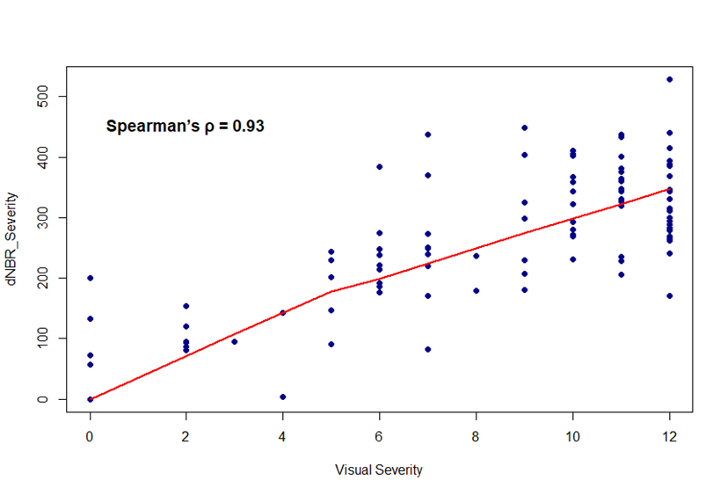
Figure S1. Correlation between field-based visual fire severity and satellite-derived dNBR severity (mean values within 50 m buffers). The red line shows a non-parametric LOESS fit. Spearman’s ρ indicates a strong monotonic relationship (ρ = 0.93, p < 0.001), reflecting similar spatial patterns of fire severity across sampling plots.

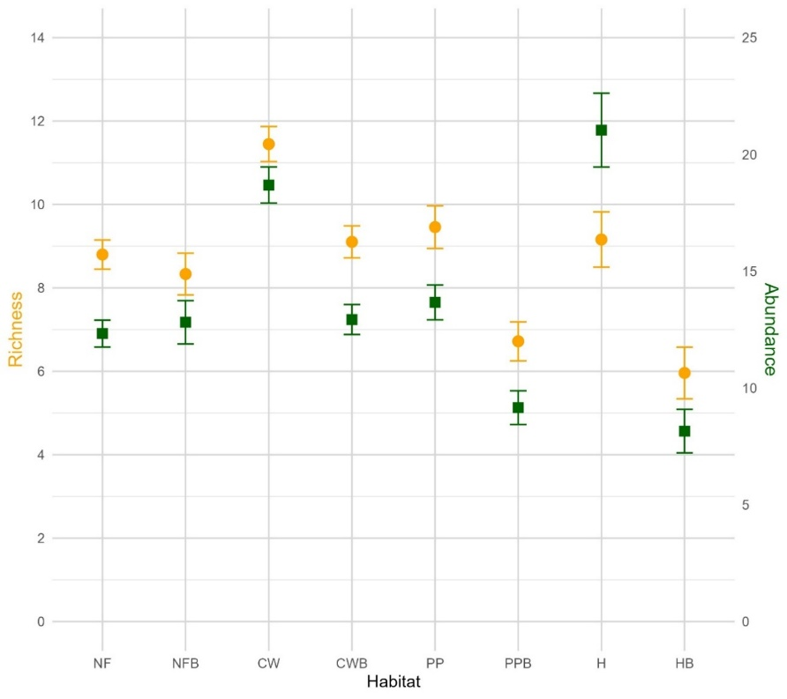
Fig. S2. Mean species richness (orange circles) and bird abundance (green squares) with standard errors across vegetation types sampled within and outside the wildfire perimeter. Habitat types: NF = Unburned native forest (n = 30), NFB = Burned native forest (n = 27), CW = Unburned chestnut woodland (n = 29), CWB = Burned chestnut woodland (n = 29), PP = Unburned pine plantation (n = 24), PPB = Burned pine plantation (n = 25), H = Unburned heathland (n = 25), HB = Burned heathland (n = 26).
Fig.S3. Model-averaged regression coefficients (±95% CI) showing the effect of elevation on bird community and functional guild metrics. Dietary guilds include insectivores, granivores, frugivores, and omnivores. Foraging stratum categories are canopy, understorey (or shrub layer), and ground. Habitat breadth (HB) classes are defined as HB1 = specialists, HB2 = intermediates, and HB3 = generalists. Habitat selection categories are forest specialists (F_specialist), facultative forest users (F_facultative), shrubland species, and open-habitat species (Open). Cavity nesters (Cavnest) were further classified as primary excavators (Cavnest_Exc) and non-excavators (Cavnest_NExc).

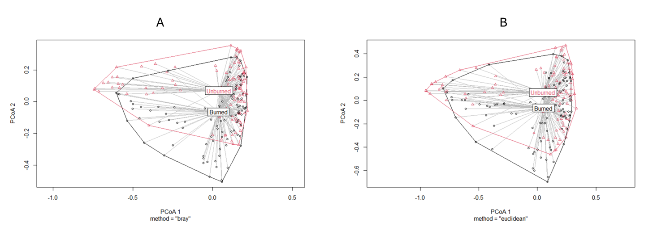
Fig.S4. Principal Coordinates Analysis (PCoA) illustrating multivariate dispersion (PERMDISP) of bird communities in burned (black) and unburned (pink) plots based on (A) Bray–Curtis dissimilarity and (B) Euclidean distance on Hellinger-transformed abundances. Points represent individual sampling plots, and polygons connect the outermost plots within each group. Both analyses show slightly greater dispersion in burned plots, indicating a trend toward higher internal heterogeneity, although differences were not statistically significant (Bray–Curtis: p = 0.09; Euclidean: p = 0.14).

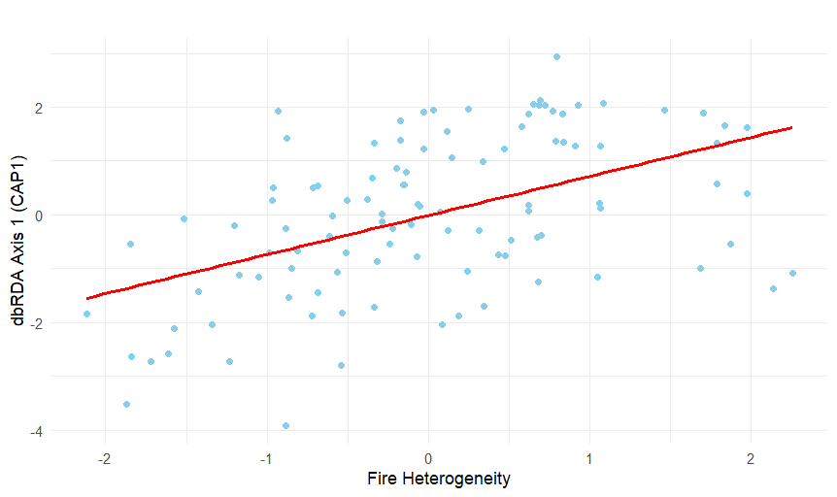
Fig.S5. Distance-based redundancy analysis (dbRDA) showing the relationship between fire severity heterogeneity and bird community composition within the burned area. Blue dots represent bird point counts located inside the burned zone. The first canonical axis (CAP1) represents the gradient in species composition explained by fire heterogeneity. Higher fire heterogeneity was associated with greater compositional dissimilarity among point counts (i.e. an increase in beta diversity). dbRDA revealed a statistically significant but weak effect (F = 2.01, p = 0.012), accounting for 1.9% of the total variance.

Texts
Text S1. Functional Trait Compilation
We compiled a functional trait matrix (Table S2) encompassing five ecologically relevant categories for all bird species recorded in the study: diet, foraging stratum, habitat breadth, habitat selection, and cavity-nesting behaviour. Trait assignment was based on published databases and regional sources, as detailed below.
- Dietary guild and foraging stratum classifications were primarily obtained from the database compiled by Mikusiński et al. (2018). For species not included in this database—mainly those associated with open habitats—information was supplemented using the EltonTraits database (Wilman et al., 2014). Species could be assigned to multiple categories within each trait, reflecting their ecological plasticity. Specifically, they were classified into one or more dietary guilds (insectivores, granivores, frugivores, or omnivores) and one or more foraging strata (canopy, understorey/shrub, or ground).
- Cavity-nesting behaviour was classified following Mikusiński et al. (2018) and further refined using Wesołowski and Martin (2018) to differentiate between primary excavators (species that create their own nesting holes) and non-excavating cavity nesters (species that rely on existing cavities). Facultative cavity nesters, which use existing cavities opportunistically but are not obligate users, were excluded from this classification.
- Habitat selection was based on the local bird guide by Guitián et al. (2004), allowing species to be grouped into four habitat categories according to their primary habitat association: forest specialists, facultative forest users, shrubland species, and open-habitat species. We selected this source to account for regional variation in habitat preferences, as recommended by Wesołowski and Fuller (2012).
- Habitat breadth was quantified following the framework proposed by Ausprey et al. (2022). For each species, we counted the number of habitat types used based on occurrence data from the latest Spanish Breeding Bird Atlas (Molina et al., 2022), which classifies species’ habitat use across 22 habitat categories. To facilitate interpretation and analysis, these were grouped into eight broader habitat types:
  - Broadleaf forests (e.g. beech, oak, holm oak, cork oak, mixed forests, riparian woodlands)
  - Coniferous forests: Juniper woodlands (e.g. stands dominated by Juniperus communis or J. thurifera) and pine or fir forests (Pinus spp. and Abies alba)
  - Exotic forest plantations (including Eucalyptus stands)
  - Wetlands (e.g. water bodies, wet meadows, coastal habitats, floodplain agriculture)
  - Shrublands (e.g. gorse, broom, heath, and spiny thickets typical of Mediterranean and Atlantic areas)
  - Open habitats (e.g. grasslands, rocky outcrops, dry and irrigated croplands)
  - Agricultural mosaics (e.g. vineyards, orchards, mixed farming areas),
  - Urban areas (e.g. towns, peri-urban environments).
A species was considered present in a given habitat category if its average density (birds/km²) within any of the included habitats exceeded 10% of its total average density across all habitats. Species were then classified into one of three habitat breadth categories based on the number of habitat groups used: (1) specialists (1–2 habitats), (2) intermediates (3–4 habitats), and (3) generalists (≥5 habitats). This classification was used as a proxy for ecological tolerance and potential resilience to environmental change.

Text S2. Comparison and selection of fire severity metrics
To validate the use of the field-based visual fire severity index in subsequent analyses, we compared it with satellite-derived severity values obtained from Sentinel-2 imagery. Specifically, we calculated the differenced Normalized Burn Ratio (dNBR) using pre-fire (14 July 2022) and post-fire (1 August 2022) scenes. Mean dNBR values were extracted within a 50 m buffer around each sampling plot—the same spatial extent used for the visual assessment.
Because the visual severity index was estimated one-year post-fire and aimed to isolate structural fire impacts from post-fire recovery signals, it was essential to compare it against dNBR values obtained immediately after the fire. We first performed a Spearman correlation restricted to burned plots (severity > 0), which showed a significant positive relationship (ρ = 0.58, p < 0.001), despite a slight non-linearity at the upper end of the visual severity scale (i.e., a plateau effect above 10).
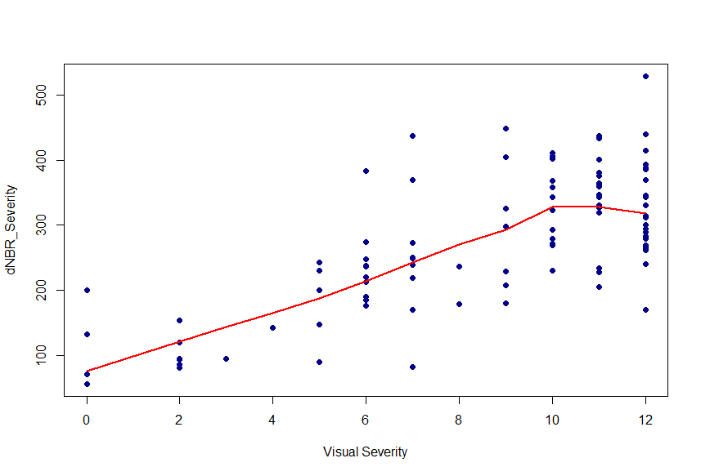
When all plots were included (burned and unburned), the correlation strengthened markedly (ρ = 0.93, p < 0.001), indicating that both indices captured a nearly identical spatial pattern of fire severity across the landscape (see Fig. S1).
Given this high correlation, only one metric was retained to avoid collinearity in subsequent models. We opted for the visual index based on the following considerations:
- Direct measurement of structural fire effects: The visual index captures observable damage to canopy, shrub layers, litter, and soil organic horizons, while deliberately excluding signals of post-fire ecological recovery such as resprouting, herbaceous regrowth, or seedling emergence (Keeley, 2009)
- Finer spatial resolution: In situ observations allowed the detection of small-scale variation within each plot that may be missed by pixel-averaged satellite data, particularly in heterogeneous burn mosaics.
- Independence from pre-fire vegetation structure: Unlike dNBR, which can be biased by pre-fire biomass density and vegetation type, the visual index reflects only the post-fire structural state of the ecosystem (Lee et al., 2024).
- Robust empirical validation: The strong agreement with satellite data supports its use as a reliable indicator of fire severity in this ecological context.
This visual index was therefore used as the sole fire severity predictor in the statistical models presented in the main text.

Text S3. Evaluation of multicollinearity for fire-related predictors
Before fitting the Generalized Linear Models (GLMs), we assessed multicollinearity among predictor variables to avoid inflation of standard errors or spurious inference. Variance Inflation Factor (VIF) analysis (threshold = 0.7; usdm R package) identified high correlation between the visual fire severity index and other fire-related variables. However, our ecological hypothesis emphasized the importance of fire severity, fire heterogeneity, and burn status as distinct yet complementary descriptors of fire disturbance.
To further explore this, we calculated pairwise Pearson correlations between all continuous predictors, including a binary numerical encoding of burn status (1 = burned, 0 = unburned). This analysis revealed high collinearity between burn status and both fire severity (r = 0.87) and fire heterogeneity (r = 0.92), while correlations with the remaining predictors were weak. These results were expected, given the spatial overlap between burned plots and areas of higher severity and heterogeneity.
Despite the statistical collinearity, we retained all three fire-related predictors in our models, based on both ecological reasoning and model performance. Specifically, we compared a full model (including burn status) to a reduced model excluding this variable. The full model showed better performance (ΔAIC = 3.9) and burn status was statistically significant (p = 0.0127), indicating added explanatory power beyond severity metrics. Importantly, the coefficients and significance of the remaining predictors were nearly identical between models, suggesting that retaining burn status did not distort model inference.
From an ecological perspective, each fire attribute reflects a distinct spatial scale and dimension of fire disturbance. Burn status distinguishes between burned and unburned zones at the landscape scale, while fire severity and fire heterogeneity capture local structural impacts and spatial variability in fire effects, respectively. Removing any of these variables would oversimplify the complex, multiscale nature of fire impacts on avian communities.
In conclusion, we retained burn status, fire severity, and fire heterogeneity in all models to preserve a more comprehensive and ecologically meaningful representation of fire disturbance.
Text S4. Exploratory species-level responses to fire severity
With the aim of identifying possible idiosyncratic responses to fire severity, an exploratory analysis was conducted focusing on individual species detected in the burned area (n = 47). For each species, we fitted a simple Poisson GLM with fire severity as the sole predictor. Despite the limitations associated with the high number of zeros in the abundance data (suggesting isolated occurrences or post-fire rarefaction), three species showed a statistically significant and positive association with increased fire severity:
Species | p_value | Estimate | Zero ratio
Phoenicurus ochruros | 0.01332345 | 2.520313 | 0.93518519
Chloris chloris | 0.02256368 | 2.1248045 | 0.93518519
Prunella modularis | 0.00336424 | 1.19496864 | 0.81481481

These results should be interpreted with caution due to the high zero-inflation (>80%) and the exploratory nature of the analysis. Although these results do not allow for robust inferences, they offer possible indications of early colonisation processes or resilience to severe disturbances during the first post-fire breeding season.

Text S5. Preliminary assessment of the relationship between fire severity heterogeneity and post-fire vegetation structure
Before testing interaction effects between fire severity heterogeneity and postfire vegetation structure in the dbRDA models (Section 2.5.4), we evaluated whether fire heterogeneity alone could predict variation in vegetation structure. To do so, we fitted separate linear models using each of the three vegetation structure principal components (PC1, PC2, PC3) as response variables and fire heterogeneity as the sole predictor.
PC | Estimate | Std. Error | t value | p-value | Adjusted R²
PC1 | 0.103 | 0.098 | 1.04 | 0.299 | 0.001
PC2 | 0.334 | 0.093 | 3.59 | 0.0005 | 0.102
PC3 | 0.047 | 0.099 | 0.48 | 0.635 | -0.007

Results showed that fire heterogeneity significantly predicted PC2 (unburned or lightly burned forest patches; p < 0.001), indicating that higher heterogeneity values were associated with a greater presence of residual forest stands within burned areas. In contrast, fire heterogeneity did not significantly predict PC1 (heavily burned forest stands with high snag abundance) or PC3 (open shrubland areas in early regeneration stages). These results suggest that the spatial configuration of unburned forest refuges may be well captured by heterogeneity in fire severity, whereas the structure of severely burned forest stands and regenerating shrublands likely depends more on pre-fire vegetation characteristics and the ecosystem’s capacity to respond to disturbance, rather than on fire heterogeneity per se.

REFERENCES

Ausprey, I.J., Newell, F.L., Robinson, S.K., 2022. Functional response traits and altered ecological niches drive the disassembly of cloud forest bird communities in tropical montane countrysides. Journal of Animal Ecology 00, 1–15. https://doi.org/10.1111/1365-2656.13816
Guitián, J., Munilla, I., González, M., Arias, M., 2004. Guía de las Aves de O Courel. Lynx Edicions, Barcelona.
HBW, BirdLife International, 2024. Handbook of the Birds of the World and BirdLife International Digital Checklist of the Birds of the World. Version 8.1.
Keeley, J.E., 2009. Fire intensity, fire severity and burn severity: A brief review and suggested usage. Int J Wildland Fire 18, 116–126. https://doi.org/10.1071/WF07049
Lee, K., van Leeuwen, W.J.D., Gillan, J.K., Falk, D.A., 2024. Examining the Impacts of Pre-Fire Forest Conditions on Burn Severity Using Multiple Remote Sensing Platforms. Remote Sens (Basel) 16, 1803. https://doi.org/10.3390/rs16101803
Mikusiński, G., Villero, D., Herrando, S., Brotons, L., 2018. Macroecological Patterns in Forest Bird Diversity in Europe, in: Ecology and Conservation of Forest Birds. Cambridge University Press, pp. 137–182. https://doi.org/10.1017/9781139680363.008
Molina, B., Nebreda, A., Muñoz, A., Seoane, J., Real, R., Bustamante, J., Del Moral, J.C., 2022. III Atlas de aves en época de reproducción en España. SEO/BirdLife, Madrid.
Wesołowski, T., Fuller, R.J., 2012. Spatial variation and temporal shifts in habitat use by birds at the European scale, in: Fuller, R.J. (Ed.), Birds and Habitat: Relationships in Changing Landscapes, Ecological Reviews. Cambridge University Press, Cambridge, pp. 63–92. https://doi.org/DOI: 10.1017/CBO9781139021654.005
Wesołowski, T., Martin, K., 2018. Tree Holes and Hole-Nesting Birds in European and North American Forests, in: Ecology and Conservation of Forest Birds. Cambridge University Press, pp. 79–134. https://doi.org/10.1017/9781139680363.006
Wilman, H., Belmaker, J., Simpson, J., de la Rosa, C., Rivadeneira, M.M., Jetz, W., 2014. EltonTraits 1.0: Species-level foraging attributes of the world’s birds and mammals. Ecology 95, 2027–2027. https://doi.org/10.1890/13-1917.1

