Supplementary Data
Table 1: The Primer Sequences Used for Real Time PCR for Gene Expression Studies.
Primers | Sequence
BAX Forward | 5’-GGAGGATTGTGGCCTTCTTT-3’
BAX Reverse | 5’-GCCGTACAGTTCCACAAAGG-3’
BCL2 associated X Forward | 5’- ACCAAGAAGCTGAGCGAGTG-3’
BCL2 associated X Reverse | 5’-AAGTAGAAAAGGGCGACAACC-3’
p53 Forward | 5’-AAGGAAATTTGCGTGTGGAG-3’
p53 Reverse | 5’-CCAGTGTGATGATGGTGAGG-3’
Caspase 3 Forward | 5’-GAGGCCGACTTCTTGTATGC-3’
Caspase 3 Reverse | 5’-AATTCTGTTGCCACCTTTCG-3’
Caspase 9 forward | 5’-AGAAAATGGTGCTGGCTTTG-3’
Caspase 9 Reverse | 5’-GCTGGTCCCATTGAAGATGT-3’
GAPDH forward | Provided in the RevertAid First Strand cDNA Synthesis Kit (Cat no. #K1622)
GAPDH reverse | Provided in the RevertAid First Strand cDNA Synthesis Kit (Cat no. #K1622)

Table 3: The Structure Validation of Top Models Predicted By trRosetta, AlphaFold2 and I-TASSER by SAVES V6.1
Servers | ERRAT | RAMACHANDRAN plot RESULTS
Servers | ERRAT | Most favoured region, % | Allowed Region, % | Disallowed Region, %
trRosetta | 90.2913 |  | 78.1% |  | 17.7% | 2%
AlphaFold2 | 93.2039 |  | 95.8% |  | 4.2% | 0%
I-TASSER | 89.3204 |  | 88.5% |  | 10.4% | 0%

Table 4: The ZDOCK Score of Docked Complexes.
Docked complex | Z dock score
LZ8-EGFR | 1089.822
FIP-Gre-EGFR | 877.065
LZ8-C-met | 1400.556
FIP-Gre-C-met | 1524.366

Table 5: The hemeagglutination assay of rFIP-Gre. A positive response took the notation (+); a negative reaction (−).
Red blood cells | PHA  2 | rFIP-Gre 0.25 | rFIP-Gre 0.5 | rFIP-Gre 1 | rFIP-Gre 2 | rFIP-Gre 4 | rFIP-Gre 8 | rFIP-Gre 16 | rFIP-Gre 32 | rFIP-Gre 64 | rFIP-Gre 128
Mouse | ++ | − | − | − | − | + | + | + | + | + | +
Human | ++ | − | − | − | − | − | − | − | − | − | −
Sheep | ++ | − | − | − | − | − | − | − | − | − | −

Table 6: The hemeagglutination assay of rLZ8. A positive response took the notation (+); a negative reaction (−).
Red blood cells | PHA  2 | rLZ8 0.25 | rLZ8 0.5 | rLZ8 1 | rLZ8 2 | rLZ8 4 | rLZ8 8 | rLZ8 16 | rLZ8 32 | rLZ8 64 | rLZ8 128
Mouse | ++ | − | − | − | − | − | + | + | + | + | +
Human | ++ | − | − | − | − | − | − | − | − | − | −
Sheep | ++ | − | − | − | − | − | − | − | − | − | −

Table 7: Anti-bacterial activity of FIP-LZ8 at different concentrations against 5 different bacterial strains.
Concentrations | E. coli | Staphylococcus aureus | Pseudomonas aeruginosa | Klebsiella pneumoniae | Salmonella typhi
25 μg/ml (LZ8) | 0 | 0 | 0 | 0 | 0
50 μg/ml(LZ8) | 0 | 0 | 0 | 0 | 0
100 μg/ml(LZ8) | 0 | 0 | 0 | 0 | 0
Nitrofurantoin 300μg | 25mm | 20mm | - | - | -
Colistin 10μg | - | - | 13mm | 14mm | -
Ceftriaxone 30μg | - | - | - | - | 25mm

Table 8: Anti-bacterial activity of FIP-Gre at different concentrations against 5 different bacterial strains.
Concentrations | E. coli | Staphylococcus aureus | Pseudomonas aeruginosa | Klebsiella pneumoniae | Salmonella typhi
25μg/ml (FIP-Gre) | 0 | 0 | 0 | 0 | 0
50μg/ml(FIP-Gre) | 0 | 0 | 0 | 0 | 0
100μg/ml(FIP-Gre) | 0 | 0 | 0 | 0 | 0
Nitrofurantoin 300μg | 24mm | 19mm | - | - | -
Colistin 10μg | - | - | 12mm | 13mm | -
Ceftriaxone 30μg | - | - | - | - | 26mm

Table 9: Quantification of RNA Extracted from Treated as well as The Control Group of Cells.

Sample | Concentration  of RNA(ng/µL) | A260/A280
Sample 1 (cells treated with 8µg/mL of LZ8) | 980 | 1.5
Sample 2 (cells treated with 8 µg/mL FIP-Gre) | 990 | 1.5
Sample 3 (control, cells treated with PBS) | 1014 | 1.6
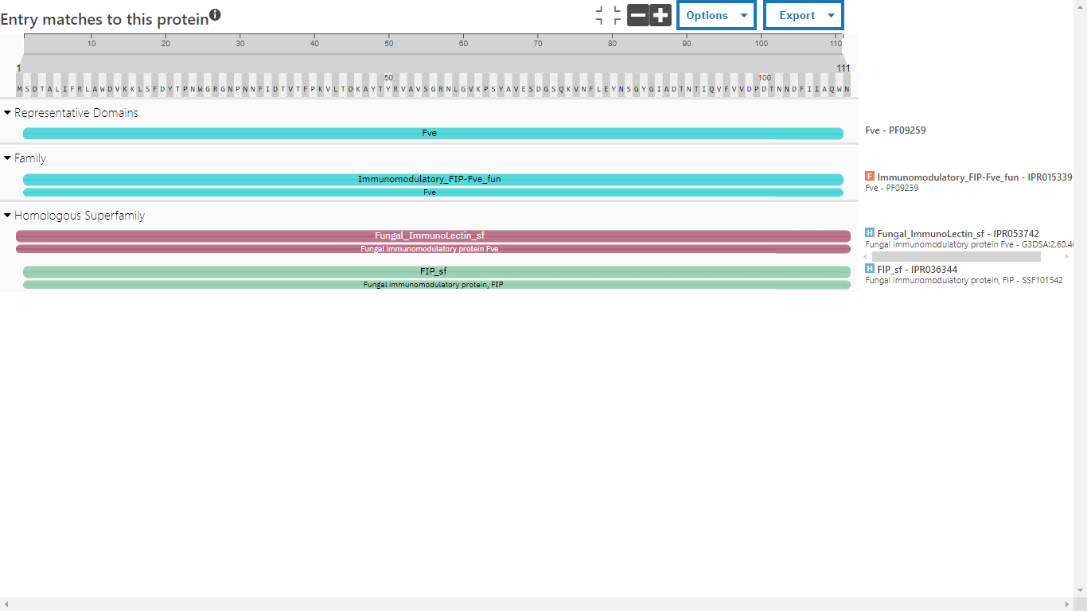
Figure 1: Domain prediction of FIP-LZ8. The domain and family of FIP-Gre was predicted by InterPro and it was found to belong to domain Fve PF09259

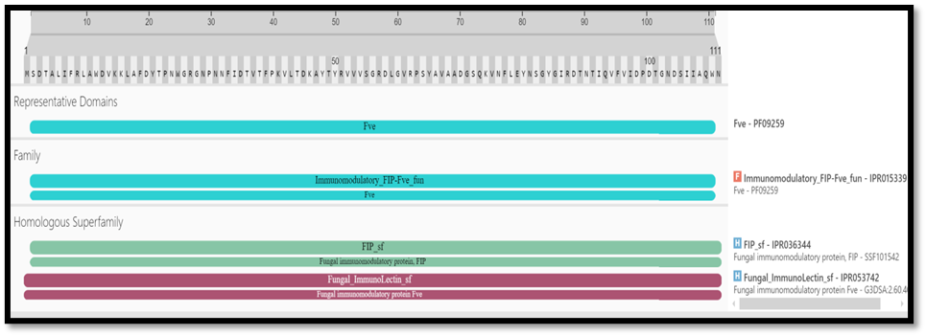
Figure 2: Domain prediction of FIP-Gre. The domain and family of FIP-Gre was predicted by InterPro and it was found to belong to domain Fve PF09259.
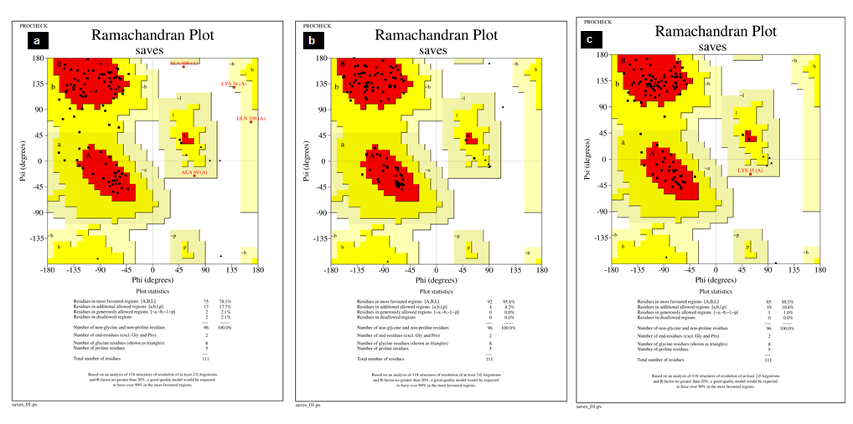
Figure 3: The Ramachandran plot generated by PROCHECK (SAVESv 6.1). (a) Ramachandran plot of the predicted model by trRosetta (b) Ramachandran plot of the predicted model by AlfaFold2. (c) Ramachandran plot of the predicted model by I-TASSER.

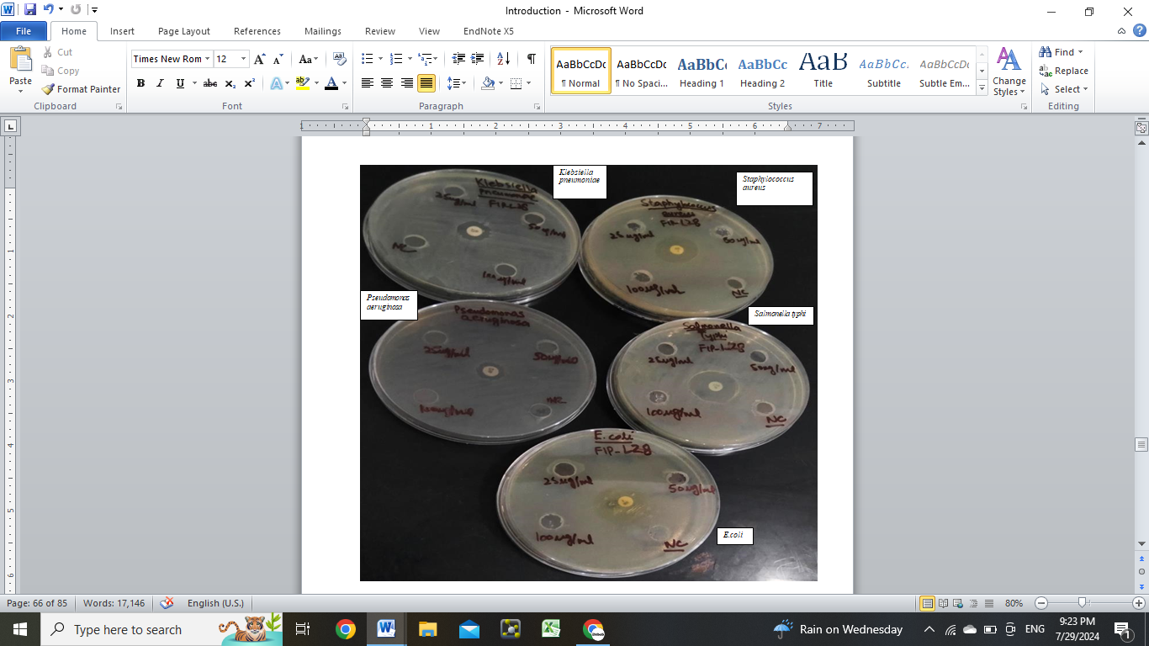
Figure 4: Evaluation of anti-bacterial activity of FIP-LZ8 against E. coli, Staphylococcus aureus, Salmonella typhi, Pseudomonas aeruginosa and Klebsiella pneumoniae by agar well diffusion assay along with positive and negative control.
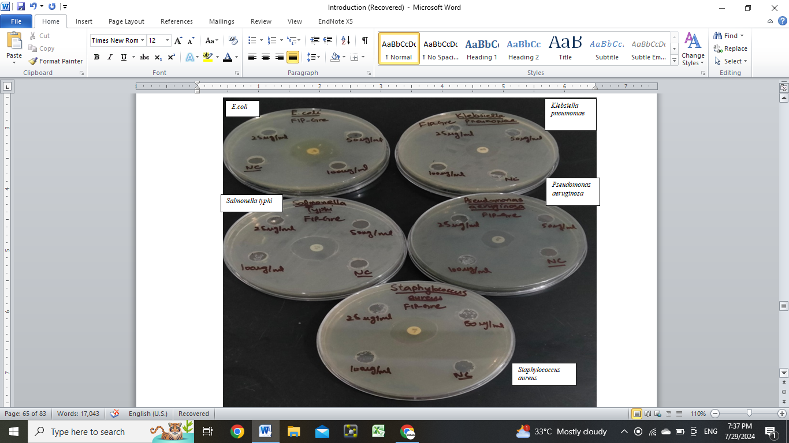

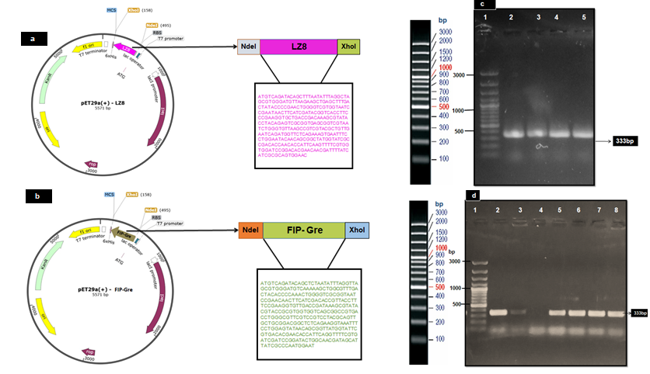
Figure 5: Evaluation of anti-bacterial activity of FIP-Gre against E. coli, Staphylococcus aureus, Salmonella typhi, Pseudomonas aeruginosa and Klebsiella pneumoniae by agar well diffusion assay along with positive and negative control.
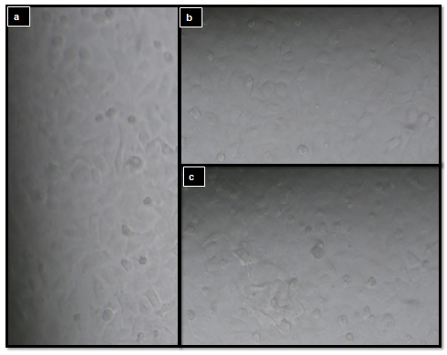
Figure 6. Construction and confirmation of recombinant plasmids. (a) schematic map of pET-29a(+)-FIP-Glu (LZ8) (b) schematic map of pET-29a(+)-FIP-Gre under the T7 promoter with His₆ tag (c) Electrophoresis of colony PCR products on agarose gel (1%). Lane 1; DNA ladder (100 kb plus, Thermo), lane 2-5, FIP-LZ8 (333 bp). (d) Electrophoresis of colony PCR products on agarose gel (1%). Lane 1; DNA ladder (100 kb plus, Thermo), lane 2-8, FIP-Gre (333 bp) and lane 4: negative control, only contains PCR reagents.

Figure 7: Morphological analysis of A549 cells followed by treatment of FIPs. (a) Morphology of control group treated with PBS. (b) Morphology changes in A549 cells on treatment of 8μg/mL of LZ8. (c) Morphology changes in A549 cells on treatment of 8μg/ml of FIP-Gre

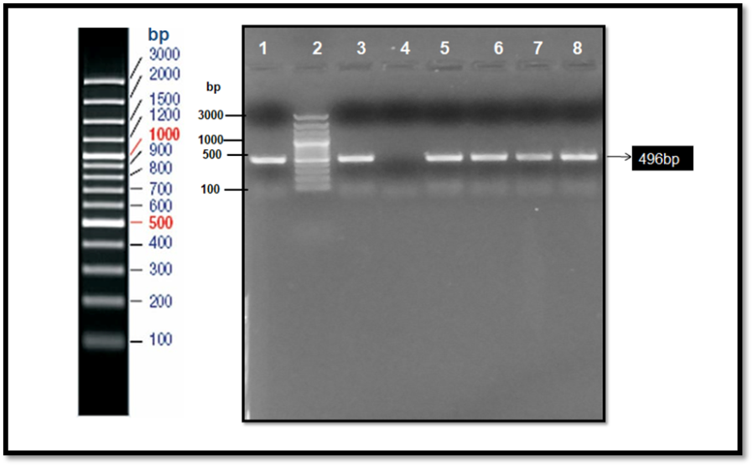
Figure 8: PCR amplification of GAPDH gene. 100kb plus ladder (thermo) (lane 2), GAPDH positive control (lane 3), PCR negative control (lane 4) and lane 1,5-8 show amplification of GAPDH using control and treated group cDNA (496bp).

