SUPPLEMENTAL DATA

Supplementary Figure S1. Representative full scans of original, unprocessed Western blot images.

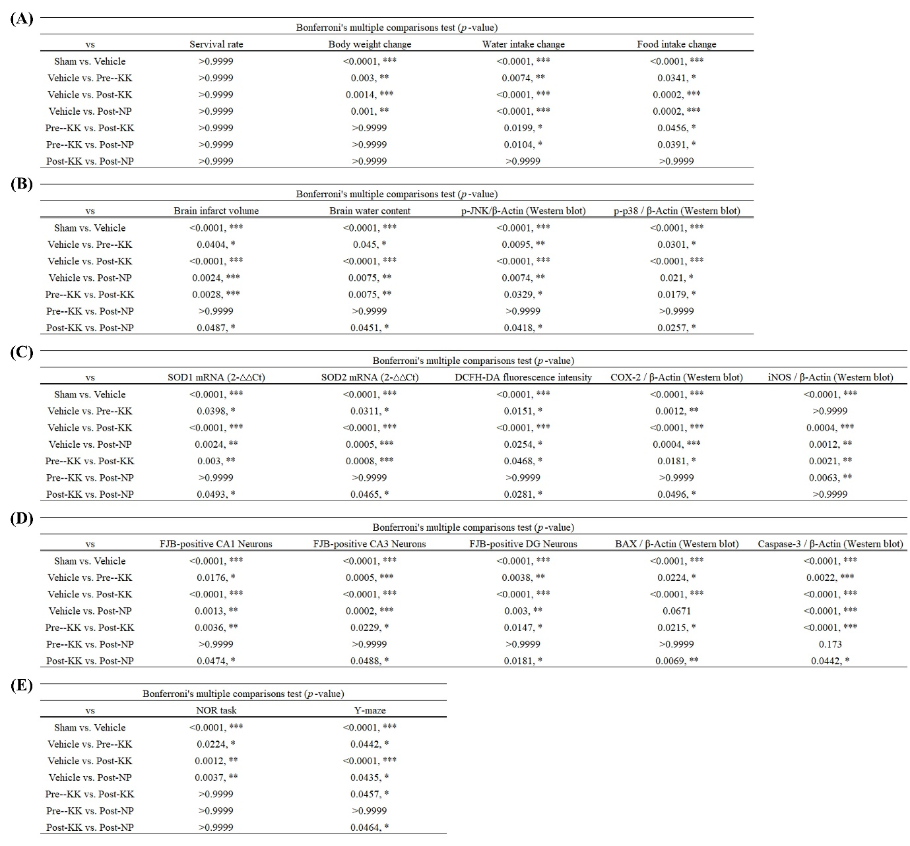
Supplementary Table S1. Specific values and statistical results in the BCCAO-induced ischemic stroke model following pre-KK, post-KK, and post-NP treatments: (A) Survival rate, body weight, water intake, and food intake changes. (B) Brain infarct volume, brain water content, and protein expression levels of p-JNK and p-p38. (C) mRNA expression levels of SOD1 and SOD2, protein expression levels of COX-2 and iNOS, and DCFH-DA fluorescence intensity. (D) FJB staining and protein expression levels of BAX and Caspase-3. *P<0.05, ** P<0.01, and *** P<0.005.

Supplementary Table S2. (A) RT-PCR primers and (B) Western blot antibodies used in this study.

