Supplementary file
Spatial-temporal patterns and risk factors for human leptospirosis in Thailand, 2012-2018

Sudarat Chadsuthi^{1*}, Karine Chalvet-Monfray^{2,3}, Suchada Geawduanglek⁴, Phrutsamon Wongnak^{2,4}, Julien Cappelle^{2,5,6}

¹Department of Physics, Faculty of Science, Naresuan University, Phitsanulok 65000, Thailand
²Université de Lyon, INRAE, VetAgro Sup, UMR EPIA, 69280 Marcy l’Etoile, France
³Université Clermont Auvergne, INRAE, VetAgro Sup, UMR EPIA, 63122 Saint Genès Champanelle, France
⁴Medical and Graduate Education Division, Faculty of Science, Mahidol University, Bangkok 10400 Thailand
⁵UMR ASTRE, CIRAD, INRAE, 34398, Montpellier, France
⁶CIRAD, UMR ASTRE, F-34398, Montpellier, France

Corresponding author: Sudarat Chadsuthi
Department of Physics, Faculty of Science, Naresuan University, Phitsanulok 65000, Thailand
E-mail : sudaratc@nu.ac.th

1. Supplementary Results

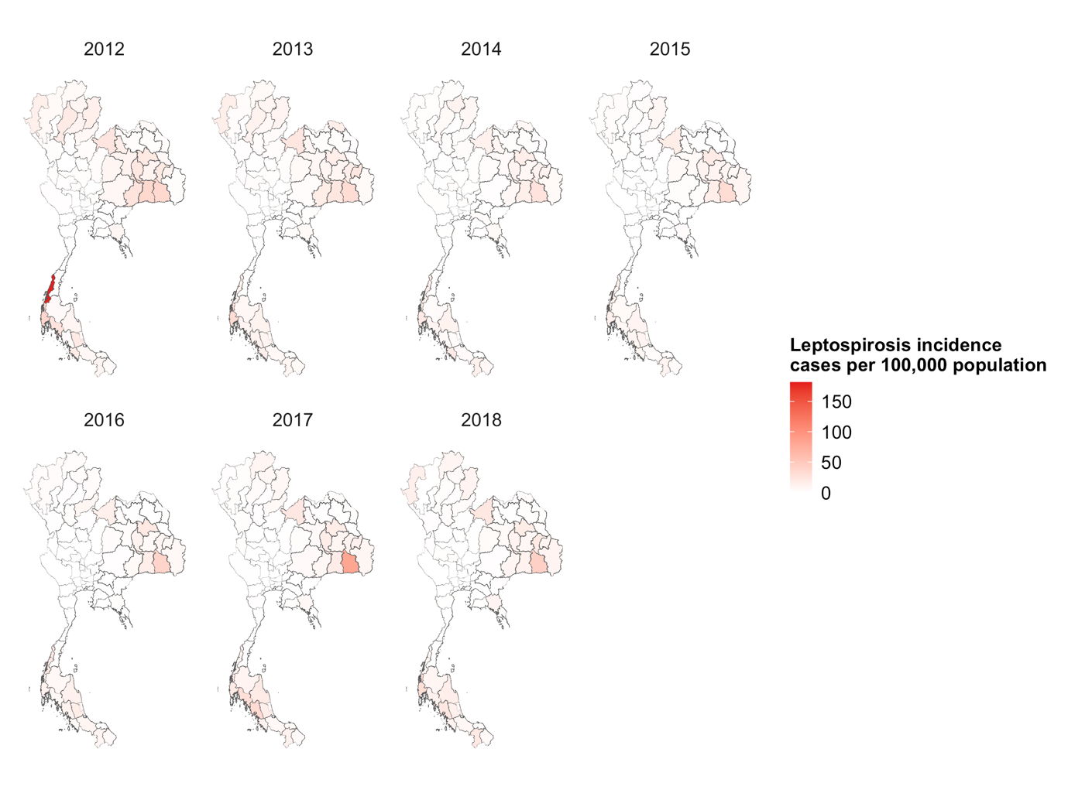
Fig. S1. The spatial-temporal pattern of annual leptospirosis incidence rate (per 100,000 population) cases during 2012–2018.

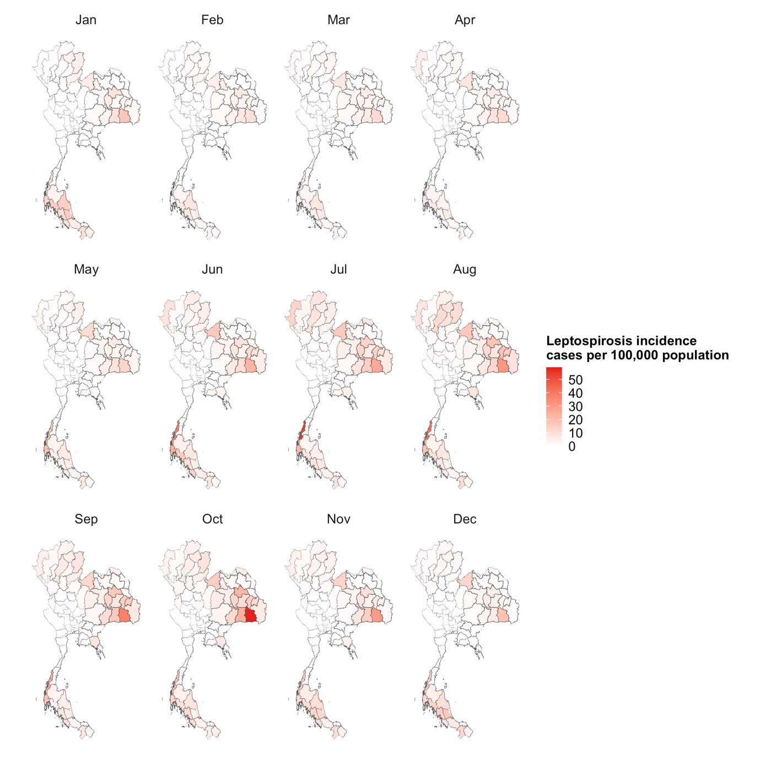
Fig. S2. The spatial-temporal pattern of monthly leptospirosis incidence rate (per 100,000 population) cases during 2012–2018.
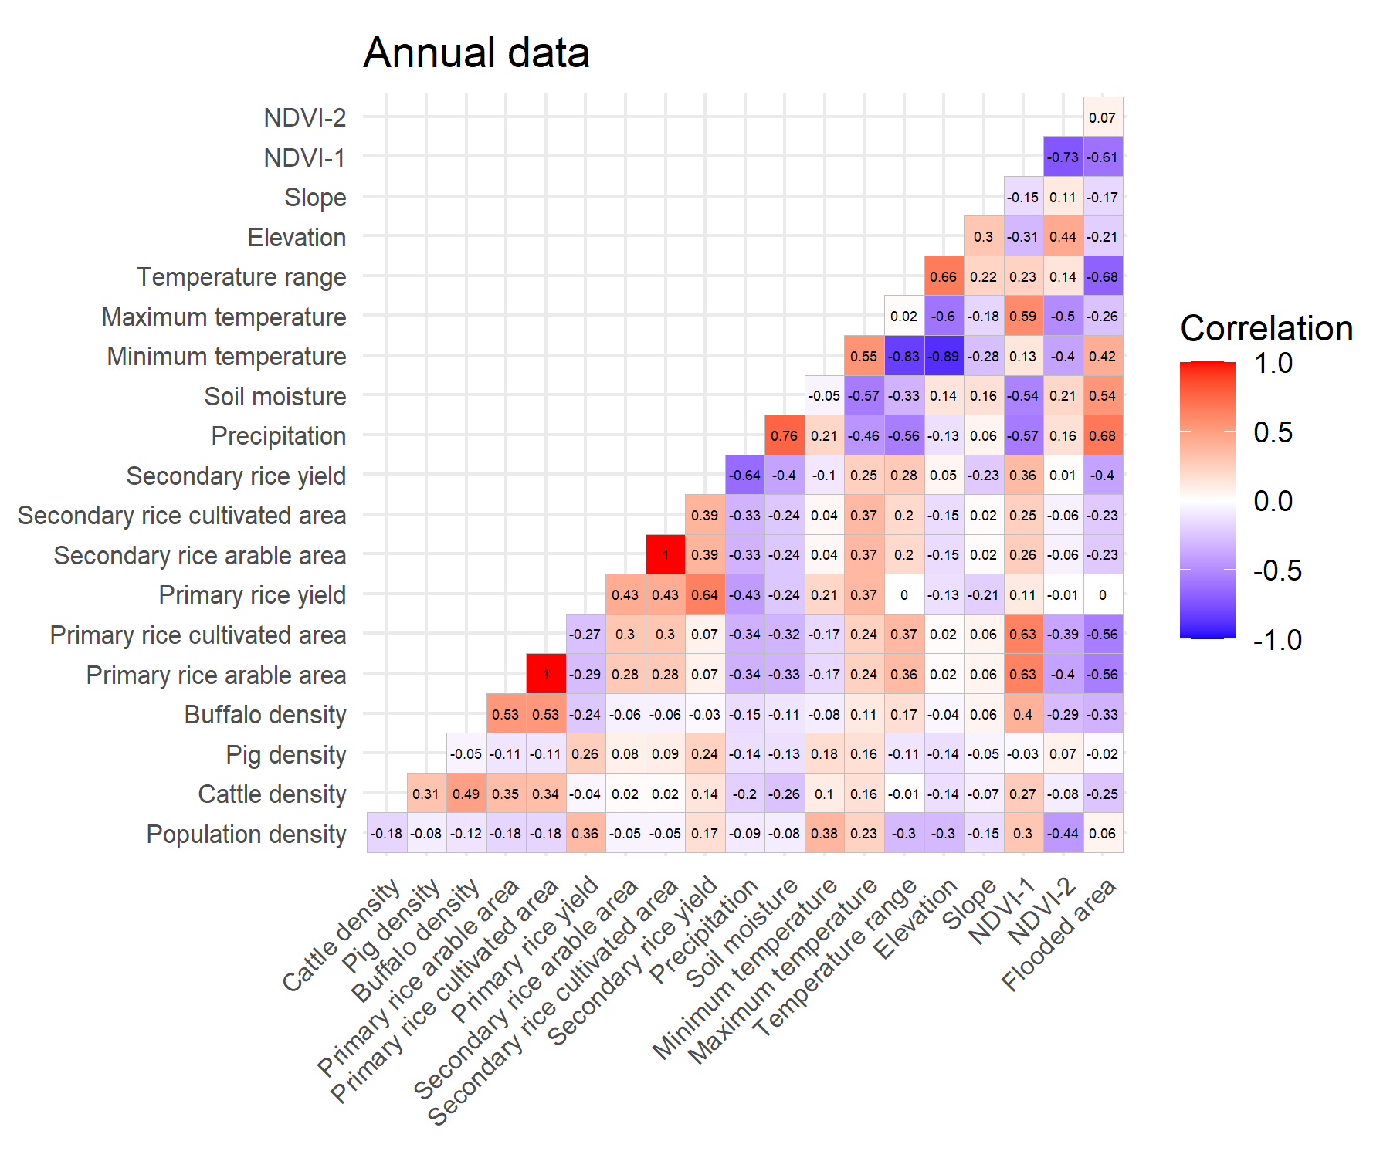
Fig. S3. Cross-correlation of the annual variables.
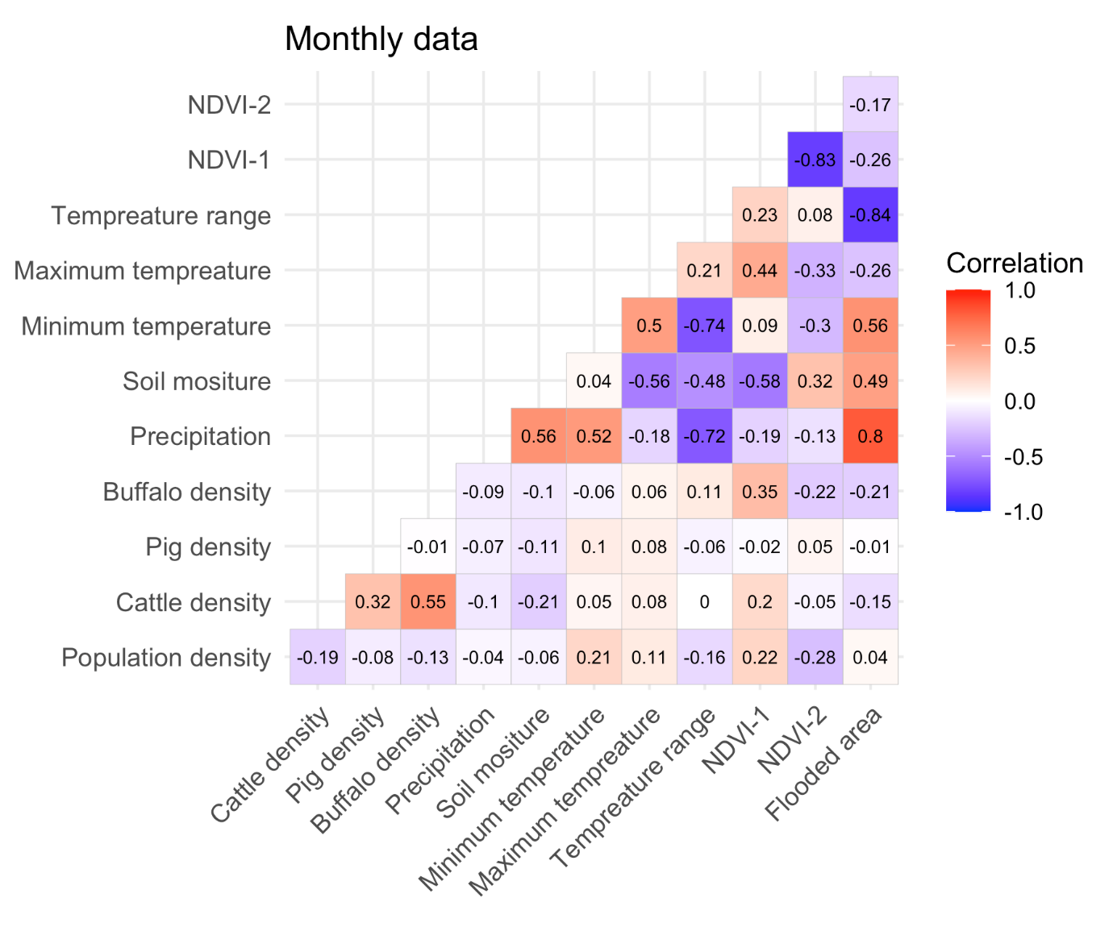
Fig. S4. Cross-correlation of the monthly variables.
Table S1. Global Moran’s I of annual leptospirosis incidence rate in Thailand from 2012–2018
Year | Moran’s I | P-value
2012 | 0.1238 | 0.004
2013 | 0.3362 | 0.001
2014 | 0.3605 | 0.001
2015 | 0.4240 | 0.001
2016 | 0.3521 | 0.001
2017 | 0.3153 | 0.001
2018 | 0.3758 | 0.001

Table S2. Global Moran’s I of monthly leptospirosis incidence rate in Thailand
Month | Moran’s I | P-value
January | 0.5567 | 0.001
February | 0.5495 | 0.001
March | 0.4529 | 0.001
April | 0.4295 | 0.001
May | 0.3993 | 0.001
June | 0.3695 | 0.001
July | 0.2562 | 0.003
August | 0.3156 | 0.001
September | 0.3865 | 0.001
October | 0.3367 | 0.001
November | 0.3950 | 0.001
December | 0.5292 | 0.001

Table S3. A set of the generalized mixed model selection for annual reported cases
Temporal correlation* | Population density* | Cattle density* | Pig density* | Elevation* | Slope* | Primary rice arable area* | Primary rice yield* | Secondary rice arable area* | df | LL** | AIC | ΔAIC
0.0705 | 0.2342 | - | - | 0.6434 | - | 0.6662 | - | - | 11 | -1936.78 | 3895.57 | 0.00
- | 0.2396 | - | - | 0.6554 | - | 0.6717 | - | - | 10 | -1937.89 | 3895.78 | 0.21
0.0703 | 0.2143 | - | -0.0876 | 0.6350 | - | 0.6643 | - | - | 12 | -1936.34 | 3896.68 | 1.11
- | 0.2193 | - | -0.0896 | 0.6468 | - | 0.6697 | - | - | 11 | -1937.44 | 3896.88 | 1.31
0.0694 | 0.2418 | 0.0423 | - | 0.6453 | - | 0.6546 | - | - | 12 | -1936.68 | 3897.36 | 1.80
- | 0.2483 | 0.0497 | - | 0.6574 | - | 0.6579 | - | - | 11 | -1937.75 | 3897.50 | 1.93
0.0704 | 0.2343 | - | - | 0.6497 | -0.0164 | 0.6658 | - | - | 12 | -1936.77 | 3897.54 | 1.98
0.0713 | 0.2349 | - | - | 0.6467 | - | 0.6605 | - | 0.0076 | 12 | -1936.78 | 3897.55 | 1.99
0.0707 | 0.2344 | - | - | 0.6407 | - | 0.6665 | -0.0104 | - | 12 | -1936.78 | 3897.56 | 2.00
* coefficient
**LL=Log likelihood

Table S4. A set of the generalized mixed model selection for monthly reported cases
Temporal correlation* | Pig density* | Buffalo density* | Average of soil moisture* | Temperature range* | NDVI-2* | df | LL** | AIC | ΔAIC
0.1180 | - | - | 0.2781 | -0.2397 | -0.0478 | 11 | -2597.24 | 5216.48 | 0
0.1181 | -0.0853 | - | 0.2772 | -0.2400 | -0.0475 | 12 | -2596.97 | 5217.93 | 1.45
0.1180 | - | 0.0748 | 0.2779 | -0.2398 | -0.0477 | 12 | -2597.13 | 5218.26 | 1.78
0.1181 | -0.0960 | 0.0943 | 0.2769 | -0.2402 | -0.0474 | 13 | -2596.79 | 5219.59 | 3.10
0.1195 | - | - | 0.2445 | -0.2596 | - | 10 | -2600.41 | 5220.83 | 4.34
* coefficient
**LL=Log likelihood
2. Supplementary Results for percentage of flooded area
Table S5. A set of the generalized mixed model selection for monthly reported cases
Temporal correlation* | Pig density* | Buffalo density* | Average of soil moisture* | Percentage of flooded area * | NDVI-2* | df | LL** | AIC | ΔAIC
0.1287 | - | - | 0.2708 | 0.2475 | - | 10 | -2601.20 | 5222.41 | 0
0.1287 | -0.0792 | - | 0.2703 | 0.2474 | - | 11 | -2600.97 | 5223.94 | 1.54
0.1287 | - | 0.0804 | 0.2706 | 0.2476 | - | 11 | -2601.08 | 5224.16 | 1.75
0.1285 | - | - | 0.2736 | 0.2451 | -0.0032 | 11 | -2601.19 | 5224.39 | 1.98
0.1288 | -0.0907 | 0.0993 | 0.2699 | 0.2476 | - | 12 | -2600.79 | 5225.57 | 3.16
* coefficient
**LL=Log likelihood

Table S6. Results of the best generalized linear mixed model for monthly reported cases
Variables | OR (95% Confidence Interval) | P-value
Temporal correlation | 1.1373 (1.0951-1.1811) | <0.0001
Average of soil moisture | 1.3110 (1.2223-1.4062) | <0.0001
Percentage of flooded area | 1.2808 (1.2170-1.3479) | <0.0001
*OR=Odds ratio

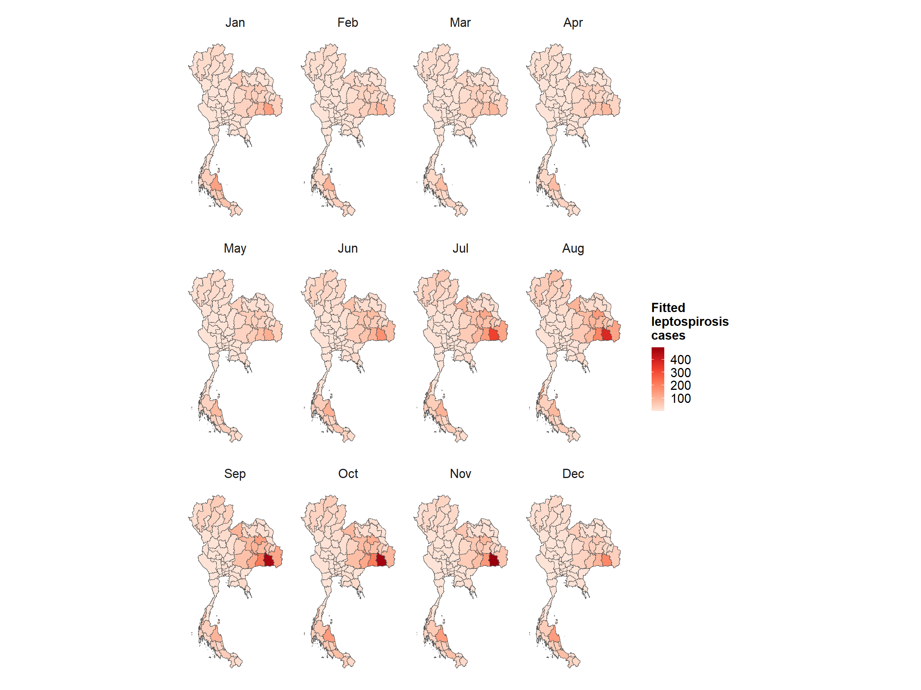
Fig. S5. Plots of monthly leptospirosis cases estimated by the best GLMM for percentage of flooded area.

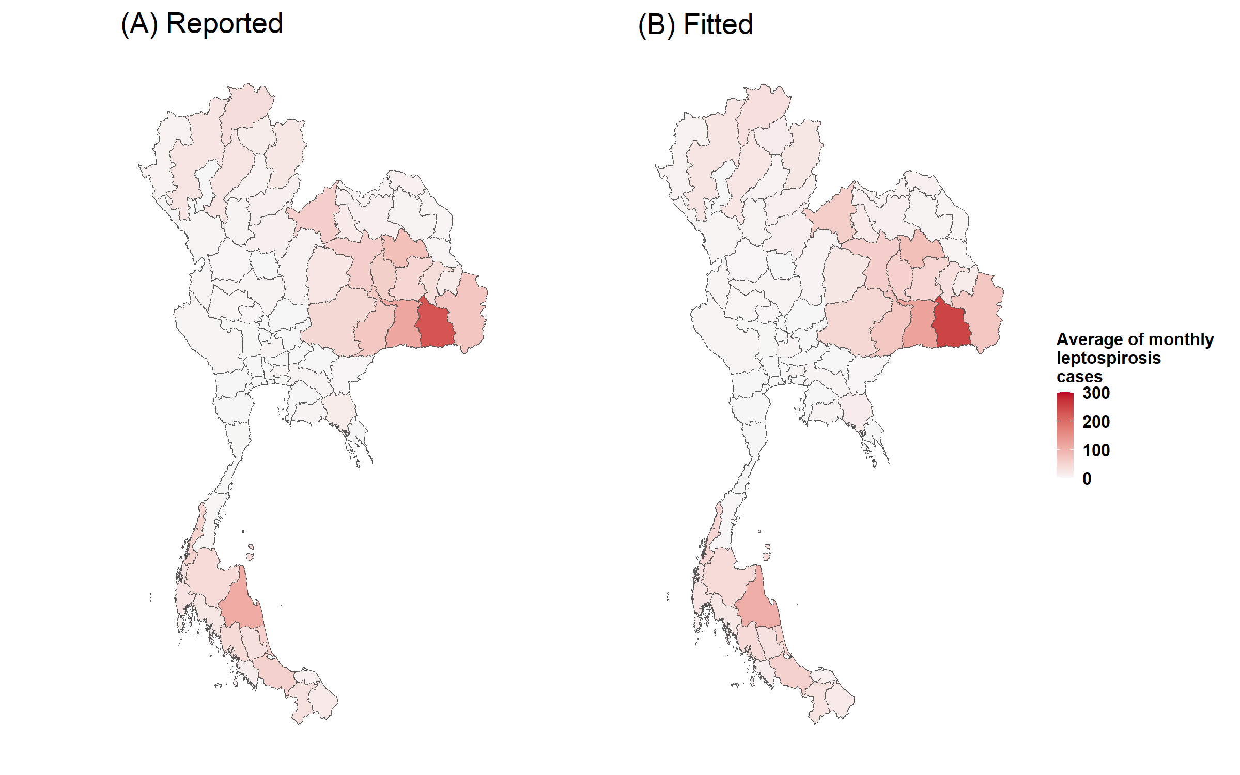
Fig. S6. Plots of comparison between average monthly reported leptospirosis cases (A) and average monthly fitted leptospirosis cases estimated by the best GLMM for percentage of flooded area.
3. Supplementary Data

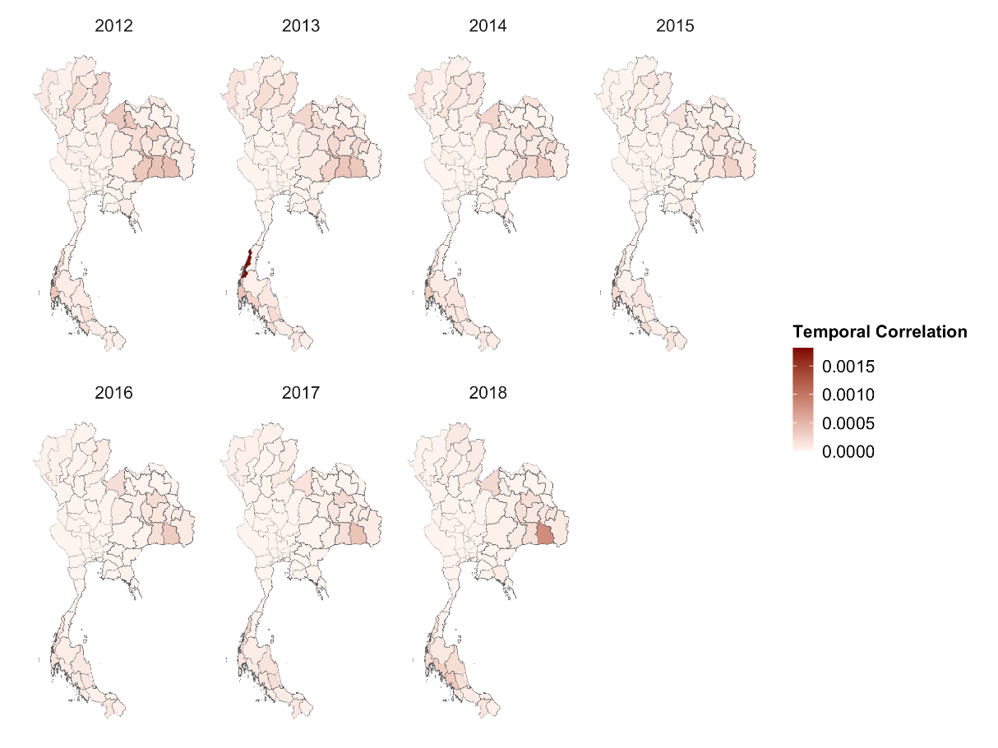
Fig. S7. Temporal correlation, Thailand 2012–2018.

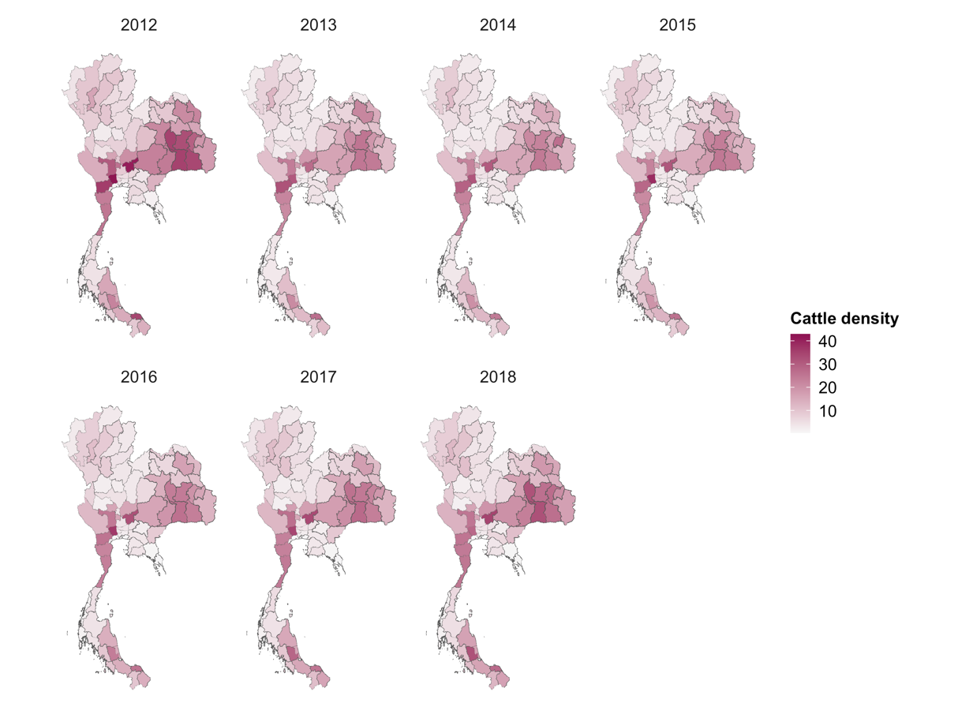
Fig. S8. Cattle density, Thailand 2012–2018.

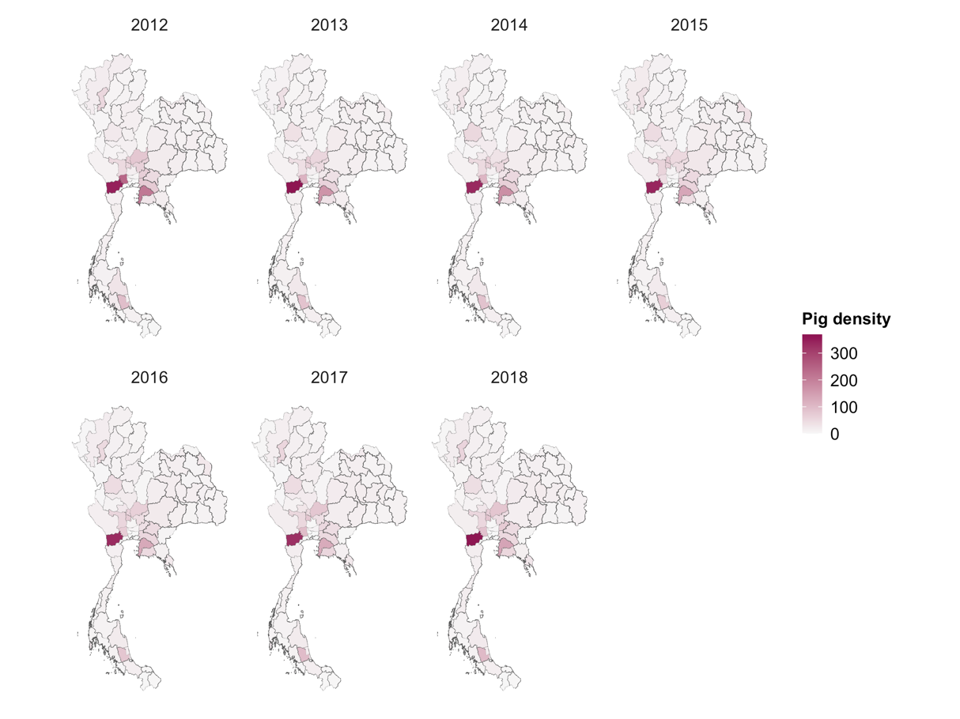
Fig. S9. Pig density, Thailand 2012–2018.

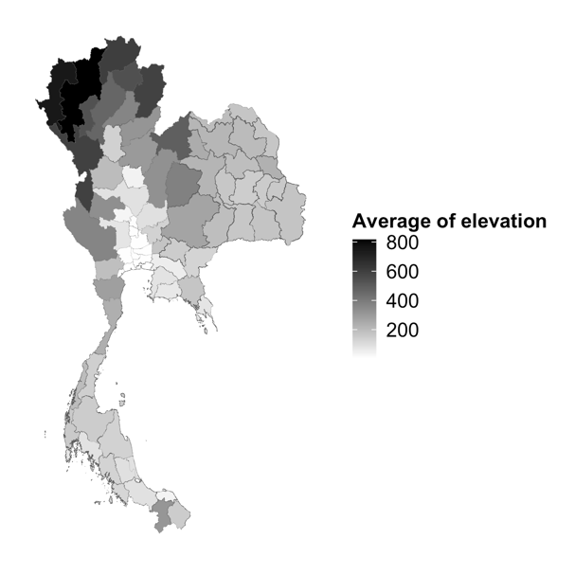
Fig. S10. Average of elevation, Thailand 2012–2018.

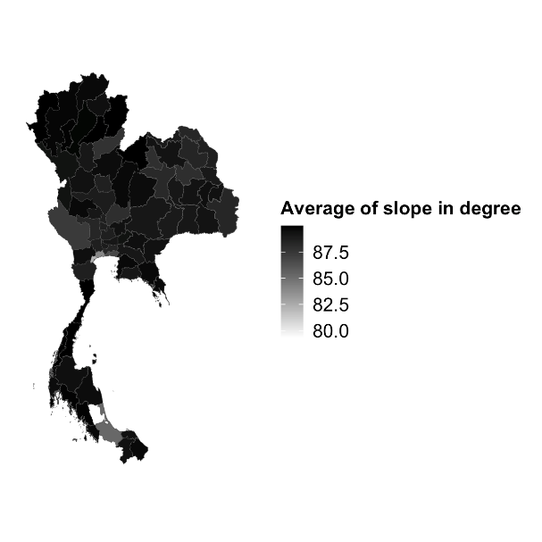
Fig. S11. Average of slope in degree, Thailand 2012–2018.

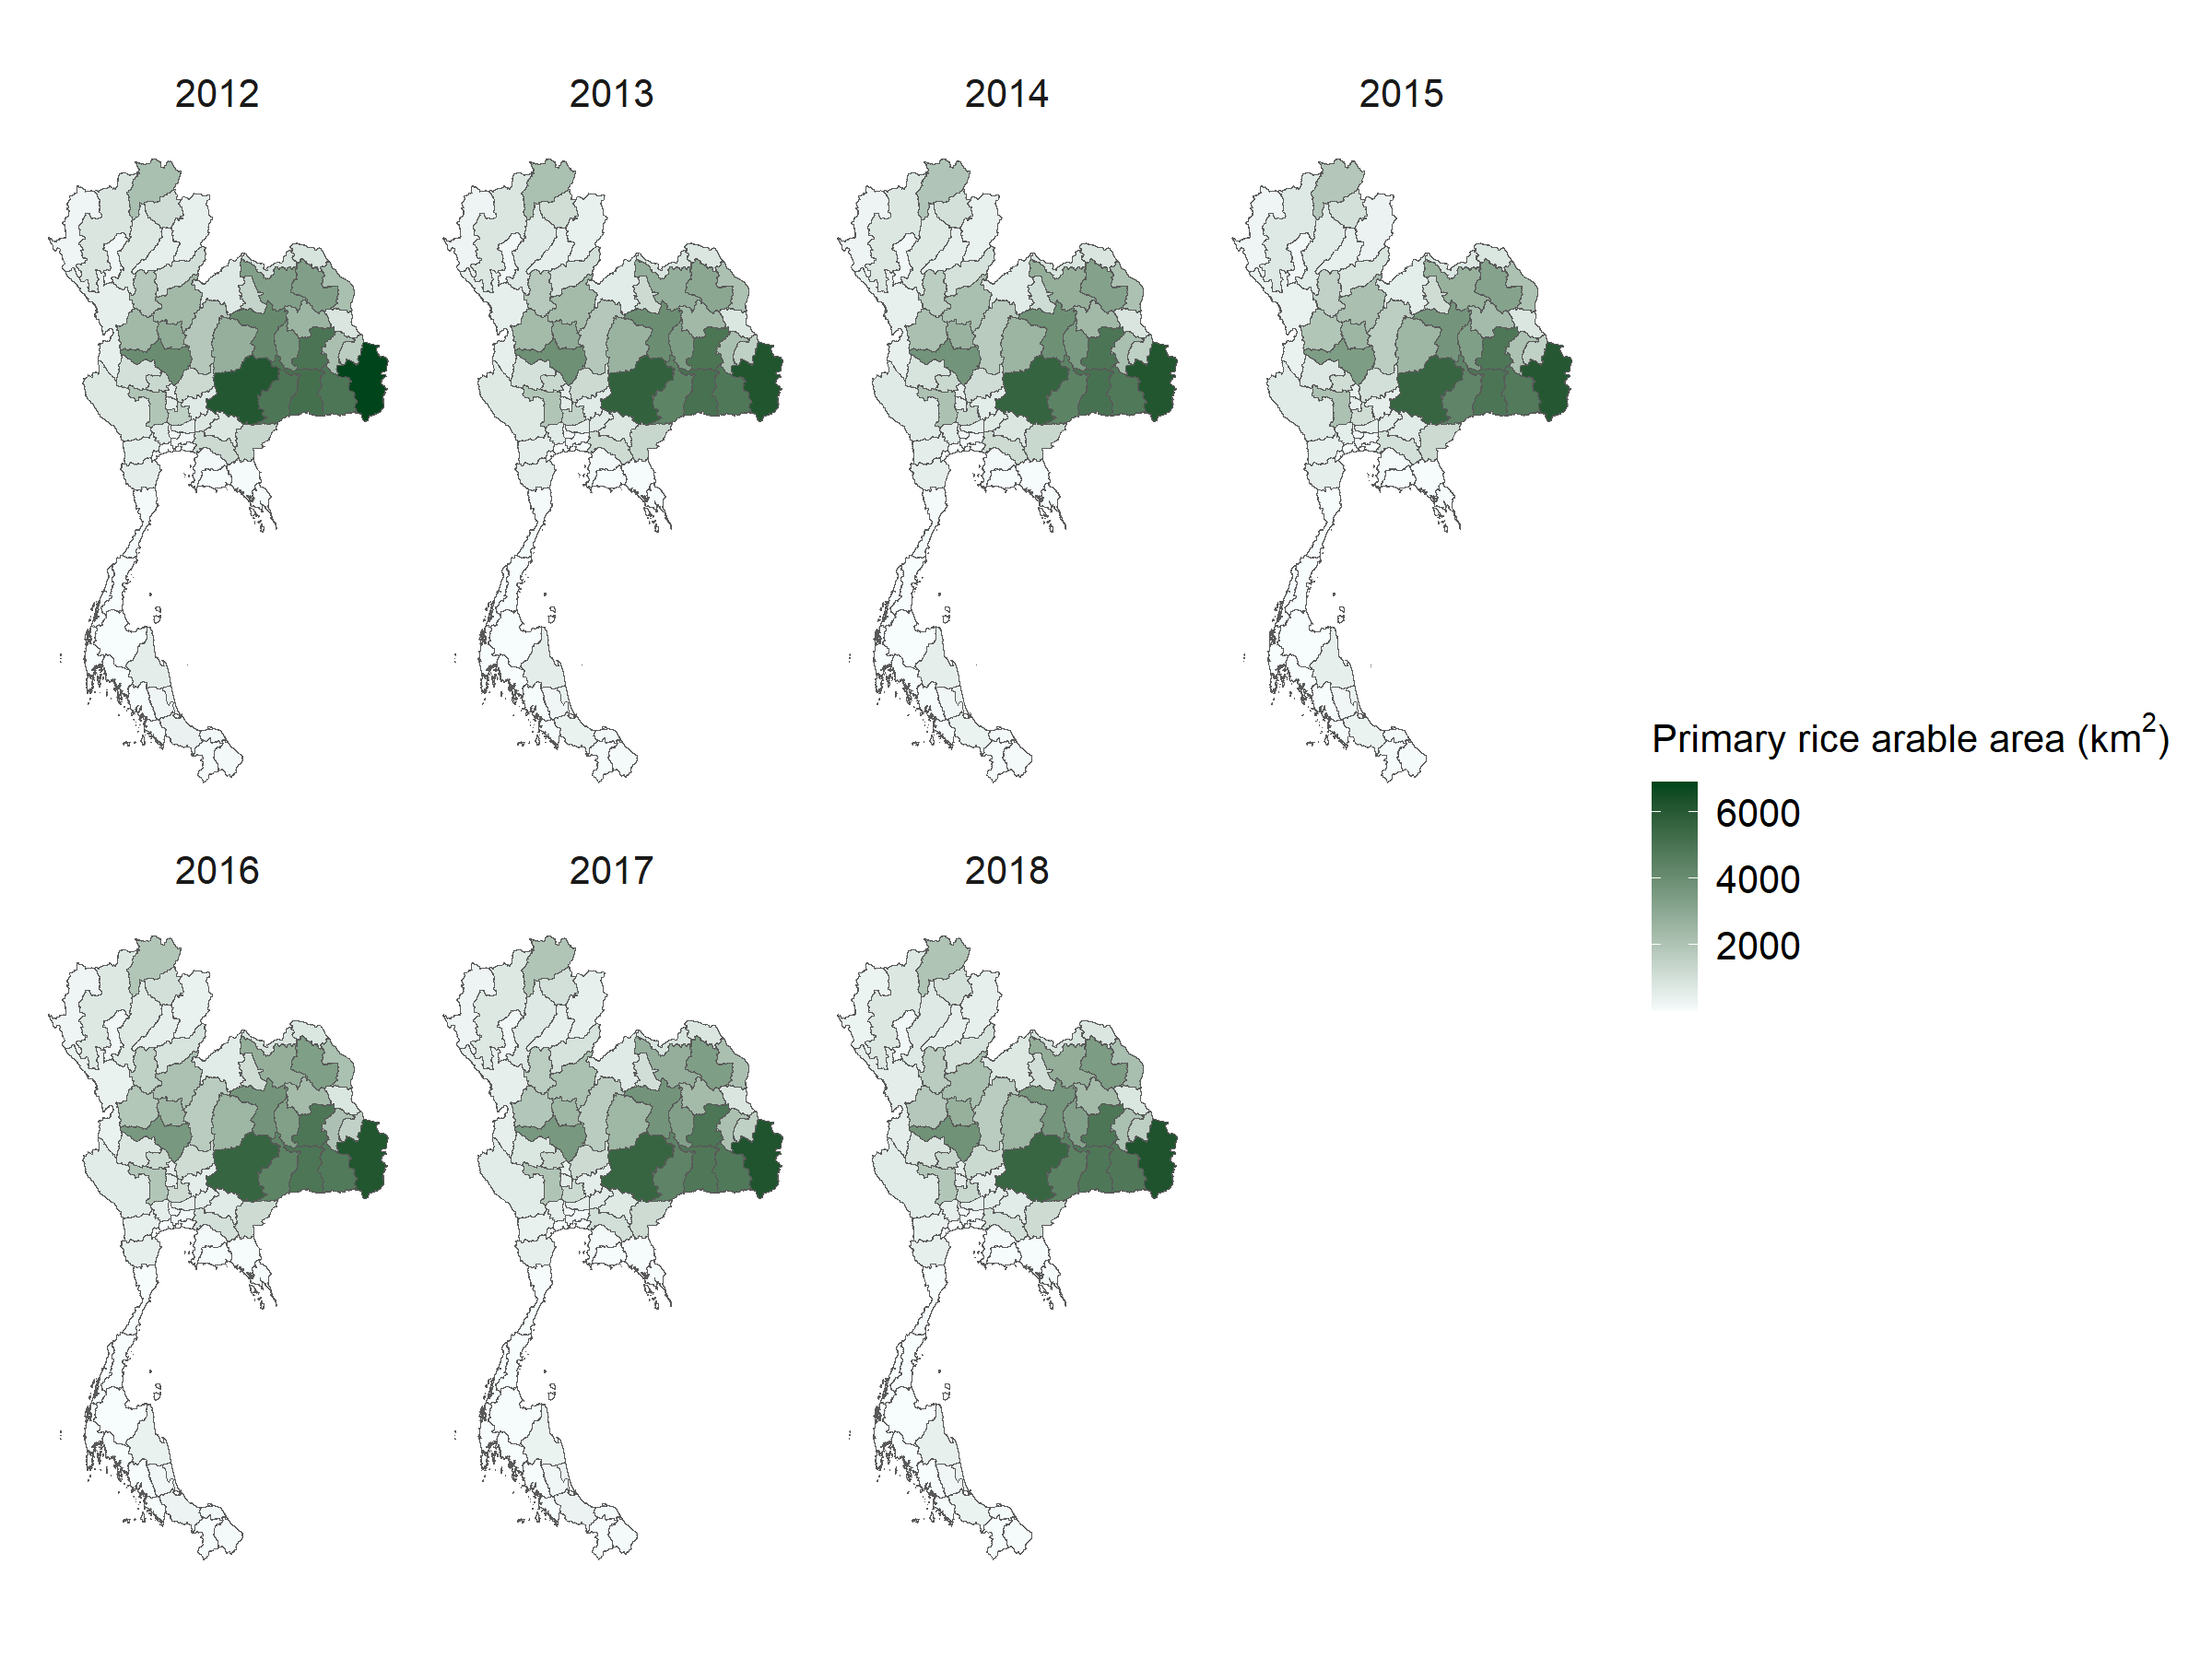
Fig. S12. Primary rice arable area, Thailand 2012–2018.
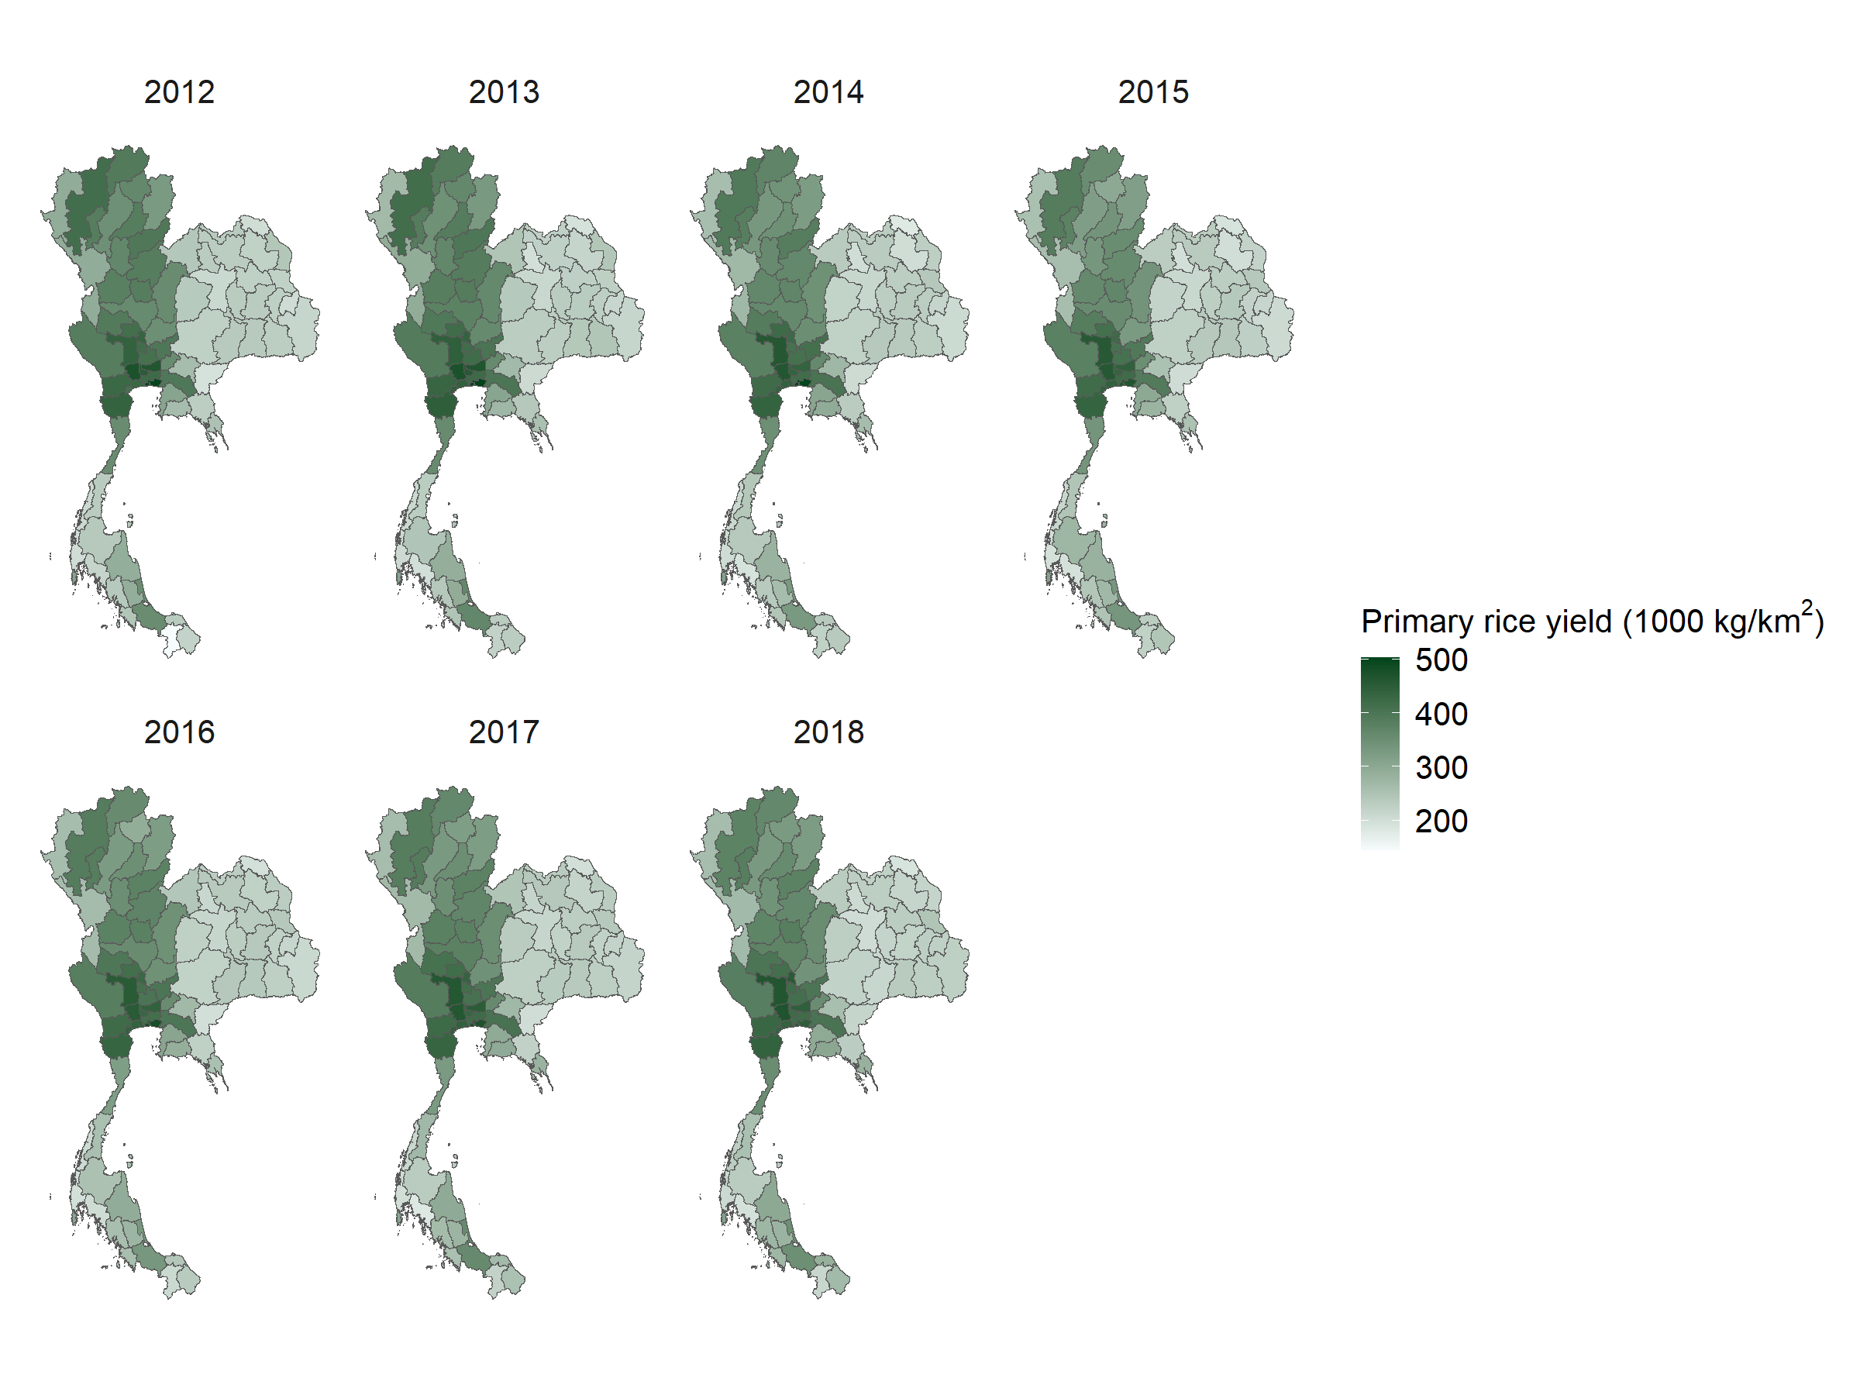
Fig. S13. Primary rice yield, Thailand 2012–2018.

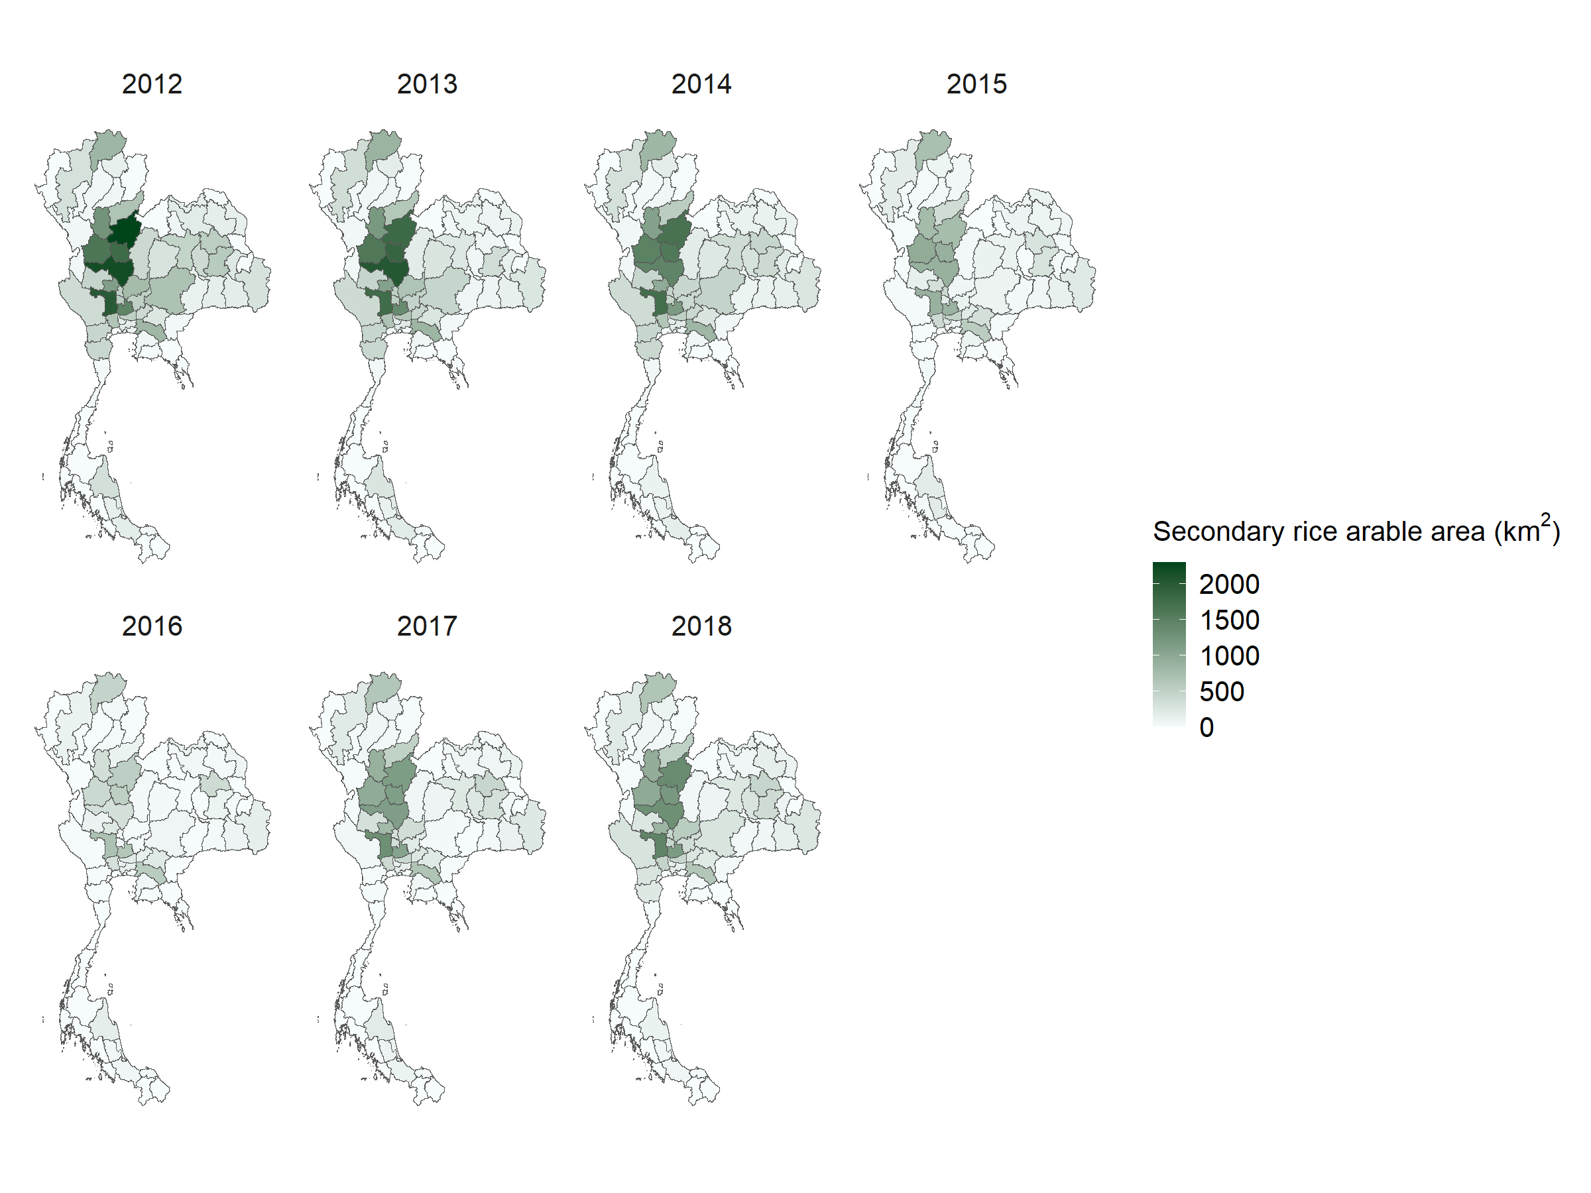
Fig. S14. Secondary rice arable area, Thailand 2012–2018.

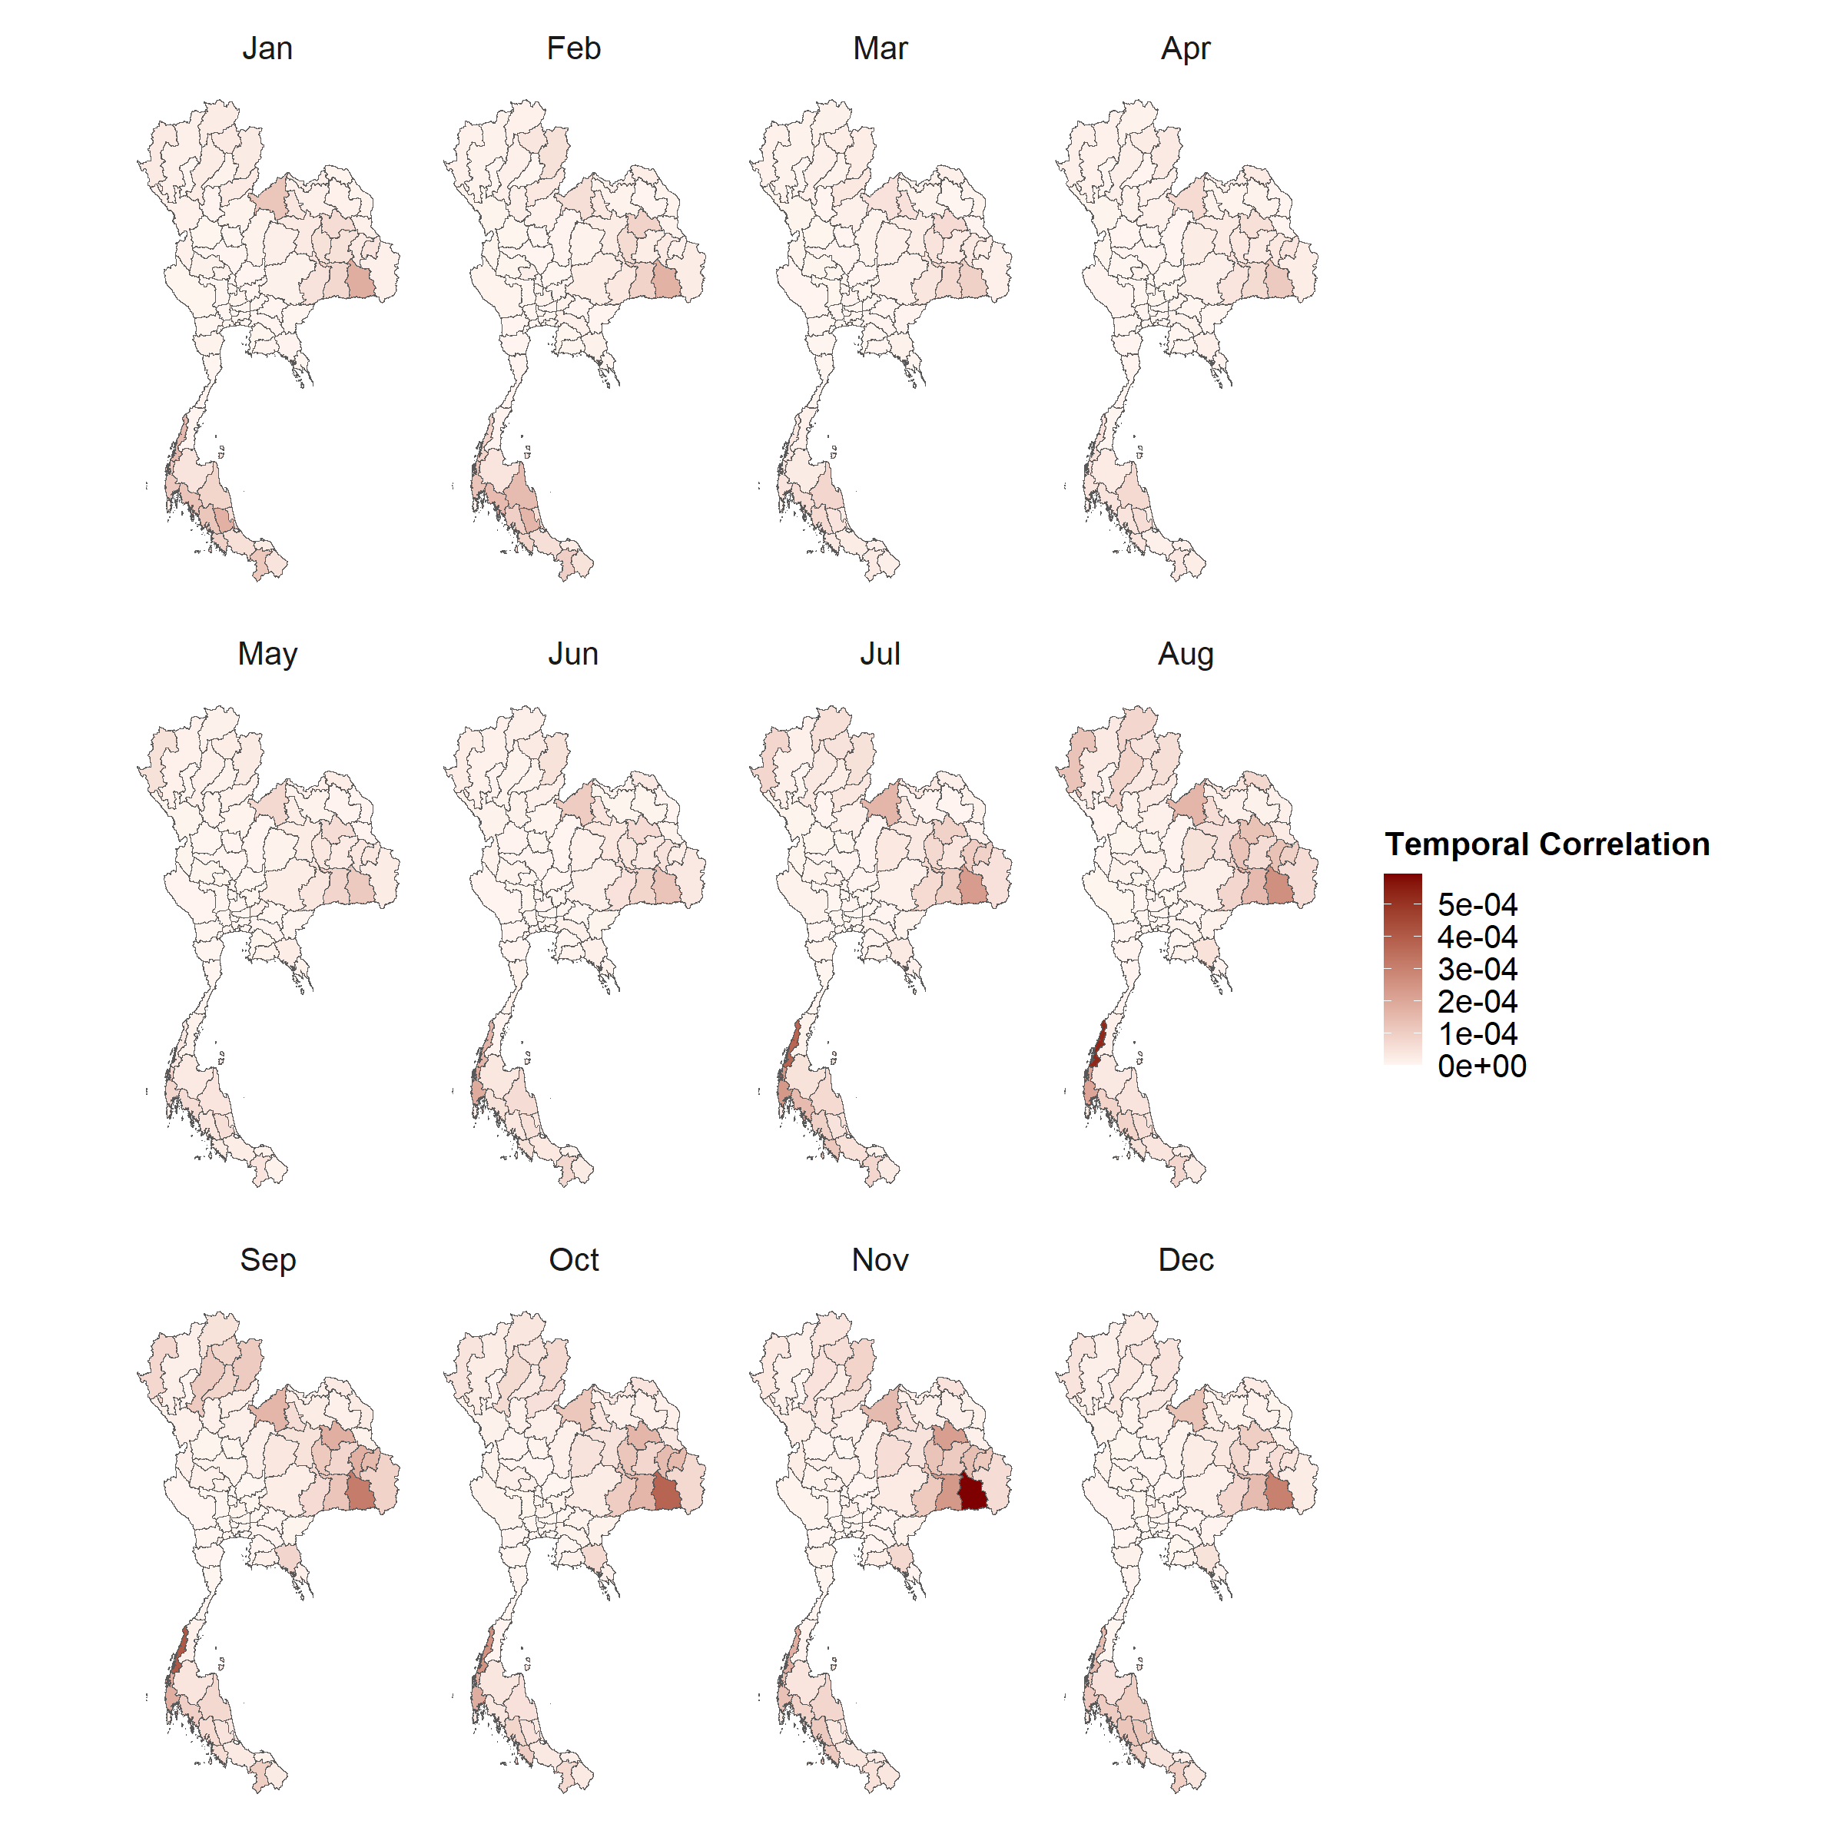
Fig. S15. Monthly temporal correlation, Thailand.

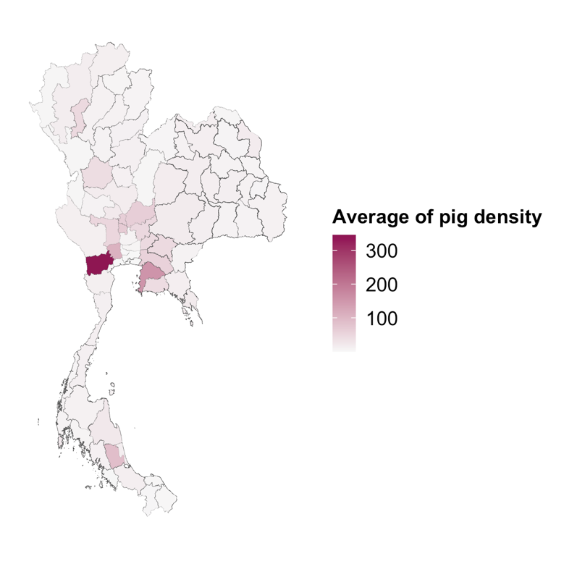
Fig. S16. Average pig density, Thailand for all years.

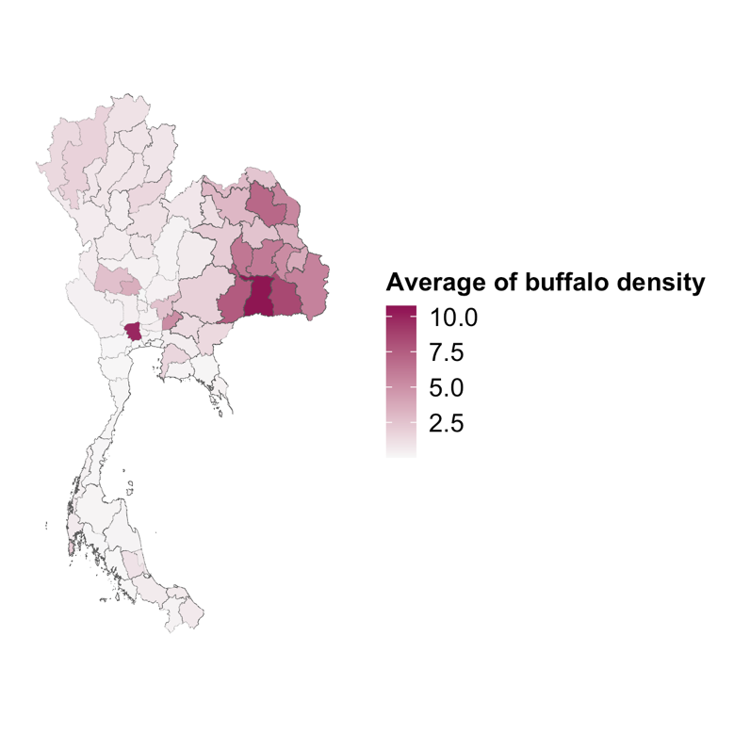
Fig. S17. Average buffalo density, Thailand for all years.

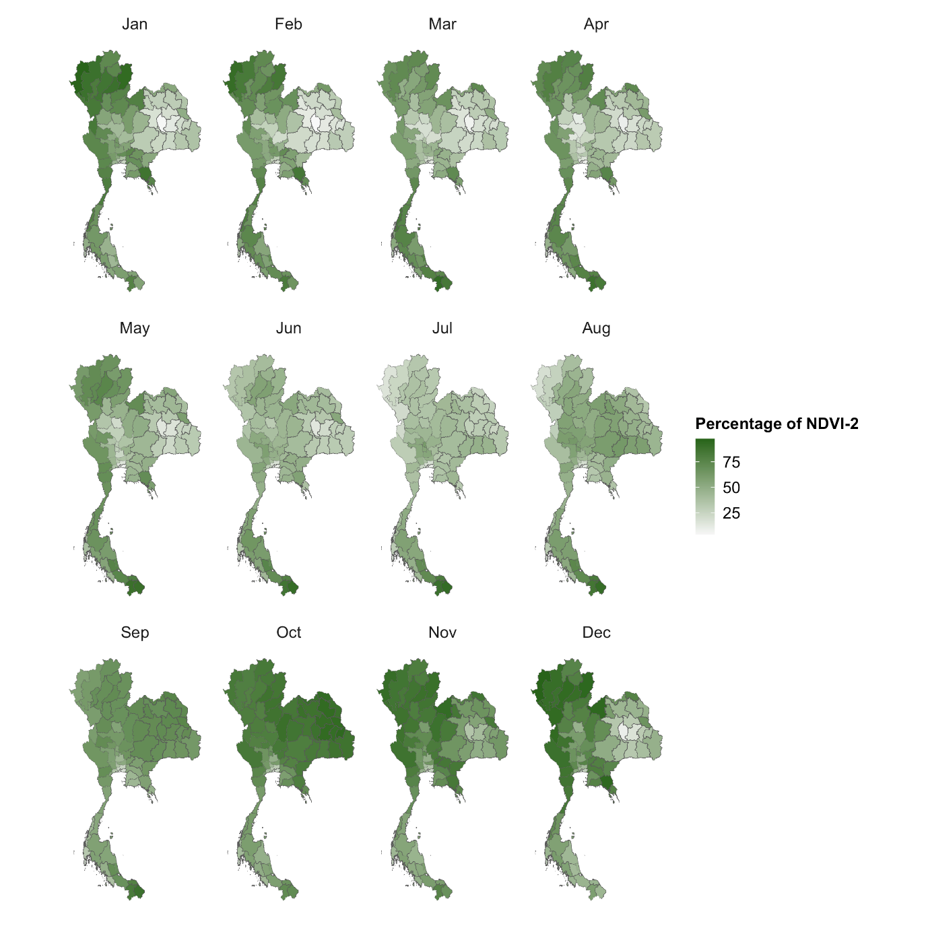
Fig. S18. Monthly percentage of NDVI-2 area, Thailand.

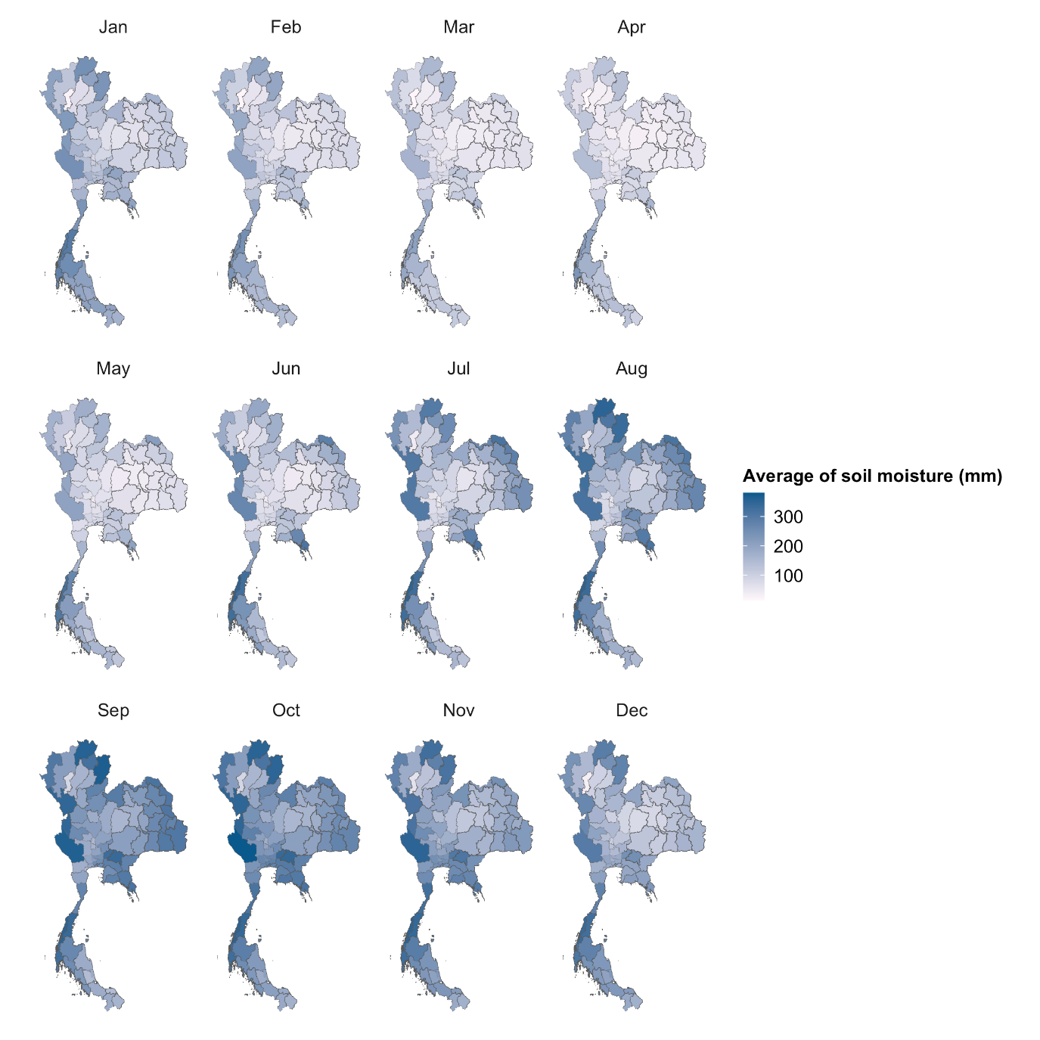
Fig. S19. Monthly average of soil moisture, Thailand.

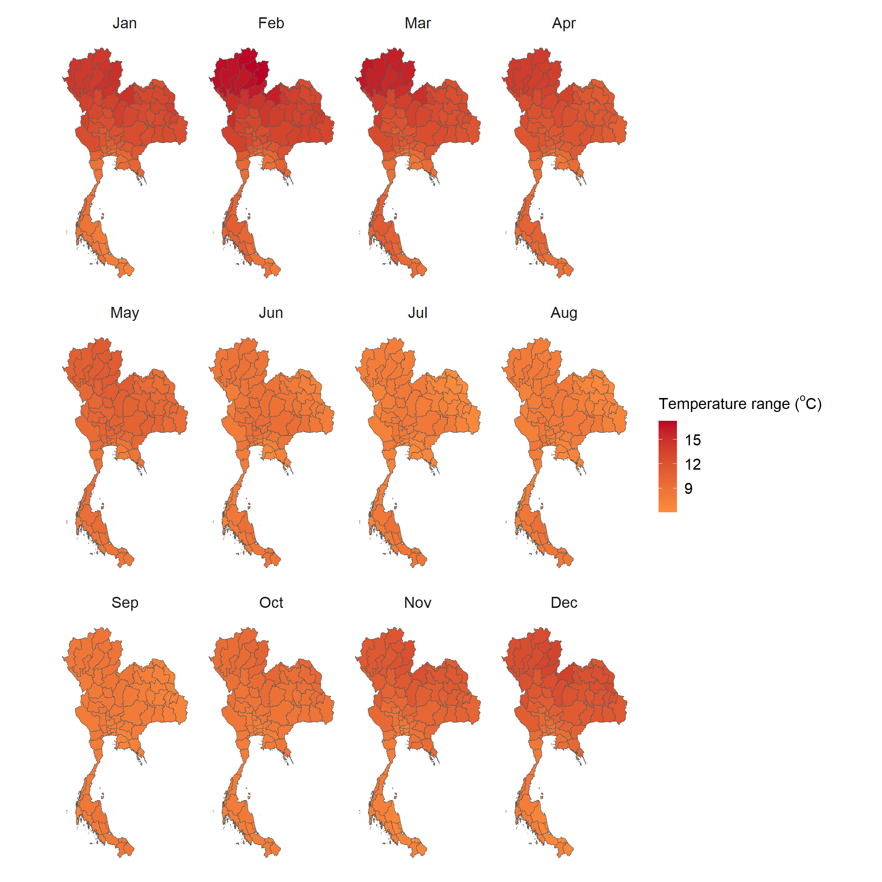
Fig. S20. Monthly temperature range, Thailand.

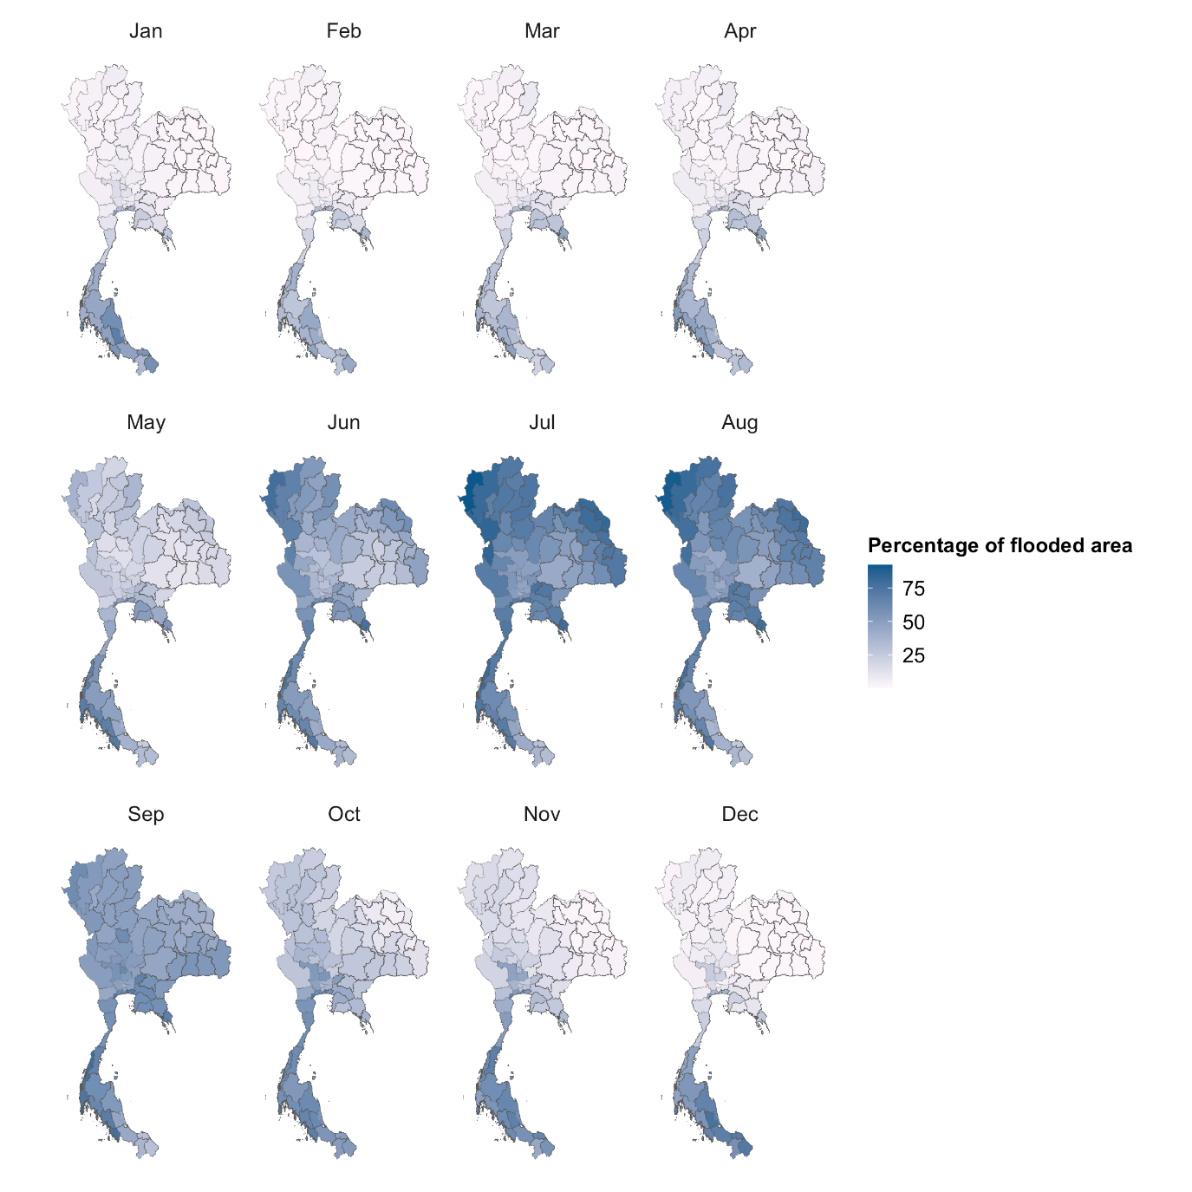
Fig. S21. Monthly percentage of flooded area, Thailand.

