Supplementary material
1. Supplemental Tables
Table S1: Genes included in the diagnostic panel for parkinsonism/dystonia.
Panel | n¹ | Genes
Parkinsonism/dystonia  PD_DYT_2022_v2 | 92 | DJ1, ATP13A2, PINK1, SLC2A1, DNAJC6, GBA, XPR1, SLC30A10, HPCA, GPR88, SPAST, SPR, DCTN1, HTRA2, REEP1, PRKRA, PNKD , GIGYF2, CYP27A1, PTRHD1, SLC19A3, COL6A3, ADCY5, EIF4G1, DNAJC13, CP, PCCB, GLB1, SNCA, ADH1C, QDPR, SLC6A3, PDGFRB, CSF1R, PARK2, MMUT, PDE10A, SGCE, DDC, RELN, RNF216, SLC20A2, THAP1, VPS13A, TOR1A, CIZ1, CACNA1B, KIAA1161, KCNMA1, TH, ANO3, ATM, ACAT1, PTS, LRRK2, SCN8A, PCCA, ATP7B, NKX2-1, ATL1, GCH1, NPC2, ATXN3, FOXG1, POLG, VPS13C, SPG11, PRRT2, VPS35, FA2H, MAPT, KIF1C, GNAL, NPC1, TUBB4a, C19orf12, ATP1A3, FTL, KMT2B, GCDH, PANK2, TMEM230 , SYNJ1, FBXO7, PLA2G6, PDGFB, KCTD17, WDR45, TAF1, RAB39B, HPRT, XK
¹ number of genes included in the panel

Table S2: Primer sequences and combinations.
Symbol | Transcript variant | RefSeq | Primer sequence, 5’ 🡪 3’
 | SPP1tv1 | NM_001040058.2 | AGC CCC ACA GAA TGC TGT GT
SPP1 |  |  | GTC GTT CGA GTC AAT GGA GT
 | SPP1tv2 | NM_000582.3 | AGC CCC ACA GAA TGC TGT GT
 |  |  | GTC GTT CGA GTC AAT GGA GT
ABCG2 | ABCG2tv1 | NM_004827.3 | CAG CTT CCA ATG ACC TGA AG
 |  |  | ATG GCG TTG AGA CCA GGT TT
PPM1K |  | NM_152542.5 | TGG TGT CAT AGC AGA ACC TG
 |  |  | GAT CAT GGC ACT GAT TGA CA
HERC6 | HERC6tv1 | NM_017912.4 | CTG CTT GTC TGA CTG CAA GT
 |  |  | TGG AAG AGC TCT GAG CAG AT
GPRIN3 |  | NM_198281.3 | AGA GAC GGT GCT TGG GAT AT
 |  |  | AGT CAG AGC TCA GAG TGA TG
 | SNCAtv1 | NM_000345.4 | TTC AAG CCT TCT GCC TTT CC
 |  |  | ACC ACT GCT CCT CCA ACA T
SNCA | SNCAtv2 | NM_001146054.2 | AGT CGG AGT TGT GGA GAA GCA
 |  |  | ACC ACT GCT CCT CCA ACA T
 | SNCAtv3 | NM_001146055.2 | ATC CAG GAA CAG CTG TCT TC
 |  |  | ACC ACT GCT CCT CCA ACA T
MMRN1 | MMRN1tv2 | NM_007351.3 | ACC AGG CTG AAA GTC ATA CA
 |  |  | GAG TAA GTG TTC CTT ACA TCA
NLRP3 | NLRP3tv1 | NM_004895.5 | TGG ATC TTC GCT GCG ATC AA
 |  |  | CAC TCC TCT TCA ATG CTG TC
TLR2 | TLR2tv4 | NM_001318790.2 | CAG TGT TTG GTG TTG CAA GC
 |  |  | TAT GTG GCA TTG TCC AGT GC
TLR4 | TLR4tv1 | NM_138554.5 | TCT CAA CCA AGA ACC TGG AC
 |  |  | GGT GGC TTA GGC TCT GAT AT
YWHAQ |  | NM_006826.4 | TAT CGG GAG AAA GTG GAG TC
 |  |  | TTC AGC AAG GTA CCG GAA GT
YWHAZ | YWHAZtv2 | NM_145690.3 | ACG GAG CTA AGA GAT ATC TGC
 |  |  | CTC AGC CAA GTA ACG GTA GTA
YWHAB | YWHABtv2 | NM_139323.4 | AGG AAG GAA GAG GTC ATC TC
 |  |  | ACT CCA AGT CCA GTG CTC TT
YWHAG |  | NM_012479.4 | AGC AAC TGG TGC AGA AAG CC
 |  |  | TAG GCC ACA GAC AGA AGG T
YWHAH |  | NM_003405.4 | TAT GAA GGC GGT GAC AGA GC
 |  |  | ATG CTG CTA ATG ACC CTC CA
SLC18A2 |  | NM_003054.6 | AGC TCA TCC TGT TCA TCG TG
 |  |  | CGG TGA CCA TAG TCG AGT TA
RPS18 |  | NM_022551.3 | CCT TTG CCA TCA CTG CCA TT
 |  |  | ATG GTG ATC ACA CGT TCC AC
RPL11 | RPL11tv1 | NM_000975.5 | CAT CCA CAA ACT CTG TCA CA
 |  |  | AGA TTT CTT CTG CCT TGG CC
SNRPD3 | SNRPDtv1 | NM_004175.5 | AGC AGA GGA CAA CAT GAA CTG
 |  |  | TAA CAT GGG TGC GTT CTT CAG
RDX |  | NM_002906.4 | ATG CCG AAA CCA ATC AAC GT
 |  |  | AAC ATC CTG CTG TGT TAC CT
PBGD1 |  | NM_032507.4 | ACA CAC AGC CTA CTT TCC AAG
 |  |  | TCA ATG TTG CCA CCA CAC TGT
ACTB |  | NM_00101.5 | TCT ACA ATG AGC TGC GTG TG
 |  |  | TAG ATG GGC ACA GTG TGG GT

Table S3: Clinical and demographic data of PD patients and control individuals.
 | PD | CTRLs
n¹ | 15 | 18
Male/female, n | 8/7 | 8/10
age sample², years (age range, years) | 46.6 (40 - 53) | 43.6 (37 - 48)
age PD onset, years (range, years) | 43.9 (38 - 50) | n/a
disease duration, years (range, years) | 2.4 (0 - 5) | n/a
¹ number of participants, ² age at sample obtaining; n/a, not applicable

2. Supplemental Figures

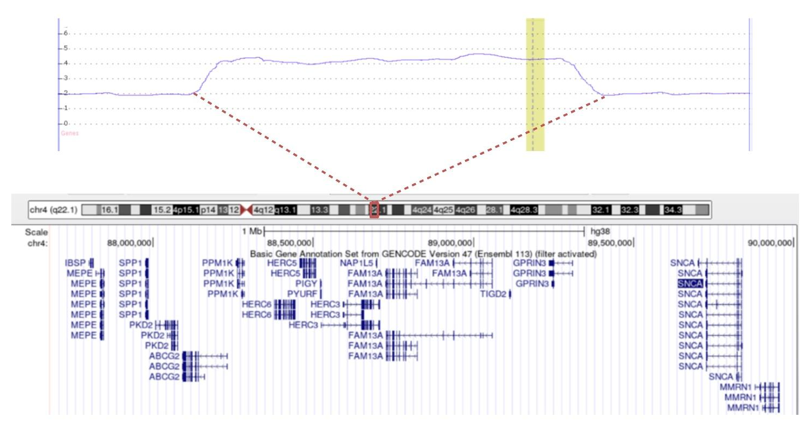
Supplementary Fig.1. Schematic representation of the SNCA locus triplication. Upper part: smooth signal of the SNCA locus amplification obtained by the Chromosome Analysis Suite (ChAS) software (the green bar represents the SNCA gene); lower part: protein-coding genes within the triplicated locus on chromosme 4q22.1 (image obtained from the UCSC Genome Browser (hg38), accessed on January 22, 2025 at https://genome.ucsc.edu/).

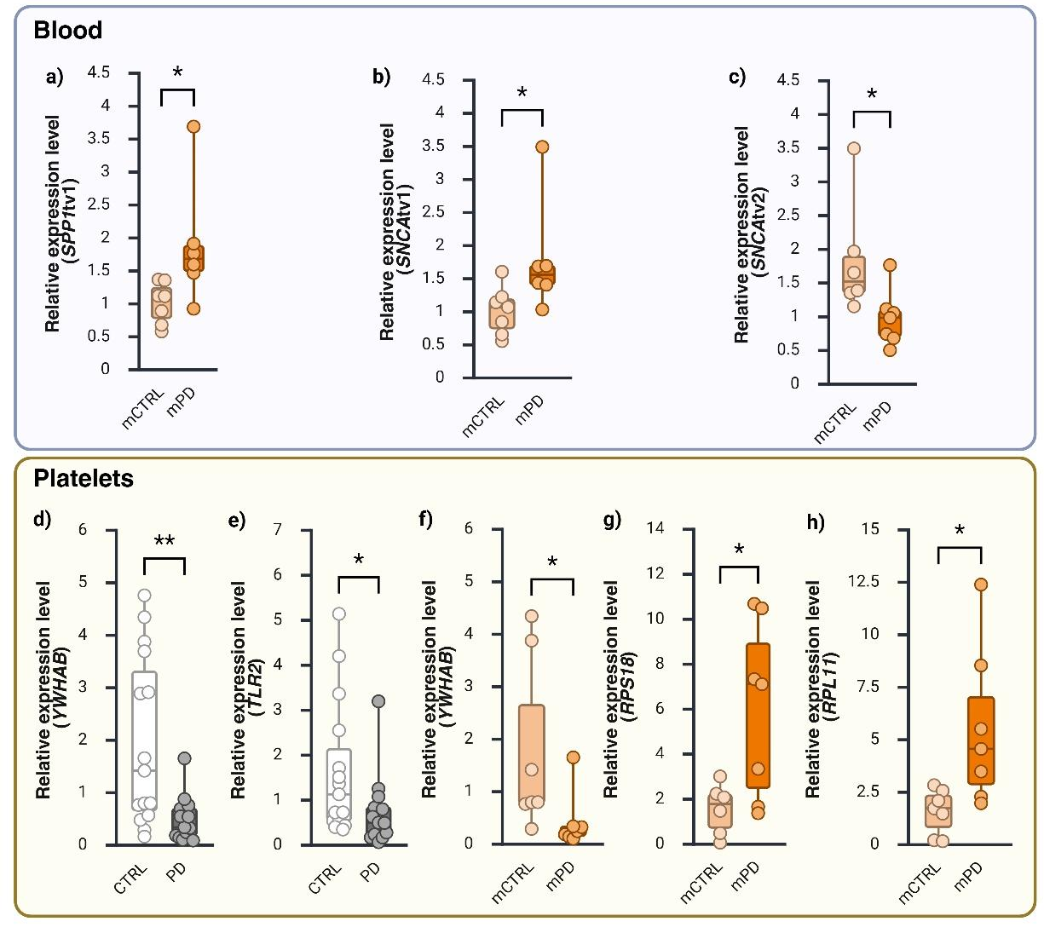
Supplementary Fig.2. Differentially expressed genes in blood and PLTs from PD vs CTRLs. Parkinson’s disease (PD), controls (CTRL), male PD (mPD), male controls (mCTRL) (*p<0.05, **p<0.01).

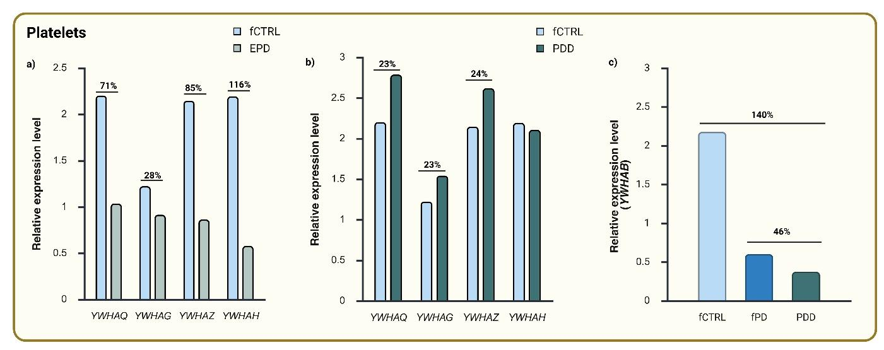
Supplementary Fig 3. Expression of 14-3-3 genes in PLTs of patient SNCA3x. Early-stage PD (EPD), advanced PD with dementia (PDD), female controls (fCTRL), female PD (fPD).

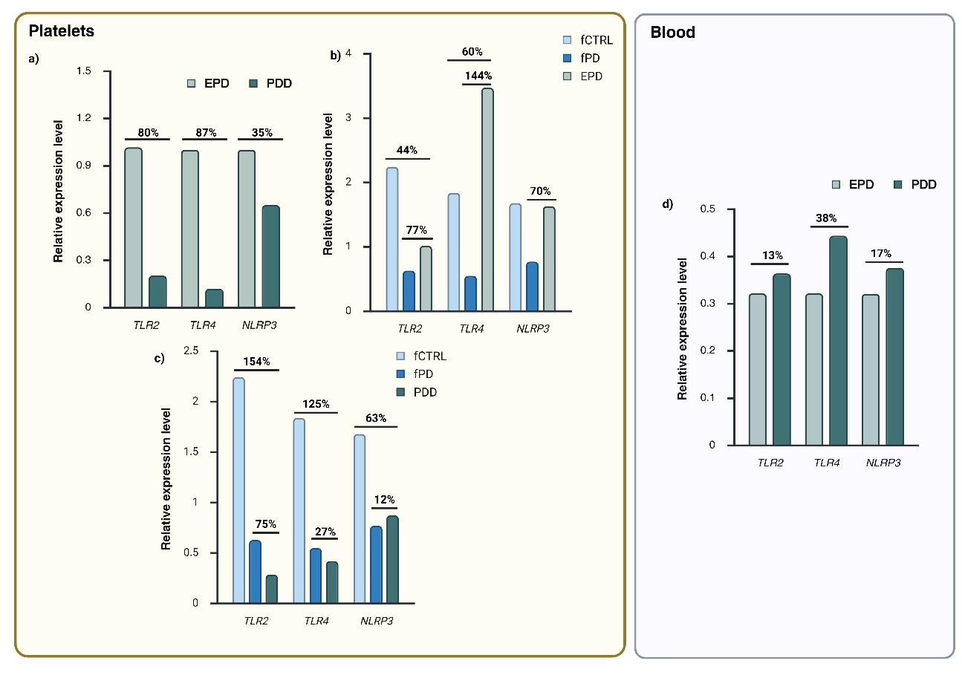
Supplementary Fig 4. Expression of inflammatory genes in PLTs and blood of patient SNCA3x. Early-stage PD (EPD), advanced PD with dementia (PDD), female controls (fCTRL), female PD (fPD).

