Supplementary Information

The synergistic inhibitory effect of PRKAA1 activation on ECM mechanical stress-induced skin fibrosis

Running title: Synergistic inhibition of skin fibrosis by PRKAA1

Yang Xiang^{1,3#}, Yuanyuan Chen^{2#}, Jin Zhang^{1#}, Bohan Pan¹, Jianyu Lu¹, Chenru Wei¹, Jiqiu Chen¹, Chan Li¹, Shizhao Ji^{1*}, Yanyong Yang^{2*}, Shihui Zhu^{1,3*}

#. These authors contributed equally to this work.
1 Department of Burns of Changhai Hospital, Department of Emergency of Changhai Hospital, Naval Medical University, Shanghai 200433, China
2 Department of Radiation Medicine, Faculty of Naval Medicine, Naval Medical University, Shanghai, 200433, China.
3 Department of Burns and Plastic Surgery, Shanghai Children’s Medical Center, School of Medicine, Shanghai Jiao Tong University, Shanghai, 200127, China.

Supplementary figures and tables

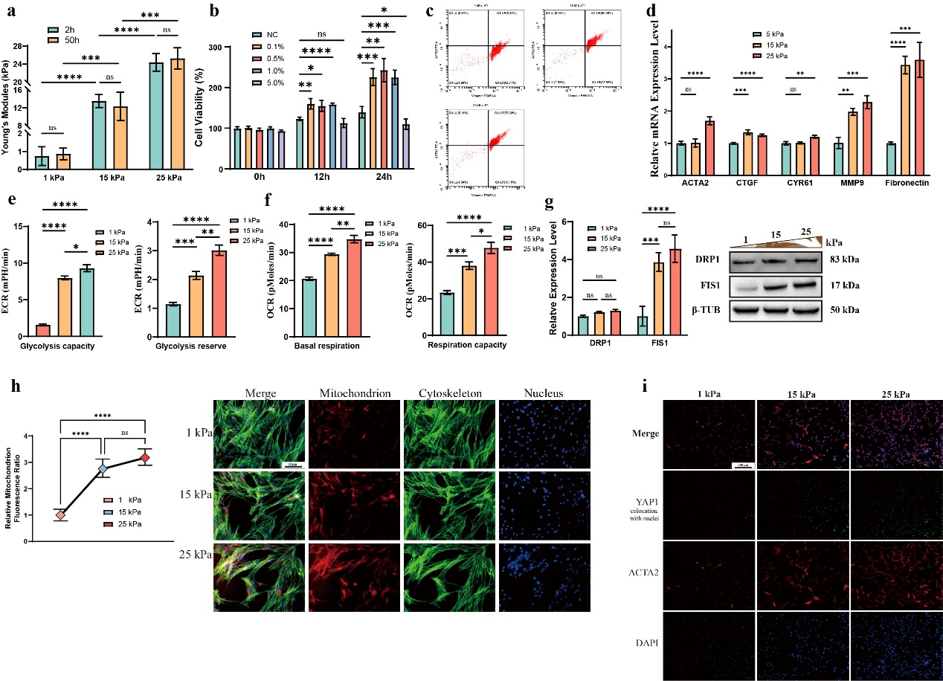
Extended Data Figure 1 Mechanical modulus induces HDF differentiation and metabolic reprogramming.
a. Statistical graph of Young’s modulus of GelMA hydrogels (n=8).
b. Biocompatibility evaluation of GelMA precursor solution on HDFs using CCK-8 assay (n=6).
c. Flow cytometry scatter plots of VIM⁺ACTA2⁺ HDFs under 1, 15, and 25 kPa mechanical stimulation.
d. Relative mRNA expression levels of ACTA2, CTGF, CYR61, MMP9, and FN1 in HDFs under 1, 15, and 25 kPa mechanical stimulation (n=6).
e. Glycolytic capacity and remaining glycolytic activity in HDFs under 1, 15, and 25 kPa mechanical stimulation (n=6).
f. Basal respiration capacity and remaining respiratory activity in HDFs under 1, 15, and 25 kPa mechanical stimulation (n=6).
g. Relative expression levels of DRP1 and FIS1 and their protein immunoblotting images in HDFs under 1, 15, and 25 kPa mechanical stimulation (n=3).
h. MitoTracker Red CMXRos-labeled mitochondrial immunofluorescence images and relative immunofluorescence intensity of HDFs under 1, 15, and 25 kPa mechanical stimulation (n=3).
i. ACTA2 and YAP1 nuclear localization immunofluorescence images and relative immunofluorescence intensity of HDFs under 1, 15, and 25 kPa mechanical stimulation (n=4).
​Abbreviations: GelMA, Gelatin Methacryloyl; HDF, human dermal fibroblast; VIM, vimentin; ACTA2, Actin Alpha 2, Smooth Muscle; CTGF, connective tissue growth factor; CYR61, cysteine-rich angiogenic inducer 61; MMP9, matrix metallopeptidase 9; FN1, Fibronectin 1; YAP1, Yes1 Associated Transcriptional Regulator; DRP1, Dynamin-Related Protein 1; FIS1, Mitochondrial Fission 1; β-TUB, β-Tubulin. ​Statistical notation: Horizontal lines indicate comparisons between two groups; ns, non-significant; *，P < 0.05；**，P < 0.01；***，P < 0.001；****，P < 0.0001.
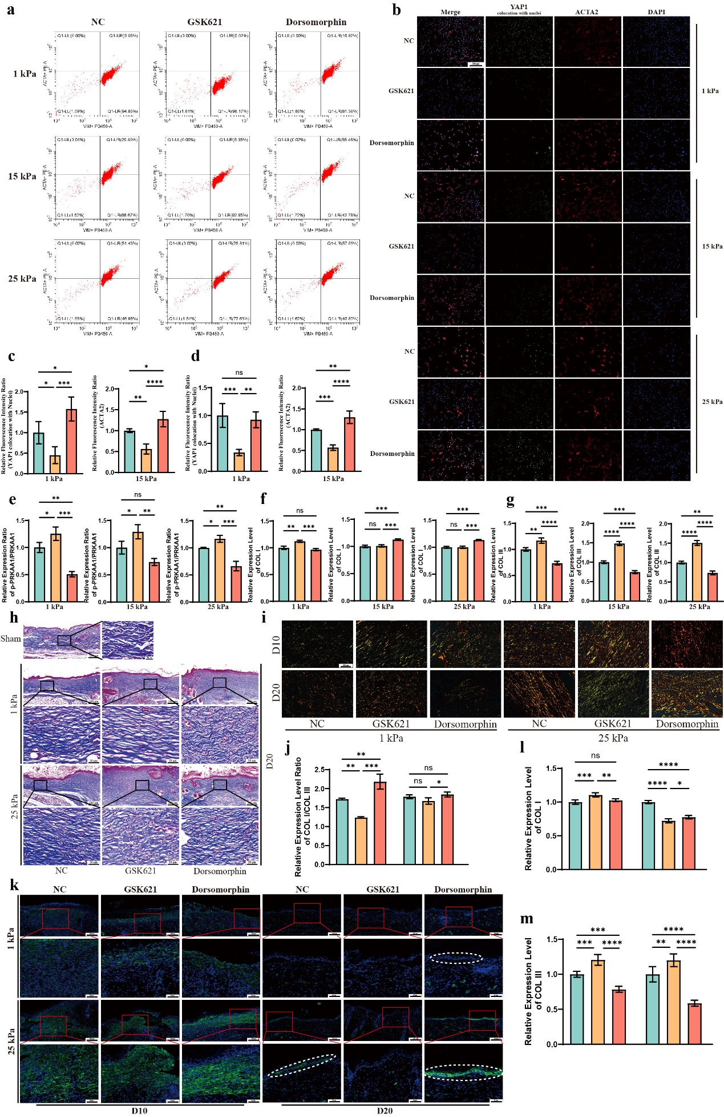Extended Data Figure 2 PRKAA1 activation inhibits mechanical modulus-induced HDF differentiation and fibrosis.
a. Flow cytometry scatter plots of VIM⁺ACTA2⁺ HDFs under GSK621 or Dorsomorphin treatment and 1 or 15 kPa mechanical stimulation.
b-d. Immunofluorescence images and relative immunofluorescence intensity of ACTA2 and YAP1 nuclear localization in HDFs under GSK621 or Dorsomorphin treatment and 1 or 15 kPa mechanical stimulation (n=4).
e-g. Western blotting images of relative PRKAA1 phosphorylation level, and relative expression levels of COL I and COL III in HDFs under GSK621 or Dorsomorphin treatment and different mechanical stimuli (n=3).
h. Masson staining images of mouse dorsal full-thickness defect wounds at day 20 under GSK621 or Dorsomorphin treatment and 1 or 25 kPa mechanical stress intervention.
i. Sirius Red staining images of mouse dorsal full-thickness defect wounds at day 10 or 20 under GSK621 or Dorsomorphin treatment and 1 or 25 kPa mechanical stress intervention.
j. Differences in Col I/Col III ratio among different mechanical stimuli at day 10, quantified by Sirius Red staining (n=3).
k. Immunofluorescence staining images of Acta2 in wounds at day 10 and 20 under 1 or 25 kPa mechanical stimulation and drug intervention. l-m. Relative expression levels of Col I and Col III in wound tissue at day 20 under differential mechanical stimulation and drug intervention, quantified by Western blotting (n=5). ​Abbreviations: HDF, human dermal fibroblast; VIM, vimentin; ACTA2, Actin Alpha 2, Smooth Muscle; PRKAA1, AMPKα1, Protein Kinase AMP-Activated Catalytic Subunit Alpha 1; YAP1, Yes1 Associated Transcriptional Regulator; COL I, collagen type I; COL III, collagen type III; Dorsomorphin, a BMP signaling inhibitor. ​Statistical notation: Horizontal lines indicate comparisons between two groups; ns, non-significant; *，P < 0.05；**，P < 0.01；***，P < 0.001；****，P < 0.0001.
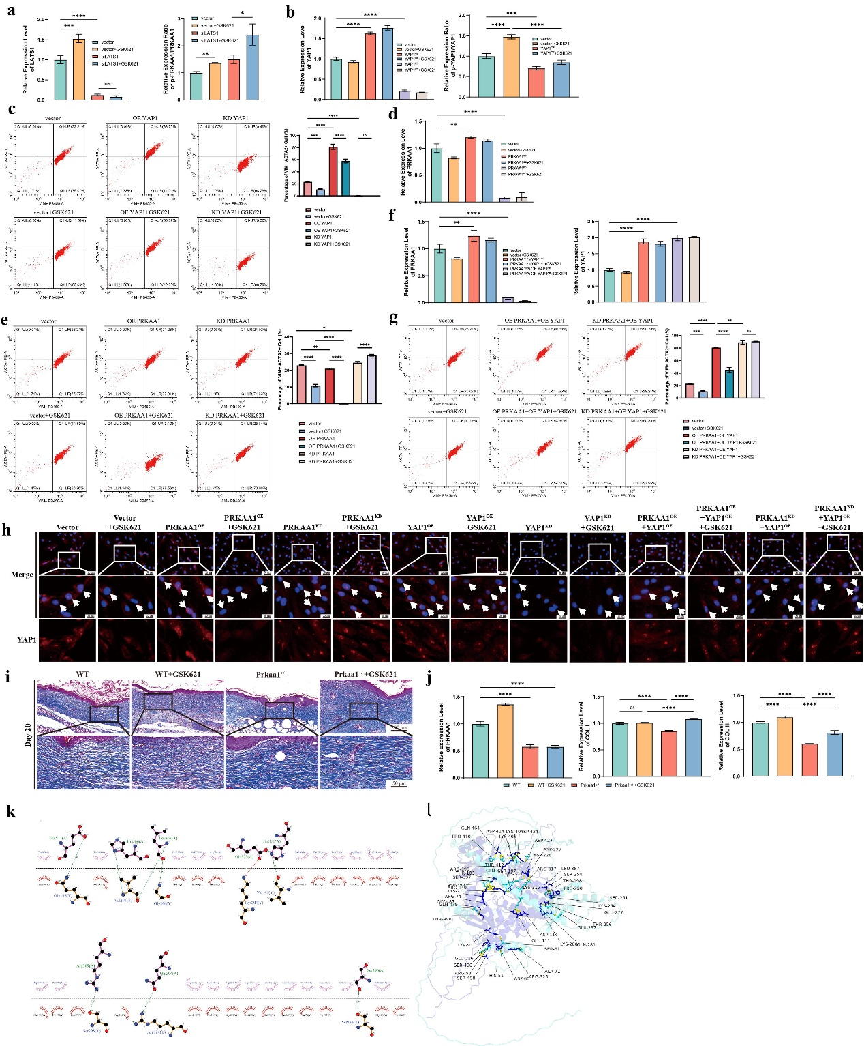
Extended Data Figure 3. PRKAA1 activation inhibits mechanical modulus-induced fibrosis by suppressing YAP1 activity.
a. Western blotting images of relative LATS1 expression levels and PRKAA1 phosphorylation levels in cells treated with GSK621 under 25 kPa mechanical stimulation and LATS1 knockdown (LATS1^{KD}) (n=3).
b. Western blotting images of relative YAP1 expression and phosphorylation levels in YAP1-overexpressing (YAP1^{OE}) or YAP1-knockdown (YAP1^{KD}) cells after GSK621 treatment (n=3).
c. Flow cytometry scatter plots and statistical graphs of VIM⁺ACTA2⁺ HDFs in YAP1^{OE} or YAP1^{KD} cells after GSK621 treatment (n=3).
d. Western blotting images of relative PRKAA1 expression levels in PRKAA1^{OE} or PRKAA1^{KD} cells after GSK621 intervention (n=3).
e. Flow cytometry scatter plots and statistical graphs of VIM⁺ACTA2⁺ HDFs in PRKAA1^{OE} or PRKAA1^{KD} cells after GSK621 intervention (n=3).
f. Western blotting images of relative PRKAA1 and YAP1 expression levels in PRKAA1^{OE}YAP1^{OE} or PRKAA1^{KD}YAP1^{OE} cells after GSK621 treatment (n=3).
g. Flow cytometry scatter plots and statistical graphs of VIM⁺ACTA2⁺ HDFs in PRKAA1^{OE}YAP1^{OE} or PRKAA1^{KD}YAP1^{OE} cells after GSK621 treatment (n=3).
h. Immunofluorescence images of YAP1 nuclear localization in WT, WT+GSK621, YAP1^{OE}, YAP1^{OE}+GSK621, YAP1^{KD}, YAP1^{KD}+GSK621, PRKAA1^{OE}YAP1^{OE}, PRKAA1^{OE}YAP1^{OE}+GSK621, PRKAA1^{KD}YAP1^{OE}, PRKAA1^{KD}YAP1^{OE}+GSK621, PRKAA1^{OE}, PRKAA1^{OE}+GSK621, PRKAA1^{KD}, and PRKAA1^{KD}+GSK621 cells.
i. Masson staining images of mouse dorsal full-thickness defect wounds at day 20 under PBS or GSK621 treatment and 25 kPa mechanical stress: WT vs. Prkaa1^{+/-} mice (n=3).
j. Western blotting images of relative Prkaa1, Col I, and Col III expression levels in wound tissue at day 20 under PBS or GSK621 treatment and 25 kPa mechanical stress: WT vs. Prkaa1+/- mice (n=5).
k. 2D interaction map of PRKAA1-YAP1 predicted by Rosetta software. l. 3D visualization of PRKAA1-YAP1 interaction sites predicted by AlphaFold3 and modeled with PyMol. ​
Abbreviations: HDF, human dermal fibroblast; VIM, vimentin; LATS1, Large Tumor Suppressor Kinase 1; ACTA2, Actin Alpha 2, Smooth Muscle; OE, over-expression; KD, knockdown; PRKAA1, AMPKα1, Protein Kinase AMP-Activated Catalytic Subunit Alpha 1; YAP1, Yes1 Associated Transcriptional Regulator; COL I, collagen type I; COL III, collagen type III; WT, wild type; Prkaa1+/-, Prkaa1 heterozygous. ​Statistical notation: Horizontal lines indicate comparisons between two groups; ns, non-significant; *，P < 0.05；**，P < 0.01；***，P < 0.001；****，P < 0.0001.

Table S1 Sequences of siRNAs and shRNAs and used in this study
Type | Target | Sequence
siRNA | LATS1 | F1: GGAGUACUUCAGAAGUUAATT  R1: UUAACUUCUGAAGUACUCCTT  F2: AGUCAGAAAUCCACCCAAATT  R2: UUUGGGUGGAUUUCUGACUTT  F3: GCCGGCAAAUGUUACAAGATT  R3: UCUUGUAACAUUUGCCGGCTT
shRNA | PRKAA1 | RNAi1:  CCGGCATAAAGTAGCTGTGAAGATACTCGAGTATCTTCACAGCTACTTTATGTTTTTG  RNAi2:  CCGGGAATGCAAAGATAGCTGATTTCTCGAGAAATCAGCTATCTTTGCATTCTTTTTG  RNAi3:  CCGGGTGGATTATTGTCACAGGCATCTCGAGATGCCTGTGACAATAATCCACTTTTTG
shRNA | YAP1 | RNAi1:  CCGGGCCACCAAGCTAGATAAAGAACTCGAGTTCTTTATCTAGCTTGGTGGCTTTTTG  RNAi2: CCGGCAGGTGATACTATCAACCAAACTCGAGTTTGGTTGATAGTATCACCTGTTTTTG  RNAi3:  CCGGGAGCTCATTCCTCTCCAGCTTCTCGAGAAGCTGGAGAGGAATGAGCTCTTTTTG

Table S2 Oligonucleotide primers for qRT-PCR analyses
Type | Target | Sequence
mRNA | ACTA2 | F: CTATGAGGGCTATGCCTTGCC  R: GCTCAGCAGTAGTAACGAAGGA
mRNA | CTGF | F: AAAAGTGCATCCGTACTCCCA  R: CCGTCGGTACATACTCCACAG
mRNA | CYR61 | F: GGTCAAAGTTACCGGGCAGT  R: GGAGGCATCGAATCCCAGC
mRNA | MMP9 | F: GGGACGCAGACATCGTCATC  R: TCGTCATCGTCGAAATGGGC
mRNA | FN1 | F: CGGTGGCTGTCAGTCAAAG  R: AAACCTCGGCTTCCTCCATAA
mRNA | β-TUBULIN | F: TGGACTCTGTTCGCTCAGGT  R: TGCCTCCTTCCGTACCACAT
TEAD1-binding | CTGF | F: GCCAAGTTGCCTTTAATACACA  R: AAGCTCAGGAAGAATTTTCGT
TEAD1-binding | CYR61 | F: GCCATATTCAACATCTGCACAC  R: TTAGTGACTCCCCACACATCT

Table S3 Antibodies used in this studty
Anbiodies | Source | Identifier
Anti-AMPK alpha 1 antibody | Abcam | ab32047
Anti-AMPK alpha 1 (phospho S487) antibody | Abcam | ab131357
Anti-YAP1 antibody | Abcam | ab52771
Anti-YAP1 (phospho S127) antibody | Abcam | ab76252
Anti-Phospho - (Ser/Thr) Phe antibody | Abcam | ab17464
Anti-Collagen I antibody | Abcam | ab316222
Anti-Collagen III antibody | Abcam | ab7778
Anti-Vimentin antibody | Abcam | ab8069
Anti-TEF1/TEAD1 antibody | Abcam | ab133533
α-Smooth Muscle Actin Rabbit mAb | CST | #19245
Anti-beta Tubulin Rabbit mAb | Engibody | AT0011
Hexokinase 2 Polyclonal antibody | Proteintech | 22029-1-AP
LDHA-Specific Polyclonal antibody | Proteintech | 19987-1-AP
MTCO2 Polyclonal antibody | Proteintech | 55070-1-AP
ATP5A1 monoclonal antibody | Proteintech | 82288-1-RR
DRP1 (C-terminal) Polyclonal antibody | Proteintech | 12957-1-AP
FIS1 Polyclonal antibody | Proteintech | 10956-1-AP
Flag Tag Rabbit Monoclonal Antibody | Beyotime | AG8050
GST Tag Rabbit Monoclonal Antibody | Beyotime | AG8054
FITC Phalloidin | Solarbio | CA1620
Goat anti-rabbit IgG Alexa Fluor 488 | ThermoScientific | A-11008
Goat anti-mouse IgG Alexa Fluor 488 | ThermoScientific | A-11001
Goat anti-rabbit IgG Alexa Fluor 594 | ThermoScientific | A 11012
Goat anti-mouse IgG Alexa Fluor 594 | ThermoScientific | A-11005
Secondary Antibody, PE | ThermoScientific | 12-4739-81
Secondary Antibody, eFluor™ 450 | ThermoScientific | 48-4015-82

