Supplementary Information for
A 160°×160° Dynamic Holographic Meta-projector
Feng-Jun Li^{1,#}, Rui-Xing Xia^{2,#}, Qian-Mei Deng^{1,#}, Yuze Lu^{2,#}, Xiangping Li¹, Fangwen Sun², Dong Zhao^{2,*}, Zi-Lan Deng^{1,*}, Kun Huang^{2,3,*}

¹Guangdong Provincial Key Laboratory of Optical Fiber Sensing and Communications, Institute of Photonics Technology, College of Physics & Optoelectronic Engineering, Jinan University, Guangzhou, 510632, China
²Department of Optics and Optical Engineering, University of Science and Technology of China, Hefei 230026, China
³National Key Laboratory of Opto-Electronic Information Acquisition and Protection Technology, Anhui University, Hefei, 230601, China

# F. L., R. X., Q. D. and Y. L. contributed equally to this work.
* Corresponding authors: D. Z. (zd10375@ustc.edu.cn), Z.-L. D. (zilandeng@jnu.edu.cn), or K. H. (huangk17@ustc.edu.cn)
Table of Contents
■ Supplementary Section 1. Design of metasurface phase for field-of-view (FOV) expansion 2
■ Supplementary Section 2. Design of nanostructures in metasurfaces 5
■ Supplementary Section 3. Simulating diffraction by the Rayleigh-Sommerfeld theory 5
■ Supplementary Section 4. Characterizing efficiency of the metasurface 6
■ Supplementary Section 5. Pixel match between compressed phase and metasurface phase 8
■ Supplementary Section 6. Distortion pre-compensation of the target image 9
■ Supplementary Section 7. Experimental setup for FOV comparison 11
■ References 12

Supplementary Section 1. Design of metasurface phase for field-of-view (FOV) expansion
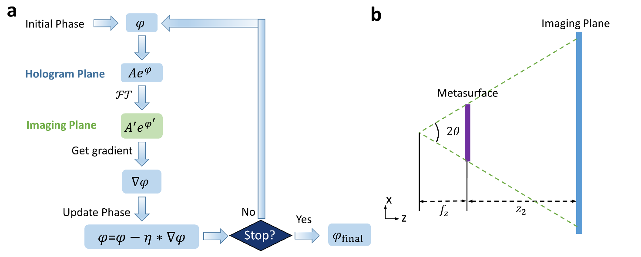
Metasurfaces are born with the capabilities of extending the FOV due to its subwavelength pixel feature. In principle, the lens phase could provide the FOV expansion capability. However, off-axis aberration of the lens will dominate the imaging process for a large-FOV so that the reconstructed image might have poor quality. Therefore, in this work, we design a FOV expansion metasurface by using a gradient descent algorithm [1].
Supplementary Figure 1. Optimization of metasurface phase for FOV expansion. (a) Flowchart of the modified GS algorithm to optimize metasurface phase. (b) Sketch of optical path for designing the metasurface phase.

The flow chat of the optimization algorithm is shown in Supplementary Fig. 1a. An initial quadratic phase $φ_{h}$ is first multiplied with amplitude $\left|A\right|$ on the hologram plane, and the resulting complex amplitude is set as the input of the iterative process. The initial phase $φ_{h}$ takes the form of $φ_{h}\left(x,y\right)=e^{ik(f_{z}-\sqrt{x^{2}+y^{2}+f_{z}^{2}} )}$, where k is the wavevector in vacuum, $f_{z}$ is the focal length. As sketched in Supplementary Fig. 1b, the focal length is determined by the geometric relationship. The size of the metasurface is set as 1.496×1.496 mm. We obtain $f_{z}=\frac{-L}{2*tan\left(80°\right)}≈-\frac{1.496}{2*5.67}mm≈-0.132mm$. The minus sign of the focal length means that it’s a concave lens.
In forward propagation, we use single fast-Fourier-transform (FFT) to calculate spatial frequency components in the k-space. The loss function is defined as the weighted mean-square error (WMSE) between the intensity in the k-space and the target intensity in the k-space, that is
$$\begin{aligned}L=\sum_{p=0}^{M-1}{ }\sum_{q=0}^{N-1}{ }α_{pq}{\left(I_{pq}-I_{t, pq}\right)}^{2}\#\left(S1\right)\end{aligned}$$
where $α_{pq}=γ^{-4}$ is the weight factor in which $γ=\sqrt{1-α^{2}-β^{2}}$ is the directional cosine along the z-axis, $I_{t, pq}$ is the target intensity in the k-space. Following Eq. 2, the weight factor is set equal to the fourth power of the gamma factor (γ⁴) in the k-space to prevent over-representation by points with high spatial frequencies. According to the chain rule, we get
$$\begin{aligned}\frac{∂L}{∂φ_{pq}}=\sum_{k,l}{ }\frac{∂L}{∂I_{kl}}⋅\frac{∂I_{kl}}{∂φ_{pq}}\#\left(S2\right)\end{aligned}$$
The first term is straightforward, as $L$ is a simple quadratic function of $I_{kl}$,
$$\begin{aligned}\frac{∂L}{∂I_{kl}}=2α_{kl}\left(I_{kl}-I_{t, pq}\right).\#\left(S3\right)\end{aligned}$$
The intensity in the k-space is calculated as the squared magnitude of the complex electric field $E_{kl}$, which is the 2D-discrete Fourier transform (DFT) of the incident field $U_{mn}$,
$$\begin{aligned}E_{kl}=\sum_{mn}{ U_{mn}ϕ_{klmn}},\#\left(S4\right)\end{aligned}$$
where $ϕ_{klmn}=exp⁡\left(-i2π\left(\frac{mk}{M}+\frac{nl}{N}\right)\right)$ is the DFT kernel. By using the product rule, we obtain
$$\begin{aligned}\frac{∂I_{kl}}{∂φ_{pq}}=\frac{∂E_{kl}E_{kl}^{*}}{∂φ_{pq}}=E_{kl}\frac{∂E_{kl}^{*}}{∂φ_{pq}}+E_{kl}^{*}\frac{∂E_{kl}}{∂φ_{pq}}.\#\left(S5\right)\end{aligned}$$
The term $\frac{∂E_{kl}}{∂φ_{pq}}$ in Eq. S5 follows
$$\begin{aligned}\frac{∂E_{kl}}{∂φ_{pq}}=\frac{∂\sum_{mn}{ U_{mn}ϕ_{klmn}}}{∂φ_{pq}}=U_{pq}\frac{∂ ϕ_{klpq}}{∂φ_{pq}}+ϕ_{klpq}\frac{∂U_{pq} }{∂φ_{pq}}=U_{pq}*0+ϕ_{klpq}\frac{∂U_{pq} }{∂φ_{pq}}=iϕ_{klpq}E_{kl}.\#\left(S6\right)\end{aligned}$$
The conjugate term of Eq. S6 is
$$\begin{aligned}\frac{∂E_{kl}^{*}}{∂φ_{pq}}={\left(\frac{∂E_{kl}}{∂φ_{pq}}\right)}^{*}= -iU_{pq}^{*}ϕ_{klpq}^{*}.\#\left(S7\right)\end{aligned}$$
Substituting Eqs. S6-7 back to Eq. S5, we obtain
$$\begin{aligned}\frac{∂I_{kl}}{∂φ_{pq}}=iU_{pq}ϕ_{klpq}E_{kl}^{*}-iU_{pq}^{*}ϕ_{klpq}^{*}E_{kl}=-2Im\left( U_{pq}ϕ_{klpq}E_{kl}^{*} \right).\#\left(S8\right)\end{aligned}$$
Substituting Eqs. S3 and S8 back into Eq. S1, we get
$$\begin{aligned}\frac{∂L}{∂φ_{pq}}=-4\sum_{k,l}{ }α_{kl}\left(I_{kl}-I_{t, pq}\right)Im\left( U_{pq}ϕ_{klpq}E_{kl}^{*} \right).\#\left(S9\right)\end{aligned}$$
To enable efficient computation, the double sum is recognized as an inverse DFT. By defining an assistant function,
$$\begin{aligned}H_{kl}=α_{kl}\left(I_{kl}-I_{t, pq}\right)E_{kl}^{*}.\#\left(S10\right)\end{aligned}$$
The phase gradient can be simplified as
$$\begin{aligned}\frac{∂L}{∂φ_{pq}}=-4Im\left[U_{pq}⋅\left(F \left\{H_{kl}\right\}\right)\left(p,q\right)\right],\#\left(S11\right)\end{aligned}$$
where $F$ is a DFT. This algorithm is highly computationally efficient, requiring only two 2D FFTs per iteration to get the phase gradient of all points in the incident plane: one for calculating the light intensity ($I_{kl}$) in k-space and the other for computing the phase gradient. In this optimization, the phase gradient is first normalized by its maximum absolution value and then multiplied by a learning rate ($η$) that gradually decreases throughout the optimization.
$$\begin{aligned}φ=φ-η*\frac{∂L}{∂φ}/{\left|(\frac{∂L}{∂φ})\right|}_{max},\#\left(S12\right)\end{aligned}$$
$$\begin{aligned}η=0.4e^{-\frac{m}{100}},\#\left(S13\right)\end{aligned}$$
where $1≤m≤200$ is the iteration count.

Supplementary Section 2. Design of nanostructures in metasurfaces
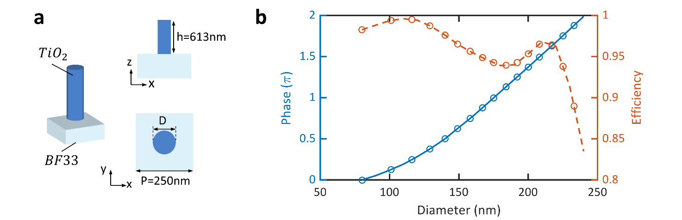
Supplementary Figure 2. Design detail of the FOV expansion metasurface. (a) Sketch of one unit cell in the dielectric metasurface made of circular TiO₂ nanopillars on a glass substrate. (b-c) Simulated transmission (b) and corresponding phase (c) modulation with the normal incidence of a plane wave.

In this work, we utilize dielectric metasurface made of circular TiO₂ nanopillars on a glass substrate, which has low absorption at the operating wavelength. The sketch of one unit cell of the metasurface is shown in Supplementary Fig. 2a, where the different views of the unit cell are shown for a better observation of our employed metasurfaces. The unit-cell of the metasurface is composed of circular titanium dioxide (refractive index n=2.3 at the wavelength of 561 nm) nanopillars on BF33 (refractive index n=1.46) substrate, with height H = 613 nm, period P = 250 nm, and diameter D varying between 80 nm and 233 nm.
The numerical simulation about optical properties of these nano-pillars is implemented by the finite-difference time-domain (FDTD) method[2]. The simulated transmission and phase profiles of nanopillars with different dimensions are presented in Supplementary Fig. 2b. One can find that the optical transmission is over 90% for most nano-pillars. Overall, a full phase modulation of 2π is achieved for these nano-pillars with the diameters ranging from 80 nm to 233 nm, thus it guarantees the require phase for FOV expansion.

Supplementary Section 3. Simulating diffraction by the Rayleigh-Sommerfeld theory
Since our work is focused on large-FOV holographic generation, the employed angular spectrum method (ASM) at infinite distance cannot give exact simulation of the large-FOV diffraction pattern from a metasurface phase because it leads to the distorted patterns in practical experiment, as discussed in main texts. Here, we give the rigorous simulation of the large-FOV diffraction pattern by using Rayleigh-Sommerfeld (R-S) theory[3], which provides more accurate solutions of the optical propagation in freespace and can be derived directly from Maxwell equations.
As the optical parameters (small pixel pitch of 250 nm×250 nm in metasurfaces, long propagation distance of 8.39 mm, the xy-axis simulation region of 125.7 mm×125.7mm) are cross-scale, it is difficult to simulate the diffraction pattern by using FFT-based direct integral according to R-S theory. A step-by-step FFT is used to calculate the diffraction image at the target plane. Due to the symmetry of the square, only the diffraction pattern in the first quadrant is calculated. The incident plane contains 6000×6000 pixels while the target plane contains 252000×252000 pixels in the first quadrant. FFT-accelerated 2D matrix convolution requires padding to a size of 351,999 × 351,999, which corresponds to the sum of both side pixel numbers minus one. To conserve computer memory, we partition the target plane matrix into 21 × 21 tiles. Each tile measures 12,000 × 12,000 pixels. By keeping the size of a single 2D-FFT matrix within the 17,999 × 17,999 pixels, 32 GB of memory is sufficient to meet the computational requirements. To reduce storage requirements, the simulated intensity matrix by R-S theory is down-sampled by 100:1 (averaging over 100×100 pixel blocks). It takes 2.7 hours to obtain the first quadrant of the diffraction pattern of Fig. 3j in a computer (Intel Core CPU i7-12700 @ 2.1G Hz, RAM 32GB). The simulated result in Fig. 3j shows good agreement with the experimental pattern in Fig. 3l.

Supplementary Section 4. Characterizing efficiency of the metasurface
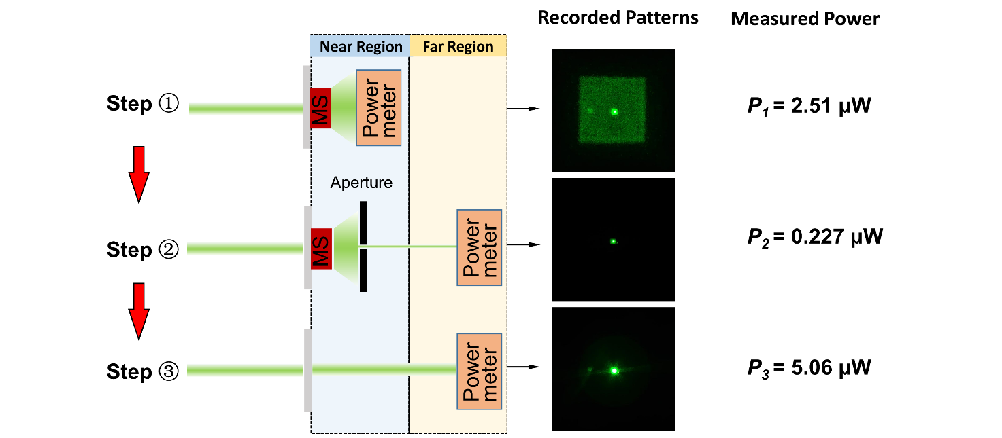
Supplementary Figure 3. Steps of characterizing the experimental efficiency of the metasurface.

As shown in Supplementary Fig. 3, three steps are used to calculate the efficiency of the fabricated metasurface. First, the metasurface is illuminated by the collimated light with a size smaller than the metasurface with the help of the SLM. The metasurface's diffraction angular range reaches 160° × 160°, which exceeds the detection range of our power meter probe. When light illuminates the power meter probe at large oblique angles, it results in an underestimation of the power measurement. A 0.15 × 0.15 mm square beam (1/10 side length of the metasurface) illumination is generated by programming a specific phase pattern on the SLM. The central 200 × 200 pixels of the SLM is set to zero, while a buffer region with an outwardly divergent radial phase gradient (8 pixels per 2$π$) is applied to the surrounding area. The square transmitted light records a total power of P₁ = 2.51 $μ$W including a central hot spot.
Second, we adopt a small aperture to measure the power of the central hot spot. The central spot is attributed to unmodulated light transmitting the metasurface which is at a power of P₂ = 0.227 $μ$W. To avoid overexposure, the second image at the central-right panel of Supplementary Fig. 3 was captured with a much shorter exposure time compared to the first image (0.02s vs 0.5s), which results in the spot appearing dimmer. Thus, we can obtain the power of the signal light by using P₁ – P₂=2.283 $μ$W.
Finally, to measure the total power incident on the metasurface, we move the metasurface outside the incident-light region, so that we can record the total power (measured with P₃ = 5.06 mW) incident on the metasurface substrate by using the power meter in the far region. The recorded pattern (at the bottom-right panel of Supplementary Fig. 3) shows a square shape of the incident light. As a result, the total efficiency of the metasurface can be calculated as $\frac{P_{1} - P_{2}}{P_{3}}≈45.1\%$. Although it is lower than the simulated efficiency of ~90% due to the imperfect fabrication and unavoidable measurement noise, the experimental efficiency of 45% is sufficiently high at the operating green wavelength of 561 nm. Considering illumination with a 0.15×0.15 mm rectangular beam, the FOV remains as high as 59°. Also, the metasurface is not designed for a beam of this size, a few lights are diffracted into the 59–160° FOV range, resulting in diffraction loss. When a beam with such large diffraction angle (59° full FOV) illuminates the power meter probe, the measured power may be underestimated, potentially leading to an underestimation of the efficiency mentioned above.

Supplementary Section 5. Pixel match between compressed phase and metasurface phase
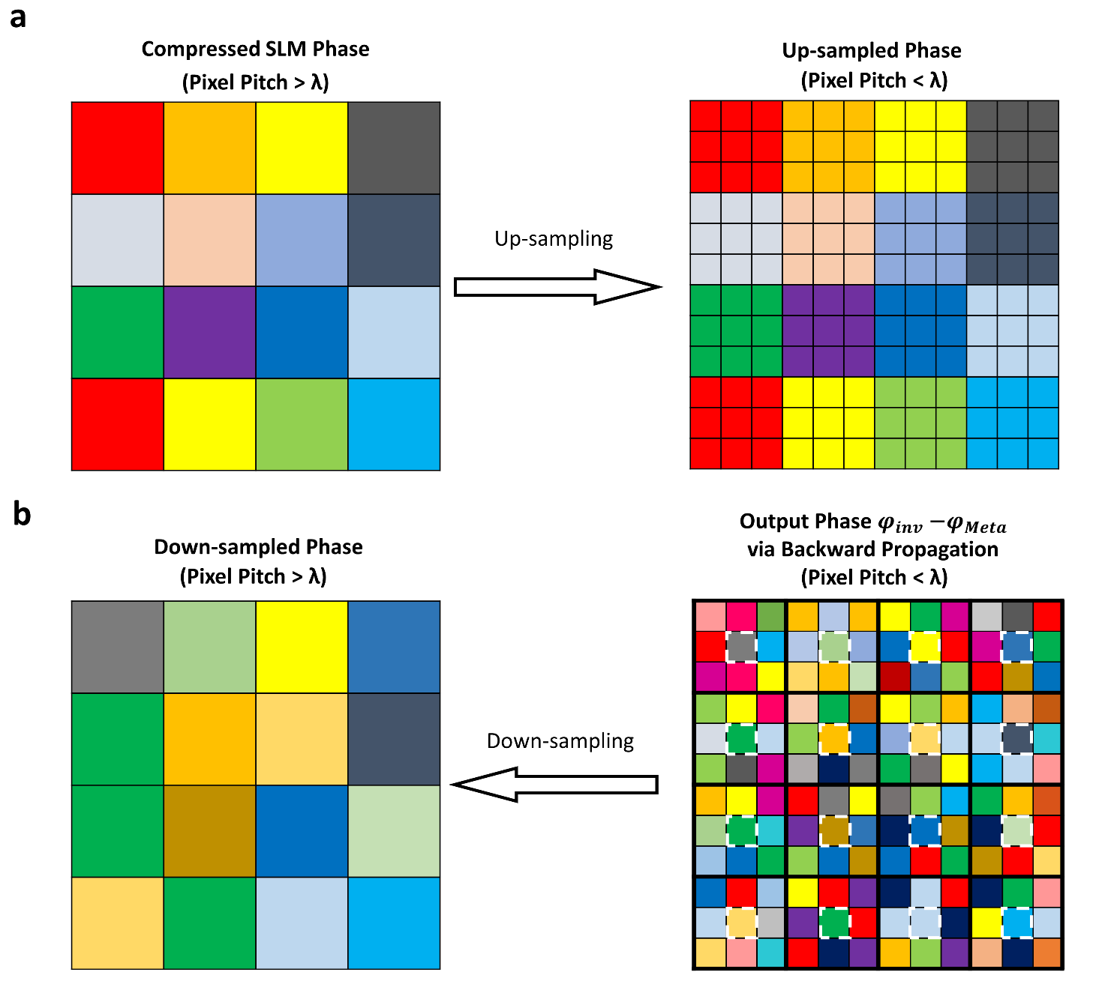
Supplementary Figure 4. Sketch for up-sampling (a) and down-sampling (b) process of optimizing the SLM phase in our pixel-interpolation meta-holography.

During the algorithm iteration process, a pixel matching algorithm is required to address the mismatch between the pixel pitch of the metasurface and that of the hologram. Its core function is to realize our proposed pixel-interpolation operation, thereby both phases can be re-generated smoothly in the forward and backward propagation of the optimization algorithm (see the sketch in Fig. 4a of main text).
First, we calculate the sampling ratio defined as η =a*P_{SLM}/P_{META}, where a is the scaling factor of the imaging system, P_{SLM} and P_{META} represent the pixel sizes of the spatial light modulator (SLM) and the metasurfaces, respectively. To match the pixel pitch, the compressed SLM phase is up-sampled by dividing one original pixel into several subwavelength pixels, where each subwavelength pixel inherits the same phase from the original pixel (as sketched in Supplementary Fig. 4a). Thus, the interpolated SLM phase has the same sampling size with the metasurface phase so that the pixel-interpolation operation can be implemented correctly during the hologram design.
The down-sampling operation is carried out after backward propagation which yields the reversed phase with subwavelength pixel. The subwavelength-pixel phase is down-sampled by using the phase of only one pixel for each N/M, where N and M are the effective pixel numbers of the metasurfaces and the SLM along one direction, respectively. For instance, in our case of N/M=3, we take one every 3 pixels (see Supplementary Fig. 4b), thus creating a down-sampled phase of sizeM×M.

Supplementary Section 6. Distortion pre-compensation of the target image
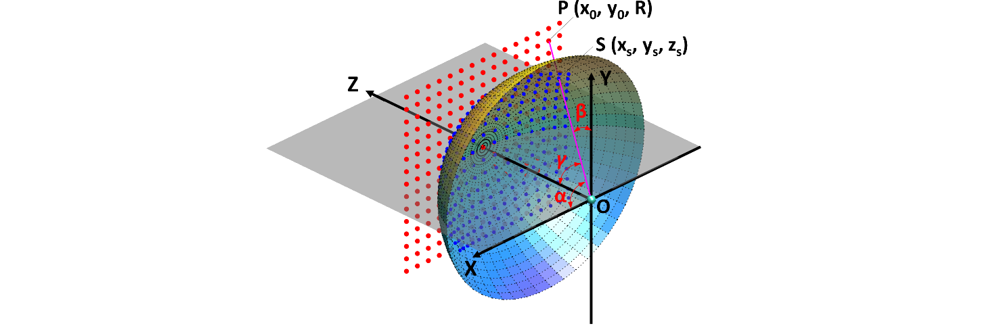
Supplementary Figure 5. Sketch for the central projection from a plane to a sphere. $α$, $β$ and $γ$ are direction cosines between the line OP and three axes.

When the angular spectrum method is used to simulate the propagation of light, the diffracted pattern can be numerically calculated by a 2D-FFT transformation of the incident field multiplied by a quadratic phase. It means that the calculated pattern takes the coordinates of spatial frequency rather than spatial position. Under the Fresnel region, the spatial frequency can be approximated in terms of k_{x}=k·α≈k·x/z and k_{y}=k·β≈k·y/z, where the wave number k=2π/λ (λ is the operating wavelength), x, y and z are the spatial coordinates at the target plane. Only when the ratios x/z and y/z are small sufficiently, the Fresnel approximation is valid without the distortion. But, in our case, we simulate the diffracted patterns with up to 160° FOV, where the spatial frequencies are large so that α and β must be calculated accurately. Thus, the target pattern in the spatial coordinates cannot be used as the ideal pattern for the large-FOV case. The correct method is to project the expected spatial pattern onto a sphere, where we can obtain a new pattern at the spatial frequency as the target of the Fresnel diffraction. This new pattern works as a pre-compensation of the distortion in the target plane, which holds the fundamental origins of distortion pre-compensation in this work.
Figure S5 sketches the central projection of a uniform dot array at the plane onto a sphere with a radius of R. For the sake of easy demonstration, the plane located at z is assumed to be tangential to the sphere with its origin of O. Following the central projection, we get the following geometric relationship
$$\begin{aligned}x=\frac{αz}{\sqrt{1-α^{2}-β^{2}}}, y=\frac{βz}{\sqrt{1-α^{2}-β^{2}}},\#\left(S14\right)\end{aligned}$$
where $α$ and $β$ are direction cosines between the line OP and the x-axis and y-axis. By using Eq. (S14), we obtain $\begin{aligned}\frac{∂x}{∂α}=z\left[γ^{-1}⋅\frac{∂}{∂α}\left(α\right)+α⋅\frac{∂}{∂α}\left(γ^{-1}\right)\right]=z\left[γ^{-1}+α⋅\left(-γ^{-2}\right)\frac{∂γ}{∂α}\right]=zγ^{-3}\left(γ^{2}+α^{2}\right),\#\left(S15a\right)\end{aligned}$
$$\begin{aligned}\frac{∂x}{∂β}=αz\frac{∂}{∂β}\left(γ^{-1}\right)=αz⋅\left(-γ^{-2}\right)\frac{∂γ}{∂β}=αβzγ^{-3},\#\left(S15b\right)\end{aligned}$$
$$\begin{aligned}\frac{∂y}{∂α}=βz\frac{∂}{∂α}\left(γ^{-1}\right)=βz⋅\left(-γ^{-2}\right)\frac{∂γ}{∂α}=βz⋅\left(-γ^{-2}\right)⋅\left(-αγ^{-1}\right)=αβzγ^{-3},\#\left(S15c\right)\end{aligned}$$
$$\begin{aligned}\frac{∂y}{∂β}=z\left[γ^{-1}⋅\frac{∂}{∂β}\left(β\right)+β⋅\frac{∂}{∂β}\left(γ^{-1}\right)\right]=z\left[γ^{-1}+β⋅\left(-γ^{-2}\right)\frac{∂γ}{∂β}\right]=zγ^{-3}\left(γ^{2}+β^{2}\right),\#\left(S15d\right)\end{aligned}$$
where $γ=(1-α^{2}-β^{2})^{1/2}$ is the direction cosines between the line OP along the z-axis. By employing the Jacobian determinant, we derive
$$\begin{aligned}J=\frac{∂x}{∂α}\frac{∂y}{∂β}-\frac{∂x}{∂β}\frac{∂y}{∂α}=\left[zγ^{-3}\left(1-β^{2}\right)\right]\left[zγ^{-3}\left(1-α^{2}\right)\right]-\left[αβzγ^{-3}\right]\left[αβzγ^{-3}\right]=\frac{z^{2}}{γ^{4}},\#\left(S16\right)\end{aligned}$$
$$\begin{aligned}dxdy=\frac{z^{2}}{(1-α^{2}-β^{2})^{2}}dαdβ=\frac{z^{2}}{γ^{4}}dαdβ\#\left(S17\right)\end{aligned}$$
Equation (S14) denotes the relationship between the spatial position of P and the spatial-frequency coordinates. One can find that there is a scaling factor of $γ$ from the spatial position (x₀, y₀) to the spatial frequency (α, β). The scaling factor ($\frac{z^{2}}{γ^{4}}$) in Eq. S17 results in the distorted shape of pattern at the spatial-frequency domain. By deriving the coordinate mapping relationship, we can achieve complete distortion correction.

Supplementary Section 7. Experimental setup for FOV comparison
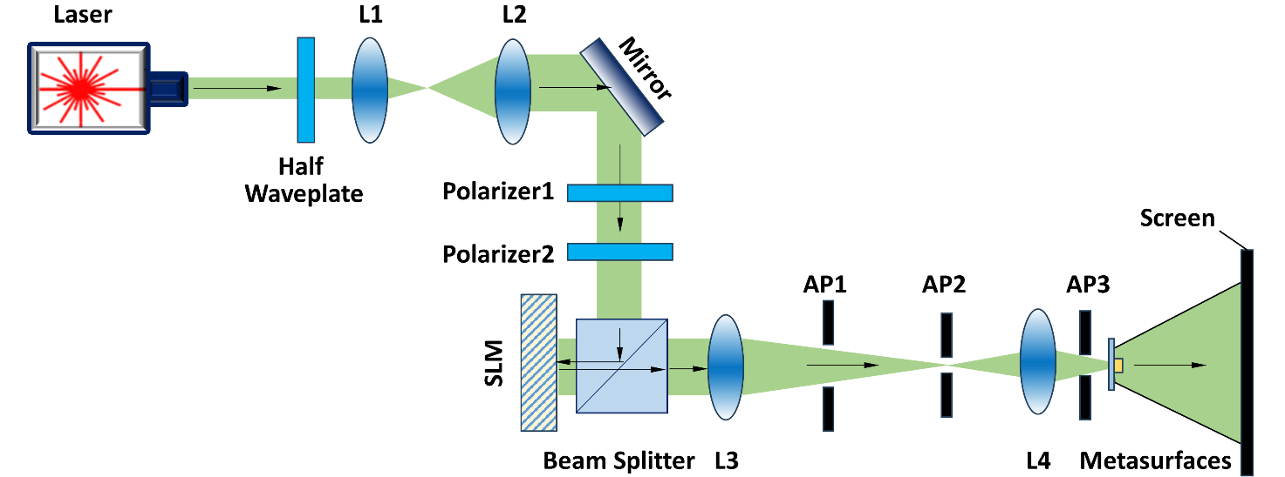
Supplementary Figure 6. Experimental setup for characterizing the FOV. AP: aperture, L: lens.

To demonstrate the metasurface's capability for expanding the FOV and its phase modulation performance, we build the experimental setup as sketched in Supplementary Fig. 6. In the optical path, a 561 nm laser beam (which is a linear polarized mode) passes through a half-wave plate to adjust the incident light's polarization state. The beam then traverses a 4-f beam expander system (comprising lenses L₁ and L₂) and two polarizers. The first polarizer is to adjust the power of the beam, while the second polarizer is to guarantee the proper linear polarized state for the SLM. The beam subsequently illuminates a reflective spatial light modulator (SLM) for phase modulation by a beam splitter (BS). After SLM phase modulation, the beam passes through the telescopic system (composed of lenses L₃ and L₄), where an aperture filters stray light. Optical beam modulated by SLM is compressed with a scaling factor of 5 (from 3.74 μm to 0.748 μm) to realize the pixel match between compressed SLM phase and the metasurface phase. Two apertures are added between lenses L3 and L4. The square aperture AP1 filters out areas where the spot exceeds the modulation range. Aperture AP2 performs low-pass filtering at the focal plane to eliminate stray light. An additional aperture (AP3) is placed between L4 and the metasurface to remove background light with large tilt angles. Light with compressed SLM phase illuminates on the metasurfaces for FOV expansion. The reconstructed images with large FOV are projected onto the display screen, thereby realizing large-FOV holography. The imaging distance between the metasurfaces and the screen is measured as z=8.39 mm, while the imaging size (see Fig. 5a in the main text) is 91.16×88.34 mm. Therefore, for metasurface holography, the FOV is
$$\begin{aligned}FOV=2∙\arctan\left(\frac{d}{2z}\right)=2∙\arctan\left(\frac{91.16}{2*8.39}\right)={159.1}^{°}.\#\left(S18\right)\end{aligned}$$
SLM-only holographic characterization is also realized by the setup in Supplementary Fig. 6. Due to the phase profile difference, AP1-AP3 are enlarged. Considering the refractive index of the metasurface substrate, 0.25mm equivalent distance is added the diffraction distance. For the SLM-only case, the FOV (see Fig. 5b in the main text) is calculated as
$$\begin{aligned}FOV=2∙\arctan\left(\frac{3.4}{2*\left(8.39+0.25\right)}\right)={22.3}^{°}.\#\left(S19\right)\end{aligned}$$

References
1. Ruder, S., An overview of gradient descent optimization algorithms. arXiv preprint arXiv:1609.04747, 2016.
2. Kane, Y., Numerical solution of initial boundary value problems involving maxwell's equations in isotropic media. IEEE Transactions on Antennas and Propagation, 1966. 14(3): p. 302-307.
3. Shen, F. and A. Wang, Fast-Fourier-transform based numerical integration method for the Rayleigh-Sommerfeld diffraction formula. Applied optics, 2006. 45: p. 1102-10.

