Table 1. Chemical structure of designed imine sulphonamide compounds.
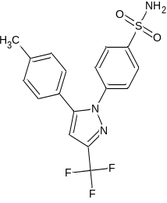  Celecoxib | C-1  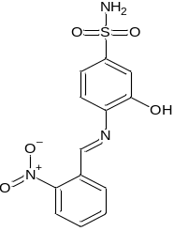 | C-2  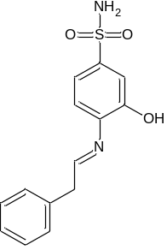 | C-3  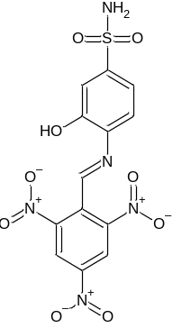 | C-4  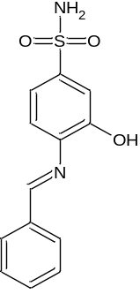
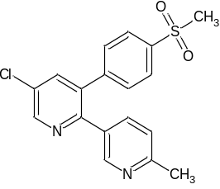  Etoricoxib | E-1  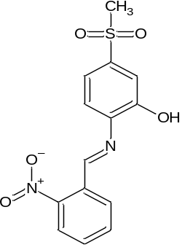 | E-2  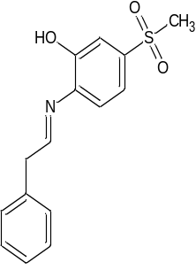 | E-3  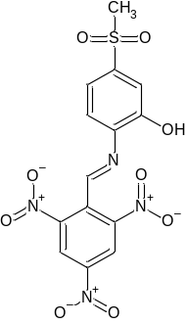 | E-4  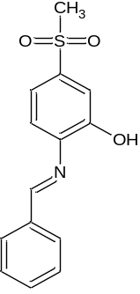
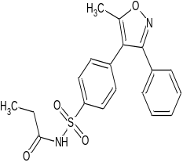  Parecoxib | P-1  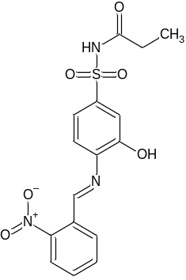 | P-2  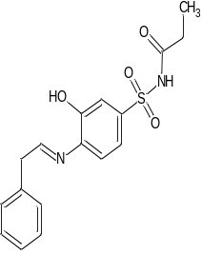 | P-3  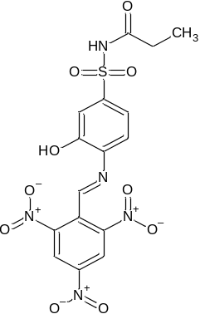 | P-4  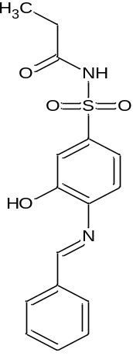
Table 2. The binding interactions and binding scores of best docked compounds and co crystal ligand against CA II (PDB: 2AW1).
Sr. No. | Name of compound | Interacted residue | Type of Interactions | Binding Score
 |  |  |  | Plants Score(Grid) | MolDock Score
 | Co crystal Ligand  Ligand 4-(5-methyl-3-phenylisoxazol-4-yl) benzene sulphonamide | HIS 96, HIS 94, THR 199 | Hydrogen bonding | -70.41 | -125.46
 |  | HIS 119, THR 199, LEU 198 HIS 94 and HIS 96 | Steric interactions
 | C-1 | ASN 232, LYS 170 | Hydrogen bonding | -65.61 | -75.74
 | C-1 | PHE 231 and ASN 232. GLY 233, THR 169 and GLY 171 | Steric interactions | -65.61 | -75.74
 | C-2 | ASN 232 and PHE 231, GLU 239 | Hydrogen bonding | -69.58 | -89.45
 | C-2 | ASN 230, MET 241, ASN 61, GLY 63, Phe 231, LYS 170, LYS 172, THR 169, GLY 171and ASN 232, LEU240, PHE 231and MET 241, PHE 231 and GLY 63, LYS 170, ASN 61. GLY 63, PHE 231 | Steric interactions | -69.58 | -89.45
 | C-4 | Lys 172 and LYS 170 | Hydrogen bonding | -66.51 | -77.08
 | C-4 | ASN 230, THR 169 ASN 61, ILE167, LYS 168, LYS 170and GLY 171, ASN 61, LYS 168, LEU 164, ILE 167, LEU 229, THR 169, LYS 170 and ASN 61 | Steric interactions | -66.51 | -77.08
 | E-1 | ASN 232, LYS170 | Hydrogen bonding | -65.48 | -90.15
 | E-1 | PHE 231, ASN 232, GLY 171, THR169, GLY 233 and LYS 170, ASN232, LYS170, and PHE231, PHE 231, and ASN232, LYS 170 | Steric interactions
 | E-2 | PHE231 and ASN232 | Hydrogen bonding | -69.22 | -70.33
 | E-2 | ASN 230, ASN 61, GLY 171, LEU 240,PHE231, THR 169, ASN 232, GLY 63, GLY 233, LYS 170, LYS 171, LYS 172, GLU 239, MET 241 | Steric interactions | -69.22 | -70.33
 | E-4 | LYS172, LYS 170, ASN 61, THR169 and ILE 167 | Hydrogen bonding | -63.59 | -73.15
 | E-4 | ASN 230, ASN 61, ILE 167, LEU229,LYS168, GLY171, LEU 164.E-2 | Steric interactions | -63.59 | -73.15
 | P-1 | ASN 232, LYS170. | Hydrogen bonding | -67.64 | -96.67
 | P-1 | ASN 232, PHE231, LYS 170, GLY 171, and THR169, ASN 232, PHE231, ASN 11 | Steric interactions | -67.64 | -96.67
 | P-2 | GLU239, PHE231 and ASN 232 | Hydrogen bonding | -69.99 | -79.28
 | P-2 | ASN 230, ASN 61, GLY 171, LEU 240,PHE 231, THR 169, ASN 232, GLY 63, GLY 233, LYS 170, GLY 171, LYS 172, and MET 241 | Steric interactions | -69.99 | -79.28
 | P-4 | ASN 61, THR 169, LYS 172, ILE 167, LYS 170 and LEU 229 | Hydrogen bonding | -66.58 | -79.07
 | P-4 | ASN 61, TRP 97, MET 241, LYS228, LEU 164, ILE267, LYS 168, ASN230, LYS 170, PHE 226, GLY 171, LYS 172, and LEU 229 | Steric interactions | -66.58 | -79.07
Table 3. Calculated molecular properties of best docked compounds based on Koopmans’s theory.
Compound | LUMO | HOMO | ΔH  (eV) | IE  (eV) | EA(eV) | χ  (eV) | η  (eV) | σ  (eV)⁻¹ | μ(eV) | ω (eV)
C-1 | -3.9116 | -5.7785 | 1.8669 | 5.7785 | 3.9116 | 4.84505 | 0.93345 | 1.0712 | 4.84505 | 12.57
C-2 | -2.0990 | -5.4686 | 3.3696 | 5.4686 | 2.0990 | 3.7838 | 1.6848 | 0.5936 | -3.7838 | 4.2489
C-4 | -3.0780 | -5.3303 | 2.2523 | 5.3303 | 3.0780 | 4.2041 | 1.1261 | 0.8881 | -4.2042 | 7.84
E-1 | -4.0302 | -5.6557 | 1.6255 | 5.6557 | 4.0302 | 4.8429 | 0.8128 | 1.2306 | -4.8429 | 14.43
E-2 | -3.9270 | -5.7053 | 1.7783 | 5.7053 | 3.9270 | 4.8161 | 0.8892 | 1.1245 | -4.8162 | 13.04
E-4 | -3.0351 | -5.3990 | 2.3639 | 5.3990 | 3.0351 | 4.2170 | 1.1819 | 0.8463 | -4.2171 | 7.52
P-1 | -4.4050 | -5.8462 | 1.4412 | 5.8462 | 4.4050 | 5.1256 | 0.7206 | 1.3878 | -5.1256 | 18.22
P-2 | -2.4273 | -5.7908 | 3.3635 | 5.7908 | 2.4273 | 4.1090 | 1.6818 | 0.5947 | -4.1090 | 5.02
P-4 | -3.5287 | -5.6264 | 2.0977 | 5.6264 | 3.5287 | 4.5775 | 1.0489 | 0.9534 | -4.5776 | 9.99

Table 4. Frontier Molecular Orbitals (FMOs) of selected compounds illustrating HOMO and LUMO energy levels and gaps (ΔE, eV), indicating chemical reactivity and electronic stability as computed by Density Functional Theory (DFT).

SR. NO. | NAME OF COMPOUNDS | LUMO | HOMO
 | C-1 | 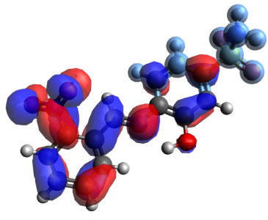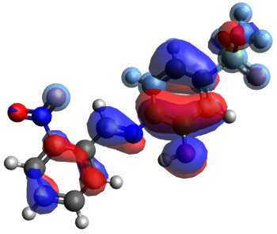  ΔE=1.8669
 | C-2 | 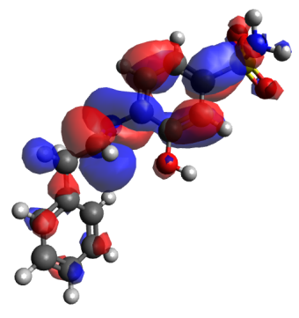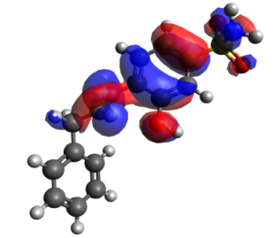  ΔE=3.3696
 | C-4 | 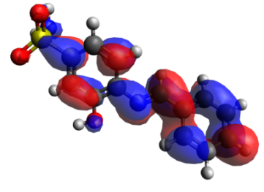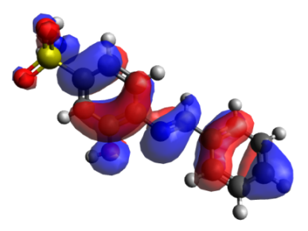  ΔE=2.2523
 | E-1 | 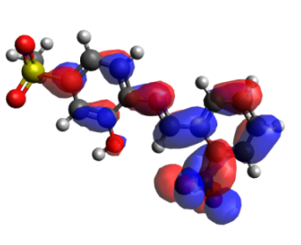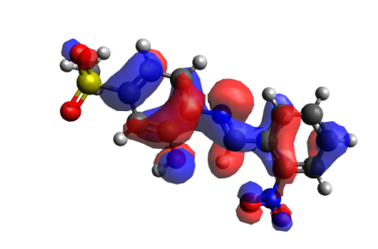  ΔE=1.6255
 | E-2 | 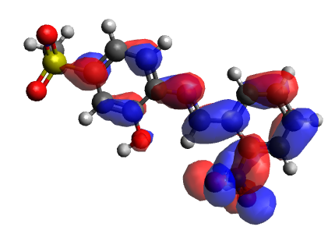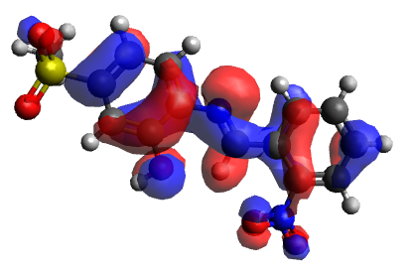  ΔE=1.7783
 | E-4 | 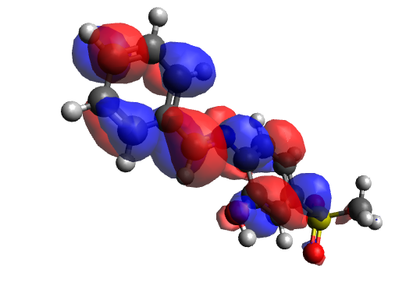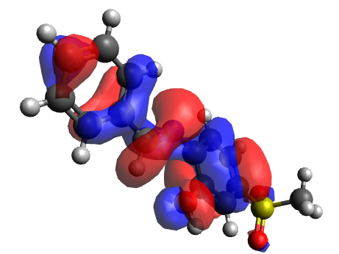  ΔE=2.3639
 | P-1 | 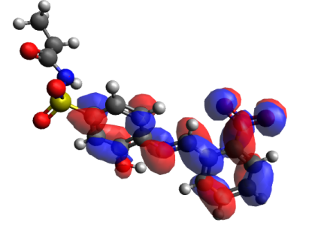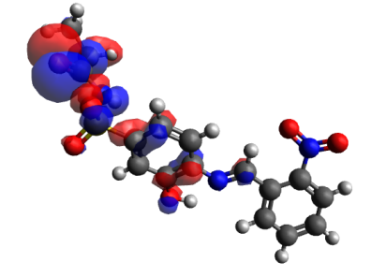  ΔE=1.4412
 | P-2 | 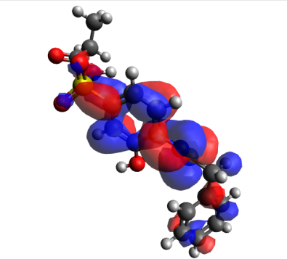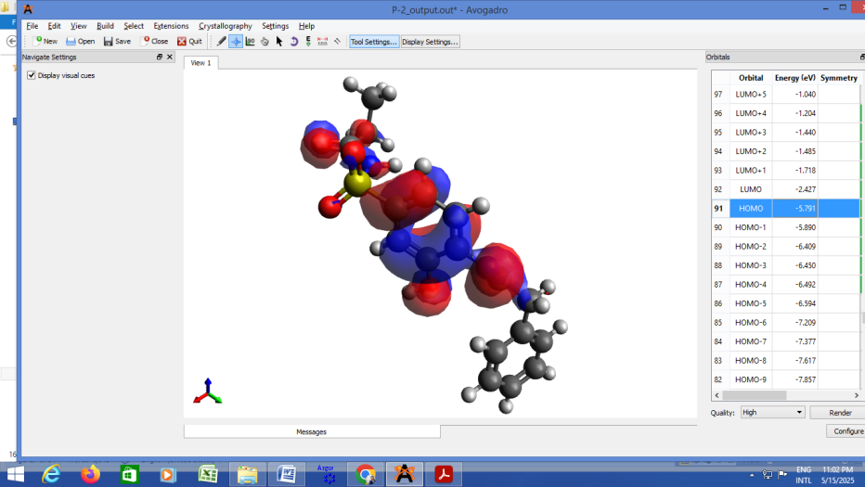  ΔE=3.3635
 | P-4 | 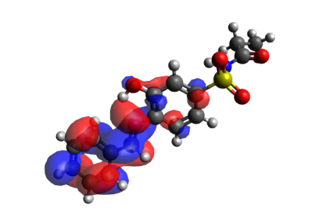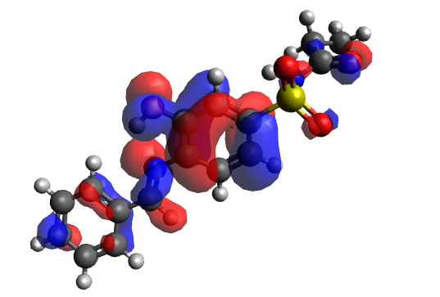  ΔE=2.0977

