Supplementary Information
Table S1. Primer sequences used in this study.

Fig. S1 Reconfirmation of transgene copy number by genomic Southern blot hybridization.
Genomic DNA was isolated from leaves of T₃ transgenic rice plants, including OsTPR1-Ox lines 1-5 and OsTPR1-Ri lines 1-3. The DNA samples were digested with PstI and subjected to Southern blot analysis using a DIG-labeled hygromycin phosphotransferase (Hpt) gene probe. M, DNA marker; P, SMY1H binary vector digested with PstI; H, 1.1 kb Hpt DNA fragment.

Fig. S2 Ectopic expression of OsEP3A-Ox-1 and OsEP3A-Ri-1 constructs in transgenic rice.
(A) Northern blot analysis of OsEP3A expression in 5-day-old WT, Ox-1, and Ri-1 T₃ rice seedlings. Total RNA was isolated and subjected to Northern blot hybridization using a DIG-labeled OsEP3A 3′UTR probe. (B) Phenotypes of WT, Ox-1, and Ri-1 seedlings 7 days after germination. (C) Quantitative analysis of shoot length as shown in (B). (D) Quantitative analysis of root length as shown in (B). Each value represents the mean ± SD of three independent measurements. Different letters above the bars indicate statistically significant differences according to one-way ANOVA (P < 0.05 for C; P < 0.01 for D).

Table S1
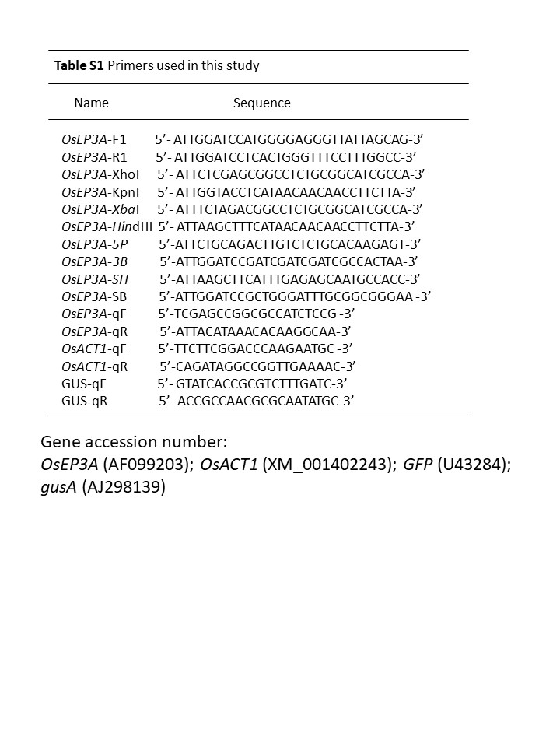

Fig. S1
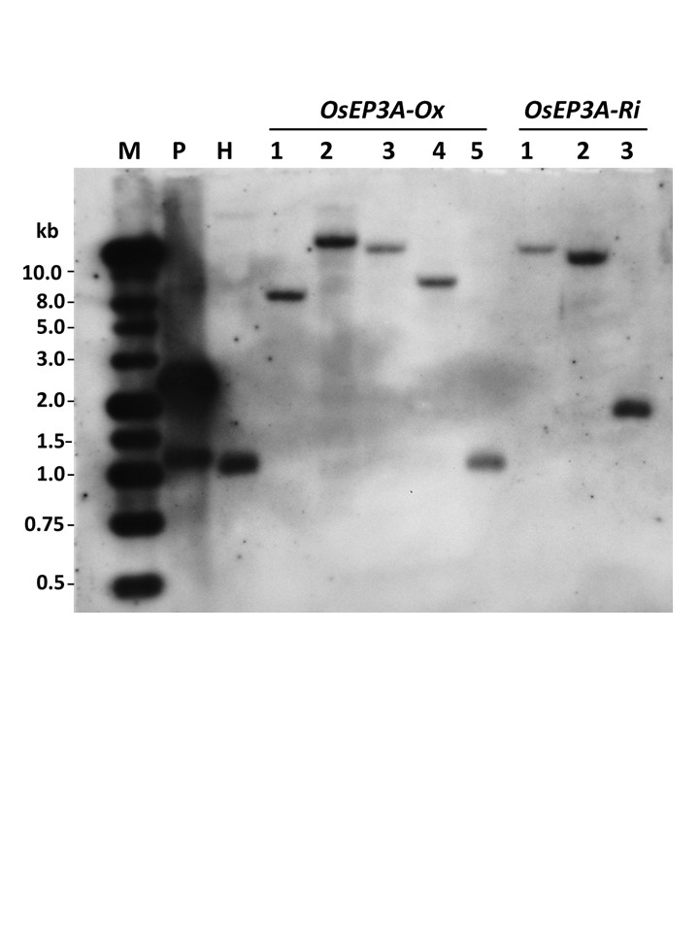

Fig. S2
