Supporting Information
Tumor microenvironment-responsive nanodrug for clear-cell renal cell carcinoma therapy via triggering waterfall-like cascade ferroptosis
Wenjun Ni^{1#}, Yongxiang Li^{4#}, Lingxia Liang³, Cuixia Lu³, Meixiao Zhan², Ligong Lu^{2*}, Qun Xie^{1*}, Liewei Wen^{2*}
1 Department of Urology, Zhuhai People's Hospital, Zhuhai Hospital Affiliated with Jinan University, Jinan University, 519000, Zhuhai, Guangdong, China
2 Zhuhai Interventional Medical Center, Zhuhai Precision Medical Center, Zhuhai People’s Hospital, Zhuhai Hospital Affiliated with Jinan University, Jinan University, 519000, Zhuhai, Guangdong, China
3 Medical College of Guangxi University, Guangxi University, 530004, Nanning, Guangxi, China
4 Department of Urology, Weifang People's Hospital, 261000, Weifang, Shandong, China
*Correspondence: Liewei Wen, wenner1989@163.com; Qun Xie, xqwjf@126.com; Ligong Lu, E-mail: luligong1969@126.com
*Correspondence: Liewei Wen, wenner1989@163.com; Qun Xie, xqwjf@126.com; Ligong Lu, E-mail: luligong1969@126.com
#Wenjun Ni and Yongxiang Li contributed equally to this work.

Figure S1. FT-IR spectra of MIL-101(Fe), RSL3, PEG-COOH and PEG-MIL-101(Fe)@RSL3 NPs.

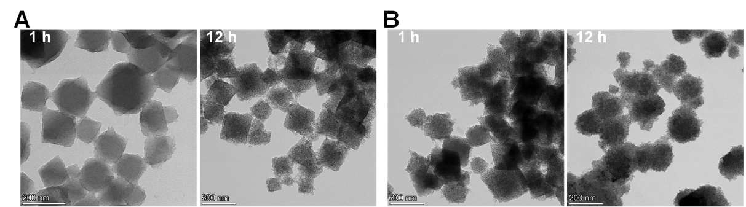
Figure S2. The TEM images of the MIL-101(Fe) NPs under (A) pH 7.4 and (B) pH 5.0 PBS solutions for different times.
Figure S3. The Fe³⁺ ions released from MIL-101(Fe) NPs at different pH PBS solution. (A) The absorbance spectrum of the red complex which was the product of different Fe³⁺ ions reacts with o-phenanthroline, and (B) the linear fit of absorbance intensity at 521 nm. (C) The Fe³⁺ ions released from MIL-101(Fe) NPs at pH 7.4 and (D) pH 5.0 PBS solution.

Figure S4. Hydroxyl radical production induced MB degradation. (A) UV-Vis absorbance and photograph (insert) of MB after different treatment at pH 7.4 solution and (B) pH 5.0 aqueous solution.

Figure S5. The cell uptake of ICG labeled MIL-101(Fe) NPs at different incubation time.
Figure S6. DCF fluorescence of 786-O cells determined by CLSM (A) and FACS (B).

Figure S7. In vitro cytotoxicity of MIL-101(Fe)@RSL3 NPs in LO2 and HK2 cells. The error bars represented the standard error of mean of six replicates. P values: *P <0.05.

Figure S8. Hemolysis evaluation of the MIL-101(Fe)@RSL3 NPs with different concentrations, inset represents the hemolysis images the tubes, PBS as negative control group and water as positive control group (n=3 in each treatment group).
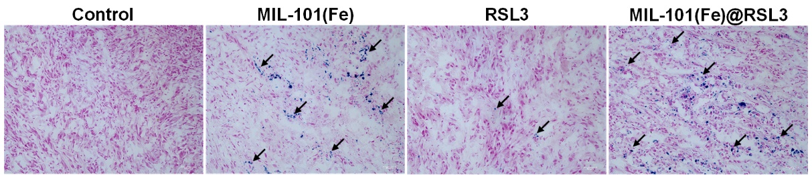
Figure S9. Prussian-blue stained tissue slices of tumor collected 1 h after intravenously injected with MIL-101(Fe)@RSL3.

