Appendix
Validation of the Local Imputation Algorithm

Stabilization and Validation
The imputation algorithm stabilized after 15 iterations, with the lead1 and lag1 variables consistently showing significant contributions to the model. This was evidenced by their narrow confidence intervals and substantial predictive value across all imputation periods. Lead2 was important during the initial year following diagnosis but its significance diminished over subsequent periods. Lag2, while less influential, maintained statistical significance throughout the five-year follow-up.

Figure 1 illustrates the stabilization of the model for imputations performed on biomarker collections scheduled one year after diagnosis, based on three-month intervals (90-day intervals). It highlights the consistent impact of lead1 and lag1 across iterations, whereas lead2 and lag2 demonstrate more variable contributions, particularly in earlier iterations.

Figure A1

Stabilization of Imputation Algorithm: Impact of Lead and Lag Predictors on Imputed Values for Biomarker Collections One Year After Diagnosis

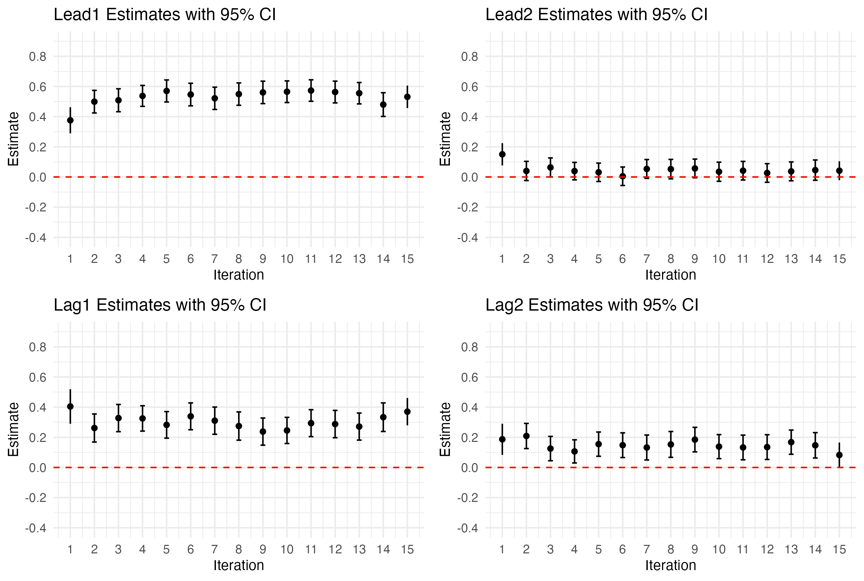

Validation Through Visual Inspection of Patient Trajectories

As an additional validation step, we visually inspected the BCR::ABL1 biomarker trajectories of randomly selected patients, overlaying imputed values as red asterisks. Figures 2a, 2b, 2c, and 2d illustrate these trajectories, combining observed (solid lines) and imputed values (red markers).

The visualizations confirm that the imputed values align well with the overall trajectory of the biomarker levels, preserving the longitudinal trends observed in the data. Notably, the imputed points follow the expected direction and magnitude of changes, seamlessly integrating into the observed data points. This consistency demonstrates the ability of our imputation algorithm to maintain the integrity of individual patient trajectories, ensuring that imputed values are plausible and clinically interpretable.

Figure A2
Observed and Imputed BCR::ABL1 Trajectories for Randomly Selected Patients: Validation of Longitudinal Consistency and Trends

A2a.
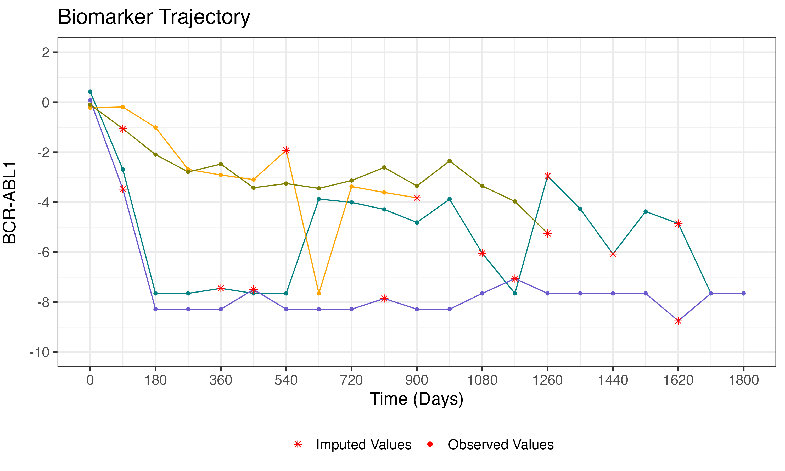
A2b.
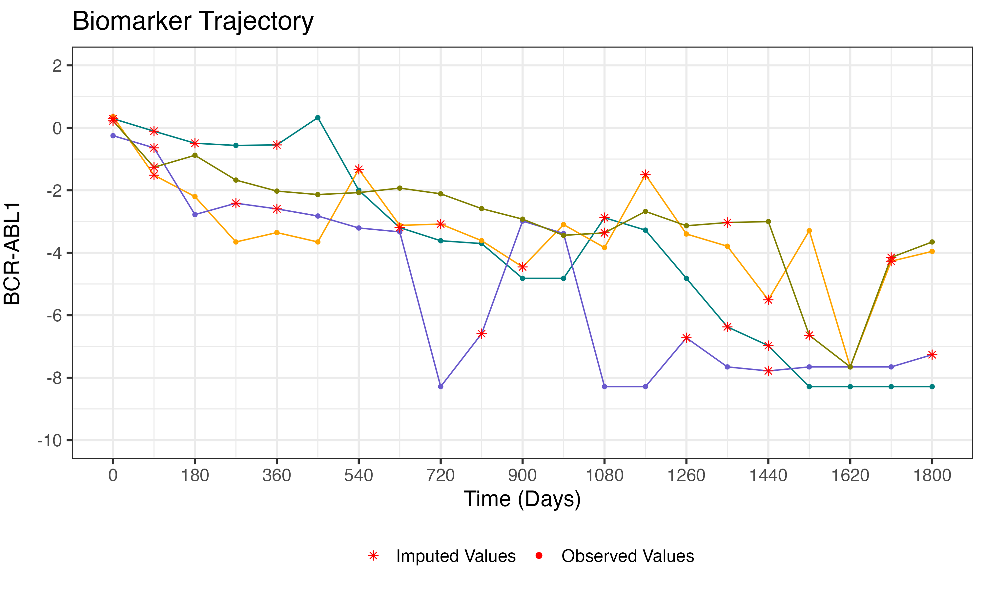

A2c.

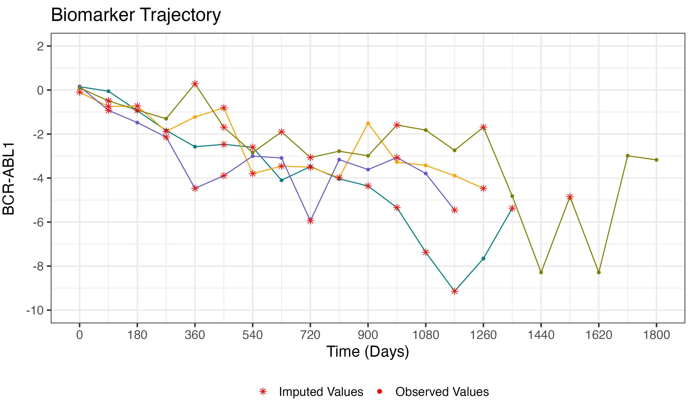
A2d.
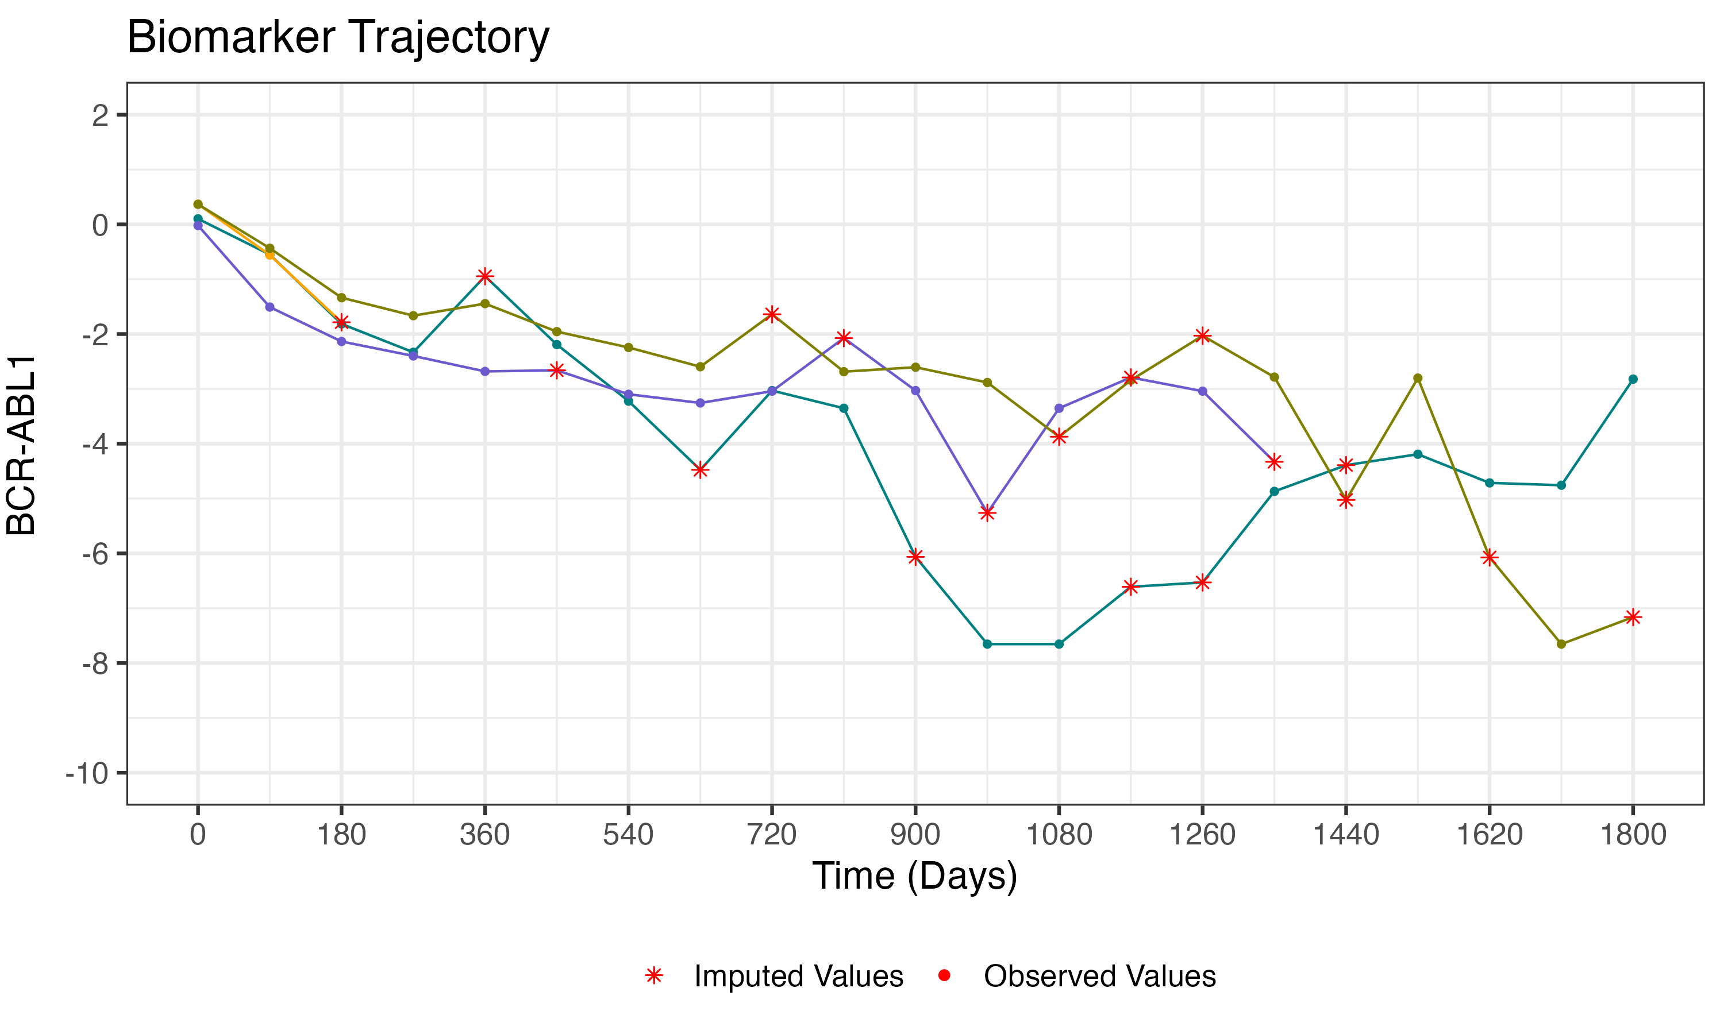

Validation Using Artificially Introduced Missing Values

To further validate our local imputation algorithm, we conducted an additional test using individuals with no missing biomarker collections during follow-up. For these patients, we artificially introduced missing values at specific time points and then applied our algorithm to impute the missing values. Figures 3a, 3b, 3c, and 3d compare the imputed trajectories (solid lines) with the original observed trajectories (dashed lines).

The results demonstrate that the algorithm reliably reconstructs the missing data, with imputed values aligning closely with the observed values. In most cases, the imputed trajectories either match the observed values exactly or remain within a clinically acceptable margin of error. This consistency highlights the accuracy and robustness of our imputation method in maintaining the integrity of individual biomarker trajectories, even when faced with artificially introduced data gaps.

Figure A3
Validation of Imputation Algorithm Using Artificially Introduced Missing Values: Comparison of Imputed and Original Observed Trajectories

A3a.
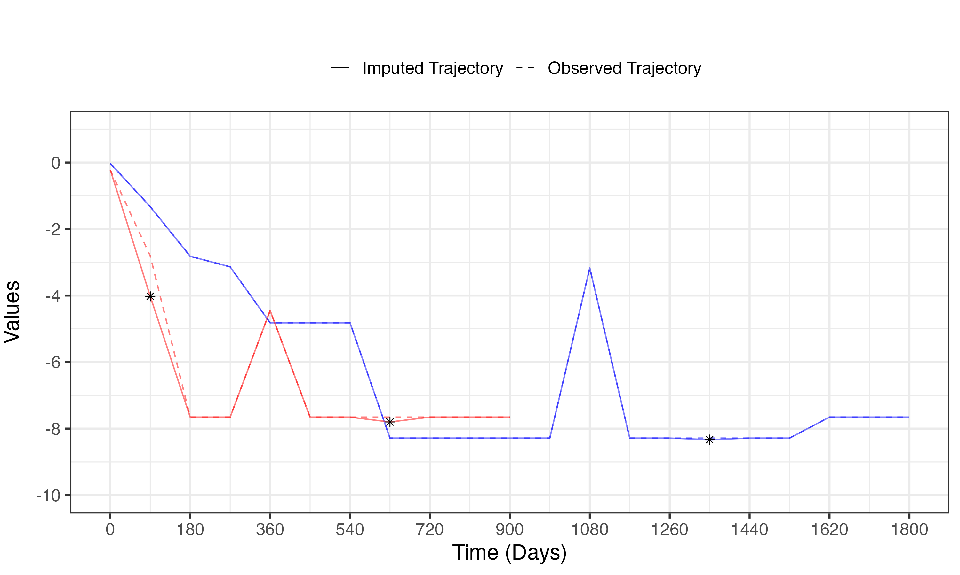
A3b.

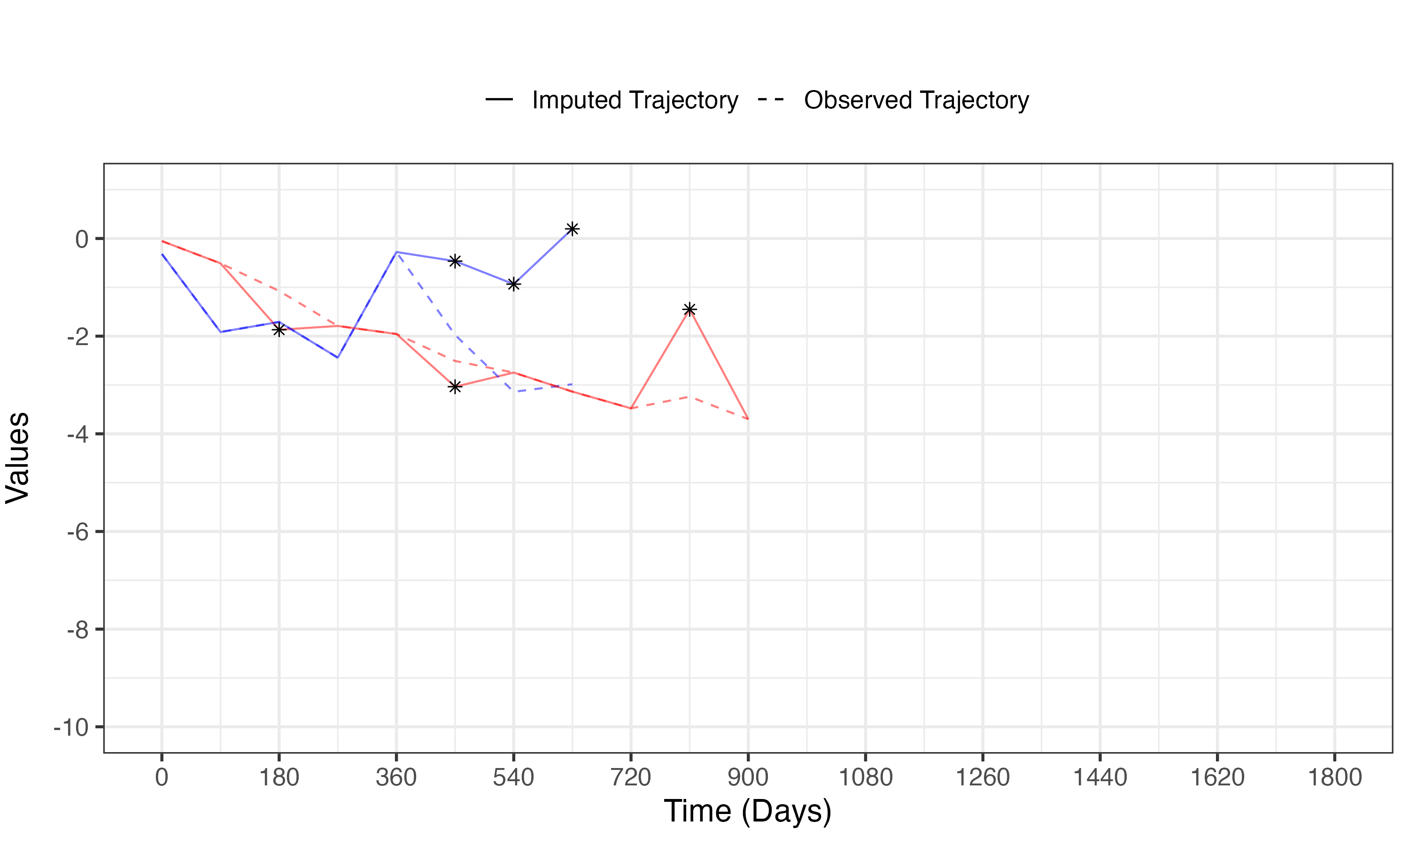

A3c.

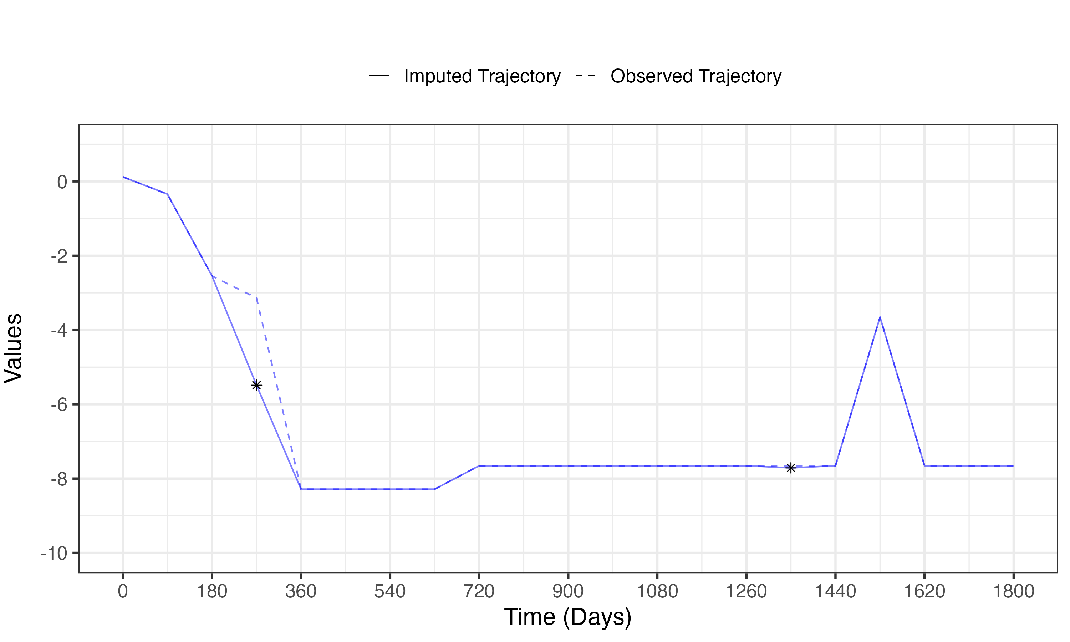

A3d.
