Supporting Information

Title: Climate regulates ecosystem carbon transfer efficiency from atmosphere to soil via soil nitrogen
Running Title: Climate-N regulation of ecosystem C transfer

Zhijing Yu^{*1,2}, Xin Song², Roger Grau-Andrés², Catherine Preece³, Liisa Ukonmaanaho⁴, and Marcos Fernández-Martínez^{*2}
¹Universitat Autònoma de Barcelona, Cerdanyola del Vallès, 08193 Barcelona, Catalonia, Spain
²CREAF, Cerdanyola del Vallès, 08193 Barcelona, Catalonia, Spain
³Institute of Agrifood Research and Technology (IRTA), Programme of Sustainability in Biosystems, Carretera de Cabrils, Km 2, 08348, Cabrils, Spain
⁴Natural Resources Institute Finland (LUKE), Latokartanonkaari 9, Helsinki 00790, Finland

*Correspondence to:
Zhijing Yu, z.yu@creaf.cat
Marcos Fernández-Martínez, m.fernandez@creaf.uab.cat

Figure S1 Geographic distribution of the studied forest sites and the corresponding histograms of carbon fluxes across all sites.
Figure S2 Comparison between observed (ICP Forests) and EMEP modeled nitrogen and sulfur deposition rates.
Figure S3 Correlation heatmaps showing the relationships among six flux products.
Figure S4 Pairwise comparison of GPP, NEP and Re estimates from three ecosystem flux ensembles.
Figure S5 Principal component analysis (PCA) of climatic, soil, foliar nutrients, and community diversity variables.
Figure S6 Mean STN Stock and STN accumulation rate across soil layers, forest types, and climate zones.
Figure S7 Mean STN Stock and STN accumulation rate across soil layers, forest habits, and climate zones.
Figure S8 Partial residual plots showing the effects of predictors on mean STN stock, STN accumulation rate.
Figure S9 Partial residual plots showing the effects of predictors on GPP-to-SOC efficiency and NEP-to-SOC efficiency.
Figure S10 Total effects derived from PSEMs based on NEP. Panels a-c show results of the NEP-SOCS model, and panels d-f show results of the NEP-RSOC model.
Figure S11 Mean SOC Stock, SOC accumulation rate, GPP-to-SOC Efficiency, and NEP-to-SOC Efficiency across soil layers, forest habit, and climate zones.
Figure S12 Piecewise structural equation model (PSEM) based on GPP illustrating the direct and indirect effects on soil organic carbon (SOC) stock.
Figure S13 PSEM based on GPP illustrating the direct and indirect effects on SOC accumulation rate (RSOC).
Figure S14 PSEMs illustrating direct and indirect effects on GPP-to-SOC efficiency (GSE) and NEP-to-SOC efficiency (NSE).
Table S1 Patterns of soil organic carbon (SOC) stock, SOC accumulation rate, and efficiencies of GPP-to-SOC and NEP-to-SOC conversion across soil depths.
Table S2 Overview of terrestrial carbon flux products used in this study.
Table S3 Results of linear mixed-effects models.
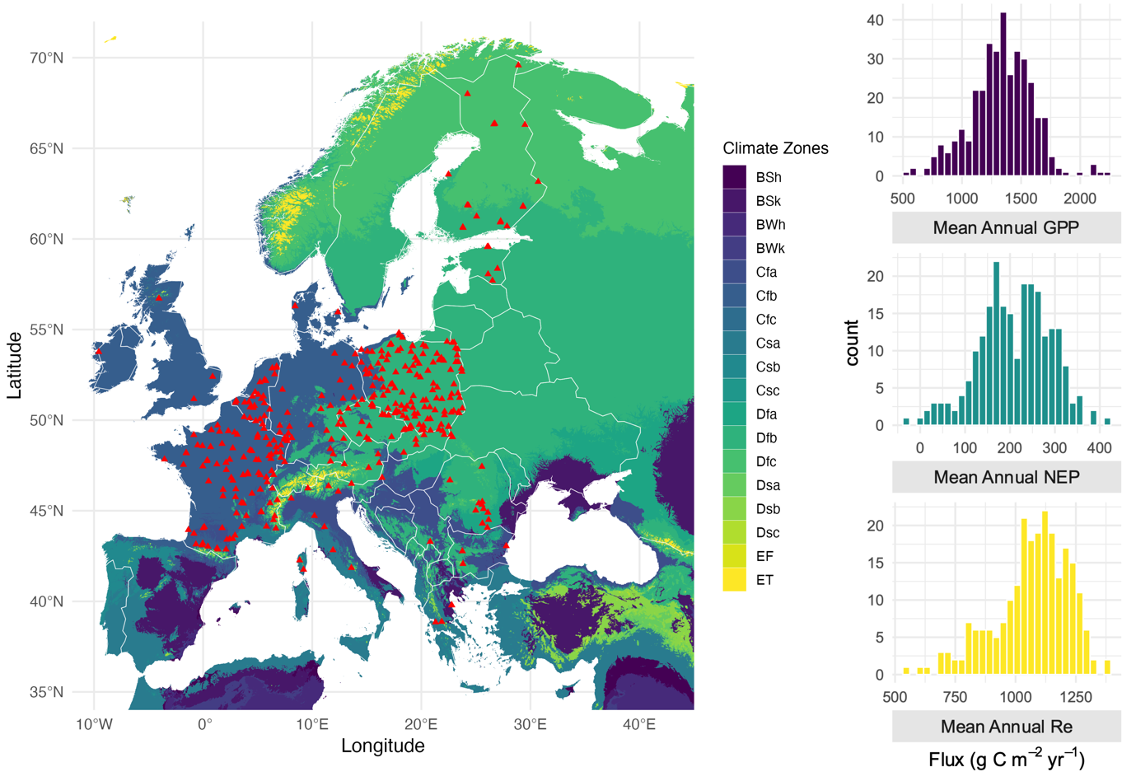
Figure S1: Geographic distribution of the studied forest sites and corresponding histograms of carbon fluxes across all sites. Climate zones follow the Köppen-Geiger classification, which categorizes global climates into major types based on temperature and precipitation patterns, with temperate climates including Cfa, Cfb, Csa, and Csb, and cold climates including Dfa, Dfb, Dfc, and Dsb (Beck et al., 2023). GPP: gross primary production, NEP: net ecosystem production, Re: ecosystem respiration.
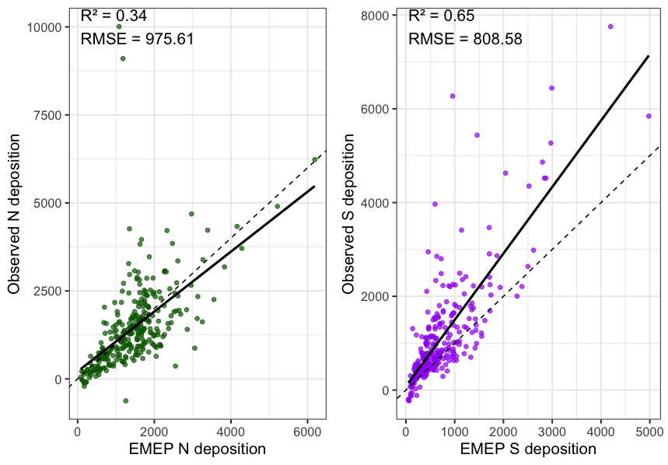 Figure S2: Comparison between observed (ICP Forests) and EMEP-modeled nitrogen (N) and sulfur (S) deposition rates. Rates are expressed in mg m⁻² yr⁻¹. Thick lines show the predicted values from linear regression (dotted 1:1 line for comparison; n = 364). The coefficient of determination and root mean square error are also shown.
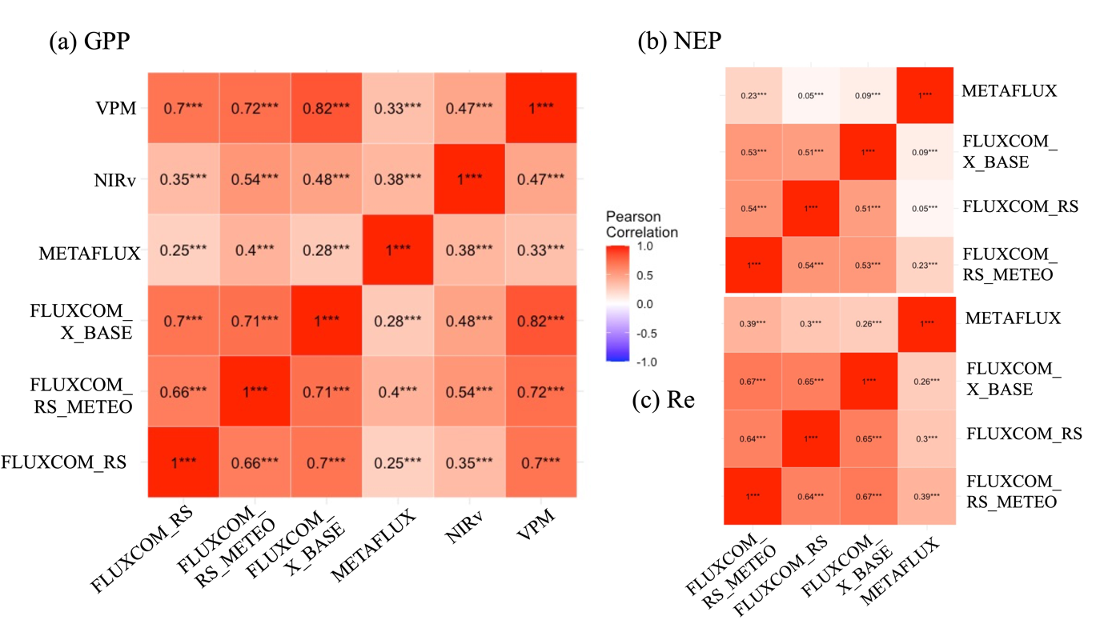
Figure S3: Correlation heatmaps showing the relationships among six flux products. An overview of the products highlighting the differences among them is shown in Table S2. GPP: gross primary production, NEP: net ecosystem production, Re: ecosystem respiration.
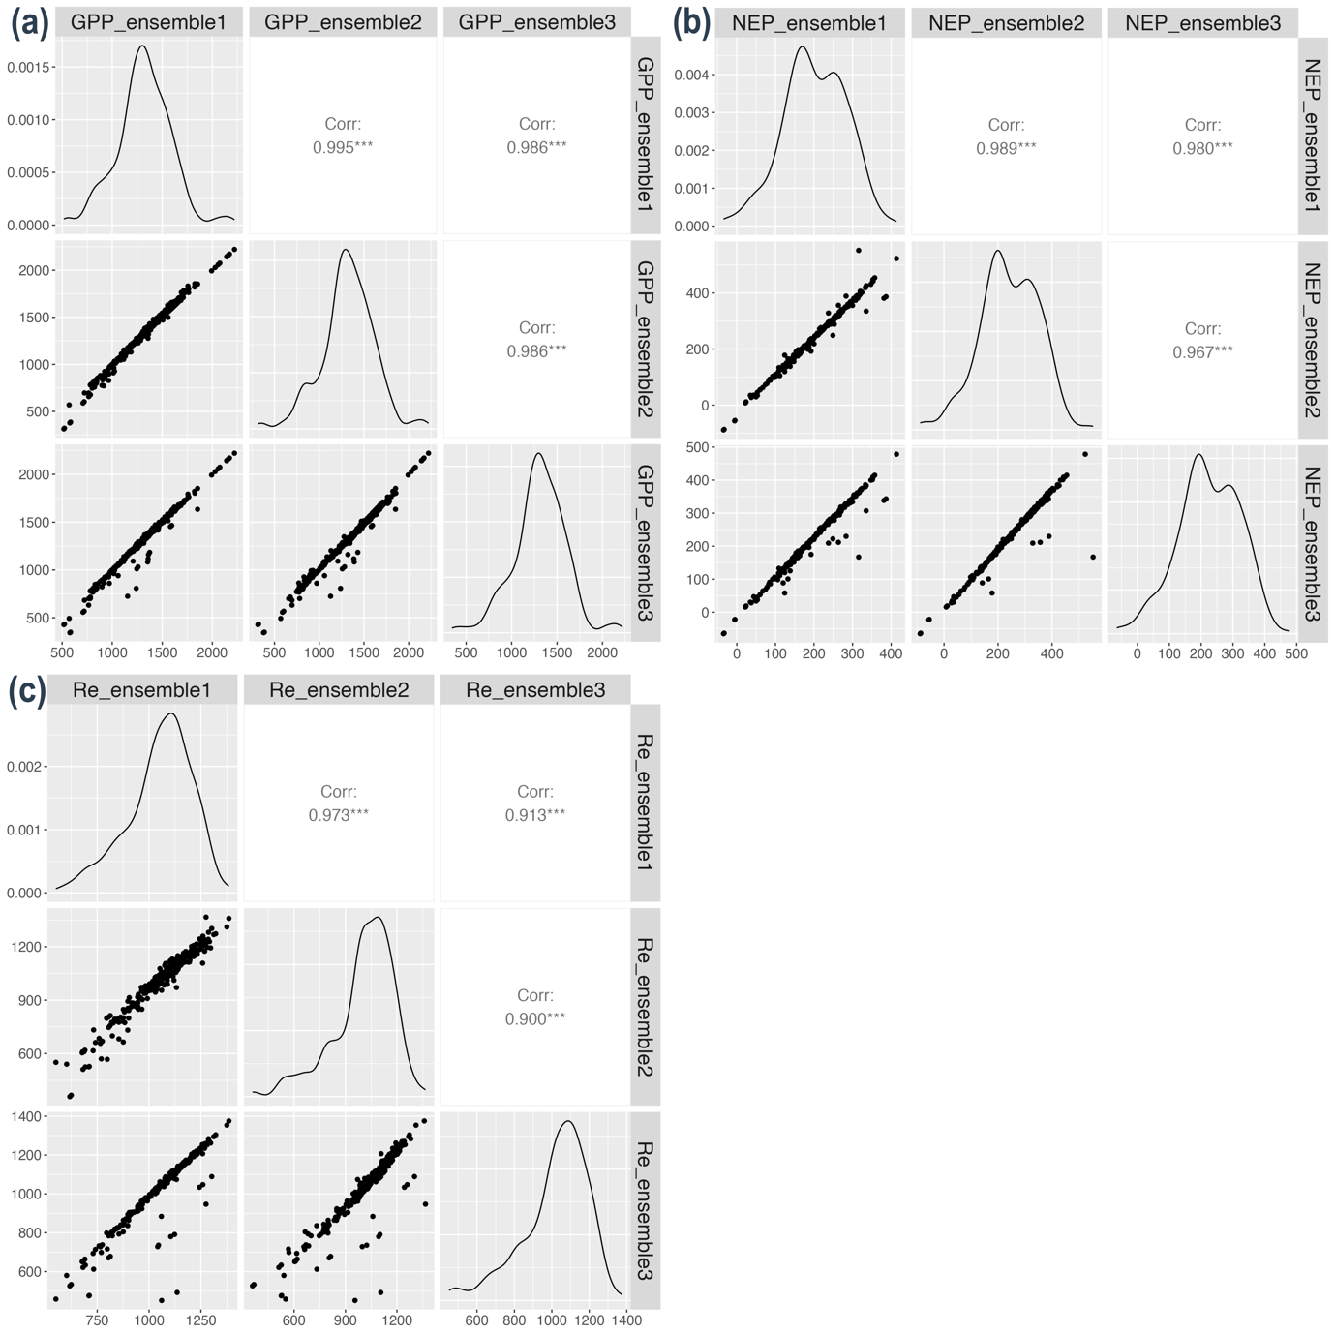
Figure S4 Pairwise comparison of GPP, NEP and Re estimates from three ecosystem flux ensembles. For each panel, the upper plots show Pearson correlation coefficients between ensemble pairs, the lower plots display scatterplots illustrating their pairwise relationships, and the diagonal plots show the probability density distributions for each ensemble. The three flux ensembles: (1) the unweighted mean of all six products, (2) the mean of five products excluding METAFLUX, which exhibits the lowest correlation coefficient among the products, and (3) a correlation-weighted ensemble, in which each flux product was assigned a weight proportional to its mean pairwise correlation with all other products. GPP, gross primary production; NEP, net ecosystem production; Re, ecosystem respiration.

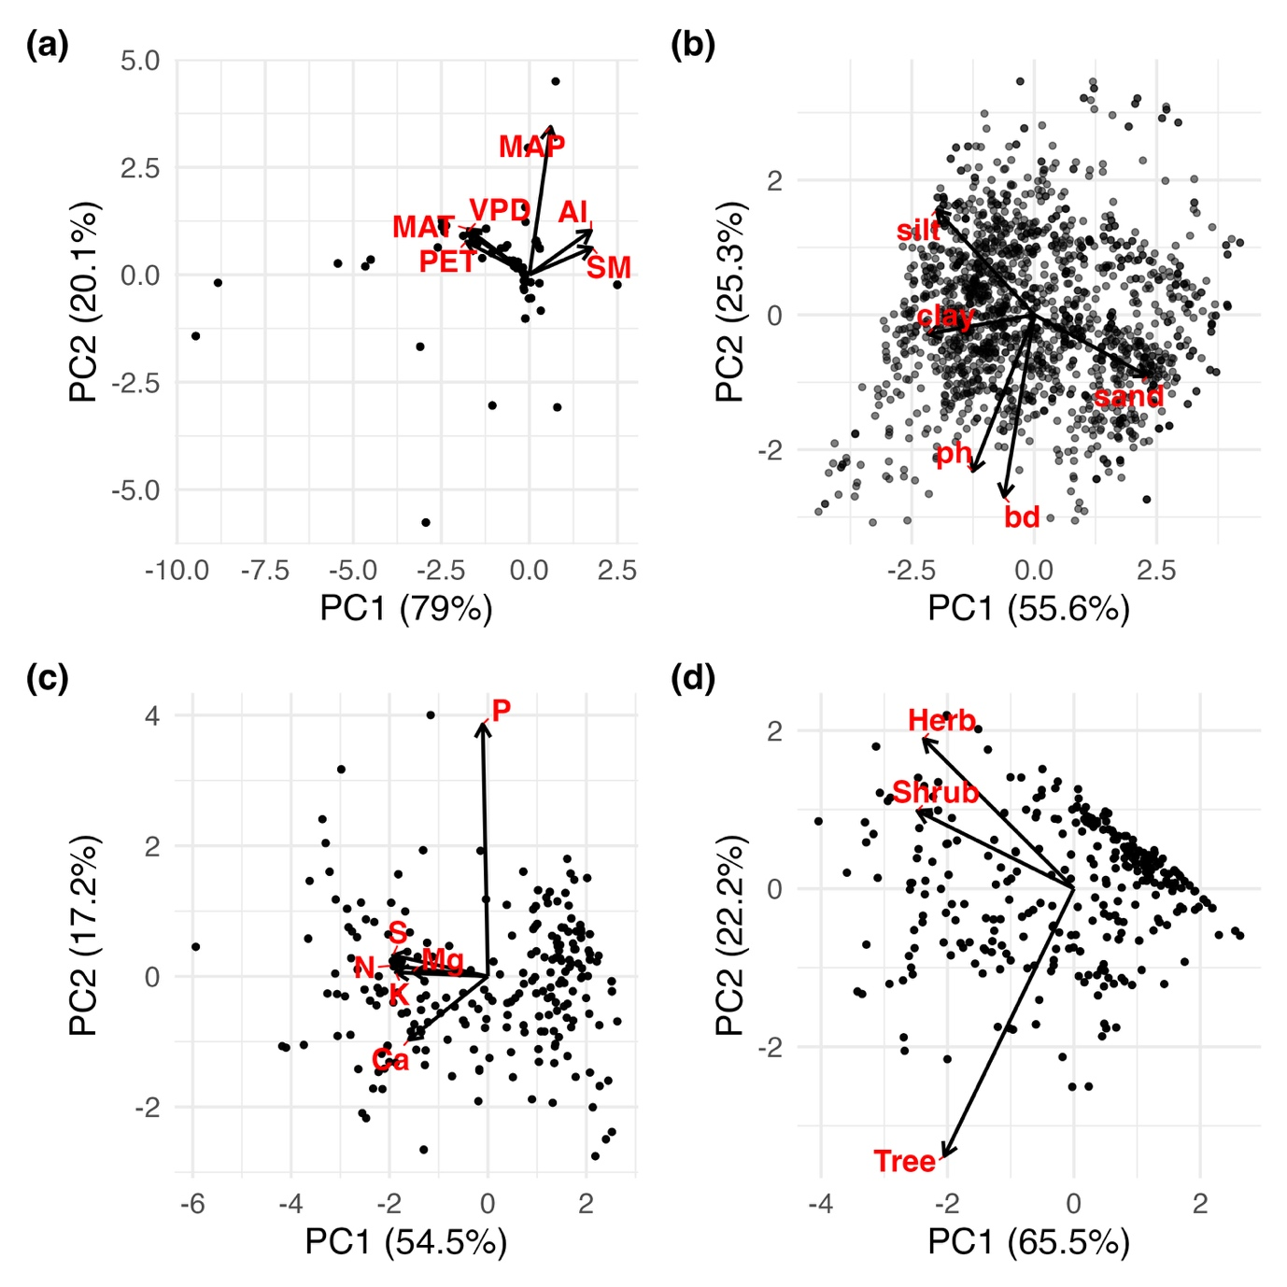
Figure S5: Principal component analysis (PCA) of (a) climatic, (b) soil properties, (c) foliar nutrients, and (d) community diversity. Climate PC1 (energy-moisture gradient, from warm and dry to cool and wet environments at higher PC1 values; n = 364), Community Diversity PC1 (vegetation vertical structural complexity, with higher values indicating greater Shannon diversity across trees, shrubs and herbaceous plants; n = 343), Foliar Nutrients PC1 (total foliar nutrients loadings, with higher PC1 scores indicating low concentrations of N, P, S, K, Ca and Mg; n = 276), and Soil Properties PC1 (soil texture gradient, from finer-textured to coarse-textured soils at higher PC1 values; n = 1668).
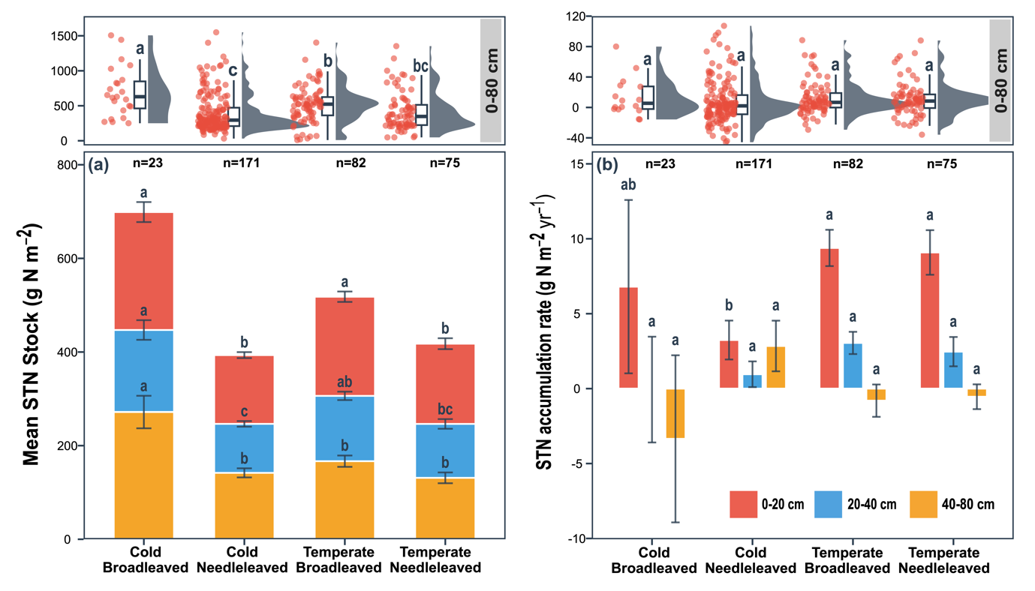
Figure S6: Mean STN Stock (a) and STN accumulation rate (b) across soil layers, forest types, and climate zones. Panel (a) shows stacked bar charts represented the contributions of different soil layers (0–20, 20–40, 40–80 cm). Panel (b) uses bar charts to display the respective variables. Raincloud plots show all observations across the 0–80 cm soil layer. Temperate and cold climate zones are based on aggregated Köppen-Geiger classes. Different lowercase letters indicate statistically significant differences among groups (climatic zones and forest types) based on a multiple comparison test (Tukey, P < 0.05). Mixed forests were not shown here due to limited representativity (n = 3). The error bar is the standard error. Letter “n” denotes the sample size per group. STN, soil total nitrogen.

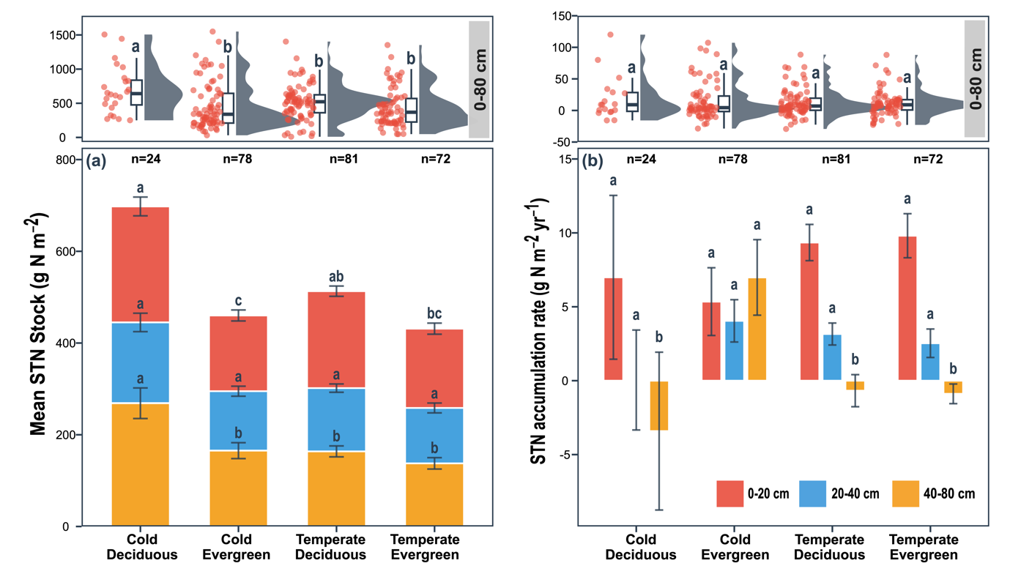
Figure S7: Mean STN stock (a) and rate of STN stock change (b) across soil layers, forest habits, and climate zones. Panel (a) shows stacked bar charts represented the contributions of different soil layers (0–20, 20–40, 40–80 cm). Panel (b) uses bar charts to display the respective variables. Raincloud plots show all observations across the 0–80 cm soil layer. Temperate and cold climate zones are based on aggregated Köppen-Geiger classes. Different lowercase letters indicate statistically significant differences among groups (climatic zones and forest types) based on a multiple comparison test (Tukey, P < 0.05). Mixed forests were not shown here due to limited representativity (n = 3). The error bar is the standard error. Letter “n” denotes the sample size per group. STN, soil total nitrogen.

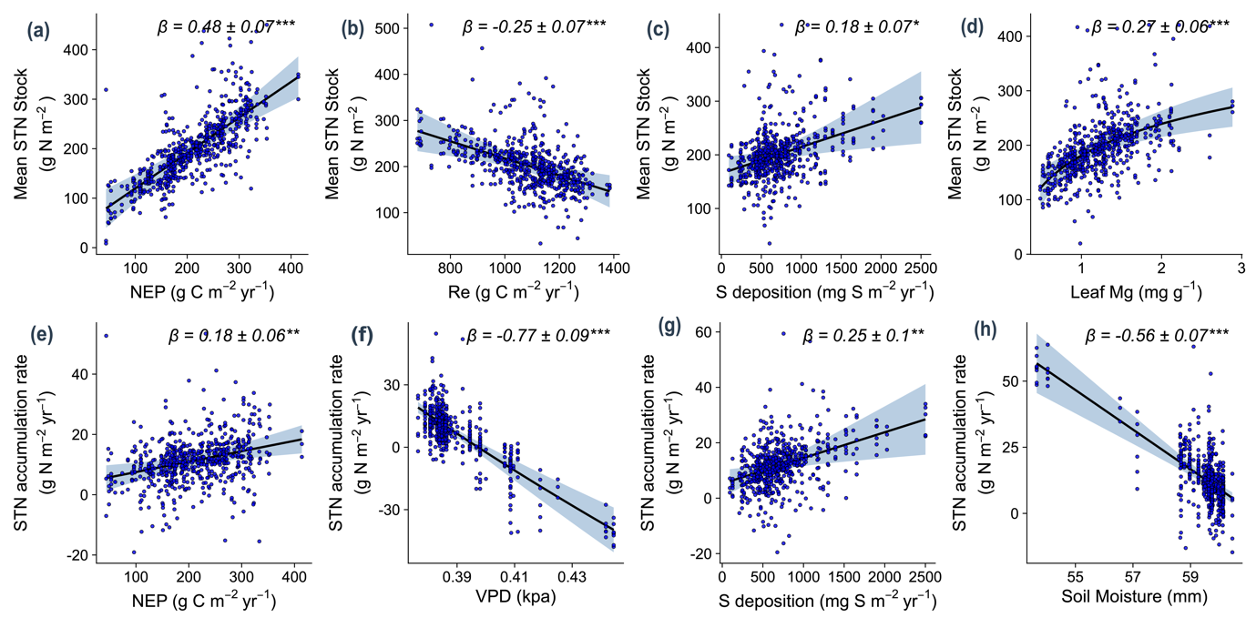
Figure S8: Partial residual plots showing the effects of predictors on mean STN stock, rate of STN stock change. Upper panels show the relationships of (a) net ecosystem production (NEP), (b) ecosystem respiration (Re), (c) sulfur (S) deposition and (d) foliar magnesium (Mg) concentrations with STN stock. Lower panels show the relationships of (e) net ecosystem production (NEP), (f) vapour pressure deficit (VPD), (g) S deposition and (h) soil moisture with rate of STN stock change. Beta weights (β ± SE) and their significance (* P < 0.05; ** P < 0.01; *** P < 0.001) within the model are shown in each panel. Light blue shading indicates 95% confidence bands.
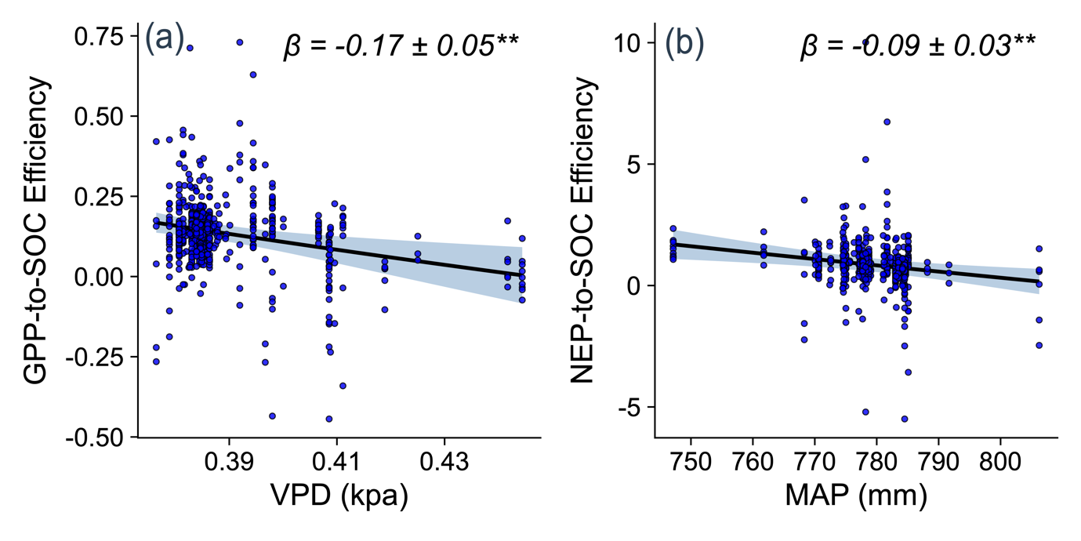
Figure S9: Partial residual plots showing the effects of predictors on GPP-to-SOC efficiency and NEP-to-SOC efficiency. Panel (a) shows the relationship of vapor pressure deficit (VPD) with GPP-to-SOC efficiency, panel (b) shows the relationship of mean annual precipitation (MAP) with NEP-to-SOC efficiency. Beta weights (β ± SE) and their significance (** P < 0.01) within the model are shown in each panel. Light blue shading indicates 95% confidence bands. SOC, soil organic carbon; GPP, gross primary production; NEP, net ecosystem production.
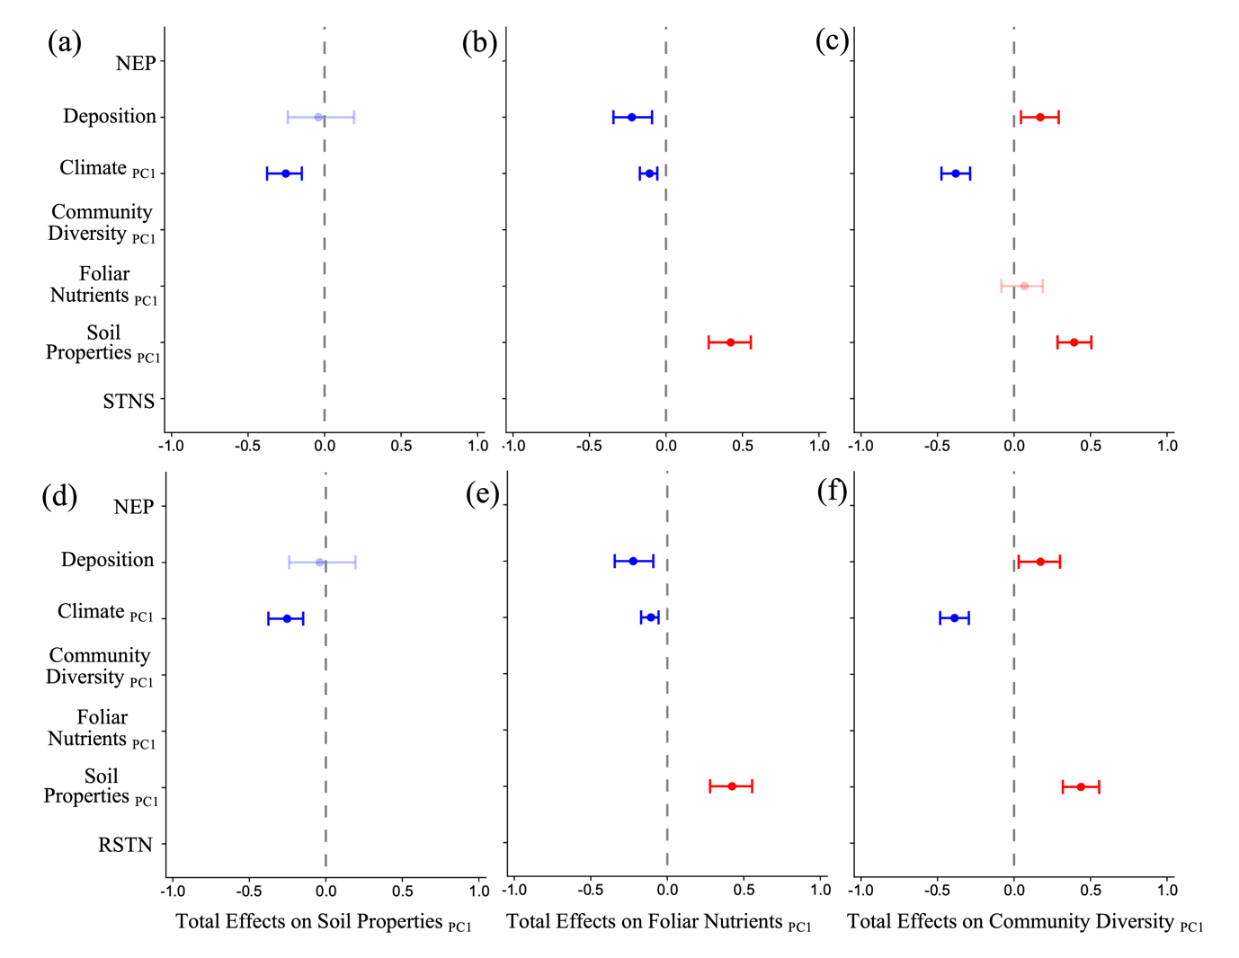
Figure S10: Total effects derived from PSEMs based on NEP. Panels (a-c) show results of the NEP-SOCS model, and panels (d-f) show results of the NEP-RSOC model. Effects shown as standardised parameter estimates indicating mean ± standard error of the mean as confidence intervals (β, n = 172). Variables included in the model are: Climate PC1 (energy-moisture gradient, from warm and dry to cool and wet environments at higher PC1 values), Deposition (annual total N and S deposition), NEP (net ecosystem production), Community Diversity PC1 (vegetation vertical structural complexity, with higher values indicating greater Shannon diversity across trees, shrubs and herbaceous plants), Foliar Nutrients PC1 (total foliar nutrients loadings, with higher PC1 scores indicating low concentrations of N, P, S, K, Ca and Mg) and Soil Properties PC1 (soil texture gradient, from finer-textured to coarse-textured soils at higher PC1 values), STNS (soil total nitrogen stock) , RSTN (soil total nitrogen accumulation rate).
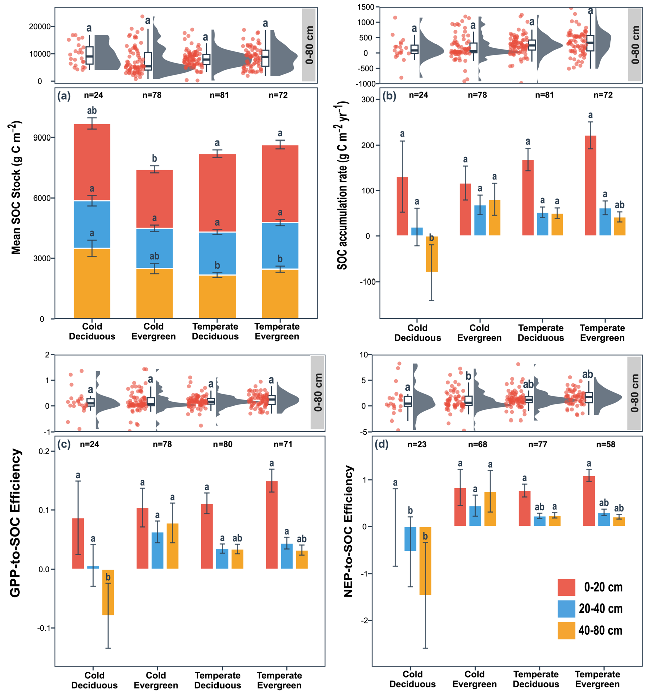
Figure S11: Mean SOC stock (a), SOC accumulation rate (b), GPP-to-SOC efficiency (c), and NEP-to-SOC efficiency (d) across soil layers, forest habits, and climate zones. Panel (a) shows stacked bar charts represented the contributions of different soil layers (0–20, 20–40, 40–80 cm). Panels (b–d) use bar charts to display the respective variables. Raincloud plots show all observations across the 0–80 cm soil layer. Temperate and cold climate zones are based on aggregated Köppen-Geiger classes. Different lowercase letters indicate statistically significant differences among groups (climatic zones and forest types) based on a multiple comparison test (Tukey, P < 0.05). Mixed forests were not shown here due to limited representativity (n = 3). The error bar is the standard error. Letter “n” denotes the sample size per group. SOC, soil organic carbon; GPP, gross primary production; NEP, net ecosystem production.
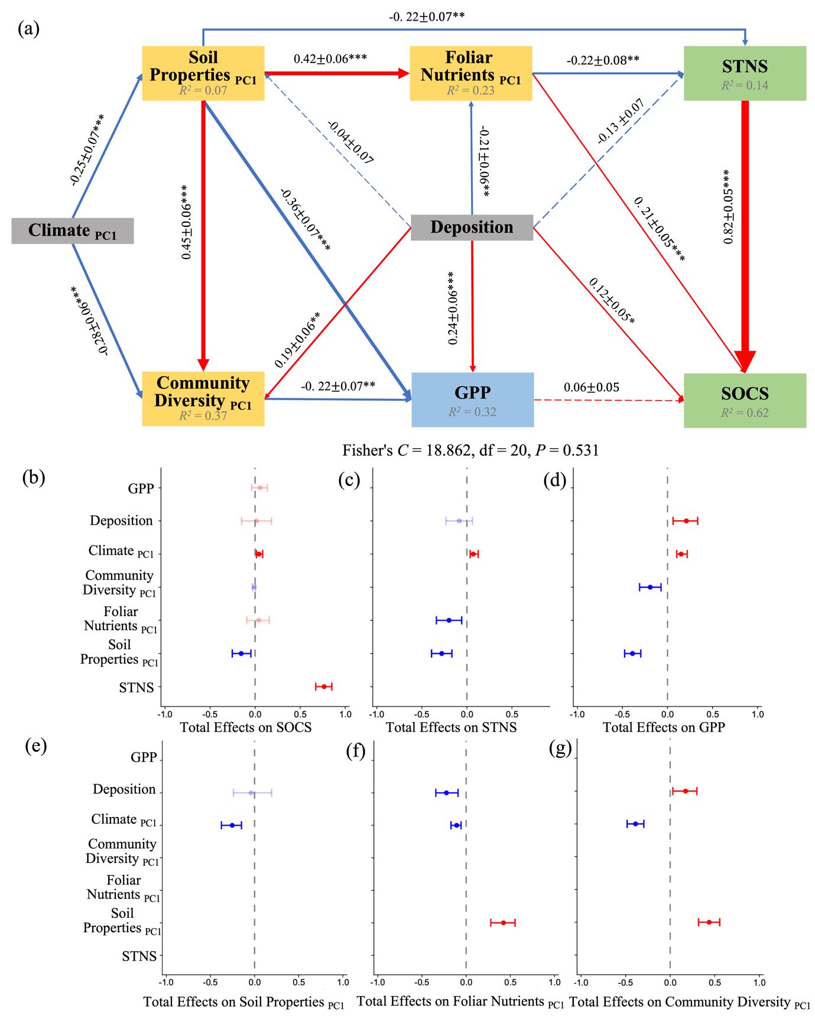
Figure S12: Piecewise structural equation model (PSEM) based on GPP illustrating the direct and indirect effects on soil organic carbon (SOC) stock. Panel (a) shows a directed acyclic graph indicating the causal effects amongst variables. Red lines indicate positive effects, while blue lines indicate negative effects. Line thickness reflects the strength of the relationships. Values on the paths are standardised coefficients ± standard errors (* P < 0.05, ** P < 0.01, *** P < 0.001). Panels (b–g) show the total effects of predictors (Y axes) on endogenous variables (X axes). Effects shown as standardised parameter estimates indicating mean ± standard error of the mean as confidence intervals (β, n = 172). Variables included in the model are: Climate PC1 (energy-moisture gradient, from warm and dry to cool and wet environments at higher PC1 values), Deposition (annual total N and S deposition), NEP (net ecosystem production), Community Diversity PC1 (vegetation vertical structural complexity, with higher values indicating greater Shannon diversity across trees, shrubs and herbaceous plants), Foliar Nutrients PC1 (total foliar nutrients loadings, with higher PC1 scores indicating low concentrations of N, P, S, K, Ca and Mg) and Soil Properties PC1 (soil texture gradient, from finer-textured to coarse-textured soils at higher PC1 values), STNS (soil total nitrogen stock) , SOCS (soil organic carbon stock).
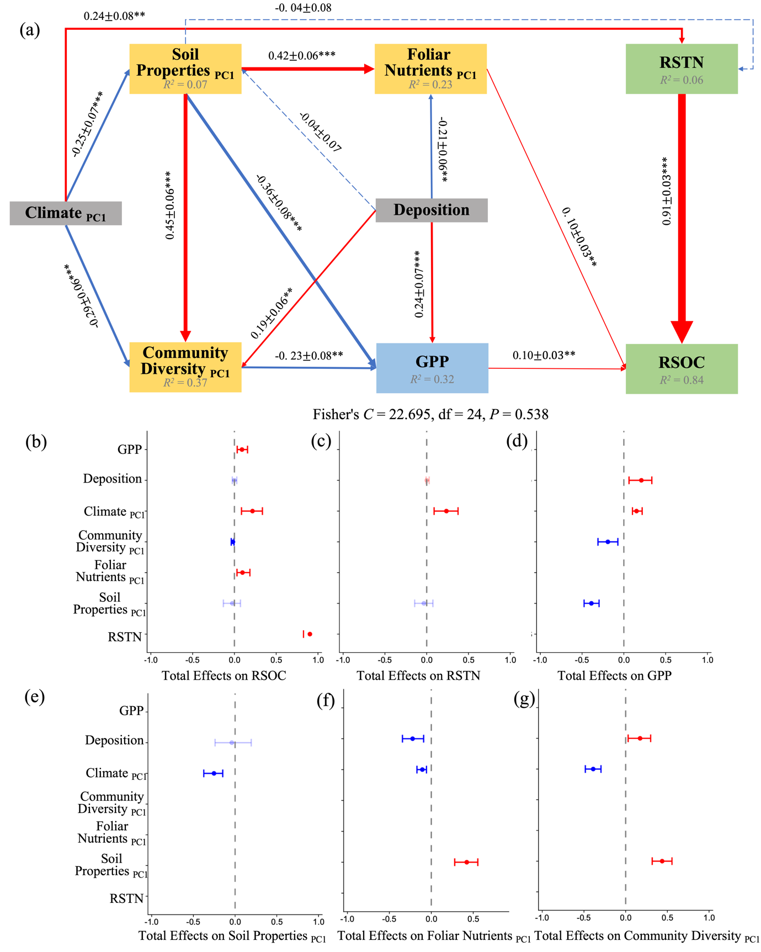
Figure S13: PSEM based on GPP illustrating the direct and indirect effects on SOC accumulation rate (RSOC). Panel (a) shows a directed acyclic graph indicating the causal effects amongst variables. Red lines indicate positive effects, while blue lines indicate negative effects. Line thickness reflects the strength of the relationships. Values on the paths are standardised coefficients ± standard errors (* P < 0.05, ** P < 0.01, *** P < 0.001). Panels (b–g) show the total effects of predictors (Y axes) on endogenous variables (X axes). Effects shown as standardised parameter estimates indicating mean ± standard error of the mean as confidence intervals (β, n = 172). Variables included in the model are: Climate PC1 (energy-moisture gradient, from warm and dry to cool and wet environments at higher PC1 values), Deposition (annual total N and S deposition), NEP (net ecosystem production), Community Diversity PC1 (vegetation vertical structural complexity, with higher values indicating greater Shannon diversity across trees, shrubs and herbaceous plants), Foliar Nutrients PC1 (total foliar nutrients loadings, with higher PC1 scores indicating low concentrations of N, P, S, K, Ca and Mg) and Soil Properties PC1 (soil texture gradient, from finer-textured to coarse-textured soils at higher PC1 values), STNS (soil total nitrogen stock) , SOCS (soil organic carbon stock).
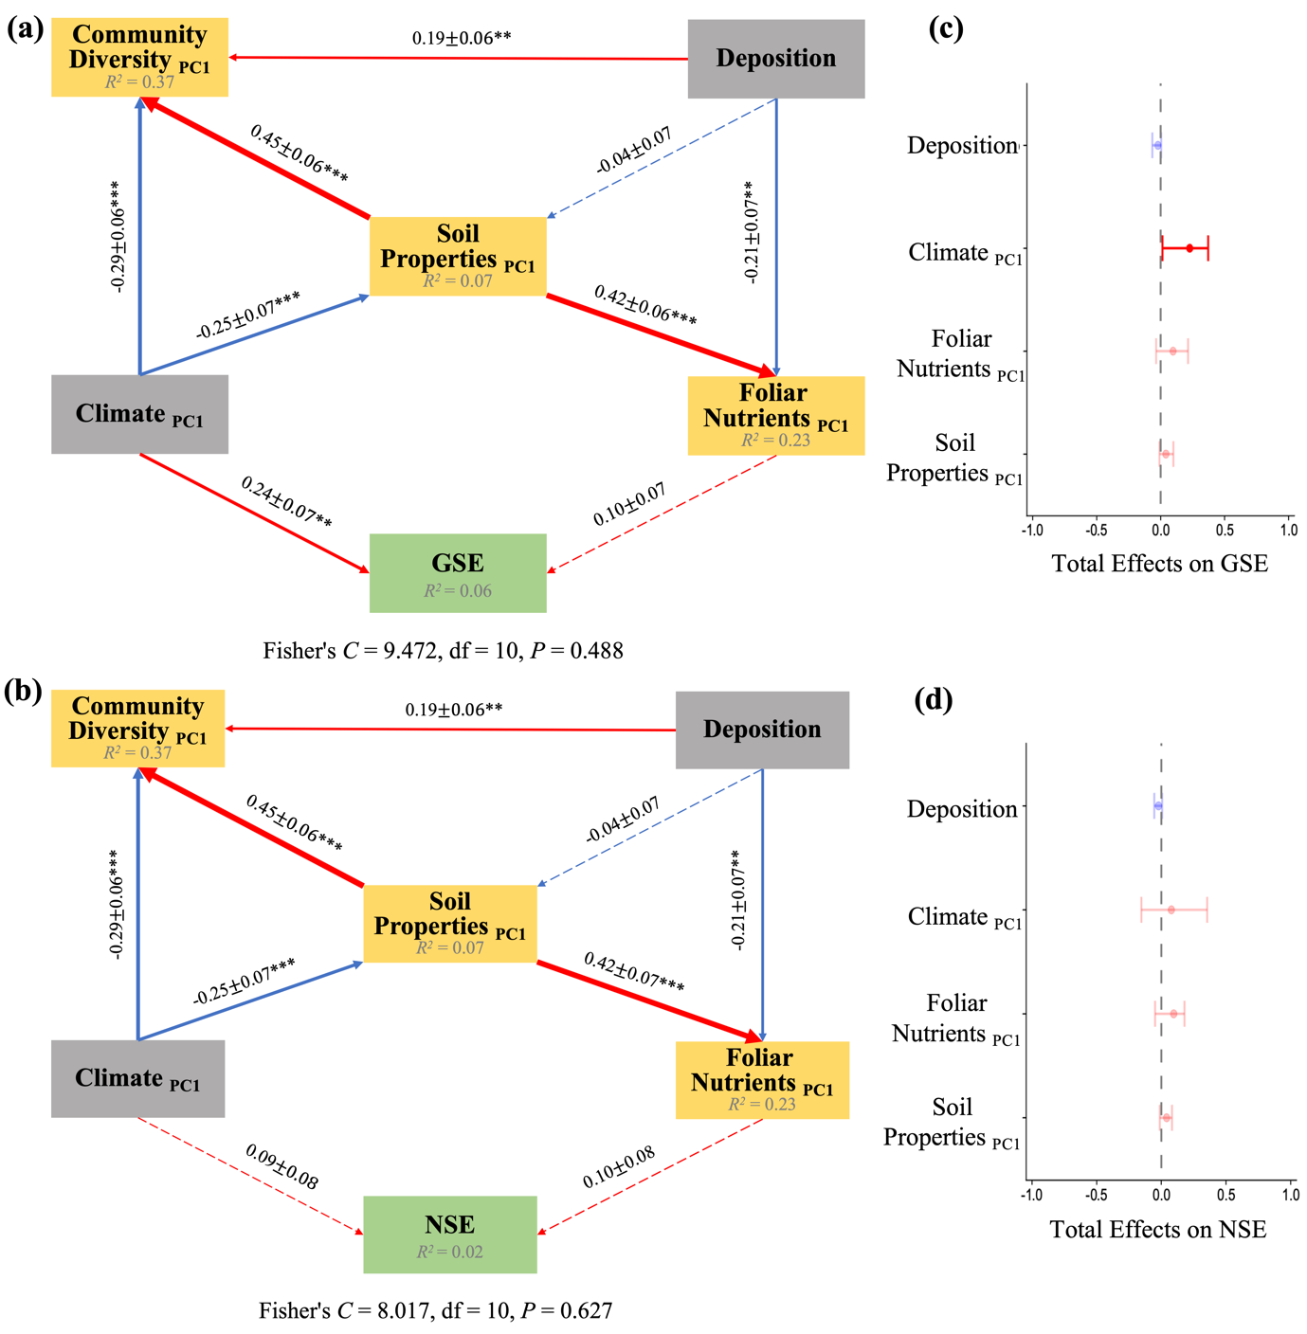
Figure S14: PSEMs illustrating direct and indirect effects on GPP-to-SOC efficiency (GSE) and NEP-to-SOC efficiency (NSE). Panels (a–b) show directed acyclic graphs indicating the causal effects amongst variables. Red lines indicate positive effects, whiles blue lines indicate negative effects. Line thickness reflects the strength of the relationships. Values on the paths are standardised coefficients ± standard errors (* P < 0.05, ** P < 0.01, *** P < 0.001). Panels (c–d) show the total effects of predictors (Y axes) on endogenous variables (X axes). Effects shown as standardised parameter estimates indicating mean ± standard error of the mean as confidence intervals (β, n = 172). Variables included in the model are: Climate PC1 (energy-moisture gradient, from warm and dry to cool and wet environments at higher PC1 values), Deposition (annual total N and S deposition), Community Diversity PC1 (vegetation vertical structural complexity, with higher values indicating greater Shannon diversity across trees, shrubs and herbaceous plants), Foliar Nutrients PC1 (total foliar nutrients loadings, with higher PC1 scores indicating low concentrations of N, P, S, K, Ca and Mg) and Soil Properties PC1 (soil texture gradient, from finer-textured to coarse-textured soils at higher PC1 values), GSE (GPP-to-SOC efficiency), NSE (NEP-to-SOC efficiency).
Table S1 Patterns of soil organic carbon (SOC) stock, rate of SOC stock change, and efficiencies of GPP-to-SOC and NEP-to-SOC conversion across soil depths.
Depth/(cm) | SOCS/(g C m⁻²) | n | RSOC/(g C m⁻² yr⁻¹) | n | GSE | n | NSE | n
0-20 | 3079.7623 ± 82.3060 | 428 | 92.1730 ± 13.1904 | 428 | 0.0649 ± 0.0106 | 425 | 0.3636 ± 0.1773 | 283
20-40 | 1876.2196 ± 58.4799 | 428 | 36.5069 ± 7.5497 | 428 | 0.0262 ± 0.0059 | 425 | 0.0311 ± 0.1191 | 283
40-80 | 2181.7478 ± 78.2862 | 428 | 38.9327 ± 12.7096 | 428 | 0.0281 ± 0.0101 | 425 | -0.0827 ± 0.2023 | 283
0-80 | 7137.7297 ± 196.5799 | 428 | 167.6126 ± 27.6751 | 428 | 0.1192 ± 0.0227 | 425 | 0.3121 ± 0.4761 | 283
Note: Values are presented as means ± standard errors. n denotes the number of samples. SOCS, soil organic carbon stock; RSOC, rate of soil organic carbon stock change; GSE, efficiency of converting gross primary production (GPP) into soil organic carbon; NSE, efficiency of converting net ecosystem production (NEP) into soil organic carbon.
Table S2 Overview of terrestrial carbon flux products used in this study.
Product | Variables used here | Spatial resolution | Temporal resolution used here | Period | Forcing / inputs | Method type | Reference
FLUXCOM-RS | GPP, NEE, Re (NEP = -NEE) | 0.0833° | monthly | 2001–2015 | MODIS remote sensing (RS) only | Machine learning (ML) ensemble trained on FLUXNET | Jung et al. 2020, Biogeosciences
FLUXCOM-RS+METEO | GPP, NEE, Re (NEP = -NEE) | 0.5° | monthly | 2001–2015 | MODIS RS + global meteorological forcing | ML ensemble trained on FLUXNET | Jung et al. 2020, Biogeosciences
FLUXCOM-X-BASE | GPP, NEE, Re (NEP = -NEE) | 0.05° | monthly | 2001–2021 | MODIS RS + core meteorology + PFT classification | XGBoost ML upscaling of FLUXNET | Nelson et al. 2024, Biogeosciences
METAFLUX | GPP, Re (NEP = GPP - Re) | 0.25° | monthly | 2001–2023 | MODIS RS + ERA5(-Land) meteorology + FLUXNET | Meta-learning deep-network ensemble | Nathaniel et al. 2023, Scientific Data
NIRv GPP | GPP | 0.05° | monthly | 1982-2018 | AVHRR/MODIS NIRv from satellite reflectance | Semi-empirical NIRv–GPP upscaling | Wang et al. 2021, Science of The Total Environment
VPM GPP V20 | GPP | 500 m (native); 0.05° (regridded) | annually | 2000-2016 | MODIS RS (EVI, LSWI, LST) + NCEP Reanalysis II | Light-use-efficiency (VPM) model | Zhang et al. 2017, Scientific Data

Table S3: Summary tables of the linear mixed-effect models (standardised coefficients). The reported LMMs correspond to the reduced models obtained after model selection and test the influence of climate, carbon flux, deposition, community diversity, foliar elements, soil layers, year gap, and their interaction on (3.1) SOCS, (3.2) STNS, (3.3) CNR, (3.4) RSOC, (3.5) RSTN, (3.6) GSE, and (3.7) NSE.
3.1 SOCS
Predictor | Std.Estimate | Std.Error | t_value | p_value
(Intercept) | 0.000 | 0.000 | 4.455 | 0.000
NEP | 0.303 | 0.055 | 5.468 | 0.000
foliar_S | 0.285 | 0.099 | 2.887 | 0.004
log(foliar_N) | -0.273 | 0.100 | -2.716 | 0.007
depthM24 | -0.442 | 0.026 | -17.092 | 0.000
depthM48 | -0.391 | 0.026 | -15.120 | 0.000
R²m = 0.283, R²c = 0.697, N = 606
Note: SOCS, soil organic carbon stock; NEP, net ecosystem production; foliar_S, foliar sulfur concentration; foliar_N, foliar nitrogen concentration; depthM24, 20–40 cm soil layer; depthM48, 40–80 cm soil layer.

3.2 STNS
Predictor | Std.Estimate | Std.Error | t_value | p_value
(Intercept) | 0.000 | 0.000 | 2.953 | 0.003
Re | -0.245 | 0.071 | -3.454 | 0.001
NEP | 0.484 | 0.071 | 6.797 | 0.000
S_deposition | 0.178 | 0.069 | 2.588 | 0.010
shannon_herbaceous | 0.192 | 0.065 | 2.967 | 0.003
log(foliar_Mg) | 0.272 | 0.061 | 4.474 | 0.000
depthM24 | -0.274 | 0.022 | -12.230 | 0.000
depthM48 | -0.156 | 0.022 | -6.964 | 0.000
R²m = 0.325, R²c = 0.783, N = 606
Note: STNS, soil total nitrogen stock; NEP, net ecosystem production; Re, ecosystem respiration; S_deposition, atmospheric total sulfur deposition; shannon_herbaceous, Shannon index of herbaceous plants; foliar_Mg, foliar magnesium concentration; depthM24, 20–40 cm soil layer; depthM48, 40–80 cm soil layer.
3.3 CNR
Predictor | Std.Estimate | Std.Error | t_value | p_value
(Intercept) | 0.000 | 0.000 | 4.568 | 0.000
N_deposition | 0.340 | 0.130 | 2.611 | 0.010
S_deposition | -0.533 | 0.139 | -3.826 | 0.000
log(foliar_N) | -0.591 | 0.155 | -3.810 | 0.000
log(foliar_S) | 0.844 | 0.159 | 5.315 | 0.000
log(foliar_Mg) | -0.461 | 0.083 | -5.571 | 0.000
depthM24 | -0.063 | 0.017 | -3.677 | 0.000
depthM48 | -0.059 | 0.017 | -3.444 | 0.001
R²m = 0.207, R²c = 0.884, N = 606
Note: CNR, soil carbon to nitrogen ratio; N_deposition, atmospheric total nitrogen deposition; S_deposition, atmospheric total sulfur deposition; foliar_S, foliar sulfur concentration; foliar_N, foliar nitrogen concentration; foliar_Mg, foliar magnesium concentration; depthM24, 20–40 cm soil layer; depthM48, 40–80 cm soil layer.

3.4 RSOC
Predictor | Std.Estimate | Std.Error | t_value | p_value
(Intercept) | 0.000 | 0.000 | 3.786 | 0.000
NEP | 0.236 | 0.071 | 3.324 | 0.001
Re | -0.212 | 0.074 | -2.858 | 0.004
log(MAP) | -0.131 | 0.035 | -3.800 | 0.000
Δyear | 0.556 | 0.072 | 7.707 | 0.000
depthM24 | 0.473 | 0.116 | 4.074 | 0.000
depthM48 | 0.489 | 0.116 | 4.212 | 0.000
Δyear:depthM24 | -0.731 | 0.118 | -6.185 | 0.000
Δyear:depthM48 | -0.796 | 0.118 | -6.733 | 0.000
R²m = 0.2, R²c = 0.585, N = 606
Note: RSOC, soil organic carbon accumulation rate; NEP, net ecosystem production; Re, ecosystem respiration; MAP, mean annual precipitation; Δyear, the difference between two inventory years; depthM24, 20–40 cm soil layer; depthM48, 40–80 cm soil layer.
3.5 RSTN
Predictor | Std.Estimate | Std.Error | t_value | p_value
(Intercept) | 0.000 | 0.000 | 3.362 | 0.001
NEP | 0.176 | 0.057 | 3.078 | 0.002
log(VPD) | -0.773 | 0.086 | -9.036 | 0.000
SM | -0.556 | 0.069 | -8.103 | 0.000
N_deposition | -0.283 | 0.092 | -3.075 | 0.002
S_deposition | 0.253 | 0.097 | 2.612 | 0.010
Δyear | 0.179 | 0.079 | 2.254 | 0.025
depthM24 | 0.347 | 0.107 | 3.245 | 0.001
depthM48 | 0.489 | 0.107 | 4.564 | 0.000
Δyear:depthM24 | -0.564 | 0.109 | -5.173 | 0.000
Δyear:depthM48 | -0.818 | 0.109 | -7.508 | 0.000
R²m = 0.256, R²c = 0.634, N = 606
Note: RSTN, soil total nitrogen accumulation rate; NEP, net ecosystem production; VPD, vapor pressure deficit; SM, soil moisture; N_deposition, atmospheric total nitrogen deposition; S_deposition, atmospheric total sulfur deposition; Δyear, the difference between two inventory years; depthM24, 20–40 cm soil layer; depthM48, 40–80 cm soil layer.

3.6 GSE
Predictor | Std.Estimate | Std.Error | t_value | p_value
(Intercept) | 0.000 | 0.000 | 4.180 | 0.000
log(VPD) | -0.165 | 0.053 | -3.105 | 0.002
log(MAP) | -0.154 | 0.036 | -4.330 | 0.000
Δyear | 0.330 | 0.080 | 4.100 | 0.000
depthM24 | 0.423 | 0.115 | 3.684 | 0.000
depthM48 | 0.454 | 0.115 | 3.948 | 0.000
Δyear:depthM24 | -0.642 | 0.117 | -5.491 | 0.000
Δyear:depthM48 | -0.714 | 0.117 | -6.110 | 0.000
R²m = 0.132, R²c = 0.585, N = 606
Note: GSE, GPP-to-SOC efficiency; VPD, vapor pressure deficit; MAP, mean annual precipitation; Δyear, the difference between two inventory years; depthM24, 20–40 cm soil layer; depthM48, 40–80 cm soil layer.
3.7 NSE
Predictor | Std.Estimate | Std.Error | t_value | p_value
(Intercept) | 0.000 | 0.000 | 3.077 | 0.002
Re | -0.249 | 0.073 | -3.422 | 0.001
log(MAP) | -0.094 | 0.031 | -3.042 | 0.002
Δyear | 0.388 | 0.074 | 5.250 | 0.000
depthM24 | 0.267 | 0.098 | 2.707 | 0.007
depthM48 | 0.365 | 0.098 | 3.710 | 0.000
Δyear:depthM24 | -0.403 | 0.100 | -4.021 | 0.000
Δyear:depthM48 | -0.515 | 0.100 | -5.144 | 0.000
R²m = 0.082, R²c = 0.722, N = 606
Note: NSE, NEP-to-SOC efficiency; Re, ecosystem respiration; MAP, mean annual precipitation; Δyear, the difference between two inventory years; depthM24, 20–40 cm soil layer; depthM48, 40–80 cm soil layer.

