Supplementary Figure:
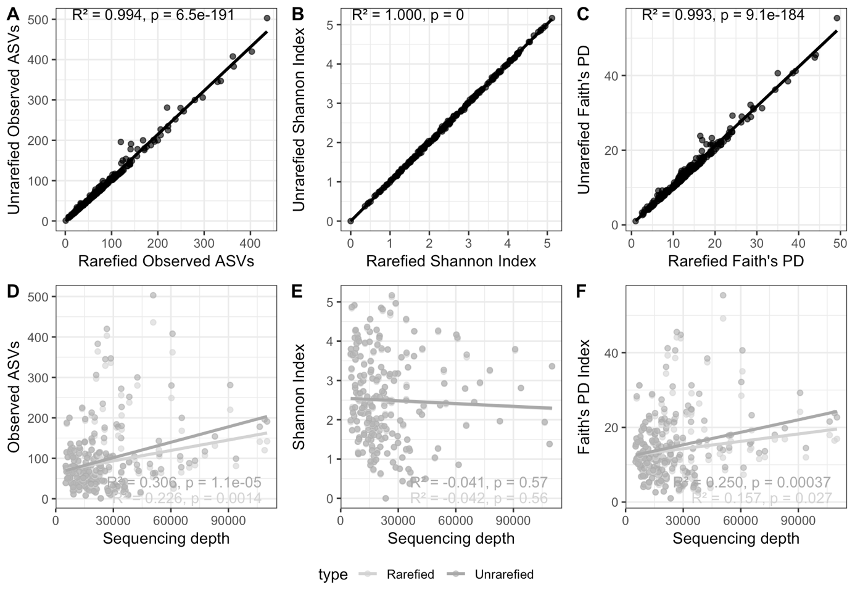
Supplementary Figure 1. A-C) Comparison of rarefied versus unrarefied alpha diversity metrices from samples with more than 5000 reads and D-F) in relation to sample sequencing depth.

