SUPPLEMENTAL CONTENT

MPT: A Comprehensive Toolbox for Deriving Cardiorespiratory Physiomarkers from Biosignals with LLM-Based Interpretation
Tilendra Choudhary, Md Hassanuzzaman, Preethi Krishnan, Ayman Ali, Victor Moas, and Rishikesan Kamaleswaran

TABLE OF CONTENTS
- Table - 1: Physiomarkers derived from the Electrocardiogram (ECG) waveform categorized by time domain and frequency domain. — Page 1
- Table - 2: Physiomarkers derived from the Photoplethysmographic (PPG) waveform categorized by time domain, frequency domain, class, statistical, and hybrid. — Page 2
- Table - 3: Physiomarkers derived from the respiratory (RESP) waveform categorized by time domain and frequency domain. — Page 6
- Table - 4: Physiomarkers derived from the arterial blood pressure (ABP) waveform categorized by time domain, temporal periodicity, and hemodynamic. — Page 6
- Table - 5: Physiomarkers derived from the heart rate variability (HRV) categorized by time domain, frequency domain, non-linear, entropy-based, geometric, and statistical. — Page 7
- Section - 1: Prompts used for LLM-based analysis and interpretation of physiomarkers. — Page 18
- Figures 1-18: MPT-Web App Extended Figures — Pages 21-31
- Section - 2: Details on Our Physiological Report Validator Pipeline — Page 31
- Table - 6: Performance results of clinical summary reports generated by two different sized LLM-models on BIDMC dataset using our proposed automated validation pipeline. — Page 33

Table - 1: Physiomarkers derived from the Electrocardiogram (ECG) waveform categorized by time domain and frequency domain.
Category | Features | Description | Statistical Significance
Time | HR_bpm | Heart rate in beats per minute, calculated as the inverse of the average RR interval duration | A large meta-analysis found that each 10 bp increase → ~9% higher all cause death risk [1].
Time | pr_interval_ms | The time duration from the onset of the P wave to the onset of the QRS complex, measured in milliseconds | Prolonged PR (≥200 ms, 1st-degree AV block) signals conduction delay and higher risk of arrythmia/death [2]
Time | pr_segment_ms | The time duration from the end of the P wave to the onset of the QRS complex, measured in milliseconds | PR segment depression indicates the ischaemia/pericarditis. PR↓≥1.2 mm gave 44.4% vs 11.7% mortality (P=0.015) [3]
Time | qt_interval_ms | The time duration from the onset of the QRS complex to the end of the T wave, measured in milliseconds | QT extremes predict arrythmias/ sudden death. In NHANEX-III, QT ≥ 95th percentile doubled total mortality risk [4].
Time | qtc_interval_ms | The corrected QT interval, adjusted for heart rate, measured in milliseconds | Prolonged QTc likewise predicts risk.: e.g. QTc ≥ 95th percentile had ~2x all-cause mortality [4].
Time | st_interval_ms | The time duration from the end of the QRS complex to the end of the T wave, measured in milliseconds | ST interval indicates ischemia. In STEMI, 30-day mortality was ~6% vs 0.2% in general controls [5].
Time | st_segment_ms | The time duration from the end of the QRS complex to the onset of the T wave, measured in milliseconds | ST depression indicates subendocardial ischemia. 1 year mortality was 10.3% with ST↓ vs 5.6% without (p=0.002) [6].
Time | ventSys_phase | The phase of ventricular systole within the cardiac cycle, typically measured in milliseconds | No study found
Time | atrialSys_phase | The phase of atrial systole within the cardiac cycle, measured in milliseconds | No study found
Time | P_duration | The duration of the P wave, measured in milliseconds | Both abnormally short and long P predict AF. In one cohort, P ≥ 130 ms had hazard ratio (HR) ≈ 2.06 for incident AF [7].
Time | QRS_duration | The duration of the QRS complex, measured in milliseconds | Prolonged QRS (≥120 ms) indicates conduction block. QRS ≥ 120ms had 49.3% vs 34% mortality (P<0.001) [8].
Time | T_duration | The duration of the T wave, measured in milliseconds | No association was seen between T duration and arrythmia events [9].
Time | T_rr_ms | The RR interval, the time between consecutive R peaks in the QRS complex, measured in milliseconds | Meta analysis: lowest HRV quartile had HR ≈ 1.56 for all cause death [10].
Time | ecgInterbeat_eigval1 | The first eigenvalue from the analysis of interbeat intervals | No specific references found
Time | ecgInterbeat_eigval2 | The second eigenvalue from the analysis of interbeat intervals | No specific references found
Time | ecgInterbeat_eigval3 | The third eigenvalue from the analysis of interbeat intervals | No specific references found
Frequency | ecgBeatCenterFreq | The dominant frequency of ECG beats, derived from spectral analysis | No specific references found
Frequency | edr_rate_Bpm | ECG-derived respiration rate in breaths per minute. | One QRS based algorithm achieved Pearson r≈0.88 with true respiratory rate [11].
Table – 2: Physiomarkers derived from the Photoplethysmographic (PPG) waveform categorized by time domain, frequency domain, class, statistical, and hybrid.
Category | Features | Definition | Statistical Significance
Time | AUC_dias_nu | Normalized area under the curve for the diastolic phase of the PPG waveform | No specific references found
Time | AUC_pulse_nu | Normalized area under the curve for the entire PPG pulse | No specific references found
Time | AUC_sys_nu | Normalized area under the curve for the systolic phase of the PPG waveform | No specific references found
Time | AUCos_nu | Normalized area under the curve from onset to systolic peak | No specific references found
Time | AUCow_nu | Normalized area under the curve from onset to wave peak | No specific references found
Time | AUCso_nu | Normalized area under the curve from systolic peak to offset | No specific references found
Time | AUCwo_nu | Normalized area under the curve from wave peak to offset | No specific references found
Time | A_AC | Amplitude of the alternating current (pulsatile) component of the PPG signal | AC component is strongly correlated with stroke volume [12].
Time | A_dn | Amplitude at the diastolic notch in the PPG waveform | No specific references found
Time | A_off | Amplitude at the offset point of the PPG waveform | No specific references found
Time | A_sp | Amplitude at the systolic peak of the PPG waveform | Correlated with stroke volume [12]
Time | Augmentation_index | Ratio of the reflected wave amplitude to the systolic peak amplitude, indicating arterial stiffness | It increases with age and vascular diseases [12].
Time | DN_exists | Binary indicator (0 or 1) of whether a diastolic notch is present in the waveform | Absence of a diastolic notch is strongly linked to vascular aging. In large study, absent -notch cases had ~4x higher myocardial infraction prevalence (p<0.001) compared to distinct notch cases [13].
Time | Delta_A_dn_dp | Difference in amplitude between the diastolic notch and diastolic peak | No specific references found
Time | Delta_A_sp_sp | Difference in amplitude between two systolic peaks (if multiple peaks exist) | No specific references found
Time | Delta_T_sd | Time difference between the systolic peak and diastolic peak | It correlates with vascular stiffness, age and pulse wave velocity (PWV) (r≈0.69, p<0.0001) [14]
Time | PR | Pulse rate, calculated as the inverse of the time interval between consecutive pulses | A UK Biobank study found higher heart rate in absent-notch subjects versus others (p<0.001) [13].
Time | PW_10 | Pulse width at 10% of the pulse height | No specific references found
Time | PW_25 | Pulse width at 25% of the pulse height | No specific references found
Time | PW_33 | Pulse width at 33% of the pulse height | No specific references found
Time | PW_50 | Pulse width at 50% of the pulse height | Correlates with systematic vascular resistance [12].
Time | PW_66 | Pulse width at 66% of the pulse height | No specific references found
Time | PW_75 | Pulse width at 75% of the pulse height | No specific references found
Time | RI | Reflection index, the ratio of the diastolic peak amplitude to the systolic peak amplitude | higher arterial stiffness yields lower RI [15].
Time | SI | Stiffness index, derived from the time delay between systolic and diastolic peaks divided by the subject’s height | Strongly correlates with aortic PWV and age. In one study SI correlated with PWV (r=0.65, p<0.0001) and age (r=0.69, p<0.0001) [14].
Time | T_dn_dp_ms | Time interval between the diastolic notch and diastolic peak, in milliseconds | No specific references found
Time | T_os_ms | Time from waveform onset to systolic peak, in milliseconds | It is longer in vascular disease [12].
Time | T_ow_ms | Time from waveform onset to wave peak (e.g., dicrotic wave), in milliseconds | No specific references found
Time | T_so_cd_ms | Time from systolic peak to the dicrotic notch, in milliseconds | Decreased in stiffer arteries [14].
Time | T_so_ms | Time from systolic peak to waveform offset, in milliseconds | It is a part of the pulse width (PW). PW correlates with systematic vascular resistance [12].
Time | T_wo_ms | Time from wave peak to waveform offset, in milliseconds | No specific references found
Time | Tdias_ms | Duration of the diastolic phase of the PPG waveform, in milliseconds | In a study, It has been noted as an important feature for blood pressure (BP) and hypertension prediction [16].
Time | Ton_off_ms | Time from waveform onset to offset (pulse duration), in milliseconds | Full pulse duration (“pulse width”) correlates with vascular resistance [12].
Time | Tsp_sp_ms | Time between two systolic peaks (if applicable), in milliseconds | It strongly correlates with ECG heart-rate variability (r≈0.9) [12].
Time | Tsys_ms | Duration of the systolic phase of the PPG waveform, in milliseconds | It reflects cardiac ejection: longer it indicates robust systolic function [16].
Time | dpat_ms | Consecutive pulse arrival time difference, in ms | No specific references found
Time | pat_ms | Pulse arrival time, in ms | Pulse arrival time (ECG R-wave to PPG foot) is strongly inversely correlated with BP (e.g. SBP; r≈−0.9, p<0.01 in ICU patients [17].
Time | max_upslope | Maximum slope of the rising edge of the PPG waveform, indicating the rate of blood volume change | The slope transit time correlates with BP. Addison (2016) showed a single PPG upslope feature is strongly BP-related [18].
Time | mean_slope_os | Mean slope from waveform onset to systolic peak, reflecting the average rate of rise | No specific references found
Time | mean_slope_so | Mean slope from systolic peak to waveform offset, reflecting the average rate of fall | No specific references found
Frequency | center_freq_ppg_Hz | Center frequency of the PPG signal’s power spectrum, in Hertz | No specific references found
Frequency | energy_ppg | Total energy in the PPG signal’s frequency spectrum, indicating signal power | No specific references found
Frequency | ppgBeatCenterFreq | Center frequency of the power spectrum for individual PPG beats, in Hertz | No specific references found
Frequency | ppgInterbeat_eigval1 | The first eigenvalues from spectral decomposition of interbeat interval frequency components | No specific references found
Frequency | ppgInterbeat_eigval2 | The second eigenvalues from spectral decomposition of interbeat interval frequency components | No specific references found
Frequency | ppgInterbeat_eigval3 | The third eigenvalues from spectral decomposition of interbeat interval frequency components | No specific references found
Statistical | entropy_ppg | Entropy of the PPG signal, measuring its complexity or randomness | It has been used to detect motion/noise artifacts with very high accuracy (~99%) [19].
Statistical | kurtosis_ppg | Kurtosis of the PPG signal amplitude distribution, indicating the “tailedness” of the distribution | It distinguishes clean vs. artifact PPG; combining kurtosis and entropy yielded artifact-detection accuracies >93% [19].
Statistical | mean_ppg | Mean amplitude of the PPG signal over a given time window | No specific references found
Statistical | median_ppg | Median amplitude of the PPG signal over a given time window | No specific references found
Statistical | skewness_ppg | Skewness of the PPG signal amplitude distribution, indicating asymmetry | It (with kurtosis and entropy) has been proposed for artifact detection [19].
Statistical | std_ppg | Standard deviation of the PPG signal amplitude, measuring variability | No specific references found
Statistical | variance_ppg | Variance of the PPG signal amplitude, quantifying the spread of values | No specific references found
Class | ppg_class | Categorical label for the PPG waveform | Distinct PPG waveform classes correlate with age and cardiovascular pathology [18].
Hybrid | IPA | Inflection Point Area, likely the area around an inflection point in the waveform | It correlates with total peripheral resistance [12].
Table 3: Physiomarkers derived from the respiratory (RESP) waveform categorized by time domain and frequency domain.
Category | Feature | Description | Statistical Significance
Time | exp_time | Directly measures the duration of expiration in seconds | A randomized controlled trial found exp_time rose significantly while respiratory rate fell (p<0.05), suggesting longer exhalation improves breathing pattern in chronic obstructive pulmonary disease (COPD) [20].
Time | insp_time | Directly measures the duration of inspiration in seconds | Yamauchi et al. found that breath-to-breath variability (coefficient of variation) of inspiratory time (Ti) was significantly higher in mixed-apnea–dominant OSA patients than in pure obstructive OSA (p<0.05) [21].
Time | insp_exp_ratio | Ratio of inspiratory time to expiratory time, derived from insp_time and exp_time | In a murine ARDS model, increasing I:E from 1:2 to 1:1 (longer inspiratory time) significantly worsened lung injury and survival [22]. High I:E (1:1) caused marked increases in inflammation and mortality (p<0.001) compared to 1:2, demonstrating that shortened expiration (higher I:E) can critically aggravate ventilator-induced lung injury.
Time | resp_width_PPresp_s | Duration of a pressure-related event in the respiratory cycle, measured in seconds | No specific references found
Frequency | resp_rate_Bpm | Respiratory rate, measured as the number of breaths per minute (Bpm) | RR >27/min strongly predicted in-hospital cardiopulmonary arrest (significantly higher arrest risk) [23]. In one large study, patients with RR>25–29/min had >20% in-hospital mortality.

Table - 4: Physiomarkers derived from the arterial blood pressure (ABP) waveform categorized by time domain, temporal periodicity, and hemodynamic.
Category | Features | Description | Statistical Significance
Time Domain | SBP | Systolic blood pressure, the peak of the ABP waveform | Large cohort studies show a linear increase in cardiovascular risk as SBP [24].
Time Domain | DBP | Diastolic blood pressure, the trough of the ABP waveform | An extensive cohort (n>1.2M) found a J-curve: DBP <60 mmHg was associated with significantly higher mortality. Compared to DBP 70–79 mmHg, those with DBP<60 had ~1.23× all-cause and ~1.37× cardiovascular mortality [25].
Time Domain | MAP | Mean arterial pressure, the time-averaged ABP over a cardiac cycle | 89% accuracy in predicting hypertension-related vascular change, higher than SBP/DBP [26].
Time Domain | PP_ABP | Pulse pressure, the difference between systolic and diastolic pressures | In a large ACS cohort, both low (<30 mmHg) and high (>80 mmHg) PP were linked to worse prognosis. Compared to ~50 mmHg, PP<30 had ~2.0× and PP>80 had ~1.6× higher 1-yr mortality [27]
Temporal Periodicity | HR_ABP | Heart rate derived from ABP, extracted from the timing of ABP pulses | In septic shock patient, HR > 85 bpm was associated with ~1.8 fold higher 28 day mortality than HR ≤ 85 bpm, indicating tachycardia as a risk factor [28]
Temporal Periodicity | ShockIndex (SI) | The ratio of heart rate to systolic blood pressure (HR/SBP) | A meta-analysis (35 studies, ~670k patients) found SI alone poorly predicted mortality (AUC ≈ 0.55) in trauma patients. It might predict low-risk patients [29].
Hemodynamic | CO | Cardiac output, related to ABP via MAP ≈ CO × TPR | In septic shock, patients with low cardiac innex (CI) (< 1.85) or very high CI (>2.8) had significantly higher mortality [30]. CI = CO / BSA. BSA is “body surface area”
Hemodynamic | TPR | Total peripheral resistance, inversely related to CO | In acute heart failure, a higher TRP index at admission strongly predicted 30-day mortality and rehospitalization [31]
Table - 5: Physiomarkers derived from the heart rate variability (HRV) categorized by time domain, frequency domain, non-linear, entropy-based, geometric, and statistical.
Category | Features | Description | Statistical Significance
Time | HRV_CVNN | Coefficient of variation of NN intervals (standard deviation divided by mean) | No specific references found
Time | HRV_CVSD | Coefficient of variation of successive differences of NN intervals | No specific references found
Time | HRV_IQRNN | Interquartile range of NN intervals | No specific references found
Time | HRV_MCVNN | Modified coefficient of variation of NN intervals | No specific references found
Time | HRV_MadNN | Median absolute deviation of NN intervals | No specific references found
Time | HRV_MaxNN | Maximum NN interval | No specific references found
Time | HRV_MeanNN | Mean of NN intervals | Significant difference in MeanNN between mild cognitive impairment (MCI) and control groups (p = 0.0021). [32]
Time | HRV_MedianNN | Median of NN intervals | No specific references found
Time | HRV_MinNN | Minimum NN interval | No specific references found
Time | HRV_Prc20NN | 20th percentile of NN intervals | No specific references found
Time | HRV_Prc80NN | 80th percentile of NN intervals | No specific references found
Time | HRV_SDANN1 | Standard deviation of the average NN intervals over 1 minutes | No specific references found
Time | HRV_SDANN2 | Standard deviation of the average NN intervals over 2 minutes | No specific references found
Time | HRV_SDANN5 | Standard deviation of the average NN intervals over 5 minutes | Significantly lower in poor-prognosis acute decompensated heart failure group (t = 4.520, p < 0.001). [33]
Time | HRV_SDNN | Standard deviation of NN intervals | - Significant in MCI vs controls (p = 0.0192). [32]  - Significant predictor of prognosis in acute decompensated heart failure (p < 0.001). [33]  - Lower SDNN associated with increased mortality post-MI (p < 0.01). [34]
Time | HRV_SDNNI1 | Standard deviation of NN intervals over 1 minutes | No specific references found
Time | HRV_SDNNI2 | Standard deviation of NN intervals over 2 minutes | No specific references found
Time | HRV_SDNNI5 | Standard deviation of NN intervals over 5 minutes | No specific references found
Time | HRV_RMSSD | Root mean square of successive differences of NN intervals | - Significant in MCI vs controls (p = 0.0206). [32]  - Significant in acute decompensated heart failure prognosis (p < 0.001). [33]
Time | HRV_SDSD | Standard deviation of successive differences of NN intervals | No specific references found
Time | HRV_TINN | Triangular interpolation of NN interval histogram | No specific references found
Time | HRV_pNN20 | Percentage of NN intervals differing by more than 20 ms | No specific references found
Time | HRV_pNN50 | Percentage of NN intervals differing by more than 50 ms | Significantly lower in poor prognosis ADHF patients (p = 0.035). [33]
Frequency | HRV_HF | High-frequency power, associated with parasympathetic activity | In the MyoVasc heart failure cohort, LF/HF and HR (per SD) and total power (TP) were significant predictors of mortality; HF itself is part of that model. In particular, HR per SD: HR = 1.21 (95% CI 1.01–1.45), p = 0.04; LF/HF: HR = 0.71 (95% CI 0.58–0.86), p = 0.0005; TP: HR = 0.84 (95% CI 0.71–0.98), p = 0.03. [35]
Frequency | HRV_HFn | Normalized high-frequency power | The same study (MyoVasc) emphasizes normalized indices (LF/HF, normalized units) as part of their model. But the paper reports specifically LF/HF rather than “HFn.” [35]
Frequency | HRV_LF | Low-frequency power, associated with both sympathetic and parasympathetic activity | In the CHF patient study, LF power was a strong predictor of cardiac events (univariate) and significant along with VLF and TP. [36]
Frequency | HRV_LFn | Normalized low-frequency power | Similar to HFn: normalization is used in spectral analysis literature, but I did not find a paper explicitly reporting “LF normalized (LFn)” with its own p-value or hazard ratio. Many studies report LF in normalized units or ratios (e.g. LF/(LF+HF)) implicitly. [37]
Frequency | HRV_LFHF | Ratio of low-frequency to high-frequency power | In the MyoVasc study: LF/HF ratio was independently prognostic in Cox regression (HR = 0.71, 95% CI 0.58–0.86, p = 0.0005) for mortality in HF patients. [35]
Frequency | HRV_LnHF | Natural logarithm of high-frequency power | No specific references found
Frequency | HRV_TP | Total power across all frequency bands | In the MyoVasc heart failure cohort, total power (TP) was independently prognostic: HR = 0.84 (95% CI 0.71–0.98), p = 0.03. [35]
Frequency | HRV_ULF | Ultra-low-frequency power, relevant in long-term recordings | No specific references found
Frequency | HRV_VHF | Very-high-frequency power, less commonly used | No specific references found
Frequency | HRV_VLF | Very-low-frequency power, associated with long-term regulatory mechanisms | In the 2004 CHF study by Hadase et al.: VLF power was a strong independent predictor of cardiac events (multivariate chi-square = 6.24, p = 0.01) after adjusting for other factors. [36]
Non-Linear | HRV_C1a | Heart rate accelerations to short-term HRV | No specific references found
Non-Linear | HRV_C1d | Heart rate decelerations to short-term HRV | No specific references found
Non-Linear | HRV_C2a | Heart rate accelerations to long-term HRV | No specific references found
Non-Linear | HRV_C2d | Heart rate decelerations to long-term HRV | No specific references found
Non-Linear | HRV_CSI | Cardiac sympathetic index | Beniczky et al. used CSI (from Lorenz plot) and Modified CSI (L²/T) in short-term windows in epilepsy patients. They showed that during seizures, the maximum CSI (30/50/100 windows) was higher by 121–296 % compared to non-seizure/exercise periods in 4/5 patients. This is a within-subject comparative effect (not prognostic hazard ratio) but does show detectable statistical shift. [38]
Non-Linear | HRV_CSI_Modified | Modified cardiac sympathetic index | The “Modified CSI” was defined (L²/T) and compared similarly in the epilepsy context; authors report that Modified CSI had pronounced peaks during seizure periods vs control periods. [38]
Non-Linear | HRV_CVI | Cardiac vagal index | No specific references found
Non-Linear | HRV_Ca | Total contributions of heart rate accelerations | No specific references found
Non-Linear | HRV_Cd | Total contributions of heart rate decelerations | No specific references found
Non-Linear | HRV_DFA_alpha1 | Detrended fluctuation analysis, short-term fractal scaling exponent | The short-term fractal exponent DFA α₁ has prognostic and discriminative utility. For example, in patients after MI / in heart failure, lower α₁ in acute phase is associated with worse prognosis. [39]
Non-Linear | HRV_DFA_alpha2 | Detrended fluctuation analysis, long-term fractal scaling exponent | No specific references found
Non-Linear | HRV_HFD | Higuchi fractal dimension, measuring signal complexity | No specific references found
Non-Linear | HRV_KFD | Katz fractal dimension, another fractal complexity measure | No specific references found
Non-Linear | HRV_MFDFA_alpha1_Asymmetry | Multifractal detrended fluctuation analysis asymmetry metrics for short-term scaling | No specific references found
Non-Linear | HRV_MFDFA_alpha1_Delta | Multifractal detrended fluctuation analysis delta metrics for short-term scaling | No specific references found
Non-Linear | HRV_MFDFA_alpha1_Fluctuation | Multifractal detrended fluctuation analysis fluctuation metrics for short-term scaling | No specific references found
Non-Linear | HRV_MFDFA_alpha1_Increment | Multifractal detrended fluctuation analysis increment metrics for short-term scaling | No specific references found
Non-Linear | HRV_MFDFA_alpha1_Max | Multifractal detrended fluctuation analysis maximum metrics for short-term scaling | No specific references found
Non-Linear | HRV_MFDFA_alpha1_Mean | Multifractal detrended fluctuation analysis mean metrics for short-term scaling | No specific references found
Non-Linear | HRV_MFDFA_alpha1_Peak | Multifractal detrended fluctuation analysis peak metrics for short-term scaling | No specific references found
Non-Linear | HRV_MFDFA_alpha1_Width | Multifractal detrended fluctuation analysis width metrics for short-term scaling | No specific references found
Non-Linear | HRV_MFDFA_alpha2_Asymmetry | Multifractal detrended fluctuation analysis metrics asymmetry for long-term scaling | No specific references found
Non-Linear | HRV_MFDFA_alpha2_Delta | Multifractal detrended fluctuation analysis delta metrics for long-term scaling | No specific references found
Non-Linear | HRV_MFDFA_alpha2_Fluctuation | Multifractal detrended fluctuation analysis fluctuation metrics for long-term scaling | No specific references found
Non-Linear | HRV_MFDFA_alpha2_Increment | Multifractal detrended fluctuation analysis metrics for long-term scaling | No specific references found
Non-Linear | HRV_MFDFA_alpha2_Max | Multifractal detrended fluctuation analysis max metrics for long-term scaling | No specific references found
Non-Linear | HRV_MFDFA_alpha2_Mean | Multifractal detrended fluctuation analysis mean metrics for long-term scaling | No specific references found
Non-Linear | HRV_MFDFA_alpha2_Peak | Multifractal detrended fluctuation analysis peak metrics for long-term scaling | No specific references found
Non-Linear | HRV_MFDFA_alpha2_Width | Multifractal detrended fluctuation analysis width metrics for long-term scaling | No specific references found
Non-Linear | HRV_S | Area of the ellipse in the Poincaré plot | No specific references found
Non-Linear | HRV_SD1 | Standard deviation of short-term variability in Poincaré plot | No specific references found
Non-Linear | HRV_SD1SD2 | Ratio of SD1 to SD2 in Poincaré plot | No specific references found
Non-Linear | HRV_SD1a | Components of SD1, accelerating segments | No specific references found
Non-Linear | HRV_SD1d | Components of SD1, decelerating segments | No specific references found
Non-Linear | HRV_SD2 | Standard deviation of long-term variability in Poincaré plot | No specific references found
Non-Linear | HRV_SD2a | Components of SD2, accelerating segments | No specific references found
Non-Linear | HRV_SD2d | Components of SD2, decelerating segments | No specific references found
Non-Linear | HRV_SDNNa | Standard deviation of NN intervals for accelerating segments | No specific references found
Non-Linear | HRV_SDNNd | Standard deviation of NN intervals for decelerating segments | No specific references found
Non-Linear | HRV_rqa_DET | Recurrence quantification analysis, determinism | No specific references found
Non-Linear | HRV_rqa_LAM | Recurrence quantification analysis, laminarity | No specific references found
Non-Linear | HRV_rqa_REC | Recurrence quantification analysis, recurrence rate | No specific references found
Entropy Based | HRV_AI | Approximate entropy index | No specific references found
Entropy Based | HRV_ApEn | Approximate entropy, measuring signal irregularity | No specific references found
Entropy Based | HRV_CMSEn | Composite multiscale entropy | No specific references found
Entropy Based | HRV_FuzzyEn | Fuzzy entropy, a refined entropy measure | No specific references found
Entropy Based | HRV_LZC | Lempel-Ziv complexity, measuring pattern diversity | No specific references found
Entropy Based | HRV_MSEn | Multiscale entropy (general measure) | No specific references found
Entropy Based | MSE_0 | Multiscale entropy at scales 0 | No specific references found
Entropy Based | MSE_1 | Multiscale entropy at scales 1 | No specific references found
Entropy Based | MSE_2 | Multiscale entropy at scales 2 | No specific references found
Entropy Based | MSE_3 | Multiscale entropy at scales 3 | No specific references found
Entropy Based | MSE_4 | Multiscale entropy at scales 4 | No specific references found
Entropy Based | MSE_5 | Multiscale entropy at scales 5 | No specific references found
Entropy Based | MSE_6 | Multiscale entropy at scales 6 | No specific references found
Entropy Based | MSE_7 | Multiscale entropy at scales 7 | No specific references found
Entropy Based | MSE_8 | Multiscale entropy at scales 8 | No specific references found
Entropy Based | MSE_9 | Multiscale entropy at scales 9 | No specific references found
Entropy Based | MSE_10 | Multiscale entropy at scales 10 | No specific references found
Entropy Based | MSE_11 | Multiscale entropy at scales 11 | No specific references found
Entropy Based | MSE_12 | Multiscale entropy at scales 12 | No specific references found
Entropy Based | MSE_13 | Multiscale entropy at scales 13 | No specific references found
Entropy Based | MSE_14 | Multiscale entropy at scales 14 | No specific references found
Entropy Based | MSE_15 | Multiscale entropy at scales 15 | No specific references found
Entropy Based | MSE_16 | Multiscale entropy at scales 16 | No specific references found
Entropy Based | MSE_17 | Multiscale entropy at scales 17 | No specific references found
Entropy Based | MSE_18 | Multiscale entropy at scales 18 | No specific references found
Entropy Based | MSE_19 | Multiscale entropy at scales 19 | No specific references found
Entropy Based | HRV_RCMSEn | Refined composite multiscale entropy | No specific references found
Entropy Based | HRV_SampEn | Sample entropy, a robust entropy measure | No specific references found
Entropy Based | HRV_ShanEn | Shannon entropy, measuring information content | No specific references found
Geometric and Statistical | HRV_CD | Correlation dimension | No specific references found
Geometric and Statistical | HRV_GI | Geometric index | No specific references found
Geometric and Statistical | HRV_HTI | HRV triangular index | A strong piece of evidence: “Heart Rate Variability Triangular Index as a Predictor of Cardiovascular Mortality in Patients With Atrial Fibrillation” — lower HRV triangular index (≤ median) was an independent predictor of cardiovascular death (HR = 1.7, 95% CI 1.1–2.6, p = 0.01) and all-cause death (HR = 1.42, 95% CI 1.02–1.98, p = 0.04) in a Cox model with covariates. [40]
Geometric and Statistical | HRV_IALS | Index of average length of segments | No specific references found
Geometric and Statistical | HRV_PAS | Percentage of alternating segments | No specific references found
Geometric and Statistical | HRV_PI | Parasympathetic index | No specific references found
Geometric and Statistical | HRV_PIP | Percentage of inflection points | No specific references found
Geometric and Statistical | HRV_PSS | Percentage of stable segments | No specific references found
Geometric and Statistical | HRV_SDRMSSD | Ratio of SDNN to RMSSD | No specific references found
Geometric and Statistical | HRV_SI | Sympathetic index | No specific references found

References for Above Tables:

[1] D. Zhang, X. Shen, and X. Qi, “Resting heart rate and all-cause and cardiovascular mortality in the general population: a meta-analysis,” Canadian Medical Association Journal, vol. 188, no. 3, pp. E53–E63, Nov. 2015, doi: https://doi.org/10.1503/cmaj.150535.
[2] S. Cheng, “Long-term Outcomes in Individuals With Prolonged PR Interval or First-Degree Atrioventricular Block,” JAMA, vol. 301, no. 24, p. 2571, Jun. 2009, doi: https://doi.org/10.1001/jama.2009.888.
[3] M.-H. Jim, C.-W. Siu, A. O.-O. Chan, R. H.-W. Chan, S. W.-L. Lee, and C.-P. Lau, “Prognostic implications of PR-segment depression in inferior leads in acute inferior myocardial infarction,” Clinical Cardiology, vol. 29, no. 8, pp. 363–368, Aug. 2006, doi: https://doi.org/10.1002/clc.4960290809.
[4] Y. Zhang, “QT-Interval Duration and Mortality Rate,” Archives of Internal Medicine, vol. 171, no. 19, p. 1727, Oct. 2011, doi: https://doi.org/10.1001/archinternmed.2011.433.
[5] P. G. Thrane et al., “10-Year Mortality After ST-Segment Elevation Myocardial Infarction Compared to the General Population,” Journal of the American College of Cardiology, vol. 83, no. 25, pp. 2615–2625, 2024, doi: https://doi.org/10.1016/j.jacc.2024.04.025.
[6] R. J. Krone, H. Greenberg, E. J. Dwyer, R. E. Kleiger, and W. E. Boden, “Long-term prognostic significance of ST segment depression during acute myocardial infraction,” Journal of the American College of Cardiology, vol. 22, no. 2, pp. 361–367, Aug. 1993, doi: https://doi.org/10.1016/0735-1097(93)90038-3.
[7] J. B. Nielsen et al., “P-wave duration and the risk of atrial fibrillation: Results from the Copenhagen ECG Study,” Heart Rhythm, vol. 12, no. 9, pp. 1887–1895, Sep. 2015, doi: https://doi.org/10.1016/j.hrthm.2015.04.026.
[8] S. Iuliano, S. G. Fisher, P. E. Karasik, R. D. Fletcher, and S. N. Singh, “QRS duration and mortality in patients with congestive heart failure,” American Heart Journal, vol. 143, no. 6, pp. 1085–1091, Jun. 2002, doi: https://doi.org/10.1067/mhj.2002.122516.
[9] A. Sugrue et al., “Utility of T-wave amplitude as a non-invasive risk marker of sudden cardiac death in hypertrophic cardiomyopathy,” Open Heart, vol. 4, no. 1, p. e000561, Feb. 2017, doi: https://doi.org/10.1136/openhrt-2016-000561.
[10] M. N. Jarczok et al., “Heart rate variability in the prediction of mortality: A systematic review and meta-analysis of healthy and patient populations,” Neuroscience & Biobehavioral Reviews, vol. 143, p. 104907, Dec. 2022, doi: https://doi.org/10.1016/j.neubiorev.2022.104907.
[11] C. Varon et al., “A Comparative Study of ECG-derived Respiration in Ambulatory Monitoring using the Single-lead ECG,” Scientific Reports, vol. 10, no. 1, p. 5704, Mar. 2020, doi: https://doi.org/10.1038/s41598-020-62624-5.
[12] J. Park, H. S. Seok, S.-S. Kim, and H. Shin, “Photoplethysmogram Analysis and Applications: An Integrative Review,” Frontiers in Physiology, vol. 12, Mar. 2022, doi: https://doi.org/10.3389/fphys.2021.808451.
[13] J. W. Cunningham et al., “Machine Learning to Understand Genetic and Clinical Factors Associated With the Pulse Waveform Dicrotic Notch,” Circulation. Genomic and precision medicine, vol. 16, no. 1, Feb. 2023, doi: https://doi.org/10.1161/circgen.121.003676.
[14] S. C. MILLASSEAU, R. P. KELLY, J. M. RITTER, and P. J. CHOWIENCZYK, “Determination of age-related increases in large artery stiffness by digital pulse contour analysis,” Clinical Science, vol. 103, no. 4, pp. 371–377, Aug. 2002, doi: https://doi.org/10.1042/cs1030371.
[15] M. Elgendi, “On the Analysis of Fingertip Photoplethysmogram Signals,” Current Cardiology Reviews, vol. 8, no. 1, pp. 14–25, Jun. 2012, doi: https://doi.org/10.2174/157340312801215782.
[16] R. Pal, A. Rudas, S. Kim, J. N. Chiang, A. Braney, and Maxime Cannesson, “An algorithm to detect dicrotic notch in arterial blood pressure and photoplethysmography waveforms using the iterative envelope mean method,” medRxiv (Cold Spring Harbor Laboratory), Mar. 2024, doi: https://doi.org/10.1101/2024.03.05.24303735.
[17] E. Finnegan et al., “Pulse arrival time as a surrogate of blood pressure,” Scientific Reports, vol. 11, no. 1, Nov. 2021, doi: https://doi.org/10.1038/s41598-021-01358-4.
[18] M. Elgendi et al., “The use of photoplethysmography for assessing hypertension,” npj Digital Medicine, vol. 2, no. 1, pp. 1–11, Jun. 2019, doi: https://doi.org/10.1038/s41746-019-0136-7.
[19] N. Selvaraj, Y. Mendelson, K. H. Shelley, D. G. Silverman, and K. H. Chon, “Statistical approach for the detection of motion/noise artifacts in Photoplethysmogram,” Annual International Conference of the IEEE Engineering in Medicine and Biology Society. IEEE Engineering in Medicine and Biology Society. Annual International Conference, vol. 2011, pp. 4972–4975, 2011, doi: https://doi.org/10.1109/IEMBS.2011.6091232.
[20] K. Ito et al., “Electrically stimulated ventilation feedback improves the ventilation pattern in patients with COPD,” Journal of Physical Therapy Science, vol. 27, no. 2, pp. 325–330, Jan. 2015, doi: https://doi.org/10.1589/jpts.27.325.
[21] M. Yamauchi et al., “Differences in Breathing Patterning During Wakefulness in Patients With Mixed Apnea-Dominant vs Obstructive-Dominant Sleep Apnea,” Chest, vol. 140, no. 1, pp. 54–61, Jul. 2011, doi: https://doi.org/10.1378/chest.10-1082.
[22] H. C. Müller-Redetzky et al., “Increasing the inspiratory time and I:E ratio during mechanical ventilation aggravates ventilator-induced lung injury in mice,” Critical Care, vol. 19, no. 1, 2015, doi: https://doi.org/10.1186/s13054-015-0759-2.
[23] M. A. Cretikos, R. Bellomo, K. Hillman, J. Chen, S. Finfer, and A. Flabouris, “Respiratory rate: the neglected vital sign,” Medical Journal of Australia, vol. 188, no. 11, pp. 657–659, Jun. 2018, doi: https://doi.org/10.5694/j.1326-5377.2008.tb01825.x.
[24] M. Wang, W. Su, C.-Y. Jiang, W.-P. Li, H. Chen, and H.-W. Li, “Association Between Pulse Pressure With All-Cause and Cardiac Mortality in Acute Coronary Syndrome: An Observational Cohort Study,” Frontiers in Cardiovascular Medicine, vol. 9, Jul. 2022, doi: https://doi.org/10.3389/fcvm.2022.930755.
[25] H. Kimm, Y. Mok, S. J. Lee, S. Lee, J. H. Back, and S. H. Jee, “The J-curve between Diastolic Blood Pressure and Risk of All-cause and Cardiovascular Death,” Korean Circulation Journal, vol. 48, no. 1, pp. 36–36, Nov. 2017, doi: https://doi.org/10.4070/kcj.2017.0036.
[26] H. Kandil, A. Soliman, N. S. Alghamdi, J. R. Jennings, and A. El-Baz, “Using Mean Arterial Pressure in Hypertension Diagnosis versus Using Either Systolic or Diastolic Blood Pressure Measurements,” Biomedicines, vol. 11, no. 3, p. 849, Mar. 2023, doi: https://doi.org/10.3390/biomedicines11030849.
[27] A. M. Dart and B. A. Kingwell, “Pulse pressure—a review of mechanisms and clinical relevance,” Journal of the American College of Cardiology, vol. 37, no. 4, pp. 975–984, Mar. 2001, doi: https://doi.org/10.1016/s0735-1097(01)01108-1.
[28] Y.-L. Ning, W.-J. Li, X. Lu, Y. Zhang, J.-W. Zhang, and J.-H. Zhou, “Association between heart rate and mortality in patients with septic shock: an analysis revealed by time series data,” BMC Infectious Diseases, vol. 24, no. 1, Oct. 2024, doi: https://doi.org/10.1186/s12879-024-10004-z.
[29] A. Carsetti et al., “Shock index as predictor of massive transfusion and mortality in patients with trauma: a systematic review and meta-analysis,” Critical Care, vol. 27, no. 1, Mar. 2023, doi: https://doi.org/10.1186/s13054-023-04386-w.
[30] C. Ngan, X. Zeng, T. Lia, W. Yin, and Y. Kang, “Cardiac index and heart rate as prognostic indicators for mortality in septic shock: A retrospective cohort study from the MIMIC-IV database,” Heliyon, vol. 10, no. 8, pp. e28956–e28956, Apr. 2024, doi: https://doi.org/10.1016/j.heliyon.2024.e28956.
[31] Muhammad Anshory et al., “Can non-invasive cardiac hemodynamics and fluid content system (NICaS) parameters predict Acute Heart Failure outcomes in Caucasian and Asian patients in the emergency department?,” Advances in Medical Sciences, vol. 69, no. 1, pp. 81–89, Feb. 2024, doi: https://doi.org/10.1016/j.advms.2024.02.005.
[32] A. Xavier, S. Noble, J. Joseph, and T. G. Issac, “Heart Rate and its Variability from Short-term ECG Recordings as Biomarkers for Detecting Mild Cognitive Impairment in Indian Population,” arXiv (Cornell University), Aug. 2024, doi: https://doi.org/10.48550/arxiv.2408.02296.
[33] H. Liu, X. Wang, and X. Wang, “The correlation between heart rate variability index and vulnerability prognosis in patients with acute decompensated heart failure,” PeerJ, vol. 11, p. e16377, Nov. 2023, doi: https://doi.org/10.7717/peerj.16377.
[34] R. E. Kleiger, J. Philip. Miller, J. Thomas. Bigger, and A. J. Moss, “Decreased heart rate variability and its association with increased mortality after acute myocardial infarction,” The American Journal of Cardiology, vol. 59, no. 4, pp. 256–262, Feb. 1987, doi: https://doi.org/10.1016/0002-9149(87)90795-8.
[35] S. Zeid et al., “Heart rate variability: reference values and role for clinical profile and mortality in individuals with heart failure,” Clinical Research in Cardiology, Jul. 2023, doi: https://doi.org/10.1007/s00392-023-02248-7.
[36] Mitsuyoshi Hadase et al., “Very Low Frequency Power of Heart Rate Variability is a Powerful Predictor of Clinical Prognosis in Patients With Congestive Heart Failure,” vol. 68, no. 4, pp. 343–347, Jan. 2004, doi: https://doi.org/10.1253/circj.68.343.
[37] Y. Amekran, N. Damoun, and A. J. El Hangouche, “Analysis of frequency-domain heart rate variability using absolute versus normalized values: implications and practical concerns,” Frontiers in Physiology, vol. 15, Sep. 2024, doi: https://doi.org/10.3389/fphys.2024.1470684.
[38] J. Jeppesen, Sandor Beniczky, P. Johansen, Per Sidenius, and Anders Fuglsang-Frederiksen, “Using Lorenz plot and Cardiac Sympathetic Index of heart rate variability for detecting seizures for patients with epilepsy,” Research Portal Denmark, pp. 4563–4566, Aug. 2014, doi: https://doi.org/10.1109/embc.2014.6944639.
[39] H.-T. Hsin, C.-Y. Yang, D.-F. Yeih, J.-S. Shieh, and A.-H. Li, “The detrended fluctuation analysis of acute-phase heart-rate variability in acute coronary syndromes — A pilot study,” International Journal of Cardiology, vol. 140, no. 2, pp. 252–255, Apr. 2010, doi: https://doi.org/10.1016/j.ijcard.2008.11.044.
[40] P. Hämmerle et al., “Heart Rate Variability Triangular Index as a Predictor of Cardiovascular Mortality in Patients With Atrial Fibrillation,” Journal of the American Heart Association, vol. 9, no. 15, Aug. 2020, doi: https://doi.org/10.1161/jaha.120.016075.

Section -1: Prompts used for LLM-based analysis and interpretation of physiomarkers.

prompt = f"""
You are a medical data analyst specializing in physiological markers. Produce a concise, structured clinical interpretation using the supplied feature context and patient data summary.

PHYSIOMARKER CONTEXT:
{self.meaning_context}

PATIENT DATA SUMMARY:
{data_summary}

INSTRUCTIONS:
- Keep the report short: aim for 8-16 bullet lines total.
- Use the emoji legend below. Begin section headers with the appropriate emoji.
- For each reported metric include: observed value (or summary), brief comparison to typical range (if available), and one-line clinical significance.
- Accurately classify deviations: Values below range = 'decreased/shortened/low'; above = 'increased/elevated/prolonged/high'. **Do NOT assume "higher = worse". Use the PHYSIOMARKER CONTEXT above to interpret directionality correctly.**
- If the data is limited or ranges are uncertain, append "(uncertain)".
- Prioritize clinically actionable findings and top 2-3 concerns.

SECTIONS (use emojis and short headings):
1. ❤️ Cardiovascular Health — heart rate, rhythm, cardiac phases, ECG timing, HRV, blood pressure, qSOFA_sbp
2. 🫁 Respiratory Function — respiratory rate, patterns, coupling, qSOFA_rr
3. 🩸 Vascular Health — pulse rate, arterial stiffness, pulse wave morphology
4. 🩺 Key Clinical Insights — top 2-3 bullet findings (use ⚠️ for concerns, ✅ for normal)

Emoji legend:
{emoji_legend}

Produce the report now.
"""

meaning_context = f"""
# Physiomarkers Feature Reference

## Key Feature Categories (short descriptions + typical adult resting ranges / significance)

### ECG Features:
- ECG_HR_bpm_*: Heart Rate (bpm). Significance: overall heart rate; higher → tachycardia, lower → bradycardia. Typical resting range: ~60-100 bpm.
- ECG_atrialSys_phase_*: Phase of atrial systole (ms). Typical: ~100-150 ms.
- ECG_ventSys_phase_*: Phase of ventricular systole (ms). Typical: ~250-350 ms.
- ECG_P_duration_*: Duration of P wave (ms). Typical: ~80-120 ms.
- ECG_T_duration_*: Duration of T wave (ms). Typical: ~160-200 ms.
- ECG_pr_interval_ms_*: PR interval (ms). Typical: ~120-200 ms.
- ECG_st_interval_ms_*: ST interval (ms). Typical: ~300-400 ms.
- ECG_st_segment_ms_*: ST segment (ms). Typical: ~80-120 ms.
- ECG_qt_interval_ms_*: QT interval (ms). Significance: QT interval; higher (>450 ms) → prolonged, lower (<350 ms) → shortened. Typical: ~350-450 ms (varies with HR; corrected QT below).
- ECG_qtc_interval_ms_*: Corrected QT interval (ms). Significance: QTc interval; higher (>450 ms) → prolonged, lower (<350 ms) → shortened. Typical: ~350-450 ms (varies with HR; Bazett's formula).

### Heart Rate Variability (HRV) Features:
- HRV_HRV_MeanNN: Mean NN (ms). Significance: central tendency of beat-to-beat intervals.
- HRV_HRV_SDNN: SDNN (ms). Significance: overall HRV; lower values may indicate reduced autonomic variability. Typical: >50 ms often seen in healthy adults (population dependent).
- HRV_HRV_RMSSD: RMSSD (ms). Significance: short-term vagal activity. Typical: ~20-50 ms (varies with age/fitness).
- HRV_HRV_LF / HRV_HRV_HF: Spectral power (ms²). Significance: markers of sympathetic/parasympathetic balance; interpret with caution.
- HRV_HRV_LFHF: LF/HF ratio. Significance: sympathovagal balance. Typical (very approximate): ~0.5-3 (context dependent).
- HRV_HRV_pNN50: Proportion of NN intervals differing by >50 ms (%). Significance: parasympathetic activity; higher → more variability. Typical: ~20-30% in young healthy adults; ~10-20% in middle-aged; often <5% in elderly or in autonomic dysfunction.
- HRV_HRV_CSI: Cardiac Sympathetic Index (dimensionless).
- HRV_HRV_CVI: Cardiac Vagal Index (dimensionless).
- HRV_HRV_MSEn: Mean Multiscale Entropy of scales (dimensionless).

### PPG (Photoplethysmography) Features:
- PPG_PR_*: Pulse rate (bpm). Compare with ECG_HR_bpm_*.
- PPG_A_AC_*: Amplitude of AC/pulsatile component of PPG. Significance: Reflects blood volume changes; higher values often seen in better peripheral perfusion.
- PPG_SI_*: Stiffness Index. Significance: surrogate of arterial stiffness; higher → stiffer arteries.
- PPG_pat_ms_*: Pulse Arrival Time (ms). Significance: Time delay from ECG R-peak to PPG onset; Shorter time (<150 ms) → faster pulse wave → increased arterial stiffness, Longer time (>250 ms) → slower propagation → more compliant arteries (often normal in young/healthy individuals). Typical: ~150-250 ms (age- and BP-dependent).
- PPG_RI_*: Reflection Index. Significance: ratio of the PPG diastolic peak amplitude to the systolic peak amplitude; higher → increased peripheral resistance, decreased arterial stiffness.

### Respiratory Features:
- RESP_resp_rate_Bpm_*: Respiratory rate (breaths/min). Typical resting: ~12-20 breaths/min. Significane: tachypnea (>20) or bradypnea (<12) may indicate distress.
- RESP_insp_time_*, RESP_exp_time_*: Inspiratory/expiratory time (s).
- ECG_edr_rate_Bpm_*: Respiratory rate estimated from ECG (breaths/min), a fallback for RESP_insp_time_*. Typical resting: ~12-20 bpm.
- PPG_pdr_rate_Bpm_*: Respiratory rate estimated from PPG (breaths/min), a fallback for RESP_insp_time_* and ECG_edr_rate_Bpm_*. Typical resting: ~12-20 bpm.

### Blood Pressure Features:
- ABP_SBP_*, ABP_DBP_*, ABP_MAP_*: Systolic/Diastolic/Mean Arterial Pressure (mmHg). Typical adult resting SBP: ~90-140 mmHg; DBP: ~60-90 mmHg, MAP: ~70-105 mmHg.
- ABP_PP_ABP_*: Pulse Pressure (mmHg). Typical: ~30-50 mmHg.
- ABP_CO_*: Cardiac Output (L/min). Typical resting: ~4-8 L/min.

### PPG Pulse Morphology & Timing:
- PPG_AUC_*, PPG_Tsys_ms_*, PPG_Tdias_ms_*: Areas, systolic duration (ms), and diastolic duration (ms) — used for waveform morphology and arterial stiffness insights.
- PPG_DN_exists, PPG_A_dn_*: Dicrotic notch exists (binary), Amplitude at dicrotic notch.
- PPG_max_upslope_*: Maximum slope in rising edge of PPG.
- PPG_Delta_T_sd_*: Time difference between systolic and diastolic peaks (ms). Significance: It correlates with vascular stiffness, age and pulse wave velocity.

### qSOFA Score Features (if exist):
- qSOFA_rr: qSOFA (Quick Sequential Organ Failure Assessment) respiratory rate. Significance: 1 indicates respiratory dysfunction.
- qSOFA_sbp: qSOFA systolic blood pressure. Significance: 1 indicates hemodynamic instability.
- qSOFA_gcs: qSOFA Glasgow Coma Scale. Significance: 1 indicates neurologic dysfunction.
- qSOFA_total: Total qSOFA score. Significance: 0-3 scale; higher scores indicate greater risk of poor outcomes in sepsis.

### Statistical Suffixes:
- _mean, _std, _min/_max, _valid_n, _median, _p25, _p75: summary statistics.
- (no suffix): single value (e.g., binary/categorical or single measurement).
- valid_n: number of valid samples used in summary stats.

### Guidance for LLM use:
- Use these descriptions to map feature IDs to clinical meaning.
- When possible, compare observed values to the typical ranges above. If a precise range is absent, state relative deviation (e.g., "elevated vs typical resting range") and mark uncertainty.
- Prefer concise, actionable statements. Flag uncertain interpretations with "(uncertain)".
- Provide short one-line clinical significance for abnormal findings.
"""

Figures: MPT-Web App Extended Figures

- MPT Web Application Interface:


Figure - 1: The interface of the MPT web application. The web-based application interface displays the file upload (File extension: hea, dat, csv, txt, mat, npy) functionality for processing physiological waveforms.

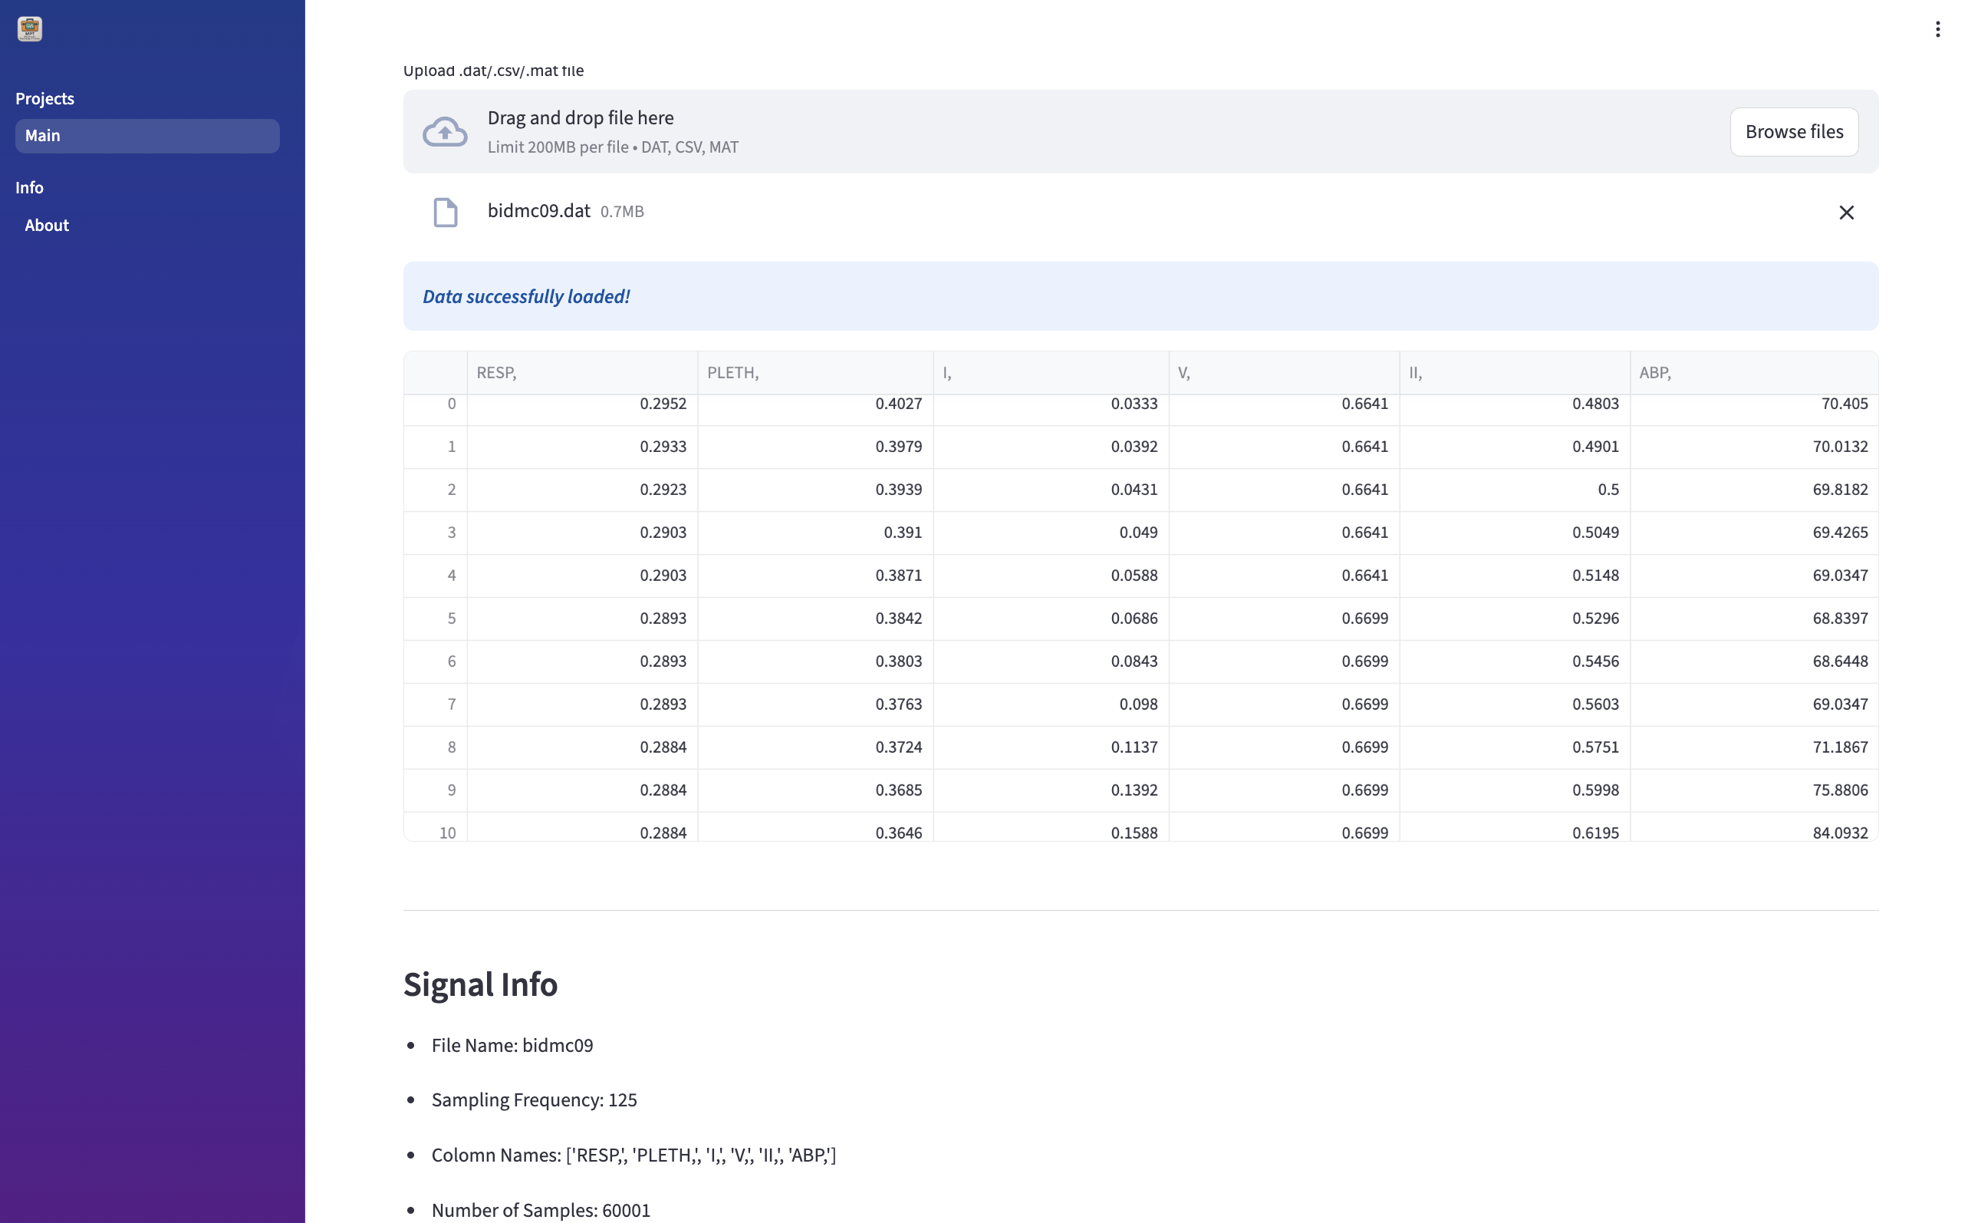

Figure - 2: The interface shows the uploaded file in an interactive way after loading it as an interactive table.

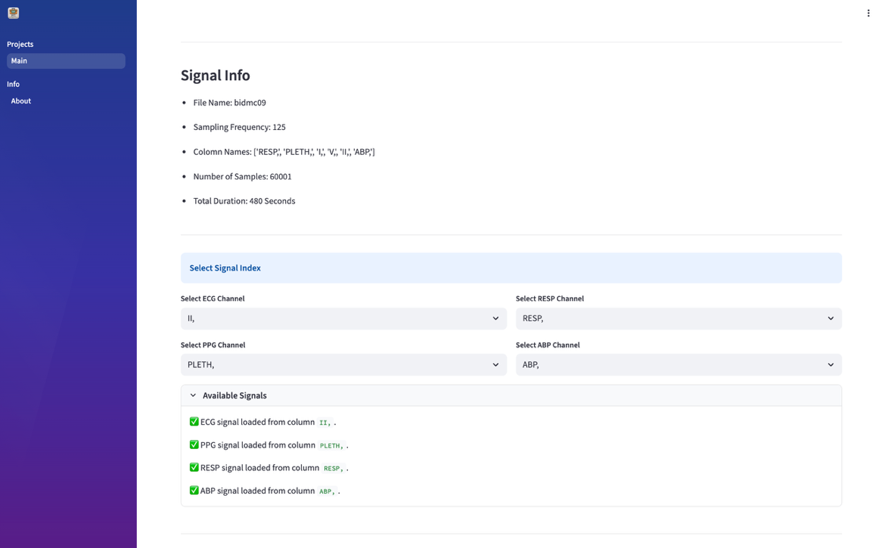

Figure - 3: The MPT web application shows the signal info of the loaded file. The user can select the channel index to identify the ECG, PPG, RESP, and ABP signals. It also shows the signal’s existence information.

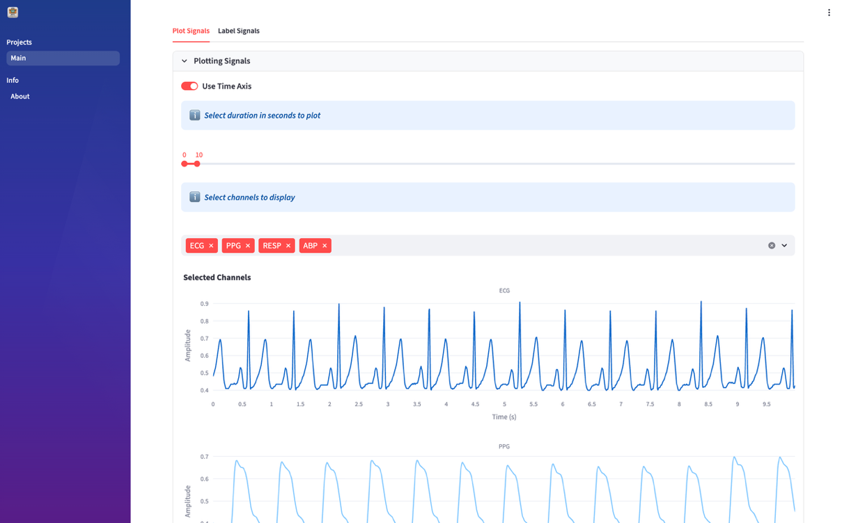

Figure - 4: The user can plot the signals by varying the x-axis value in time (seconds) or sampling points. The user can select a single or multiple signals for the plot.

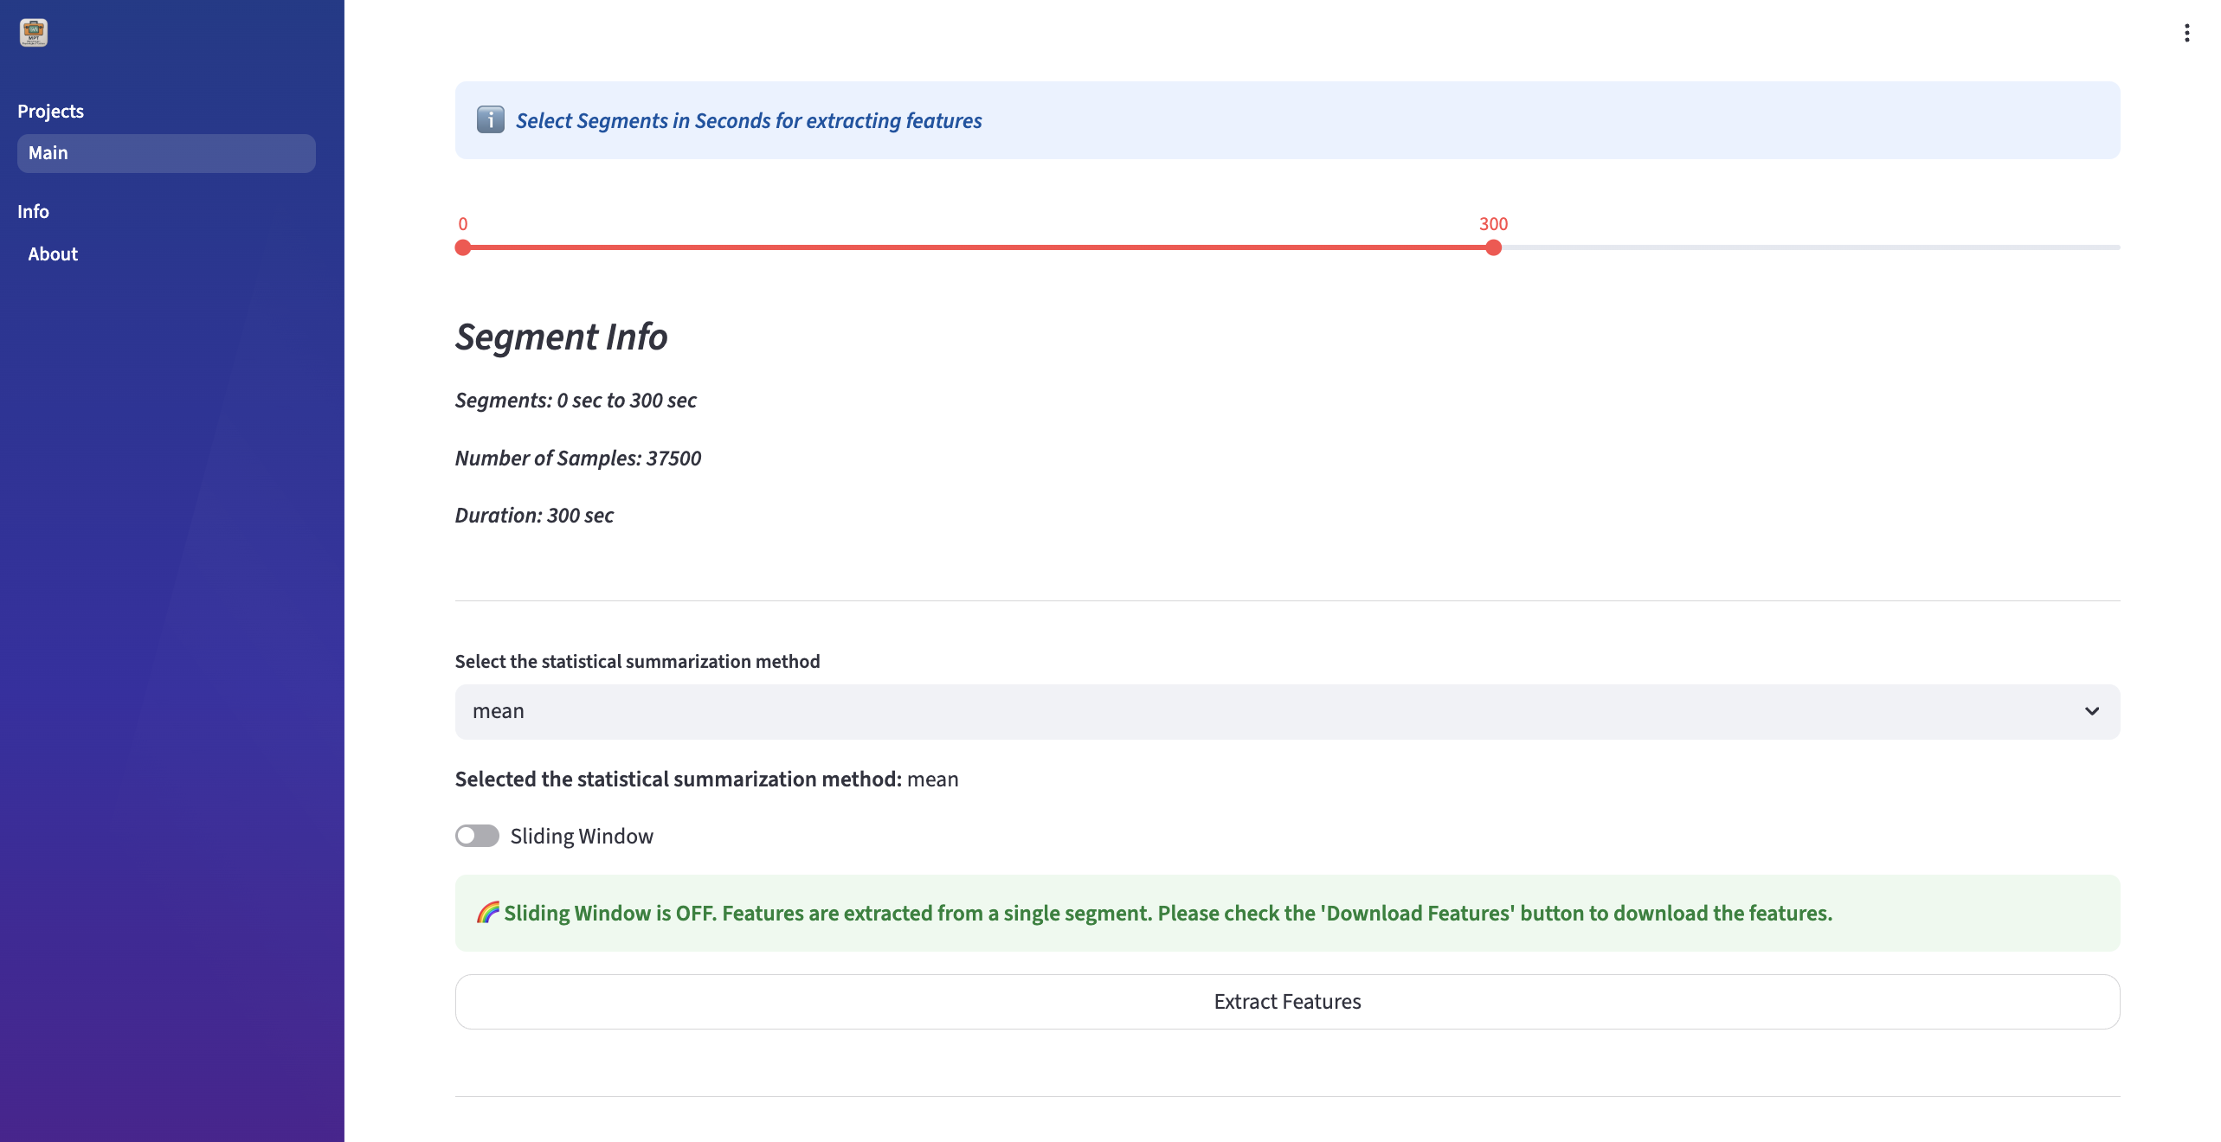

Figure - 5: The user can select the segment in the signal by varying the time in seconds. The user can also see the segment info, including the starting and ending points, number of samples, and duration of the segment. After clicking the ‘Extract features’ button, around 200 physiological features are extracted and displayed in an interactive way.

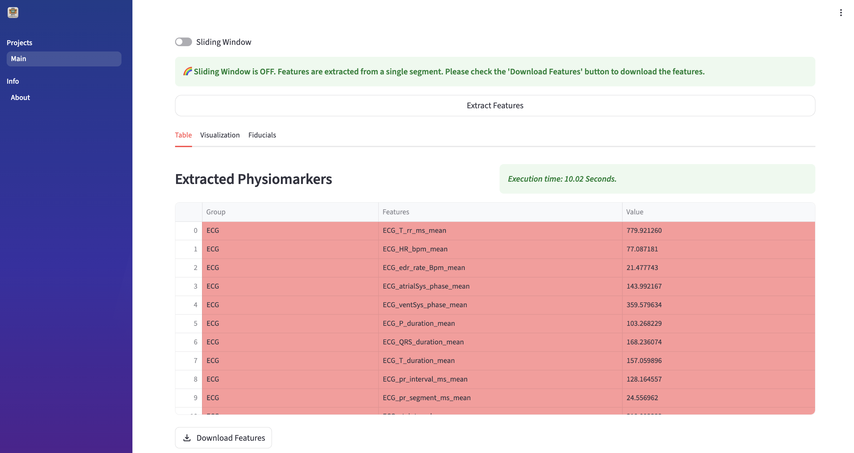

Figure - 6: The user can see the feature table after extracting it. The total execution time is displayed in the MPT web application. The user can also download the extracted features in CSV format.
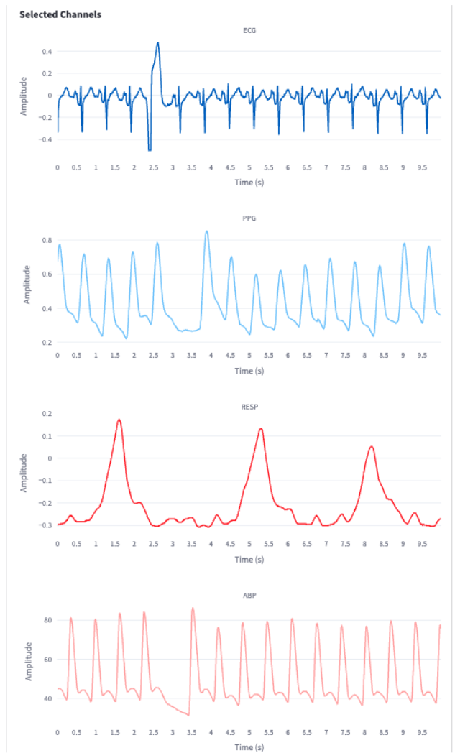

Figure - 7: The selected segment of all the raw waveforms is displayed in the MPT web application.

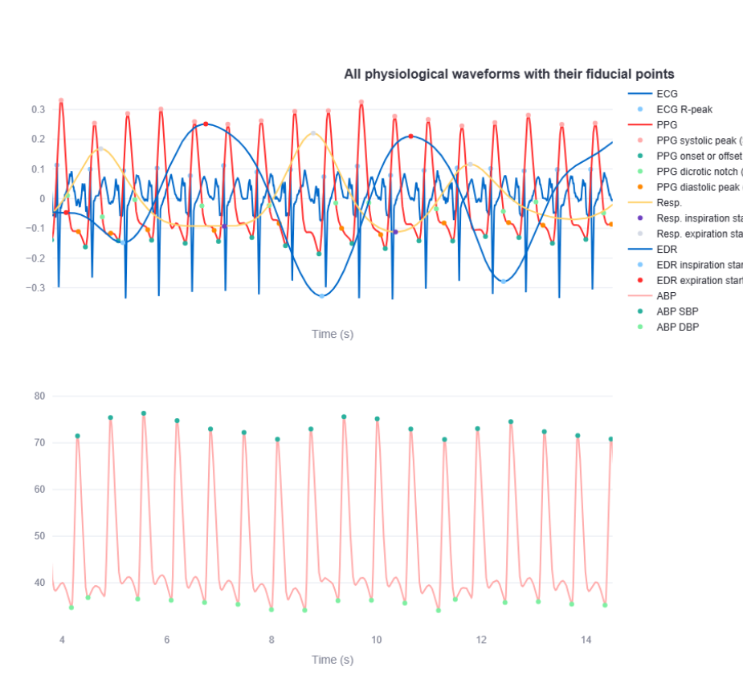

Figure - 8: User-interactive figure panel for signals with detected fiducial points. Due to the rendering issue, the MPT web application uses the maximum 20s segment for visualization. But the user can see all the signals with fiducial points by selecting the segment.

- Feature Visualization:
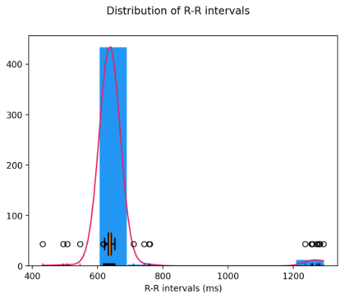
Figure – 9: It represents the distribution of RR intervals (in milliseconds), overlaid with a kernel density estimate for visualization of the underlying probability density.

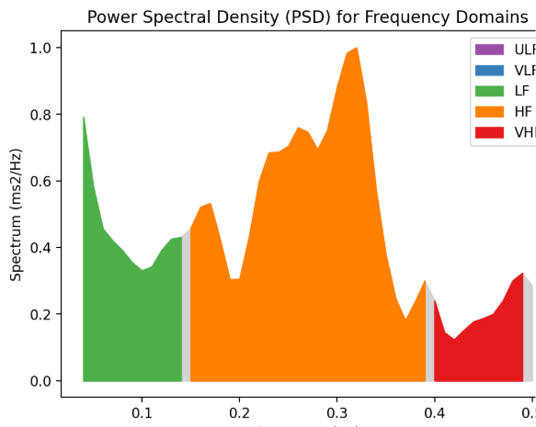
Figure – 10: It displays the power spectral density (PSD) of heart rate variability across frequency bands. It segments into standard frequency domains: Ultra-Low Frequency (ULF), Very Low Frequency (VLF), Low Frequency (LF), High Frequency (HF), and Very High Frequency (VHF). Each frequency band component shows prominent spectral peaks, reflecting autonomic nervous system contributions to heart rate modulation.
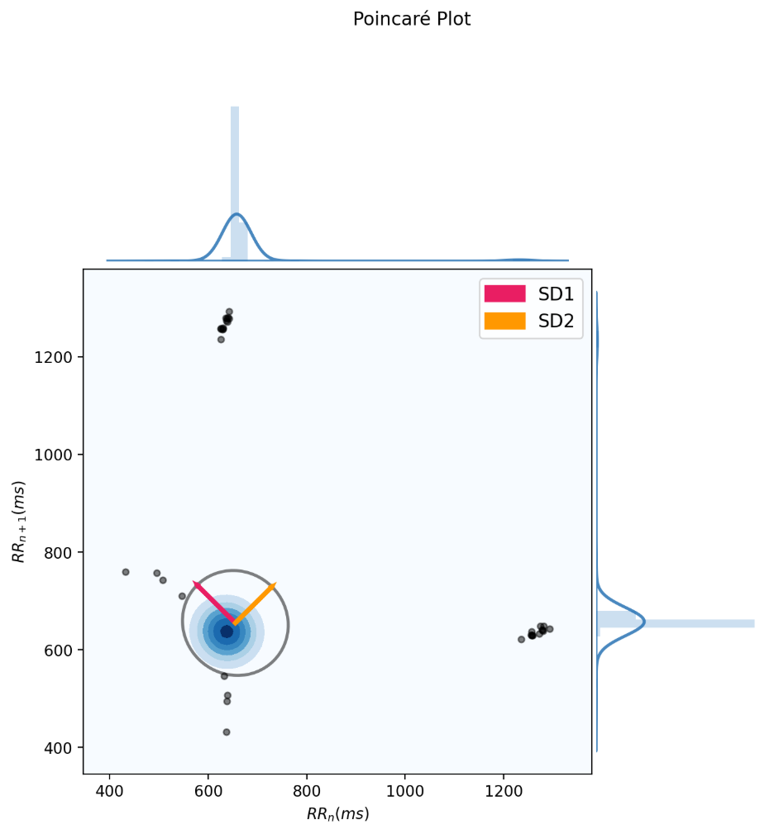
Figure - 11: The Poincaré plot of RR intervals with SD1 and SD2 metrics. It presents a scatter of consecutive RR intervals (RRₙ vs. RRₙ₊₁), providing a nonlinear visualization of heart rate variability (HRV). The central cluster is highlighted with a fitted ellipse, capturing short-term (SD1) and long-term (SD2) variability components. Density contours and marginal histograms further illustrate the distribution of intervals. It reveals beat-to-beat variability and can help identify arrhythmic patterns, autonomic regulation, and signal quality anomalies.
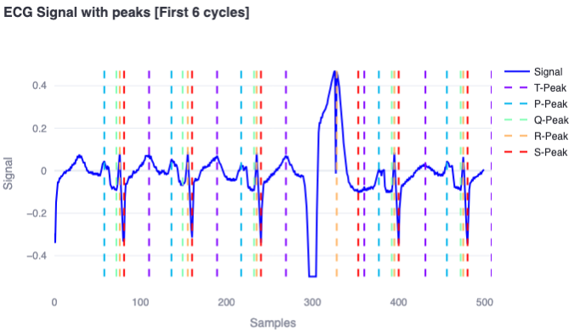
Figure – 12: It represents the cleaned ECG signal with annotated fiducial points (P, Q, R, S, T) extracted from the ECG signal for the first 6 cycles.

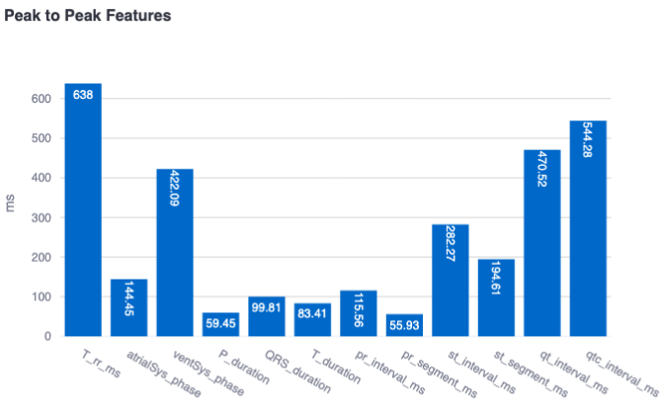
Figure - 13: Peak-to-peak signal feature analysis under variable conditions. It represents the peak-to-peak time domain features (in milliseconds) extracted from the ECG signal

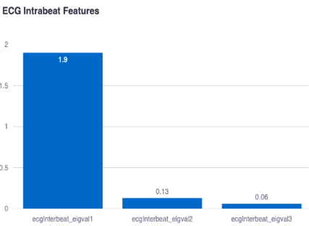 | 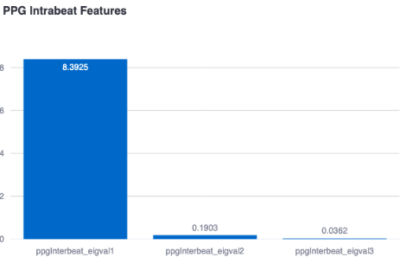

Figure – 14: It represents the morphology of the ECG (Left) and PPG (Right) waveform through the three eigenvalues of the ECG (Left) and PPG (Right) intrabeat. These features are related to the shape of the ECG and PPG waveform, respectively, components that occur within one beat.

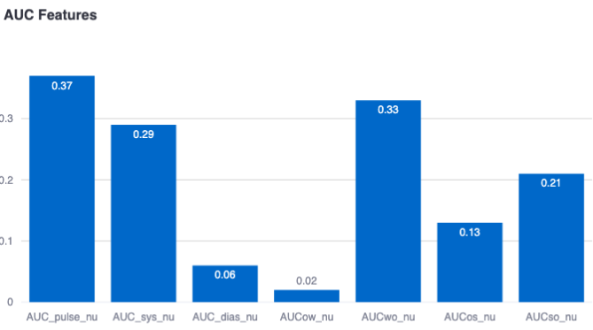

Figure – 15: Illustration of normalized area under the curve (AUC) values for the selected pulsatile region in the PPG waveform.

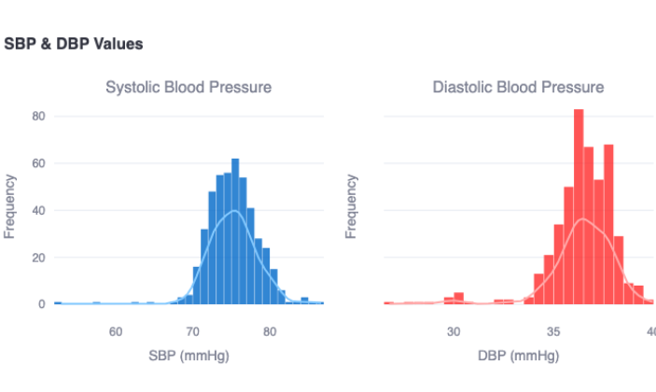
Figure - 16: Represents the systolic blood pressure percentage decline and diastolic blood pressure percentage decline extracted from the atrial blood pressure signals.

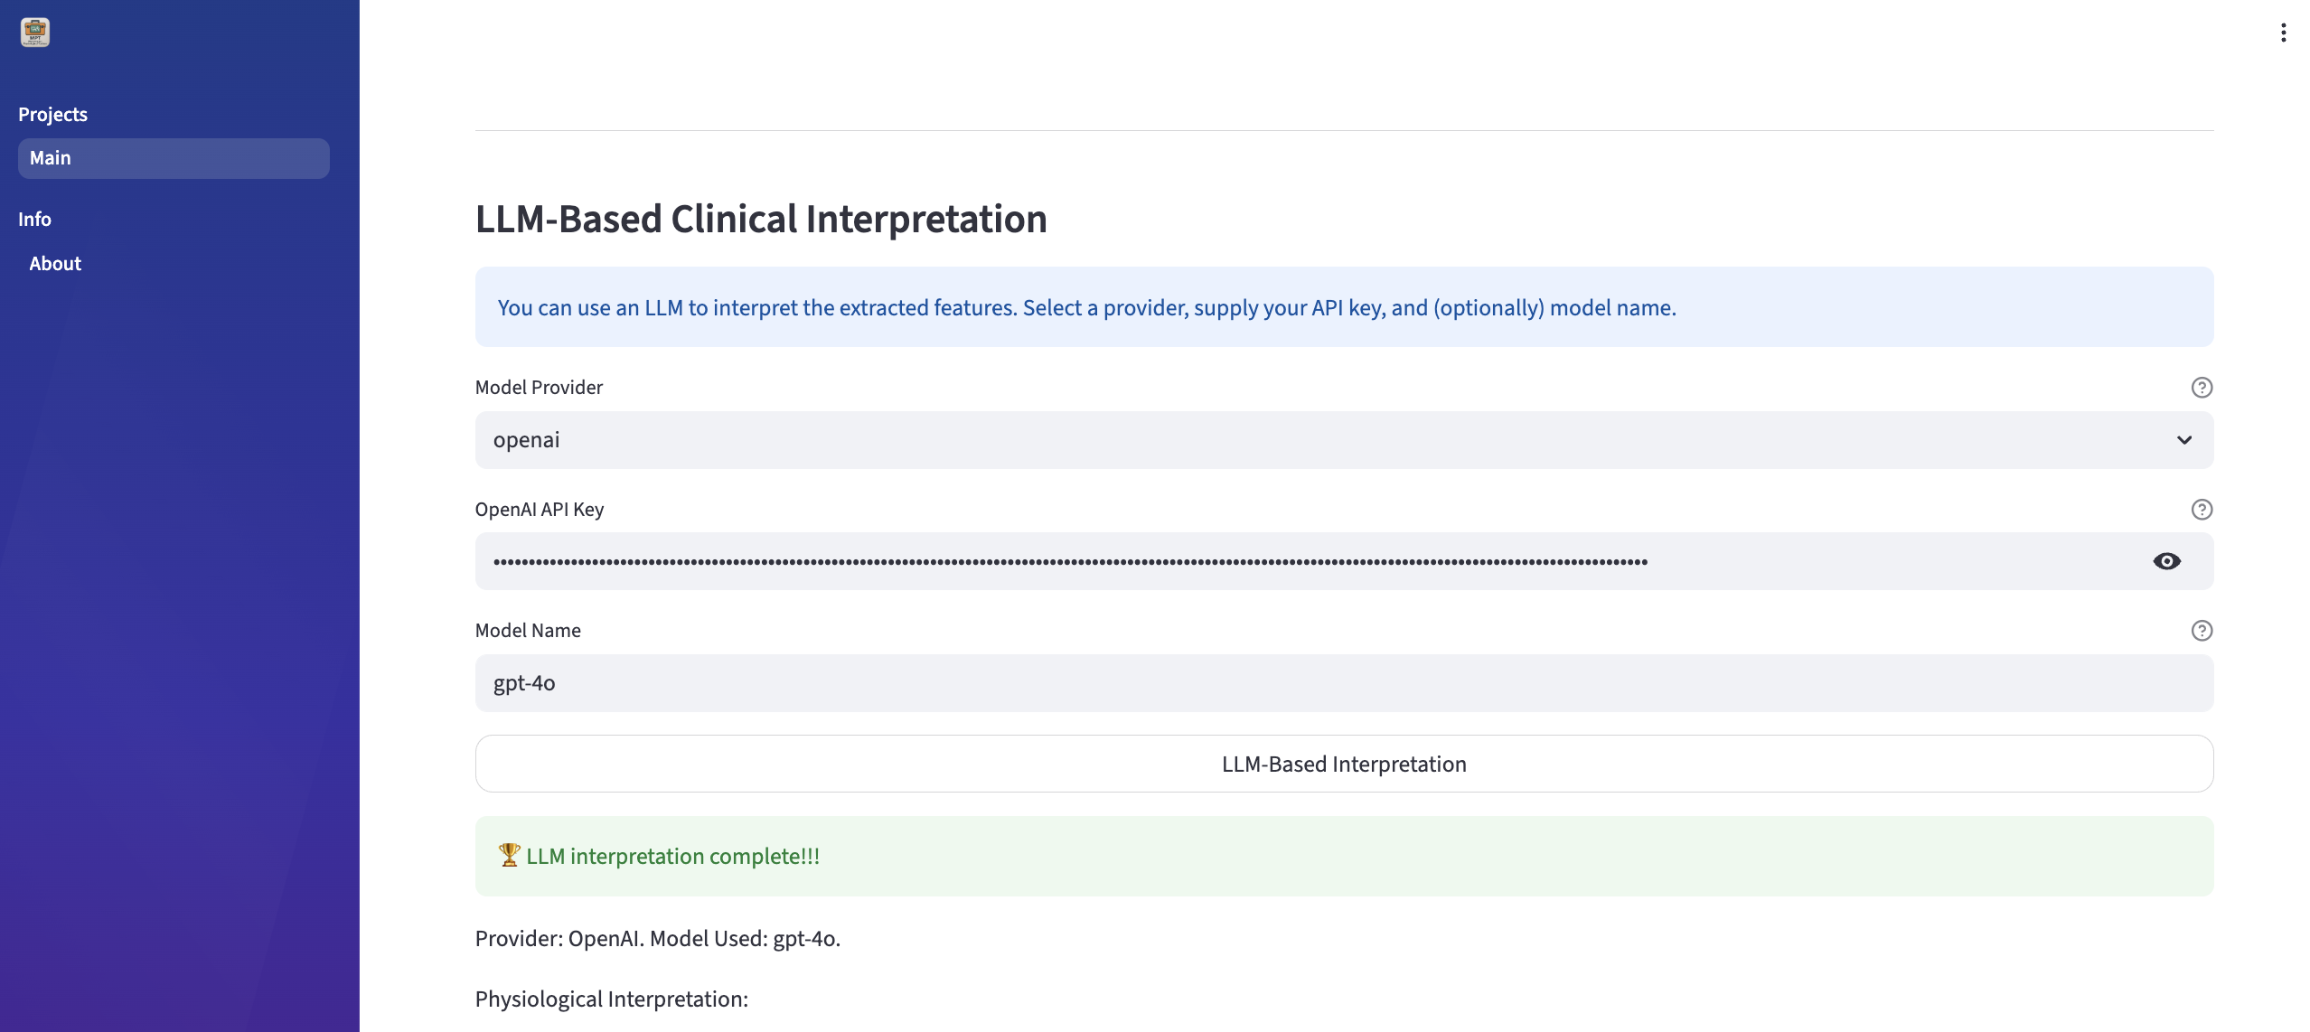

Figure - 17: The MPT offers LLM-based clinical interpretation. The user can select the available LLM models. Users must use the API keys and mention the model name.

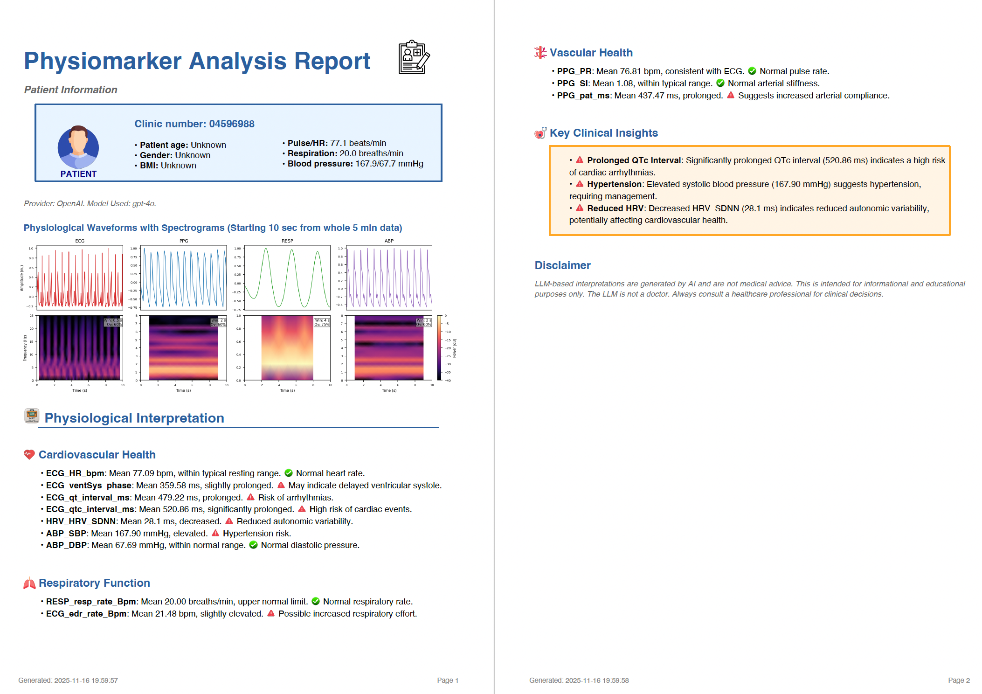

Figure – 18: The MPT webapp generates a medical report based on the LLM feedback that leverages the extracted features. The report typically consists of patient’s vital signs, signal plots with their spectrograms, physiological interpretation narrative texts in three sections, followed by key clinical insights and disclaimer.

Section - 2: Details on Our Physiological Report Validator Pipeline

To evaluate the performance of LLM-generated physiological summary reports, we developed an automated validation framework for assessing the physiomarker accuracy, physiological consistency, and clinical reasoning quality using paired raw ground-truth data and narrative reports. Our validation pipeline comprises two key modules: (A) the Physiomarker Accuracy and Consistency Evaluator, and (B) the LLM-Based Physiological Significance Validator Agent, powered by the GPT-4o model. This pipeline addresses three critical aspects: (1) Physiomarker Correctness, which ensures value accuracy within a tolerance of 0.1 by comparing against ground-truth data; (2) Consistency Rate, which evaluates the stability of physiomarker values using min-max deviation and occurrence consistency through the Jaccard Index or Intersection over Union (IoU) metric; and (3) Physiological Significance Correctness, which assesses the reasoning accuracy of LLM-generated clinical insights across individual sections and overall.

Physiomarker Accuracy: Initially, physiomarkers values from reports were parsed using a custom parser. Then, module A compares extracted values against raw ground-truth data using absolute differences. A tolerance threshold (0.1) was used to classify values as correct or incorrect. Physiomarker accuracy was computed as:
$$\text{Physiomarker Accuracy}=\frac{\text{Number of Correct Values}}{\text{Total Checks}}×100$$
Consistency Evaluation: Module A further assesses consistency across multiple LLM-generated reports for the same patient with two metrics, (i) Physiomarker Occurrence Consistency: Jaccard Index or Intersection-over-Union (IoU) of reported physiomarkers, and (ii) Value Parsing Accuracy Consistency: Variability in parsing accuracy across runs through min-max deviation.
Physiological Reasoning Validation: A structured-prompt guided LLM-based agent was developed to validate clinical reasoning in reports. Input prompt was engineered for the model to provide the reasoning accuracy with detailed rationale and suggested corrections for each bullet line across health sections: Cardiovascular Health, Respiratory Function, Vascular Health, and Key Clinical Insights. Thus, it evaluates correctness for each section and overall, on bullet lines with three scores: 1-correct, 0-incorrect, 0.5-partial correct.
Prompts used for LLM-Based Physiological Significance Validator Agent:

validation_prompt = f"""
You are a clinical validation expert. Using the physiomarker reference context below, evaluate the correctness of each bullet point in the {section_name} section.

PHYSIOMARKER REFERENCE CONTEXT:
{self.meaning_context}

REPORT SECTION TO VALIDATE:
{report_text}

For EACH bullet point in the {section_name} section, evaluate:
1. Is the stated physiomarker value interpretation medically correct based on typical ranges?
2. Is the clinical reasoning/logic sound?
3. Are there any incorrect assumptions or misinterpretations?

Format your response as:
- Bullet Point: [exact text]
- Correctness: [Correct/Partially Correct/Incorrect]
- Rationale: [brief explanation]
- Suggested Correction: [if applicable]

Focus only on the bullet points in the specified section.
"""

Final Metrics: Finally, validation results were aggregated with mean summary statistics, evaluating three major metrics, including overall physiomarker accuracy, consistency score, and LLM-reasoning accuracy.
Validation Results: Our experimental workflow involved the following steps: (1) Collecting 53 BIDMC data records, each with first 5-minute physiological data; (2) Generating physiomarker tables using the median summary statistic method and producing five multiple-run reports for each record using GPT-4o (large model, ~200B parameters) and GPT-4o-mini (smaller model, ~8B parameters); (3) Developing the automated validation pipeline with integrated modules for physiomarker accuracy, consistency evaluation, and LLM-based reasoning validation; (4) Applying the pipeline to evaluate the generated reports; and (5) Analyzing the decisions and rationales provided by the validator agent to critique and refine the evaluations. Final validation results are listed in Supplemental Table 6. The results demonstrate that LLM-generated physiomarker reports under the MPT framework are highly reliable, stable, and reproducible. GPT-4o and GPT-4o-mini both achieve strong value-level accuracy, with GPT-4o providing markedly superior physiological reasoning quality and GPT-4o-mini offering exceptionally high cross-run consistency. Together, these findings confirm that the MPT pipeline can generate clinically coherent, internally consistent, and physiologically meaningful reports, supporting its generalizability and potential clinical applicability across diverse patient records.

Table - 6: Performance results of clinical summary reports generated by two different-sized LLM models on the BIDMC dataset using our proposed automated validation pipeline.

Metric | GPT-4o-mini (~8B) | GPT-4o (~200B)
Total Reports | 265 (53×5) | 265 (53×5)
Total Patients | 53 | 53
(1) Accuracy of Reported Physiomarker Values (%) | 94.83% | 95.38%
(2) Overall Consistency Score (Across Multi-Run Reports) | 0.962 | 0.906
• Physiomarker Occurrence Consistency (IoU criteria) | 0.962 | 0.943
• Value Parsing Accuracy Consistency | 0.981 | 0.943
(3) Overall Accuracy of LLM Physiological Reasoning | 0.779 | 0.849
• Cardiovascular Health Reasoning Accuracy | 0.821 | 0.965
• Respiratory Function Reasoning Accuracy | 0.799 | 0.915
• Vascular Health Reasoning Accuracy | 0.701 | 0.708
• Key Clinical Insights Reasoning Accuracy | 0.796 | 0.810

