Supplementary Table S1. Ingredients and proximate composition of the substrate.
Ingredient | %, DM¹ basis
Ryegrass hay | 76.7
Corn, ground | 3.8
Oats, ground | 3.8
Soybean meal, solvent-extracted, ground | 15.7
DM (%) | 91.9
OM (%DM) | 94.2
CP (%DM) | 14.5
NDF (%DM) | 48.5
ADF (%DM) | 29.4
EE (%DM) | 1.50
¹Abbreviations: ADF = acid detergent fiber; CP = crude protein; DM = dry matter; EE = ether extract; NDF = neutral detergent fiber; OM = organic matter.
Supplementary Table S2. Effect of supplementation with coenzyme M (CoM) at 0 or 1 µM on digestion and fermentation, in serial transfer 5 of mixed serial rumen cultures. Results are presented across the average of four treatments of inhibition of methanogenesis (Control, 2-bromoethanesulfonate, 3-nitrooxypropanol, and bromoform) and coenzyme M spiking treatments (0 or 1 mM) (Experiment 1).
 | CoM 0 | CoM 1 µM | SEM | P =
 |  |  |  | CoM supplementation¹ | CoM supplementation × Methanogenesis inhibition | CoM supplementation  × CoM spiking²
Total gas (mmol) | 4.16 | 4.13 | 0.081 | 0.033 | 0.78 | 0.37
CH₄ (µmol) | 64.8 | 60.5 | 28.5 | 0.64 | 0.93 | 0.85
H₂ (µmol) | 44.4 | 38.7 | 3.69 | 0.37 | 0.96 | 0.94
pH | 6.28 | 6.28 | 0.052 | 0.36 | 0.74 | 0.53
Eh | -102 | -101 | 5.09 | 0.37 | 0.37 | 0.50
DMD (%) | 56.3 | 55.9 | 1.07 | 0.040 | 0.33 | 0.56
Total VFA (mM) | 66.1 | 65.6 | 1.48 | 0.30 | 0.68 | 0.17
Acetate (mM) | 33.6 | 33.5 | 1.15 | 0.71 | 0.98 | 0.44
Propionate (mM) | 24.2 | 24.2 | 0.89 | 0.71 | 0.37 | 0.61
Butyrate (mM) | 5.32 | 5.13 | 0.021 | 0.27 | 0.81 | 0.51
Isobutyrate (mM) | 0.32 | 0.30 | 0.029 | 0.055 | 0.36 | 0.38
2- and 3-methylbutyrate (mM) | 0.46 | 0.43 | 0.071 | 0.091 | 0.66 | 0.52
Valerate (mM) | 1.41 | 1.38 | 0.44 | 0.76 | >0.99 | 0.70
Caproate (mM) | 0.47 | 0.46 | 0.30 | 0.86 | 0.97 | 0.77
Heptanoate (mM) | 0.29 | 0.28 | 0.22 | 0.93 | 0.99 | 0.82
Acetate to propionate (mM/mM) | 1.40 | 1.40 | 0.074 | 0.88 | 0.87 | 0.80
Succinate (mM) | 0.35 | 0.35 | 0.14 | 0.65 | 0.77 | 0.44
Methanol (µM) | 0.19 | 0.15 | 0.035 | 0.50 | 0.83 | 0.26
Ethanol (mM) | 11.0 | 11.3 | 1.85 | 0.60 | 0.88 | 0.82
NH₄⁺ (mM) | 19.9 | 19.7 | 1.13 | 0.071 | 0.69 | 0.61
¹0 or 1 µM in serial transfers 1 to 4; ²1 mM in serial transfer 5.

Supplementary Table S3. Effects of inhibiting methanogenesis with 5 µM 2-bromoethanesulfonate (BES) and its interactions with 1000 µM coenzyme M (CoM) or methyl-coenzyme M (methyl-CoM) on archaeal diversity indices.
Inhibition of methanogenesis | Control |  |  | BES |  |  | SEM | P =
CoM (µM) | 0 | 1000 | 0 | 0 | 1000 | 0 | SEM | BES | CoM/ methyl-CoM | BES × CoM/ methyl-CoM | Contrast 1 ¹ | Contrast 2 ²
Methyl-CoM (µM) | 0 | 0 | 1000 | 0 | 0 | 1000
Richness | 39.5 | 39.5 | 39 | 36.3 | 40 | 40 | 3.58 | 0.62 | 0.57 | 0.50 | -³ | -
Shannon | 2.84 | 2.90 | 2.81 | 2.60 | 2.73 | 2.87 | 0.12 | 0.29 | 0.64 | 0.52 | - | -
Simpson | 0.90 | 0.91 | 0.90 | 0.87 | 0.89 | 0.91 | 0.019 | 0.29 | 0.64 | 0.51 | - | -
Fisher | 4.17 | 4.17 | 4.11 | 3.78 | 4.23 | 4.17 | 0.42 | 0.62 | 0.56 | 0.49 | - | -
Shannon.eveness | 0.77 | 0.79 | 0.77 | 0.73 | 0.74 | 0.78 | 0.026 | 0.24 | 0.67 | 0.49 | - | -
¹Interaction between BES and CoM; ²Interaction between BES and methyl-CoM; ³Not conducted as interaction P ≥ 0.10.

Supplementary Table S4. Effects of inhibiting methanogenesis with 5 µM 2-bromoethanesulfonate (BES) and its interactions with 1000 µM coenzyme M (CoM) or methyl-coenzyme M (methyl-CoM) on the bacterial community composition and diversity indices at the phyla level.
Inhibition of methanogenesis | Control |  |  | BES |  |  | SEM | P =
CoM (µM) | 0 | 1000 | 0 | 0 | 1000 | 0 | SEM | BES | CoM/ methyl-CoM | BES × CoM/ methyl-CoM | Contrast 1 (CoM)¹ | Contrast 2 × (methyl-CoM)²
Methyl-CoM (µM) | 0 | 0 | 1000 | 0 | 0 | 1000
%total bacterial 16S rRNA gene
Actinobacteriota | 9.69 | 12.2 | 8.02 | 5.20 | 4.38 | 4.92 | 4.76 | 0.033 | 0.80 | 0.67 | -³ | -
Bacteroidota | 17.9 | 18.6 | 13.7 | 23.9 | 19.1 | 16.7 | 4.02 | 0.16 | 0.12 | 0.59 | - | -
Desulfobacterota | 3.35 | 2.57 | 4.06 | 1.86 | 4.40 | 4.35 | 1.09 | 0.82 | 0.38 | 0.35 | - | -
Fibrobacterota | 2.94 | 3.12 | 6.75 | 3.59 | 2.60 | 3.91 | 2.38 | 0.65 | 0.55 | 0.76 | - | -
Bacillota | 62.1 | 59.9 | 64.6 | 62.0 | 64.5 | 65.7 | 7.34 | 0.44 | 0.49 | 0.70 | - | -
Panctomycetota | 1.40 | 1.03 | 1.17 | 2.01 | 0.31 | 0.28 | 0.85 | 0.45 | 0.11 | 0.32 | - | -
Spirochaetota | 0.16^{b} | 0.46ª | ND⁵ | 0.10^{b} | 0.55ª | ND | 0.24 | 0.95 | 0.071 | 0.94 | - | -
Verrucomicrobiota | 2.03 | 1.53 | 1.32 | 0.91 | 3.28 | 3.64 | 0.73 | 0.15 | 0.39 | 0.10 | - | -
¹Interaction between BES and CoM; ²Interaction between BES and methyl-CoM; ³Not conducted as interaction P ≥ 0.10; ⁴Different superscripts indicate: a significant (A, B; P < 0.05) effect of CoM or a tendency (a, b; 0.05 ≤ P < 0.10); a significant (X, Y; P < 0.05) effect of methyl-CoM or a tendency (x, y; 0.05 ≤ P < 0.10).⁵ND = not detected.
Supplementary Table S5. Effects of inhibiting methanogenesis with 5 µM 2-bromoethanesulfonate (BES) and its interactions with 1000 µM coenzyme M (CoM) or methyl-coenzyme M (methyl-CoM) on the bacterial community composition and diversity indices at the genera level.
Inhibition of methanogenesis | Control |  |  | BES |  |  | SEM | P =
CoM (µM) | 0 | 1000 | 0 | 0 | 1000 | 0 | SEM | BES | CoM/ methyl-CoM | BES × CoM/ methyl-CoM | Contrast 1 (CoM)¹ | Contrast 2 × (methyl-CoM)²
Methyl-CoM (µM) | 0 | 0 | 1000 | 0 | 0 | 1000
%total bacterial 16S rRNA gene
Phylum Actinobacteriota
Corynebacterium | 0.47 | 0.56 | 0.14 | 0.18 | 0.46 | 0.50 | 0.46 | 0.95 | 0.69 | 0.41 | -³ | -
Olsenella | 10.5 | 13.5 | 8.88 | 5.93 | 3.93 | 5.38 | 6.22 | 0.029 | 0.87 | 0.57 | - | -
Phylum Bacteroidota
Prevotella | 6.14 | 3.98 | 5.83 | 4.21 | 5.51 | 2.97 | 2.49 | 0.42 | 0.90 | 0.39 | - | -
Prevotellaceae NK3B31 group | 0.22 | 0.33 | 0.29 | 0.75 | 0.60 | 0.25 | 0.28 | 0.18 | 0.58 | 0.46 | - | -
Prevotellaceae UCG-001 | 0.66 | 1.48 | 1.15 | 1.71 | 1.34 | 1.84 | 0.67 | 0.35 | 0.89 | 0.66 | - | -
Rikenellaceae RC9 group | 5.91 | 6.11 | 3.67 | 7.81 | 7.44 | 6.05 | 2.18 | 0.050 | 0.14 | 0.89 | - | -
Phylum Desulfobacterota
Desulfovibrio | 3.79 | 3.62 | 4.79 | 1.75 | 4.57 | 5.23 | 1.22 | 0.92 | 0.27 | 0.35 | - | -
Phylum Fibrobacterota
Fibrobacter | 3.81 | 3.81 | 8.32 | 4.28 | 3.22 | 4.77 | 2.93 | 0.62 | 0.56 | 0.78 | - | -
Phylum Bacillota
Bacillus | 1.26 | 0.25 | 1.69 | 4.32 | 5.87 | 0.90 | 2.61 | 0.21 | 0.75 | 0.45 | - | -
Christensenellaceae R-7 group | 7.66 | 7.41 | 6.26 | 6.36 | 9.58 | 5.70 | 2.26 | 0.95 | 0.47 | 0.67 | - | -
[Eubacterium] halli group | 0.32^{B 4} | 0.85^{A} | 0.16 | 0.52^{B} | 1.28^{A} | 0.27 | 0.25 | 0.30 | 0.024 | 0.83 | - | -
[Ruminococcus] gauvreauii group | 0.54 | 0.30 | 0.13 | 0.71 | 0.15 | 2.43 | 1.18 | 0.33 | 0.54 | 0.39 | - | -
Acetitomaculum | 11.0 | 11.3 | 12.3 | 11.8 | 13.3 | 11.1 | 4.89 | 0.85 | 0.96 | 0.87 | - | -
Butyrivibrio | 1.99 | 2.62 | 2.53 | 1.19 | 1.27 | 1.04 | 0.59 | 0.007 | 0.77 | 0.76 | - | -
Lachnospiraceae AC2044 group | 0.20 | ND⁵ | 0.84 | 0.32 | ND | 0.061 | 0.23 | 0.27 | 0.19 | 0.15 | - | -
Lachnospiraceae NK3A20 group | 13.8 | 15.7 | 14.4 | 18.0 | 14.2 | 15.6 | 3.12 | 0.50 | 0.91 | 0.47 | - | -
Lachnospiraceae UCG-008 group | 0.86 | 0.19 | 0.14 | 0.17 | 0.34 | 0.31 | 0.16 | 0.40 | 0.21 | 0.041 | 0.028 | 0.26
Lachnospiraceae UCG-009 group | 0.20 | ND | 0.84 | 0.84 | ND | 0.047 | 0.39 | 0.88 | 0.44 | 0.27 | - | -
Lachnospiraceae XPB1014 group | 0.35 | 0.091 | 0.59 | ND | 0.25 | 0.64 | 0.35 | 0.87 | 0.43 | 0.79 | - | -
Probable genus 10 | 0.29 | 0.33 | 0.76 | 1.30 | 0.21 | ND | 0.39 | 0.91 | 0.45 | 0.14 | - | -
Pseudobutyrivibrio | 1.43 | 0.56 | 0.20 | 0.56 | 0.40 | 0.27 | 0.28 | 0.22 | 0.061 | 0.30 | - | -
NK4A214 group | 6.71 | 6.54 | 6.39 | 7.40 | 6.75 | 11.3 | 1.29 | 0.11 | 0.28 | 0.21 | - | -
Papillibacter | 5.88 | 6.29 | 5.08 | 2.64 | 5.01 | 7.29 | 1.23 | 0.37 | 0.19 | 0.052 | 0.36 | 0.018
UCG-005 | 1.82 | 2.06 | 1.96 | 0.56 | 2.07 | 1.40 | 0.78 | 0.28 | 0.43 | 0.63 | - | -
Ruminococcus | 1.56^{aX} | 1.01^{b} | 1.04^{Y} | 2.33^{aX} | 1.04^{b} | 0.11^{Y} | 0.89 | 0.92 | 0.029 | 0.22 | - | -
UCG-001 | ND | 0.25 | 0.59 | ND | 0.14 | ND | 0.22 | 0.14 | 0.30 | 0.27 | - | -
Family XIII AD3011 group | 0.53 | 0.62 | 0.72 | 1.22 | 0.51 | 1.03 | 0.53 | 0.49 | 0.79 | 0.75 | - | -
Succiniclasticum | 5.32 | 2.96 | 4.13 | 4.15 | 2.63 | 6.15 | 2.11 | 0.88 | 0.32 | 0.61 | - | -
Selenomonas | 0.84 | 1.80 | 0.73 | 0.79 | 0.72 | 0.85 | 0.69 | 0.44 | 0.61 | 0.48 | - | -
Veinolleaeae UCG-001 | 0.77 | 0.51 | 0.33 | 1.19 | 1.02 | 0.58 | 0.51 | 0.21 | 0.39 | 0.94 | - | -
Phylum Planctomycetota
p-1088-a5 gut group | 1.35 | 1.04 | 1.17 | 2.28 | 0.37 | 0.27 | 0.87 | 0.68 | 0.16 | 0.30 | - | -
Phylum Spirochaetota
Treponema | 0.21 | 0.48 | ND | 0.11 | 0.54 | ND | 0.28 | 0.94 | 0.074 | 0.94 | - | -
Phylum Verrucomicrobiota
Horsej-a03 | 0.20^{Y} | 0.22 | 0.37^{X} | ND^{X} | 0.44 | 1.71^{Y} | 0.49 | 0.19 | 0.087 | 0.18 | - | -
¹Interaction between BES and CoM; ²Interaction between BES and methyl-CoM; ³Not conducted as interaction P ≥ 0.10; ⁴Different superscripts indicate: a significant (A, B; P < 0.05) effect of CoM or a tendency (a, b; 0.05 ≤ P < 0.10); a significant (X, Y; P < 0.05) effect of methyl-CoM or a tendency (x, y; 0.05 ≤ P < 0.10).
Supplementary Table S6. Effects of inhibiting methanogenesis with 5 µM 2-bromoethanesulfonate (BES) and its interactions with 1000 µM coenzyme M (CoM) or methyl-coenzyme M (methyl-CoM) on bacterial diversity indices.
Inhibition of methanogenesis | Control |  |  | BES |  |  | SEM | P =
CoM (µM) | 0 | 1000 | 0 | 0 | 1000 | 0 | SEM | BES | CoM/ methyl-CoM | BES × CoM/ methyl-CoM | Contrast 1 (CoM)¹ | Contrast 2 × (methyl-CoM)²
Richness | 130 | 170 | 120 | 148 | 168 | 147 | 44.9 | 0.60 | 0.55 | 0.91 | -³ | -
Shannon | 4.80 | 4.91 | 4.66 | 4.88 | 5.00 | 4.73 | 0.28 | 0.64 | 0.46 | >0.99 | - | -
Simpson | 0.99 | 0.99 | 0.99 | 0.99 | 0.99 | 0.99 | 0.0023 | 0.66 | 0.36 | 0.94 | - | -
Fisher | 21.3 | 30.5 | 19.5 | 25.3 | 29.2 | 26.4 | 9.37 | 0.60 | 0.57 | 0.85 | - | -
Shannon.eveness | 0.99 | 0.99 | 0.99 | 0.99 | 0.98 | 0.99 | 0.0045 | 0.37 | 0.45 | 0.51 | - | -
¹Interaction between BES and CoM; ²Interaction between BES and methyl-CoM; ³Not conducted as interaction P ≥ 0.10.

Supplementary Figure S1. Evolution of total gas production in serial transfers 1 – 4 of mixed serial rumen cultures supplemented with 0 or 1 µM coenzyme M (CoM). CoM supplementation 1 µM, P = 0.62; serial transfer, P < 0.001; CoM supplementation 1 µM × serial transfer, P = 0.84 (Experiment 1).

Supplementary Figure S2. Evolution of methane (CH₄) production in serial transfers 1 – 4 of mixed serial rumen cultures supplemented with 0 or 1 µM coenzyme M (CoM). coenzyme M (CoM). CoM supplementation 1 µM, P = 0.52; serial transfer, P < 0.001; CoM supplementation 1 µM × serial transfer, P = 0.93 (Experiment 1).

Supplementary Figure S3. Evolution of Eh in serial transfers 1 – 4 of mixed serial rumen cultures supplemented with 0 or 1 µM coenzyme M (CoM). coenzyme M (CoM). CoM supplementation 1 µM, P = 0.41; serial transfer, P < 0.001; CoM supplementation 1 µM × serial transfer, P = 0.61 (Experiment 1).

Supplementary Figure S4. Effects of 2-bromoethanesulfonate (BES) at 5 µM, coenzyme M (CoM; (A)), and methyl-coenzyme M (methyl-CoM; (B)) on total gas production of mixed rumen batch cultures: BES, P < 0.001; CoM, P < 0.001; methyl-CoM, P < 0.001; BES × CoM, P = 0.016; BES × methyl-CoM, P < 0.001; cow (random), P = 0.48; incubation (random), P = 0.014. Concentration of CoM and methyl-CoM was added unity and log-transformed for the statistical analysis (Experiment 3).

Supplementary Figure S5. Effects of 2-bromoethanesulfonate (BES) at 5 µM, coenzyme M (CoM; (A)), and methyl-coenzyme M (methyl-CoM; (B)) on the acetate to propionate molar ratio of mixed rumen batch cultures: BES, P < 0.001; CoM, P < 0.001; methyl-CoM, P < 0.001; BES × CoM, P < 0.001; BES × methyl-CoM, P < 0.001; cow (random), P = 0.48; incubation (random), P = 0.49. Concentration of CoM and methyl-CoM was added unity and log-transformed for the statistical analysis (Experiment 3).

Supplementary Figure S6. Effects of 2-bromoethanesulfonate (BES) at 5 µM, coenzyme M (CoM; (A)), and methyl-coenzyme M (methyl-CoM; (B)) on 2- and 3-methylbutyrate concentration of mixed rumen batch cultures: BES, P < 0.001; CoM, P = 0.028; methyl-CoM, P = 0.003; BES × CoM, P = 0.022; BES × methyl-CoM, P = 0.15; cow (random), P = 0.48; incubation (random), P = 0.52. Concentration of CoM and methyl-CoM was added unity and log-transformed for the statistical analysis (Experiment 3).

Supplementary Figure S7. Effects of 2-bromoethanesulfonate (BES) at 5 µM, coenzyme M (CoM; (A)), and methyl-coenzyme M (methyl-CoM; (B)) on succinate concentration of mixed rumen batch cultures: BES, P < 0.001; CoM, P = 0.002; methyl-CoM, P < 0.001; BES × CoM, P = 0.001; BES × methyl-CoM, P = 0.001; cow (random), P = 0.48; incubation (random), P = 0.61. Concentration of CoM and methyl-CoM was added unity and log-transformed for the statistical analysis (Experiment 3).

Supplementary Figure S8. Effects of 2-bromoethanesulfonate (BES) at 5 µM, coenzyme M (CoM; (A)), and methyl-coenzyme M (methyl-CoM; (B)) on ammonium (NH₄⁺) concentration of mixed rumen batch cultures: BES, P < 0.001; CoM, P = 0.004; methyl-CoM, P < 0.001; BES × CoM, P = 0.025; BES × methyl-CoM, P = 0.001; cow (random), P = 0.48; incubation (random), P = 0.49. Concentration of CoM and methyl-CoM was added unity and log-transformed for the statistical analysis (Experiment 3).

Supplementary Figure S9. Effects of 2-bromoethanesulfonate (BES) at 5 µM, coenzyme M (CoM; (A)), and methyl-coenzyme M (methyl-CoM; (B)) on total volatile fatty acids (VFA) concentration of mixed rumen batch cultures: BES, P = 0.036; CoM, P = 0.83; methyl-CoM, P = 0.23; BES × CoM, P = 0.86; BES × methyl-CoM, P = 0.21; cow (random), P ≤ 0.001; incubation (random), P = 0.50. Concentration of CoM and methyl-CoM was added unity and log-transformed for the statistical analysis (Experiment 3).

Supplementary Figure S10. Effects of 2-bromoethanesulfonate (BES) at 5 µM, coenzyme M (CoM; (A)), and methyl-coenzyme M (methyl-CoM; (B)) on isobutyrate concentration of mixed rumen batch cultures: BES, P < 0.001; CoM, P = 0.30; methyl-CoM, P = 0.066; BES × CoM, P = 0.43; BES × methyl-CoM, P = 0.23; cow (random), P = 0.48; incubation (random), P = 0.67. Concentration of CoM and methyl-CoM was added unity and log-transformed for the statistical analysis (Experiment 3).

Supplementary Figure S11. Effects of 2-bromoethanesulfonate (BES) at 5 µM, coenzyme M (CoM; (A)), and methyl-coenzyme M (methyl-CoM; (B)) on acetate concentration of mixed rumen batch cultures: BES, P < 0.001; CoM, P = 0.19; methyl-CoM, P = 0.021; BES × CoM, P = 0.23; BES × methyl-CoM, P = 0.010; cow (random), P = 0.49; incubation (random), P = 0.58. Concentration of CoM and methyl-CoM was added unity and log-transformed for the statistical analysis (Experiment 3).

Supplementary Figure S12. Effects of 2-bromoethanesulfonate (BES) at 5 µM, coenzyme M (CoM; (A)), and methyl-coenzyme M (methyl-CoM; (B)) on propionate concentration of mixed rumen batch cultures: BES, P = 0.30; CoM, P = 0.056; methyl-CoM, P = 0.30; BES × CoM, P = 0.062; BES × methyl-CoM, P = 0.22; cow (random), P = 0.51; incubation (random), P = 0.53. Concentration of CoM and methyl-CoM was added unity and log-transformed for the statistical analysis (Experiment 3).

Supplementary Figure S13. Effects of 2-bromoethanesulfonate (BES) at 5 µM, coenzyme M (CoM; (A)), and methyl-coenzyme M (methyl-CoM; (B)) on valerate concentration of mixed rumen batch cultures: BES, P = 0.16; CoM, P = 0.073; methyl-CoM, P = 0.25; BES × CoM, P = 0.095; BES × methyl-CoM, P = 0.079; cow (random), P = 0.51; incubation (random), P = 0.53. Concentration of CoM and methyl-CoM was added unity and log-transformed for the statistical analysis (Experiment 3).

Supplementary Figure S14. Effects of 2-bromoethanesulfonate (BES) at 5 µM, coenzyme M (CoM; (A)), and methyl-coenzyme M (methyl-CoM; (B)) on caproate concentration of mixed rumen batch cultures: BES, P < 0.001; CoM, P = 0.024; methyl-CoM, P = 0.053; BES × CoM, P = 0.020; BES × methyl-CoM, P = 0.025; cow (random), P = 0.13; incubation (random), P = 0.52. Concentration of CoM and methyl-CoM was added unity and log-transformed for the statistical analysis (Experiment 3).

Supplementary Figure S15. Effects of 2-bromoethanesulfonate (BES) at 5 µM, coenzyme M (CoM; (A)), and methyl-coenzyme M (methyl-CoM; (B)) on heptanoate concentration of mixed rumen batch cultures: BES, P < 0.001; CoM, P = 0.013; methyl-CoM, P = 0.042; BES × CoM, P = 0.039; BES × methyl-CoM, P = 0.065; cow (random), P = 0.56; incubation (random), P = 0.49. Concentration of CoM and methyl-CoM was added unity and log-transformed for the statistical analysis (Experiment 3).

Supplementary Figure S16. Effects of 2-bromoethanesulfonate (BES) at 5 µM, coenzyme M (CoM; (A)), and methyl-coenzyme M (methyl-CoM; (B)) on pH of mixed rumen batch cultures: BES, P = 0.44; CoM, P = 0.53; methyl-CoM, P = 0.35; BES × CoM, P = 0.055; BES × methyl-CoM, P = 0.027; cow (random), P = 0.49; incubation (random), P = 0.49. Concentration of CoM and methyl-CoM was added unity and log-transformed for the statistical analysis (Experiment 3).

Supplementary Figure S17. Effects of 2-bromoethanesulfonate (BES) at 5 µM, coenzyme M (CoM; (A)), and methyl-coenzyme M (methyl-CoM; (B)) on Eh of mixed rumen batch cultures: BES, P = 0.071; CoM, P = 0.37; methyl-CoM, P = 0.017; BES × CoM, P = 0.78; BES × methyl-CoM, P = 0.25; cow (random), P = 0.50; incubation (random), P = 0.60. Concentration of CoM and methyl-CoM was added unity and log-transformed for the statistical analysis (Experiment 3).

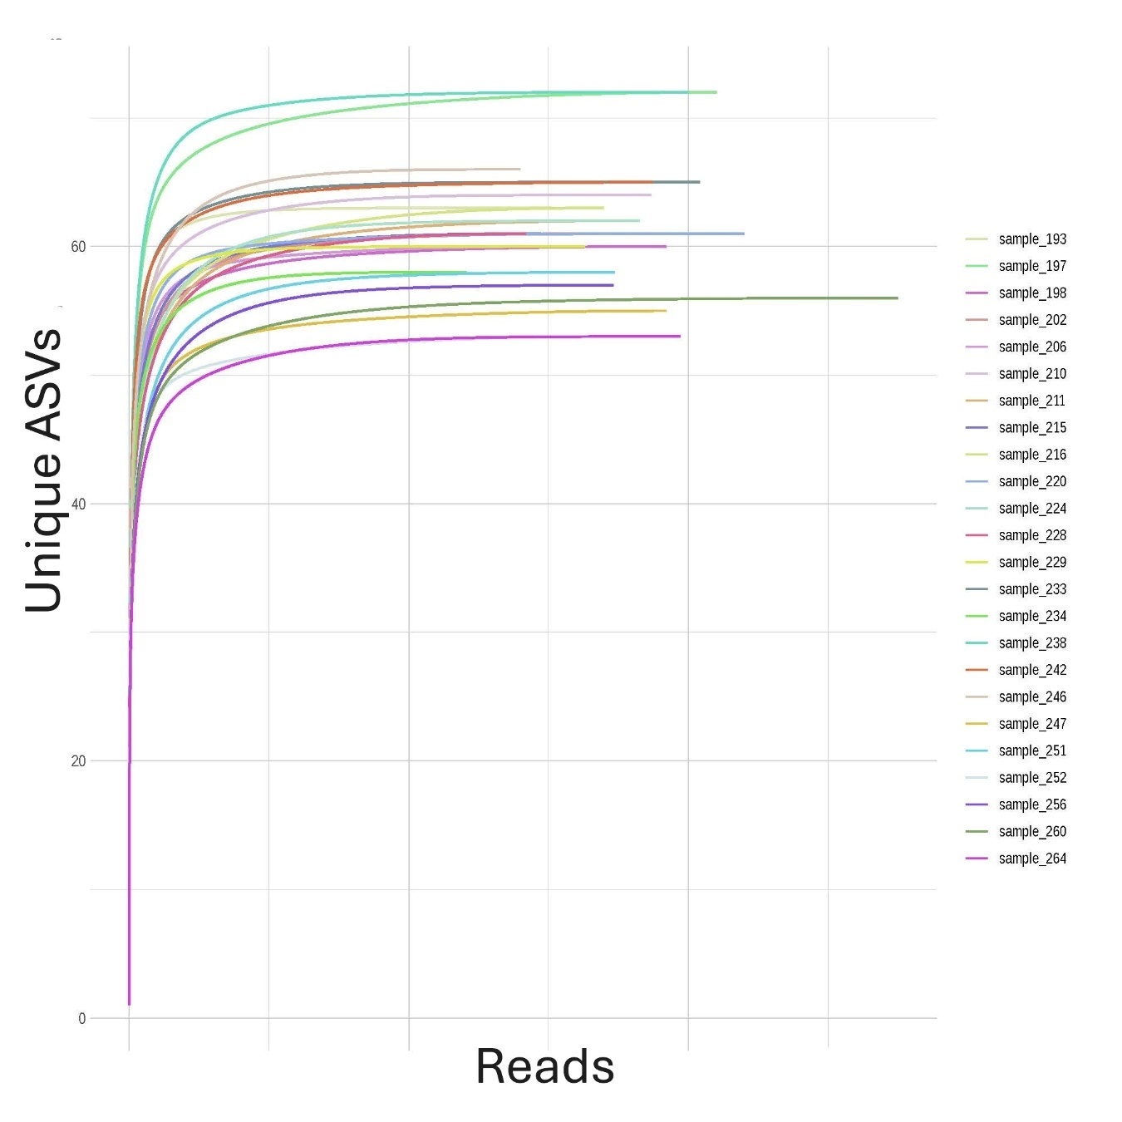
Figure S18. Archaeal rarefaction curve (Experiment 3).

Supplementary Figure S19. Effects of 5 µM 2-bromoethanesulfonate (BES), 1 mM coenzyme M (CoM), and 1 mM methyl-coenzyme M (methyl-CoM) on the archaeal 16S rRNA gene relative abundance of ruminal batch cultures at the phylum level (Experiment 3).

Supplementary Figure S20. Effects of 5 µM 2-bromoethanesulfonate (BES), 1 mM coenzyme M (CoM), and 1 mM methyl-coenzyme M (methyl-CoM) on the archaeal 16S rRNA gene absolute abundance of ruminal batch cultures at the genus level (Experiment 3).

Supplementary Figure S21. Principal components plot based on the archaeal community composition of mixed ruminal batch cultures at the genera level. Blue points correspond to the Control treatment with functional methanogenesis, and red points correspond to methanogenesis inhibition with 5 µM 2-bromoethanesulfonate (BES). Circles correspond to no addition of cofactors, regular triangles correspond to the addition of 1 mM coenzyme M (CoM), and inverted triangles correspond to the addition of 1 mM methyl-coenzyme M (methyl-CoM) (Experiment 3).

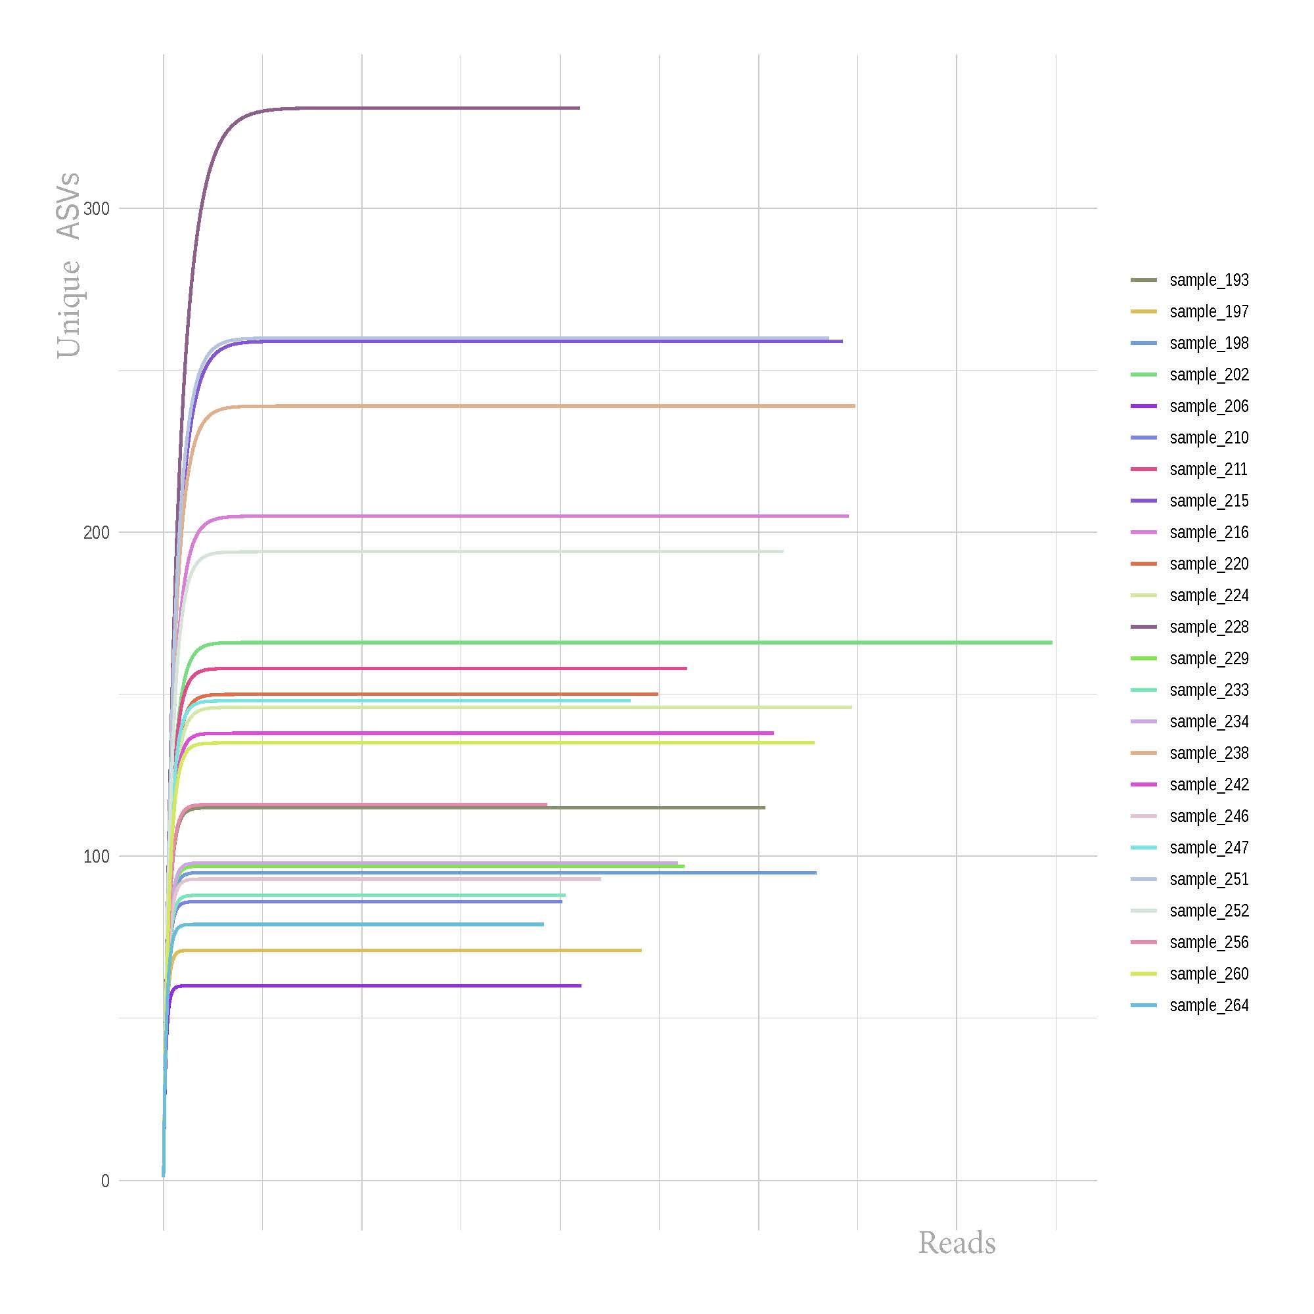
Figure S22. Bacterial rarefaction curve (Experiment 3).

Supplementary Figure S23. Principal components plot based on the bacterial community composition of mixed ruminal batch cultures at the general level. Blue points correspond to the Control treatment with functional methanogenesis, and red points correspond to methanogenesis inhibition with 5 µM 2-bromoethanesulfonate (BES). Circles correspond to no addition of cofactors, regular triangles correspond to the addition of 1 mM coenzyme M (CoM), and inverted triangles correspond to the addition of 1 mM methyl-coenzyme M (methyl-CoM) (Experiment 3).

Supplementary Figure S24. Effects of 2-bromoethanesulfonate (BES; not shown) at 5 µM, 3-nitrooxypropanol (3-NOP; (A)), and bromoform (BMF; (B)), combined with 2.5 mM coenzyme M (CoM), methyl-coenzyme M (methyl-CoM), or a control treatment without added methyl group carriers (Control), on total gas production of mixed rumen batch cultures: BES, P = 0.28; 3-NOP, P > 0.99; BMF, P = 0.51; methyl group carrier, P = 0.19; BES × methyl group carrier, P = 0.78; 3-NOP × methyl group carrier, P = 0.50; BMF × methyl group carrier, P = 0.89; cow (random), P = 0.61; incubation (random), P = 0.76 (Experiment 4).
Supplementary Figure S25. Effects of 2-bromoethanesulfonate (BES) at 5 µM, 3-nitrooxypropanol (3-NOP; refer to Figure 7A), and bromoform (BMF; refer to Figure 7B), combined with 2.5 mM coenzyme M (CoM), methyl-coenzyme M (methyl-CoM), or a control treatment without added methyl group carriers (Control), on CH₄ production of mixed rumen batch cultures: BES, P < 0.001; 3-NOP, P = 0.095; BMF, P < 0.001; methyl group carrier, P = 0.13; BES × methyl group carrier, P < 0.001; 3-NOP × methyl group carrier, P = 0.78; BMF × methyl group carrier, P = 0.56; cow (random), P = 0.50; incubation (random), P = 0.34 (Experiment 4).

Supplementary Figure S26. Effects of 2-bromoethanesulfonate (BES) at 5 µM, 3-nitrooxypropanol (3-NOP; refer to Figure 8A), and bromoform (BMF; refer to Figure 8B), combined with 2.5 mM coenzyme M (CoM), methyl-coenzyme M (methyl-CoM), or a control treatment without added methyl group carriers (Control), on H₂ accumulation of mixed rumen batch cultures: BES, P < 0.001; 3-NOP, P = 0.012; BMF, P < 0.001; methyl group carrier, P = 0.001; BES × methyl group carrier, P < 0.001; 3-NOP × methyl group carrier, P = 0.55; BMF × methyl group carrier, P = 0.14; cow (random), P = 0.49; incubation (random), P = 0.33 (Experiment 4). The response variable H₂ accumulation was decimal log-transformed for the analysis but it is shown untransformed in the figure.

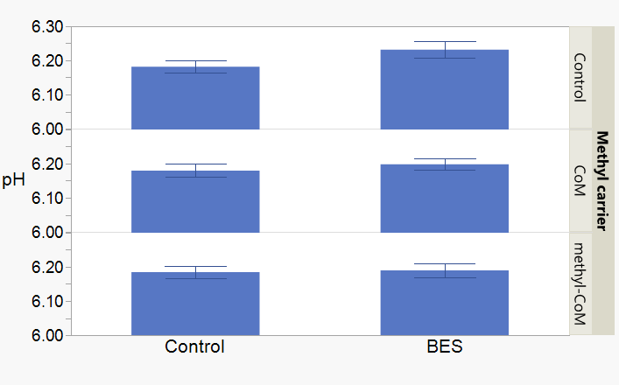
Supplementary Figure S27. Effects of 2-bromoethanesulfonate (BES) at 5 µM, 3-nitrooxypropanol (3-NOP; not shown), and bromoform (BMF; refer to Supplementary Figure S28), combined with 2.5 mM coenzyme M (CoM), methyl-coenzyme M (methyl-CoM), or a control treatment without added methyl group carriers (Control), on final pH of mixed rumen batch cultures: BES, P = 0.051; 3-NOP, P = 0.94; BMF, P 0.087; methyl group carrier, P = 0.13; BES × methyl group carrier, P = 0.28; 3-NOP × methyl group carrier, P = 0.50; BMF × methyl group carrier, P = 0.40; cow (random), P = 0.94; incubation (random), P = 0.34 (Experiment 4).
Supplementary Figure S28. Effects of 2-bromoethanesulfonate (BES; refer to Supplementary Figure S27) at 5 µM, 3-nitrooxypropanol (3-NOP; not shown), and bromoform (BMF), combined with 2.5 mM coenzyme M (CoM), methyl-coenzyme M (methyl-CoM), or a control treatment without added methyl group carriers (Control), on final pH of mixed rumen batch cultures: BES, P = 0.051; 3-NOP, P = 0.94; BMF, P 0.087; methyl group carrier, P = 0.13; BES × methyl group carrier, P = 0.28; 3-NOP × methyl group carrier, P = 0.50; BMF × methyl group carrier, P = 0.40; cow (random), P = 0.94; incubation (random), P = 0.34 (Experiment 4).

Supplementary Figure S29. Effects of 2-bromoethanesulfonate (BES; not shown) at 5 µM, 3-nitrooxypropanol (3-NOP; not shown), and bromoform (BMF), combined with 2.5 mM coenzyme M (CoM), methyl-coenzyme M (methyl-CoM), or a control treatment without added methyl group carriers (Control), on final reducing potential (Eh) of mixed rumen batch cultures: BES, P = 0.63; 3-NOP, P = 0.63; BMF, P 0.028; methyl group carrier, P < 0.001; BES × methyl group carrier, P = 0.94; 3-NOP × methyl group carrier, P = 0.87; BMF × methyl group carrier, P = 0.67; cow (random), P = 0.48; incubation (random), P = 0.33 (Experiment 4).

Supplementary Figure S29. Effects of 2-bromoethanesulfonate (BES; not shown) at 5 µM, 3-nitrooxypropanol (3-NOP; not shown), and bromoform (BMF), combined with 2.5 mM coenzyme M (CoM), methyl-coenzyme M (methyl-CoM), or a control treatment without added methyl group carriers (Control), on final reducing potential (Eh) of mixed rumen batch cultures: BES, P = 0.63; 3-NOP, P = 0.63; BMF, P 0.028; methyl group carrier, P < 0.001; BES × methyl group carrier, P = 0.94; 3-NOP × methyl group carrier, P = 0.87; BMF × methyl group carrier, P = 0.67; cow (random), P = 0.48; incubation (random), P = 0.33 (Experiment 4).

