Supplementary Materials

Supplementary to: A deep learning-based early warning system for renal replacement therapy in the intensive care unit

Behrooz Mamandipoor, MS^{1,2}; Julian McAuley, PhD³; Martin Krause, MD^{2,4}; Ulrich H. Schmidt, MD, PhD, MBA⁴; Chun-Nan Hsu, PhD²; Rodney A. Gabriel, MD, MAS^{1,2}

¹Department of Biomedical Informatics, University of California, San Diego Health, La Jolla, CA, USA
²Division of Perioperative Informatics, Department of Anesthesiology, University of California, San Diego, La Jolla, CA, USA
³Department of Computer Science and Engineering, University of California, San Diego, La Jolla, CA, USA
⁴Division of Critical Care Medicine, Department of Anesthesiology, University of California, San Diego, La Jolla, CA, USA

Corresponding author: Rodney A. Gabriel, Email: ragabriel@health.ucsd.edu

TABLE OF CONTENTS

- A detailed description of pre-processing of time-invariant data ………………………………………...…….... 02
- A detailed description of pre-processing of time-variant data …………………………………………...……… 03
- A detailed description of approaches for outlier removal and missing data imputation ……………...……... 04
- Seven distinct categories of features computed for each hourly time point ……………….………………...… 05
- Details of methods related to labeling of events ……………………………………………………………….….. 06
- Details of models architecture and training process …………………………….……………………...………... 07
- Details of the interpretability pipeline ………………………………………………………….……………….….. 08
- Details of bias and fairness evaluation approach ………………………………………………………..……….. 09
- A detailed breakdown of demographic data for MIMIC-III ………………………………………..……………. 10
- A detailed breakdown of demographic data for MIMIC-IV …………………………………………………....… 11
- A detailed breakdown of demographic data for eICU…………………………………………..………………… 12
- A detailed breakdown of demographic data for the pandemic period in MIMIC dataset………………….…. 13
- Performance metrics for early prediction of the need for RRT (screeningEWS) …………………………..…. 14
- Hospital-level external validation of screeningEWS model across eight individual eICU hospitals ………. 15
- Feature-importance rankings of screeningEWS model for each cohort………………………………...…..….. 16
- Performance metrics for real-time dynamic prediction of RRT initiation (dynamicEWS) …………………... 19
- Hospital-level external validation of dynamicEWS model across eight individual eICU hospitals……..….. 20
- dynamicEWS model evaluations for the remaining patient cohorts …………………………………….….…… 21
- Population-level SHAP feature-importance rankings for each cohort ……………………..…………..……… 22
- Additional examples of real-time RRT risk assessment ………………………………………………….…...…... 23
- Fairness evaluations for each cohort and additional subgroup analyses …………………………….…...…... 26
- Performance metrics for prediction of RRT duration (durationEWS)…………………………………………... 30
- Feature-importance rankings of durationEWS model for each cohort ……………………………….....……... 31
- Performance metrics for mortality prediction post-RRT onset (prognosisEWS) ……………………………... 34
- Feature-importance rankings of prognosisEWS model for each cohort ……………………………..………... 35

Supplementary File 1. A detailed description of pre-processing of time-invariant data

Data pre-processing for time-invariant features
For static data (time-invariant features), if age was not directly available, it was calculated based on the patient's date of birth and admission date and was top-coded at 90 years. Height and weight measurements were converted to centimeters and kilograms, respectively. Baseline BMI was calculated using height and weight. Patient gender was converted into a binary representation, and race was encoded in numerical format by assigning a number to each race/ethnicity category. We also standardized admission type, admission location, first care unit, and insurance by grouping similar entries into broader categories. We simplified the admission type into three clinically relevant categories—Elective, Urgent, and Emergency—and encoded them ordinally to reflect increasing urgency levels. Other categorical variables were one-hot encoded to avoid introducing unintended order or bias.

Supplementary File 2. A detailed description of pre-processing of time-variant data

Data pre-processing for time-variant features
For dynamic data (time-variant features), the time-variant features included laboratory values, medications, ventilator settings, clinical scores (e.g., clinical risk scores, Glasgow Coma Scale [GCS], etc.), clinical events (e.g., procedures), and hemodynamics. Categorical variables were numerically encoded, and inconsistencies in variable types were corrected (e.g., converting misclassified strings to floats). Variable names and units were standardized across tables to ensure consistency and comparability. Dynamic variables were binned into non-overlapping 1-hour windows, within which the mean for continuous variables or the mode for categorical variables was calculated when multiple values were recorded within a bin. This approach allowed us to accommodate varying sampling frequencies across measurements. To standardize urine output measurements in clinical datasets and to support accurate fluid balance assessments, we created a list that included various descriptors and terms used to denote urine output within the dataset. This list encompassed a range of expressions, from general terms like “Urine” and “URINE CATHETER” to more specific descriptors such as “Output External Urethral Device Condom Catheter” and “Urine Output-Foley.” We also calculated six widely recognized clinical severity scores and mortality estimation systems hourly by utilizing the EHR data. These include the PaO₂/FiO₂ ratio, Shock Index, Systemic Inflammatory Response Syndrome (SIRS), Sequential Organ Failure Assessment (SOFA), Simplified Acute Physiology Score II (SAPS II), and Oxford Acute Severity of Illness Score (OASIS).

For medication pre-processing, we created extensive lists of drug names for each critical care medication to ensure thorough coverage during the extraction process. We then converted the presence of drugs into a binary representation indicating whether patients received them or not. Vasopressor use was defined based on whether a patient received any of the following medications: epinephrine, vasopressin, milrinone, dobutamine, phenylephrine, or norepinephrine. To identify antibiotic medications, we created a list of known antibiotic substances, including both common names and specific drug identifiers (GSN codes). Any drug name that contained any part of the antibiotic substrings or matched any GSN code was flagged with a binary indicator denoting antibiotic exposure.

Supplementary File 3. A detailed description of approaches for outlier removal and missing data imputation

Outlier removal
To ensure data quality and consistency, we first addressed potential entry errors in static features. In particular, patient height and weight values, which were often entered manually, were occasionally swapped. When such inconsistencies were detected (e.g., implausible combinations), the values were corrected by swapping height and weight. For dynamic clinical variables, we applied outlier detection and removal using clinically validated ranges based on medical knowledge specific to each variable. Measurements falling outside these physiologically plausible ranges were treated as outliers and excluded from the analysis.

Missing data imputation
We addressed missing data through a clinically informed imputation approach. Initially, we imputed missing values by leveraging established clinical relationships among variables. For instance, missing Glasgow Coma Scale (GCS) total scores were derived either from available component scores or mapped directly from corresponding Richmond Agitation-Sedation Scale (RASS) scores (e.g., RASS = 0 was mapped to a GCS of 15). Hemoglobin and hematocrit values were imputed based on their known linear relationship. Similarly, bilirubin measurements (total or direct) were imputed using their typical clinical ratio when one measurement was absent. Missing arterial blood pressure values (systolic, diastolic, and mean arterial pressure) were estimated using their known physiological relationships. Additionally, we introduced a binary indicator variable at each time point, indicating whether a given measurement was originally recorded or imputed. We implemented forward-filling of data for predefined intervals based on clinical judgment: up to 24 hours for medication-related variables and up to 12 hours for other dynamic physiological variables. These intervals represented clinically valid active periods during which previously recorded measurements could reasonably reflect the patient’s current physiological status. Beyond these intervals—or if no prior measurements existed—we imputed missing values using summary statistics derived exclusively from the training dataset (mean for continuous variables, mode for categorical variables, and zero for binary variables) to prevent data leakage.

Supplementary File 4. Seven distinct categories of features computed for each hourly time point

Feature generation
Current values: We directly used clinical measurements at each hourly interval as features.
Time since admission: We included elapsed time (in hours) since the patient's ICU admission.
Measurement density features: As missing imputation process eliminated information about measurement frequency and timing, we reintroduced them through several derived features:
Time since last measurement: Duration since the most recent valid measurement was recorded.
Variable change over time: Rate of change between the current and previous recorded values.
Missing indicator: A binary indicator showing whether a clinical measurement at a given time point was observed (1) or imputed or missing (0).
Ventilation status: We included the patient's current ventilation state, as a binary variable.
Static features: We incorporated patient-level static variables recorded at the time of ICU admission. These variables consisted of age, gender, race, height, weight, body mass index (BMI), admission type and location, initial care unit, and insurance status.
Multi-resolution summaries: We computed statistical summaries over multiple retrospective time windows to capture temporal trends and summarize the physiological dynamics. Clinical variables were categorized into three frequency groups (high, medium, or low) based on their typical measurement intervals within the training set. For each frequency category, we defined short-term (12-hour), medium-term (24-hour), and long-term (48-hour) windows. Within each window, we calculated summary statistics, including mean, median, mode, standard deviation, median absolute deviation, minimum, maximum, range, and interquartile range (25th and 75th percentiles). Additionally, to characterize patient status over their entire ICU stay up to the current time, we computed minimum and maximum values, the proportion of measurements above or below the median, and the number of zero crossings relative to the mean.
Clinical risk scores: We included clinically established risk scores derived from existing clinical knowledge. These comprised the PaO₂/FiO₂ ratio, Shock Index, Systemic Inflammatory Response Syndrome (SIRS), Sequential Organ Failure Assessment (SOFA), Simplified Acute Physiology Score II (SAPS II), and Oxford Acute Severity of Illness Score (OASIS).

Supplementary File 5. Details of methods related to labeling of events

Labeling of events
(1) Early prediction of the need for RRT (screeningEWS): For the early prediction model, we restricted the cohort to ICU stays lasting at least 12 hours and excluded patients who initiated RRT within the first 12 hours of admission, as the prediction relied exclusively on clinical data from this initial 12-hour window. Each remaining ICU admission was labeled positive if the patient received RRT or deceased at any time after the first 12 hours during the remainder of the ICU stay, and negative if the patient never received RRT and survived during that admission.
(2) Real-time dynamic prediction of RRT initiation (dynamicEWS): For the dynamic model, we generated an hourly time series for each ICU stay and labeled each hour based on the timing of RRT initiation. An hourly data point at time t was labeled positive if the patient was not on RRT at hour t or t + 1, but RRT was initiated at least once within the subsequent 24-hour window (from t + 2 to t + 26). An hourly data point was labeled negative if the patient remained free of RRT during the current hour, the next hour, and throughout the subsequent 24-hour period (from t to t + 26). Hourly data points were labeled invalid and excluded from model training and evaluation if the patient was already on RRT at the current hour or the next hour, to avoid label leakage around the time of initiation.
(3) Prediction of RRT duration (durationEWS): For the duration model, we focused on patients who initiated RRT during their ICU stay. For each RRT episode, we computed the total RRT duration as the time elapsed from RRT initiation to RRT discontinuation. Each episode was labeled short-term if the total RRT duration following the 12 hours observation period was ≤48 hours and prolonged if the total duration was >48 hours. These labels were used as binary outcomes for durationEWS, with data from the first 12 hours after RRT initiation serving as the input feature window.
(4) Mortality prediction post-RRT onset (prognosisEWS): For the mortality model, we considered ICU patients who received RRT and followed them until ICU discharge. Each patient was labeled positive if they died before ICU discharge and negative if they survived to ICU discharge. Input features for prognosisEWS were derived from the 12 hours immediately before and the 12 hours after RRT onset.

Label masking on presence of vital sign monitoring
All predictive labels underwent additional masking based on the patient’s current vital sign monitoring status. Specifically, if a patient had no recorded vital signs (heart rate, respiratory rate, SpO₂, temperature) during the current hour, the label for that hour was considered invalid. Such data points were excluded from analysis, and no prediction was generated at these time points.

Supplementary File 6. Details of models architecture and training process

Supervised learning of prediction models
We implemented task-specific predictive models for each EWS variant as detailed below:

Bidirectional Long Short-Term Memory (Bi-LSTM): We developed three Bi-LSTM models with a hidden size of 64 units as our screeningEWS, durationEWS, and prognosisEWS classifiers. Outputs from both directions of each Bi-LSTM model were concatenated and fed into a classification module comprising a linear layer with 32 units, followed by a ReLU activation and a dropout layer to mitigate overfitting. For improved training stability and faster convergence, we applied Xavier uniform initialization to all linear and recurrent network layers. To address class imbalance, we employed weighted random sampling, assigning sampling probabilities inversely proportional to class frequencies to ensure balanced representation of each class within training batches. Additionally, we utilized a weighted cross-entropy loss function that emphasized the minority class, thereby maintaining balanced training dynamics. Model optimization involved the Adam optimizer with a learning rate of 5×10⁻⁴ and weight decay set at 0.01. We included a StepLR scheduler to decrease the learning rate by a factor of 10 every 20 epochs. Training proceeded with a batch size of 16 and was halted if no improvement in validation AUC or F1 score occurred over 20 consecutive epochs. A checkpoint system was employed to save the model state whenever validation performance improved.

XGBoost: We also developed an XGBoost model as our dynamicEWS classifier, which operates sequentially over hourly EHR data and provides real-time estimates of future RRT risk. To optimize the predictive performance of the XGBoost model, we conducted a randomized hyperparameter search aimed at maximizing the F1 score while enforcing a minimum recall of 0.8 on the validation set. We randomly sampled 50 hyperparameter combinations from a predefined search space, varying the number of trees, maximum tree depth, minimum child weight, learning rate, and tree-level regularization. Each configuration was trained on the training set with early stopping based on the validation area under the receiver operating characteristic curve (AUROC), ending training if the validation AUROC did not improve for 10 consecutive boosting rounds. After training, we obtained predicted probabilities on the validation set and converted them to binary labels using a threshold chosen to achieve at least 0.8 recall. We then computed the F1 score at this threshold and selected the hyperparameter configuration that yielded the highest F1 score on the validation data. This procedure yielded the optimal hyperparameter set, which was subsequently used to train the final model and evaluate its performance on the independent test set.

Supplementary File 7. Details of the interpretability pipeline

Interpretability
Many predictive models used in critical care provide limited interpretability at both the population level (i.e., identifying which factors generally drive predictions across a cohort) and the individual patient level (i.e., explaining why a specific patient is flagged at a specific time). This limitation is particularly problematic for real-time clinical decision support, where clinicians require transparent and actionable rationales alongside risk estimates. To address interpretability at both levels, we used Integrated Gradients (IG) for our Bi-LSTM classifiers and SHapley Additive exPlanations (SHAP) for our XGBoost-based model, and we designed temporally resolved, patient-specific explanations suitable for hourly ICU monitoring.

Therefore, we adopted the Integrated Gradients (IG) method to address the interpretability of the Bi-LSTM models used as our screeningEWS, durationEWS, and prognosisEWS classifiers. IG identifies influential parts of the input data by comparing the model’s prediction for the actual input with a baseline input—a sequence of zeros or padding sequence of the same length as the input. This method involves interpolating between the baseline and actual input, then integrating the gradients of the model's output with respect to the input along this interpolation path. The result is a set of attributions that highlight which aspects of the input are most responsible for the model's prediction. For EHR data, attributions for each feature are aggregated across all time steps to identify key influences on the model’s prediction. Positive attributions increase the predicted likelihood for a specific class, thereby supporting the model's decision, while negative attributions decrease this likelihood.

We also employed SHapley Additive exPlanations (SHAP) to interpret the XGBoost model predictions used as our dynamicEWS classifier. Specifically, we utilized the TreeExplainer module from the SHAP library to calculate Shapley values for each feature across all instances in the test dataset. For population-level interpretability, a SHAP summary plot was generated, visualizing the global importance of features by highlighting the magnitude and direction of each feature's contribution to the predictions. This enabled clinicians to identify the most influential predictors and understand their associations with predicted outcomes. For individualized interpretability and temporally resolved explanations, we developed a SHAP-based prioritization algorithm to produce hourly summaries of feature attributions for individual ICU patients. At each hourly interval, the top-k features with the highest absolute SHAP values were identified, clearly indicating their direction of influence (positive or negative) on model predictions, and the corresponding actual feature values were reported. Additionally, we provided temporal trend indicators, showing whether each feature's value increased, decreased, or remained stable compared with the previous hour. To further enhance interpretability, we designed an animated real-time dashboard that visualizes model predictions alongside explanatory features for individual ICU patients. At each hourly update, the dashboard displays: (1) a time-series plot of predicted risk with annotations for model-triggered and alarm-triggered events; (2) line plots illustrating temporal trends for the top-k most influential features; and (3) horizontal SHAP bar plots indicating the magnitude and direction of each feature’s contribution to the current prediction. Feature explanations are clearly annotated using directional arrows, SHAP values, and, optionally, trends relative to prior hours.

Supplementary File 8. Details of bias and fairness evaluation approach

Bias and fairness
We evaluated model bias and fairness with respect to gender (Male, Female) and race (White, Asian, Hispanic, African American, Other) within the target patient cohort. For each demographic axis, we selected a baseline subgroup (Male for gender, White for race) and computed subgroup-specific performance metrics, including area under the ROC curve (AUC), positive predictive value (PPV), negative predictive value (NPV), true positive rate (TPR), true negative rate (TNR), false positive rate (FPR), and false negative rate (FNR).

Our fairness evaluation was designed to audit multiple widely used fairness objectives through subgroup performance comparisons. Specifically, equal opportunity was assessed by comparing TPR (equivalently FNR) across subgroups, reflecting whether the model detects true positive cases at similar rates in each group. Equalized odds was assessed by jointly comparing TPR and FPR across subgroups, reflecting whether both true-positive detection and false-alarm rates are comparable across demographic groups. Predictive value parity was assessed by comparing PPV and NPV across subgroups, reflecting whether positive and negative predictions have similar reliability across groups.

To quantify disparities relative to the baseline subgroup, fairness was assessed using both the absolute difference in metric values (Δ, defined as the difference between the subgroup and baseline metric) and the disparity ratio (R, defined as the subgroup metric divided by the baseline metric). We applied a combined rule whereby a disparity was considered potentially important only if it exceeded both an absolute threshold of 0.10 (|Δ| > 0.10) and a relative threshold of 0.20 (|R − 1| > 0.20). This combined rule was motivated by the fact that ratio-based comparisons can be misleading when the baseline metric is very small (e.g., FPR ≈ 0.01), where a difference of 0.01 can double the rate (R = 2.0) but remain small in absolute terms, whereas for mid-range metrics (e.g., TPR ≈ 0.6–0.7) absolute differences of 0.10 can be clinically important even when the ratio is modest.
We first generated performance disparity heatmaps with subgroups on the rows and metrics on the columns, using the absolute difference (Δ) as the heatmap value and annotating each cell with the subgroup metric, the absolute difference (Δ), and the disparity ratio (R). Cells exceeding the combined rule were visually highlighted, yielding a set of candidate metric–subgroup pairs for closer inspection. For these candidates, we then used performance disparity histograms to show the disparity ratio and absolute difference for all non-baseline subgroups and to classify each bar into one of five categories: (i) fair (small ratio and small absolute difference), (ii) ratio-only concern, (iii) absolute-only concern, (iv) combined concern with better performance compared with the baseline subgroup, or (v) combined concern with worse performance compared with the baseline subgroup. This two-step procedure allowed us to evaluate clinically meaningful differences and to determine whether any observed disparities were in favor of or against minority subgroups.

Supplementary File 9. A detailed breakdown of demographic data for MIMIC-III

MIMIC-III | RRT: Negative | RRT: Positive | P-Value
Heart Rate | 84.5 [73.0,97.0] | 85.0 [74.0,97.0] | <0.01
SpO2 | 97.5 [96.0,99.0] | 98.0 [96.0,100.0] | <0.01
Oxygen Saturation | 96.0 [87.0,98.0] | 96.0 [90.0,98.0] | <0.01
Respiratory Rate | 19.0 [16.0,23.0] | 19.0 [16.0,23.0] | <0.01
Temperature | 37.0 [36.5,37.6] | 36.7 [36.2,37.3] | <0.01
Blood Pressure mean | 76.0 [67.0,86.7] | 73.0 [63.0,85.0] | <0.01
Blood Pressure systolic | 119.0 [105.0,135.0] | 116.0 [101.0,135.0] | <0.01
Blood Pressure diastolic | 60.0 [50.0,70.0] | 56.0 [47.0,68.0] | <0.01
Glucose | 129.0 [107.0,159.0] | 129.0 [103.0,164.0] | <0.01
Creatinine | 0.9 [0.7,1.4] | 3.1 [1.8,4.8] | <0.01
Base Excess | 0.0 [-2.0,3.0] | -1.0 [-5.0,1.0] | <0.01
BUN | 21.0 [13.0,35.0] | 43.0 [27.0,66.0] | <0.01
Anion Gap | 13.0 [11.0,15.0] | 17.0 [14.0,20.0] | <0.01
Bicarbonate | 25.0 [22.0,28.0] | 23.0 [20.0,26.0] | <0.01
Lactate | 1.7 [1.1,2.6] | 2.2 [1.4,4.2] | <0.01
Hemoglobin | 10.0 [9.0,11.2] | 9.6 [8.7,10.6] | <0.01
Hematocrit | 29.8 [26.9,33.0] | 28.6 [26.0,31.4] | <0.01
pH | 7.4 [7.3,7.4] | 7.4 [7.3,7.4] | <0.01
Bilirubin | 0.4 [0.2,1.6] | 1.7 [0.4,6.2] | <0.01
pO2 | 110.0 [84.0,152.0] | 104.0 [81.0,138.0] | <0.01
pCO2 | 41.0 [36.0,46.0] | 40.0 [35.0,45.0] | <0.01
WBC | 10.3 [7.2,14.1] | 11.0 [7.2,16.5] | <0.01
RBC | 3.4 [3.0,3.8] | 3.3 [2.9,3.7] | <0.01
Potassium | 4.0 [3.7,4.4] | 4.2 [3.8,4.7] | <0.01
Sodium | 139.0 [136.0,142.0] | 137.0 [134.0,140.0] | <0.01
Chloride | 105.0 [102.0,109.0] | 101.0 [97.0,105.0] | <0.01
Magnesium | 2.0 [1.8,2.2] | 2.1 [1.9,2.3] | <0.01
GCS Total | 14.0 [10.0,15.0] | 11.0 [9.0,15.0] | <0.01
SOFA | 3.0 [1.0,5.0] | 5.0 [3.0,8.0] | <0.01
SAPS II | 29.0 [23.0,37.0] | 35.0 [28.0,46.0] | <0.01
OASIS | 19.0 [18.0,22.0] | 20.0 [18.0,23.0] | <0.01
Supplementary File 10. A detailed breakdown of demographic data for MIMIC-IV

MIMIC-IV | RRT: Negative | RRT: Positive | P-Value
Heart Rate | 84.0 [72.0,97.0] | 87.0 [76.0,100.0] | <0.01
SpO2 | 97.0 [95.0,99.0] | 98.0 [95.5,100.0] | <0.01
Oxygen Saturation | 94.0 [73.0,97.0] | 94.0 [75.5,97.0] | <0.01
Respiratory Rate | 19.0 [16.0,23.0] | 20.0 [16.0,24.0] | <0.01
Temperature | 36.9 [36.6,37.3] | 36.8 [36.4,37.2] | <0.01
Blood Pressure mean | 77.0 [68.0,88.0] | 73.0 [64.0,85.0] | <0.01
Blood Pressure systolic | 118.0 [105.0,134.0] | 114.0 [100.0,132.0] | <0.01
Blood Pressure diastolic | 64.0 [55.0,74.5] | 60.0 [50.0,71.0] | <0.01
Glucose | 133.0 [110.0,168.0] | 136.0 [108.0,178.0] | <0.01
Creatinine | 0.9 [0.7,1.4] | 2.6 [1.5,4.2] | <0.01
Base Excess | 0.0 [-3.0,3.0] | -1.0 [-5.0,0.0] | <0.01
BUN | 21.0 [13.0,35.0] | 37.0 [23.0,60.0] | <0.01
Anion Gap | 13.0 [11.0,16.0] | 17.0 [15.0,20.0] | <0.01
Bicarbonate | 24.0 [21.0,27.0] | 22.0 [19.0,25.0] | <0.01
Lactate | 1.7 [1.2,2.6] | 2.1 [1.4,4.0] | <0.01
Hemoglobin | 9.7 [8.5,11.2] | 8.9 [7.9,10.0] | <0.01
Hematocrit | 29.3 [26.0,33.6] | 27.0 [24.3,30.1] | <0.01
pH | 7.4 [7.3,7.4] | 7.4 [7.3,7.4] | <0.01
Bilirubin | 0.4 [0.1,1.2] | 1.5 [0.4,5.8] | <0.01
pO2 | 104.0 [74.0,152.0] | 97.0 [74.0,127.0] | <0.01
pCO2 | 41.0 [35.0,47.0] | 40.0 [35.0,46.0] | <0.01
WBC | 10.3 [7.2,14.2] | 12.1 [8.0,18.1] | <0.01
RBC | 5.0 [1.0,18.0] | 9.0 [3.0,32.0] | <0.01
Potassium | 4.0 [3.7,4.4] | 4.2 [3.8,4.7] | <0.01
Sodium | 139.0 [136.0,142.0] | 137.0 [134.0,140.0] | <0.01
Chloride | 104.0 [100.0,108.0] | 100.0 [96.0,104.0] | <0.01
Magnesium | 2.1 [1.9,2.3] | 2.1 [1.9,2.3] | <0.01
GCS Total | 14.0 [11.0,15.0] | 13.0 [9.0,15.0] | <0.01
SOFA | 3.0 [1.0,6.0] | 7.0 [4.0,10.0] | <0.01
SAPS II | 29.0 [23.0,38.0] | 38.0 [29.0,50.0] | <0.01
OASIS | 19.0 [18.0,22.0] | 20.0 [18.0,24.0] | <0.01
Supplementary File 11. A detailed breakdown of demographic data for eICU

eICU | RRT: Negative | RRT: Positive | P-Value
Heart Rate | 84.5 [73.0,97.3] | 87.6 [75.9,100.6] | <0.01
SpO2 | 97.0 [95.0,98.9] | 97.7 [95.5,99.5] | <0.01
O2 Saturation | 97.0 [95.0,99.0] | 98.0 [95.8,99.8] | <0.01
Respiratory Rate | 19.5 [16.2,23.2] | 19.9 [16.4,23.9] | <0.01
Temperature | 36.9 [36.6,37.4] | 36.8 [36.4,37.3] | <0.01
Blood Pressure mean | 81.0 [71.0,92.5] | 76.0 [66.5,87.2] | <0.01
Blood Pressure systolic | 121.0 [107.0,138.0] | 117.0 [103.0,135.0] | <0.01
Blood Pressure diastolic | 65.0 [56.0,75.0] | 60.5 [52.1,71.0] | <0.01
Glucose | 135.0 [110.0,170.0] | 135.0 [108.0,168.0] | <0.01
Creatinine | 1.0 [0.7,1.6] | 2.7 [1.6,4.4] | <0.01
Base Excess | 0.5 [-3.4,4.1] | -1.0 [-5.0,2.2] | <0.01
BUN | 22.0 [13.0,37.0] | 39.0 [24.0,59.0] | <0.01
Anion Gap | 10.0 [7.0,13.0] | 11.0 [8.0,14.0] | <0.01
Bicarbonate | 24.8 [21.3,28.0] | 24.0 [20.5,26.8] | <0.01
Lactate | 1.7 [1.1,2.9] | 2.5 [1.4,5.3] | <0.01
Hemoglobin | 9.8 [8.5,11.5] | 8.8 [7.9,10.0] | <0.01
Hematocrit | 30.0 [26.1,34.8] | 27.0 [24.2,30.6] | <0.01
pH | 7.4 [7.3,7.4] | 7.4 [7.3,7.4] | <0.01
Bilirubin | 0.3 [0.1,0.7] | 0.7 [0.2,2.0] | <0.01
pO2 | 92.0 [73.0,129.0] | 90.0 [71.2,124.0] | <0.01
pCO2 | 40.1 [34.9,48.0] | 39.5 [34.0,46.0] | <0.01
WBC | 10.7 [7.8,14.7] | 12.4 [8.5,17.8] | <0.01
RBC | 3.4 [2.9,3.9] | 3.0 [2.7,3.4] | <0.01
Potassium | 3.9 [3.6,4.3] | 4.2 [3.8,4.6] | <0.01
Sodium | 139.0 [136.0,143.0] | 138.0 [135.0,142.0] | <0.01
Chloride | 105.0 [101.0,109.0] | 103.0 [99.0,107.0] | <0.01
Magnesium | 2.0 [1.8,2.2] | 2.0 [1.8,2.3] | <0.01
GCS Total | 14.0 [11.0,15.0] | 11.0 [9.0,15.0] | <0.01
SOFA | 3.0 [1.0,5.0] | 5.0 [3.0,8.0] | <0.01
SAPS II | 29.0 [23.0,35.0] | 34.0 [26.0,43.0] | <0.01
OASIS | 19.0 [18.0,21.0] | 19.0 [18.0,22.0] | <0.01
Supplementary File 12. A detailed breakdown of demographic data for the pandemic period in MIMIC datasets
Covid-19 | RRT: Negative | RRT: Positive | P-Value
Heart Rate | 82.0 [70.0,95.0] | 90.0 [77.0,104.0] | <0.01
SpO2 | 97.0 [95.0,99.0] | 97.0 [95.0,99.0] | <0.01
Oxygen Saturation | 91.0 [64.0,96.0] | 90.0 [65.5,95.0] | <0.01
Respiratory Rate | 19.0 [16.0,23.0] | 21.0 [16.0,26.0] | <0.01
Temperature | 36.9 [36.7,37.3] | 36.8 [36.5,37.2] | <0.01
Blood Pressure mean | 83.0 [73.0,94.0] | 76.0 [68.0,86.0] | <0.01
Blood Pressure systolic | 119.0 [105.0,135.0] | 111.0 [100.0,127.0] | <0.01
Blood Pressure diastolic | 68.0 [59.0,79.0] | 62.0 [54.0,72.0] | <0.01
Glucose | 135.0 [112.0,170.0] | 148.0 [118.0,191.0] | <0.01
Creatinine | 0.9 [0.7,1.3] | 2.0 [1.3,3.3] | <0.01
Base Excess | -1.0 [-4.0,3.0] | -2.0 [-6.0,1.0] | <0.01
BUN | 21.0 [13.0,35.0] | 33.0 [20.0,56.0] | <0.01
Anion Gap | 11.0 [9.0,13.0] | 15.0 [13.0,18.0] | <0.01
Bicarbonate | 23.0 [21.0,26.0] | 22.0 [19.0,25.0] | <0.01
Lactate | 1.7 [1.2,2.7] | 2.2 [1.4,4.1] | <0.01
Hemoglobin | 9.7 [8.3,11.5] | 8.4 [7.6,9.5] | <0.01
Hematocrit | 30.1 [25.9,35.3] | 25.9 [23.5,29.1] | <0.01
pH | 7.4 [7.3,7.4] | 7.4 [7.3,7.4] | <0.01
Bilirubin | 0.2 [0.1,0.8] | 1.4 [0.3,5.7] | <0.01
pO2 | 98.0 [68.0,144.0] | 93.0 [73.0,120.0] | <0.01
pCO2 | 42.0 [37.0,49.0] | 41.0 [36.0,49.0] | <0.01
WBC | 10.7 [7.8,14.5] | 14.6 [9.8,22.0] | <0.01
RBC | 3.0 [1.0,12.0] | 9.0 [2.0,33.0] | <0.01
Potassium | 4.1 [3.7,4.4] | 4.2 [3.8,4.6] | <0.01
Sodium | 139.0 [135.0,143.0] | 137.0 [134.0,140.0] | <0.01
Chloride | 104.0 [100.0,108.0] | 100.0 [96.0,103.0] | <0.01
Magnesium | 2.1 [1.9,2.3] | 2.1 [1.9,2.3] | 0.03
Total GCS | 14.0 [11.0,15.0] | 10.0 [6.0,14.0] | <0.01
SOFA | 3.0 [1.0,6.0] | 9.0 [5.0,11.0] | <0.01
SAPS II | 29.0 [23.0,39.0] | 45.0 [33.0,58.0] | <0.01
OASIS | 19.0 [18.0,22.0] | 22.0 [18.0,29.0] | <0.01
Supplementary File 13. Performance metrics for early prediction of the need for RRT (screeningEWS)

Database | ACC  (95% CI) | PRC  (95% CI) | F-1  (95% CI) | SPE  (95% CI) | AUC  (95% CI) | AP  (95% CI) | MCC  (95% CI) | Brier  (95% CI)
MIMIC-III | 0.826  (0.818-0.834) | 0.331 (0.311-0.350) | 0.468 (0.446-0.489) | 0.829 (0.821-0.837) | 0.896 (0.886-0.906) | 0.530 (0.496-0.564) | 0.438 (0.417-0.460) | 0.090 (0.086-0.093)
MIMIC-IV | 0.842 (0.836-0.848) | 0.327 (0.309-0.345) | 0.464 (0.444-0.484) | 0.846 (0.839-0.852) | 0.909 (0.901-0.918) | 0.547 (0.516-0.578) | 0.443 (0.424-0.463) | 0.082 (0.079-0.085)
eICU | 0.785 (0.780-0.789) | 0.250 (0.240-0.259) | 0.381 (0.369-0.393) | 0.783 (0.778-0.788) | 0.871 (0.863-0.878) | 0.436 (0.413-0.459) | 0.364 (0.353-0.377) | 0.103 (0.101-0.106)
Covid-19 | 0.834 (0.827-0.843) | 0.357 (0.337-0.379) | 0.494 (0.473-0.516) | 0.838 (0.830-0.847) | 0.904 (0.894-0.913) | 0.567 (0.534-0.602) | 0.460 (0.438-0.483) | 0.130 (0.125-0.135)

Supplementary File 14. Hospital-level external validation of screeningEWS model across eight individual eICU hospitals

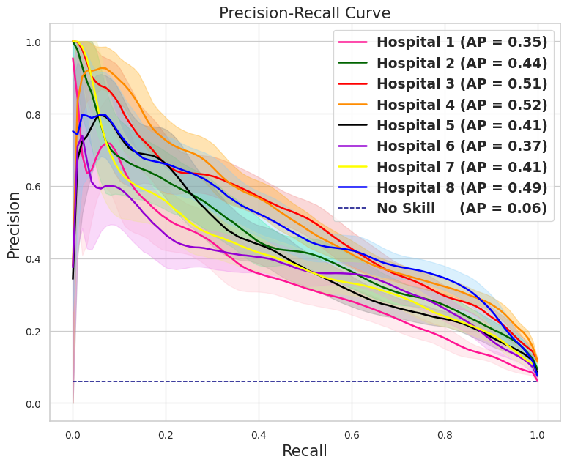
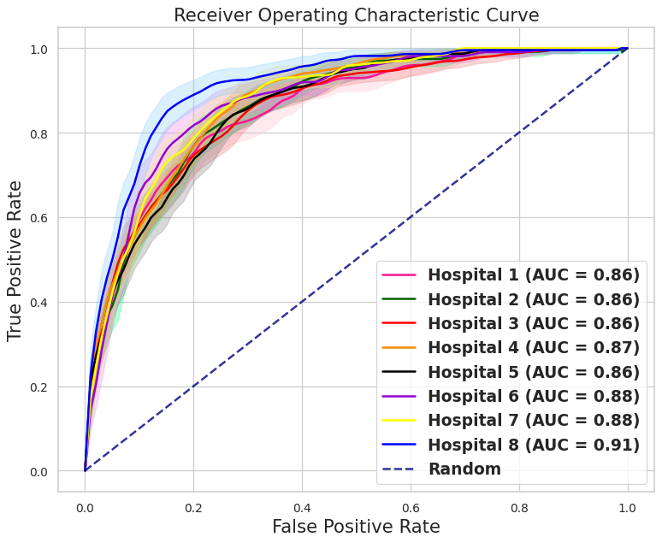

Supplementary File 15. Feature-importance rankings of screeningEWS model for each cohort, along with an illustrative example of individual patient–level explanations

Variable importance of screeningEWS model validation on MIMIC-III dataset

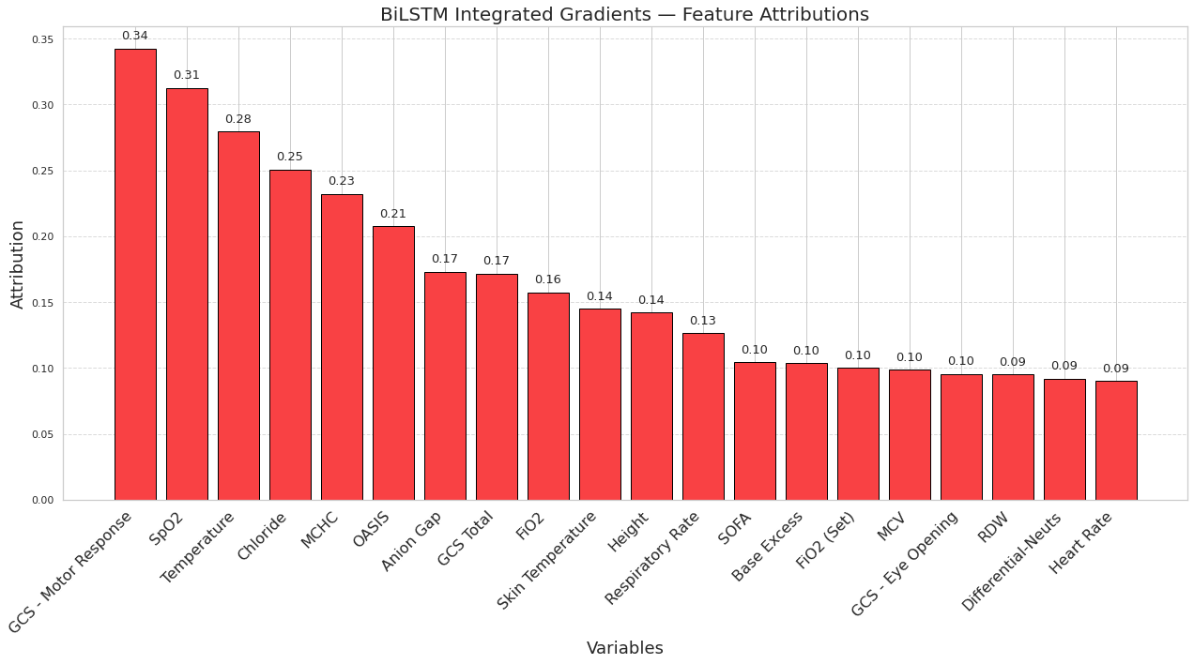

Variable importance of screeningEWS model validation on MIMIC-IV dataset

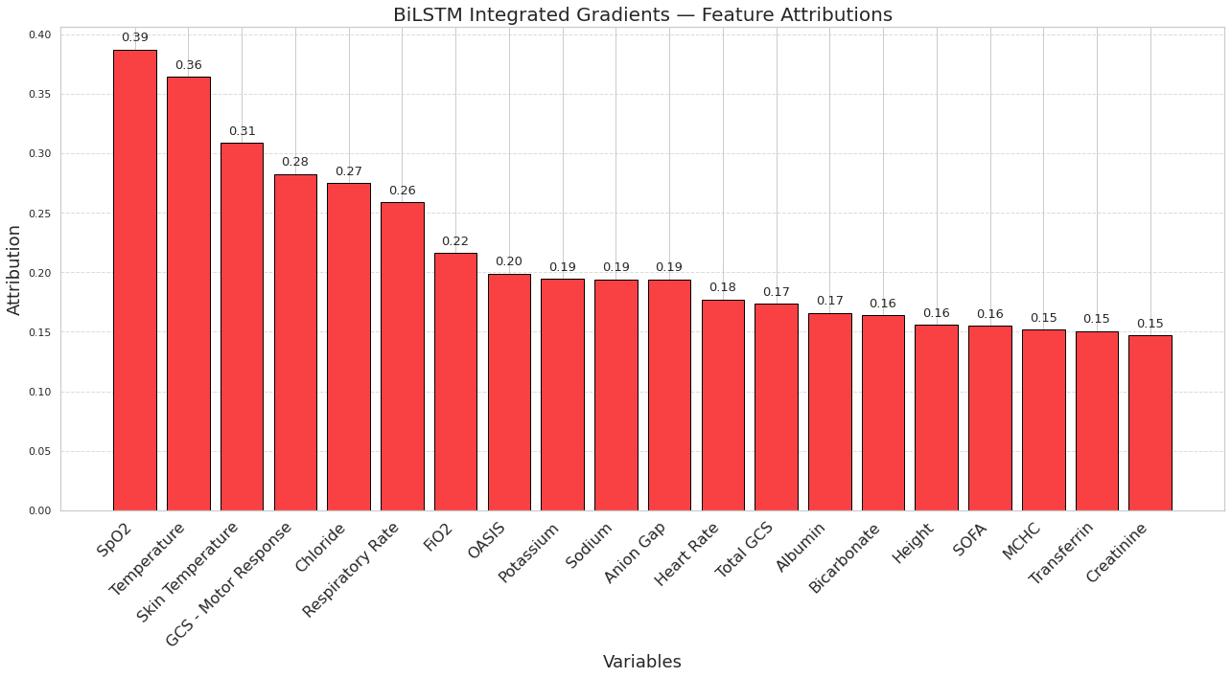
Variable importance of screeningEWS model validation on Covid-period dataset

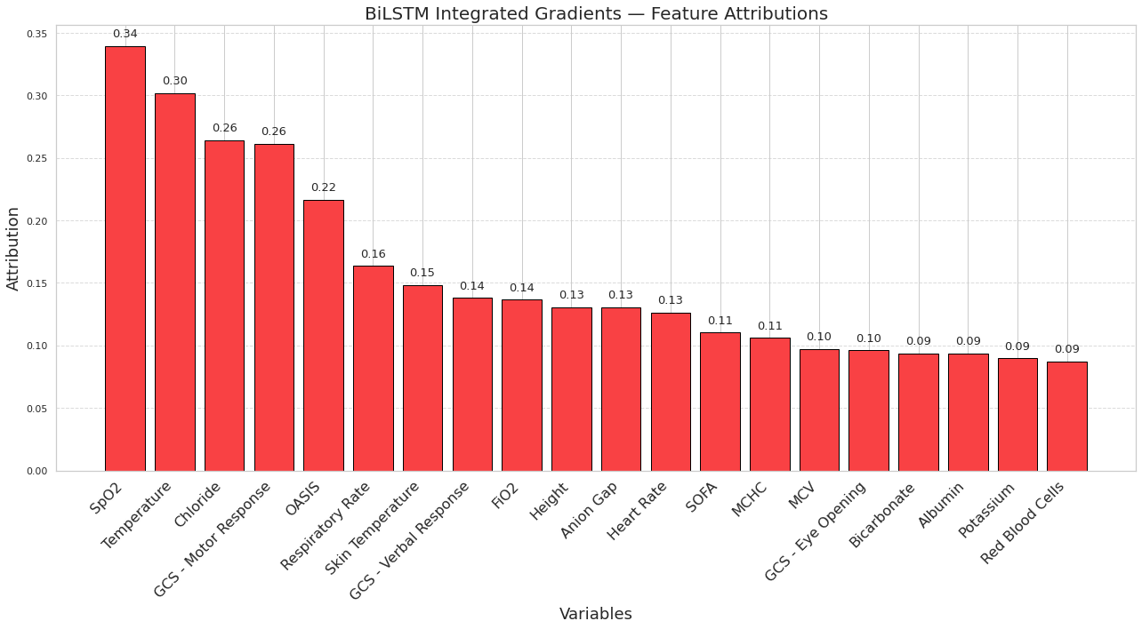

Variable importance of screeningEWS model validation on eICU dataset

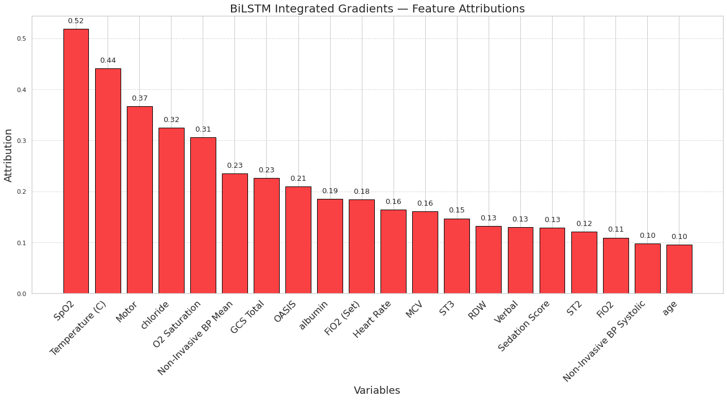

An illustrative example of individual patient–level explanations of screeningEWS:

A 30-year-old male patient who stayed in the hospital for 4 days had a 30% predicted risk of needing RRT after initial 12 hours of screening and ultimately received RRT and survived in hospital.

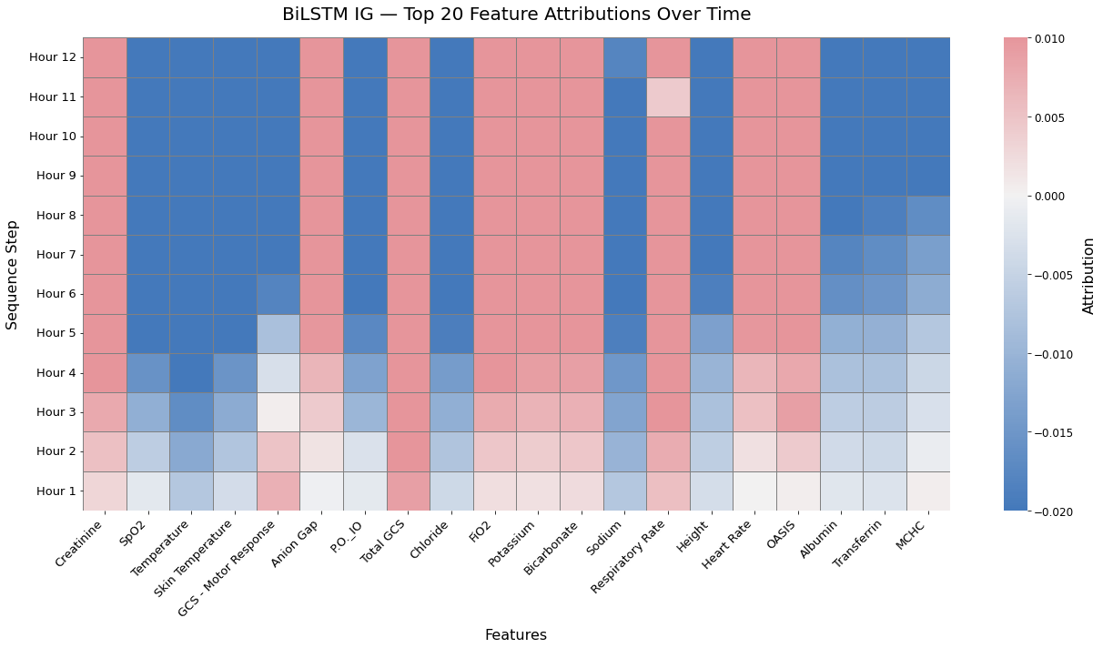

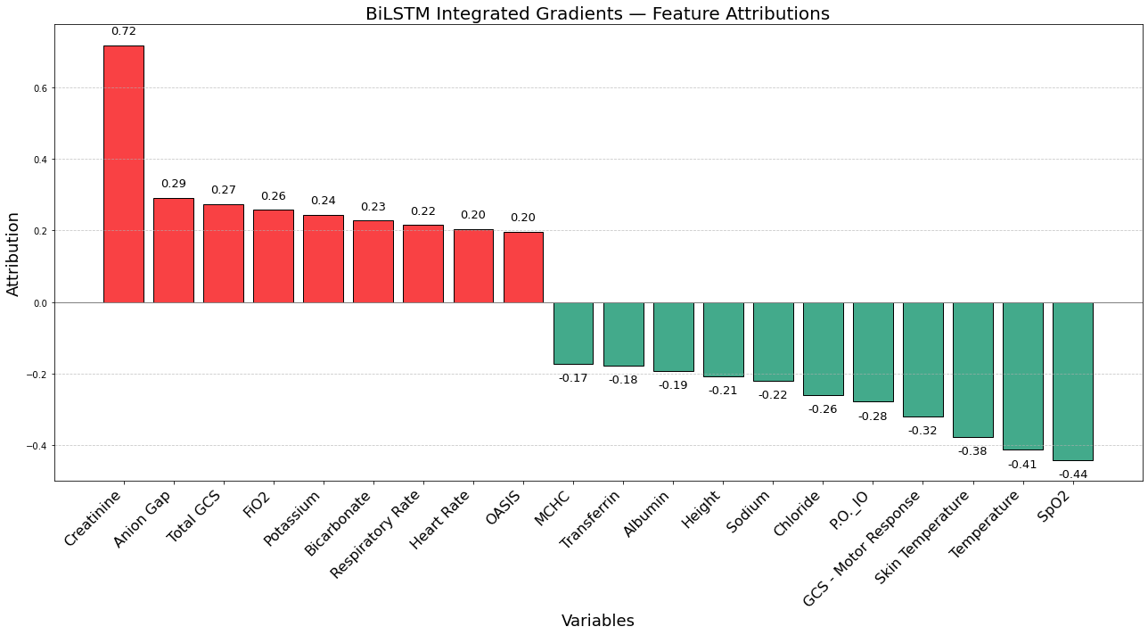
Supplementary File 16. Performance metrics for real-time dynamic prediction of RRT initiation (dynamicEWS)

Database | ACC  (95% CI) | PRC  (95% CI) | F-1  (95% CI) | SPE  (95% CI) | AUC  (95% CI) | AP  (95% CI) | MCC  (95% CI) | Brier  (95% CI)
MIMIC-III | 0.975 (0.975-0.976) | 0.350 (0.343-0.356) | 0.469 (0.462-0.475) | 0.979 (0.979-0.980) | 0.970 (0.969-0.972) | 0.395 (0.387-0.402) | 0.488 (0.482-0.494) | 0.011 (0.011-0.011)
MIMIC-IV | 0.951 (0.951-0.952) | 0.395 (0.391-0.400) | 0.473 (0.469-0.478) | 0.965 (0.965-0.966) | 0.936 (0.934-0.937) | 0.402 (0.397-0.408) | 0.458 (0.454-0.463) | 0.027 (0.027-0.027)
eICU | 0.899 (0.899-0.900) | 0.161 (0.159-0.162) | 0.256 (0.254-0.258) | 0.907 (0.907-0.907) | 0.892 (0.891-0.893) | 0.227 (0.223-0.229) | 0.283 (0.281-0.285) | 0.024 (0.024-0.024)
Covid-19 | 0.955 (0.954-0.955) | 0.440 (0.435-0.445) | 0.496 (0.492-0.501) | 0.970 (0.970-0.971) | 0.936 (0.935-0.937) | 0.455 (0.449-0.460) | 0.477 (0.473-0.482) | 0.027 (0.027-0.027)

Supplementary File 17. Hospital-level external validation of dynamicEWS model across eight individual eICU hospitals

Hospital-level external validation of dynamicEWS model across eight individual eICU hospitals

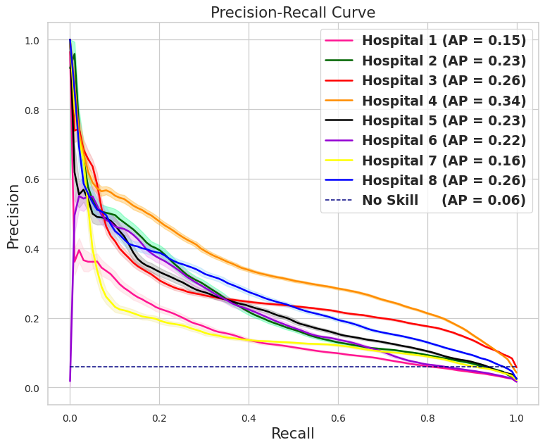
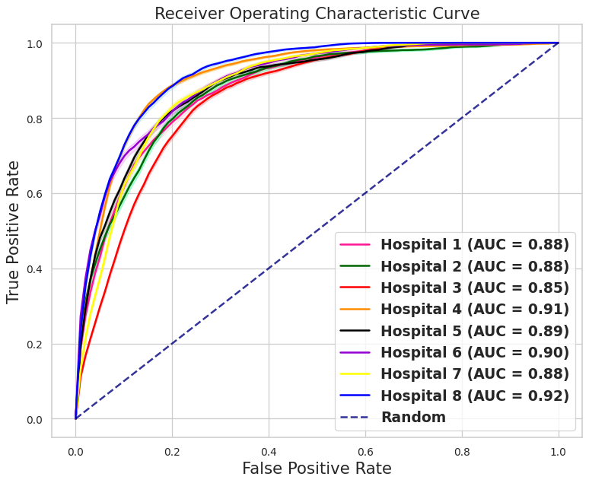

Supplementary File 18. dynamicEWS model evaluations for the remaining patient cohorts

In the MIMIC-III cohort, the dynamicEWS model generated predictions for 791,000 patient-hours, corresponding to 9,821 ICU patients and 885 unique RRT events, with 12,164 hours falling within predefined early-alert windows. Using a fixed decision threshold chosen to achieve a recall of 80% (95% CI 0.77–0.82), the model correctly identified 706 RRT events. At this operating point, the initial hourly alarm rate was 3.1% (24,683 alarms), which was reduced to 0.5% (4,246 alarms) after applying a 6-hour silencing policy, while maintaining the same precision–recall performance. At this threshold, the model produced approximately 1.9 false-positive predictions for every true positive and would prompt a clinical assessment in approximately 13% of patient-days (about 13 alerts per 100 patient-days), corresponding to roughly 0.06 alerts per patient per 12-hour shift (about 6 alerts per 100 patients per shift).

In the Covid-period cohort, the dynamicEWS model generated predictions for 752,000 patient-hours, corresponding to 8,980 ICU patients and 1,333 unique RRT events, with 29,517 hours within early-alert windows. Using the same recall-targeted threshold of 80% (95% CI 0.78–0.82), the model correctly identified 1,075 RRT events. The initial hourly alarm rate of 5.1% (38,274 alarms) decreased to 0.9% (6,856 alarms) after applying the 6-hour silencing policy. At this operating point, the model produced approximately 1.3 false-positive predictions for every true positive and would prompt a clinical assessment in approximately 22% of ICU patient-days (about 22 alerts per 100 patient-days), corresponding to 0.11 alerts per patient per 12-hour shift (about 11 alerts per 100 patients per shift).

In the eICU cohort, the dynamicEWS model generated predictions for 2.55 million patient-hours, corresponding to 28,412 ICU patients and 1,725 unique RRT events, with 70,172 hours within early-alert windows. With recall fixed at 80% (95% CI 0.78–0.82), the model correctly identified 1,384 RRT events. The initial hourly alarm rate of 10% (274,879 alarms) was reduced to 1.9% (48,444 alarms) after applying the 6-hour silencing policy. At this threshold, the model produced approximately 5.7 false-positive predictions for every true positive and would prompt a clinical assessment in approximately 46% of patient-days (about 46 alerts per 100 patient-days), corresponding to 0.23 alerts per patient per 12-hour shift (about 23 alerts per 100 patients per shift).

Supplementary File 19. Population-level SHAP feature-importance rankings for each cohort
Variable importance of dynamicEWS model
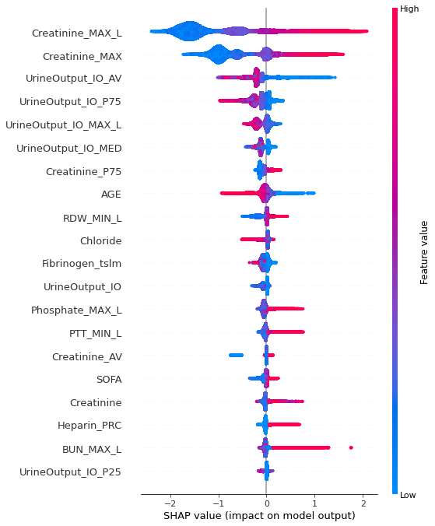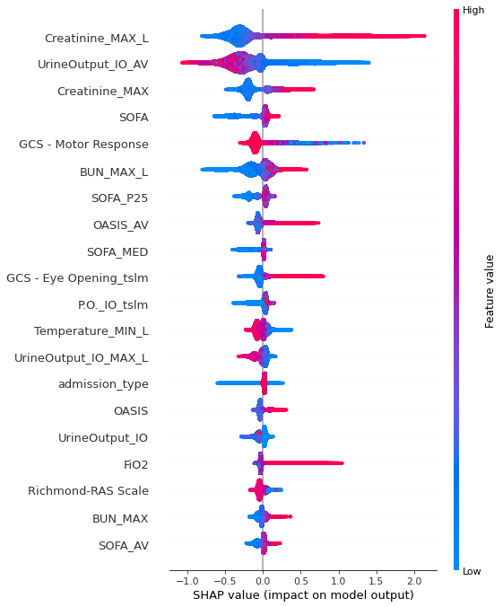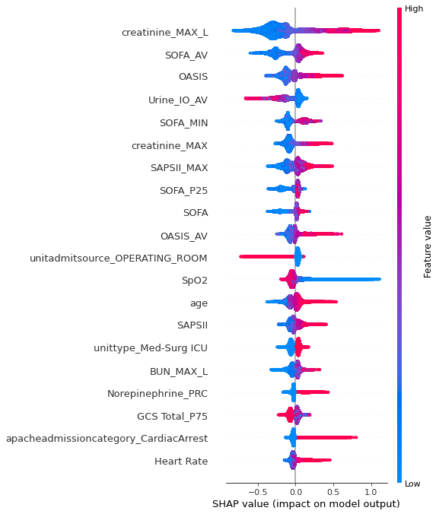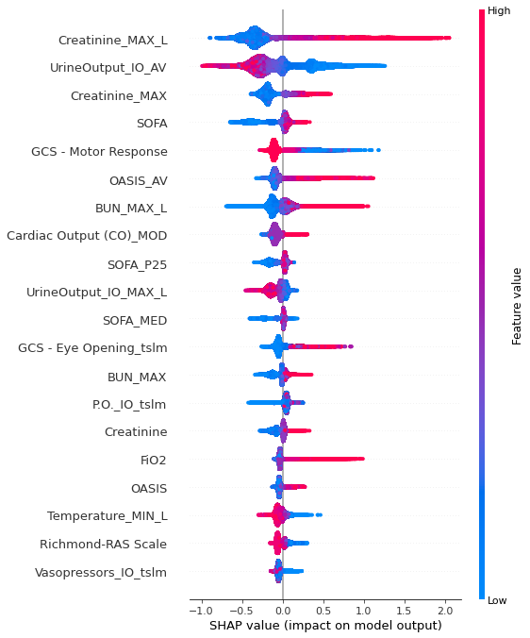

MIMIC-III
MIMIC-IV
eICU
Covid-period
Supplementary File 20. Additional examples of real-time RRT risk assessment

Illustrative examples of individual patient–level explanations of dynamicEWS:

Example 1 is a 66-year-old female with a 13-day ICU stay and RRT initiation at 141 hours, who survived to hospital discharge.

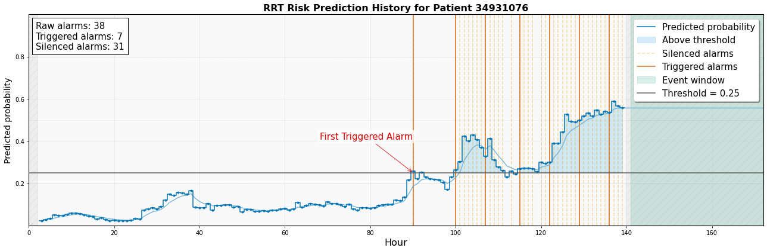

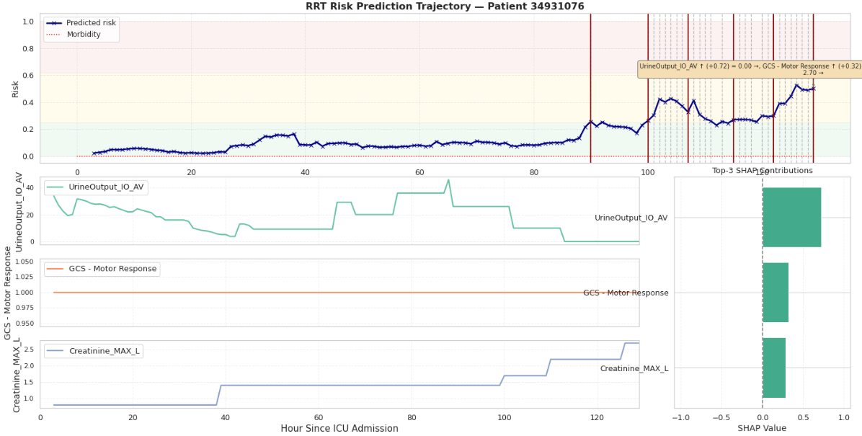

Example 2 is a 41-year-old male who remained in the ICU for 26 days, initiated RRT 86 hours after ICU admission, and ultimately died before hospital discharge.

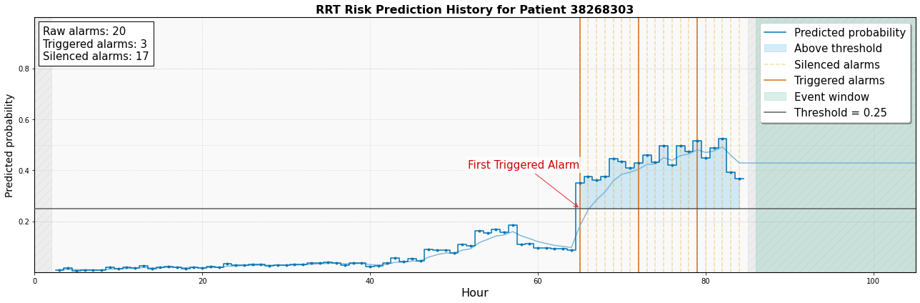

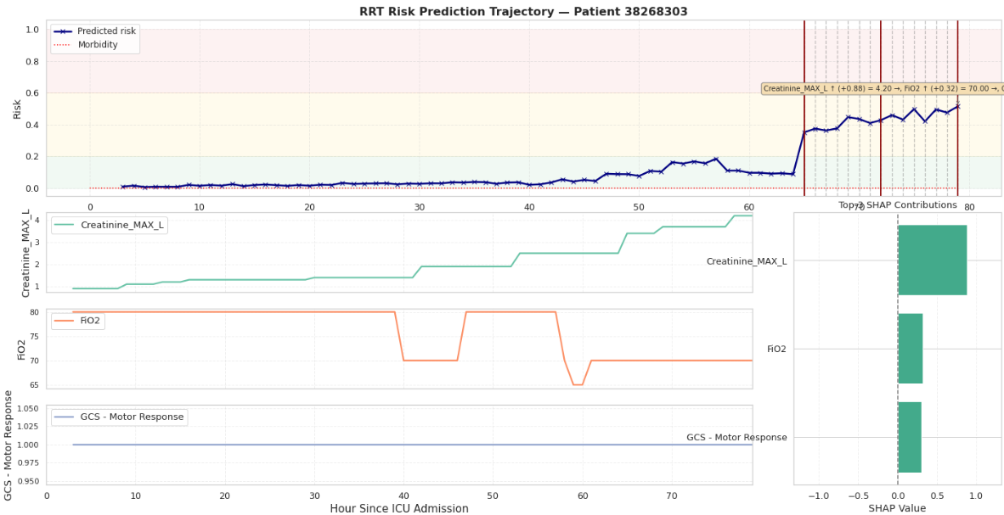

Example 3 is a 20-year-old female who remained in the ICU for 19 days, initiated RRT 156 hours after admission, and survived to hospital discharge.

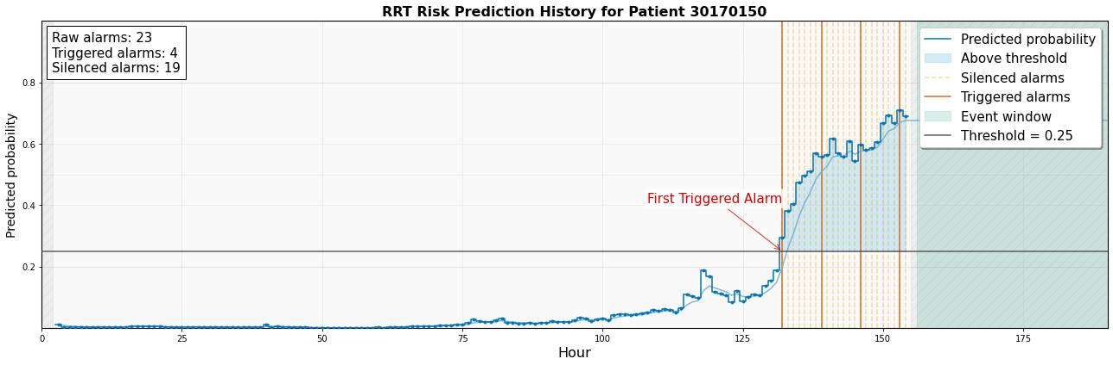

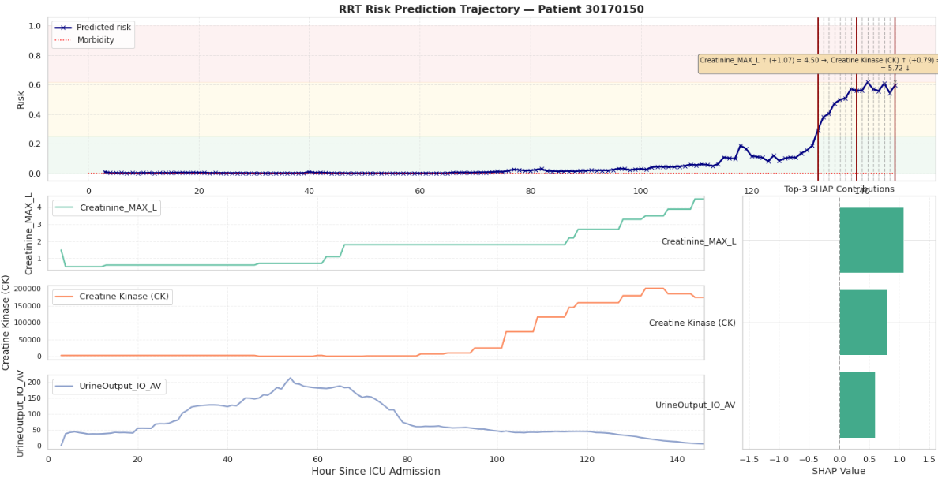

Supplementary File 21. Fairness evaluations for each cohorts and additional subgroup analyses

Bias and fairness evaluation of dynamicEWS model on MIMIC-III dataset:
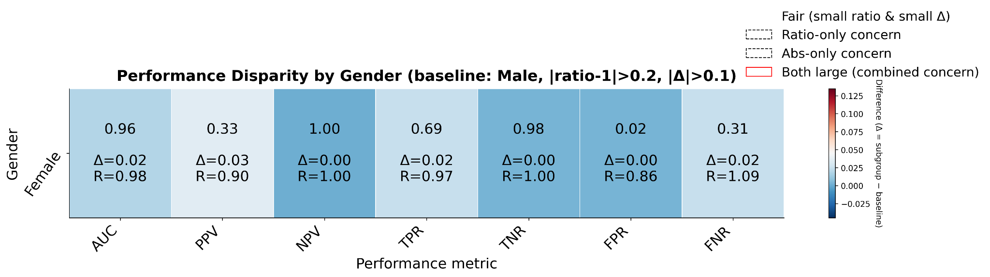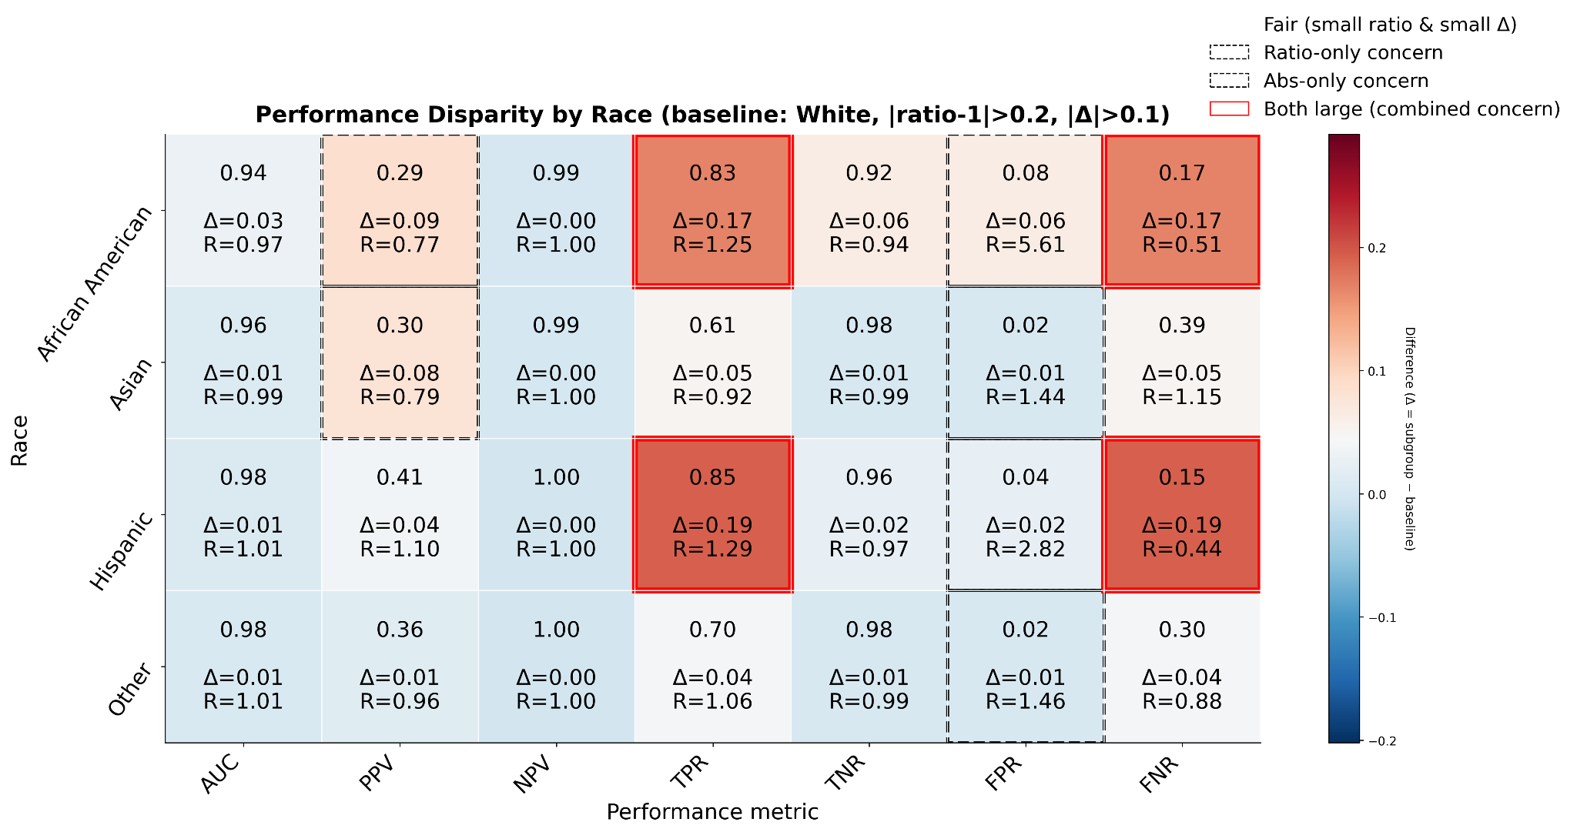
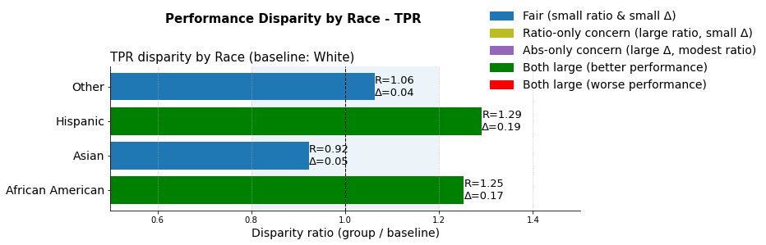
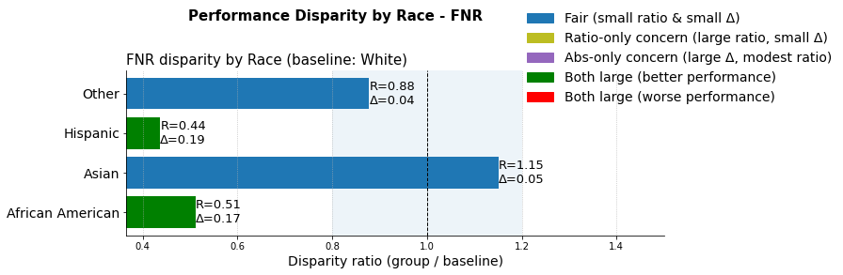
Bias and fairness evaluation of dynamicEWS model on MIMIC-IV dataset:
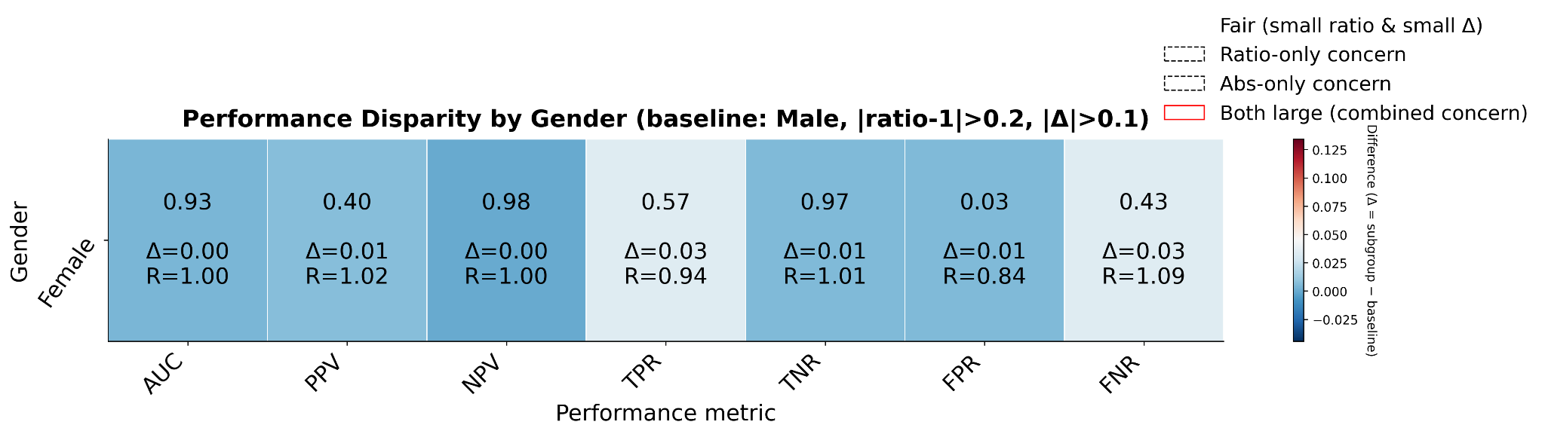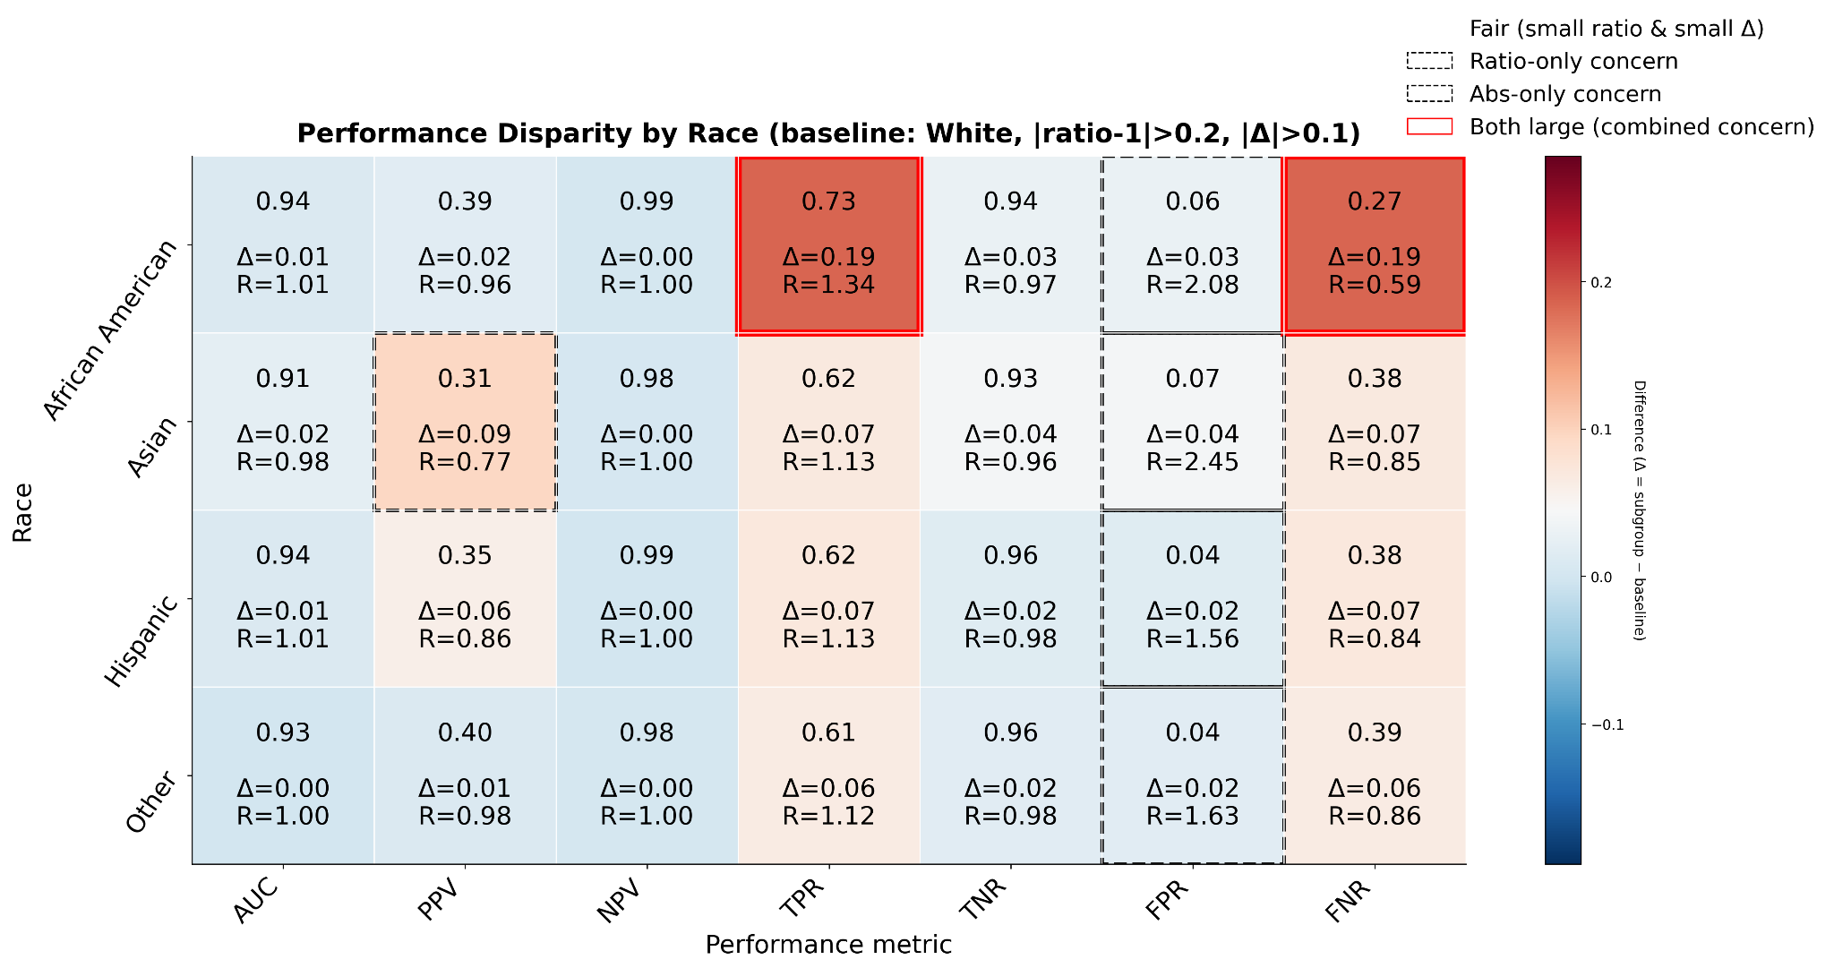
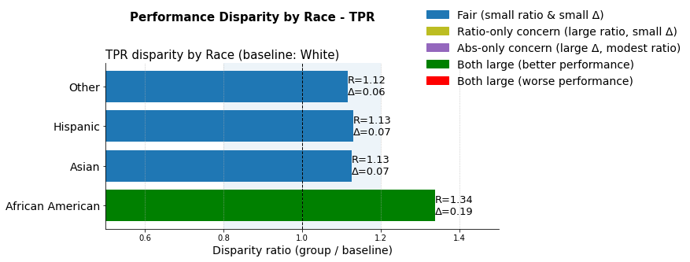
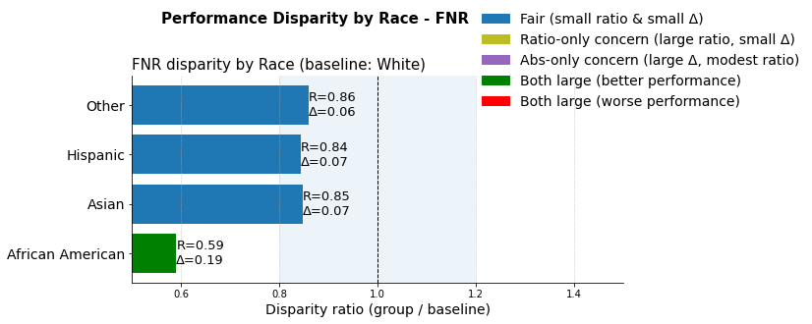
Bias and fairness evaluation of dynamicEWS model on Covid-period dataset:
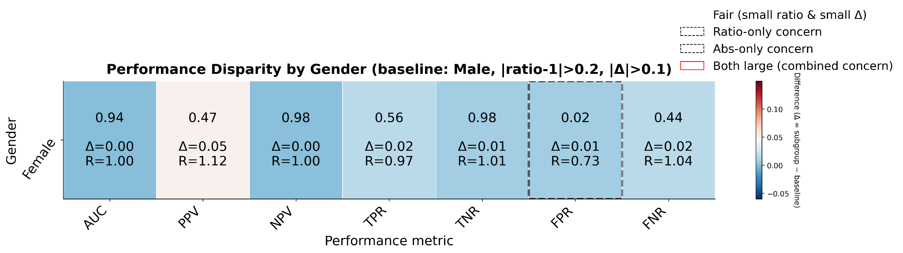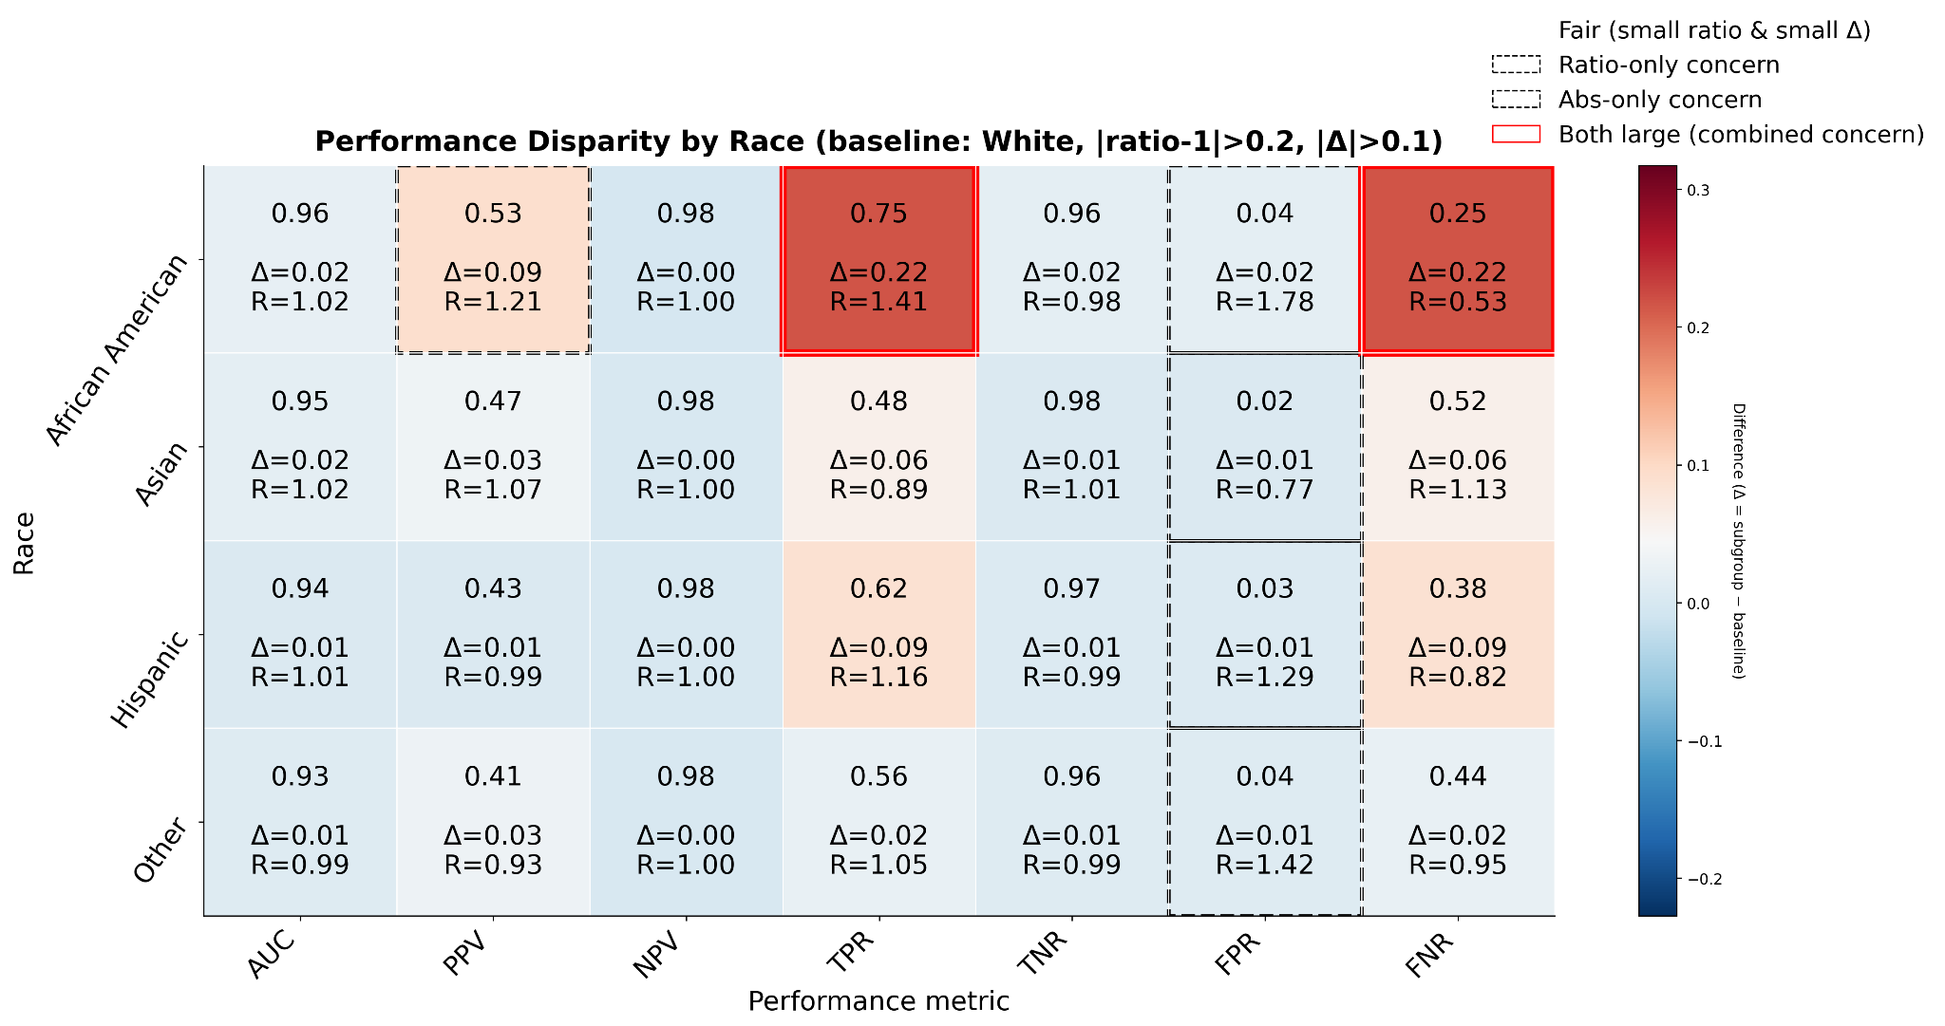
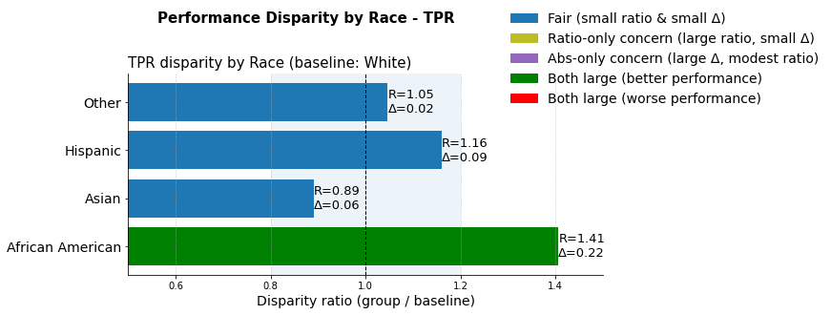
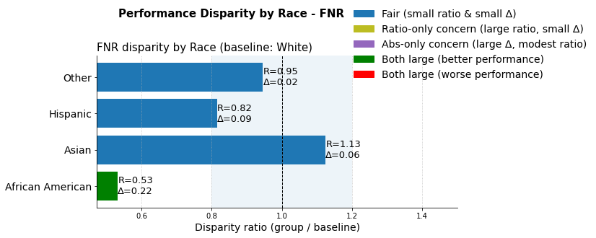
Bias and fairness evaluation of dynamicEWS model on eICU dataset:
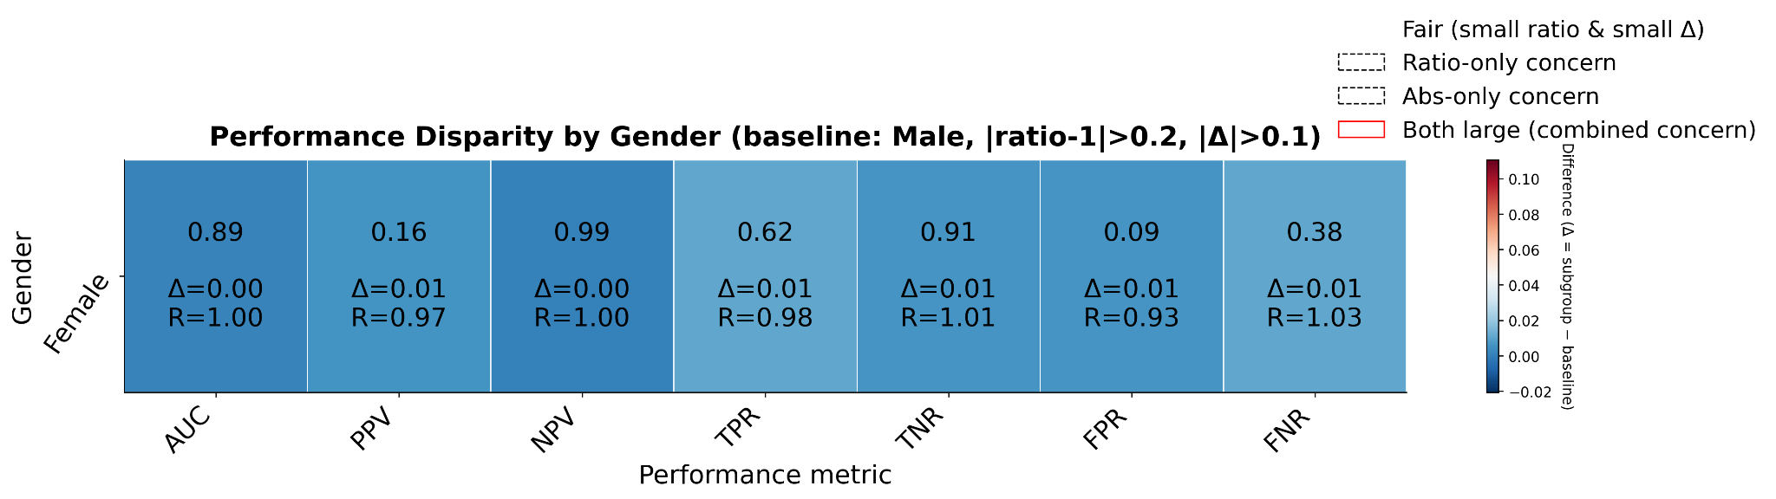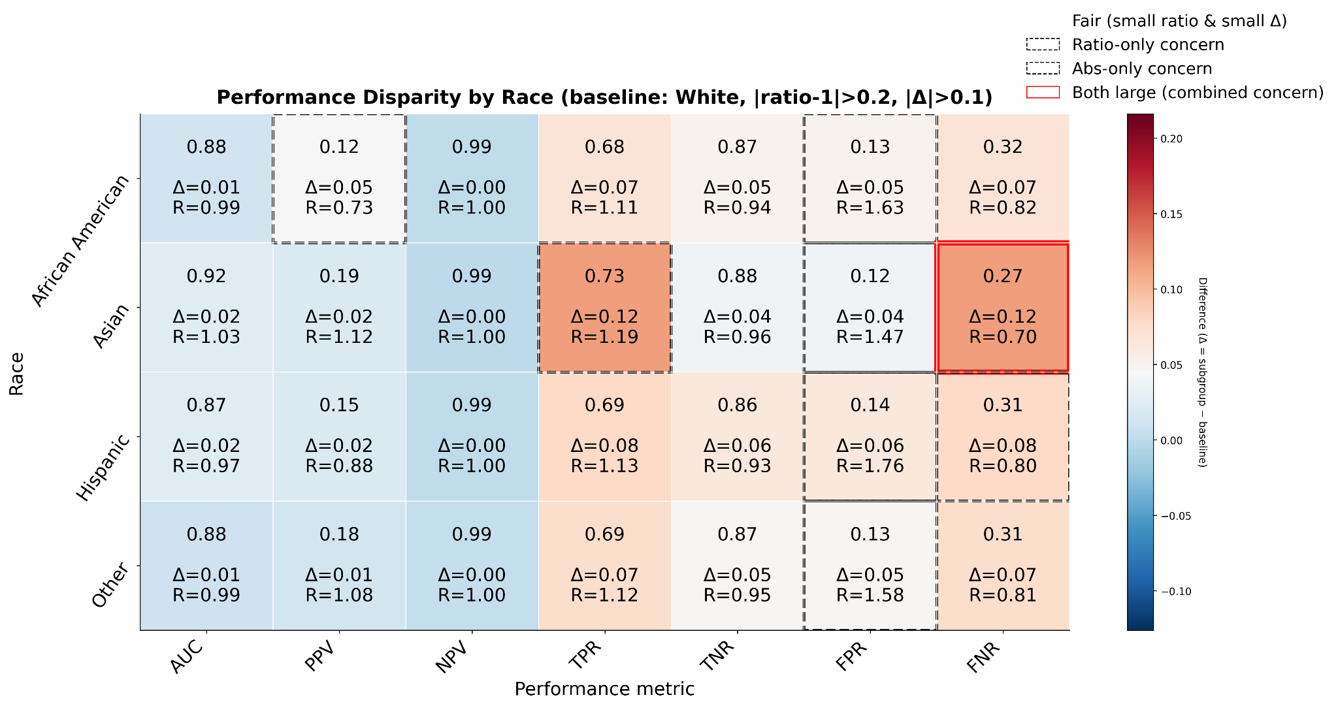
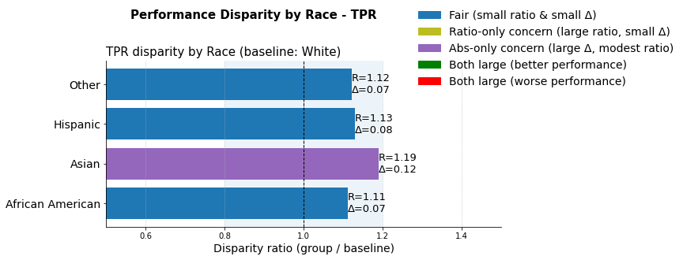
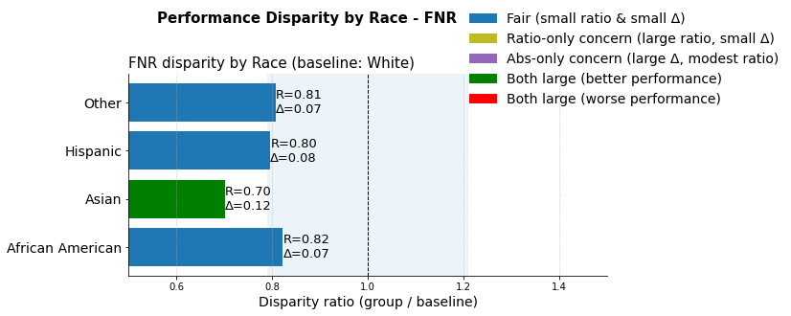
Supplementary File 22. Performance metrics for prediction of RRT duration (durationEWS)

Database | ACC  (95% CI) | PRC  (95% CI) | F-1  (95% CI) | SPE  (95% CI) | AUC  (95% CI) | AP  (95% CI) | MCC  (95% CI) | Brier  (95% CI)
MIMIC-III | 0.782 (0.748-0.816) | 0.763 (0.711-0.809) | 0.778 (0.738-0.814) | 0.769 (0.719-0.815) | 0.860 (0.828-0.889) | 0.865 (0.830-0.901) | 0.564 (0.496-0.631) | 0.162 (0.140-0.184)
MIMIC-IV | 0.809 (0.779-0.838) | 0.806 (0.764-0.846) | 0.801 (0.767-0.832) | 0.821 (0.783-0.859) | 0.896 (0.873-0.919) | 0.899 (0.873-0.922) | 0.618 (0.558-0.676) | 0.138 (0.119-0.158)
eICU | 0.715 (0.688-0.746) | 0.502 (0.458-0.549) | 0.616 (0.576-0.658) | 0.682 (0.649-0.718) | 0.814 (0.785-0.844) | 0.670 (0.608-0.725) | 0.436 (0.383-0.490) | 0.166 (0.149-0.182)
Covid-19 | 0.782 (0.748-0.819) | 0.869 (0.834-0.902) | 0.832 (0.801-0.861) | 0.745 (0.682-0.806) | 0.833 (0.795-0.871) | 0.893 (0.855-0.925) | 0.525 (0.449-0.601) | 0.165 (0.142-0.189)

Supplementary File 23. Feature-importance rankings of durationEWS model for each cohort, along with an illustrative example of individual patient–level explanations

Variable importance of durationEWS model validation on MIMIC-III dataset

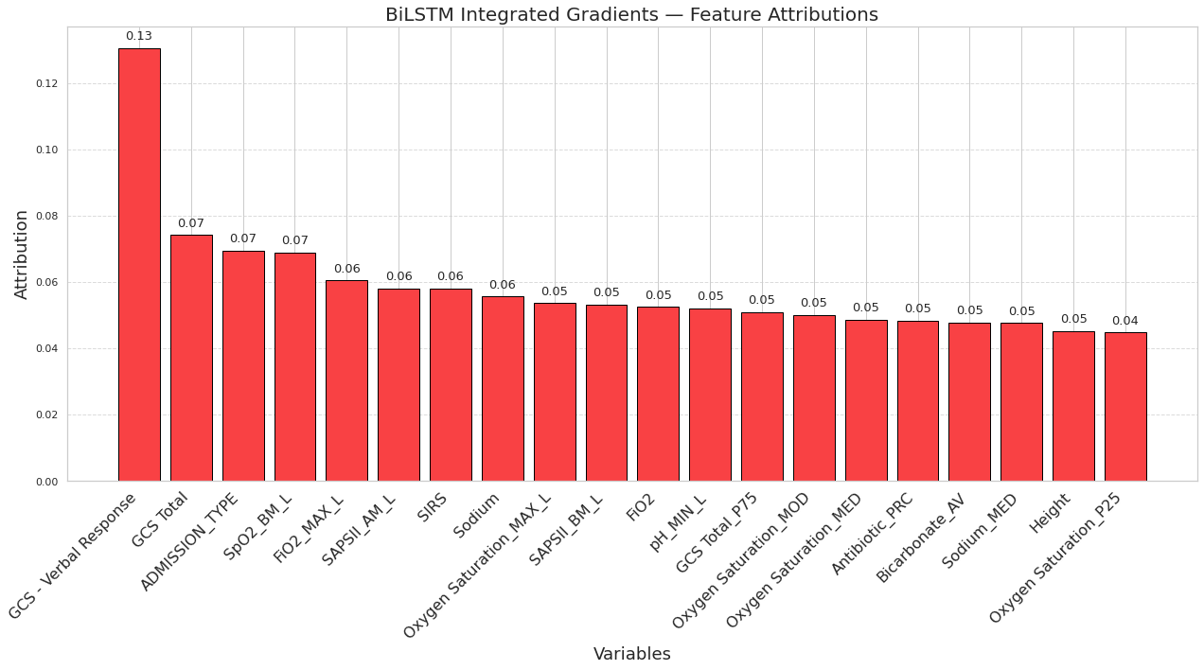

Variable importance of durationEWS model validation on MIMIC-IV dataset

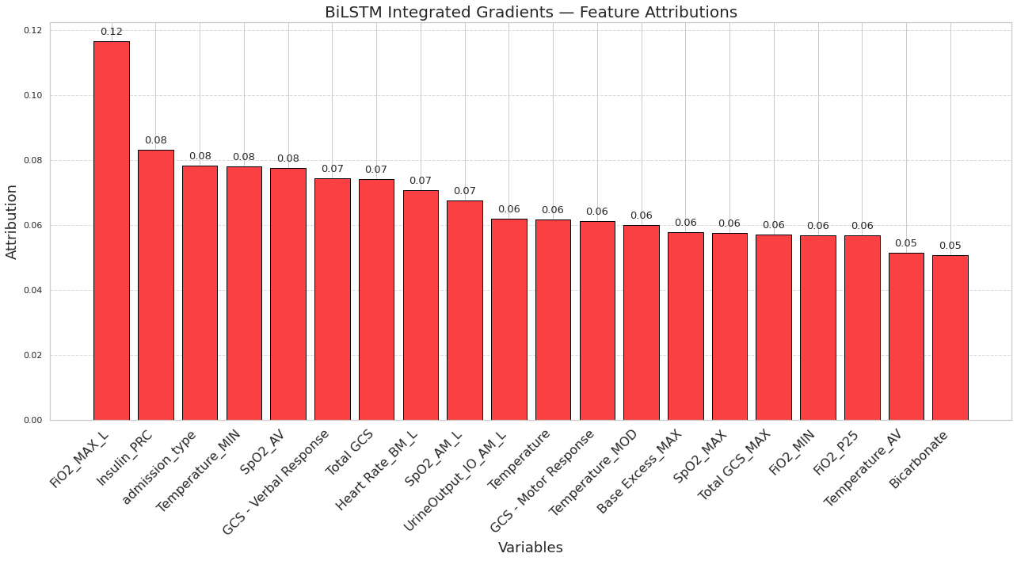
Variable importance of durationEWS model validation on Covid-period dataset

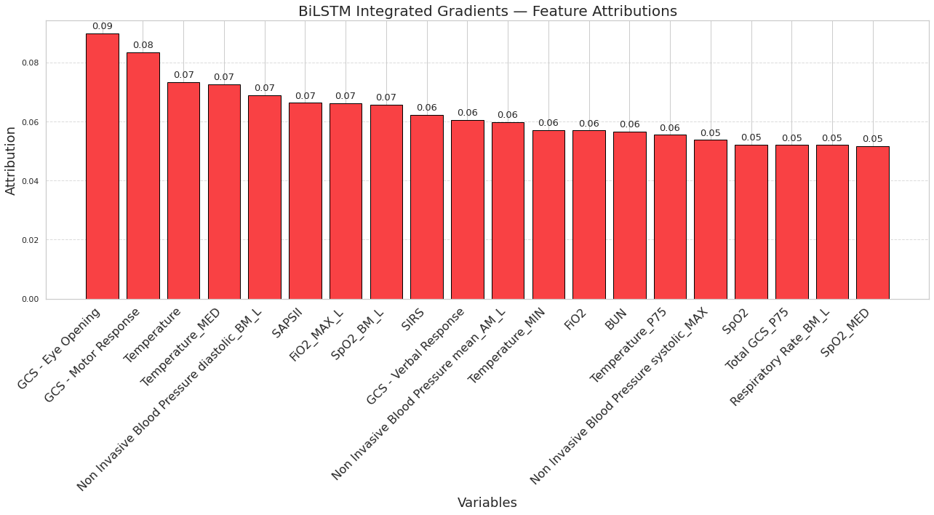

Variable importance of durationEWS model validation on eICU dataset

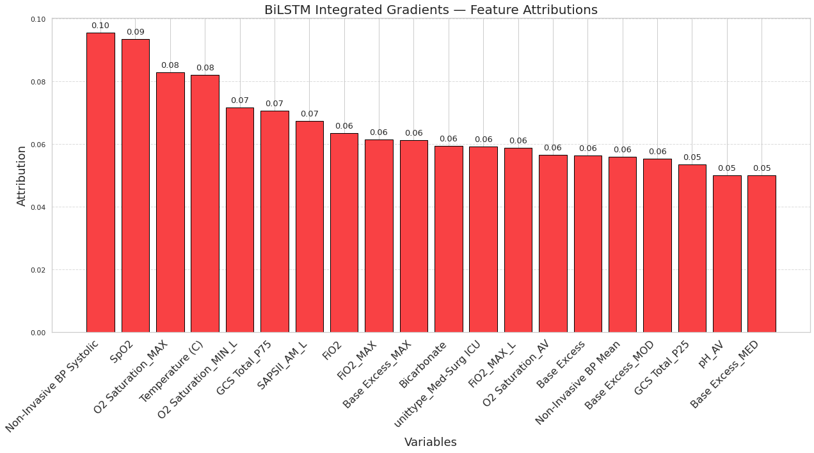

An illustrative example of individual patient–level explanations of durationEWS:

A 72-year-old male patient who stayed in the ICU for 20 days had a 88% predicted risk of prolong RRT at hour 112 and ultimately received RRT for 3 days and survived in hospital.

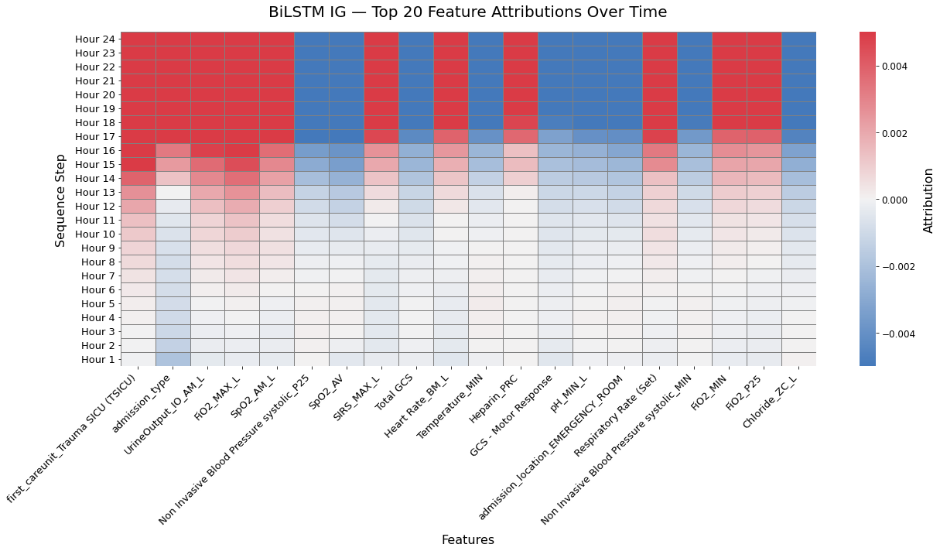
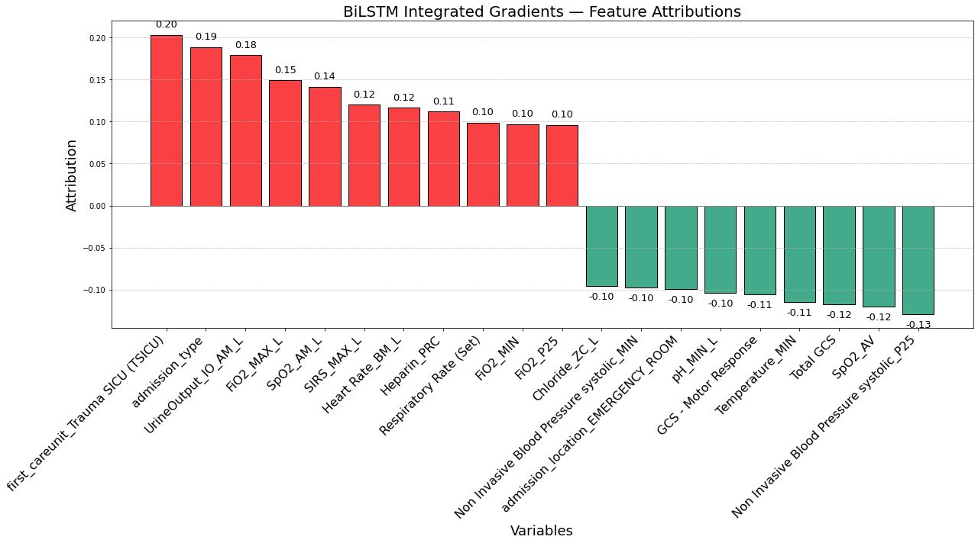

Supplementary File 24. Performance metrics for mortality prediction post-RRT onset (prognosisEWS)

Database | ACC  (95% CI) | PRC  (95% CI) | F-1  (95% CI) | SPE  (95% CI) | AUC  (95% CI) | AP  (95% CI) | MCC  (95% CI) | Brier  (95% CI)
MIMIC-III | 0.796 (0.764-0.827) | 0.507 (0.434-0.579) | 0.618 (0.548-0.680) | 0.797 (0.760-0.831) | 0.885 (0.848-0.917) | 0.722 (0.638-0.797) | 0.511 (0.434-0.585) | 0.113 (0.095-0.133)
MIMIC-IV | 0.789 (0.757-0.817) | 0.515 (0.455-0.574) | 0.625 (0.571-0.676) | 0.787 (0.752-0.821) | 0.879 (0.850-0.908) | 0.697 (0.622-0.763) | 0.510 (0.446-0.574) | 0.120 (0.106-0.135)
eICU | 0.719 (0.691-0.751) | 0.445 (0.393-0.500) | 0.571 (0.521-0.622) | 0.695 (0.659-0.733) | 0.824 (0.788-0.858) | 0.592 (0.517-0.671) | 0.423 (0.363-0.485) | 0.246 (0.227-0.264)
Covid-19 | 0.738 (0.701-0.774) | 0.640 (0.584-0.695) | 0.711 (0.665-0.754) | 0.697 (0.646-0.744) | 0.842 (0.809-0.874) | 0.770 (0.709-0.822) | 0.487 (0.413-0.555) | 0.198 (0.179-0.217)

Supplementary File 25. Feature-importance rankings of prognosisEWS model for each cohort, along with an illustrative example of individual patient–level explanations.

Variable importance of prognosisEWS model validation on MIMIC-III dataset

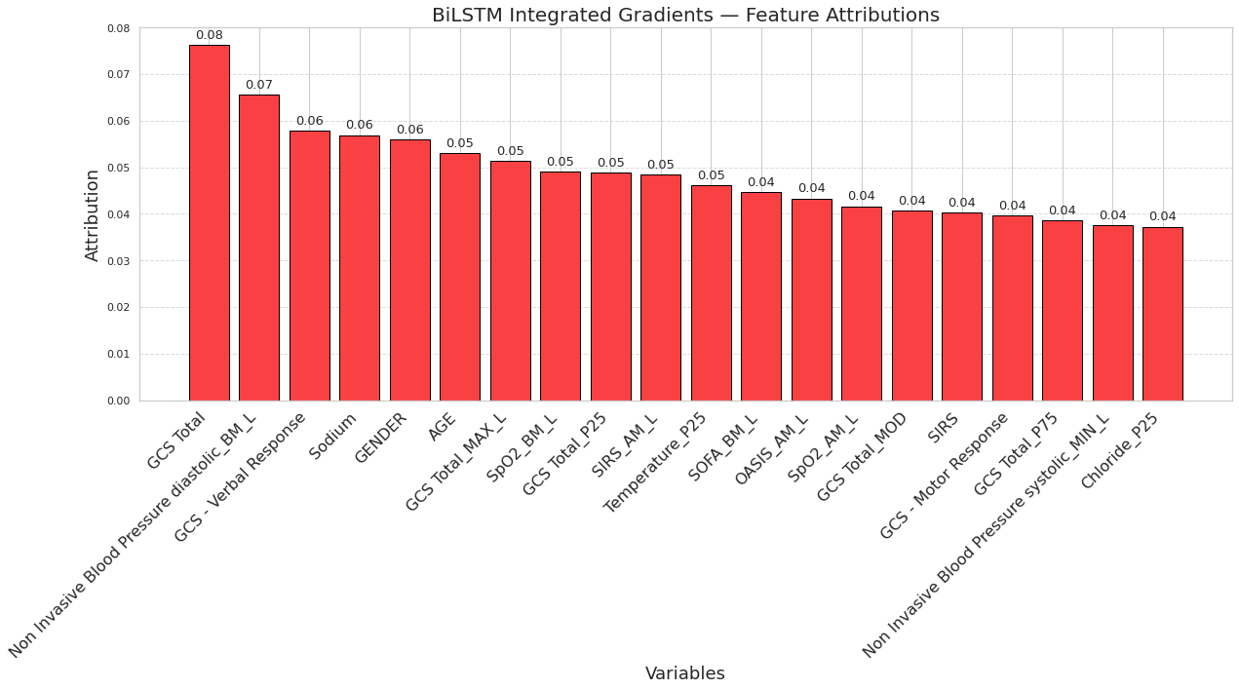

Variable importance of prognosisEWS model validation on MIMIC-IV dataset

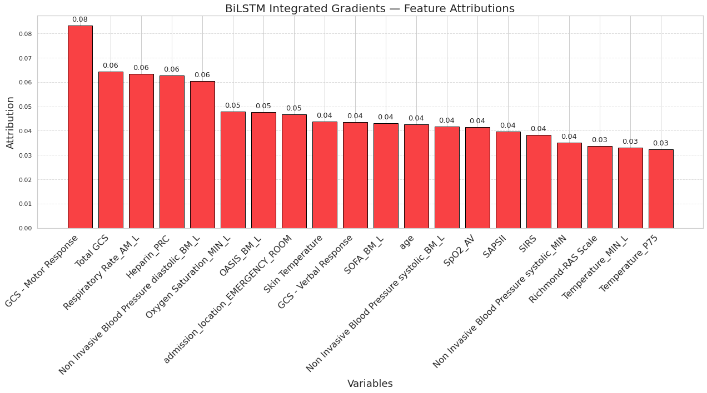
Variable importance of prognosisEWS model validation on Covid-period dataset

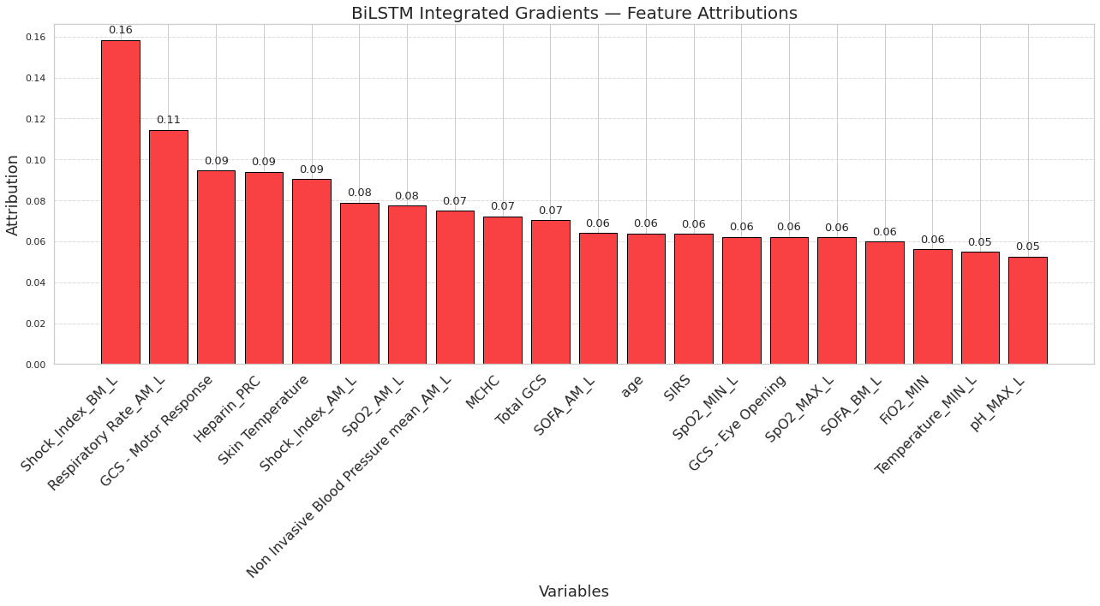

Variable importance of prognosisEWS model validation on eICU dataset

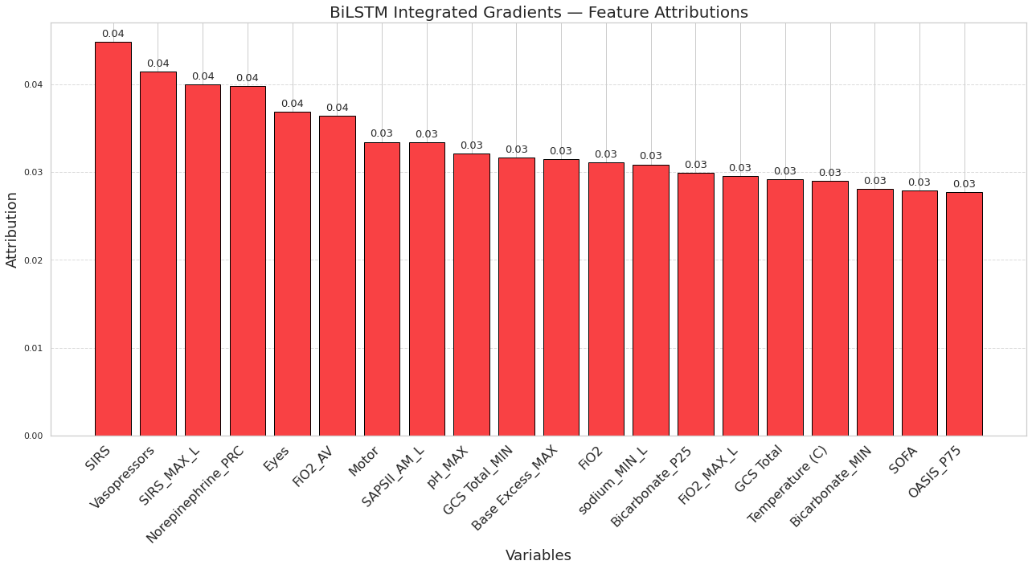

An illustrative example of individual patient–level explanations of prognosisEWS:

A 66-year-old male patient who stayed in the ICU for 18 days had a 42% predicted risk of mortality following the initiation of RRT and ultimately died in hospital.

