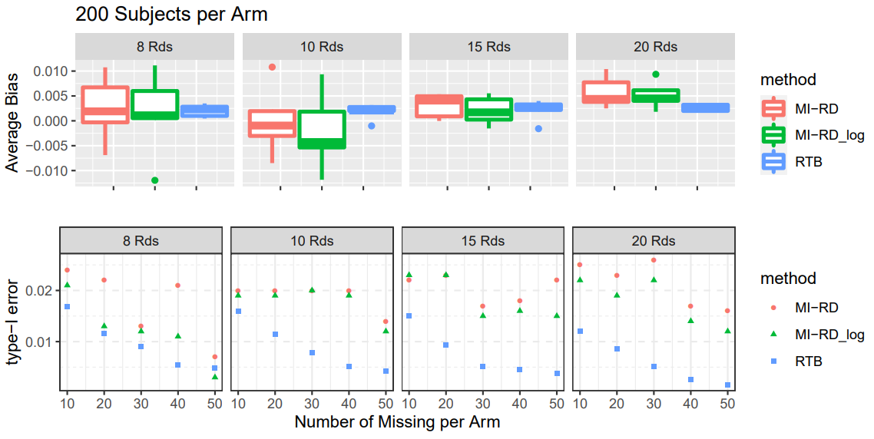
Figure 5.b Type-I Error Rate and Average Bias with respect to Different Amount of Missingness and Different Number of RDs, for 200 Subjects per Arm
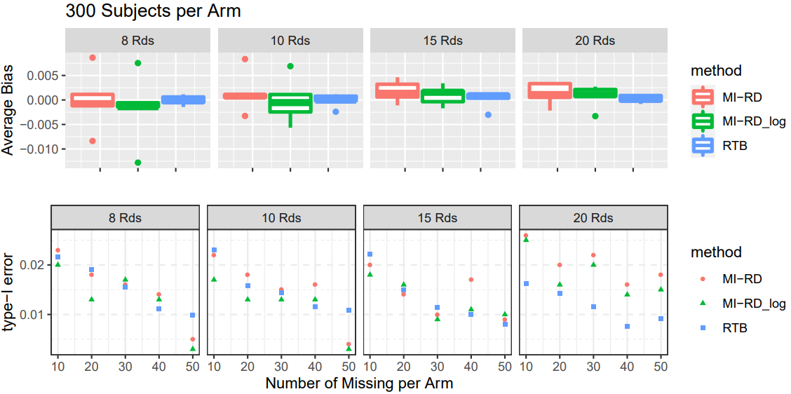
Figure 5.c Type-I Error Rate and Average Bias with respect to Different Amount of Missingness and Different Number of RDs, for 300 Subjects per Arm

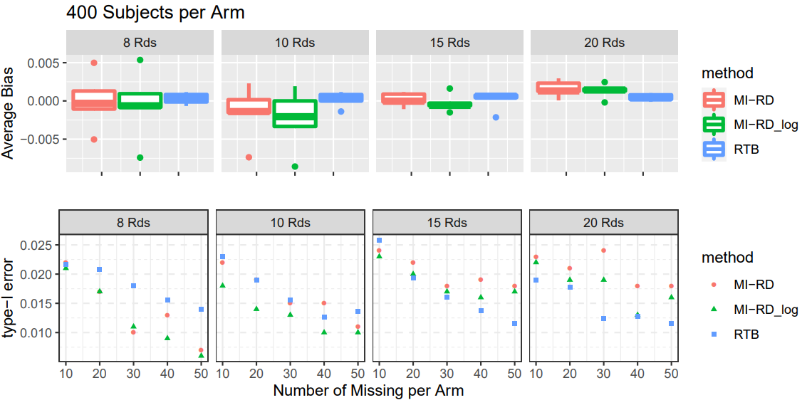
Figure 5.d Type-I Error Rate and Average Bias with respect to Different Amount of Missingness and Different Number of RDs, for 400 Subjects per Arm
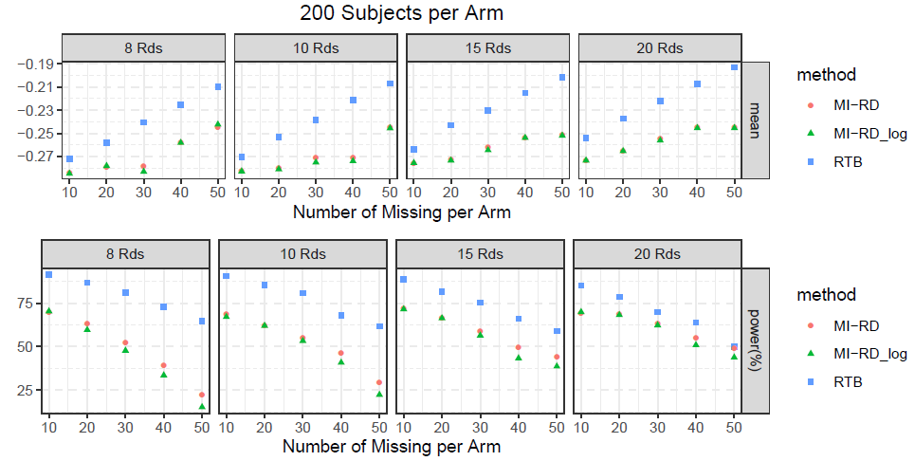
Figure 6.b Power Rate and Effect Size Estimates with respect to Different Amount of Missingness and Different Number of RDs, for 200 Subjects per Arm

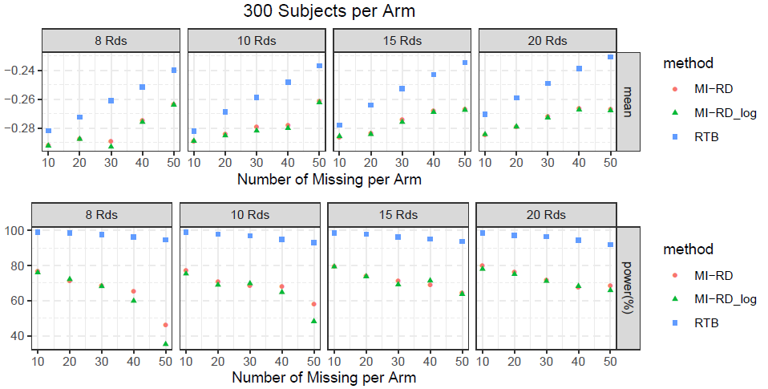
Figure 6.c Power Rate and Effect Size Estimates with respect to Different Amount of Missingness and Different Number of RDs, for 300 Subjects per Arm

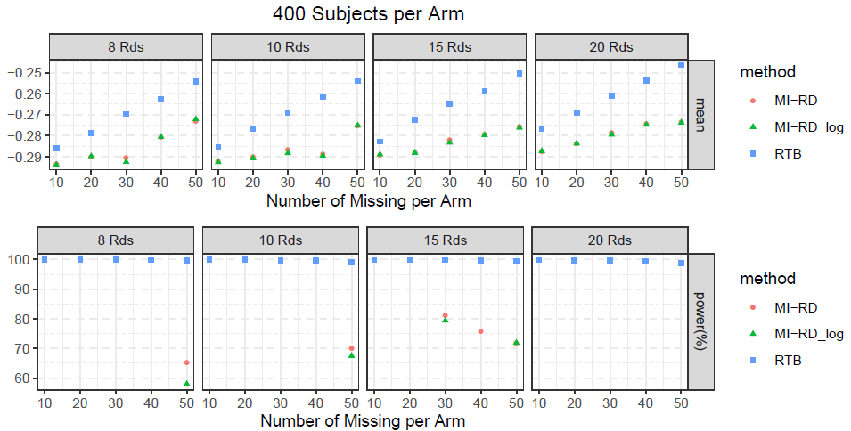
Figure 6.d Power Rate and Effect Size Estimates with respect to Different Amount of Missingness and Different Number of RDs, for 400 Subjects per Arm

